FlowCast (Xero)
Product Explainer — what it is, what is done, what is not done and why

Project code: 003-MoPr03-flowcast_xero
Document version: v001
Date: 20 September 2026, 10:59 BST
Author: Claude for Senthil/KP
Status: Released — for Senthil review
Source artefacts: Sprint tracker v024 (20 Sep 2026 10:14) · Product workbook v036 · Code v0.30.0 (zip flowcast_v036_codebase_and_docs) · Perplexity V001 review (16 Sep 2026) · ChatGPT V001 review (13 Sep 2026)
Companion workbook: claude_V001_MoPr03-flowcast_xero_versiondetail_manualtest_20260920_1059.xlsx
Diagrams: Embedded below and supplied as PNG + SVG (01_product_overview, 02_live_data_path, 03_status_map, 04_why_not_complete)
Colour convention: green = built, tested at 100% and gate-proved in the sandbox · amber = code-complete, never run live, or waiting on a decision · red = not built · grey = outside the codebase.

Version control
File naming: claude_v<NNN>_<name>_YYYYMMDD_HHMI. Nothing is deleted between versions; superseded lines are marked, never removed.
Version | Date/Time | Author | Change description | Status
v001 | 2026-09-20 10:59 | Claude for Senthil/KP | First explainer. Four diagrams (product overview, live data path, status map, why-not-complete tree) plus the completed / not-completed record at feature, story, enhancement-pool and gate level. Companion to claude_V001_MoPr03-flowcast_xero_versiondetail_manualtest_20260920_1059.xlsx. | Released
v002 | PLANNED | — | Opens when the status changes: a Senthil decision (PPX-D1..D6, DEC-F16/F17), sprint P1-8, or the first live run against a Xero dev org. | Planned

Contents

Context
FlowCast is product 12 of 12 in the marketplace-app portfolio: a Xero App Store app giving SMB owners a 13-week cash forecast with traffic lights, what-if scenario sliders, invoice-chasing nudges, bank-feed anomaly alerts, and an accountant portal that triages a whole client book reds-first.
It has been built entirely in a sandbox under D13 (100% automated coverage, zero pragmas) across 36 workbook versions and 24 tracker versions between 5 and 20 September 2026, with two independent external AI reviews (ChatGPT V001 on 13 Sep, Perplexity V001 on 16 Sep). Neither the code nor any document has ever touched a real Xero organisation.
This document exists because the same fact has to be said two ways at once: the engineering discipline is unusually strong (49 suites / 719 tests at 100%, 14 gate files proved by 15 mutations), and the product is further from a listing than a "77 of 100 stories Done" rollup suggests. Both are true, and the second is the one a reader needs.
Colour convention throughout: green = built, tested at 100% and gate-proved in the sandbox; amber = code-complete but never run live or waiting on a decision; red = not built; grey = outside the codebase (Xero, vendors, people).

How to use this document
- Read the four diagrams first (sections 1–4); each has a one-paragraph reading guide under it. They are also supplied as standalone PNG and SVG files so they can be pasted into a deck or printed.
- Section 5 is the feature-by-feature and story-by-story record: what "Done" means for each, and the exact reason anything is not Done. Every reason names its source id (a finding, decision, risk or handover item) so it can be checked in tracker v024 or workbook v036.
- Section 6 is the version timeline — one line per release, what it did and why. The companion Excel workbook (versiondetail_manualtest) carries the same versions in full with manual test cases per version.
- When a status changes, do not edit this version: raise v002 with the change in Version Control. Nothing here is deleted between versions; superseded lines are marked.
- Vocabulary: "Done" = code + 100% automated tests + a gate that fails under the original defect. "Code-complete — pending live" = the same, but the story can only be proved against a live Xero org. "Drafted" = a document that exists and has not been published or reviewed. "Not started" = nothing exists.

1. What FlowCast is
FlowCast answers two questions for a small business on Xero — "will I run out of cash in the next 13 weeks?" and "who owes me, and what happens if I chase them?" — and lets an accountant answer them for every client at once. It reads the organisation's Xero data (bank balances, sales invoices, supplier bills, repeating invoices, bank feed), computes a week-by-week cash position with traffic lights, lets the owner try what-if scenarios, plans invoice-chasing nudges, and watches the bank feed for anomalies.
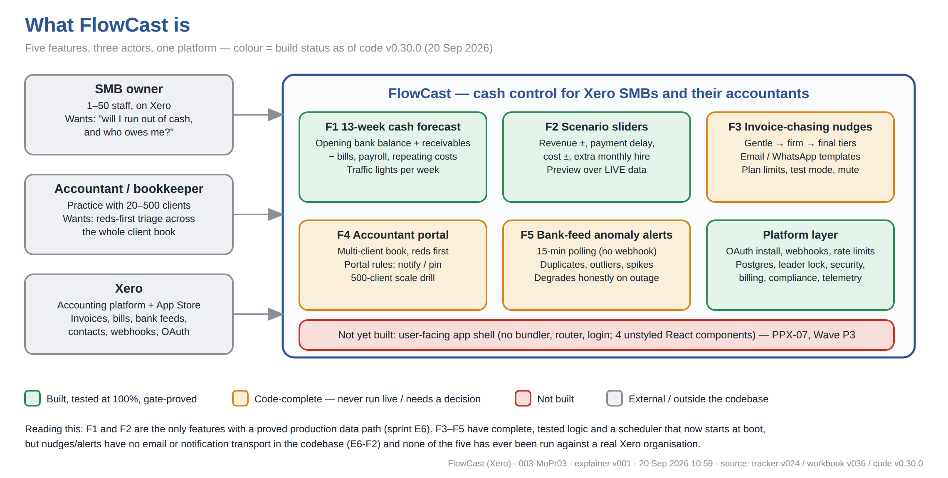
Reading the diagram: the three grey boxes are outside the codebase. The five feature boxes are the product; the platform layer is what any Xero app must have. Only F1 and F2 are green because only they have a proved path from a real Xero call to a screen-ready answer. F3–F5 are complete as logic but either cannot deliver anything (no transport) or cannot be seen (no screen). The red strip is the single largest gap: there is no application to open.

2. How it works — the live data path
This is the architecture as it exists in code v0.30.0, laid out along the path data takes. Every box names its source file so a reader can open the zip and check. The path from Xero to the forecast routes and the scheduler is new in sprint E6 (20 Sep 2026): before it, the forecast engine was a pure function fed by demo fixtures — the Perplexity reviewer's BLOCKER PPX-01.
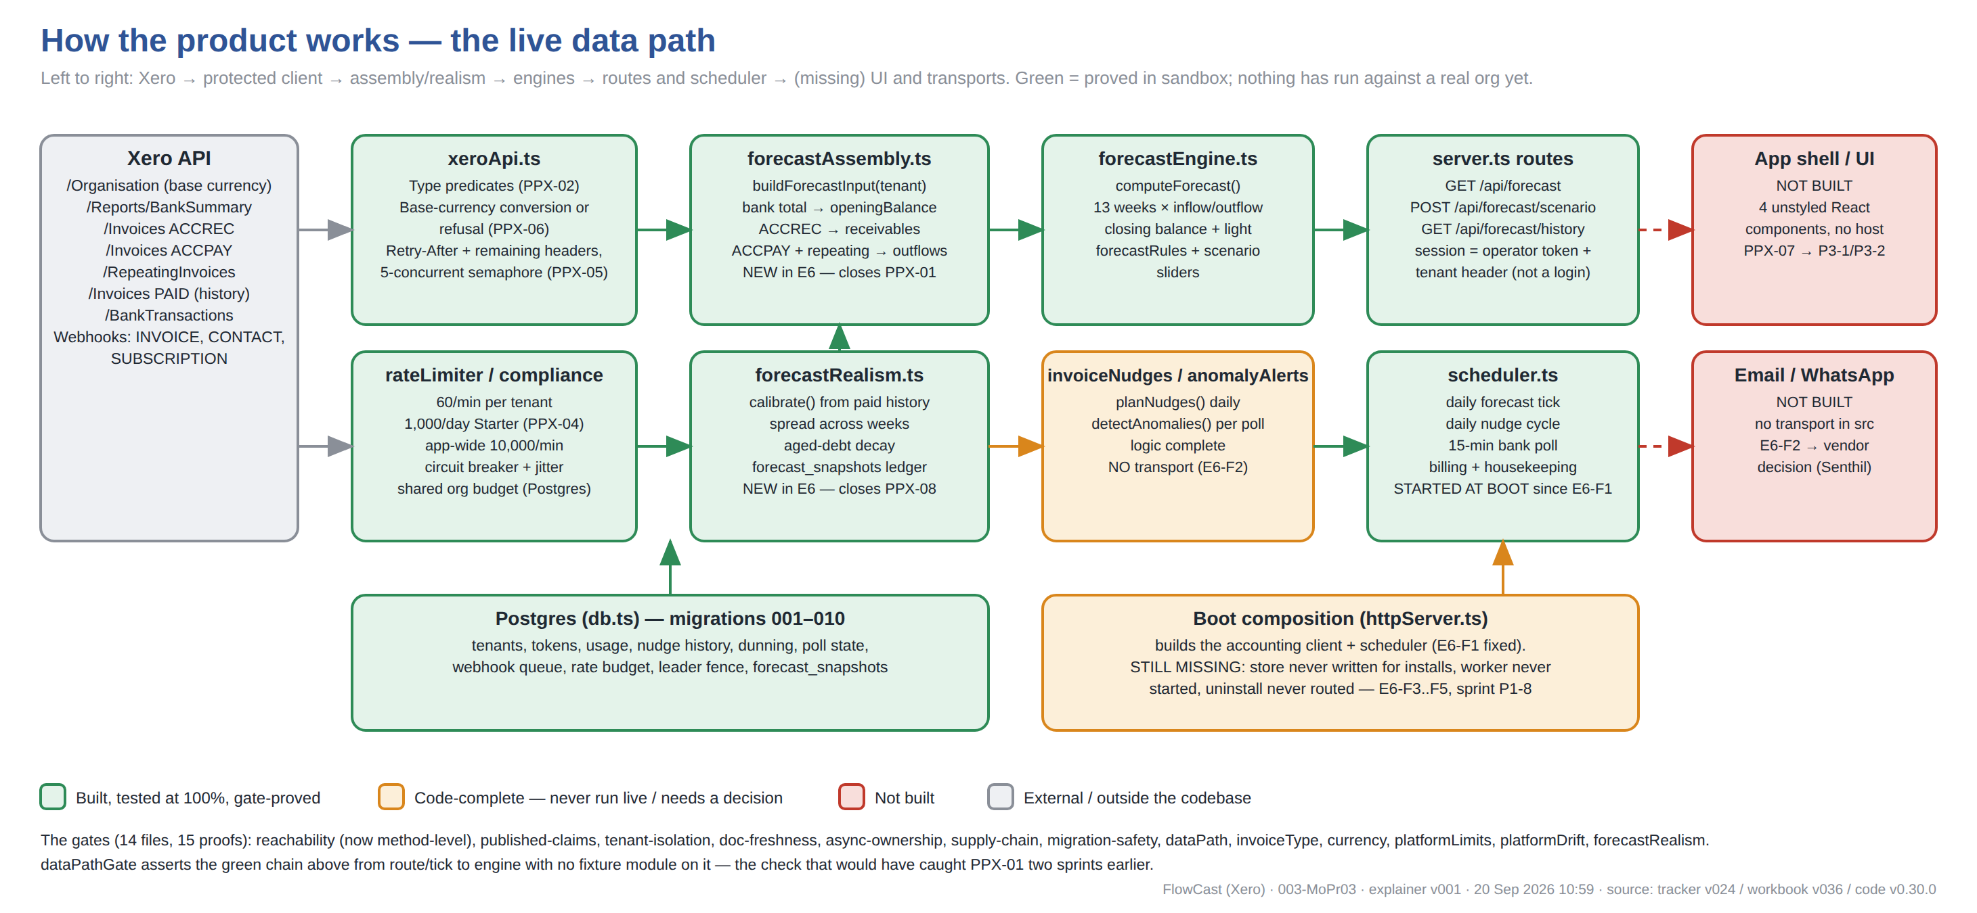
Reading the diagram: follow the green arrows. A request to GET /api/forecast (or the daily tick) calls forecastAssembly, which makes five Xero calls through the protected client (type filters, currency conversion, rate limits, concurrency cap), calibrates payment timing from paid history, and hands a real ForecastInput to the engine. The two red boxes on the right are why a customer still cannot use it: nothing renders the answer and nothing sends the nudges. The amber boot box is the newest finding: the process starts the scheduler now, but still never writes installs to the database, never starts the webhook worker and never routes an uninstall (sprint P1-8).

3. What is completed
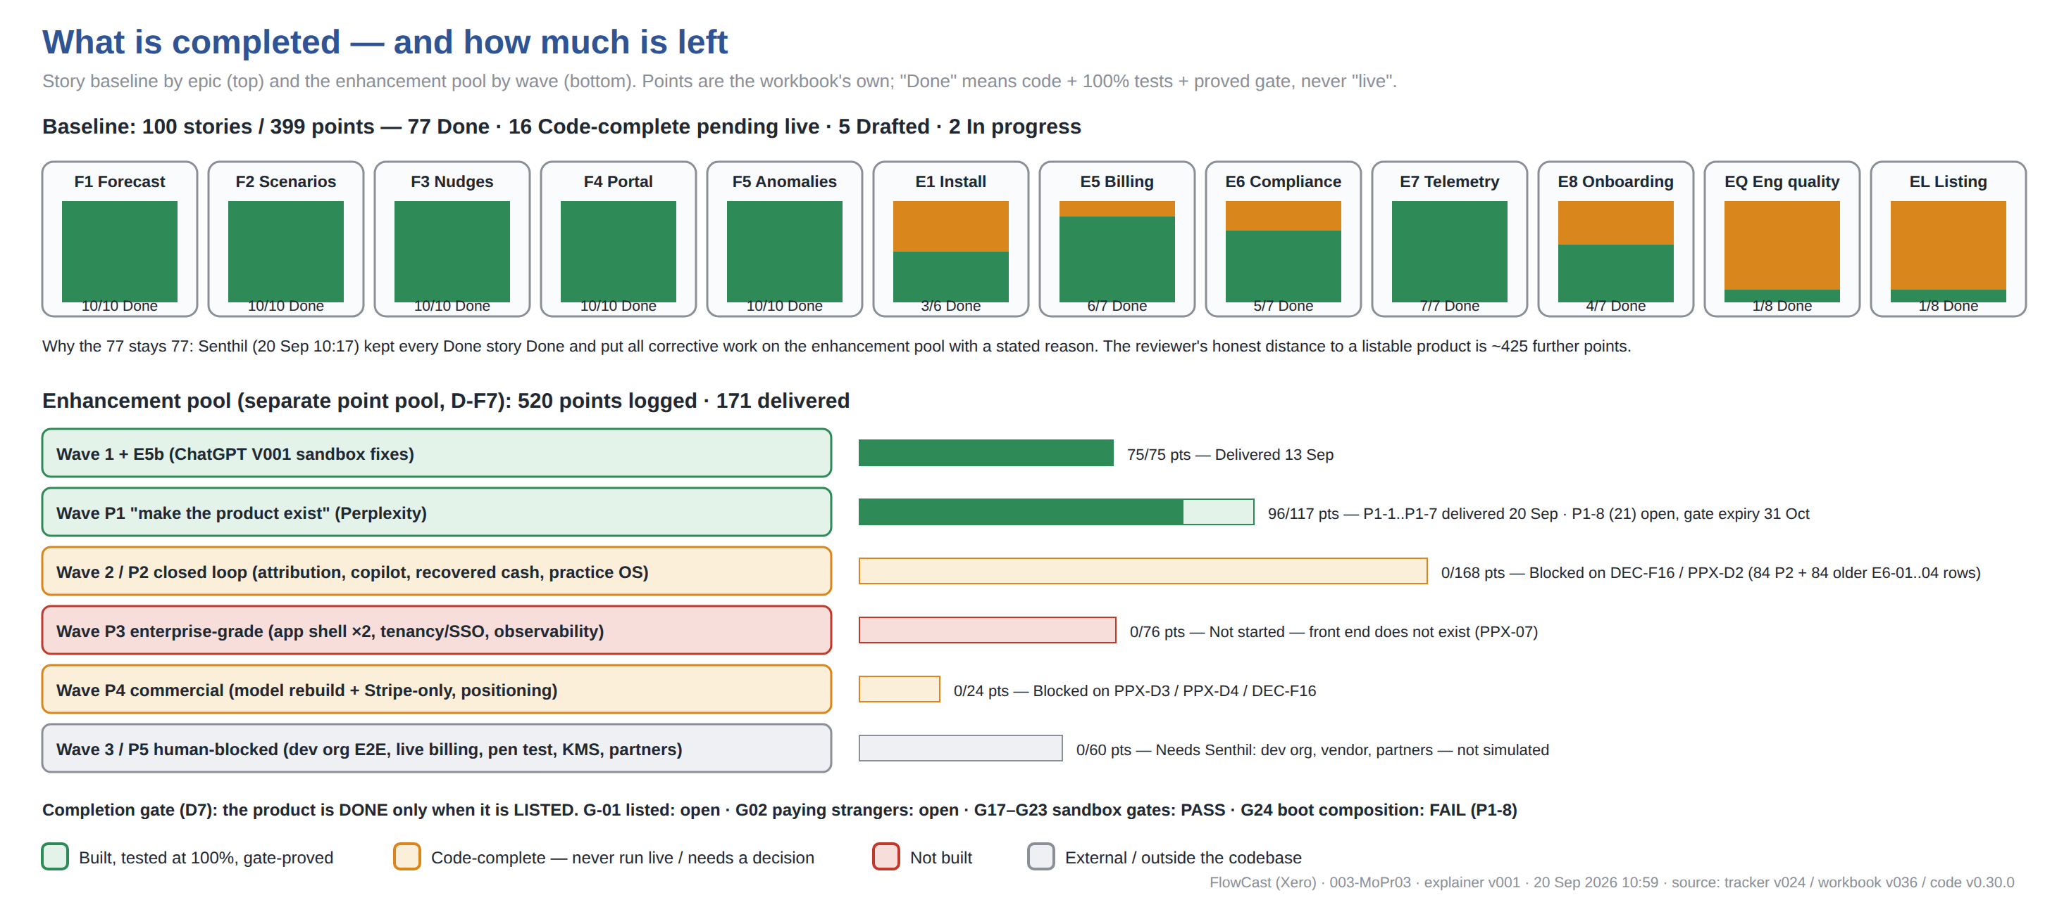
Reading the diagram: the top row is the frozen 100-story baseline — 77 Done, and the 77 will stay 77 by Senthil's instruction of 20 Sep (keep Done as Done; put corrective work on the enhancement pool with a reason). The bottom rows are that enhancement pool: 520 points logged, 171 delivered. The completion gate (D7) is unchanged: the product is Done when it is listed on the Xero App Store, and it is not.

3.1 Feature-by-feature record
Epic | Feature | Status | What is Done and what "Done" means here | What is NOT done and why
F1 | 13-week cash forecast | GREEN | 10/10 stories Done. Since sprint E6 (20 Sep) the forecast has a real production data path: opening balance from the Xero Bank Summary report, receivables (ACCREC) and bills (ACCPAY) with per-row type assertion, repeating invoices expanded across the horizon, multi-currency converted to base or refused, payment timing calibrated from paid history. Driven by GET /api/forecast and a daily scheduler tick; dataPathGate proves the chain. | Never run against a real organisation (needs the Xero dev org). Before E6 the engine was fed only by demo fixtures (PPX-01) — the stories were Done as engine logic, not as a product.
F2 | Scenario sliders | GREEN | 10/10 Done. Revenue ±, payment delay, cost ±, extra monthly cost; POST /api/forecast/scenario previews over the live base since E6. | Same live caveat as F1. No screen to move the sliders on (PPX-07).
F3 | Invoice-chasing nudges | AMBER | 10/10 Done as logic: gentle/firm/final tiers, once-per-tier history, plan limits enforced on the send path, test mode, per-type mute, WhatsApp/email templates. Daily nudge cycle now starts at boot (E6-F1). Overdue set is ACCREC-only since E6 (PPX-02 — previously the customer's own supplier bills would have been chased). | There is no email or WhatsApp transport anywhere in the codebase (E6-F2): the planner plans, the sender throws NUDGE_TRANSPORT_UNCONFIGURED. Needs a vendor decision (Senthil).
F4 | Accountant portal | AMBER | 10/10 Done as logic: multi-client book, reds-first sort, portal rules (notify / pin-top), 20-, 100- and 500-client scale drills at p95 budget. | No application shell to render it; portal screen is an unstyled React component with no host (PPX-07, R-F12 gap expires 31 Dec 2026).
F5 | Bank-feed anomaly alerts | AMBER | 10/10 Done as logic: 15-minute polling with If-Modified-Since (Xero has no bank-transaction webhook — D-F4), duplicate/outlier/spike detection with history, honest degradation banner on outage, per-tenant poll state (F4-01 fixed). | Poll state lives in the scheduler closure, not the store (E6-F3) — a restart re-polls from zero; alerts have no delivery transport (E6-F2).
E1 | Install & identity | AMBER | 3/6 Done. OAuth authorize/callback routes, single-use code, CSRF state, token sealing at rest (AES-256-GCM), refresh on rotation. | ST-051/052/055 pending live install. Installs are held in process memory: the durable store is never written for tenants or tokens (E6-F3) and the uninstall webhook is never routed to the install service (E6-F5) — sprint P1-8, gate expiry 31 Oct 2026.
E5 | Billing | AMBER | 6/7 Done: plans, proration, trial countdown, dunning day-0/3/6, read-only access level enforced. | ST-059 assumes Xero App Store Subscriptions, which Xero deprecated in March 2026 (PPX-03). Rail left in code by instruction (PPX-D4); Stripe-only migration is backlog P4-1. No live billing test.
E6 | Compliance | AMBER | 5/7 Done: scope audit, DSAR export/delete end-to-end incl. cross-tenant negative, retention coherence, STRIDE threat model. | ST-066 encryption verified only in sandbox; ST-068 pen test is the vendor half (Senthil). No KMS custody, no signing key, audit log not tamper-evident.
E7 | Telemetry & metrics | GREEN | 7/7 Done: per-feature metrics, weekly series, latency budgets, degradation counters, /health and /ready. | No OpenTelemetry, no tracing, no SLO measurement (P3-4).
E8 | Onboarding & support | AMBER | 4/7 Done: onboarding steps, help-centre search over 15 articles, built-in chat with 4-business-hour SLA engine, demo-data mode. | ST-080 hosting, ST-081 vendor optional (D-F6), ST-083 demo video needs a deployed UI to record.
EQ | Engineering quality | AMBER | 1/8 Done; 7 code-complete: CI workflow with 100% gate, k6 load harness at 5×, axe WCAG pass on 7 surfaces, chaos degradation mapping, blue/green deploy scripts, backup/restore drill procedure. | Every one needs a staging or live environment to execute (ST-086..092). Senthil handover items 1, 2, 4.
EL | Listing & launch | AMBER | 1/8 Done (launch-day runbook). Listing copy A/B drafted, pricing page generated from billing.ts with a drift gate, trust page drafted, submission dry-run first pass, SEO engine, partner tracker. | ST-093 needs Senthil's A/B pick; ST-094 screenshots need a deployed UI; ST-096/097 need a human reviewer and the dev org; ST-099/100 need post-launch data and outreach.

3.2 The gates (14 files, 15 mutation proofs)
Coverage proves a module executes; it never proves anything calls it. Each gate below fails the build when a specific shipped defect is reintroduced, and prove-gates.js demonstrates that by reintroducing the real defect into real source. This is the strongest evidence in the package and the reason "Done" can be trusted at all.
Gate | Rule | Defect it exists to catch
reachabilityGate | Every src export — and since E6 every public class method — has a production caller; file-level pardons gone; KNOWN_GAPS expire | INT-F1/F2, F3-02, GAP-F2, PPX-01 (HOLE-4)
publishedClaimsGate | Every customer promise in docs/ is backed by code (and a driver, for policies) | INT-F2, GAP-F2, INT-F5
tenantIsolationGate | No shared state across a per-tenant loop | F4-01
docFreshnessGate | Outsider-facing documents acknowledge every module | REV-1 (L-F14)
asyncOwnershipGate | Every un-awaited promise has an owner | CHAOS-1
supplyChainGate | SBOM matches the lockfile; no secret-shaped literals; security headers on every response; no stale published claims | FC-R015, FC-R006, FC-R002
migrationSafetyGate | Migrations are additive (expand/contract) | OPS-1
environmentReview (fail-closed boot) | Production refuses to start without DATABASE_URL / FLOWCAST_DATA_KEY | E5b-01/02
dataPathGate (E6) | Each headline feature reachable from a route or tick with no fixture on the chain; the engine's caller itself live-fed | PPX-01 — caught BROKEN on first proof, strengthened
invoiceTypeGate (E6) | Every /Invoices query typed; mapper asserts per row | PPX-02
currencyGate (E6) | Amounts reach the engine only via toBaseCurrency; provenance on every record | PPX-06
platformLimitsGate (E6) | Each documented Xero limit enforced on the live call; daily default = Starter | PPX-04/05
platformDriftGate (E6) | Platform assumptions sourced, dated, within budget; contradicted ones owned | PPX-03
forecastRealismGate (E6) | No live-path payProbability literal; receivables via the calibrator | PPX-08

4. What is not completed — and why
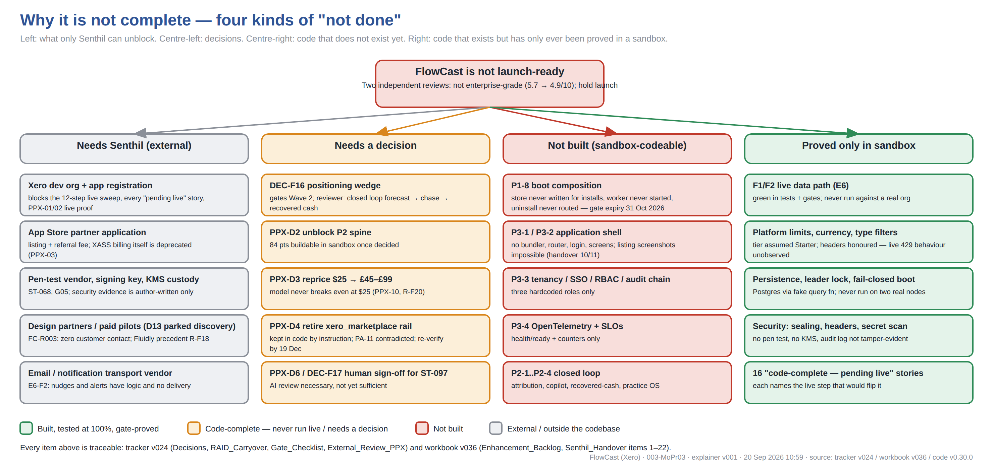
Reading the diagram: "not done" is four different things and they need four different people. The left column only Senthil can move. The second column is a decision, each with the reviewer's recommendation recorded. The third is code that does not exist and can be written in the sandbox. The fourth is the uncomfortable one: everything green in this document has been proved only in a sandbox, and the first live run will find things — both external reviews did.

4.1 Item-by-item, with the reason and who unblocks it
Item | Kind | Why it is not done | Who unblocks | Reference
Xero dev org + app registration | Needs Senthil | The 12-step live sweep, every "code-complete — pending live" story (16), and the live proof of PPX-01/PPX-02 all start here. Nothing in the package has been produced against a real organisation. | Senthil (~30 min) | Handover #1; FC-R001; PPX §5
App Store partner application | Needs Senthil | Required for the listing and the referral fee. Was also assumed to provide in-store billing; that assumption is now contradicted (XASS deprecated). | Senthil (~1 hr, 1–3 wk queue) | Handover #4, #18; PPX-03; PA-11
Pen-test vendor, signing key, KMS custody | Needs Senthil | Security evidence is author-written and self-verified; a listing reviewer will ask for an external test. Release signing needs a key the sandbox does not have. | Senthil | Handover #2, #6; ST-068; G05
Design partners / paid pilots | Needs Senthil | D13 parked discovery portfolio-wide; there has been zero customer contact. The closest comparable (Fluidly, same ICP) was written off. | Senthil (D13) | FC-R003; R-F18; Handover #3
Email / WhatsApp / notification transport | Needs Senthil | No transport exists in src. Nudges, dunning emails, trial expiry and anomaly alerts have complete logic and no delivery. Boot reports this rather than faking a sender. | Senthil (vendor pick) | E6-F2; R-F21; Handover #22
DEC-F16 positioning wedge | Needs a decision | Both reviewers say a generic forecaster loses to native Xero and Float; the defensible slice is the closed loop forecast-shortfall → chase → recovered cash. Gates Wave 2. | Senthil | DEC-F16; FC-R004; PPX §4
PPX-D2 unblock Wave P2 | Needs a decision | 84 points of sandbox-buildable depth (shortfall attribution, collections copilot, recovered-cash attribution, practice OS) held on DEC-F16. Reviewer recommends building the spine now. | Senthil | PPX-D2; P2-1..P2-4
PPX-D3 reprice | Needs a decision | At $25 ARPU the workbook's own model never breaks even inside 18 months; the category charges £45–£199 for narrower jobs. | Senthil | PPX-D3; PPX-10; R-F20; P4-1
PPX-D4 retire the xero_marketplace rail | Needs a decision | XASS is deprecated. Rail kept in code on 20 Sep by instruction; recorded as a contradicted platform assumption owned by this decision; the drift gate forces re-verification by ~19 Dec 2026. | Senthil | PPX-D4; PA-11; P4-1
PPX-D6 / DEC-F17 human sign-off for ST-097 | Needs a decision | Two AI reviews each found blockers the author missed; the recommendation is "necessary, not yet sufficient" — a human before submission. | Senthil | DEC-F17; PPX-D6; ST-097
P1-8 boot composition | Not built (sandbox-codeable) | Found by the new method-level reachability gate on its first run: the durable store is never written for installs, tenant state is never rehydrated at boot, the webhook worker is never started and drained rows never deleted, the uninstall webhook is never routed. A restart still loses every tenant. | Claude, on Senthil's "go" (21 pts) | E6-F3..F6; R-F14..R-F17; gate expiry 31 Oct 2026
P3-1 / P3-2 application shell | Not built (sandbox-codeable) | No bundler, router, session, layout or screens; four unstyled React components with no host. Listing screenshots and the demo video are impossible without it. | Claude (42 pts) | PPX-07; R-F12 (expires 31 Dec 2026); Handover #10/#11
P3-3 tenancy / SSO / RBAC / audit chain | Not built (sandbox-codeable) | Three hardcoded roles; no SSO/OIDC, delegation or approval-gated impersonation; audit log not hash-chained. | Claude (21 pts) | PPX §5 tenancy 3/10; FC-R009
P3-4 observability | Not built (sandbox-codeable) | Health/ready and counters only; no traces, no SLO measurement, no alert-to-runbook links. | Claude (13 pts) | PPX §5 observability 4/10
Wave P2 closed loop | Not built (decision-gated) | Shortfall attribution, collections copilot, recovered-cash attribution, practice-OS depth — the product the reviewers say could win. | Claude after PPX-D2 (84 pts) | P2-1..P2-4; E6-01..E6-04 (older rows kept)
Everything marked green | Proved only in sandbox | The live data path, platform limits, persistence, leader lock, fail-closed boot and security controls are green in tests and gates. None has run on a real org, a real Postgres cluster or two real nodes. The tier is assumed Starter; live 429 behaviour is unobserved. | Senthil (dev org) → live sweep | Wave P5; verification-sweep.md

5. Story-level record: the 23 stories not at Done
Every story in the 100-story baseline that is not Done, with the status vocabulary of D-F2 and the note from the traceability matrix that names the live step or decision that would flip it. The 77 Done stories are listed in tracker v024, Traceability_Matrix, with code file, test file and coverage for each.
Story | Epic | Story text | Status | Reason / what flips it
ST-051 | E1 | Marketplace OAuth install completes and lands on welcome state in <2 min | Code-complete — pending live | OAuth exchange + welcome state; Xero client mocked — needs live dev-org install
ST-052 | E1 | Uninstall webhook removes tokens, schedules data deletion per policy | Code-complete — pending live | uninstall webhook: token removal + 30-day deletion schedule; needs live webhook wiring
ST-055 | E1 | Session/token refresh survives platform token rotation | Code-complete — pending live | getValidToken refresh + rotated-token storage; needs live token rotation test
ST-059 | E5 | Marketplace billing API used where mandated; external Stripe fallback elsewhere | Code-complete — pending live | selectBillingRail marketplace/Stripe routing; live Xero billing API integration pending
ST-066 | E6 | Encryption at rest + in transit verified; secrets in vault | Code-complete — pending live | AES-256-GCM envelope + vault boundary + token sealing + TLS assertion; live vault/TLS probe pending dev org
ST-068 | E6 | Pen-test (or platform-required evidence) completed and archived | In progress | Sandbox evidence half compiled v014 with per-control citations; external pen-test = vendor half (Senthil)
ST-080 | E8 | Help center with 15 launch articles + search | Code-complete — pending live | Ranked search + manifest gate vs docs/help; hosting/publish pending
ST-081 | E8 | In-app chat with <4 business-hr first response | Code-complete — pending live | Built-in chat + 4-business-hr SLA engine; vendor decision optional (D-F6)
ST-083 | E8 | Demo video (2 min) + interactive sandbox/demo data mode | Drafted — pending publish | Demo mode coded (deterministic red-week arc); 2-min script+shot list drafted; recording pending
ST-086 | EQ | E2E smoke suite runs on every deploy | Code-complete — pending live | Workflow triggers on push/PR/deployment with typecheck + 100% gate; live repo/deploy hookup pending
ST-087 | EQ | p95 latency budgets defined and monitored per surface | Code-complete — pending live | Budgets defined per surface + p95/evaluateBudget; APM monitoring hookup pending
ST-088 | EQ | Load test at 5x expected launch traffic | Code-complete — pending live | k6 harness ready: steady/burst(25 rps)/webhook-storm scenarios at 5x launch assumptions; run pending staging
ST-089 | EQ | Accessibility WCAG AA pass on primary flows | Code-complete — pending live | Automated axe pass, zero violations on all 7 surfaces; live full-flow AA audit pending
ST-090 | EQ | Backup + restore drill executed | Drafted — pending publish | Policy + drill procedure + RTO/RPO targets drafted; first drill needs live infra
ST-091 | EQ | Chaos test: platform API outage degrades gracefully with user comms | Code-complete — pending live | Breaker→level mapping + honest user comms + banner; staging chaos drill pending
ST-092 | EQ | Zero-downtime deploy verified (blue/green or rolling) | Code-complete — pending live | Blue/green workflow drafted: 100%-gate -> idle-colour deploy -> health+smoke gate -> atomic swap -> warm rollback; live verification pending infra
ST-093 | EL | Marketplace listing copy A + B variants drafted and reviewed | Drafted — pending review | A (forecast-led) + B (chasing-led, accountant channel) drafted; Senthil review pending
ST-094 | EL | 5 screenshots + 2-min demo video meet platform asset specs | Drafted — pending publish | Specs + 5-shot plan drafted; capture needs deployed UI
ST-095 | EL | Pricing page/plan matrix published with FAQ | Code-complete — pending live | Matrix generated from billing.ts; DRIFT GATE binds published page to enforced constants
ST-096 | EL | Security/trust page (data handling, subprocessors) live | Drafted — pending publish | Scope mapping, retention, controls, subprocessor list drafted; final subprocessors at launch
ST-097 | EL | Submission dry-run against platform checklist by second reviewer | In progress | First-pass dry-run done: gap (a) dev org — Senthil; gap (b) content webhooks CLOSED in v011 (WBH-001); 6 live-verify items remain; second pass = Senthil
ST-099 | EL | Post-launch listing SEO iteration 1 from search-term data | Code-complete — pending live | SEO engine half w/ 100-impression thin-data floor; live half = post-launch data
ST-100 | EL | First 10 design-partner reviews scheduled | Code-complete — pending live | 10-slot tracker, stale-nudge, exit math: reviews ≠ G-02 paying strangers; outreach = Senthil

6. Version timeline — what each release did and why
One line per product-workbook version. The companion Excel carries the full text, the tracker versions, and manual test cases per version.
Version | Date/Time | What was done and why
v001-v004 | 2026-09-05 | Lineage: marketplace master (868 entries) -> portfolio plan (12 products) -> wave-1 (RetainKit/ShiftDesk/EngageOS, v005) -> this product selected for wave-3
v007 | 2026-09-05 19:50 | Full product workbook for FlowCast on Xero App Store: spec, screen inventory, 100+ story backlog, live sprint board, 18-month financial model (editable assumptions), GTM execution tasks, platform launch checklist, metric targets, risk register
v008 | 2026-09-10 22:01 | Sprint_Tracker_Log + Traceability_Matrix sheets added; D13 100% coverage gate applied (ST-085 amended); S1 foundation + code-completable S2-S8 stories built in TypeScript with 11 Jest suites / 120 tests at 100% stmts/branches/funcs/lines; Full_Backlog statuses updated (58 Done, 4 pending-live, 2 in progress); portfolio D15 note logged
v009 | 2026-09-10 22:20 | UI surfaces (5 React screens + MetricsPanel) with Xero deep links; ST-003 rule builder; notifications w/ per-type mute; pause toggles; portal rules; per-feature metrics/trends; CI workflow (ST-086). 13 suites / 148 tests at 100% coverage incl. components; statuses now 74 Done / 5 pending-live / 21 backlog
v010 | 2026-09-10 22:27 | Reliability + a11y code (latency budgets, degradation comms, jest-axe WCAG pass), demo-data mode, scenario/portal notification events; 12 content artifacts (15 help articles, chat SLA, video script, listing copy A/B, asset specs, pricing, trust page, dry-run gap report, 3 runbooks). 14 suites/155 tests at 100%. Dry-run found webhook build gap -> v011
v011 | 2026-09-10 22:51 | Content webhooks built (dry-run gap #4): signature verify, fast-ack idempotent queue, retry/dead-letter/heal, payment->cancel-nudges mapping; bank-txn 15-min polling (platform has no such webhook). Launch_Checklist statuses updated honestly. 15 suites / 170 tests at 100%. Sandbox work exhausted — remaining items need Senthil
v012 | 2026-09-10 22:56 | Per-tenant 60/min rate limiter; 20-client + 12-month QA drills executed (found+fixed batch-isolation anomaly blind spot via detectWithHistory); k6 load harness (5x); blue/green deploy workflow; HTTP wiring layer. 16 suites / 182 tests at 100%. Backlog down to 4 (all require live infra/humans)
v013 | 2026-09-10 23:03 | Live-sweep readiness: typed config loader + .env.example, 30-min dev-org setup guide, 12-step scripted verification sweep. Portfolio action board issued as separate workbook. 17 suites / 186 tests at 100%
v014 | 2026-09-11 11:09 | Cold-review pass 1: 5 defects found + fixed with regression tests (F-001 unbounded webhook idempotency ledger -> FIFO 10k; F-002 signed-but-malformed payload crashed fast-ack -> guarded parse; F-003 rate-limiter idle tenants never evicted -> prune(); F-004 duplicate anomaly repeated per txn with 3+ matches -> deduped; F-005 nudgesPerMonth had no cycle-scoped counter/reset -> UsageCycle built). ST-066 encryption at…
v015 | 2026-09-11 12:47 | Cold-review pass 2 (the 10 modules pass 1 did not deep-read): 4 defects found + fixed with regressions — F-006 nudge planner re-sent the same tier daily (no sent-history) -> SentHistory, tier fires once, test-mode not recorded, failed sends retried; F-007 purgeExpired flagged accounts but never deleted the record -> record deleted (data deletion honoured), purged status removed; F-008 non-finite platform dates sil…
v016 | 2026-09-11 15:27 | CODE-PHASE-COMPLETION WAVE (sibling-validated TeleField/VoiceBridge pattern): ST-081 built-in chat + 4-business-hour SLA engine (business-hours math skips weekends/out-of-hours; queue sorts tightest deadline; chat-vendor decision now OPTIONAL — D-F6); ST-099 listing SEO iteration engine sandbox half (promote/keyword/demote rules with 100-impression thin-data floor; live half needs post-launch search-term data); ST…
v017 | 2026-09-11 22:08 | EXTERNAL VERIFICATION SWEEP vs live Xero docs + artifact-gap audit (sibling TestPulse/VoiceBridge post-completion pattern). VER-001 LIVE-BLOCKING FIXED: our 200 webhook response carried a JSON body — Xero rejects responses containing a body; intent-to-receive (sweep step 4) would have FAILED on the day; both 200/401 now empty-body, accepted count moved to /health telemetry. VER-002 FIXED: only 60/min was paced — X…
v018 | 2026-09-13 10:25 | INTEGRATION + ARTIFACT AUDIT (sibling class: OnCall no-app/no-schema, EngageOS modules-never-called, MeetSync auth). GAP-F1 CRITICAL: NO RUNNABLE APPLICATION EXISTED — server.ts held pure handlers plus a comment about binding "at deploy", package.json had only a test script, while the v017 deploy scripts, the 30-min guide and live-sweep STEP 1 all assumed a bootable app; sweep would have died on row 1. Built httpS…
v019 | 2026-09-13 10:38 | COLD-REVIEW PASS 3 over the surfaces v018 itself created (OnCall L-OC4: a new surface inherits the old blind spots). F3-01 CRITICAL: NO OAUTH INSTALL ROUTES EXISTED — config requires OAUTH_REDIRECT_URI, the dev-org guide registers it with Xero and live-sweep STEP 2 expects the callback to land, but the app served only /health and /webhooks/xero; the install would have 404d. /auth/start + /auth/callback built with …
v020 | 2026-09-13 10:55 | PORTABLE REACHABILITY GATE (ported from TestPulse pass 5) + GAP-F2 + R-F9 CLOSED. Gate fails the build when a src export has no production caller — the exact blind spot behind INT-F1/INT-F2/F3-02, invisible to coverage because a module own tests execute every line. Three exemption lists with teeth: ENTRY_POINTS (process/platform boundaries, reasons containing later/todo/tbd/wire FAIL), SURFACES (per-export, named …
v021 | 2026-09-13 11:07 | R-F10 CLOSED (Xero accounting-API client) + PUBLISHED-CLAIMS GATE ported (second TestPulse pass-5 gate). src/xeroApi.ts: invoices, overdue receivables and bank transactions, every call through executeWithRateLimit (proactive 60/min + 5,000/day per VER-002) THEN callWithProtection (breaker + backoff) so a slow Xero cannot become a 429 storm; Xero /Date(...)/ parsing isolated and returning null never NaN (F-008 clas…
v022 | 2026-09-13 11:15 | COLD-REVIEW PASS 4 over the code v020/v021 wrote, run under the L-F2 standing rule. 4 defects, all mine, all from the last two sittings. F4-01 CRITICAL: ONLY THE FIRST TENANT WAS EVER POLLED — runBankPoll threaded one shared PollState through every tenant, so the first org set lastPolledAt and every later org pollDue returned false; every customer but one had NO bank-feed anomaly alerts. Same multi-tenancy class a…
v023 | 2026-09-13 11:20 | TENANT-ISOLATION GATE built and wired into CI — third portable gate, written because F4-01 proved L-F5 (knowing a defect class does not stop you writing it). Rule: inside a loop over tenants, a variable declared OUTSIDE the loop may not be both assigned and read within the body — that is tenant N deciding tenant N+1 behaviour. Pure accumulators (count += 1, arr.push) exempt as write-only. THE GATE WAS BROKEN TWICE…
v024 | 2026-09-13 11:54 | GATE AUDIT — acting on the L-F6 recommendation that the reachability and published-claims gates had only ever been proved against fixtures. Each was run against the REAL source file with the ORIGINAL defect it exists to catch reintroduced. BOTH FAILED, both for the same reason. HOLE-1 reachability: unwiring recordNudge from the send path (the INT-F1 defect) left the gate GREEN because the now-unused import satisfi…
v025 | 2026-09-13 11:58 | PORTABLE GATE PACK + PROOF HARNESS (gates/prove-gates.js, npm run prove:gates, now in CI). Addresses the portfolio open item "port gates to the other products", which L-F7 made dangerous rather than merely pending: a ported gate arrives GREEN, and green means nothing — four of the gates built here were silently permissive on their first green run. For each gate the harness takes a REAL source file, applies a mutat…
v026 | 2026-09-13 12:03 | AS-BUILT VERIFICATION + SENTHIL_HANDOVER sheet. No code change this release. As-built audit compared story statuses against what the code actually did: 7 stories (ST-022, ST-024, ST-041, ST-042, ST-044, ST-060, ST-061) had sat at DONE while the behaviour had no driver or no enforcement — the nudge cycle never ran until v020, plan limits were unenforced on the send path until v018, read-only enforced nowhere until …
v027 | 2026-09-13 16:24 | GAP-F3 CLOSED — PERSISTENCE LAYER. Every durable thing lived in a process-memory Map (tokens, usage cycles, nudge history, dunning counters, poll state, deletion schedules). Harmless while nothing could run; NOT harmless once the product gained a boot path (v018) and a deploy pipeline (v017), because BLUE/GREEN RESTARTS THE PROCESS BY DESIGN. Every release would have dropped all tokens (forcing every tenant to rei…
v028 | 2026-09-13 16:38 | ENVIRONMENT-ASSUMPTIONS REVIEW (acting on L-F10: what does this code believe about the world that no test asserts?). 3 findings, all broken by the deploy model this codebase already ships. ENV-1 CRITICAL: startScheduler assumed EXACTLY ONE PROCESS. Blue/green runs BOTH colours during a switch and scaling runs N — so every overdue customer received N NUDGES THE SAME DAY (the duplicate chasing F-006 exists to preven…
v029 | 2026-09-13 16:47 | OPS-ARTIFACT REVIEW — applying the L-F11 method (read one artifact against another) to the operational artifacts vs the database that only started existing two releases ago. OPS-1 CRITICAL: THE DEPLOY PIPELINE NEVER RAN MIGRATIONS — any release adding one would deploy code whose queries hit tables that do not exist. OPS-3 CRITICAL: /health answers from MEMORY and that is what gated the switch, so a slot with a wro…
v030 | 2026-09-13 16:52 | CHAOS REVIEW — re-running the L-F12 pairing against the newest subsystem: the degradation artifacts were written when XERO WAS THE ONLY DEPENDENCY, and Postgres has been in every request path for three releases. CHAOS-1 CRITICAL: two void-promise calls sat on the database path, one on the WEBHOOK FAST-ACK ROUTE. Since Node 15 an unhandled rejection TERMINATES THE PROCESS — verified on this runtime (node v22) with …
v031 | 2026-09-13 17:23 | CRITICAL-PATH DOCUMENT REVIEW. The pen-test vendor scopes from SECURITY_EVIDENCE.md and the external reviewer (ST-097) works from REVIEW_PACK.md — both written at v014, before the HTTP app, OAuth client, accounting client, scheduler, persistence layer, leader lock and resilience layer existed. Measured against source: the security pack mentioned the database ZERO times; the review pack mentioned ONE of the eight n…
v032 | 2026-09-13 17:29 | DOC-FRESHNESS GATE (fifth gate) — closing L-F14 mechanically. That lesson ended with three claims gate-enforced and "the rest rely on someone looking", which is exactly what failed: the reviewer pack went 13 releases out of date on the critical path because nobody inside needs to read it. Rule: a document written for an OUTSIDER must acknowledge the parts of the system it claims to describe — if a module exists an…
v033 | 2026-09-13 18:48 | ASYNC-OWNERSHIP GATE (sixth, and the last derived from a shipped defect) + REVIEW PLAYBOOK. A real defect found first: the worker tick called drainOnce with no catch, and drainOnce RETHROWS after re-queuing (F4-04) — so every store or sink failure produced an unhandled rejection that the degradation counter never saw and /ready never showed. The process guards stopped it being fatal, but it was invisible. Both tha…
v034 | 2026-09-13 22:47 | External review response, sprint E5 (code v0.28.0, tracker v022). 15 findings FC-R001..R015 from the first independent non-author review triaged into three waves. Wave 1 executed: IANA time zones with DST, shared cross-instance Xero rate budget, jittered backoff, bounded half-open probes, leader fencing token, SBOM + drift gate, evidence manifest, security headers, threat model, 20/100/500-client scale drills, DSA…
v035 | 2026-09-13 23:03 | Cross-product defect-class sweep, sprint E5b (code v0.29.0, tracker v023). Wave 2 deliberately not started — it is gated on DEC-F16. PORT-04 executed instead: RetainKit external-review questions asked of FlowCast. Four findings, two critical, both deploy-configuration rather than logic and both invisible to a 100% suite and eight prior review passes: production booted with no database (silently reinstating GAP-F3,…
v036 | 2026-09-20 10:14 | Perplexity V001 response, sprint E6 / Wave P1 (code v0.30.0, tracker v024). Second independent review found 3 BLOCKER code defects on the live path (PPX-01 no production data path for the forecast; PPX-02 supplier bills mixed into receivables; PPX-03 billing rail on the deprecated XASS channel) + 7 more. P1-1..P1-7 executed (96 pts, enhancement pool); P1-8 logged from four new boot-composition findings (E6-F3..F6)…

7. Glossary
Term | Meaning
D13 | Portfolio rule: 100% automated coverage on all four metrics, zero pragmas; discovery interviews parked.
Gate | A test that fails the build when a specific class of shipped defect is reintroduced; "proved" means prove-gates.js reintroduced the real defect and the gate failed.
Enhancement pool | A second point pool (D-F7) for corrective work arising from reviews, so the 399-point story baseline is never inflated by fixes.
PPX-nn / FC-Rnnn | Findings from the Perplexity V001 / ChatGPT V001 external reviews.
E6-Fn | Findings made during sprint E6 (20 Sep 2026) by Claude while executing the Perplexity response.
KNOWN_GAP | A reachability-gate exemption that names a RAID risk and an expiry date; the build fails when the date passes.
Live sweep | The 12-step scripted verification against a real Xero dev org (docs/live-sweep/verification-sweep.md). Not yet run.
XASS | Xero App Store Subscriptions — in-store billing, deprecated by Xero effective March 2026.

Not claimed anywhere in this document: enterprise-grade, production-ready, market-ready, or that any green item has been proved against a live Xero organisation. "Done" is a sandbox word until the live sweep runs.

