**IWExpress - Asyad Integration API**

API : Softdata Upload

API URL: [https://dev-b2b.iwexpress.com/iwexpress/softdata/upload](http://15.207.62.25:5001/iwexpress/softdata/upload)

Request Type: POST

Input Authorization as like below.

Basic $2a$10$qWHNeBhu4FCGoJfuv2XVbO9Yq4QBUwGSvNM0bGpYUVc3iY8jXsJwO

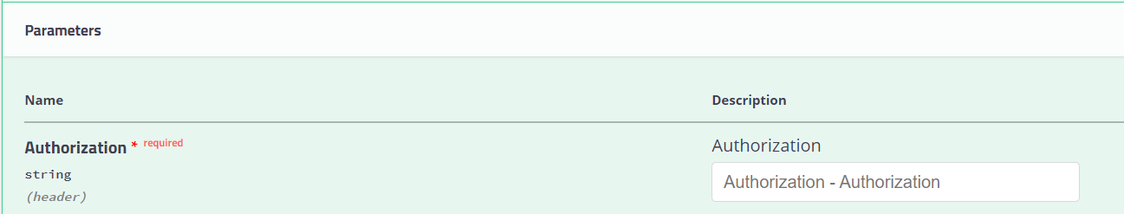

Order Details as like below structure (JSON Provided)

**JSON Request:**

{

"cod_amount": "string",

"cod_collection_mode": "string",

"cod_favor_of": "string",

"consignment_type": "string",

"customer_code": "string",

"customer_reference_number": "string",

"declared_value": 0,

"description": "string",

"destination_details": {

"address_line_1": "string",

"address_line_2": "string",

"alternate_phone": "string",

"city": "string",

"country": "string",

"name": "string",

"phone": "string",

"pincode": "string",

"state": "string"

},

"dimension_unit": "string",

"height": "string",

"is_risk_surcharge_applicable": true,

"length": "string",

"load_type": "string",

"notes": "string",

"num_pieces": 0,

"origin_details": {

"address_line_1": "string",

"address_line_2": "string",

"alternate_phone": "string",

"city": "string",

"country": "string",

"name": "string",

"phone": "string",

"pincode": "string",

"state": "string"

},

"pieces_detail": [

{

"declared_value": 0,

"description": "string",

"height": 0,

"length": 0,

"weight": 0,

"width": 0

}

],

"service_type_id": "string",

"weight": 0,

"weight_unit": "string",

"width": "string"

}

**Tested Case (Sample Request):**

{

"cod_amount": "0.00",

"cod_collection_mode": "dd1",

"cod_favor_of": "",

"consignment_type": "forward",

"customer_code": "ASD",

"customer_reference_number": "296163854",

"declared_value": 1,

"description": "Sports Nutrition",

"dimension_unit": "cm",

"height": "10",

"is_risk_surcharge_applicable": false,

"length": "10",

"load_type": "DOCUMENT",

"notes": "Sports_Nutrition",

"num_pieces": 1,

"service_type_id": "PREMIUM",

"weight": 2.62,

"weight_unit": "kg",

"width": "45",

"destination_details":

{

"name": "Mohammad_Alsmaim",

"phone": "963434",

"alternate_phone": "333333",

"address_line_1": "house 25 Block 5, street 517",

"address_line_2": "LF Logistics/Mohebi Logistics, Plot",

"pincode": "91710",

"city": "Jaber_Alahmad",

"state": "",

"country": "KW"

},

"origin_details":

{

"name": "The Hut Group1",

"phone": "97101606814455",

"alternate_phone": "",

"address_line_1": "Mohebi Logistics; Plot WT01 & WT04",

"address_line_2": "LF Logistics/Mohebi Logistics, Plot",

"pincode": "80054",

"city": "Dubai",

"state": "Dubai",

"country": "AE"

},

"pieces_detail":

[{

"description": "Sports_Nutrition",

"declared_value": 2,

"weight": 2.45,

"height": 23,

"length": 11,

"width": 13

}]

}

**Response:**

