IWExpress - Asyad Integration API

API : Softdata Upload
API URL: https://dev-b2b.iwexpress.com/iwexpress/softdata/upload
Request Type: POST
Input Authorization as like below.
Basic $2a$10$qWHNeBhu4FCGoJfuv2XVbO9Yq4QBUwGSvNM0bGpYUVc3iY8jXsJwO
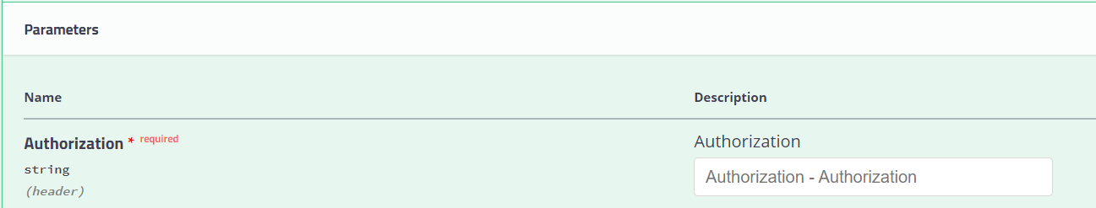

Order Details as like below structure (JSON Provided)
JSON Request:
{
"cod_amount": "string",
"cod_collection_mode": "string",
"cod_favor_of": "string",
"consignment_type": "string",
"customer_code": "string",
"customer_reference_number": "string",
"declared_value": 0,
"description": "string",
"destination_details": {
"address_line_1": "string",
"address_line_2": "string",
"alternate_phone": "string",
"city": "string",
"country": "string",
"name": "string",
"phone": "string",
"pincode": "string",
"state": "string"
},
"dimension_unit": "string",
"height": "string",
"is_risk_surcharge_applicable": true,
"length": "string",
"load_type": "string",
"notes": "string",
"num_pieces": 0,
"origin_details": {
"address_line_1": "string",
"address_line_2": "string",
"alternate_phone": "string",
"city": "string",
"country": "string",
"name": "string",
"phone": "string",
"pincode": "string",
"state": "string"
},
"pieces_detail": [
{
"declared_value": 0,
"description": "string",
"height": 0,
"length": 0,
"weight": 0,
"width": 0
}
],
"service_type_id": "string",
"weight": 0,
"weight_unit": "string",
"width": "string"
}

Tested Case (Sample Request):
{
"cod_amount": "0.00",
"cod_collection_mode": "dd1",
"cod_favor_of": "",
"consignment_type": "forward",
"customer_code": "ASD",
"customer_reference_number": "296163854",
"declared_value": 1,
"description": "Sports Nutrition",
"dimension_unit": "cm",
"height": "10",
"is_risk_surcharge_applicable": false,
"length": "10",
"load_type": "DOCUMENT",
"notes": "Sports_Nutrition",
"num_pieces": 1,
"service_type_id": "PREMIUM",
"weight": 2.62,
"weight_unit": "kg",
"width": "45",
"destination_details":
{
"name": "Mohammad_Alsmaim",
"phone": "963434",
"alternate_phone": "333333",
"address_line_1": "house 25 Block 5, street 517",
"address_line_2": "LF Logistics/Mohebi Logistics, Plot",
"pincode": "91710",
"city": "Jaber_Alahmad",
"state": "",
"country": "KW"
},

"origin_details":
{
"name": "The Hut Group1",
"phone": "97101606814455",
"alternate_phone": "",
"address_line_1": "Mohebi Logistics; Plot WT01 & WT04",
"address_line_2": "LF Logistics/Mohebi Logistics, Plot",
"pincode": "80054",
"city": "Dubai",
"state": "Dubai",
"country": "AE"
},

"pieces_detail":
[{
"description": "Sports_Nutrition",
"declared_value": 2,
"weight": 2.45,
"height": 23,
"length": 11,
"width": 13
}]

}

Response:

