PROMPT ENGINEERING LAB: (SOLO + PAIR)
Name: Maksym Perepelytsia Partner: Nikita Chobotar
Section: CEP146 Date: 11.11.2026 AI tool used: ChatGpt

===== SECTION 1: SOLO =====
PART 1: SPOT THE PROBLEM
| # | Main mistake | My better prompt |
| 1 | No specific details; you need to include information in your request about what is broken, the laptop's specifications, and its brand. | My Windows 11 laptop has broken and won't turn on. A friend of mine dropped it—how can I figure out what’s damaged, and is it possible for me to fix it myself without outside help? |
| 2 | AI cannot predict the future. The request is flawed simply because it is impossible to provide a 100% certain answer to it.
| Statistically, who has the best chance of winning the Stanley Cup next season? |
| 3 | No specific details are provided; it doesn’t state what exactly fails to open as it should, nor what should be done about it. | For some reason, the bag won’t open; the lock seems fine, and I only just bought it—what should I do? |
| 4 | The person framed the topic correctly but didn't provide any specifics.
| Create a list of food items for a healthy diet, and select 10 recipes that use these ingredients. |
| 5 | That’s a good request, but there are too many tasks in a single prompt; the AI ​​won’t be able to execute them correctly.
|Prompt 1: Create an itinerary for my 7 days trip to Japan and estimate the budget I will need.
Prompt 2: Suggest what items I should pack for the trip.
Prompt 3: Teach me some basic words and phrases that might be useful during my travels.
Prompt 4: Write a 1,000-word the history of Tokyo . |

PART 2: PROMPT MAKEOVER
Scenario chosen (S1–S5): S2
Version 1 prompt:
Screenshot: Version 1 answer

Version 2 prompt (labelled):
[Context]: I'm a student.
[Task]: Act as a nutritionist and create a one-week meal plan with a budget of $60.
[Format]: Table
[Example]: Boiled rice, fried vegetables and meat
[Constraints]: 60$ for 1 week
Technique used: Role-playing
Screenshot: Version 2 answer

===== SECTION 2: PAIR =====
PART 3: PEER REVIEW I RECEIVED
Reviewed by: Nikita Chobotar
Context ✓ Task ✓ Format ✓ Example ✓ Constraints ✓ Technique ✓
Suggestion from my partner: You could mention that the budget is in Canadian dollars and say which country you're shopping in, so the prices are more accurate.

PART 4: PROMPT CHAIN
Task chosen (C1–C3): C3
Prompt 1: "Give me 5 important things I should do before moving into my first apartment."
Prompt 2: "From the list you gave me, explain the second step in more detail. Make a simple checklist."
Prompt 3: "Turn that checklist into a table with 3 columns: Task, Deadline, and Done."
Screenshot of final answer:

PART 5: REFLECTION (my own words)
Q1: My partner's feedback taught me that I should include more details in my prompt. Without enough context, AI might give inaccurate information.
Q2:You shouldn't rely on AI for health-related matters; it's better to consult with professionals. Because AI doesn’t have access to your physical sensations, and without a doctor, you can’t get an internal examination if one is needed

Screenshot: Version 1 answer
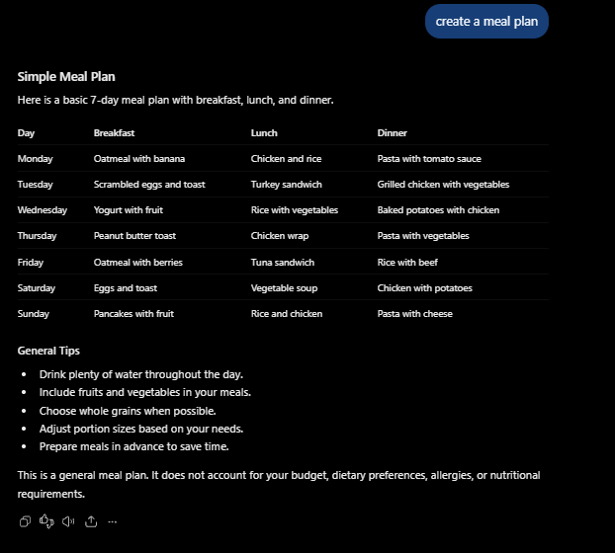
Screenshot: Version 2 answer
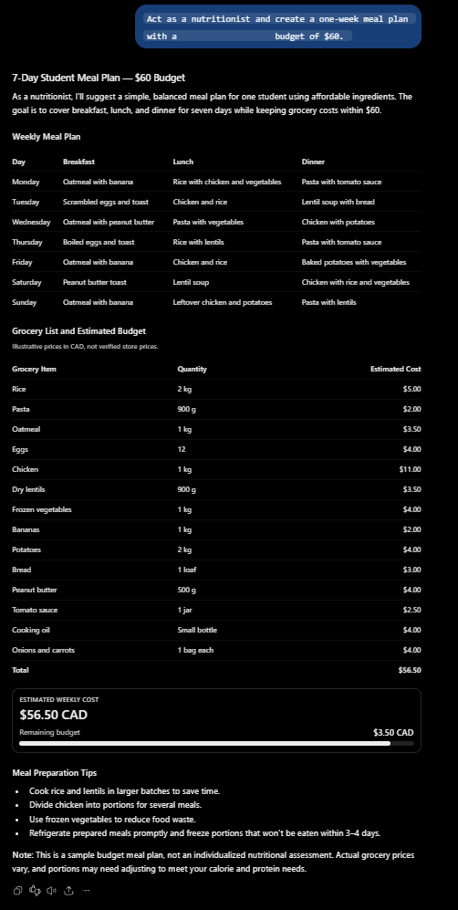

Screenshot of final answer:


