Lab3

1. 3 child processes
2. It consumes some of the CPU time and memory.
3. 3578.8 MiB of memory
4. Most of the time is gnome
5. Firefox uses the most memory
   1. Apt-get: command line tool for interacting with the Advance Package Tool, and allows you to search for, install, manage, update, and remove software
   2. Yum: used to install, update, and remove software on linux systems
   3. Wget: software used to get files using HTTP, HTTPS, FTP, and FTPS.
   4. Gzip: compression algorithm that keeps file mode, ownership, and timestamp
   5. Tar: a file format that converts files into an archive; also used to extract tar archives, lists files in an archive, and others.
   6. Rar: file format that converts files into an archive; supports error recovery and multi-volume archives
6. 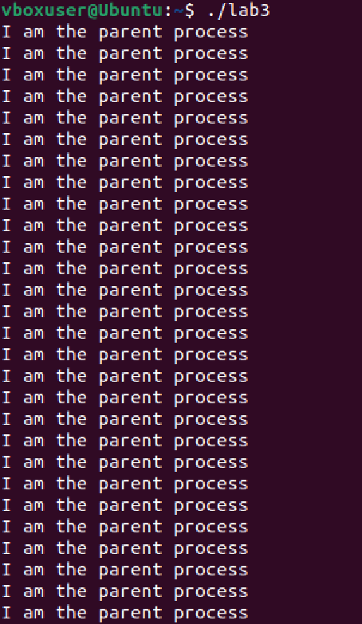
7. 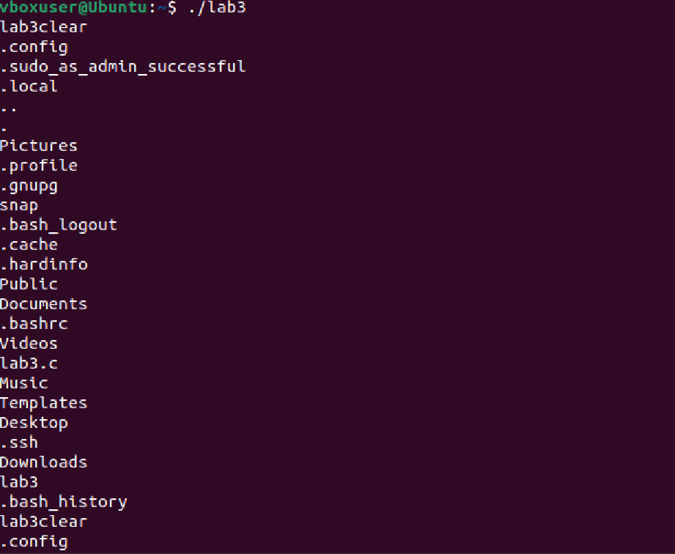
8. 