1. In the below elements which of them are values or an expression? eg:- values can be integer or string and expressions will be mathematical operators.

*

'hello'

-87.8

-

/

6

**Ans:- ‘hello’, -87.8, 6 are values and *, -, /, + are expressions.**

2. What is the difference between string and variable?

**Ans:- String:- It is a data type used to represent a sequence of characters.**

**Variable:- It is used to store data in a memory. The value of variable can be changed during the execution of the program.**

3. Describe three different data types.

**Ans:- 3 different data types:-**

1. **Int(Integer)**
2. **Float(Decimal no.)**
3. **String(character)**

4. What is an expression made up of? What do all expressions do?

**Ans:- Expressions are made up of different operators like mathematical, logical , comparison, and other operators. They are used in various contexts like looping, conditional statements, functions arguments, etc.**

5. This assignment statements, like spam = 10. What is the difference between an expression and a statement?

Ans:- **Expressions are made up of different operators like mathematical, logical , comparison, and other operators. They are used in various contexts like looping, conditional statements, functions arguments, etc.**

**Statement: It is a logical instruction which Python interpreter can read and execute.**

**In the above assignment spam = 10, ‘=’ is an assignment operator that assigns value 10 to the variable ‘spam’.**

6. After running the following code, what does the variable bacon contain?

bacon = 22

bacon + 1

**Ans:- Below is the screenshot:-**

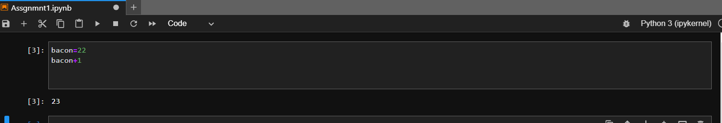

7. What should the values of the following two terms be?

'spam' + 'spamspam'

**Ans:- ‘spamspamspam’**

'spam' * 3

**Ans:- ‘spamspamspam’**

Please find attached screenshot:

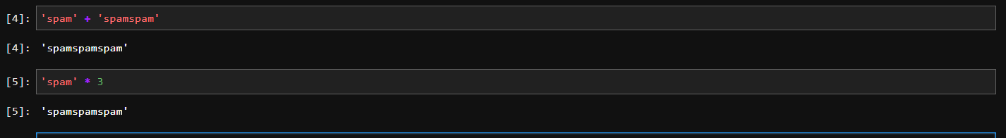

8. Why is eggs a valid variable name while 100 is invalid?

**Ans:- Because a variable name can start with a letter but cannot start with a number.**

9. What three functions can be used to get the integer, floating-point number, or string version of a value?

**Ans:- Below are the 3 functions:-**

1. **int() – for integer**
2. **float() – for floating-point number**
3. **str() – for string version of value.**

10. Why does this expression cause an error? How can you fix it?

'I have eaten ' + 99 + ' burritos.'

**Ans:- It shows because error we are adding string and integer without converting the integer to string. We need to first convert the integer to string and then add.**

**Please find the screenshot below:-**

