1.What are the two values of the Boolean data type? How do you write them?

**Ans- 2 values of Boolean data type: True and False**

**True: It represents the logical value is “True”.**

**False: It represent the logical value is “False”.**

**In python the Boolean values are written as ‘True’ and ‘False’**

2. What are the three different types of Boolean operators?

**Ans:- Different types of Boolean operators are:-**

1. **Logical AND**
2. **Logical OR**
3. **Logical NOT**

3. Make a list of each Boolean operator's truth tables (i.e. every possible combination of Boolean values for the operator and what it evaluate ).

**Ans:- Truth tables:-**

**Logical AND:**

|  |  |  |
| --- | --- | --- |
| **X** | **Y** | **Output** |
| **False** | **False** | **False** |
| **True** | **False** | **False** |
| **False** | **True** | **False** |
| **True** | **True** | **True** |

**Logical OR:**

|  |  |  |
| --- | --- | --- |
| **X** | **Y** | **Output** |
| **False** | **False** | **False** |
| **True** | **False** | **True** |
| **False** | **True** | **True** |
| **True** | **True** | **True** |

**Logical NOT:**

|  |  |
| --- | --- |
| **Operand** | **Output** |
| **False** | **True** |
| **True** | **False** |

4. What are the values of the following expressions?

(5 > 4) and (3 == 5)

**Ans- False**

not (5 > 4)

**Ans- False**

(5 > 4) or (3 == 5)

**Ans- True**

not ((5 > 4) or (3 == 5))

**Ans- False**

(True and True) and (True == False)

**Ans- False**

(not False) or (not True)

**Ans- True**

5. What are the six comparison operators?

Ans- Six comparison operators are:-

1. **Equal to**
2. **Not equal to**
3. **Greater than**
4. **Less than**
5. **Greater than or equal to**
6. **Less than or equal to**
7. How do you tell the difference between the equal to and assignment operators?Describe a condition and when you would use one.

**Ans- The equal to (‘==”) is comparison operator is used to check if the two values are equal.**

**The assignment(‘=’) operator used to assign a value to a variable.**

**Example:- screenshot below**

**Equal to:-**

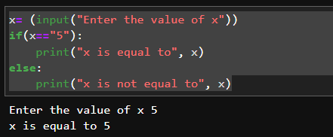

**Assignment:-**

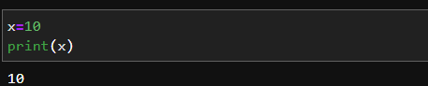

7. Identify the three blocks in this code:

spam = 0

if spam == 10:

print('eggs')

if spam > 5:

print('bacon')

else:

print('ham')

print('spam')

print('spam')

**Ans:- 3 blocks of code are:-**

**Block 1:-**

**spam = 0**

**if spam == 10:**

**print('eggs')**

**Block 2:-**

**if spam > 5:**

**print('bacon')**

**Block 3:-**

**else:**

**print('ham')**

**print('spam')**

**print('spam')**

1. Write code that prints Hello if 1 is stored in spam, prints Howdy if 2 is stored in spam, and prints Greetings! if anything else is stored in spam.

**Ans- Please check below screenshot**

**When spam==1**

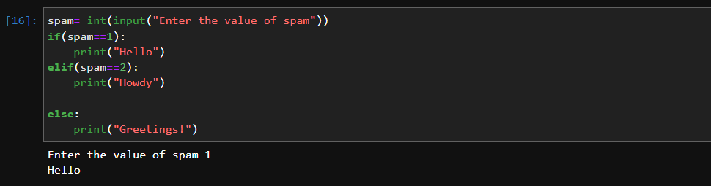

**When spam==2**

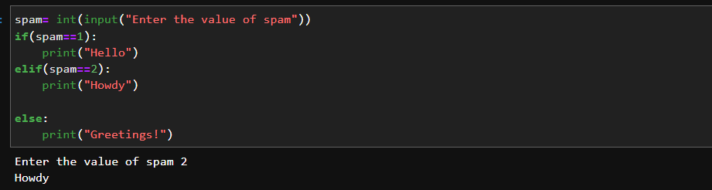

**When spam==3**

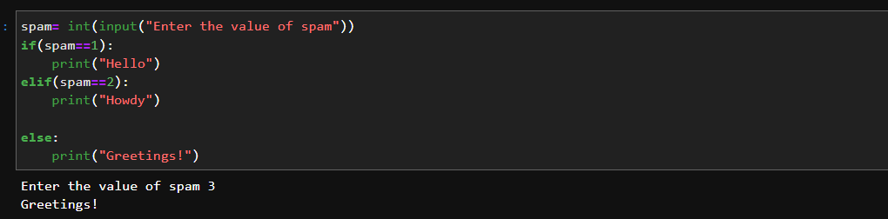

1. If your programme is stuck in an endless loop, what keys you’ll press?

**Ans- If the programme is stuck in an endless loop Ctrl+c will terminate the loop.**

1. How can you tell the difference between break and continue?

**Ans- The break statement terminated the loop immediately regardless of the condition is true while continue skips the remaining code in the current iteration and proceed to the next iteration of the loop.**

1. In a for loop, what is the difference between range(10), range(0, 10), and range(0, 10, 1)?

**Ans- range(10)- It generates sequence of integers 0 to 9 (not including 10) with a default step of 1.**

**range(0,10)- It specifies the start and end value of the range. It will generate sequence of integers start from 0 to 9 (not including 10) with a default step of 1.**

**range(0,10,1)- It specifies the start, end and step value of the range. It will generate sequence of integers start from 0 to 9(not including 10) with incrementing value of 1.**

1. Write a short program that prints the numbers 1 to 10 using a for loop. Then write an equivalent program that prints the numbers 1 to 10 using a while loop.

**Ans- Below is the screenshot:**

**Using For Loop:-**

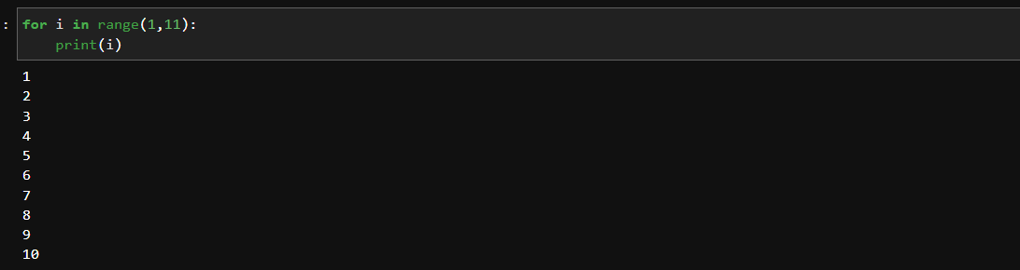

**Using while Loop:-**

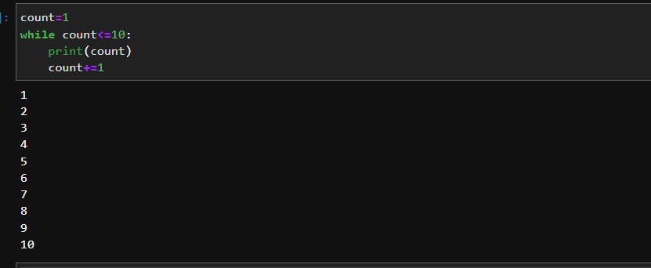

1. If you had a function named bacon() inside a module named spam, how would you call it after importing spam?

**Ans- using dot(.) notation below is the screenshot:**

