**Managerial Questions and Explanations**

**Team 9**

**Managerial Question 1**

*What is the sum total of meaningful orders coming in from each service method and on average how much discount is being offered for each?*

**Rationale:**  
Is SkipTheDishes providing enough of a benefit to CC Pizza with regards to revenue generation and how much discount is necessary for each delivery method.   
  
**Query:**

SELECT customer_order.Service_method,

(SUM(customer_order.Total_order_amount)) AS "Total Meaningful Order Amount ($)",

(AVG(customer_order.Discount)) AS "AVG Discount ($)"

from customer_order

WHERE customer_order.Total_order_amount>=20

GROUP BY customer_order.Service_method

ORDER by (SUM(customer_order.Total_order_amount)) DESC;  
  
**Question 1 results:**

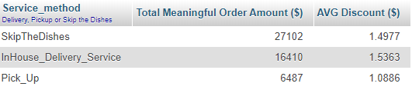

**Explanation:**  
This query serves to identify the number of meaningful orders that are coming in from each service method. The reason why the meaningful threshold is above $20 is because CC wants to make sure customers are buying pizza (typically $20+) and not just other small items (drinks, snacks) from these service methods. CC also included discounts in the query to see what the average amount being discounted was for each service method. The greater the discount, the greater the potential promotional cost to convert customers. With these results, CC understood that not only is SkipTheDishes bringing in a significantly large number of meaningful orders, but it also has a lower corresponding average discount compared to the in-house delivery service.

The reason for this may be because SkipTheDishes is an established channel with many customers often relying on it for convenience rather than discounts. All in all, with ~$10,000 more of meaningful orders coming from SkipTheDishes compared to in-house delivery service, this new service method seems to be a great addition to CC’s pizzeria and should most likely be maintained for the future. However, to make a more conclusive decision, the service fee and costs must also be analyzed for SkipTheDishes.

**Managerial Question 2***How do the costs (Service fee, Skip 15% fee and total cost) compare for SkipTheDishes vs. Inhouse Delivery Service?*

**Rationale:**While SkipTheDishes has a strong customer network, it is also important to see if it is still a feasible option in terms of profitability by taking into consideration the costs.

**Query:**

SELECT

'SkipTheDishes' as 'Delivery system', AVG(skipthedishes.Service_fee_amount) as 'Service Fee', (AVG(skipthedishes.Service_fee_amount)* 800) AS 'Service Fee*Orders',

(Sum(customer_order.Total_order_amount)*0.15) AS 'Additional 15% Fee for Skip',

((AVG(skipthedishes.Service_fee_amount)* 800)+(Sum(customer_order.Total_order_amount)*0.15)) AS 'Total Cost'

From customer_order

RIGHT join skipthedishes on customer_order.SkipTheDishes_ID = skipthedishes.SkipTheDishes_ID

UNION

SELECT

'Inhouse Delivery System',AVG(inHouse_delivery_service.Service_fee_amount), (AVG(inHouse_delivery_service.Service_fee_amount)*500), 'Not Applicable',

((AVG(inhouse_delivery_service.Service_fee_amount)* 500))

FROM customer_order

RIGHT join inHouse_delivery_service on customer_order.InHouse_Delivery_Service_ID = inHouse_delivery_service.InHouse_Delivery_Service_ID;  
  
**Question 2 results:**  
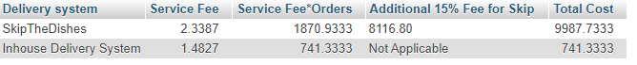

**Explanation:**  
The result of this query reveals the total cost difference between SkipTheDishes and the Inhouse Delivery System. SkipTheDishes has two costs associated with it: service fee per SkipTheDishes order and an additional 15% of total sales coming from using their platform. To account for the total service fee cost, the service fee was multiplied by 800 (Total SkipTheDishes orders) and 500 (Total Inhouse Delivery System orders). Overall, when comparing the total cost, SkipTheDishes is much more expensive in comparison to the Inhouse Delivery System. However, when accounting for both the revenue gain and customer outreach, SkipTheDishes still appears to be a profitable and an impactful addition to CC’s Pizzeria. By taking the meaningful order amount from the first query and subtracting the total cost from the second query, we can see that SkipTheDishes still has a slightly higher profit amount than the in-house delivery system ($17,115 vs $15,669). As such, CC should continue to use SkipTheDishes for the foreseeable future (unless there is a major increase to the fee) as it will help maintain current business operations and ensure CC’s Pizzeria remains sustainable during and after COVID-19.

**Managerial Question 3**  
*What are the most popular items on the menu during COVID-19?   
Compare the quantity sold, price, cost, and profit.*

**Rationale:**  
It is important for CC to identify if there have been changes in customer preferences so that he can understand which promotions/marketing campaigns the business should engage in.

**Query:**  
  
SELECT

menu_item.Name, COUNT(invoice_line.Quantity) AS 'Quantity', avg(menu_item.Cost) as 'AVG Cost', avg(menu_item.Price) AS 'AVG Price', ((avg(menu_item.Price)*COUNT(invoice_line.Quantity))-(avg(menu_item.Cost)*COUNT(invoice_line.Quantity))) AS 'Profit'

FROM invoice_line

INNER JOIN menu_item on invoice_line.Menu_Item_Num=menu_item.Menu_Item_Num

GROUP BY menu_item.Name

ORDER BY Quantity DESC, Profit;

**Question 3 results:**

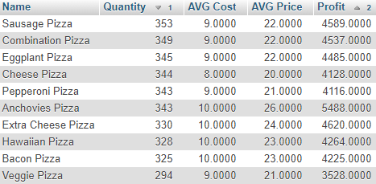

**Explanation:**This result of this query reveals the current menu items, amount sold, average cost, average price, and the corresponding profit ranked using quantity and profit. This query was important as it showed the customer demand during COVID-19. In this case, Sausage Pizza was the most sold. However, many of the other pizzas were in the same approximate quantity sold range. The clear outlier with the fewest demand was Veggie Pizza. Given this information, CC can either try to incentivize more people to buy Veggie Pizza or perhaps reduce ingredient purchases for non-popular pizzas. Additionally, using this information, CC can also work to market and promote his most profitable pizza (Anchovies) to improve the bottom line. Overall, understanding customer preferences and demand is a critical aspect of any restaurant and the results of this query will help CC’s pizzeria remain competitive.