Volodymyr Shatalov  Data Science, Physics and Mathematics Expert |  | 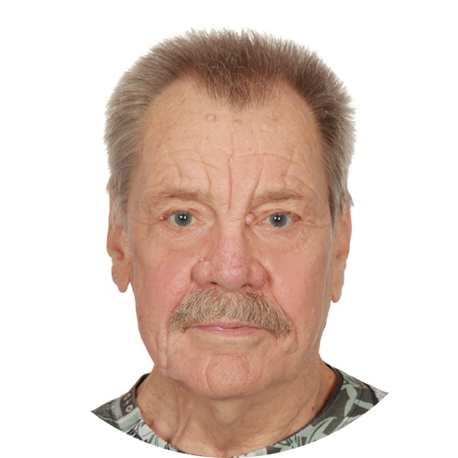
📞 +48 453 318 515,  📧 vladishat@gmail.com,  📫 Warsaw, 03-578, Poland | 🔗 https://vshatalov.github.io  🔗 https://www.linkedin.com/in/vshatalov  🔗 https://researchgate.net/profile/Volodymyr_Shatalov
SUMMARY | SKILLS
I am a former university professor of theoretical physics (see my research/publication experience), now working as a Python developer in the Data Science domain (see my Portfolio, CV, and Feedback here). I am skilled in Data Science, Statistics, Mathematics, and Physics | Python, R, MATLAB, UX/UI, HTML, CSS, JS  Data Science, Machine Learning, Time Series Analysis, Trading Algorithm, Predictive Model Fitting, Natural Language Processing, Neural Networks,
EXPERIENCE | SELECTED PUBLICATIONS
Counselor on Data Science, Mathematics, and Physics  Freelancer  2016 - Present  Artificial Intelligence, Statistics, Mathematics, Computer Sciences | UVGI Scientific Calculator  arXiv preprint arXiv:2006.02205, 2020  N. Bouri, V. Shatalov  Hidden revolution of human priorities: An analysis of biographical data from Wikipedia  Journal of Informetrics 01/2016; 10(1):124-131., DOI:10.1016/j.joi.2015.12.002  Ilia Reznik, Vladimir Shatalov  Mechanism of the biological impact of weak electromagnetic fields and in vitro effects of degassing of blood  Biophysics 01/2014; 57(6):808-813., DOI:10.1134/S0006350912060152  V. M. Shatalov  Bubbles induced fluctuations of some properties of aqueous solutions  Biophysics 08/2013; 57(4)., DOI:10.1134/S0006350912040161  Vladimir M. Shatalov, A. É. Filippov, Inna V. Noga  The influence of high pressure on bio-system reaction kinetics and the Preservation of vitamin C  LWT- Food Science and Technology 01/2013; 58(2)., DOI:10.1016/j.lwt.2013.01.012  Valerii Sukhmanov, Vladimir Shatalov, Juliya Petrova, Adriana Birca, Liviu Gaceu  FeO double-well potential as a result of spin density redistribution  JETP Letters 04/2009; 89(4):167-169., DOI:10.1134/S0021364009040018  Olga V. Gornostaeva, Vladimir M. Shatalov, Yurii G. Pashkevich  Gas separation of hydrogen isotopes by means of multicell metal membrane  Desalination 08/2002; 148(1-3):293-296., DOI:10.1016/S0011-9164(02)00719-1  V. V. Rumyantsev, V. M. Shatalov, G. Ya. Misuna
Professor
Kiev Polytechnic Institute, Slavutych branch
2014 - 2018 Ukraine
- Lecturs on Data Science, Decision Theory, Theory of Algorithms, Web-design, System Analysis
Professor
Donetsk National University, Department of Biophysics
1999 - 2014 Ukraine
Theory of the biological impact of low electromagnetic fields. Molecular structure and dynamics of air/water interface
- Professor certificate
Lead Scientist
Donetsk Institute for Physics and Engineering
1975 - 1999 Ukraine
Quantum theory of electronic properties of semiconductors. Theory of Electron-Photon Emition. Molecular structure and dynamics.
EDUCATION
Dr.Sci. Diploma
National Academy of Sciences of Ukraine
12/1990 - 05/1991 Kiev, Ukraine
- D.Sc. thesis "Effects of the band structure of solids in the inelastic scattering of slow electrons"
Ph.D. Diploma
Donetsk National University
1972 - 1976 Donetsk, Ukraine
- Ph.D. thesis "Quasistationary exitons in the valence semiconductors"
MSc diploma
Southern Federal University
1965 - 1970 Rostov-on-Don, Russia

