FATE : Fish And The Environment. Project Report. 2015-05-14

FVCOM Drifter Track Dataset and Calculation of Retention Index

Vitalii Sheremet

FVCOM GOM3 30yr hindcast data are available from the aggregated server
http://www.smast.umassd.edu:8080/thredds/dodsC/fvcom/hindcasts/30yr_gom3.html
which does not work reliably. Alternatively, individual month long files are available at
http://www.smast.umassd.edu:8080/thredds/dodsC/models/fvcom/NECOFS/Archive/

The subset of data (ua,va,u0,v0,uwind_stress,vwind_stress,temp0,zeta; years 1978-2010) was extracted from the online archive (by means of get_fvcom_mon.py and get_fvcomgrid.py) and stored locally in npy files (local archive GOM3_DATA size 1.5TB).

The local archive structure:
GOM3_XXXX/get_fvcom_mon.py
accesses gom3_yyyymm.nc files and saves each 1hour time frame in individual variable (ua,va,u0,v0,uwind_stress,vwind_stress,temp0,zeta), GOM3_YYYY/var/yyyymmddhh0000_var.npy files.

In order to analyze the fish larvae advection the particle tracks were precalculated for all years of the FVCOM hindcast. A dataset DriftTrackDATA was created which contains information on drifter trajectories. The trajectories are characterized by initial launched time and position.
The launch times were once a week starting each year. The initial launch positions were made to coincide with the nodes of the GOM3R rectangular grid having spatial step of 1.2km.

The GOM3R grid was designed to be consistent with the grid used in satellite-derived imagery employed in a parallel study of ocean fronts. A realistic numerical model must resolve fronts and support frontogenesis. We compare satellite-derived fronts in URI/GSO database (Cornillon, xxxx) with fronts in FVCOM model. The same algorithm is applied to FVCOM surface temperature fields in order to derive fronts positions.

Satellite-derived dataset uses grid 6144x6144 nodes (6144=3*2^11) and spans rectangular area
(-112.11026,-27.889736) deg longitude by (71.172195, 4.8278008) deg latitude centered at
lat,lon=38.,-70.
This grid is designed from assumptions
#dla*111.11111111km/deg-> 1.2 km
#dlo*111.11111111km/deg*cos(38deg) ->1.2 km
In searching for fronts the algorithm splits the image into 32x32 pixel subwindows.
The grids GOM3R and GOM3R32 are generated by script p_fronts.py

We interpolate FVCOM surface temperature field, temp0, onto a rectangular grid GOM3R which completely covers GOM3 triangular grid. We also make GOM3R to coincide with the boundaries of 32x32 subwindows.
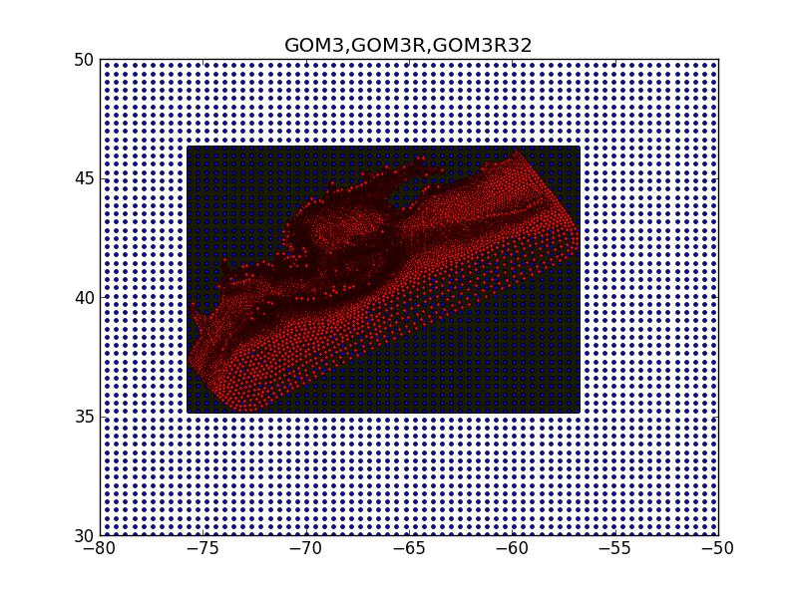
Figure 1. GOM3 triangular grid (red) is completely covered by rectangular GOM3R grid (solid blue) with resolution of 1.2km x 1.2km. Sparser grid GOM3R32 corresponding to 32x32 pixel subwindows used by front detection algorithm is marked by blue dots.

Calculation of drifter trajectories with dtr.py

The main program script that does the drifter tracking is dtr.py. It is a well structures program which can be used with output from other models, not just FVCOM. The script requires start and stop time of the simulations, typically 2 months, and an array of initial positions of the drifters (launch positions) which is subset of the GOM3R grid, completely covering the Georges Bank with large overlapping margings. We avoided using all nodes of GOM3R since drifters close to the coast do not behave physically correct. Such drifters are irrelevant for the fish recruitment study on Georges Bank. The following aspects of the code should be noted.

The script is made generic since the advecting velocity fields defined on an unstructured grid are imported with the function
u,v=get_uv(tRD,D)
where tRD is Rata Die time, the python sequential day number (fractional) which is equal to MATLAB datenum-366; D is depth code: 0 - surface, a – depth averaged. This function can be changed in order to adapt the script for a different model. A function get_uv2 is used when the time step is smaller than 1 hour and the velocity in linearly interpolated between two hourly fields.

The time stepping of the drifter positions is accomplished by the 4th order Runge-Kutta scheme.
TheRungeKutta4_lonlattime(lon,lat,Grid,ua,va,uc,vc,ub,vb,tau)
Such scheme is essential for a drifter to follow a closed loop contour as in a gyre.
This version of RungeKutta4 function also uses a linear interpolation of velocity fields in time to improve accuracy.

Spatial interpolation is accomplished by the following function
VelInterp_lonlat(lonp,latp,Grid,u,v)
which uses
w,Aj=polygonal_barycentric_coordinates(lonp,latp,lonv,latv)
generalized barycentric coordinates within an N-sided polygon based on formula of (Wachpress, 1975). Along the polygon edges the formula reduces to linear interpolation and provide a robust interpolation method without introducing any hight order numerical artificats. In this way we generate continuous velocity fields. The difference between the nearest neighbor interpolation (which give discontinuous fields) and the interpolation based on barycentric coordinates is illustrated in Figure 2 for a trajectory close to a stagnation point where drifter makes a turn.

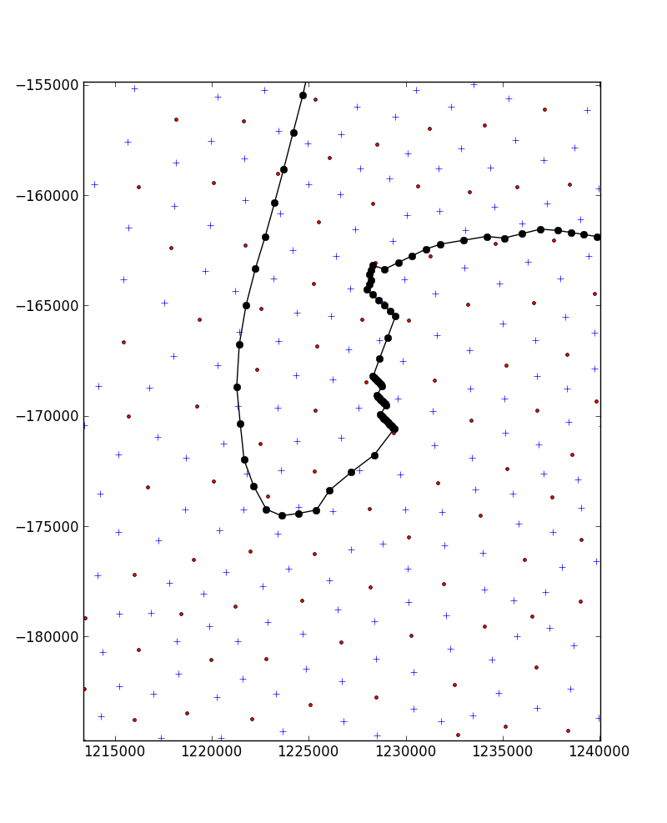
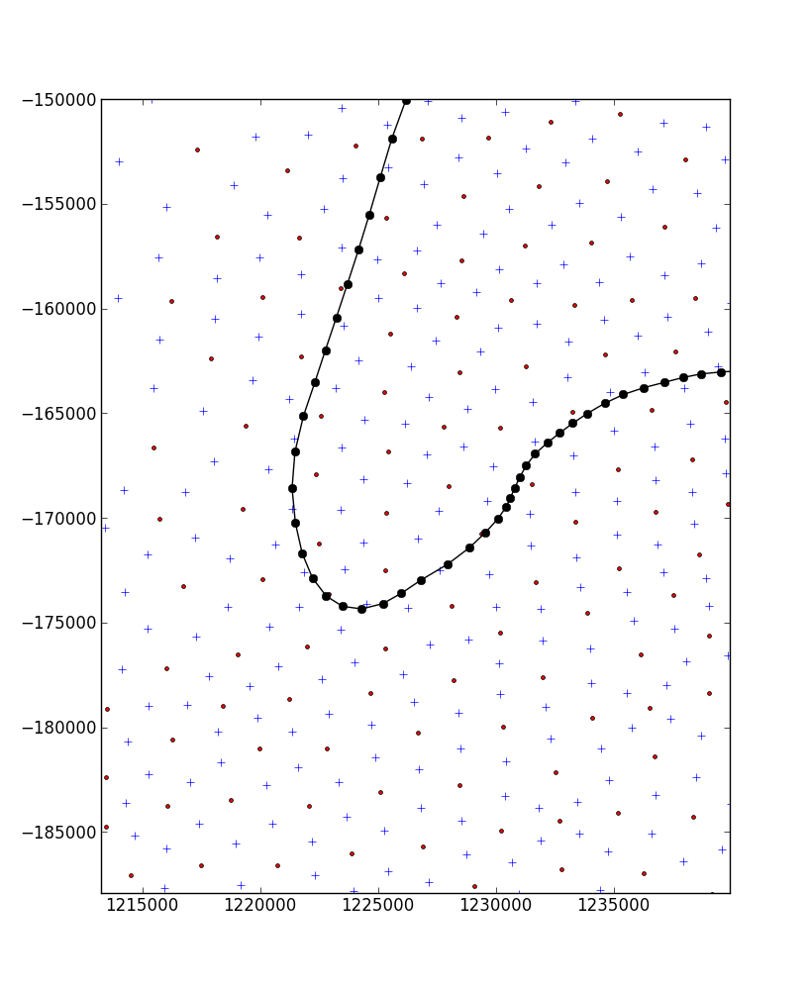
Figure 2. Comparison of a drifter trajectory near a turning point: using the nearest neighbor interpolation (left) and using the interpolation based on barycentric coordinates (right). The velocity fields are held fixed in time in order to emphasize the spatial structures.

The drifter tracking program uses spherical coordinate system (longitude, latitude) with proper metrics and Lame coefficients.

The program can take advantage of multiprocessing capability by specifying the number of CPU parameter ( NCPU).

The initial positions of the drifters can be generated by the script dtr_init_positions.py based on the nodes on the GOM3R grid discussed above. The script creates files llond0.npy and llatd0.npy.

To run the drifter tracking script use command
[]: ipython dtr.py 19970212 a
where 19970212 is an example of drifter array launch time,
'a' means use depth averaged fields or '0' use surface velocities.

To run a batch job specified in file dtr_job.bat:
...
ipython dtr.py 19800101 a
ipython dtr.py 19810101 a
ipython dtr.py 19860101 a
…
issue the following command at linux terminal prompt
$ source dtr_job.bat

The output will be saved into files with 1h or 1d step:
dtr_19970212_a_latt.npy, dtr_19970212_a_lonn.npy

The precalculated drifter trajectory dataset for all 30year hindcast 1978-2010 is located in the folder GBextVavg, which stands for the initial launch area extending beyond the Georges Bank (GBext) and using depth averaged velocities. The GBext area is shown by a red pentagon in Figure 3.

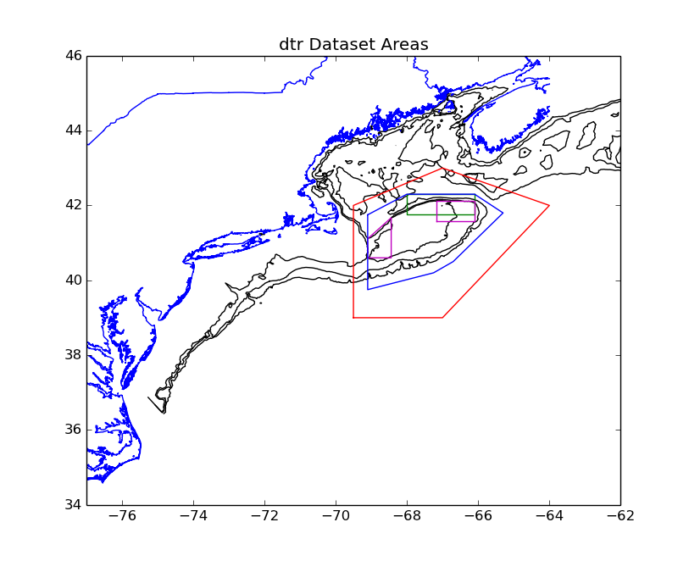
Figure 3. The FVCOM Georges Bank 70, 100, 200m isobaths are shown in black. The red pentagon shows GBext are where drifters were launched. The green rectangle is NE Peak spawning area used in retention index analysis. The magenta areas are alternative spawning areas
WGB and NEP used in analysis of interannual variability. The blue polygon is an area based on bathymetric features associated with 200m depth (shelfbreak, straits) and defines favorable settlement conditions.

Calculation of retention index with dtr_retind.py

Once the trajectories have been calculated we can perform analysis of the retention indices on Georges Bank. We need to define spawning and settlement areas for that. In Figure 3 several options are plotted pertinent to the Cod species. The script dtr_retind.py goes through all drifters released in the dataset, finds those that initially fall into the spawn area and tracks the number of those that stay in the settlement area every day. The number of drifters is saved in files nGB_yyyymmdd_a.npy or nSet_yyyymmdd_a.npy, where yyyymmdd is the launch day of the drifters. Since we launched drifters once a week, there is a corresponding retention index.
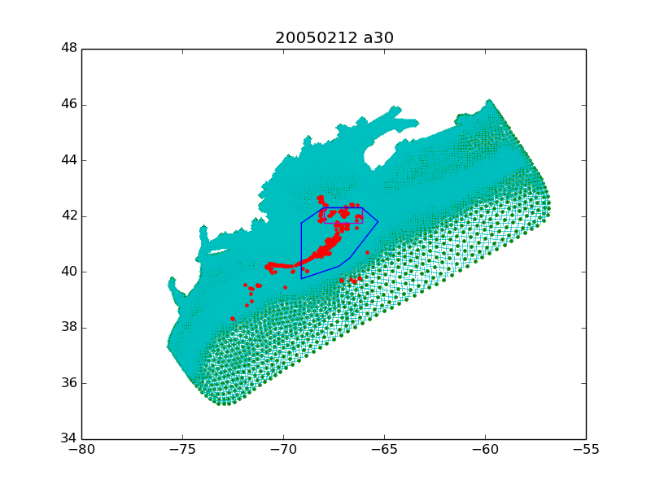
Figure 4a. Position of drifters 30 days after release on 2005-02-12.

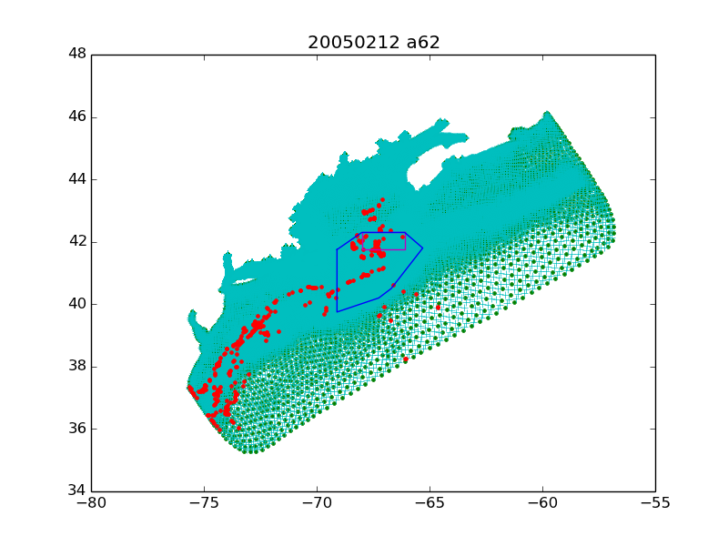
Figure 4b. Position of drifters 62 days after release on 2005-02-12.

As an illustration in Figure 4, the results of a drifter release on 2005-02-12 are shown 30 and 62 days after the release. The corresponding plot of the retention index is shown in Figure 5.
It is a typical behavior of the retention index: there is an initial plateau as the drifters initially stay on Georges Bank, then decline as some drifters cross the settlement area border, and finally reaching end plateau as some drifters got trapped on the bank. Typical advective type scale for this behavior is 40 days which is similar to the timing of first larvae development stage until they are able to swim and hide on the bottom.

For comparison Figure 6 shows behavior of the retention index based on the surface flows.
The index declines much faster as the drifters are swept away by stronger surface currents.
Observations suggest that the fish lavae are distributed more or less uniformly over the water column during the first life stage due to strong turbulent vertical mixing. This is especially true during winter spring period when the stratification is weak.
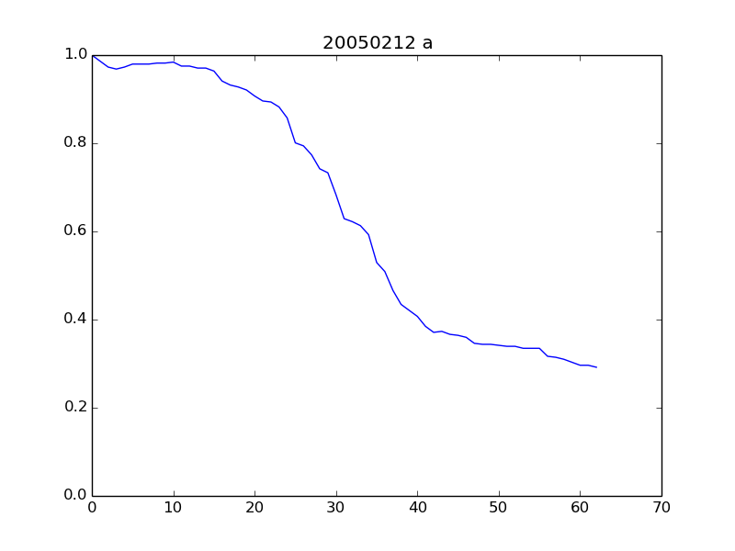
Figure 5. The Retention index for Cod larvae released on 2005-02-12, advection by depth averaged flow. The x-axis is time in days since launch.

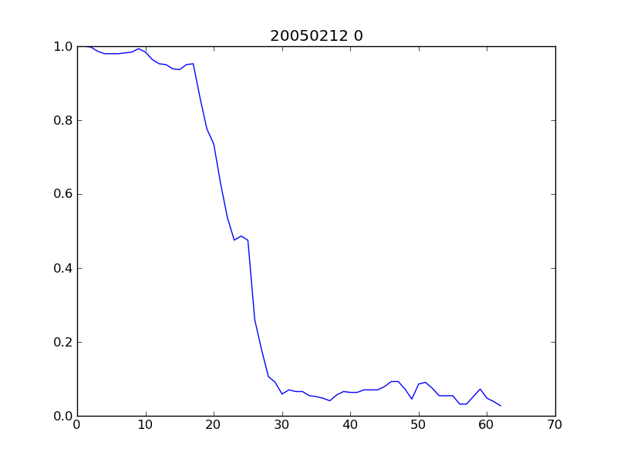
Figure 6. The Retention index for Cod larvae released on 2005-02-12, advection by surface flow.

The retention index for all weekly drifter launches for two years 2004 and 2005 is shown in Figure 7. We see the annual variability with smaller retention during spring period when winds are stonger during storms and larger retention in summer months. We also see some episodic events leading to sharp drops in the retention index associated with storms and shelfbreak eddies.
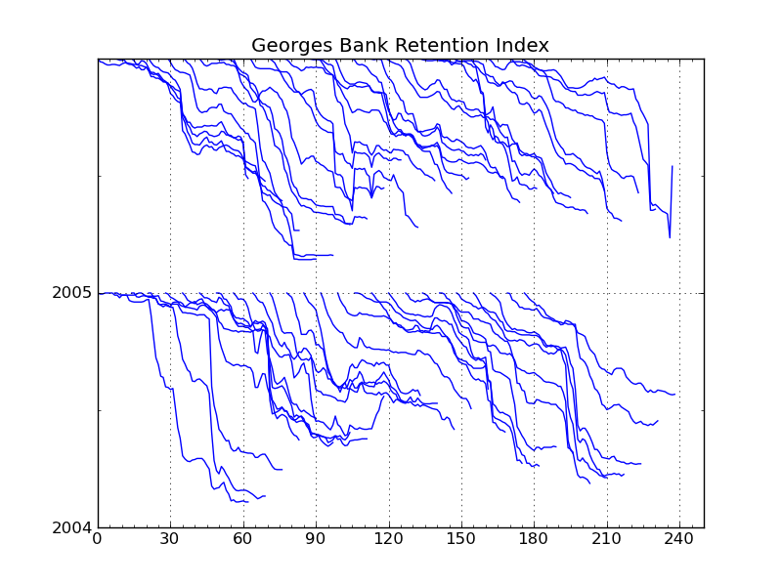
Figure 7. The retention index based on weekly drifter releases in 2004 and 2005.

The corresponding satellite images obtained from (http://marine.rutgers.edu/cool/sat_data/) are shown in Figure 8 for about the same period as during the simulation. During spring time a good satellite image cam be obtained approximately every 2-3 weeks.

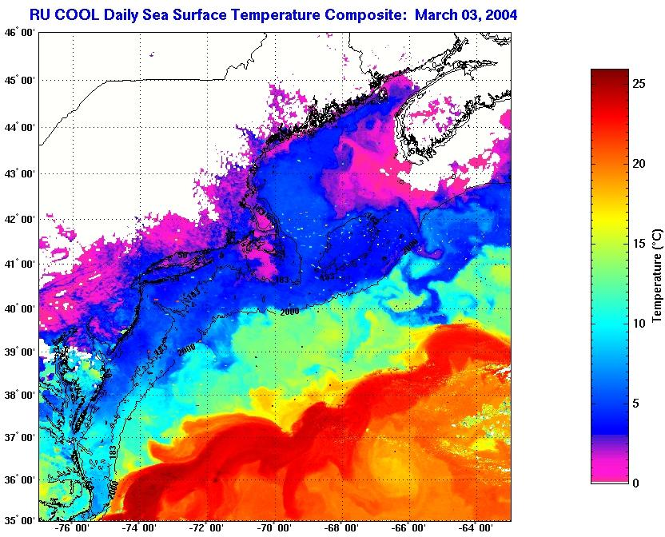

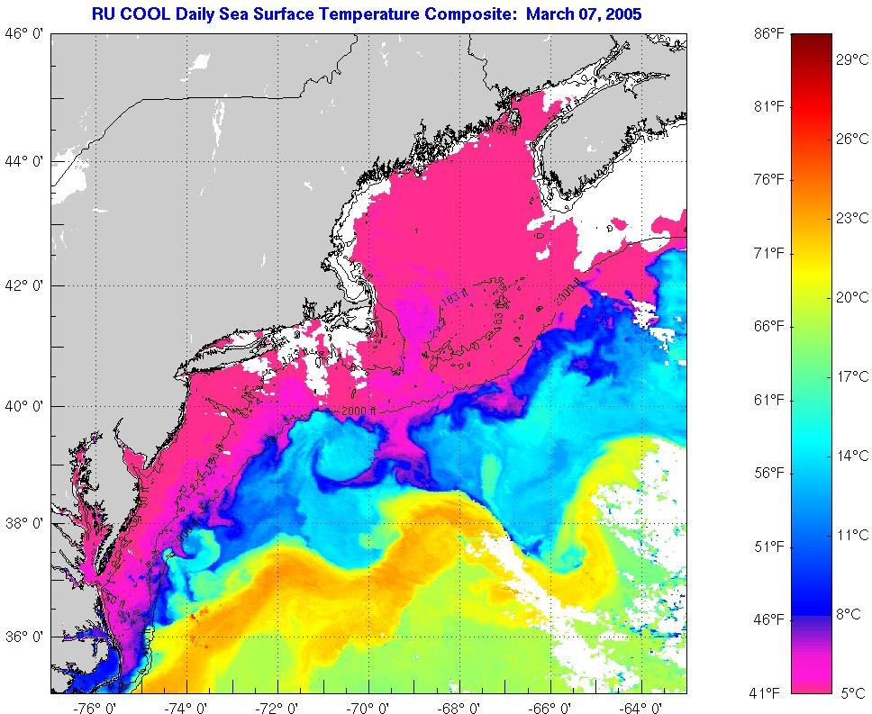
Figure 8. Satellite images for early March of 2004 and 2005.

The retention index for the whole drifter track dataset is shown in Figure 9. It is produced by the script pl_mult_retention_index.py along with other plots.

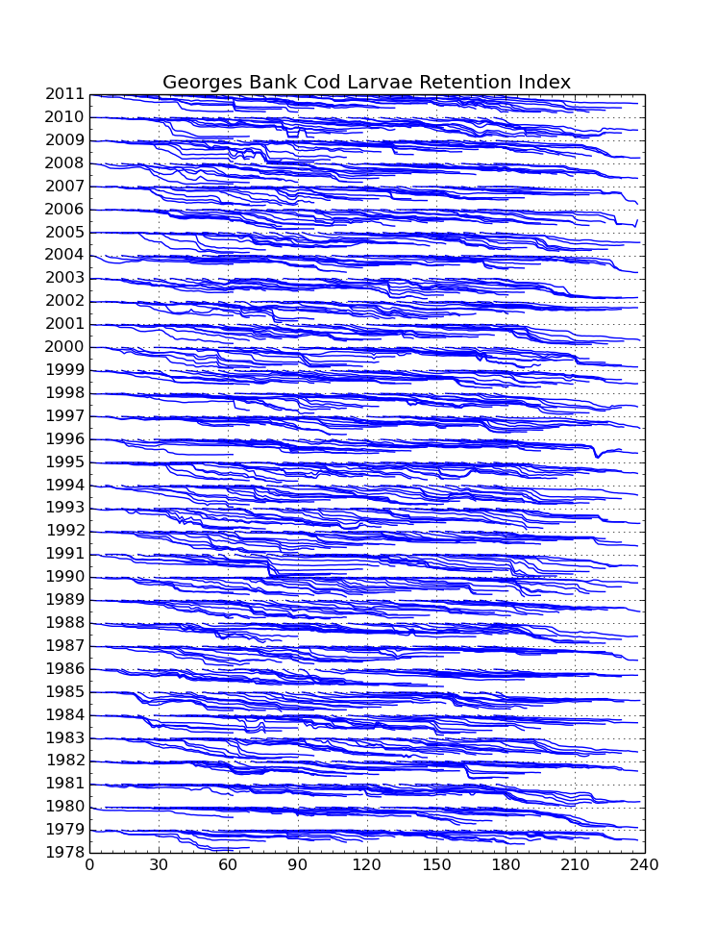

Figure 9. The retention index for the whole drifter track dataset. X-axis is days since launch, along Y-axis retention index if offset by 1 each year.
In order to characterize the whole year some sort of temporal averaging or integration of the retention index is required. Since spawning occurs over a several week period, we average the retention index for each weekly release with the weighing coefficients. For example, Cod spawning peaks around early to mid February, therefore we use triangular shaped distribution of width about 1 month. Thus obtained cumulative retention index is shown in Figure 10.

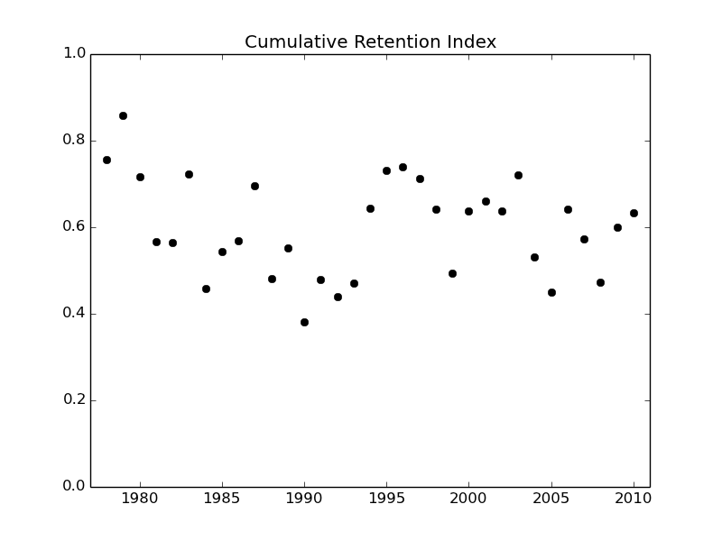
Figure 10. Cumulative Retention Index for Cod with triangular weighting between Jan 15 and Mar 12.

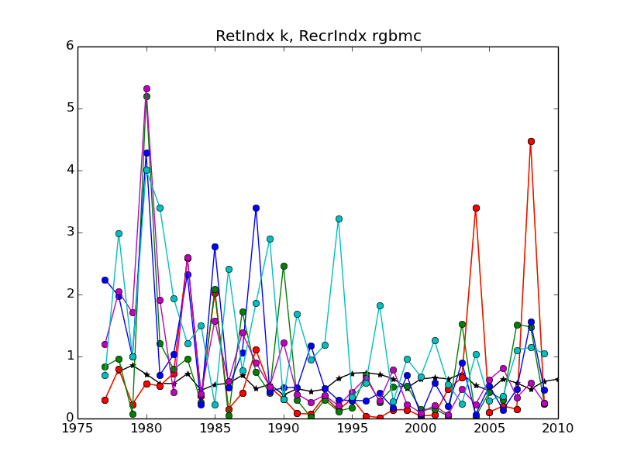
Figure 11. Retention index and recruitment indices based on different age classes for the whole dataset.

The comparison of the retention and recruitment indices for all available years shows that the variability of these indices is similar with the factor of about 3 between years. This suggests that potentially the retention process could significantly contribute to the recruitment. However, there is no obvious direct correspondence between the indices implying that either the available velocity fields or catch information are completely realistic or there are other important factors at play.

Speaking of the velocity fields we find based on comparison with the observed drifter data in a parallel analysis that the surface flow is described reasonably well, but the near bottom flows are not as good due to the scarceness of in situ measurements.

The effect of time step

The standard time step of dt=1 hour was used for the drifter trajectory calculations. This is largely dictated by the fact that the FVCOM output fields are available every hour. For accurate numerical simulations it is required that the information does not propagate more than one grid cell in one time step or, in other words, that the nondimensional Courant number should be smaller than one

C= V_h*dt / H,

where V_h is the horizontal velocity magnitude, H – horizontal size of the grid cell. We picked H to be the radius of a circle of the same area as the area of a triangular cell. Figure 12 shows the distribution of the Courant number for a typical winter velocity fields on 2005-02-12 00:00:00UTC. Blue color indicates C=1/4; green C=1; red C=4. It is seen that in most of the areas the Courant number is smaller than one except at some coastal places and in canyons along the shelf break where the spatial resolution is high.

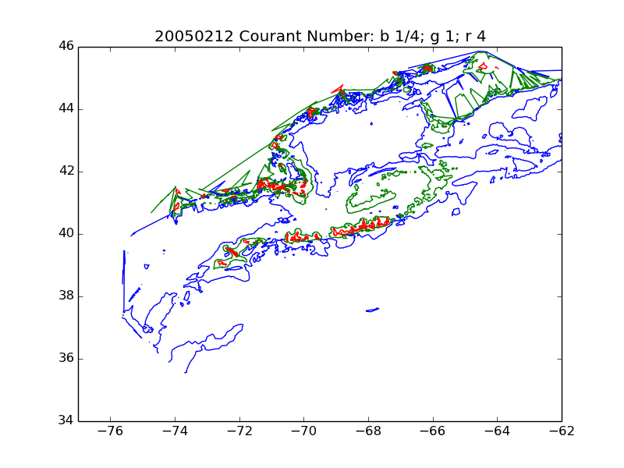
Figure 12. Map of Courant number distribution for time step 1 hour and typical winter surface velocity fields on 2005-02-12 00:00:00UTC.

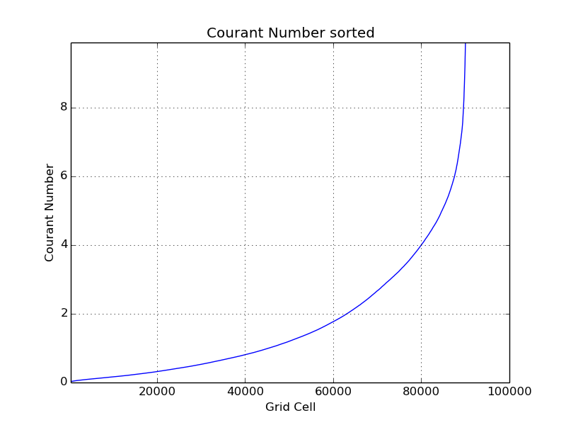
Figure 13. The distribution of Courant number among Grid cells for the same velocity field 2005-02-12.

For Lagrangian methods such as drifter tracking the Courant number exceeding 1 does not lead to an explosive instability as in Eulerian finite difference numerical methods. Instead solution slowly deteriorate in accuracy as the information comes from places farther than one grid cell.
For example, if you consider a drifter in a strait with swift currents moving 10 grid cells in 1 hour, such a trajectory will be inaccurate because 9 grid cells along the way do not contribute information to it. In such a case a reduction in time step will be required for an accurate trajectory calculation.

A comparison of two simulations with the time step of 1 hour and 12 min is shown in Figure 14.
For the simulations with time step smaller than 1 hour the velocity fields were linearly interpolated in time between the hourly fields. In these simulations the drifters were launched in a line along a shelf break. After 4 days the same structures in drifter positions persist, but some individual drifters that leave the groups may have somewhat different positions depending on the time step used. Therefore, we conclude that the effect is negligible in the area of Georges Bank for the purposes of the recruitment index calculations.

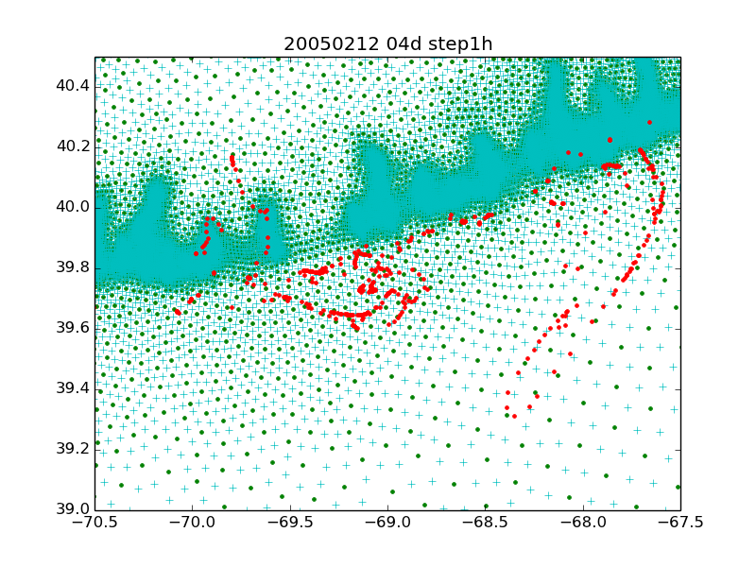
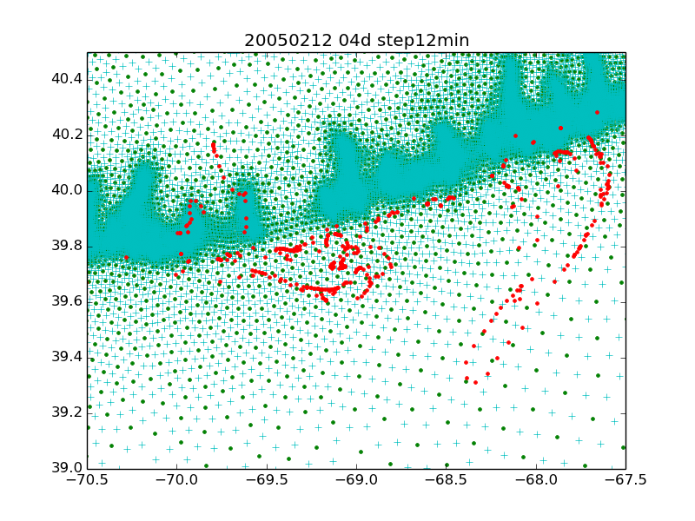
Figure 14. Two 4 day long simulations of drifters launched along the shelf break with a standard time step of 1h (panel a) and 12 min (panel b).

Testing dtr.py: circular gyre flow field

An anticyclonic circular gyre flow field was specified with the center at
loc=-67.5;lac=41.5 (in the middle of Georges Bank)
and velocity linearly increasing with the distance from the center
a=1.010027492283031 m/s/deglat
u=-a*di*np.sin(an)
v= a*di*np.cos(an)
u=u*Grid['coslatc']/np.cos(lac*np.pi/180)

Advected by such a flow field a drifter must make a full circle in exactly 8 days. We ran the dtr_test_vel_circle.py for 32 days at 1h time step for drifters deployed throughout the whole GOM3 grid. Thus all of them should complete 4 full circles. The resulting arrangement of drifters is shown in Figure CIRCLE (produced by dtr_test_vel_circle_plt.py).
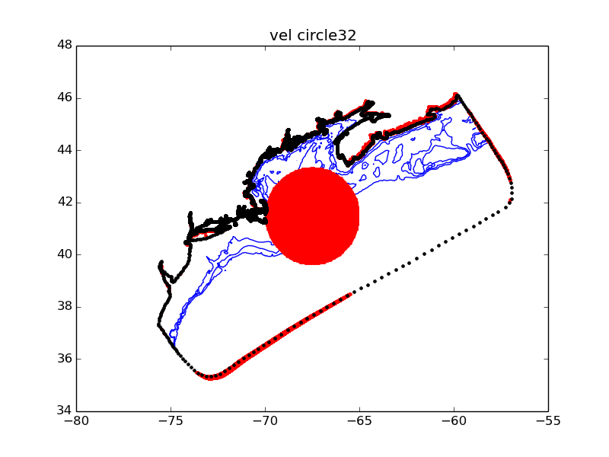
Figure CIRCLE. Drifter positions after completing 1 (or 4) full circles in the gyre flow field.

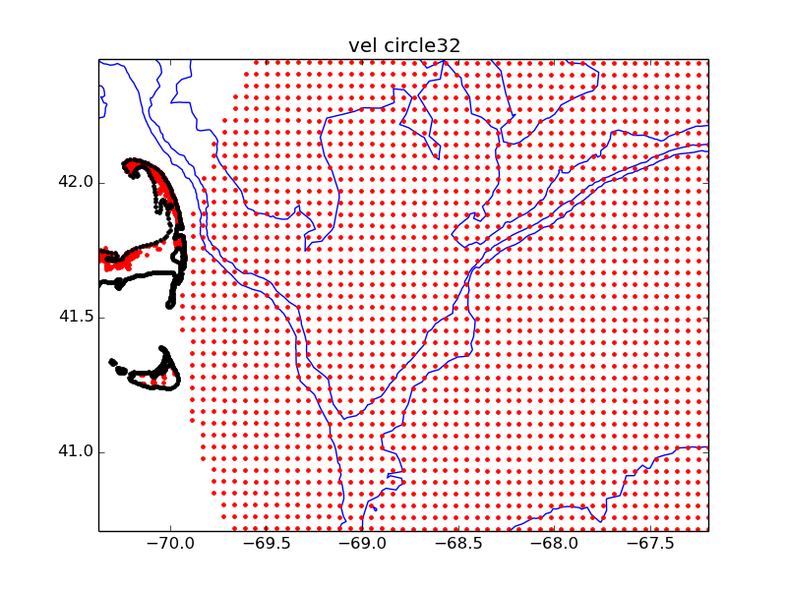
Figure CIRCLEXP. Drifter positions after completing 1 (or 4) full circles in the gyre flow field:
expanded view. The original grid pattern with horizontal spacing of 4.8 km is visible.

The drifters within a critical distance from the gyre center continue to move along the circular trajectories, which corresponds to a big red circle touching Cape Cod in the Figure. Outside that region, the drifters hit the land or the domain boundary and remain steady after that.

Result of drifter tracking with dtr.py

We start our analysis by considering drifter advection by the depth averaged fields (ua,va) during month of February (which corresponds to the Cod peak spawning). The drifters are launched at initial positions on a rectangular grid with 4.8km x 4.8 km spacing (GOM3R grid subsampled every 4 steps). As an illustration we show the position of drifters launched in 2005 on February 1 and following 1 month long advection by time-dependent hourly FVCOM fields (Figure D200502_1h). Coherent features along several frontal zones Georges Bank and on shelf south of Cape Cod are seen to appear due to velocity convergences and divergences. Typically such features become evident in about 2-4 weeks, the time it takes for the drifter to travel between divergence and convergence regions.

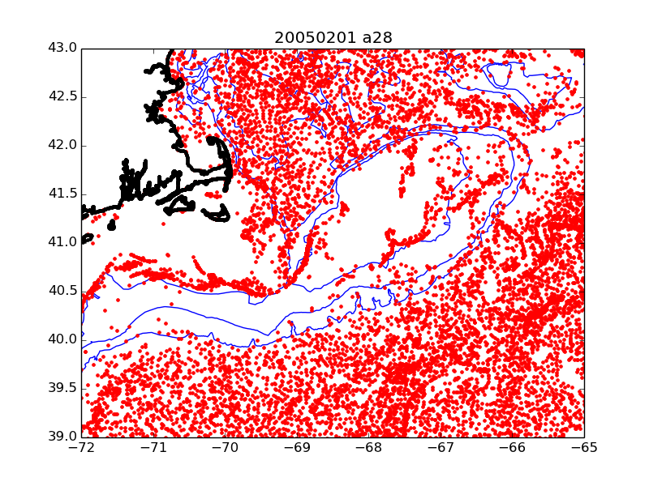
Figure D200502_1h

The coherent features and associated frontal zones are even more evident if the drifters are allowed to be advected by a time independent mean flow, such as monthly mean velocities for February of 2005 (Figure D200502m). In this way the chaotic advection associated with smaller scale eddies is filtered out. Especially dramatic becomes a midshelf front caused by tidal mixing (Ref. XXXX Ulman).

If the drifters are allowed to be advected by the mean field obtained by averaging February mean fields for all 33 years in the dataset (1978-2010) the resulting clustering is less sharp, but it reveals several modes of frontal positions realized during the three decades.

Finally, the effect of advection by the mean flow, the average over all years and all months or in other words, the plain time average over the 33 year time span, is shown in Figure DMEAN.
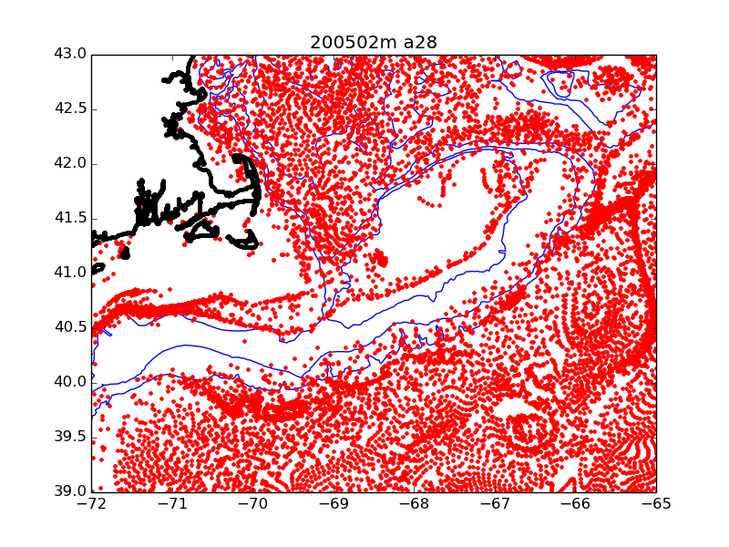
Figure D200502m

We note that, assuming that the effect of surface elevation change due to tides, etc. is neglected, the depth averaged flow fields approximately satisfy the continuity equation

div (ua * H) = 0,

where H is the bathymetry. Thus some of velocity convergence-divergence is due to flow moving over the areas with changing bottom depth. However, the large scale frontal features that approximately follow bathymetry are caused by two-dimensional convergence across the bathymetry and divergence along the bathymetric contours.
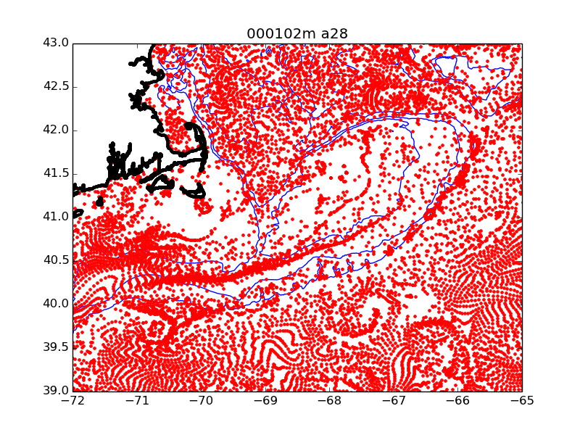
Figure D000102m

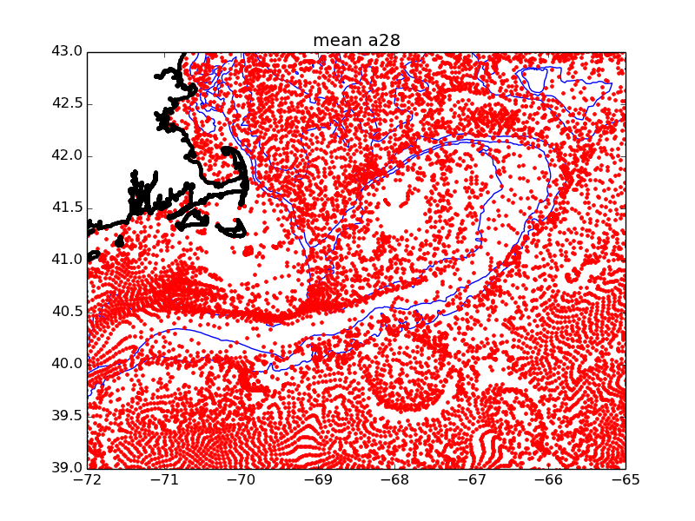
Figure F:mean_a.png.

We now compare the role of surface vs depth averaged fields and hourly vs monthly averaged fields as illustrated Figure Drifts from NEP. The NEP region is defined as a longitude - lattitutude square [-67.18, -66.10, 41.57, 42.13]. Each point corresponds to drifters release once a month during all 33 years of the dataset: the shift in the centroid of a drifter cluster from the initial position on the NEP to the final position 30 days later. On average the centroids shift about 130km km southeast with velocities of about 5cm/s.

(vx[1h],vy[1h],vx[1mo],vy[1mo]) survace
(-0.448, -5.477, -3.558, -5.973) cm/s
(vx[1h],vy[1h],vx[1mo],vy[1mo]) depth averaged
(-3.071, -3.742, -4.832, -4.037) cm/s
Mean drifts are very similar for surface and depth averaged currents as well as for hourly and monthly currents, though the surface currents give rise to substantially larger scatter.

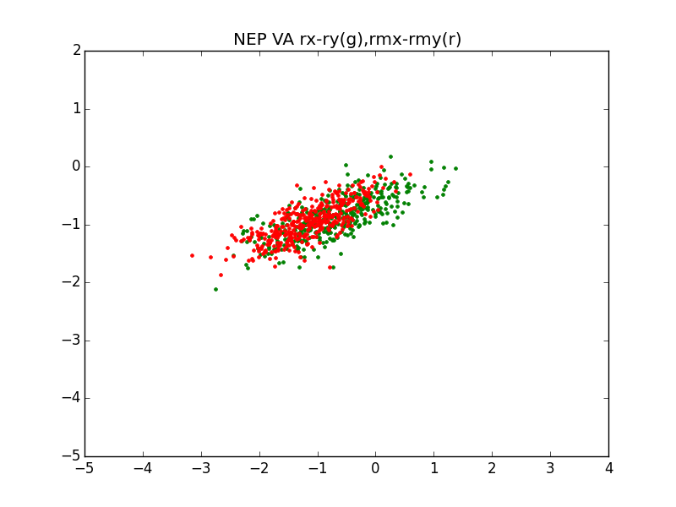
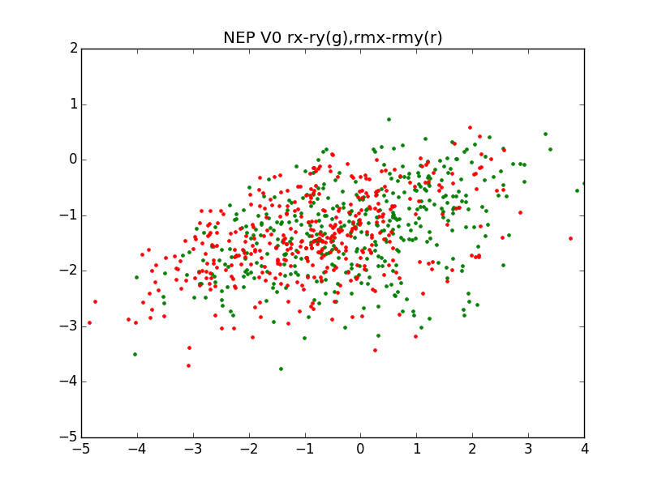
Figure. 30 day drifts from NEP: (top) hourly(r)-monthly(g) surface fields, (bottom) hourly(r)-monthly(g) depth averaged fields. Horizontal scale is degree of arc.

Summary of drifter track simulations:
launch domain depth distribution temporal avg length of simulation
GOM3R4 V0,Va 1h,mo,yr,33yr 30d every month
GBextR4 V0 1h 62d every 7d (Jan-Jun)*some years missing
GBextR4 Va 1h 62d every 7d (Jan-Jun)
NEPR4 V0,Va 1h 60d every 7d (Jan-Dec)

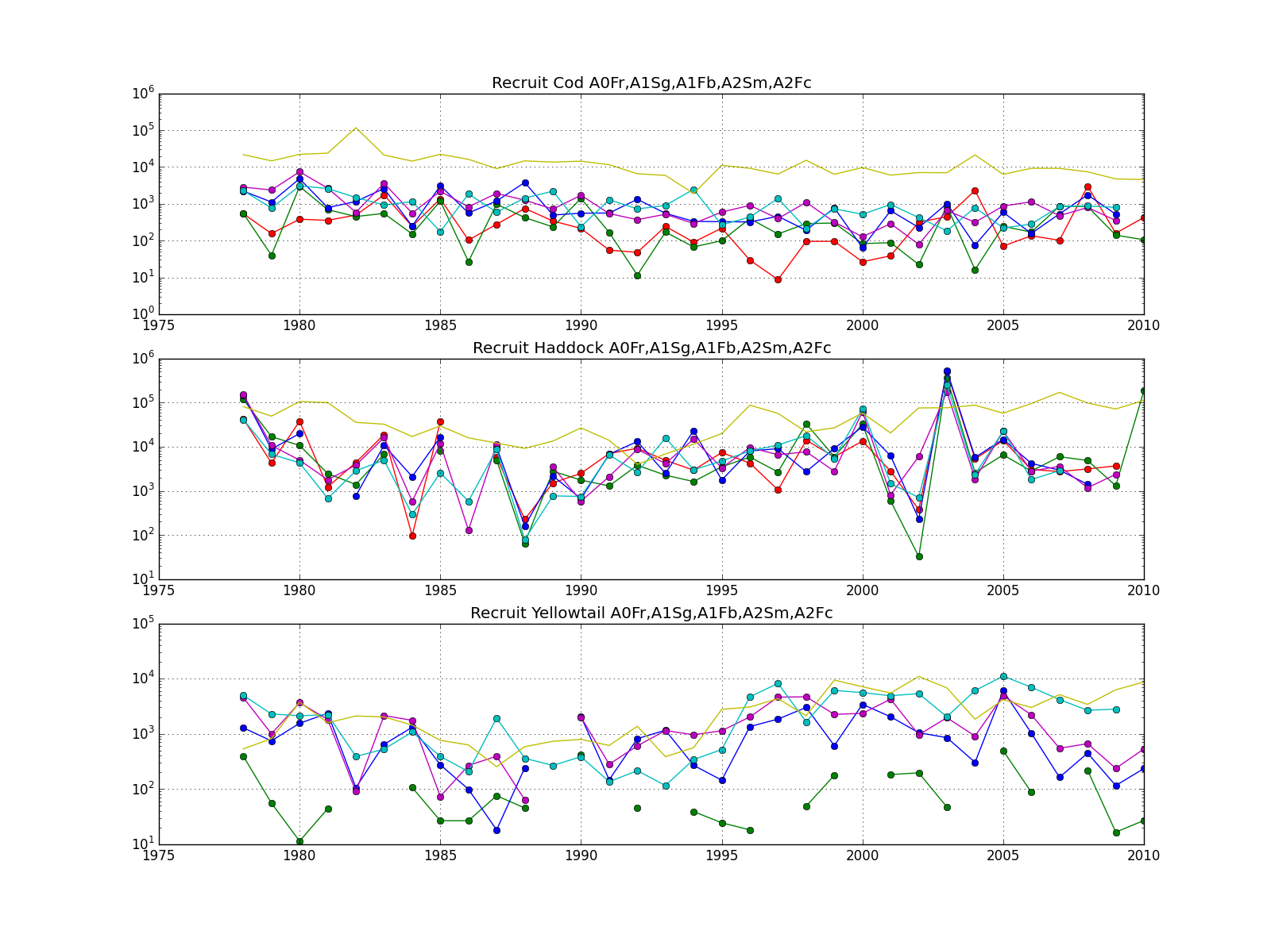
Fig. Recruitment Index (Cod,Haddock,Yellowtail) based on different surveys. Self consistent estimates are evident for Haddock.

A sequence of Hadddock Lo,Hi recruitment years
19820226 Lo
19830226 Hi
19840226 Lo
19850226 Hi
19860226 Lo
19870226 Hi
19880226 Lo
19890226 Hi

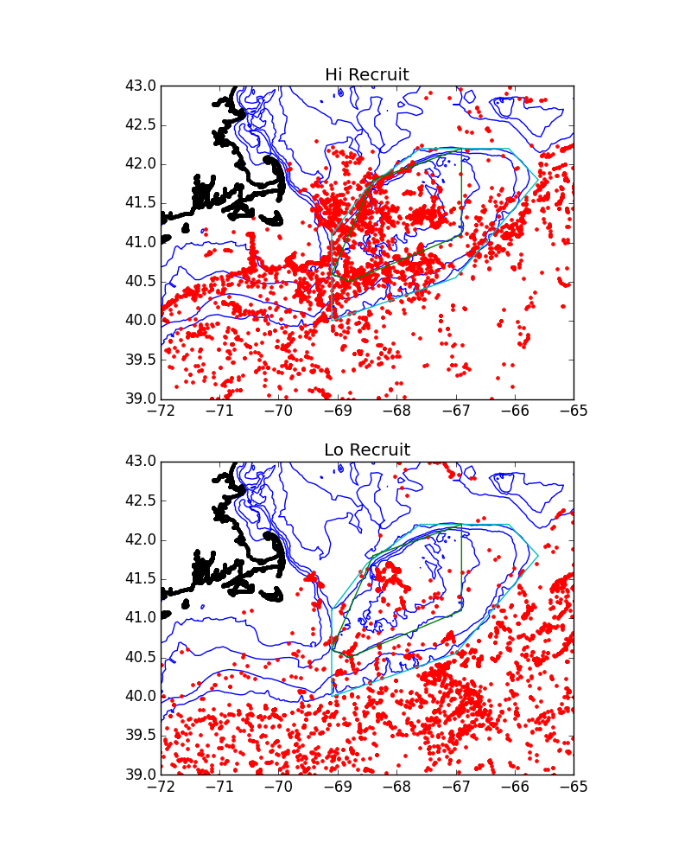
Fig. Fields V0
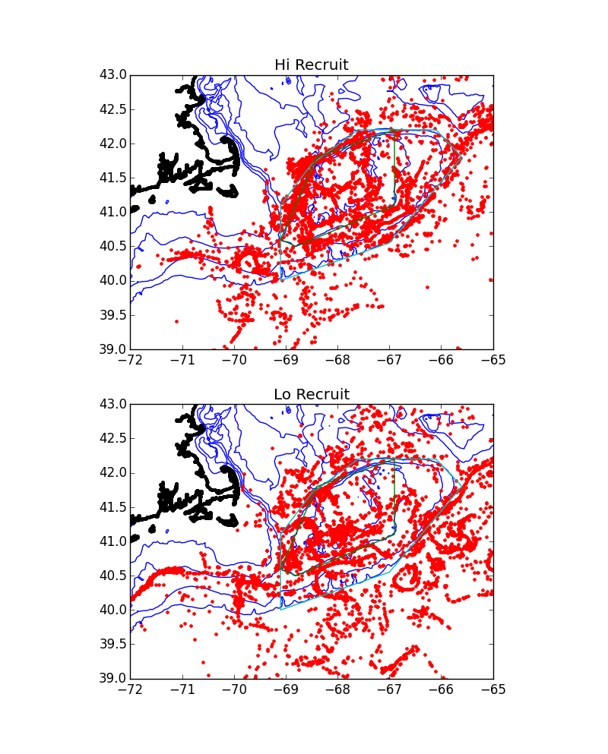
Fig. Fields Va

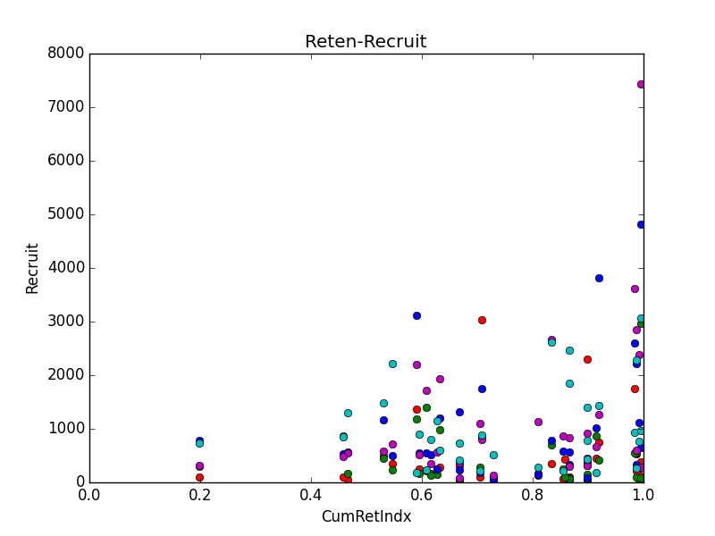
Fig. Recruit-Retent Cod February NEP->GB200mB 30d)
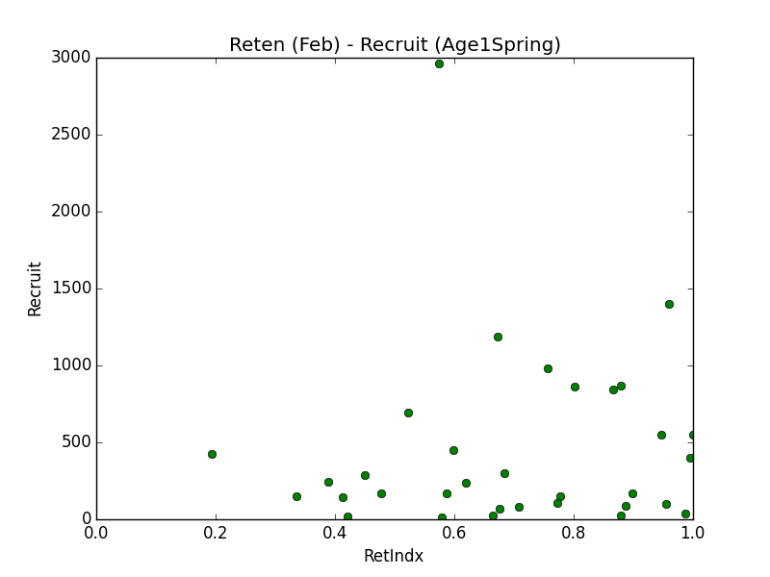

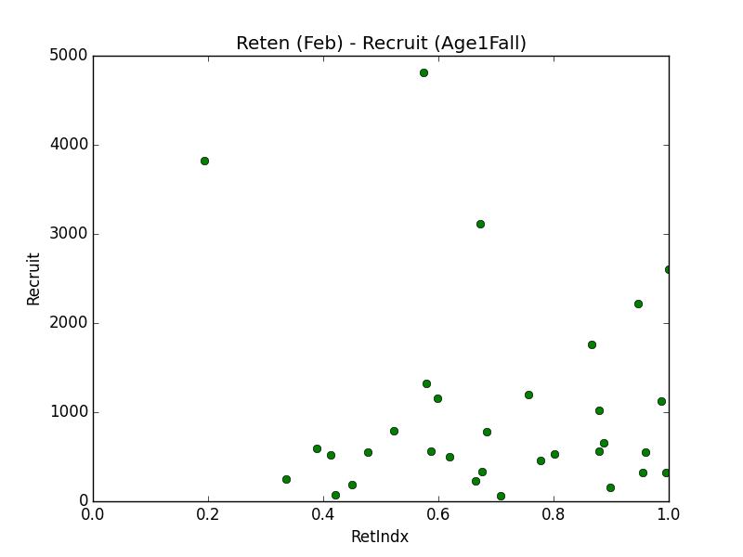
Fig. Recruit-Retent Cod February NEP->GB200mB 30d)

Appendix.

FVCOM Notes

FVCOM uses unstructured triangular grid. The primary mesh is formed out of triangles, with vertices coinciding with the grid nodes. The dual mesh is built of polygons (typically 12 sided for 6 triangles surrounding a triangular grid node) based on medians passing through the triangle centroid.

Reminder, various definitions of the triangle center (http://en.wikipedia.org/wiki/Triangle_center):

The centroid of a triangle – intersection of medians (a median is a line segment joining a vertex to the midpoint of the opposing side), geometric center, barycenter.

The circumcenter of a triangle -- the intersection of the three perpendicular bisectors (a perpendicular bisector is a line that forms a right angle with one of the triangle's sides and intersects that side at its midpoint). The circumcenters and the perpendicular bisectors form the Voronoi-Delaunay dual mesh.

REFERENCES

Eugene Wachpress. A Rational Finite Element Basis. manuscript, 1975.

