# **Contextual Inquiry, Task Analysis, Competitive Analysis**

Master Builders (Group M)

**Team Members**

Angela Sheu: Conducted interviews, target users, task analysis

Victoria Shi: Wrote competitive analysis, made interface design, analysis of tasks

Roger Wang: Wrote problem and solution overview, task analysis

Allison Yee: Conducted interviews, target users

**Target Users**

Our target user group is people who use laundromats to wash and/or dry their clothes on a consistent basis. We chose this user group because they are composed of the primary individuals who use laundromat laundry machines. We did not consider people who use laundromats as a temporary solution (e.g. travelers who need to wash their clothes, people who go to laundromats while they are waiting for their newly purchased washing machine to arrive), since their needs may be vastly different from people who consider going to laundromats as their main method of cleaning their clothes. For example, travelers might not bring delicates with them on a trip, so their laundry needs would be different from someone who washes all types of fabrics at a laundromat. People who consistently go to a laundromat spend a considerable amount of time interacting with laundry machines, so this target user group seems to be the most relevant to our connected device experience.

Interviewee 1

(Did not wish to be photographed).

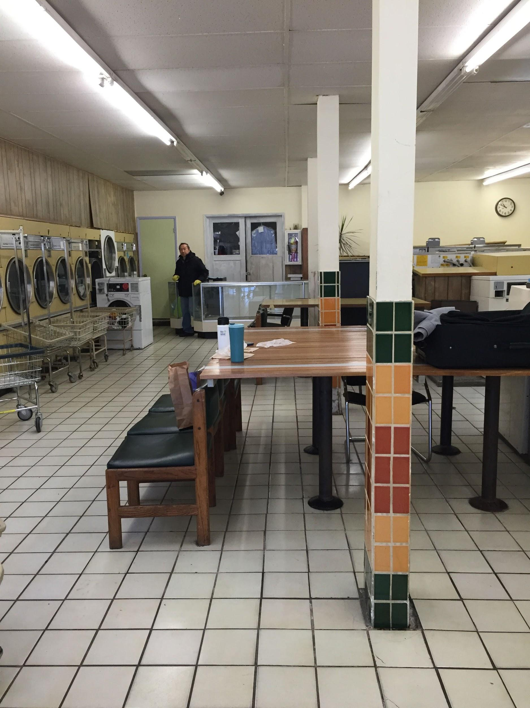

Location: Bing Wong Laundromat, late morning

Observed interviewee as he loaded his laundry into the laundry machine.

* Asian male, late 40s-early 50s
* Has lived in Berkeley (specifically, Gourmet Ghetto area) for quite some time
* Values reliability: washing machine at home is unreliable, so he takes certain items to laundromat
* Goes to Bing Wong Laundromat around once a month
* Married
* Based on how he declined to be photographed, he prefers as much privacy as possible

Interviewee 2

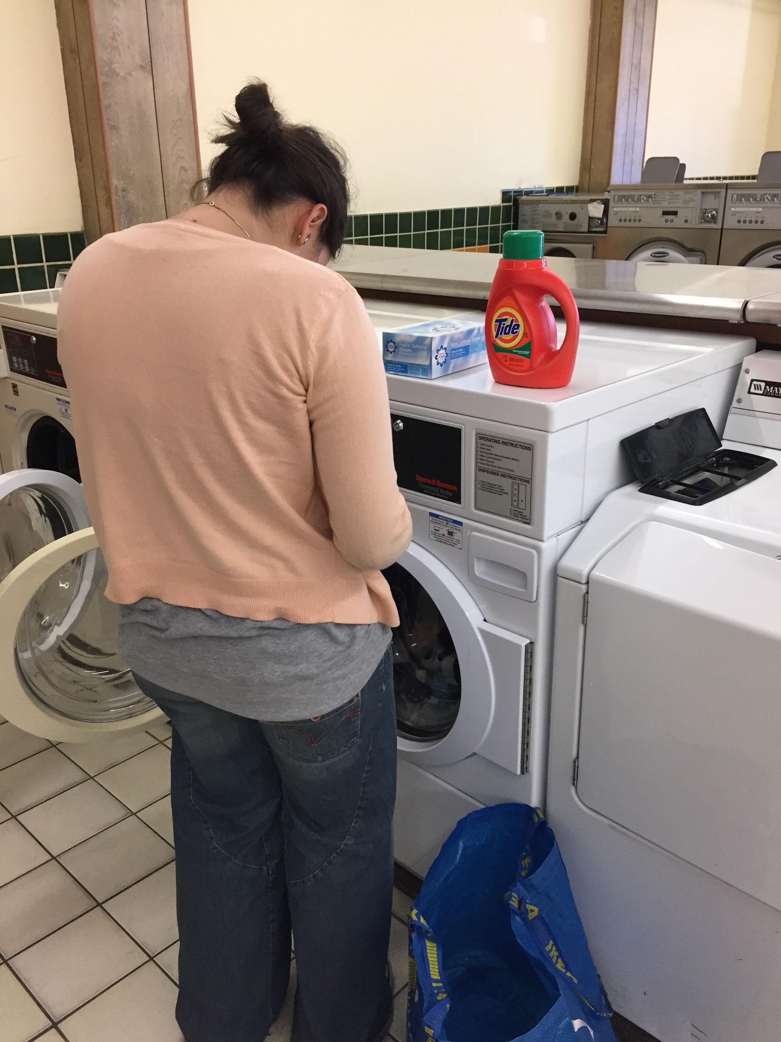

Location and time: Bing Wong Laundromat, late morning

Observed interviewee when she was coming back to pick up her finished laundry load.

* Hispanic female, late 20s
* Goes to Bing Wong on weekly basis
* Has only been in the area for 2 months and is moving again
* Her residence does not have a laundry machine
* Either engaged or married
* Values convenience (she mentioned that went to Bing Wong because it was the closest laundromat)
* English is not her first language
* Methodical: does a lot of things due to “personal preference”--sprinkled powder detergent carefully in a circle, loaded in laundry in order of decreasing size (largest items first)

Interviewee 3

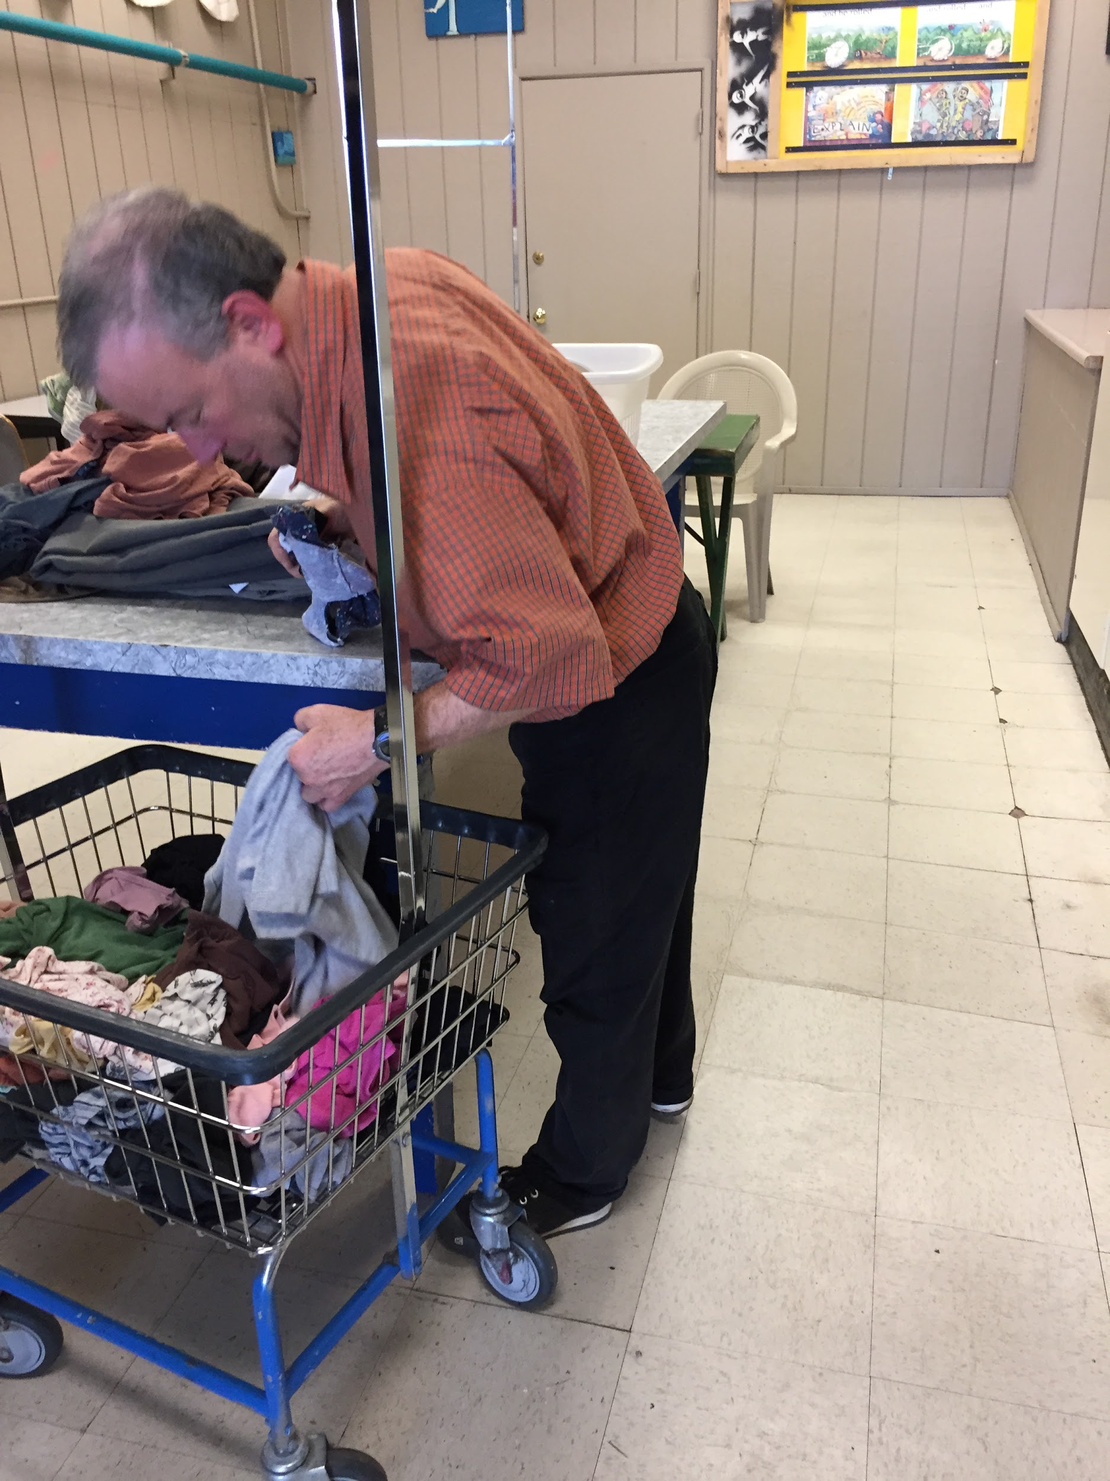

Location and time: Cal Suds, early afternoon

* Caucasian male, late 40s
* Comes consistently, once a month
* Lives alone in a house with no laundry machines
* Not inconvenient but hard to find the time to come out and do laundry
* Uses the triple load washing machine (different types at facility)
* Used to stuff one machine but decided he yielded better results when not overloading
* Uses several dryers
* Sticks around while his clothes wash and dry, studies in the meantime
* Prefers to come to Cal Suds because it's quiet and on the way home from work
* Comes earlier in the day when it's less crowded
* Brings his detergent
* Generally washes clothes with hot water, doesn’t have delicates
* Finds machines easy to use
* Nice to get it done (feels productive)

**Problem and Solution Overview**

Many people live in areas where they use communal laundry machines, namely laundromats. The main problems that are unique to our project specifically involve the struggles of working in the context of a community. Some examples of problems that users might face are having to wait because the machines are taken, forgetting when they should get their laundry and thus inconveniencing others, and feeling insecure about leaving their laundry in the public space. Our connected laundry machines will solve these issues and promote conducive use of shared laundry machines by allowing the user to interact with the machines via their smartphone app. The app will display all available machines, as well as the time they have until they’re done, so users can know when to head over to the machines to guarantee a spot; remind the user when their machine finishes washing/drying; and lock their machine with a password sent to the user.

**Contextual Inquiry: Interview Descriptions**

We went to laundromats in Berkeley to conduct our interviews--Bing Wong Laundromat on Northside and Cal Suds on Southside--since our user would mainly use our interface in a laundromat, as they are doing their laundry. We interviewed individuals who were both loading their laundry into a laundry machine and coming back to get their laundry from a laundry machine that had finished running, in order to get a complete picture of a user’s experience in using a laundromat laundry machine.

For each interview, we first introduced ourselves and explained our assignment to them.

We then stood by the interviewee as he/she did his/her laundry, and asked them to explain the reasoning behind the actions they took. Interviewees usually would begin explaining their process to us, and we would continue asking questions based on those statements.

Observations from Interviews:

Commonalities:

* Brought their own detergent
* Chose a laundromat mainly based on convenience
* Paid for laundry load using coins
* Were Non-students
* Went consistently to the laundromat at which he/she was interviewed

Interviewee 1:

* Wiped down the basin of the laundry machine with wet wipes before putting in his laundry because he liked a specific machine but saw that there were dirty particles inside of it
* Had the most methodical way of doing laundry that involved sprinkling the detergent and placing articles of clothing in a specific manner. When we questioned the rationality behind these actions, he conceded that his actions probably did not have a big effect, but they were based upon “personal preference”

Interviewee 2:

* Only one to leave laundry as the washing machine was running and come back later to pick it up; she felt that no one would open the laundry machine as it was running since she was using a front-loading machine, and according to her, the water would spill out if someone opened the machine as it was running
* Was careful about separating out certain items to air dry after laundry finished before placing wet laundry in a drying machine

Interviewee 3:

* Used triple load laundry machine because only came once a month and had a lot of clothes to wash
* Didn’t care as much about how specifically he did his laundry, didn’t have many delicate clothes

**Task Analysis Questions**

1. *Who is going to use the system?*

People who use laundry machines at public laundromats to wash their clothes. A subset of users will be the owners of the laundromats, who will have special accounts.

1. *What tasks do they now perform?*

Users take their laundry to the laundromat, put their clothes in the wash, add detergent, adjust the temperature and parameters for their load, pay, then start the machine. After the wash is done, the users transfer their clothes to the dryer, empty out the lint catcher, add dryer sheets, adjust parameters (heat, cycles), pay, and start the machine. Some users will sort their clothes (colors or whites), and fold their clothes afterwards.

1. *What tasks are desired?*

* See what machines are available, make sure that none are broken
* Do laundry–wash and dry
* Keep clothes safe: interviewees (except for Interviewee #2) stayed at the laundromat while the washing machine was running
* Know when to get clothes: interviewee #2 looked at her watch before she left and let me know what time she would be back to get her clothes. She came back a couple minutes early to wait out the last few minutes of the washing cycle.
* Have finer granularity control over laundry machine settings: Interviewee #1 stated that he liked a certain laundry machine because it did not combine temperature and agitation level into one setting like some other machines in the laundromat (e.g. hot/normal, warm/perm-press, cold/delicate).
* Pay with ease and guarantee that it went through: all interviewees paid with coins; interviewee #1 mentioned that he would find it easier if he could pay with card.

1. *How are the tasks learned?*

Tasks are learned through previous knowledge, trial and error, and reading instructions posted on the machines/walls.

Interviewee #2 had to learn to use the dryer at Bing Wong through trial and error: she stated that she just fiddled with the buttons until she figured out the right order in which to add money and add drying cycles.

1. *Where are the tasks performed?*

These tasks are performed in laundromats, mostly in front of the laundry machines. Users also wander around the laundromat as they wait for their laundry to finish.

1. *What’s the relationship between user & data?*

Users currently have to be physically near the laundry machines to view data about how much time is left and what settings the machines are on. They know the current settings a laundry machine based on indicator lights (if a setting is selected, there is usually a light next that that setting that is turned on). They do not know whether the laundry machine works or not unless they find out that a laundry machine is not functioning themselves or is informed by someone else. Users can determine how new a machine is by its settings: Interviewee #1 noted that the newer machines at Bing Wong Landromat have blue read-out displays, while older machines have green ones. Laundry machines also make a beeping noise to alert users that the load has finished.

1. *What other tools does the user have?*

Laundromats have carts into which users can place their laundry from a finished

washer, then wheel to a nearby dryer (used by Interviewee #1, Interviewee #3). Users transport their laundry to the laundry machine using plastic bags, suitcases, or laundry baskets. Users utilize detergent and fabric softener in washers and drying sheets in dryers. When pouring out the amount of detergent or fabric softener needed, users measure out the amount using the cap of the detergent or fabric softener container. Users pay for the load done by a laundry machine using coins. Some users place delicate clothes into laundry bags before placing them into a washer (Interviewee #2 did this with her delicates).

1. *How do users communicate with each other?*

Since users share the same space with others while doing laundry (they have to physically go to a laundromat in order to load their clothing), they come into close proximity with one another. Generally, users do not need to communicate with one another, although it would be useful if users could alert other users when their laundry is complete. The interviewees we observed usually did their laundry in silence.

1. *How often are the tasks performed?*

Depending on the user, but our interviewees do laundry regularly, on a basis between once a week and once a month.

1. *What are the time constraints on the tasks?*

Users have to take time out of their days to transport their laundry to/from the laundromat and their home, so they are often on a schedule for work or school. They try to complete their goal of doing their laundry as efficiently as possible.

Washing cycles are usually between 20-30 minutes long. Drying cycles vary depending on the number of cycles that a user adds to the machine, but usually range between 20-90 minutes. Most users will stay at the laundromat and wait for their clothes to finish washing or drying, since there is not enough time to go do another task at a different location, or because they wish to ensure the security of their clothes.

1. *What happens when things go wrong?*

If something malfunctions with the laundry machine, users can contact the manager of the laundromat and alert them of the issue. However, users often take things into their own hands, such as Interviewee 1, who had to wipe down the basin of his washing machine.

Other things that could go wrong are getting clothes stolen or having an undesirable outcome after washing and drying clothes (i.e. clothes shrinking, color bleeding). Users also get frustrated in cases swallows their coins without registering the payment.

**Tasks**

Easy:

* Locking and unlocking the machine: When the machine’s cycle is started, the machine is automatically locked and an unlock code sent to the user’s phone; the user does not have to worry about locking the machine themselves. To unlock, the user simply scans the code with the machine.
* Paying: The bill appears as a pop-up on the app. All the user has to do is select “ok”, and they will automatically be charged via a credit or debit card registered through the app.
* Reminders: Users will receive notifications about their laundry being (close to) finished.

Medium:

* Scanning a tag and setting the machine accordingly (fig. 3): the user must locate the tag on their clothing and scan it with the laundry machine. The app will then recommend a setting for the machine. The user can either reject or accept it. This may be confusing for some users if they do not understand the machine’s settings.
* Measuring detergent into the machine: Once the user has loaded their clothes, the app will prompt the user to enter a level of dirtiness (normal, soiled, very soiled). Once the user has picked an option, the machine will automatically load the correct amount of detergent and add the appropriate charge to the bill. This may confuse some users if they’re not sure what option to pick.
* Checking for available machines: The user has to look on their smartphone, click the option for viewing machines (either at a particular laundromat, or look for ones nearby). If possible, the user will be able to view a space map of the laundromat and easily see which machines are available based on some visual indicators. This would take 3-4 steps, such as searching for the correct laundromat, clicking on it, and finally viewing the laundry machines.

Hard:

* Controlling washing/drying procedures in detail: For those who want more control over their laundry, our app will allow them to control a variety of settings for each wash/dry cycle, including cycle time and type (e.g. normal, delicates, hand wash, etc), fabric setting (colors, whites, etc), water temperature (hot, cold, warm), and drier temperature. To accomplish this task the user has to navigate through a series of setting buttons/text fields and select or enter options. This task will be difficult for users who do not understand laundry settings in detail to accomplish.
* Creating and storing a preset laundry procedure (fig. 5): The user must complete a procedure similar to the one described above. Additionally, at the end, the user must choose to save the stored laundry procedure, then give the procedure a name. To access stored preset procedures, the user must navigate to a “saved procedures” menu, and either swipe down until they see the procedure they want or search for the procedure’s name via a search field.
* Setting up payment method: User has to enter credit card information, billing address, etc. which can be very tedious, but can be made easier with integration with services like Apple Pay or Google Wallet.

**Interface Design**

Functionality:

* Find available laundry machines, either near the user’s location or near a specified address
* View prices of laundromats
* Reserve machines for a limited amount of time
* Track washer/dryer cycles in progress
* Set laundry settings for washers/dryers. You can either create a new setting (this gives you the option to save it), reuse a previously saved setting, or scan a clothing item and receive an automatic setting recommendation
* Receive alerts when a washer/dryer cycle is complete
* Unlock the machine when a cycle is complete
* Pay

**fig. 1: Working With In-Progress Laundry**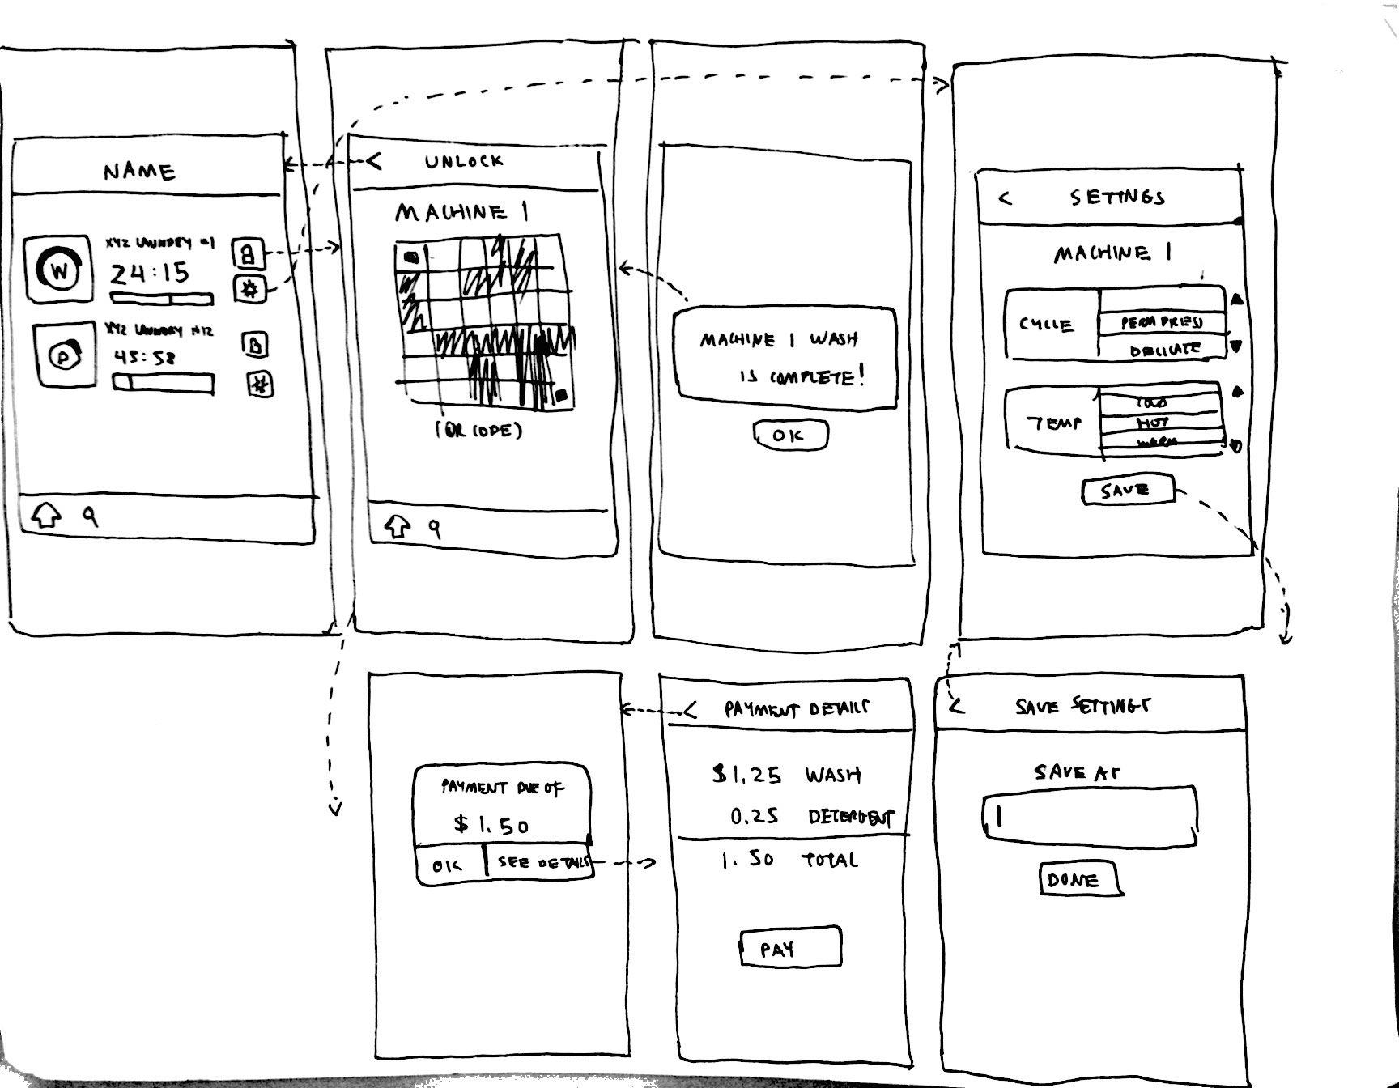

* After the laundry load has been paid via a credit/debit card registered through the app (the first screen on the 2nd row in **fig. 1**), the washing machine begins a cycle. Note that the user can view payment details at a finer granularity by clicking ‘See Details’ to go to the 2nd screen on the 2nd row
* The home screen (1st screen, **fig 1**) shows washing and drying cycles in progress, the laundromat name and machine number, a timer showing time left. There are two options: unlock the machine, or change the laundry settings.
* Clicking on unlock brings up the code the machine needs to scan in order to unlock it
* When a cycle is complete, a pop-up alert (3rd screen) alerts the user. Clicking “OK” will bring the user back to the code.
* The machine will then be unlocked

**fig. 2: Changing Laundry Settings**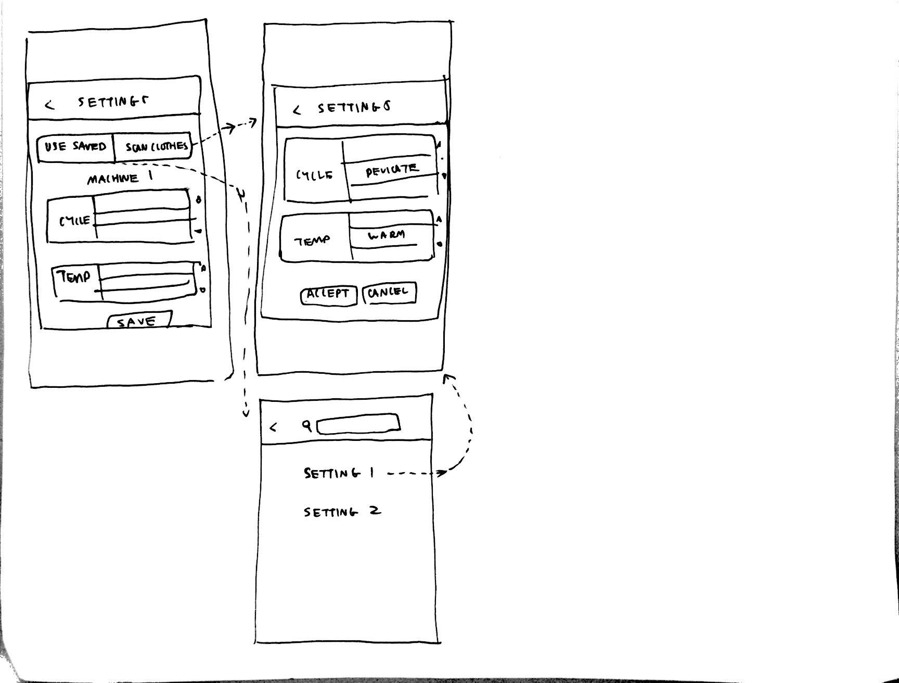

* Hitting settings from the home screen will bring the user to a dialogue where they can view and change the machine’s settings. They can use a previously saved setting, scan a clothing item to receive suggestions, or customize their settings. If they choose to customize their settings, they can save it.
* Selecting “Scan Clothes” and then scanning an item will bring up the recommended settings. The user can accept or reject them.
* Selecting “Use Saved” will bring up a list of saved laundry procedures. The user can scroll through them and select one or search for one by name. Selecting one will bring the user back to the 2nd screen.

**fig. 3: Finding and Reserving Available Machines, Laundromat Information**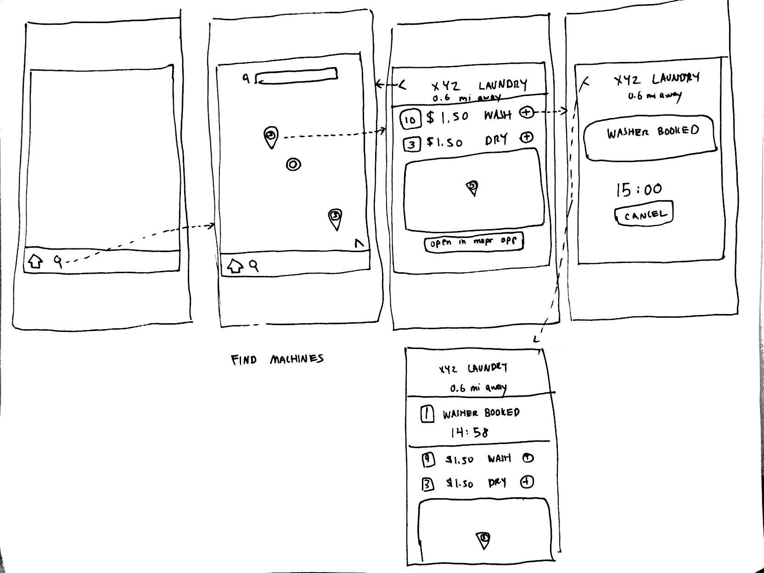

* The user selects the search icon from the bottom navigation bar to bring up the maps (2nd) screen. The maps will show icons over nearby laundromats, which are red if all machines are occupied. If some machines are free, the icon will be green and display the number of open machines.
* Tapping on an icon will bring up a screen displaying information for the laundromat, including the name, distance from user, cost of wash and dry, and number of free machines. The laundromat’s location is displayed in a small map. The user can choose to open the location in a maps app to help route them there.
* Clicking on the + icon next to wash or dry books a machine. A timer counts down the amount of time the user has the machine booked. The user can cancel their reservation.
* If the user then goes back to screen 3, it now displays their booked machine along with the timer, in addition to the previous information.

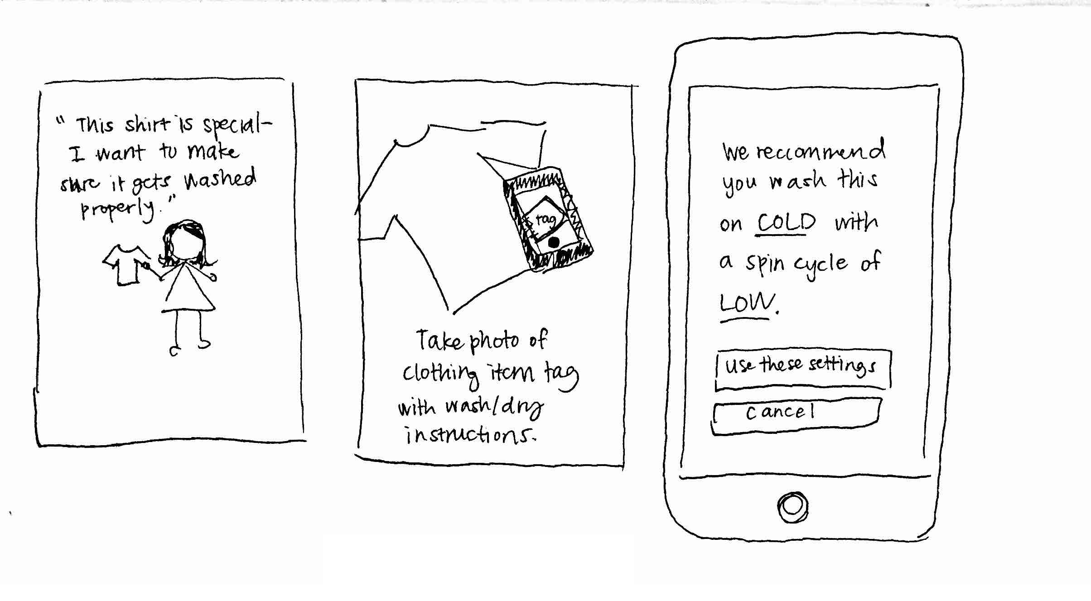

**fig. 4: Scenario 1 - Task of scanning the tag and setting the machine**

* The scenario starts out with an individual with the need to make sure a specific item of clothing gets washed properly.
* He/she can proceed by using the app to take a photo of the tag on the garment.
* The app will parse the instructions from the tag and designate appropriate settings.

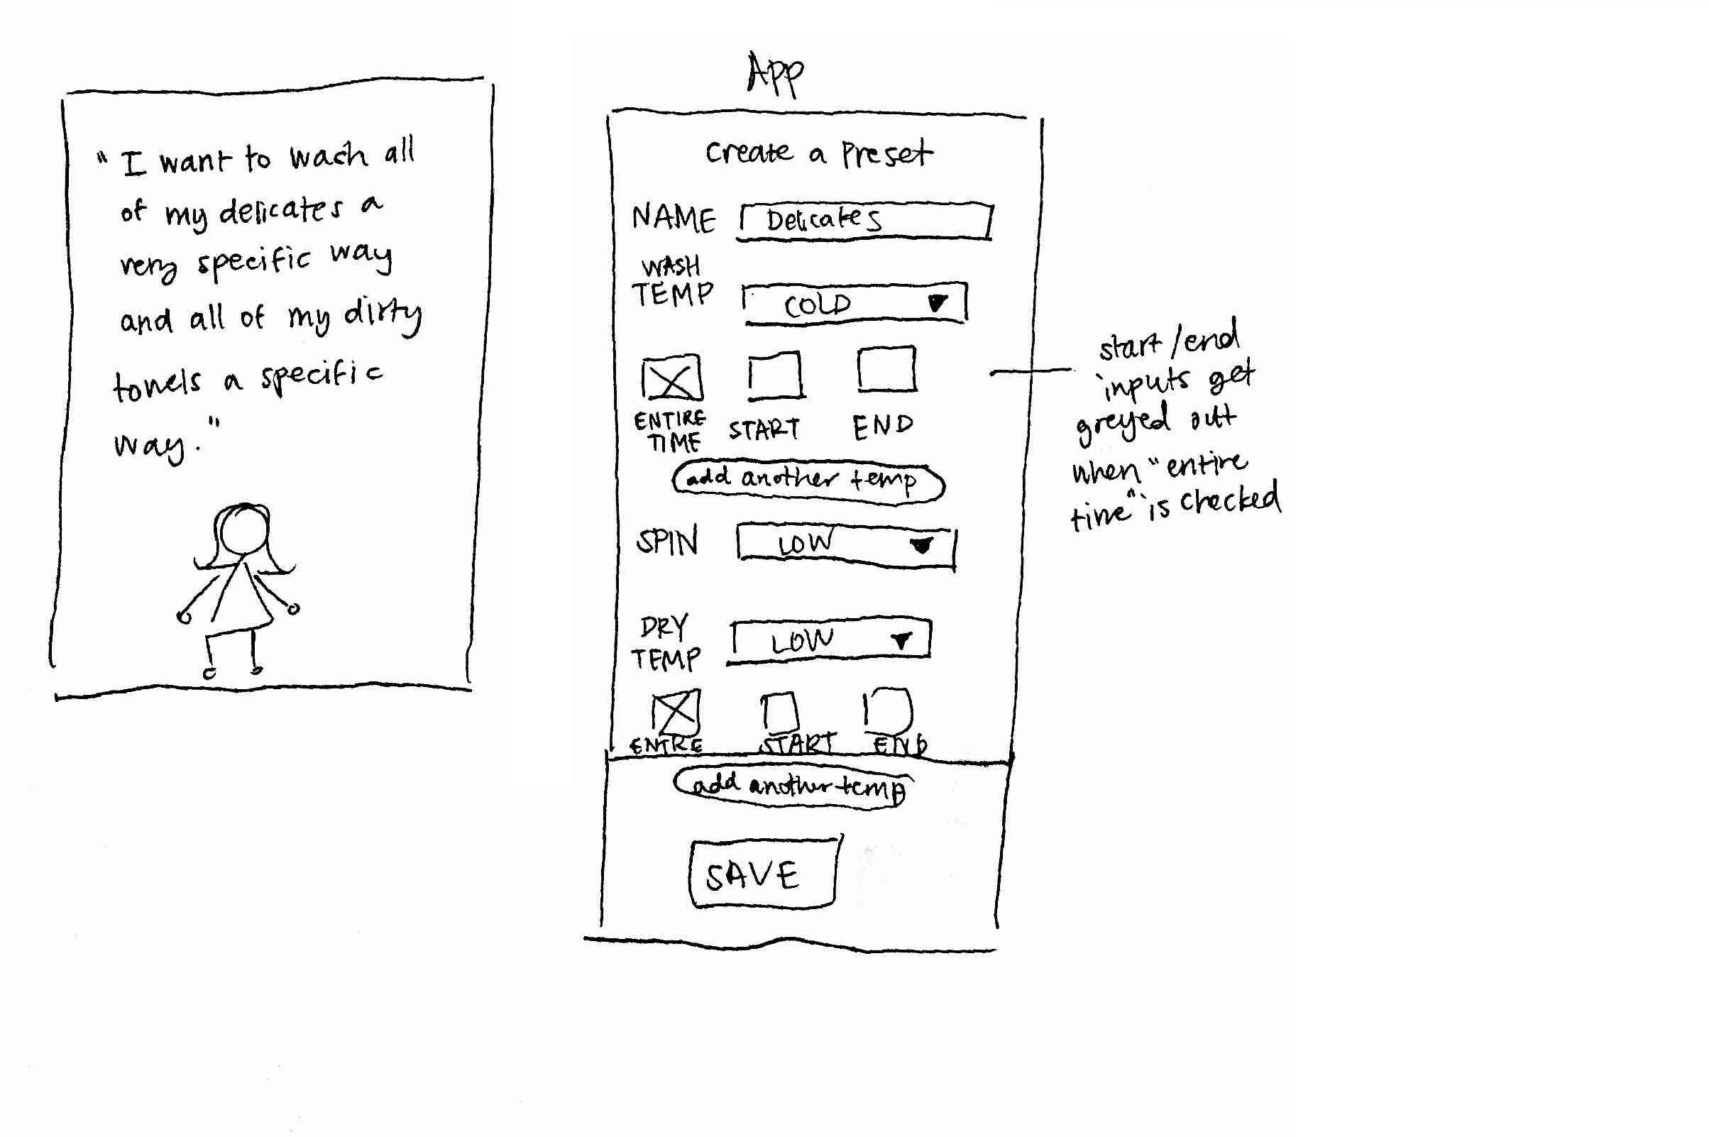

**fig 5: Scenario 2 - Task of creating a preset**

* The scenario starts with a user who knows what specific settings he/she wants to wash things depending on what is included in the load of laundry and wants an easy way to keep all of her customized settings saved.
* She goes to the option to create a preset and indicates the desired settings

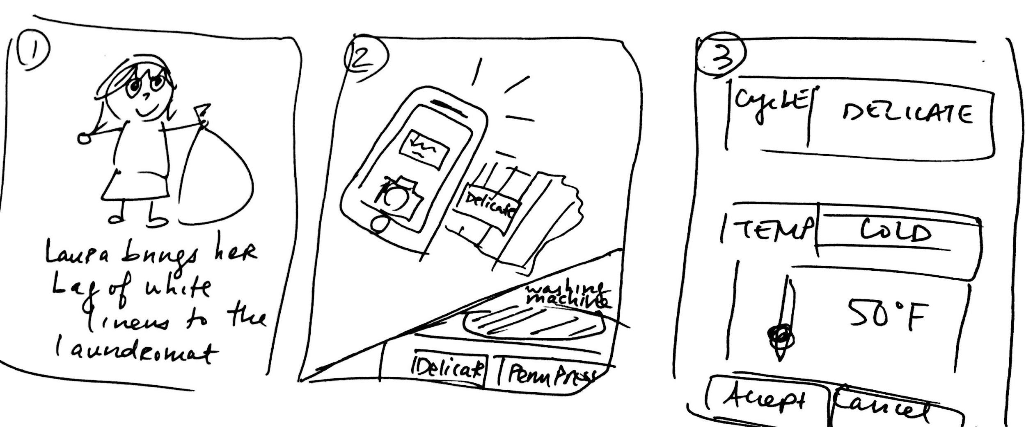

**fig 6: Scenario 6- Task of changing laundry settings**

* Laura brings a bag of white linens to her nearby laundromat’s washing machine and scans the tag of one of the linens using her phone camera (**fig 6-2**) to get a set of suggested settings that correspond to the washing machine’s settings. The washing machine brings up a set of suggested settings after the image has been scanned (**fig 6-2, fig 2**), and Laura chooses to use the suggested agitation level and adjusts the suggested temperature settings to be a little colder. She hits accept and then pays (the first screen in the second row of **fig 1**) to begin her laundry load.

**Competitive Analysis**

1. **UM Laundry** (<https://itunes.apple.com/us/app/um-laundry/id455514358?mt=8>)
   1. Target User Group: College students living in the dorms; this is a much more specific audience than we are hoping to target (i.e. people who use laundromat laundry machines, be they students or non-students).
   2. Functionality: This app allows the user to view washers and dryers in each of several buildings, filter machines by available versus in-use, favorite certain laundry rooms, and set washer and dryer reminders; ours will include these features and other improvements, such as the machine-locking feature, location of and price comparison between nearby laundromats, and the ability to ping other users when their laundry is complete.
   3. Usability: The app is extremely bare-bones, with most of the screens composed of lists (i.e. of buildings, then rooms with each building, then machines in each room), but has few bugs and accomplishes its task well. Our app’s design will be more visually appealing, as well as be more complex to handle additional features.
2. **Laundry Alert** (<https://www.laundryalert.com/cgi-bin/selu3999/LMPage>)
   1. Target User Group: Also college students living in the dorms; again, we plan to people who use laundry machines in public laundromats, not including dorm or apartment laundry machines.
   2. Functionality: This app shows the user the number of available washers and dryers in dorms of certain colleges, allows them to track machines that are in use, and sends the user a reminder when their laundry is complete; ours will improve this by allowing not only viewing but also booking of available machines, as well as allowing the user to browse for available machines in other locations.
   3. Usability: The app is extremely buggy and crashes frequently; the UI is difficult to navigate, with repetitive and annoying pop-up dialogues and an unintuitive layout; we aim for our app to be stable and functional, while also providing a more navigable and aesthetically pleasing UI.
3. **Laundry** (https://itunes.apple.com/us/app/laundry-timer/id617833877?mt=8)
   1. Target User Group: Anyone that needs to time their laundry; our app has a more specific user group.
   2. Functionality: This app has a narrow scope and only allows the user to manually set times for washer and dryer timers; our app will improve on the timer by automatically setting the correct time in accordance with the machine’s settings, as well as providing many more features.
   3. Usability: This app is not very convenient to use if the user is in a hurry, since they have to manually select machine type as well as time, and also requires an in-app payment to set more than one timer, while our app will help the user by automatically setting timer and machine type and also providing free services.
4. **LG Smart Laundry & DW** (https://play.google.com/store/apps/details?id=com.lg.apps.lglaundry&hl=en)
   1. Target User Group: Owners of the LG smart laundry and dryer machines; our app targets those who use laundry machines outside of the home.
   2. Functionality: The app allows users to start and monitor laundry cycles, diagnose problems with their machine and view general laundry tips; our app will not cover the second feature since it is not intended for use by machine owners, but will instead include security features that would help public laundromat users, such as auto-locking the machine and requiring a phone password to be entered to unlock it.
   3. Usability: Most reviewers complained about the smart diagnosis not working or the app crashing; we aim for our app to be stable and functional and recover gracefully from crashes.
5. **Circuit** (https://play.google.com/store/apps/details?id=com.greenwald.circuit&hl=en)
   1. Target User Group: Users of Circuit laundrette systems; we target a similar audience (aka users of a certain smart-laundry system).
   2. Functionality: The app allows users to select laundering options, pay from a Circuit account via their phone, and receive alerts when their laundry is done; our app will improve on the paying feature by allowing users to price-compare between different nearby laundromats, as well as show users which and how many machines are open.
   3. Usability: The most frequent complaint about the app was the inability to register an account or login, as well as the inconvenience of doing so to use the app; our app will improve on this by not requiring the user to create an account or login.

**Conclusion**

Many of the features our app will provide (e.g. laundry timer/alert system, finding available machines) are already implemented by other apps. However, no app we have found so far ties together all these features. In addition, we have found no apps that provide a machine-locking phone-unlocking laundry system, booking of machines, and/or price comparison. Competitor apps mainly cater to owners of smart laundry machines or college students; our app will provide unique value to its target users, people who use public laundromats, by helping them save time on laundry by easily locating the cheapest available machines and securing their laundry, leaving them free to leave the laundromat.