READ ME:

**Data Sources**

Our **Data Sources** include individual instances from **Yelp, Google reviews,**

**individual restaurant websites, and Google maps.**

**Inserting data from Excel to SQL Server**

1. Open SQL Server Management Studio and connect to your SQL Server database.

2. Expand the Databases and the Tables folders for the table where you would like to insert your data from Excel.

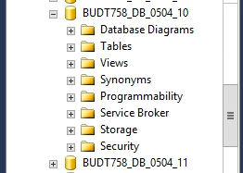

3. Right-click the table and select the fourth option – Edit Top 200 Rows.

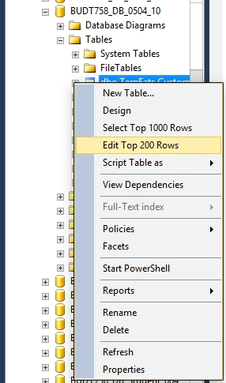

4. Switch to Excel and select the rows and columns to insert from Excel to SQL Server.

Right-click the selected cells and select Copy.

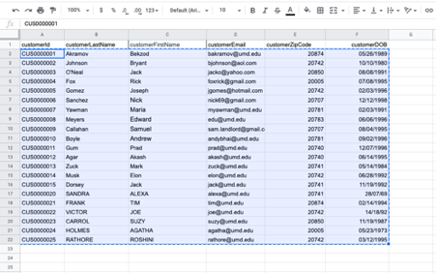

5. Switch back to SQL Server Management Studio and scroll down to the last row at the bottom and locate the row with a star in the left-most column.

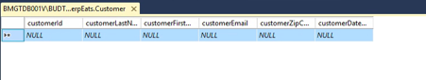

6. Right click the star in the column header and select Paste.

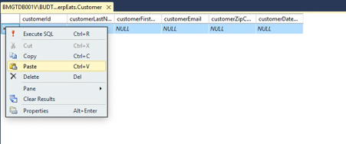

**Business Transaction 1:**

**Sheet 1** answers the Business Transaction **‘What are the names of the restaurants ranked by their average rating and the number of reviews?’**

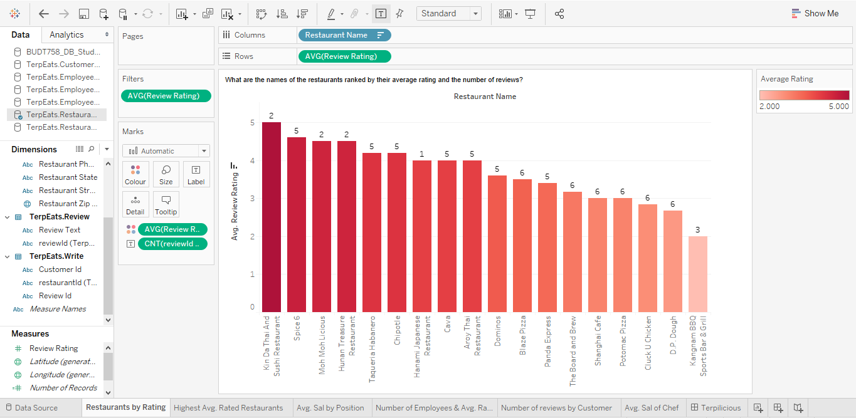

**Business Transaction 2:**

**Sheet 2** answers the Business Transaction **‘Which locations offers the restaurants with the highest average ratings?’**

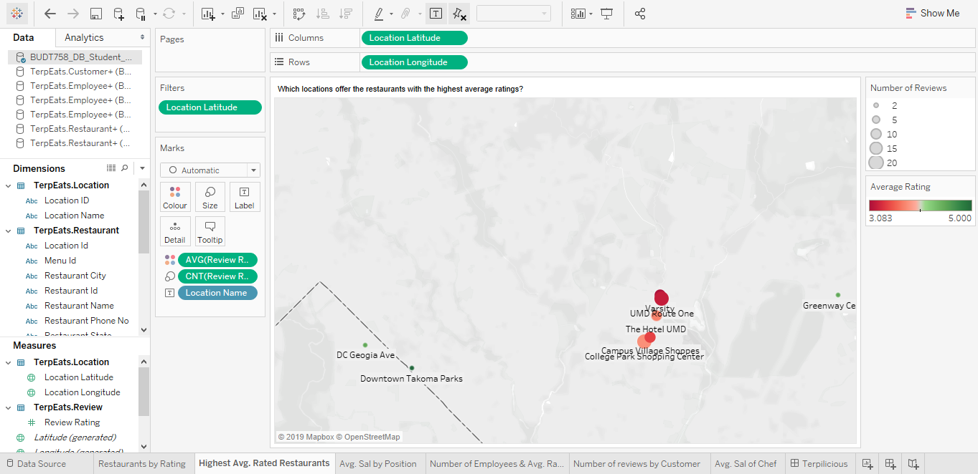

**Business Transaction 3:**

**Sheet 3** answers the Business Transaction **‘What is the average salary of employees by employee position?’**

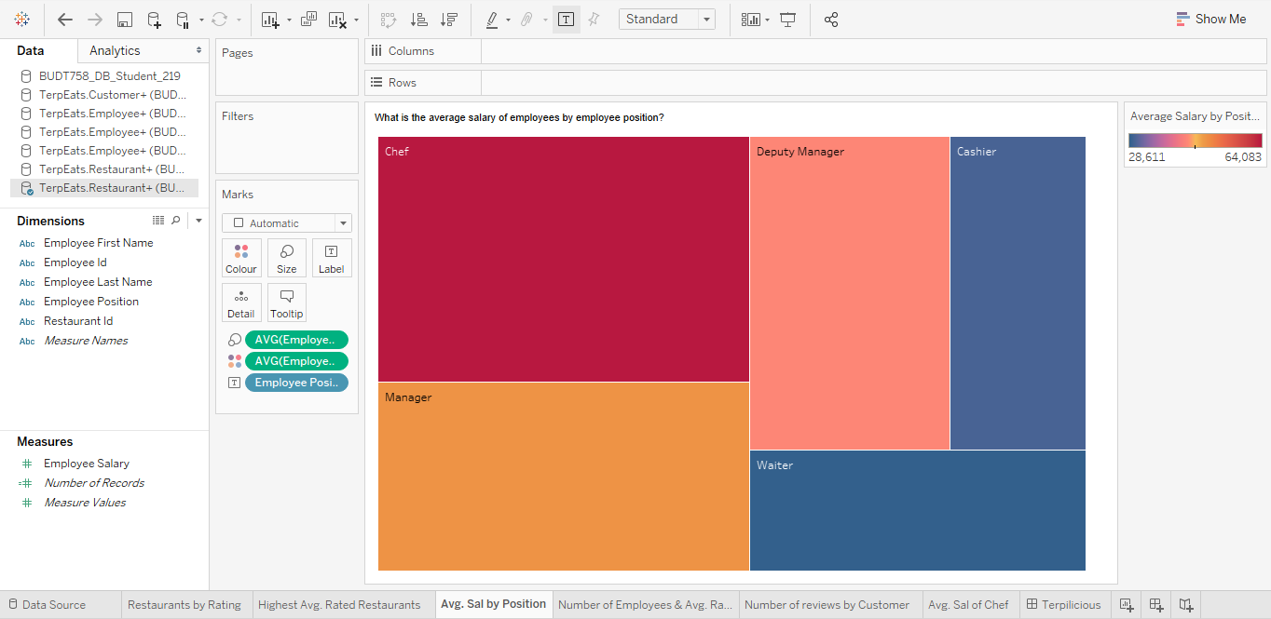

**Business Transaction 4:**

**Sheet 4** answers the Business Transaction **‘What are the number of employees and the average rating of restaurants?’**

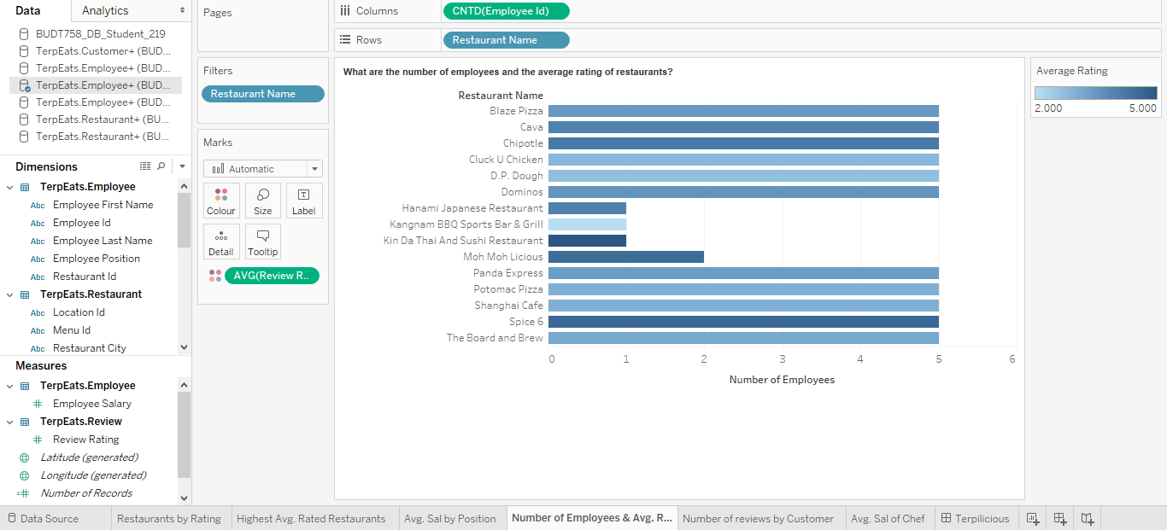

**Business Transaction 5:**

**Sheet 5** answers the Business Transaction **‘Which customers have written the most reviews?’**

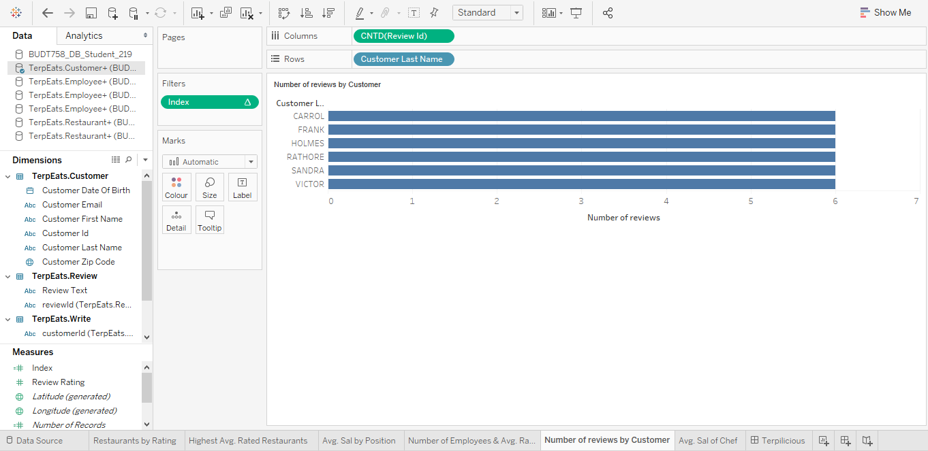

**Business Transaction 6:**

**Sheet 6** answers the Business Transaction **‘What is the average salary of Chefs at restaurants which have average ratings greater than 3?’**

