**Core Java**

**Java Features**

|  |  |
| --- | --- |
| **Arrays** | **List** |
| Arrays are not dynamic, fixed sized | List is dynamic |
| Homogenous values only we can store (Int),or any single type values | Hertogenous values we can store (Ex : String,Int,Float,Object) |
| We don’t have implementations from java | Java having implementation |
|  | List maintains the insertion order |
| Good for the searching | Good for searching elements |

**10,20,30,40**

**[10,20,30,40] --insertion order maintaining**

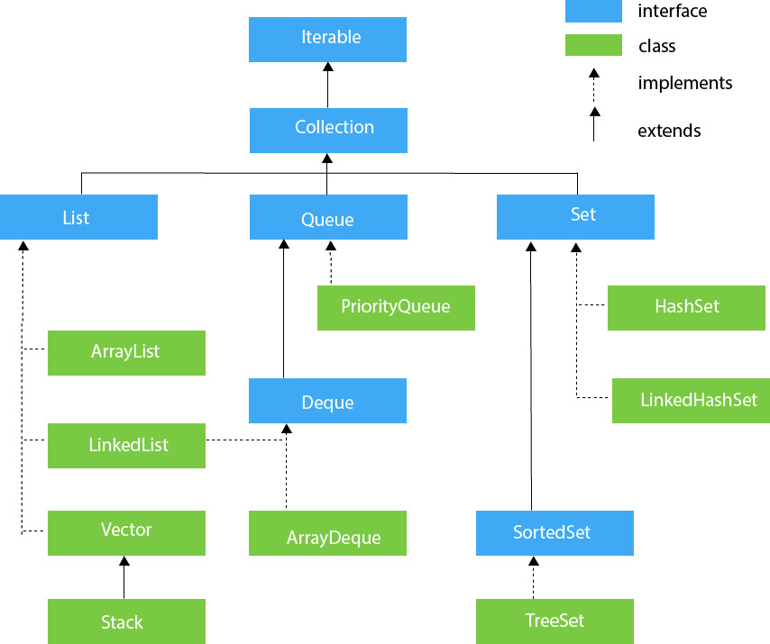

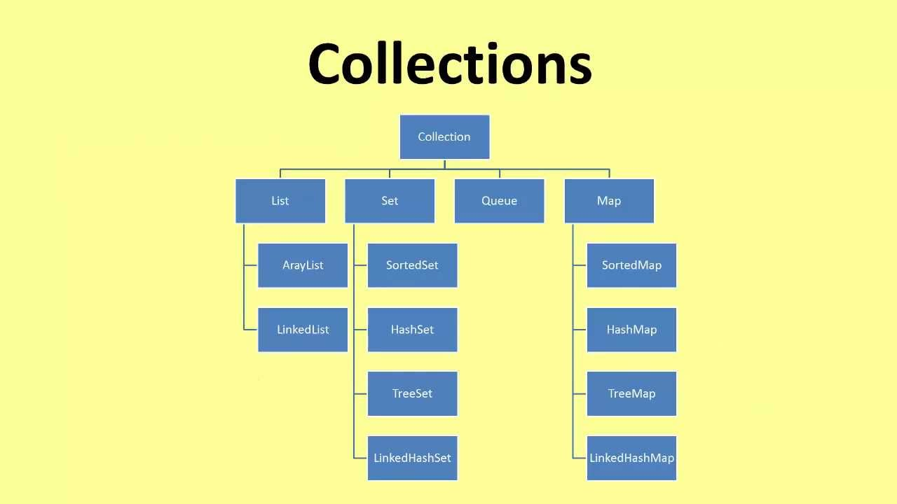

**Collections**

**Array --store as index ArrayList --preserves the insertion order ,internal works as arrays onlyLinkedList --store node address of the other values Iterator --cursors hasNext() and next()ListIterator --can modify concurrrentlyEnumeration**

**Vector //difference data structurs**

**Vector ArrayList LinkedList difference**

**HashMap --store in the key and value pair**

**Hashtable --does not allow duplicate key and vaues ,and this is legacy and scnchronizedLinkedHashMap -- stores internally as next node address TreeMap --dont allow the null key ,null values can be thereHashSet -- duplicat value are not allowed in the set ,dosent preserve the insertion order LinkedHashSet -- when the inserion is needs to maintain then we can gor for the this TreeSet --duplicate values are not allowed ,sorted and ascending order Comparable --compareTo ()Comparator --compare(); SpliteratorPriorityQueuePriorityBlockingQueueArrayBlockingQueueLinkedTransferQueueCopyOnWriteArrayListCopyOnWriteArraySet**

**For the sorting purpose on the arrays we can use the Arrays.sort() the Arrays class to use the method for common purpose**

**For the other data structure we can use the Collections class for the common util method**

**Difference between the collection and Collections**

**What it the base interface for the collection interface**

**Cursors for iterating the values on the data structure**

**Iterator -> we go forward direction only -- remove()**

**Enumeration 🡪 we can vectors ,legacy types**

**List Iterator 🡪 we can bi direction forward backward –adding elements and backward direct**

|  |  |  |
| --- | --- | --- |
| **Iterator** | **List Iterator** | **Enumerations** |
| **Can be forward direction** | **Forword and backward direcetion** | **Forward direction** |
| **1.4** | **1.4** | **1.2** |
| **Cannot add new elements** | **Can add new elements** | **Cannot modify** |
| **Remove** | **Remove** |  |

**Generics**