**Adding “New” Bins on Terminal:**

1. Copy “New” Bins to your directory.
2. Open ESCONNECT Location with Winscp” Application. Example: 156.24.63.114 ricie/@Ricie08

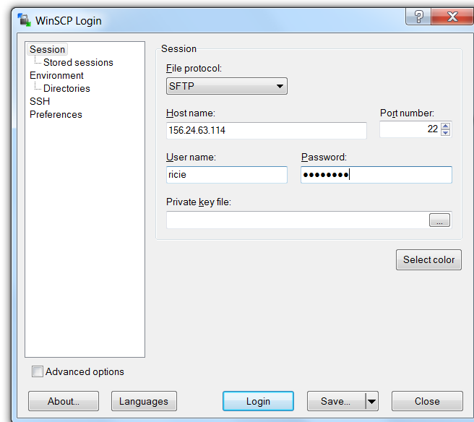

1. Go to the following location “/usr/local/gtech/eseries/esconnect3.9/dls.root/config”.
2. Click on either Terminal Folder (Altura, AlturaC, Gemini)

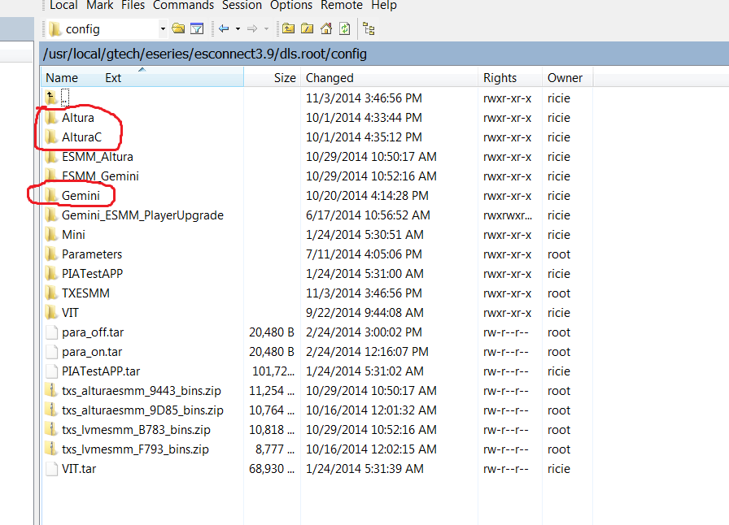

1. Add your “New” Bin Folder and replace “acl.bin” and “smex.bin” with the one inside the Bin Folder.

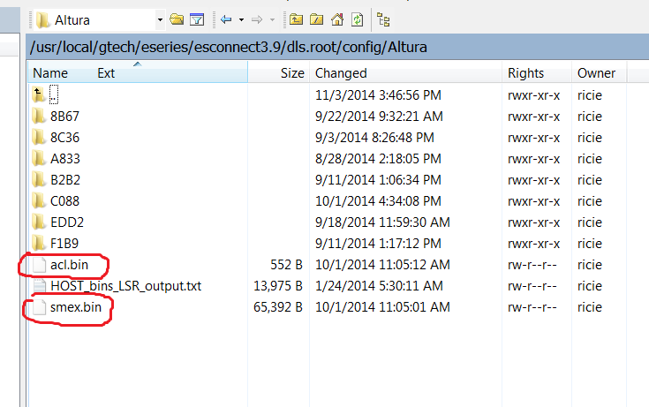

1. Go to “ESConnect Admin” (Dashboard).
2. Select “Terminal Information” Option under “Communications”.
3. Now select “Create New Configuration” under “Application Configuration”.

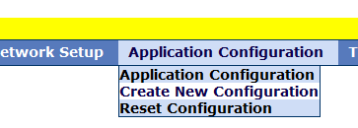

1. Hit “Submit” to submit the “New” Bin’s.
2. Now select “Reset Configuration” under “Application Configuration”.

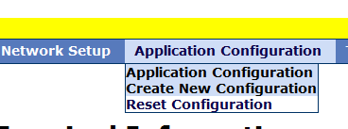

1. Submit the following down below.

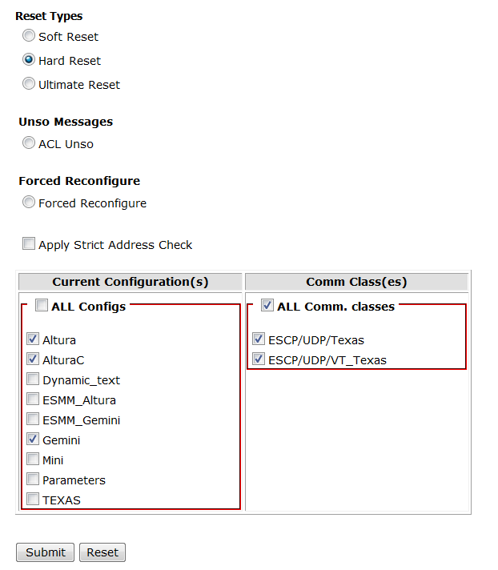

1. Downloading of the “New” Bins is going to take a while for each Terminal.