Go to CAT dashboard

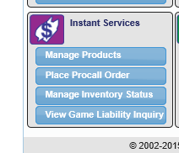 >> Manage Inventory Status

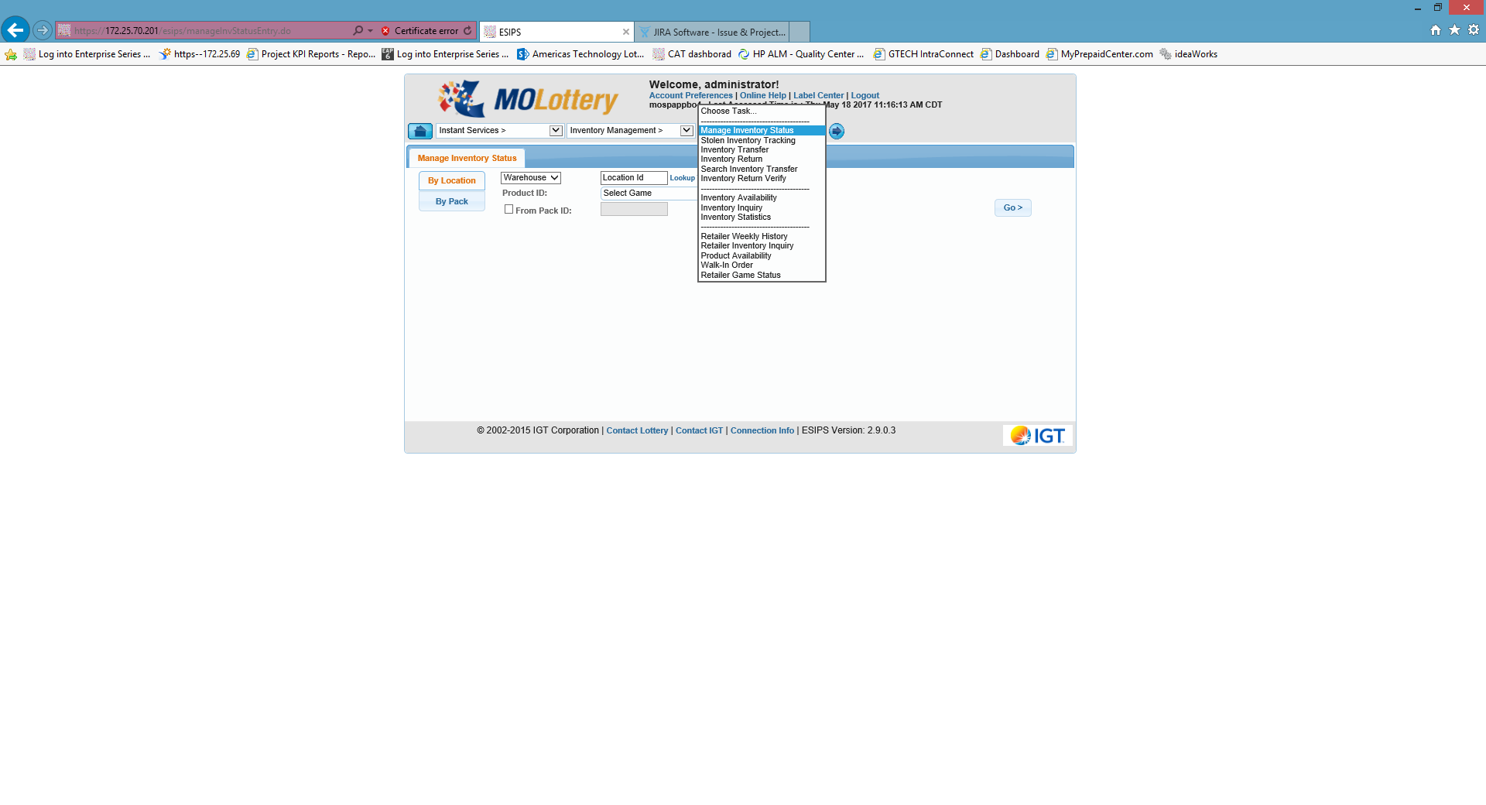

>> Walk-in order

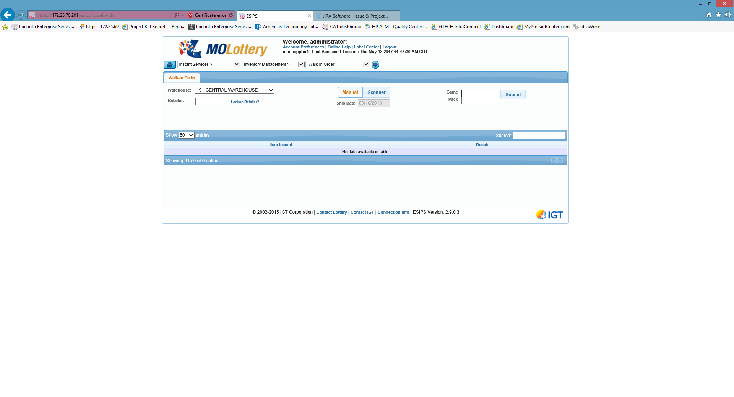

>> Make it Manual

>>Enter Retailer id,

>>Game and pack number

Go to: (Check the status of assigned pack)



>>Retailer Inventory Inquiry

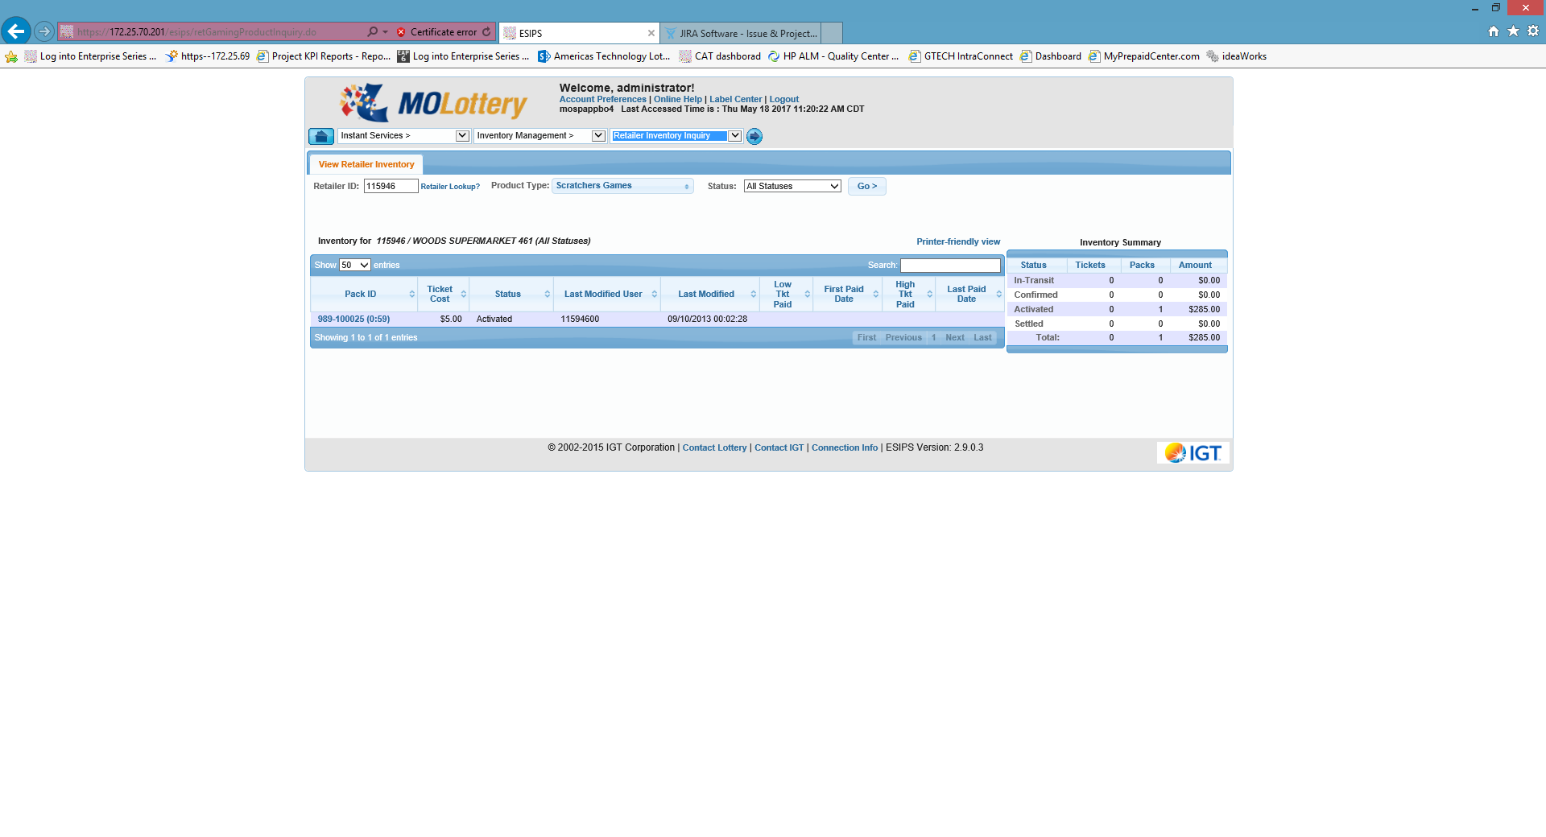

>>You will see if its assigned

Now go to attached terminal and activate the pack.