

**QA Checklist**

**How to Day-End & Run ETL**

**Revision 1.0**

### 29-Mar-2017

This item is the property of GTECH Corporation, West Greenwich, Rhode Island, and contains confidential and trade secret information. It may not be transferred from the custody or control of GTECH except as authorized in writing by an officer of GTECH. Neither this item nor the information it contains can be used, transferred, and reproduced, published, or disclosed, in whole or in part, and directly or indirectly, except as expressly authorized by an officer of GTECH, pursuant to written agreement.

Copyright © 2017 GTECH Corporation. All rights reserved.

**How to Day-End**

**How to run ETL process**

**Step 1:**

As we bring up the system and we opened these 4 putty windows;

**HOW:** login with your credentials, select 10-OLTP menu. You will find all three options.

(gxvision, mxvision, ewatch)

In Day-End process, these windows help to assure we are day-ending right.

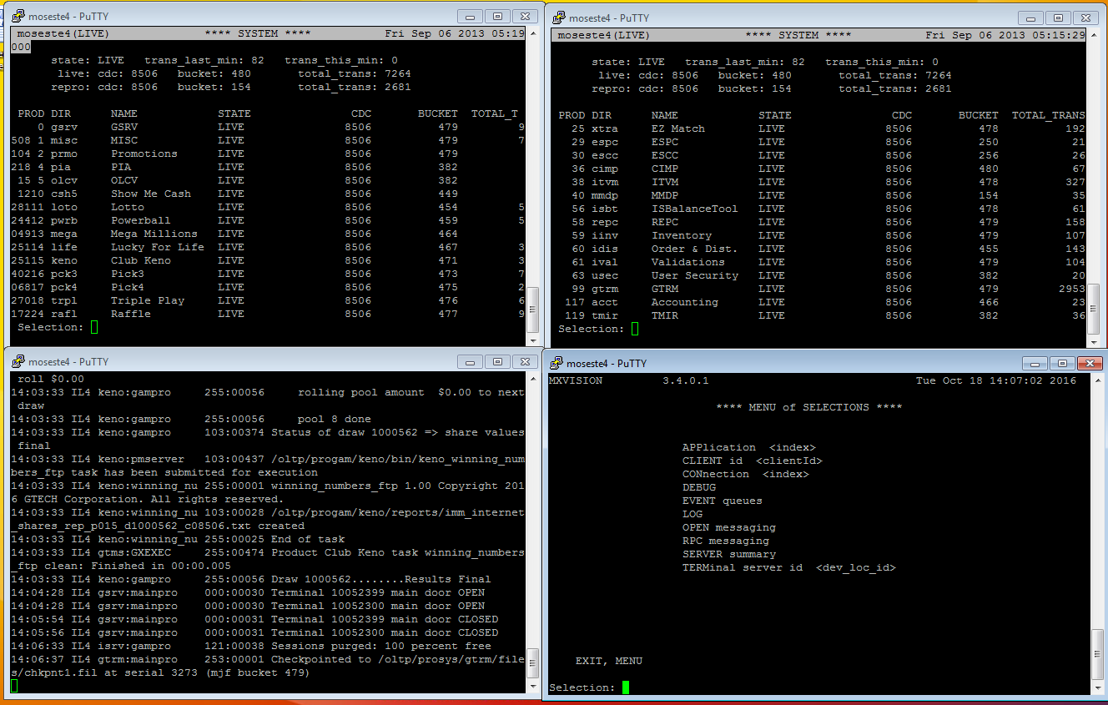

We need to keep them on throughout the day till you go home at the end of the day

**Step 2: DAY-END**

**Adjust time to >> 23:40:00 (when resetting Gemini)**

**23:58:00**

**01:51:00 (Last keno draw>> this needs to run at any cost)**

**Step 3: Login to CAT dashboard:**

**Use your Credentials**

**You can also use default: Administrator/welcome (Emergency use)**

**Step 4:** OLPM>>System activity Monitor>>ESTE Progress Monitor

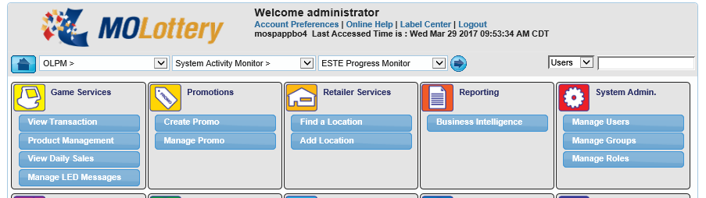

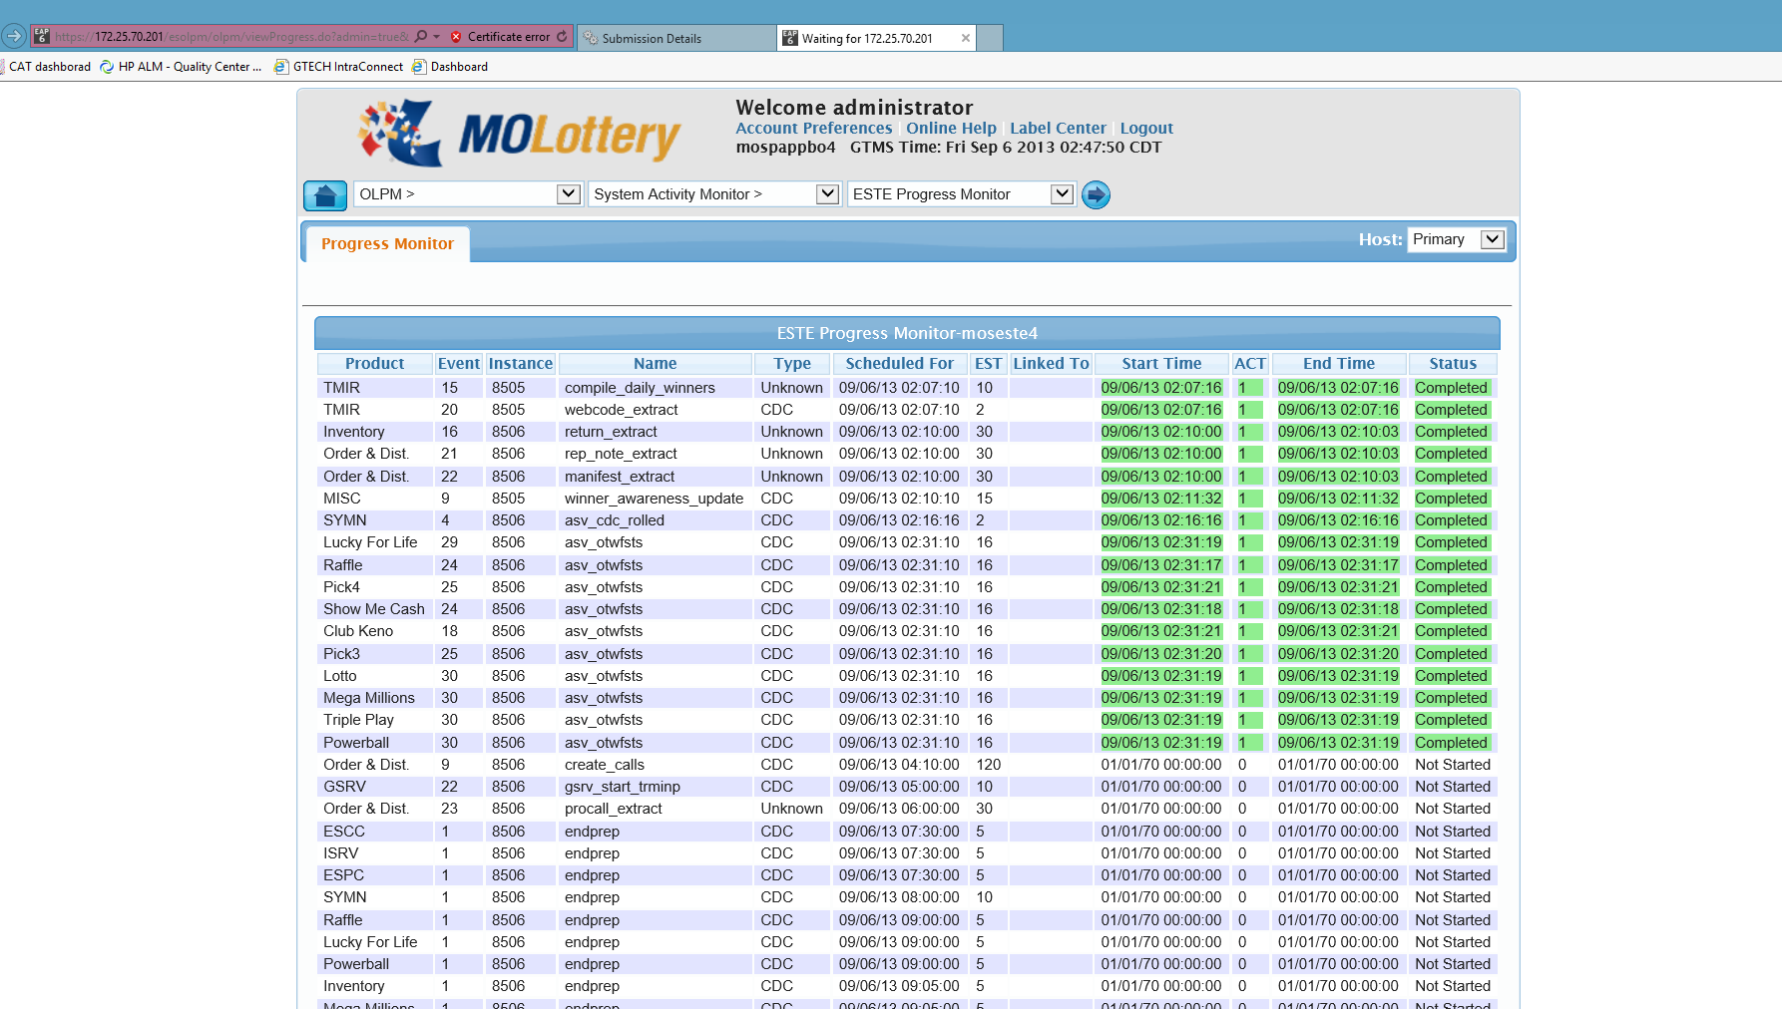You need to wait till the files run and make sure all the files are completing without fail.

**Step 5:** You also need to make sure that you check this Cruise Control checkbox in order to refresh the system activity monitor every 5 seconds

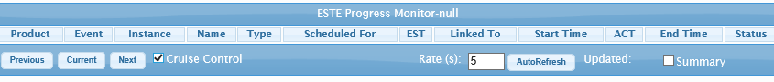

**Step 6:**

Now Go to remote desktop>>**computer: mosutl3**>>connect

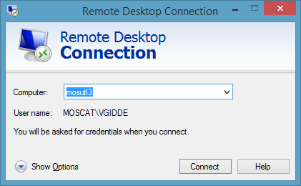

**Username:** **MOSCAT/vgidde**

**Password:** **myfairyWorld1!**

(You will use your credentials)

**Step 7:**

Start Mozilla Firefox

Address bar: Open this link : http:\\ mosesoa3\#

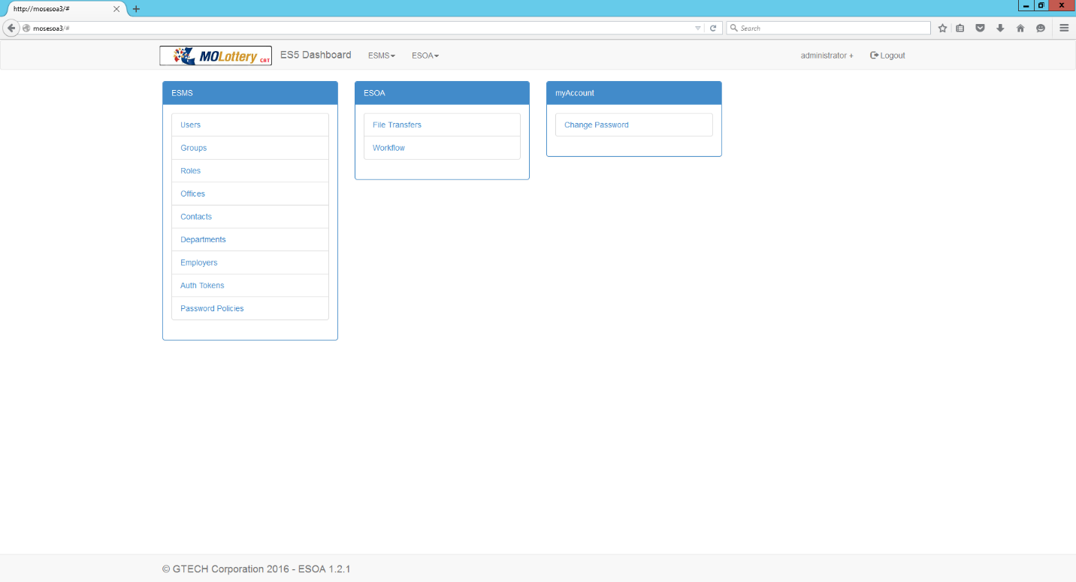Enter

**Step 8:**

ESOA >> workflow

You need to wait till **2:16** to let the day-end happen. This will run all the required files on the host.

Now Adjust time to **2:32:00**

(This will run OTWF file which is the last file to run. Verify that it will be completed on ESTE progress monitor in CAT Dashboard.)

**Step 9:**

Keep an eye on Activities: make sure everything is finished

Adjust time to 3:00

File clean up happens at 3:01

Monitoring tool: make sure file clean-up is completed

Now Adjust time to **4:08,** this will run order & dist file. (to create calls)

You are done for day ending here, this will take 15-20mins approx.

When rolling the day:

Remember to roll it to 4:55 and let it pass 5 o’ clock that’s when system is back up.

After this you can run ETL

**HOW:**

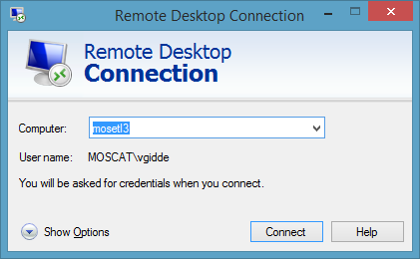

**Step 10:**

Now Go to remote desktop>>**computer: mosetl3**>>connect

**Username:** **MOSCAT/vgidde**

**Password:** **myfairyWorld1!**

(You will use your credentials)

**Step 11:**

**Open** Internet Explorer :

open link in explorer >> <http://mosrdsc3:9080/ibm/iis/ds/console/login.html>

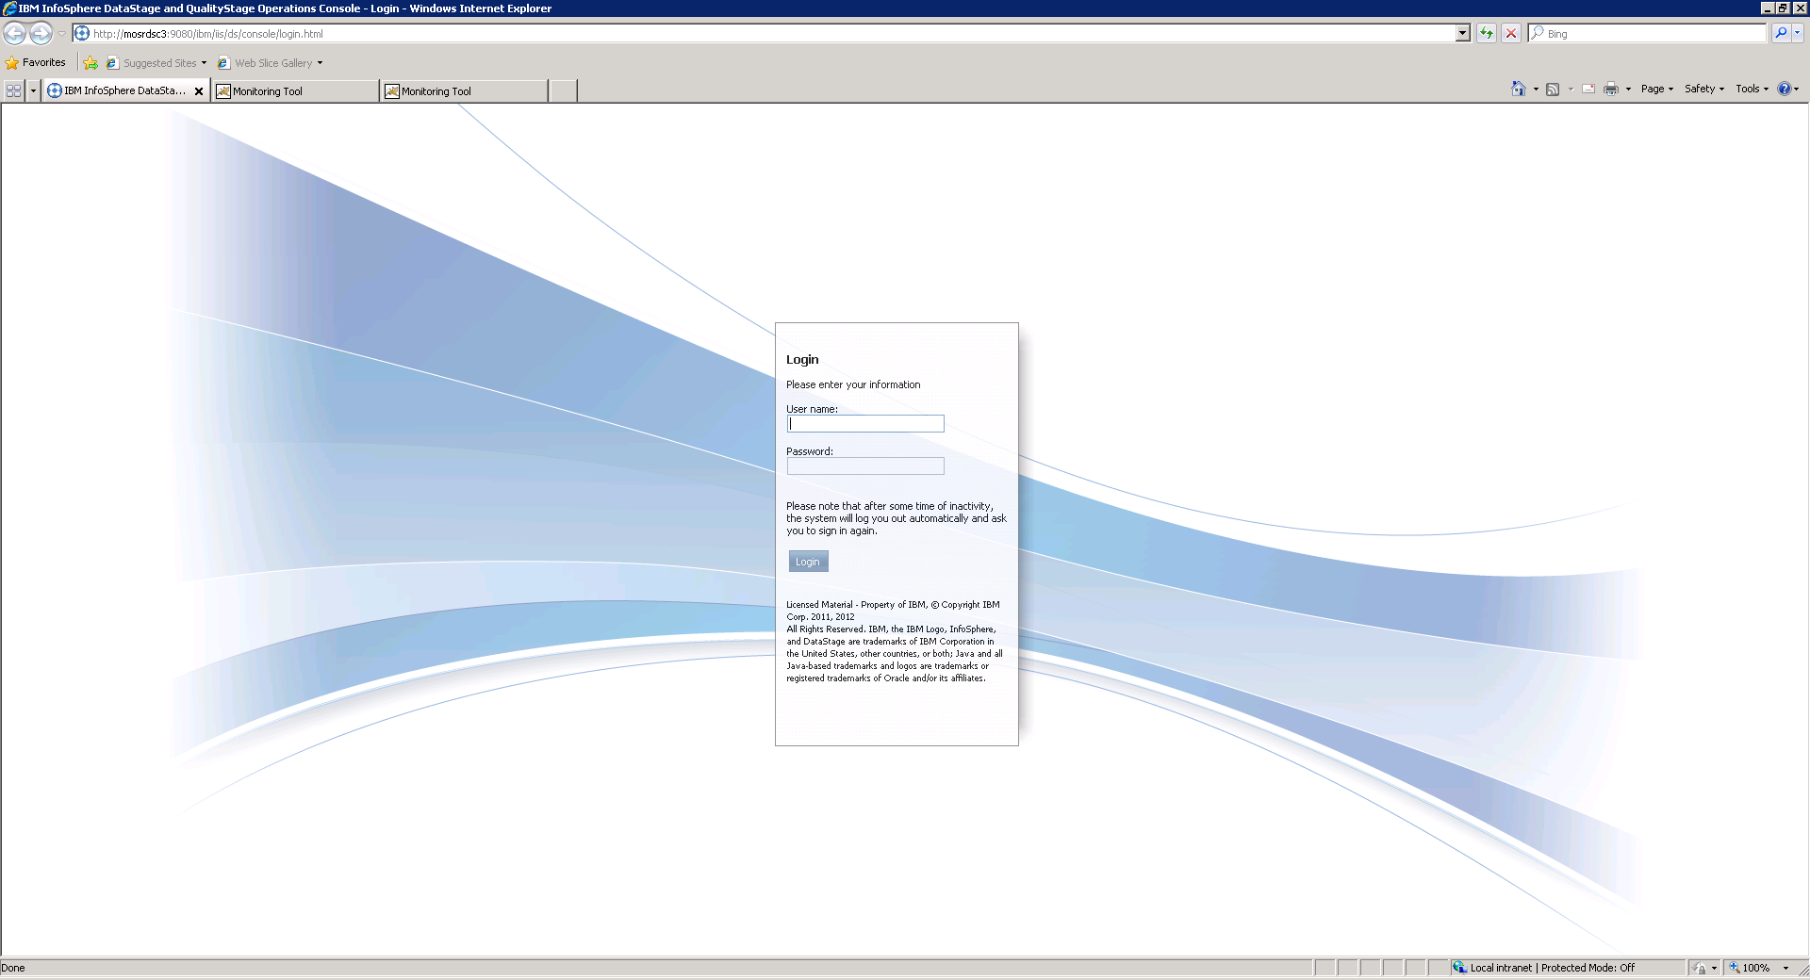You will see this window

Login as

Dsadm / Dsadm2015

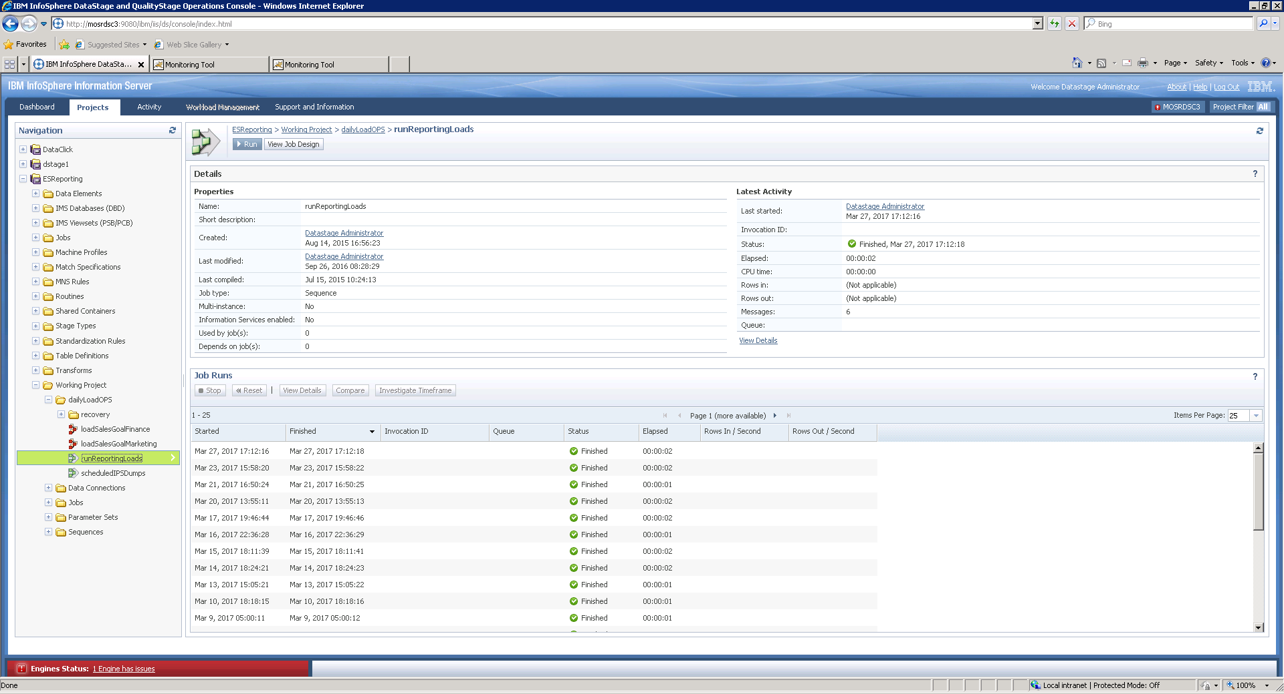

**Step 12:**

ESReporting>>Working projects>>DailyLoadsOPS>>runReportingLoads

Click on Run

**Step 13:**

Go to Options >> uncheck the check box “Abort job after”

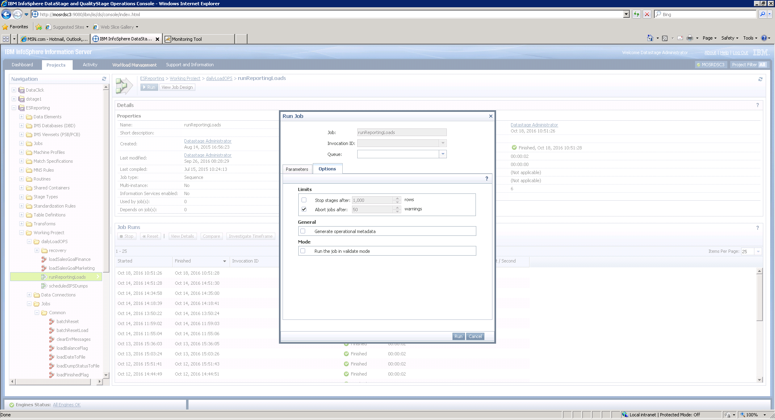

>>Click Run

**Step 14:** open another link in explorer >> <http://mospappbo4:8080/loadmonitor/>

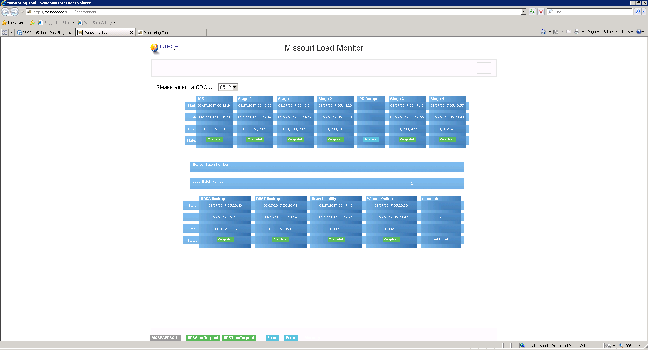Make sure all the reports get completed successfully.

**Step 15:**

Now go to Activities

(It’s on the same page where you run your daily loads)

Make items per page as 100

If everything says completed/finish

You are good to go

This ETL running process takes 20 mins approx..

