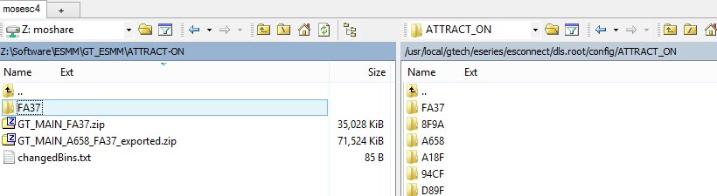

Revert back ESMM:

Whenever you forget to write down the segments, you need to do the broadcast all over again.

For that, you have to first revert the bins back to production, broadcast those and then re broadcast the new files again.

Ex: you have to go to ESCONNECT putty, 21, select the new bins which you had messed up :P, select the 2nd option in 21. Go to esconnect, app details, submit modified .

Application: broadcast configuration , chk broadcast status.