**Terminal Release**

Get all the bin versions from wiki.

Download each terminal type bin in the respected folder in shared drive.

Software>> Terminal>> Terminal type>>create new folder containing the bin version>>

Extract the zip files there.

Open winscp, copy the bin folders in below mentioned path.

Repeat for each terminal type.

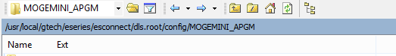

Now go to Esconnect server on putty

Go to menu 21

Activate the bins for each terminal type.

Go to Esconnect on CAT Dashboard

Application >> Available application >> modified/pending>> Submit

(Here you can cross check whether the bin files have successfully been updated and activated on the server)

Broadcast the bin version: