**Following are JIRA courses which I have taken indiviually.**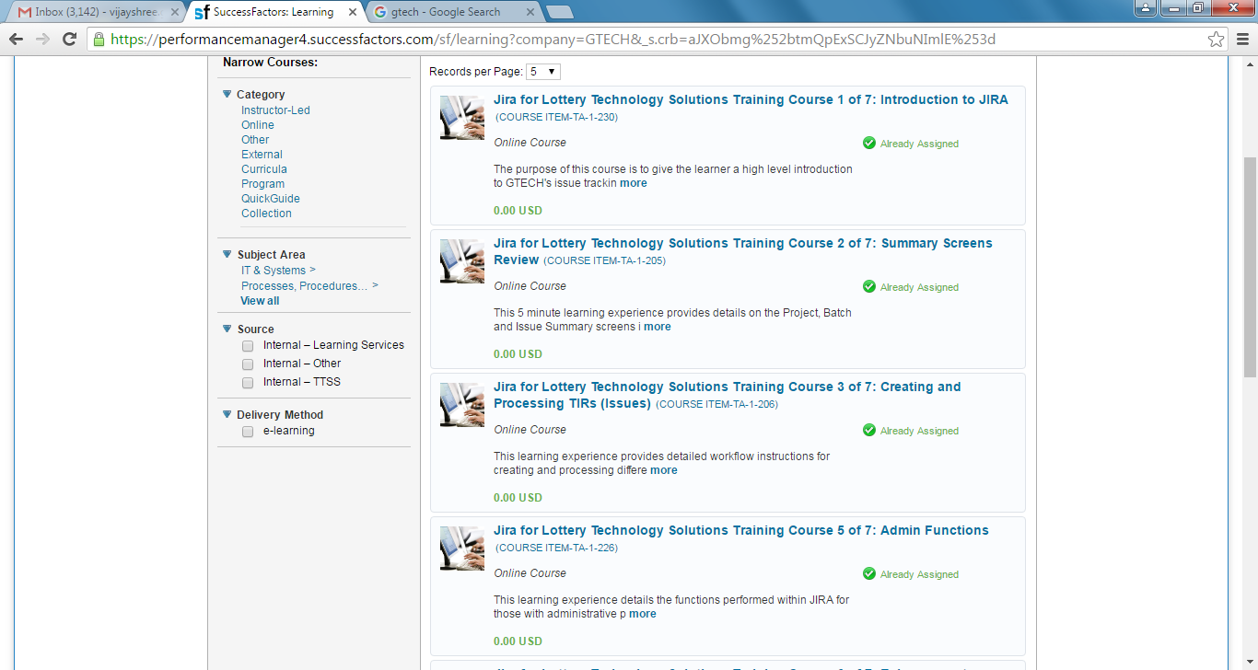

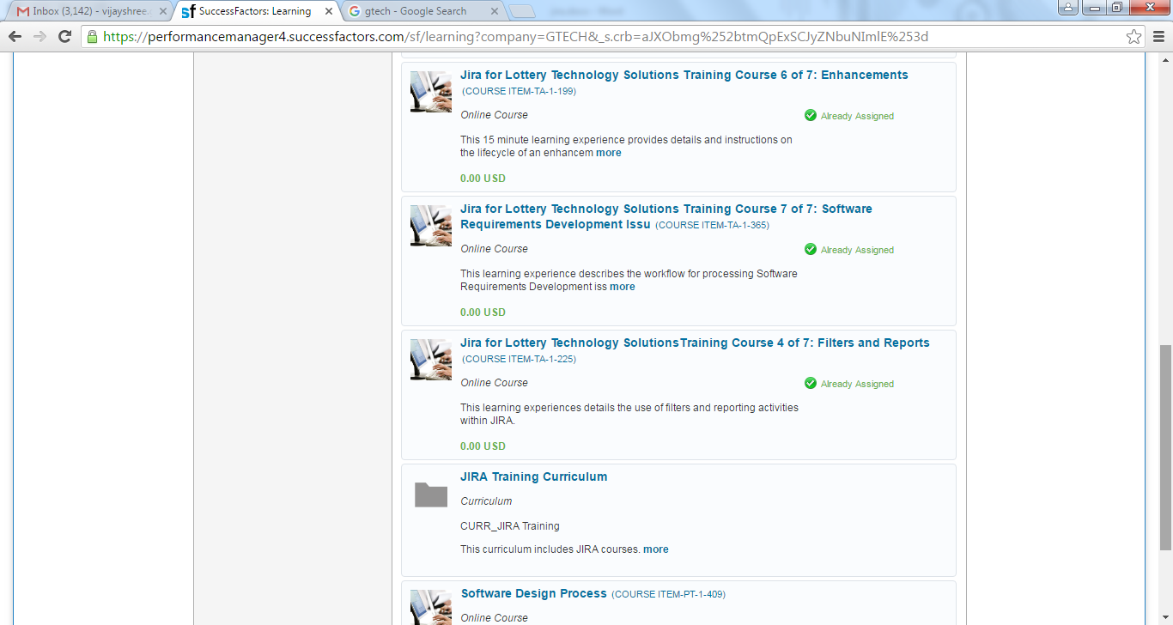

Looking up the history of completed work,

It is showing only 3 among 7 courses.

I am unsure whether it happened because I did not disable the pop up blocker or I used other browser (chrome) in between.

P.S: course’s duration ranges between 9-25mins max and I have not skipped any from my end.

