EasyLipi: an Online Sketch Recognition Based
Devanagiri Learning Tool for Android

Shreyas Vinayakumar
Texas A&M University
College Station, Texas
vshreyas@tamu.edu
Raj Shah
Texas A&M University
College Station, Texas
helloraj90@yahoo.co.in

Abstract— We have developed an application which allows the user to learn to write Hindi quickly by practicing drawing letters on the screen. Our system, which can run on an Android device, uses a handwriting recognition module to find out what letter the user has entered. The recognizer is based on a simple template matching technique followed by a domain specific procedure to distinguish between similar characters. The recognition module was able to recognize 75% of the drawn templates; further improvement is possible through additional tests to distinguish similar characters. We have also implemented word level recognition as a part of our learning system. This is achieved through comparison with a dictionary. The user interface was evaluated and found to be effective in terms of usability and feedback for accelerating learning.
Keywords—online handwriting recognition;Devanagiri; OCR; learning tools

Introduction
Hindi and Gujarati are Indian languages in use by a lot of people from India. Hindi is based on the Devanagari script which has about 47 letters and 11 modifier and diacritical marks. Devanagari script can be used to learn Hindi, Sanskrit and Nepali languages. Gujarati is closely related to Hindi and one can be learned very easily if one knows the other one. Unfortunately, most of the learning tools for these languages are limited in that they require the user to use a computer and they don’t give a very good writing practice. We wanted to create an Android app that would teach English speakers how to read and write in these languages using a mobile device. Our approach is to show the user Hindi letters and ask them to replicate them in order that they might learn to write proficiently in Devanagiri script at the alphabet level.

In order to be effective, our system needs to have a high rate of recognition. Otherwise, the user will be frustrated as he will perceive his rendering as correct but the system classifies it as another character. Unfortunately, this is not a trivial problem. While recognition of Roman characters is a well-researched area, Devanagiri characters pose a different set of challenges which have not yet been solved. For example, a line in the script can be divided into 3 regions, upper, lower and main central where the symbols may appear. In an environment like a phone screen, this spatially relationship is weakly maintained. Another issue is that
Devanagiri characters can be joined together when two consecutive consonants appear. In order to simplify our recognition process we have assumed only whole characters to be learnt by the user. While the script is read from left to right, the spatial location of the strokes may not follow this order. For example, some of the matras(vowel sound modifiers) start after the character body and end before it. We have circumvented the above problems by provided an intuitive way for the user to indicate the end of a letter/stroke.

Another feature of our system is that it displays words for the user to practice from. While displaying letters is the conventional approach, we feel that it will aid learning much better to recall at the word level. It will break the monotony and help the user to concentrate on the characters he got wrong. The system could display feedback such as advice when the user gets confused between two similar words.

RELATED WORK
Offline Devanagiri recognition has been the subject of many studies[ (Bansal, 1995), (Sinha, 1999), (Chaudhary, 1999). While this is a well-covered area, we felt that using merely offline data would not be appropriate in this case as the drawing is expected to be on a phone screen with a small writing area, forcing the user to budget his letters appropriately and resulting in poor spatial qualities. Using the temporal data at least for distinguishing one letter from another seems wiser choice.
Online techniques for recognition have been devised and implemented for both individual characters (Kumar, 2008)and for the unconstrained case[Donnell ‘00]. We are more interested in the former, as we have made several simplifying assumptions using our unique interface.
While earlier methods[Kumar ‘08] relied on sophisticated techniques such as HMM, they were primarily aimed at high end devices such as the iPhone. By targeting the generic Android device we are looking at potentially much more space constrained devices.
Jain et al.[Jain ‘07] have implemented a simple recognizer for individual Bangla characters. They report a high level of accuracy using templatesto classify with minimal memory and code footprint. Rather than using the same technique, we have opted to go for a more customizable approach. Our approach takes advantage of the geometric template based technique but uses the score output to determine whether an additional test is to be performed in order to distinguish each character from its similarity class.
Template based approaches to classifying multi-stroke gestures include geometric, vision based and perception based[Trier ‘96]. We are more interested in the geometric based techniques. Our goal is that we not constrain the user in any way with regards to the number and order of appearance of the strokes. However, temporal data is still used in the form of sequencing the points. This can be achieved through multiple templates for the ordering, and treating it as a sequence of points for the number of strokes. Additionally, the use of resampling and rotational invariance helos cover most of the expected cases. The $1 algorithm[Wobbrock 2007] is one such template matching technique which rotates, resamples and matches with the template and scores it.

METHOdology used
Our recognition is done using $1- gesture recognizer in the rotation invariant mode. First, templates are collected and go through a preprocessing stage to get a codebook of data points. We have tried different resampling frequencies. When the application runs, it collects the points entered by the user before he indicates end of character and feeds them to the recognizer, which scores each template match. The characters that were entered incorrectly are displayed and feedback provided. For refinement, more than 1 template is used per character for some character classes.
Using just the $1 algorithm is not sufficient. We cannot risk increasing the number of templates, as matching is done online. For this purpose, we have identified a few character classes where the output of one character is misclassified as another despite being able to visually distinguish the two. If the score returned by the template matching falls below the threshold, we run the distinguishing test for that class of characters.
- If output is ट/ढ/द, we calculate the curvature and end direction. They have different mutually exclusive ranges of values for these thresholds.
- If output is म/भ, we use the start angle
- More such tests can be devised for each similarity class.
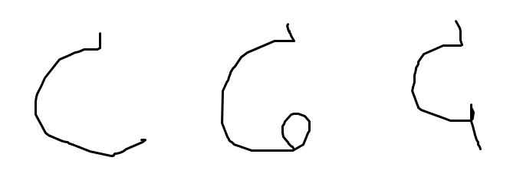
Figure 1: Three commonly misclassified characters

One can envision using another level of template matching if the score falls below the threshold but the output does not belong to a similarity class. One problem which we have not yet solved is determining an appropriate threshold for the $1 score. We currently determined this empirically from a few examples to be around 0.25.
The way we’ve implemented the program allows the segmentation of the different letters from the word automatically so there’s no need to process the word and get the individual letters.
To recognize if the user was able to entire the entire word correctly, we use a very simple yet effective approach. Each letter recognized is converted to a code (the letter- id) and a code for the entire word is generated in this way. We already have the expected codes for different words in our database stored in the program’s memory. The input word’s code is compared to the expected code and a measure of difference between the two is calculated. If they’re the same, the user successfully entered the word otherwise the user is informed what letters they missed.

EVALUATION AND RESULTS
2 stages of evaluation were performed. First we evaluated the recognition module. Templates were drawn freehand by a different person and matching was performed for each character. The user was proficient in Hindi.
In the second stage we evaluated the user interface. 4 randomly chosen non-Hindi literate subjects used our system.
They were asked to submit a Likert scale type evaluation survey with 5 qualities being measured.

Part 1 recognition
60% of the symbols(43/57) were identified correctly in all the trials. Some were occasionally misclassified as a similar character in spite of the tests.

We present the confusion matrix of only the highest misclassified characters in the appendix. Commonly misclassified letters include पी/श, ka/pha. Possible reasons for misclassification are that we perform rescaling, so that the scale information that is used to distinguish these is lost, and rotation, due to which we can even transform one character to another. Other reasons could be

Part 2 subjective evaluation

Users were asked questions on a 1-5 Likert scale as shown in Fig. 2. Questions included – was it easy to use, did it penalize me even though I felt I had entered the right character, was it useful in learning Hindi and did it provide useful feedback. Users were happy with the overall interface, however they found that the system was too demanding that they match the templates exactly(score 3/5). They liked the feedback and enjoyed using the tool rather than using a Hindi keyboard or practicing writing in a copy book. The results of the survey can also be seen in Fig. 2.

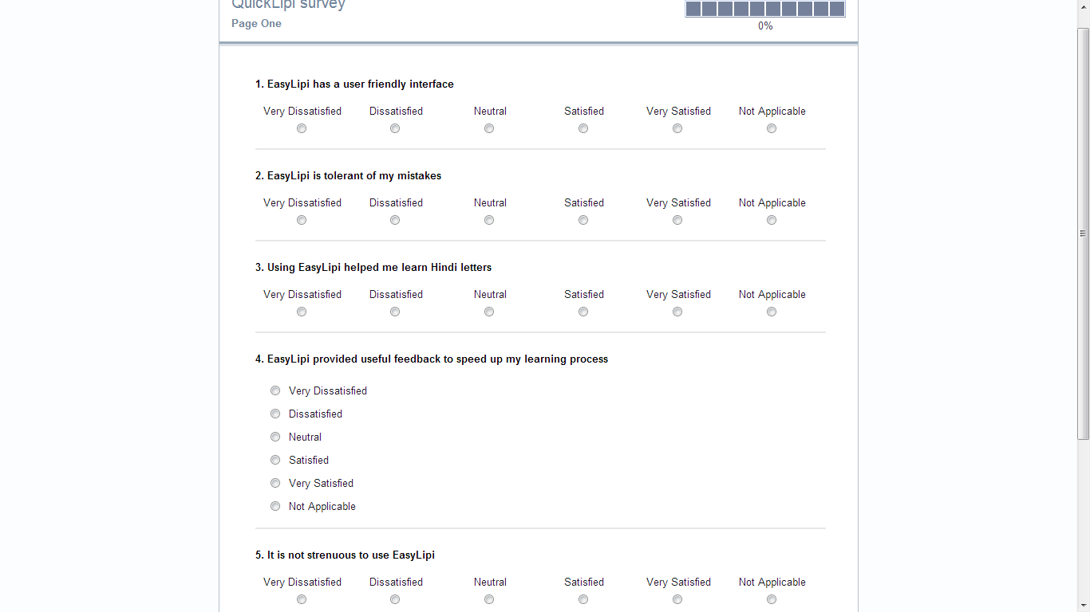
CONCLUSIONS
We have used a simple yet surprisingly effective method for recognizing Hindi letters. Combined with an attractive interface this achieves our goal of teaching Hindi script to new users. Using a more sophisticated template matching with the same tests may yield better results. The template matching would have to be sensitive to aspect and positional information. Alternatively, we could use more additional tests to distinguish potential conflicts.
The user interface could be improved to show pictures for aiding memory, and showing animations of how to draw the letter.

References
Bansal. (1995).
Chaudhary. (1999). An OCR system to read. Proc. 4th Int. Conf. Document Analysis and Recognition,. Germany.
Kumar, S. B. (2008). Online Devanagari Isolated Character Recognition for. Proc 2010 IEEEE students conference IIT Kharagpur. Kharagpur.
Sinha. (1999).

