REU Tutorial
Introduction to MATLAB
Daniela Raicu
draicu@cs.depaul.edu
School of Computing
College of Computing and Digital Media
DePaul University, Chicago, IL 60604

The purpose of this first part of the tutorial is to present basics of MATLAB. We do not assume any prior knowledge of this package; this tutorial is intended for users running a professional version of MATLAB R2013a.
Topics discussed in this tutorial include:
- Introduction to MATLAB and its toolboxes
- Development environment
- MATLAB help and basics
- MATLAB Programming
- Image Processing with Matlab

1.0 MATLAB and its toolboxes
MATLAB (Matrix Algebra laboratory), distributed by The MathWorks, is a technical computing environment for high performance numeric computation and visualization. It integrates numerical analysis, matrix computation, signal processing, and graphics in an easy-to-use environment.
MATLAB also features a family of application-specific solutions called toolboxes. Toolboxes are comprehensive collections of MATLAB functions that extend its environment in order to solve particular classes of problems. The table below lists several toolboxes available for MATLAB:
Communications | Image Processing | System Identification
Control System | Instrument Control | Wavelet
Data Acquisition | Mapping | MATLAB Compiler
Database | Neural Network | MATLAB C/C++ Graphics Library
Datafeed | Optimization | MATLAB C/C++ Math Library
Filter Design | Partial Differential Equation | MATLAB Report Generator
Financial | Robust Control | MATLAB Runtime Server
Frequency Domain System Identification | Signal Processing | MATLAB Web Server
Fuzzy Logic | Statistics | Simulink
Higher-Order Spectral Analysis | Spline | Symbolic/Extended Math
2.0 Development Environment: Command Window
To perform a simple computations type a command and next press the Enter or Return key. For instance,
>> s = 1 + 2
s =
3
Note that the results of these computations are saved in variables whose names are chosen by the user. If they will be needed during your current MATLAB session, then you can obtain their values typing their names and pressing the Enter or Return key.
For instance,
>> s
s =
3
Variable name begins with a letter, followed by letters, numbers or underscores. MATLAB recognizes only the first 31 characters of a variable name.
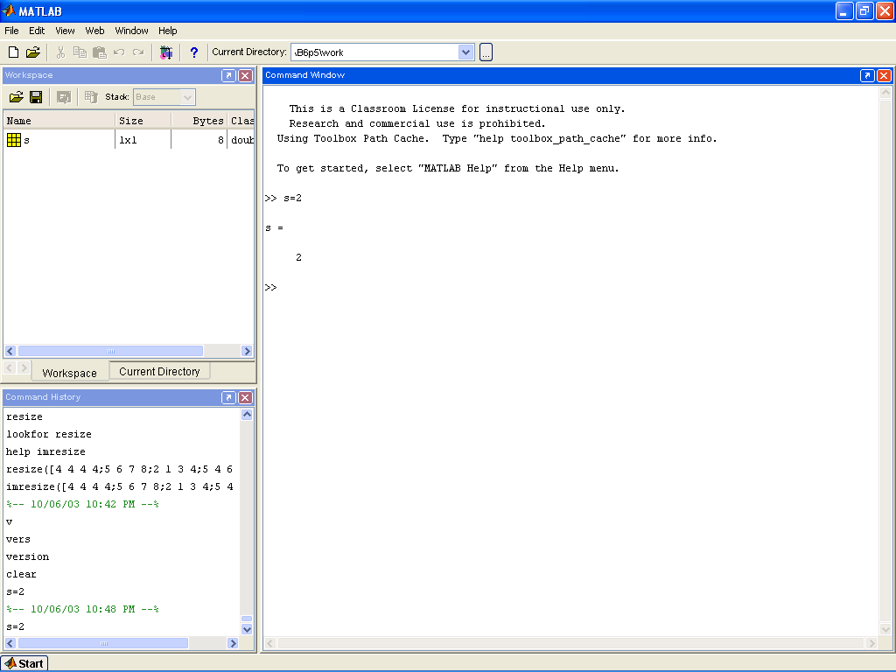
Figure 1: A screenshot of the development environment, command windows
For a demo for the MATLAB Desktop, you can visit http://www.mathworks.com/products/demos/# (it will also provide of all Matlab toolboxes).
To close MATLAB type exit in the Command Window and next press Enter or Return key. A second way to close your current MATLAB session is to select Exit in the MATLAB's toolbar. All unsaved information residing in the MATLAB Workspace will be lost.

3.0 MATLAB Help and Basics
To get help type “help” (will give you a list of help topics) or “help topic”.
If you don't know the exact name of the topic or command you are looking for, type "lookfor keyword" (e.g., "lookfor regression")
When writing a long MATLAB statement that exceeds a single row use “...” to continue statement to next row.
When using the command line, a ";" at the end means MATLAB will not display the result. If ";" is omitted then MATLAB will display result.
Use the up-arrow to recall commands without retyping them (and down arrow to go forward in commands).
The symbol "%" is used in front of a comment.
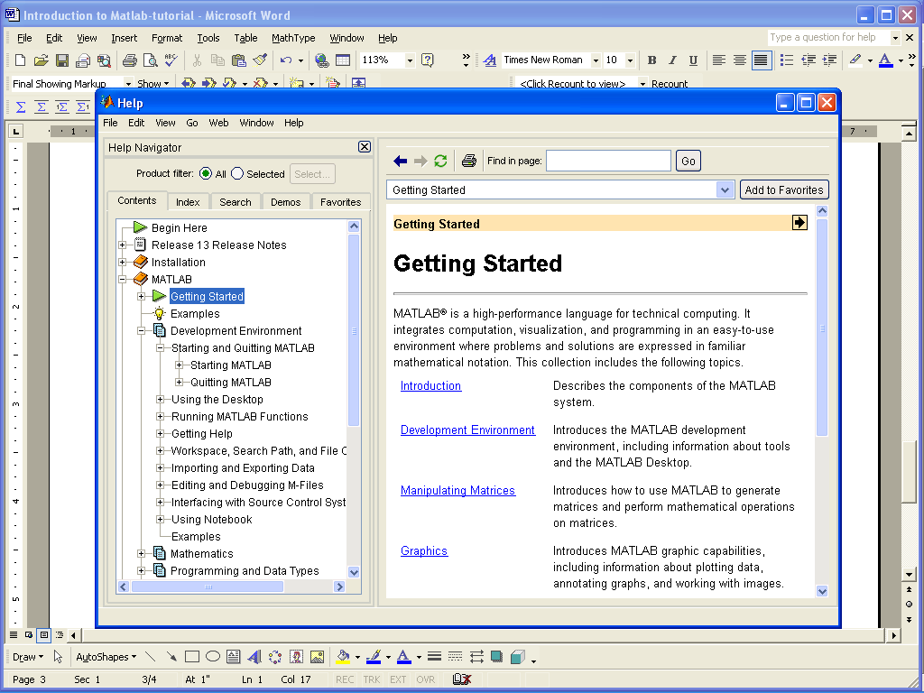
Figure 2: A screenshot of Help

4.0 MATLAB Programming
%%%%%%%%%%%%%%%%%%%%%%%%%%%%%%%%%%%%%%%%%%%%%%%%%%%%%%%%%%%%%%%%%%%%%%%
% Introducing MATLAB (adapted from http://www.cns.nyu.edu/~eero and
% http://www.cs.dartmouth.edu/~farid/teaching/cs88/MATLAB.intro.html)
%%%%%%%%%%%%%%%%%%%%%%%%%%%%%%%%%%%%%%%%%%%%%%%%%%%%%%%%%%%%%%%%%%%%%%%

%(0) MATLAB INDICES

MATLAB indices start at 1!!!

% (1) Objects in MATLAB -- the basic objects in MATLAB are scalars, vectors, and matrices...
N = 5 % a scalar
v = [1 0 0] % a row vector
v = [1; 2; 3] % a column vector
v = v' % transpose a vector
v = [1:.5:3] % a vector in a specified range:
v = pi*[-4:4]/4 % [start: stepsize: end]
v = [] % empty vector

m = [1 2 3; 4 5 6] % a matrix: 1ST parameter is ROWS
% 2ND parameter is COLS
m = zeros(2,3) % a matrix of zeros
v = ones(1,3) % a matrix of ones
w = 3*ones(1,3) % a matrix of threes
m = eye(3) % identity matrix
v = rand(3,1) % rand matrix (see also randn)

v = [1 2 3]; % access a vector element
v(3) % vector(number)
v(0) % error!!!
v(1) % first element

m = [1 2 3; 4 5 6]
m(1,3) % access a matrix element
% matrix(rownumber, columnnumber)

m(2,:) % access a matrix row (2nd row)
m(:,1) % access a matrix column (1st row)

size(m) % size of a matrix
size(m,1) % number rows
size(m,2) % number of columns

m1 = zeros(size(m)) % create a new matrix with size of m

who % list of variables
whos % list/size/type of variables

%%%%%%%%%%%%%%%%%%%%%%%%%%%%%%%%%%%%%%%%%%%%%%%%%%%%%%%%%%%%%%%%%%%%%%%
% (2) Simple operations on vectors and matrices

%%%%%%%%%%%%%%%%%%%%%%%%%%%%%%%%%%%%%%%%%%%%%%%%
% (A) Pointwise (element by element) Operations:

% addition of vectors/matrices and multiplication by a scalar
% are done "element by element"
a= [1 2 3 4]; % vector
2 * a % scalar multiplication
a / 4 % scalar multiplication
b = [5 6 7 8]; % vector
a + b % pointwise vector addition
a - b % pointwise vector addition
a .^ 2 % pointise vector squaring (note .)
a .* b % pointwise vector multiply (note .)
a ./ b % pointwise vector divide (note .)

log( [1 2 3 4] ) % pointwise arithmetic operation
round( [1.5 2; 2.2 3.1] ) % pointwise arithmetic operation

%%%%%%%%%%%%%%%%%%%%%%%%%%%%%%%%%%%%%%%%%%%%%
% (B) Vector Operations (no for loops needed)
% Built-in MATLAB functions operate on vectors, if a matrix is given,
% then the function operates on each column of the matrix

a = [1 4 6 3] % vector
sum(a) % sum of vector elements
mean(a) % mean of vector elements
var(a) % variance
std(a) % standard deviation
max(a) % maximum

a = [1 2 3; 4 5 6] % matrix
mean(a,1) % mean of each column as a row (dimension 1)
mean(a,2) % mean of each row as a column (dimension 2)
max(a) % max of each column
max(max(a)) % to obtain max of matrix
max(a(:)) % or...

%%%%%%%%%%%%%%%%%%%%%%%%
% (C) Matrix Operations:
[1 2 3] .* [4 5 6] % dot product
[1 2 3] * [4 5 6]' % row vector 1x3 times column vector 3x1
% results in single number, also
% known as dot product or inner product

[1 2 3]' * [4 5 6] % column vector 3x1 times row vector 1x3
% results in 3x3 matrix, also
% known as outer product

a = rand(3,2) % 3x2 matrix
b = rand(2,4) % 2x4 matrix
c = a * b % 3x4 matrix

a = [1 2; 3 4; 5 6] % 3 x 2 matrix
b = [5 6 7]; % 3 x 1 vector
b * a % matrix multiply
a' * b' % matrix multiply

%%%%%%%%%%%%%%%%%%%%%%%%%%%%%%%%%%%%%%%%%%%%%%%%%%%%%%%%%%%%%%%%%%%%%%%
%(3) Saving your work

save mysession % creates session.mat with all variables
save mysession a b % save only variables a and b

clear all % clear all variables
clear a b % clear variables a and b

load mysession % load session
a
b

%%%%%%%%%%%%%%%%%%%%%%%%%%%%%%%%%%%%%%%%%%%%%%%%%%%%%%%%%%%%%%%%%%%%%%%
%(4) Relations and control statements

for i = 5:-1:1 % start:step:end
print i
end

% Example: given a vector v, create a new vector with values equal to v if they are greater than 0, and equal to 0 if they less than or equal to 0.

v = [3 5 -2 5 -1 0] % 1: FOR LOOPS
u = zeros( size(v) ); % initialize
for i = 1:size(v,2)
if( v(i) > 0 )
u(i) = v(i);
end
end
u

v = [3 5 -2 5 -1 0] % 2: NO FOR LOOPS
u2 = zeros( size(v) ); % initialize
ind = find( v>0 ) % index into >0 elements
u2(ind) = v( ind )

%%%%%%%%%%%%%%%%%%%%%%%%%%%%%%%%%%%%%%%%%%%%%%%%%%%%%%%%%%%%%%%%%%%%%%%
%(5) Creating functions using m-files:
% Functions in MATLAB are written in m-files. Create a file called 'thres.m' In this file put the following:

function res = thres( v )

u = zeros( size(v) ); % initialize
ind = find( v>0 ) % index into >0 elements
u(ind) = v( ind )

v = [3 5 -2 5 -1 0]
thres( v ) % call from command line

%%%%%%%%%%%%%%%%%%%%%%%%%%%%%%%%%%%%%%%%%%%%%%%%%%%%%%%%%%%%%%%%%%%%%%%
%(6) Plotting

x = [0 1 2 3 4]; % basic plotting
plot( x );
plot( x, 2*x );
axis( [0 8 0 8] );

x = pi*[-24:24]/24;
plot( x, sin(x) );
xlabel( 'radians' );
ylabel( 'sin value' );
title( 'dummy' );
gtext( 'put cursor where you want text and press mouse' );

figure; % multiple functions in separate graphs
subplot( 1,2,1 );
plot( x, sin(x) );
axis square;
subplot( 1,2,2 );
plot( x, 2.*cos(x) );
axis square;

figure; % multiple functions in single graph
plot( x,sin(x) );
hold on;
plot (x, 2.*cos(x), '--' );
legend( 'sin', 'cos' );
hold off;

figure; % matrices as images
m = rand(64,64);
imagesc(m)
colormap gray;
axis image
axis off;

%%%%%%%%%%%%%%%%%%%%%%%%%%%%%%%%%%%%%%%%%%%%%%%%%%%%%%%%%%%%%%%%%%%%%%%
%%%%%%%%%%%%%%%%%%%%%%%%%%%%%%%%%%%%%%%%%%%%%%%%%%%%%%%%%%%%%%%%%%%%%%%
5.0 Image Processing in Matlab
%(7) Working with Images

[I,map]=imread('trees.tif'); % read a TIFF image

figure, imshow(I,map) % display it as indexed image

I2=ind2gray(I,map); % convert it to grayscale

figure
imagesc(I2,[0 1]) % scale data to use full colormap
% for values between 0 and 1
colormap('gray') % use gray colormap
axis('image') % make displayed aspect ratio %proportional
% to image dimensions

I=imread('photo.jpg'); % read a JPEG image into 3D %array

figure
imshow(I)
rect=getrect; % select rectangle
I2=imcrop(I,rect); % crop
I2=rgb2gray(I2); % convert cropped image to grayscale
imagesc(I2) % scale data to use full colormap
% between min and max values in I2
colormap('gray')
colorbar % turn on color bar
pixval % display pixel values interactively
truesize % display at resolution of one %screen pixel
% per image pixel
truesize(2*size(I2)) % display at resolution of two %screen pixels
% per image pixel

I3=imresize(I2,0.5,'bil'); % resize by 50% using bilinear
% interpolation
I3=imrotate(I2,45,'bil','same'); % rotate 45 degrees and crop to
% original size
I3=double(I2); % convert from uint8 to double, to %allow
% math operations
imagesc(I3.^2) % display squared image (pixel-wise)
imagesc(log(I3)) % display log of image

%%%%%%%%%%%%%%%%%%%%%%%%%%%%%%%%%%%%%%%%%%%%%%%%%%%%%%%%%%%%%%%%%%%%%%%

