

SYNOPSIS

**Shoppy E-Commerce Website**

**Department of Computer Science & Application**

**Institute of Engineering & Technology**

Submitted By: Submitted To:

Vishal kumar Mrs. Gurpreet Kaur

Section: K Training and Development Deptt.

University Roll No. : 2115001127 GLA University,Mathura

Dhruv sharma

Section:K

University Roll No. : 2115000363

**CONTENTS**

* Declaration
* Acknowledgement
* Title of the Project
* Objective
* Scope of the project
* Methodology
* Proposed System
* Features
* Implementation plan
* Team Members
* Resources Required
* References
* Expected Outcomes
* Project Supervisor
* Conclusion

**DECLARATION**

We hereby declare that the work which is being presented in the project synopsis “ **Shoppy E-commerce Website** ” in partial fulfilment of the requirement for project is an authentic record of our work carried under the supervision of **Mrs. Gurpreet Kaur, Technical Trainer, GLA University, Mathura** during session **2023-24**.

Sign:

**Name of the team members University Roll N0.**

Vishal Kumar 2115001127

Dhruv Sharma 2115000363

**ACKNOWLEDGEMENT**

It gives us a great sense of pleasure to present the synopsis of the B. Tech. Mini Project undertaken during III Year. This project is going to be an acknowledgement for the inspiration, drive and technical efforts which will becontributed to it by its contributors. We would like to express our gratitude to **Mrs. Gurpreet Kaur , Technical Trainer (T&D Department),** for his unwavering encouragement and support, which allowed us to develop this project to the fullest extent of our skills.

We would also like to thanks all the faculty members of the department of Computer Science & Application for their kind guidance and cooperation.

Vishal Kumar (2115001127)

Dhruv Sharma (2115000363)

**Title of the Project:-**

**“Shoppy E-commerce Website”**

**Objective:-**

The objective of this project is to create an e-commerce web portal with a contentmanagement system which would allow product information to be updated securely usinga mobile device.The web portal will have an online interface in the form of an e-commerce website thatwill allow users to buy goods from the merchants.The e-commerce portal will have the following key features:

* An online shop that will allow online shoppers to buy wares from formal andinformal merchants.
* A search engine on the website to allow customers to find specific types ofmerchandise.
* A secure online transaction system that will allow shoppers to purchase goodssafely using their credit cards.
* A database of merchandise with photos, product descriptions and stockinformation. This database will also contain all relevant merchant and customerinformation.
* A data security system that will ensure that all data that is transmitted between thevarious system.

**Scope:-**

* Increasing the value of the content with accessibility, reusability, and durability.
* We will develop the necessary skills to get our business on the Web and available to a worldwide audience.
* We’ll understand the concepts, and we’ll have the knowledge.
* Affiliation program helps to generate many visitors and is one of the best marketing strategies.

**Limitations :-**

* INTERNET CONNECTION IS ABSOLUTELY REQUIRED.
* BASIC INTERNET KNOWLEDGE IS REQUIRED.
* USER REGISTRATION IS COMPULSORY FOR PARTICIPATION.

**Methodology:-**

The methods, tools, and technologies we plan to use in our project are as follows:-

**HTML**: Hyper-Text-Markup-Language is used forstructuring web pages over the internet. HTML is the language in which most websites are written.

HTML is used to create pages and make them functional.

**CSS**: Cascading-Style-Sheet is a styling language used to style and basically define how the content will appear on the website.

**JavaScript**: JavaScript is a scripting or programming language which is now used extensively to design modern web applications and website, it allows the developer to write application which modify themselves according to each user and its data, this made web applications much more accessible and suitable for many purposes.

**Python:** Python is an interpreted, object-oriented, high-level programming language with dynamic semantics.

**NodeJS:** Node.js is a cross-platform, open-source server environment that can run on Windows, Linux,

Unix, macOS, and more. Node.js is a back-end JavaScript runtime environment, runs on theV8 JavaScript Engine, and executes JavaScript code outside a web browser.

**ExpressJS:** Express.js is a popular web application framework for Node.js. It provides a simple, yet powerful set of features for buildingweb applications and APIs. With Express, developers can easily define routes, handle HTTP requests and responses, and implement middleware to add additional functionality to their applications.

**Bootstrap**: Bootstrap is a free and open-source CSS framework directed at responsive, mobilefirst front-end web development. It contains HTML, CSS and (optionally) JavaScript-based design templates for typography, forms, buttons,navigation,and other interface components.

**MongoDB:** MongoDB is a popular NoSQL database that uses a document-oriented data model. Unlike traditional relational databases, MongoDB stores data in flexible JSON-like documents, which allows for greater flexibility and scalability.

**Proposed System:-**

We cover a wide variety of topics which are:

1. Build a product catalog that can be browsed and searched.
2. Implement the catalog administration pages that allow adding, modifying, and removing products, categories, departments, and other administrative features.
3. Create your own shopping basket and check-out mechanism.
4. Increase sales by implementing product recommendations and product reviews.
5. Implement a customer accounts system.

While implementing these features, we’ll learn how to:

1. Design relational databases and write MySQL queries and stored procedures.
2. Use the MySQL full-text search feature to implement product searching.
3. Implement search engine optimization features.
4. Integrate external web services.

**Features:-**

* **User-Friendly Design**
* **Mobile- Friendly Features**
* **Multiple Payment Options**
* **24/7 Customer Service**
* **User Reviews**
* **User Features and Discounts**
* **Extensive Product Information**

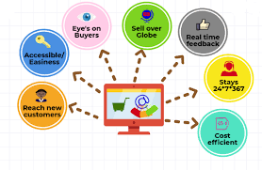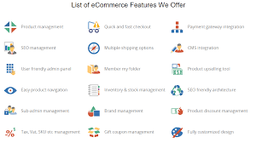

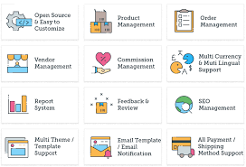

**Implementation Plan:-**

We aim to follow the following implementation plan:-

* Project Initiation
* Needs Assessment
* Planning and Design
* Content Development
* Development
* User Interface and Experience (UI/UX)
* User Engagement and Interaction
* Mobile Optimization
* Deployment and Report Generation
* Final Submission

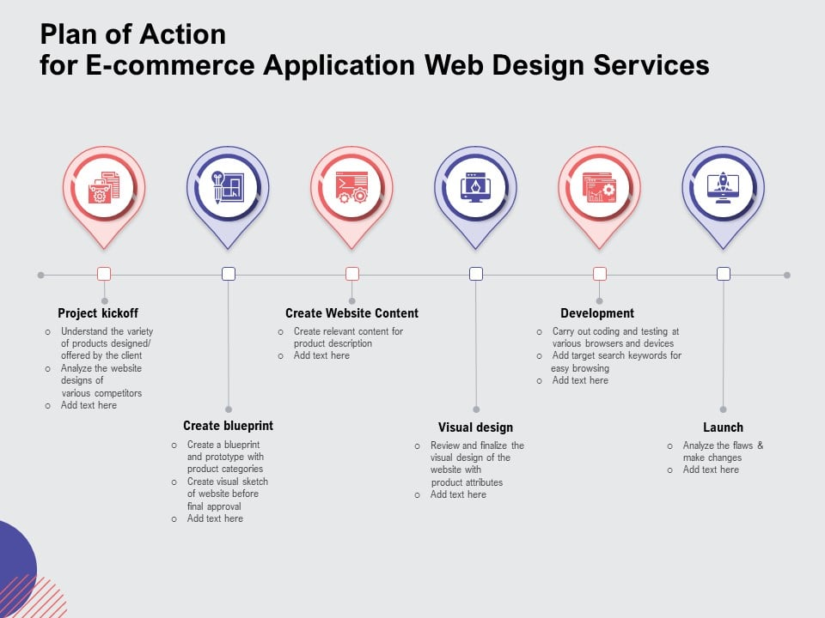

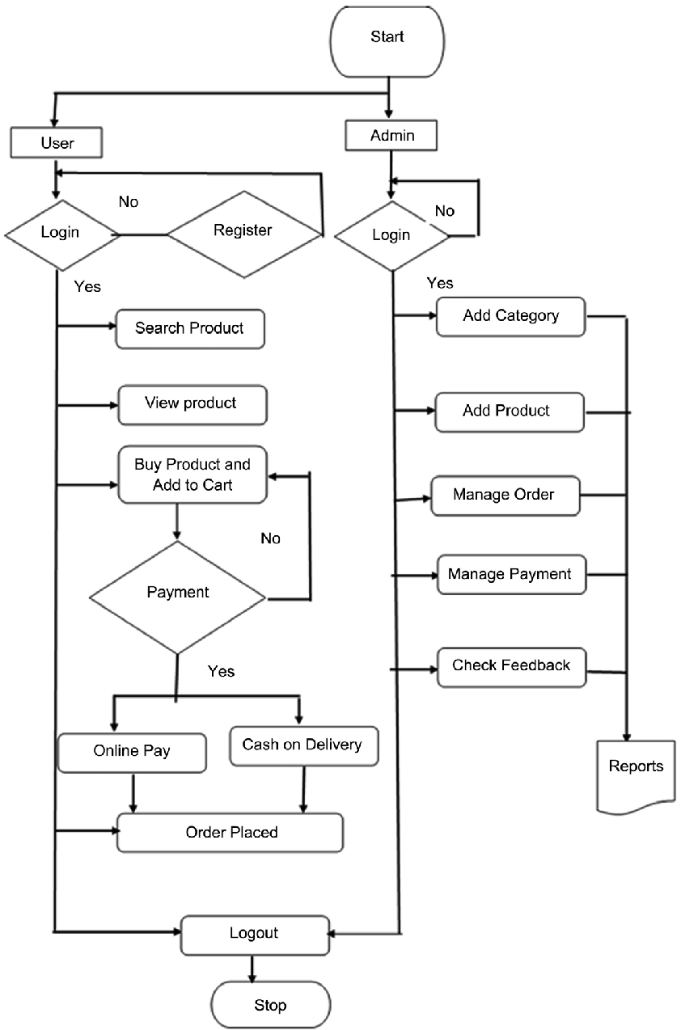**Team Member:-**

1. **Vishal Kumar - FRONTEND/BACKEND DEVELOPER**
2. **Dhruv Sharma - FRONTEND/BACKEND DEVELOPER**

**Resources Required:-**

1. Hardware Required:-

* Processor : Pentium IV or Above
* RAM : 2GB or above
* Hard Disk : 50GB or above
* Input Devices : Keyboard, Mouse
* Output Devices : Monitor

1. Software Required:-

* Operating System : Linux,Ubuntu,Mac,Windows XP,7,8,8.1, 10
* Frontend : HTML,CSS, Bootstrap, JavaScript
* Backend : MySQL
* Local host : XAMPP/WAMP/LAMP/MAMP

**References:-**

http://en.wikipedia.org/wiki/Electronic_commerce  
http://www.ecommerce-blog.org   
http://www.amazon.com

**Expected Outcomes:-**

* **Fast loading time.**
* **Promotions and free shipping.**
* **Customer service.**
* **Social media links.**
* **Pricing details easily available.**

**Project Supervisor:-**

Mrs. Gurpreet Kaur

Training and Development Deptt.

GLA University,Mathura

**Conclusion:-**

* E-Commerce are support the potential customers decision making process by introducing personalized Web-based decision support systems such as recommender systems .
* Recommender Systems provide consumers with personalized recommendations based on their purchase history, past ratings, profile or interest .
* A person’s decision for buying product is influence by friends, business s partners rather than strangers.
* The Social Network playing the an important rule in online Market .
* E-Commerce support the relationship between the customers and companies such as e-mail.