DAY - 02

OOAD & Design

Project Name: Online Bookstore Application
Prepared By : Sukhwinder Singh ( vsisukhw )
Date : 07 September, 2025

1. Class Diagram (Book, User, Cart, Order)

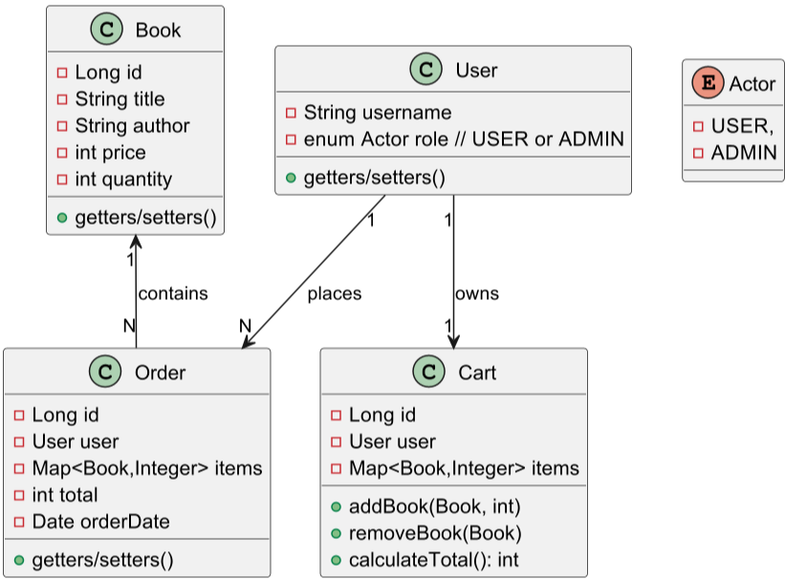
@startuml
class Book {
- Long id
- String title
- String author
- int price
- int quantity
+ getters/setters()
}

enum Actor {
- USER,
- ADMIN
}
class User {
- String username
- enum Actor role // USER or ADMIN
+ getters/setters()
}

class Cart {
- Long id
- User user
- Map<Book,Integer> items
+ addBook(Book, int)
+ removeBook(Book)
+ calculateTotal(): int
}

class Order {
- Long id
- User user
- Map<Book,Integer> items
- int total
- Date orderDate
+ getters/setters()
}

Book "1" <-- "N" Order : contains
User "1" --> "N" Order : places
User "1" --> "1" Cart : owns
@enduml

2. Use Case Diagram (Users interact with system)

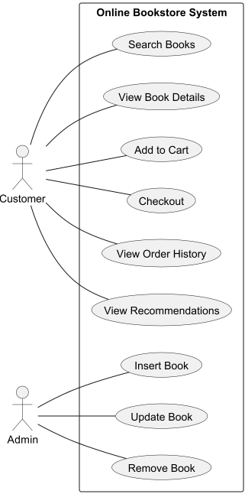

@startuml
left to right direction
actor Customer
actor Admin

rectangle "Online Bookstore System" {
Customer -- (Search Books)
Customer -- (View Book Details)
Customer -- (Add to Cart)
Customer -- (Checkout)
Customer -- (View Order History)
Customer -- (View Recommendations)

Admin -- (Insert Book)
Admin -- (Update Book)
Admin -- (Remove Book)
}
@enduml

3. ER Diagram (MySQL tables: Book, User, Cart, Orders)

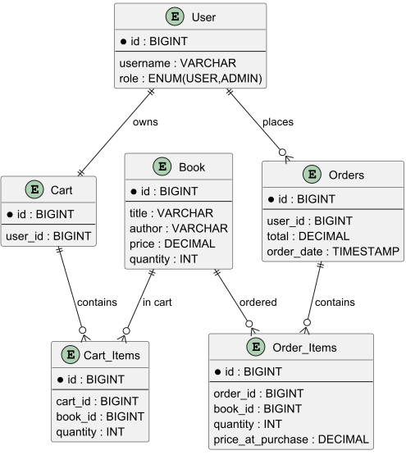

@startuml
entity User {
*id : BIGINT
--
username : VARCHAR
role : ENUM(USER,ADMIN)
}

entity Book {
*id : BIGINT
--
title : VARCHAR
author : VARCHAR
price : DECIMAL
quantity : INT
}

entity Cart {
*id : BIGINT
--
user_id : BIGINT
}

entity Cart_Items {
*id : BIGINT
--
cart_id : BIGINT
book_id : BIGINT
quantity : INT
}

entity Orders {
*id : BIGINT
--
user_id : BIGINT
total : DECIMAL
order_date : TIMESTAMP
}

entity Order_Items {
*id : BIGINT
--
order_id : BIGINT
book_id : BIGINT
quantity : INT
price_at_purchase : DECIMAL
}

User ||--|| Cart : owns
Cart ||--o{ Cart_Items : contains
Book ||--o{ Cart_Items : "in cart"

User ||--o{ Orders : places
Orders ||--o{ Order_Items : contains
Book ||--o{ Order_Items : "ordered"
@enduml

SQL Schema – Online Bookstore

-- USERS table
CREATE TABLE users (
id BIGINT AUTO_INCREMENT PRIMARY KEY,
username VARCHAR(100) NOT NULL UNIQUE,
role ENUM('USER','ADMIN') DEFAULT 'USER',

);

-- BOOKS table
CREATE TABLE books (
id BIGINT AUTO_INCREMENT PRIMARY KEY,
title VARCHAR(255) NOT NULL,
author VARCHAR(255) NOT NULL,
price DECIMAL(10,2) NOT NULL,
quantity INT DEFAULT 0,
);

-- CART table
CREATE TABLE carts (
id BIGINT AUTO_INCREMENT PRIMARY KEY,
user_id BIGINT NOT NULL,
FOREIGN KEY (user_id) REFERENCES users(id)
);

-- CART_ITEMS table (many-to-many between cart and books)
CREATE TABLE cart_items (
id BIGINT AUTO_INCREMENT PRIMARY KEY,
cart_id BIGINT NOT NULL,
book_id BIGINT NOT NULL,
quantity INT NOT NULL,
FOREIGN KEY (cart_id) REFERENCES carts(id) ON DELETE CASCADE,
FOREIGN KEY (book_id) REFERENCES books(id)
);

-- ORDERS table
CREATE TABLE orders (
id BIGINT AUTO_INCREMENT PRIMARY KEY,
user_id BIGINT NOT NULL,
total DECIMAL(12,2) NOT NULL,
status VARCHAR(50) DEFAULT 'PLACED',
order_date TIMESTAMP DEFAULT CURRENT_TIMESTAMP,
FOREIGN KEY (user_id) REFERENCES users(id)
);

-- ORDER_ITEMS table (many-to-many between orders and books)
CREATE TABLE order_items (
id BIGINT AUTO_INCREMENT PRIMARY KEY,
order_id BIGINT NOT NULL,
book_id BIGINT NOT NULL,
quantity INT NOT NULL,
price_at_purchase DECIMAL(10,2) NOT NULL,
FOREIGN KEY (order_id) REFERENCES orders(id) ON DELETE CASCADE,
FOREIGN KEY (book_id) REFERENCES books(id)
);

