DAY - 02

OOAD & Design

Project Name : Online Bookstore Application
Prepared By : Sukhwinder Singh ( vsisukhw )
Date : 07 September, 2025

- Class Diagram (Book, User, Cart, Order)

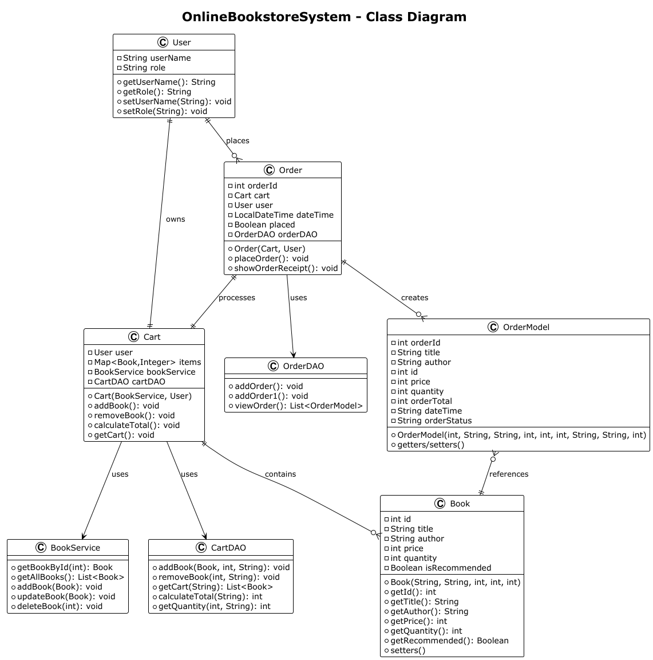

@startuml
!theme plain
title OnlineBookstoreSystem - Class Diagram
class Book {
- int id
- String title
- String author
- int price
- int quantity
- Boolean isRecommended
+ Book(String, String, int, int, int)
+ getId(): int
+ getTitle(): String
+ getAuthor(): String
+ getPrice(): int
+ getQuantity(): int
+ getRecommended(): Boolean
+ setters()
}
class User {
- String userName
- String role
+ getUserName(): String
+ getRole(): String
+ setUserName(String): void
+ setRole(String): void
}
class Cart {
- User user
- Map<Book,Integer> items
- BookService bookService
- CartDAO cartDAO
+ Cart(BookService, User)
+ addBook(): void
+ removeBook(): void
+ calculateTotal(): void
+ getCart(): void
}
class Order {
- int orderId
- Cart cart
- User user
- LocalDateTime dateTime
- Boolean placed
- OrderDAO orderDAO
+ Order(Cart, User)
+ placeOrder(): void
+ showOrderReceipt(): void
}
class OrderModel {
- int orderId
- String title
- String author
- int id
- int price
- int quantity
- int orderTotal
- String dateTime
- String orderStatus
+ OrderModel(int, String, String, int, int, int, String, String, int)
+ getters/setters()
}
class BookService {
+ getBookById(int): Book
+ getAllBooks(): List<Book>
+ addBook(Book): void
+ updateBook(Book): void
+ deleteBook(int): void
}
class CartDAO {
+ addBook(Book, int, String): void
+ removeBook(int, String): void
+ getCart(String): List<Book>
+ calculateTotal(String): int
+ getQuantity(int, String): int
}
class OrderDAO {
+ addOrder(): void
+ addOrder1(): void
+ viewOrder(): List<OrderModel>
}
' Relationships
User ||--|| Cart : owns
User ||--o{ Order : places
Cart ||--o{ Book : contains
Order ||--|| Cart : processes
Order ||--o{ OrderModel : creates
OrderModel }o--|| Book : references
Cart --> BookService : uses
Cart --> CartDAO : uses
Order --> OrderDAO : uses
@enduml

2. Use Case Diagram (Users interact with system)

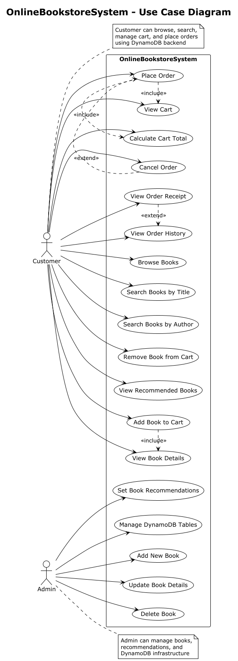

@startuml
!theme plain
title OnlineBookstoreSystem - Use Case Diagram
left to right direction
actor Customer as C
actor Admin as A
rectangle "OnlineBookstoreSystem" {
' Customer Use Cases
usecase (Browse Books) as UC1
usecase (Search Books by Title) as UC2
usecase (Search Books by Author) as UC3
usecase (View Book Details) as UC4
usecase (Add Book to Cart) as UC5
usecase (Remove Book from Cart) as UC6
usecase (View Cart) as UC7
usecase (Calculate Cart Total) as UC8
usecase (Place Order) as UC9
usecase (Cancel Order) as UC10
usecase (View Order History) as UC11
usecase (View Order Receipt) as UC12
usecase (View Recommended Books) as UC13
' Admin Use Cases
usecase (Add New Book) as UC14
usecase (Update Book Details) as UC15
usecase (Delete Book) as UC16
usecase (Set Book Recommendations) as UC17
usecase (Manage DynamoDB Tables) as UC18
' Customer Relationships
C --> UC1
C --> UC2
C --> UC3
C --> UC4
C --> UC5
C --> UC6
C --> UC7
C --> UC8
C --> UC9
C --> UC10
C --> UC11
C --> UC12
C --> UC13
' Admin Relationships
A --> UC14
A --> UC15
A --> UC16
A --> UC17
A --> UC18
' Include/Extend Relationships
UC5 .> UC4 : <<include>>
UC9 .> UC7 : <<include>>
UC9 .> UC8 : <<include>>
UC10 .> UC9 : <<extend>>
UC12 .> UC11 : <<extend>>
}
note right of C
Customer can browse, search,
manage cart, and place orders
using DynamoDB backend
end note
note right of A
Admin can manage books,
recommendations, and
DynamoDB infrastructure
end note
@enduml

3. ER Diagram (MySQL tables: Book, User, Cart, Orders)

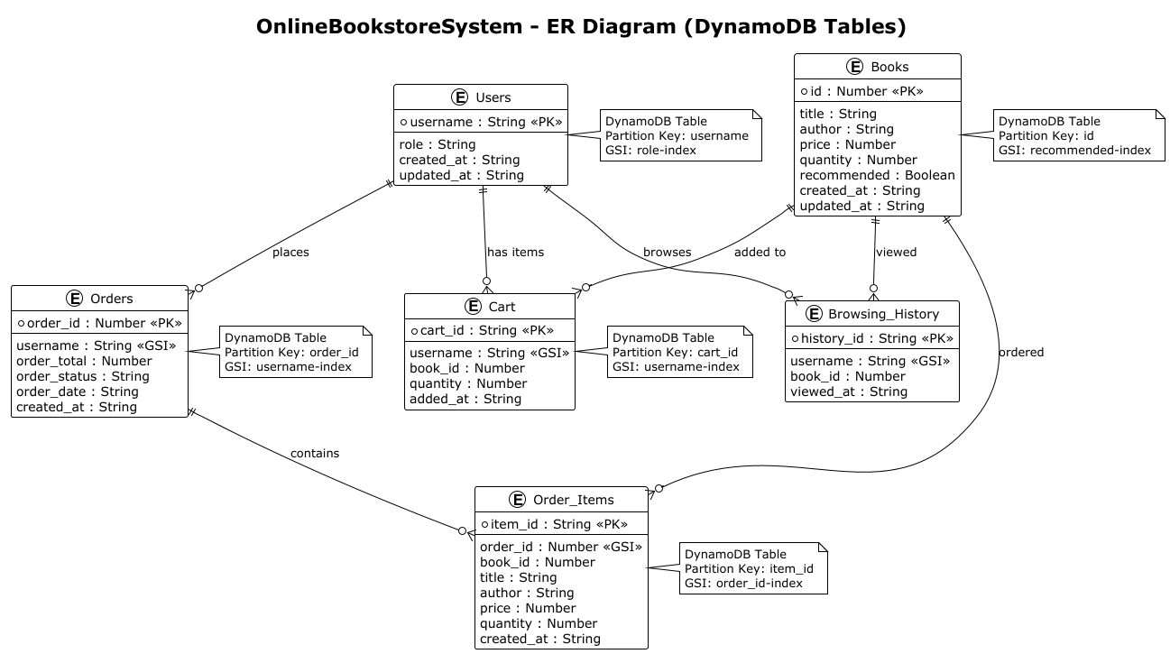

@startuml
!theme plain
title OnlineBookstoreSystem - ER Diagram (DynamoDB Tables)
entity Users {
*username : String <<PK>>
--
role : String
created_at : String
updated_at : String
}
entity Books {
*id : Number <<PK>>
--
title : String
author : String
price : Number
quantity : Number
recommended : Boolean
created_at : String
updated_at : String
}
entity Cart {
*cart_id : String <<PK>>
--
username : String <<GSI>>
book_id : Number
quantity : Number
added_at : String
}
entity Orders {
*order_id : Number <<PK>>
--
username : String <<GSI>>
order_total : Number
order_status : String
order_date : String
created_at : String
}
entity Order_Items {
*item_id : String <<PK>>
--
order_id : Number <<GSI>>
book_id : Number
title : String
author : String
price : Number
quantity : Number
created_at : String
}
entity Browsing_History {
*history_id : String <<PK>>
--
username : String <<GSI>>
book_id : Number
viewed_at : String
}
' Relationships
Users ||--o{ Cart : "has items"
Books ||--o{ Cart : "added to"
Users ||--o{ Orders : "places"
Orders ||--o{ Order_Items : "contains"
Books ||--o{ Order_Items : "ordered"
Users ||--o{ Browsing_History : "browses"
Books ||--o{ Browsing_History : "viewed"
' DynamoDB Specific Notes
note right of Users
DynamoDB Table
Partition Key: username
GSI: role-index
end note
note right of Books
DynamoDB Table
Partition Key: id
GSI: recommended-index
end note
note right of Cart
DynamoDB Table
Partition Key: cart_id
GSI: username-index
end note
note right of Orders
DynamoDB Table
Partition Key: order_id
GSI: username-index
end note
note right of Order_Items
DynamoDB Table
Partition Key: item_id
GSI: order_id-index
end note
@enduml

