This is an ML example taken from my (Shruti Satrawada’s) 288 assignment where I applied our tool to ease the workload of the assignment.

The file is called ml_example.ipynb and I use the tool to test out different lambda, gamma, and example number parameters for my model.

Table output:

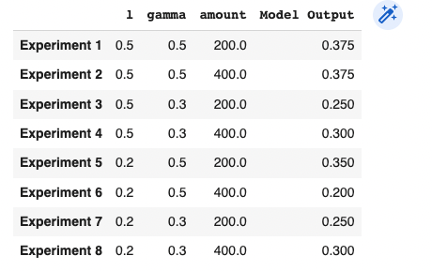

In the folder:

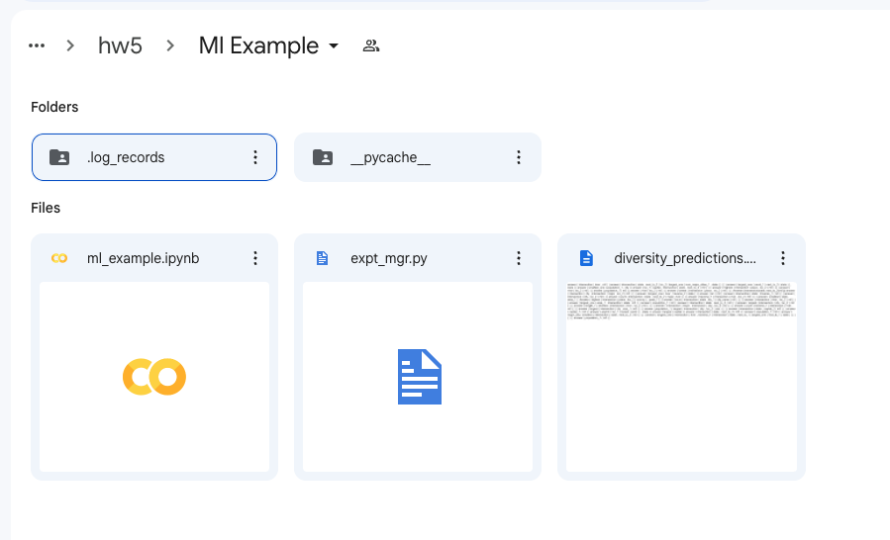

We can see the .log_records folder which contains the different runs:

