1. Launch one ec2 using Amazon Linux 2 image and add script in user data to install Apache.

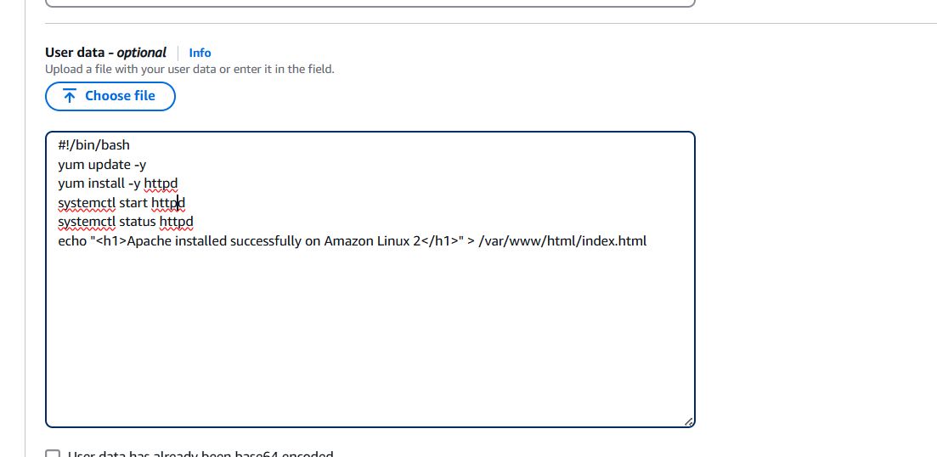

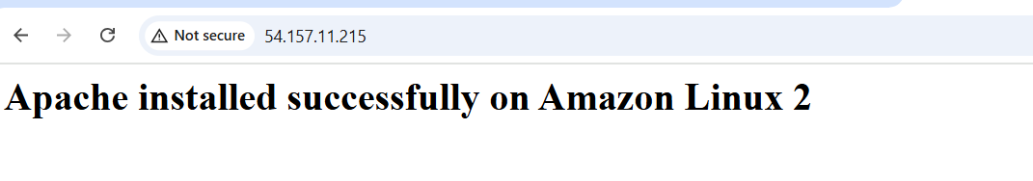

STEPS:

1. create instance with the APACHE script
2. Launch instance it is created new instance
3. Open webpage with PUBLIC-ID
4. It will show Apache Installed successfully

Script:

#!/bin/bash

yum update -y

yum install -y httpd

systemctl start httpd

systemctl status httpd

echo "<h1>Apache installed successfully on Amazon Linux 2</h1>" > /var/www/html/index.html

1. Launch one ec2 using Ubuntu image and add script in user data to install Nginx.

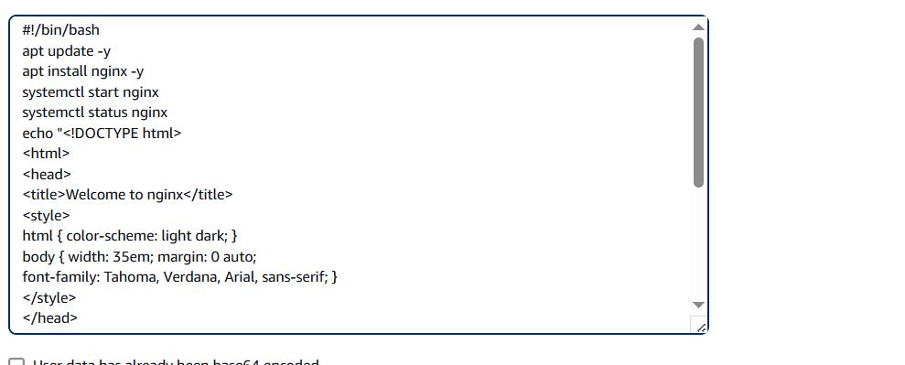

STEPS:

1.create instance with the nginx script

2.Launch instance it is created new instance

3.Open webpage with PUBLIC-ID

4.It will show nginx Installed successfully

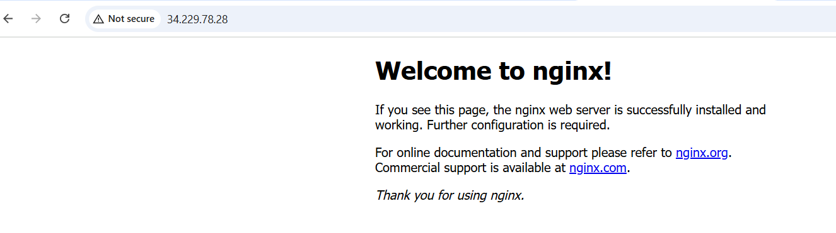

1. Launch one windows server and install tomcat in windows. 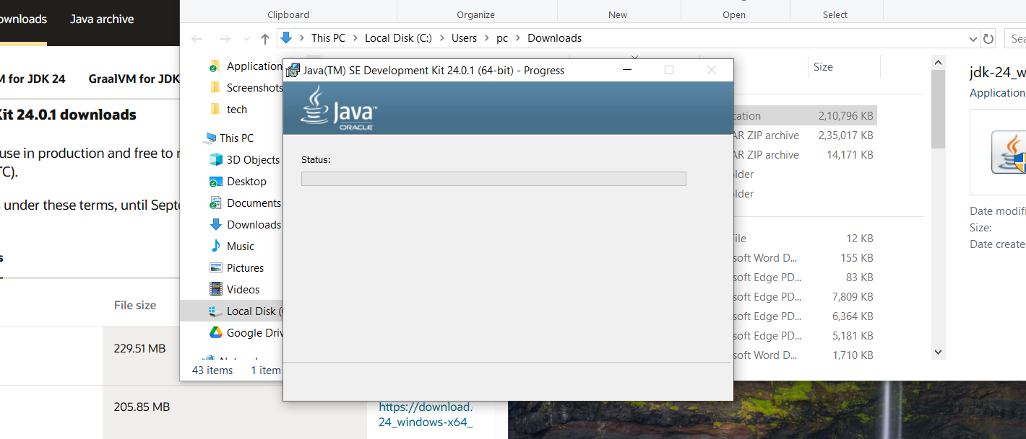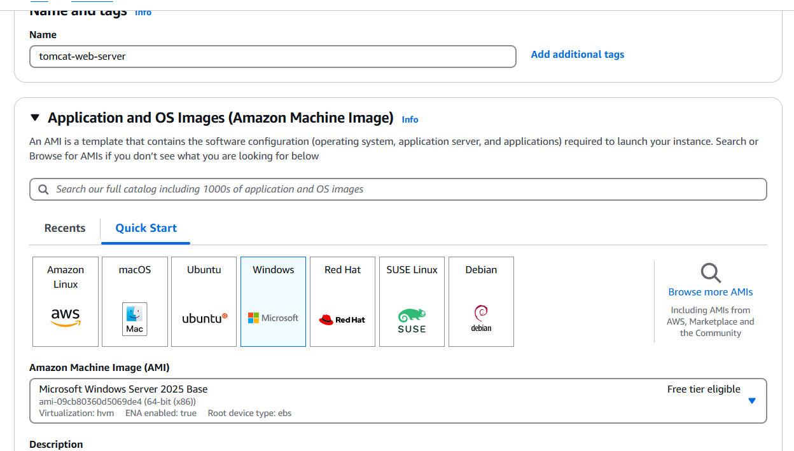

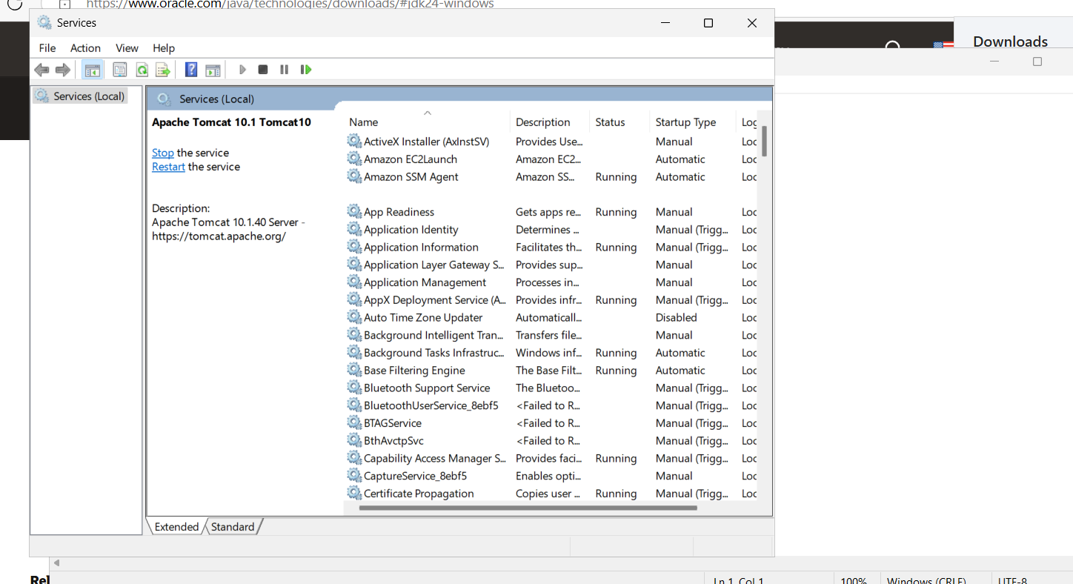

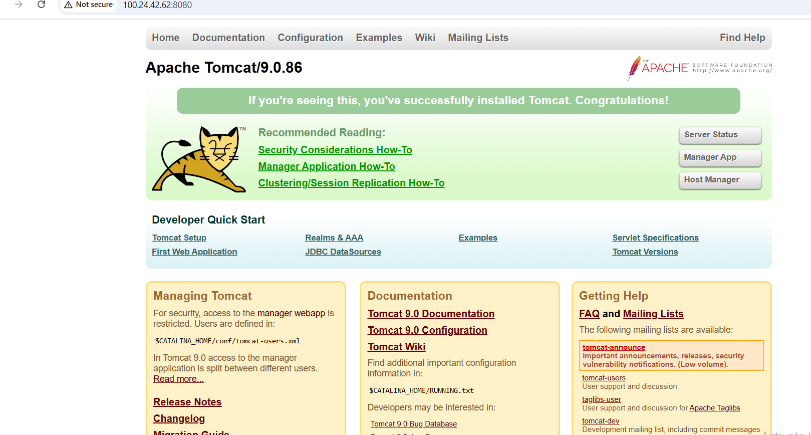

1. Take snapshot of the instane created in Task 1.

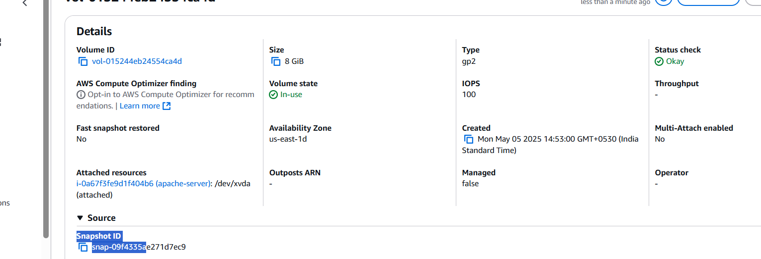

1. Assign password less authentication for ec2 created on Task 2

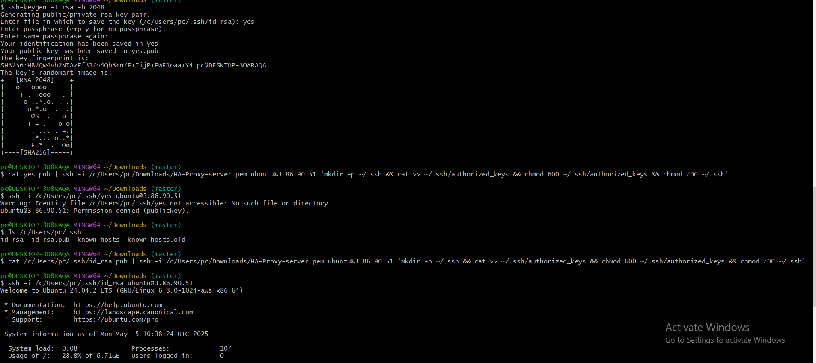

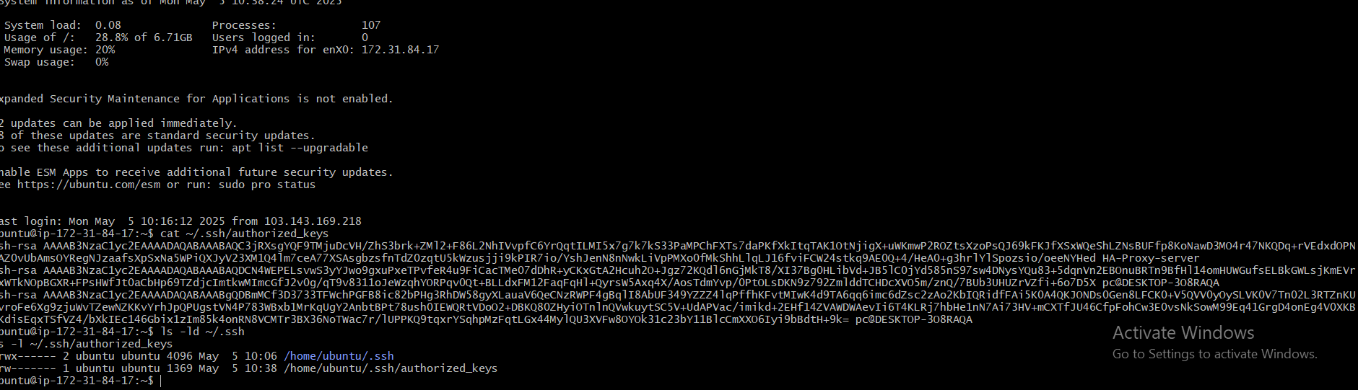

STEPS:

**Generate SSH Key Pair:**

* Run ssh-keygen -t rsa -b 2048.
* Save keys as yes (private) and yes.pub (public).
* Copy Public Key to EC2 Instance:
* cat yes.pub | ssh -i /path/to/HA-Proxy-server.pem ubuntu@3.86.90.51 'mkdir -p ~/.ssh && cat >> ~/.ssh/authorized_keys && chmod 600 ~/.ssh/authorized_keys && chmod 700 ~/.ssh'
* Test SSH Passwordless Login:
* ssh -i /path/to/yes [ubuntu@3.86.90.51](mailto:ubuntu@3.86.90.51)

**Verify Public Key on EC2 Instance:**

* Check ~/.ssh/authorized_keys on EC2:
* Verify Public Key on EC2 Instance:
* Check ~/.ssh/authorized_keys on EC2:

**Verify File Permissions:**

* Ensure correct permissions for .ssh and authorized_keys:

ls -ld ~/.ssh

ls -l ~/.ssh/authorized_keys

1. Launch any ec2 using spot purchasing option.

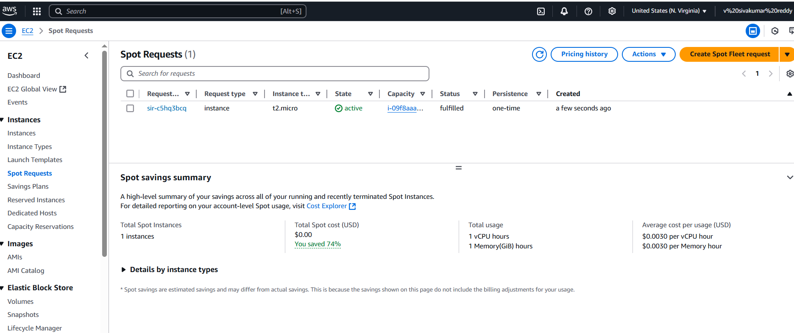

1. Enable Termination policy on ec2 created in Task 2.

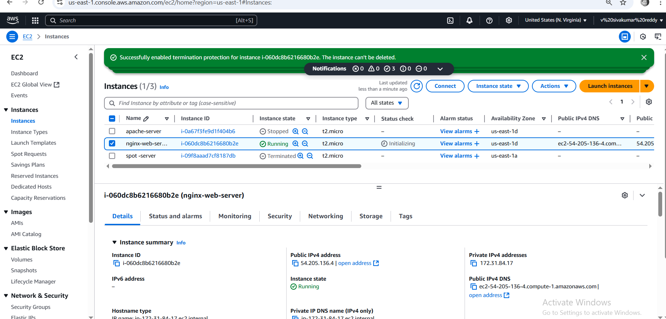

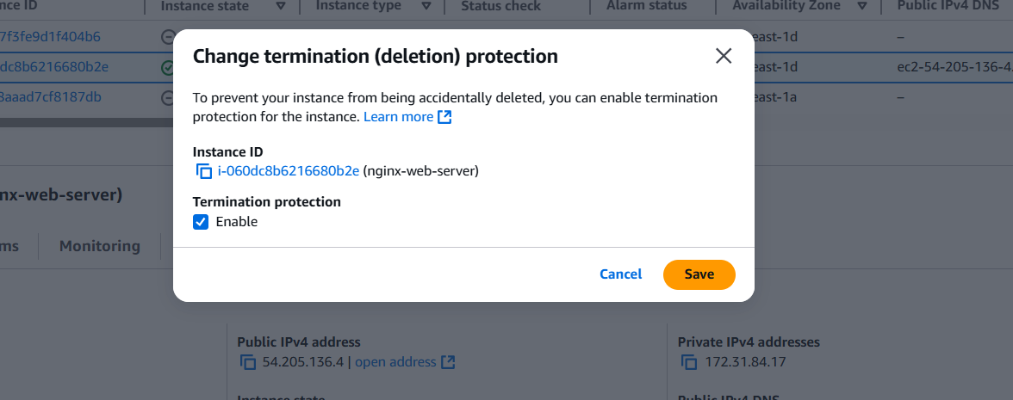

STEPS:

### **✅ Steps to Enable Termination Protection on an EC2 Instance:**

**Via AWS Management Console:**

1. **Go to EC2 Dashboard**  
   Log in to the AWS Console → Navigate to **EC2 > Instances**.
2. **Select the Instance**  
   Click the checkbox for your **Ubuntu instance**.
3. **Actions > Instance Settings > Change Termination Protection**  
   Choose this from the menu.
4. **Enable Protection**  
   In the popup, select **"Enable"** and click **Update**.
5. Launch one ec2 using Aws CLI.

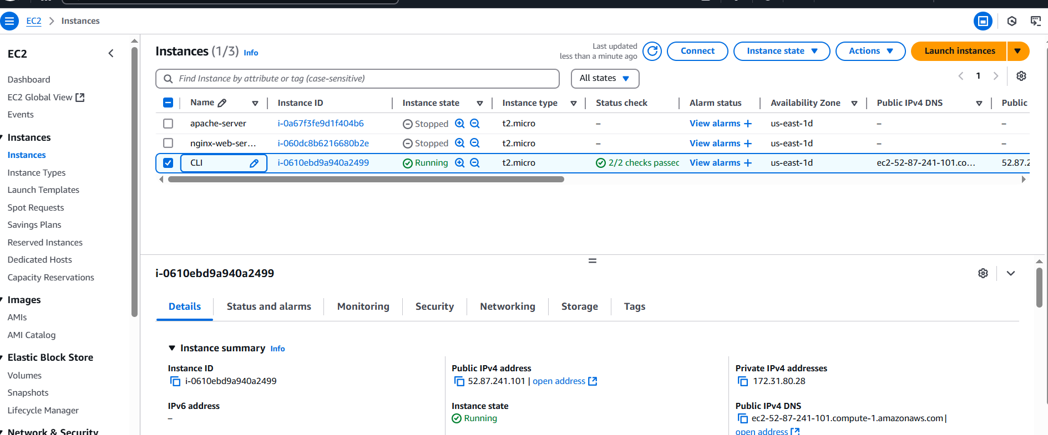

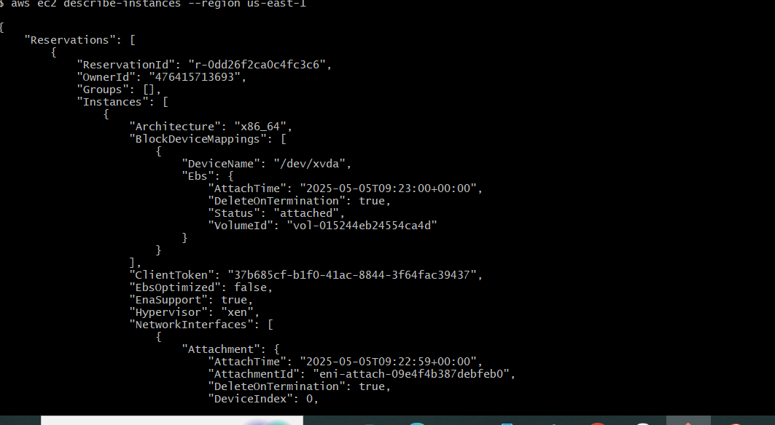

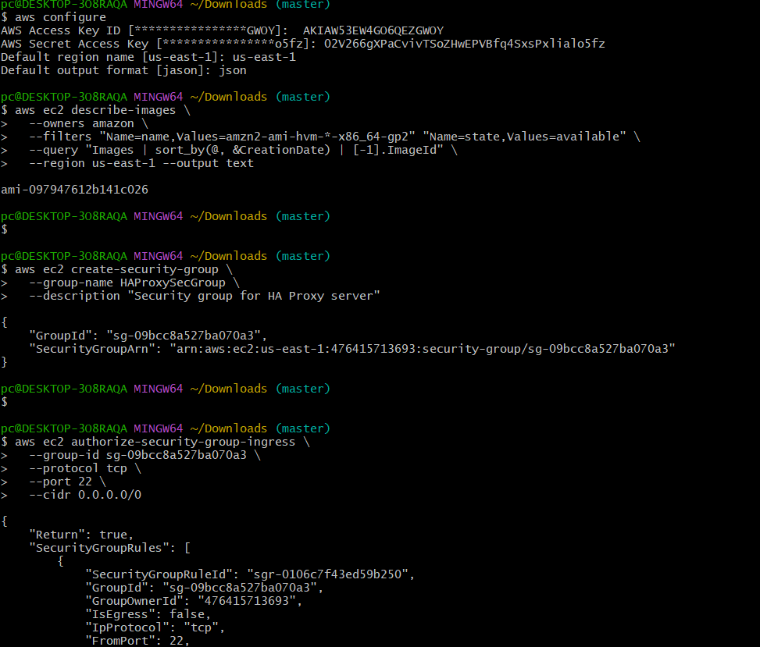

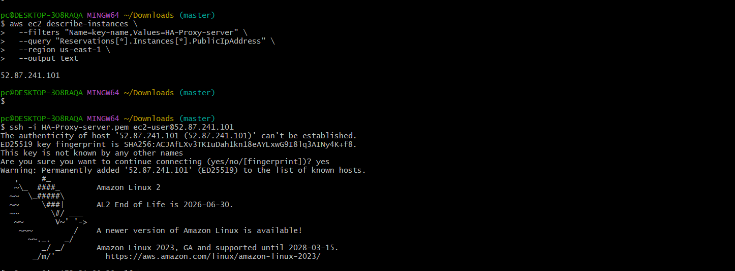

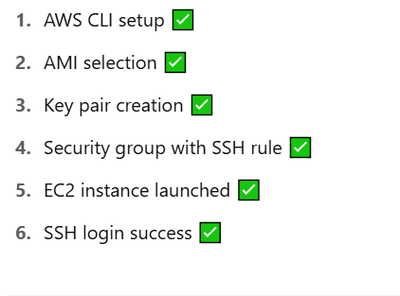

STEPS:

**1. AWS CLI Setup**

* Installed AWS CLI and configured access with key and region.

**✅ 2. Retrieve AMI ID**

* Got the latest Amazon Linux 2 AMI ID (ami-097947612b141c026).

**✅ 3. Create SSH Key Pair**

* Created **HA-Proxy-server.pem** for SSH access.

**✅ 4. Create Security Group**

* Created **HAProxySecGroup** and allowed inbound SSH (port 22).

**✅ 5. Launch EC2 Instance**

* Launched EC2 instance using the AMI, key pair, and security group.

**✅ 6. Get Public IP**

* Retrieved public IP: 52.87.241.101.

**✅ 7. SSH Login**

* Logged into EC2 instance via SSH: ssh -i HA-Proxy-server.pem ec2-user@52.87.241.101.