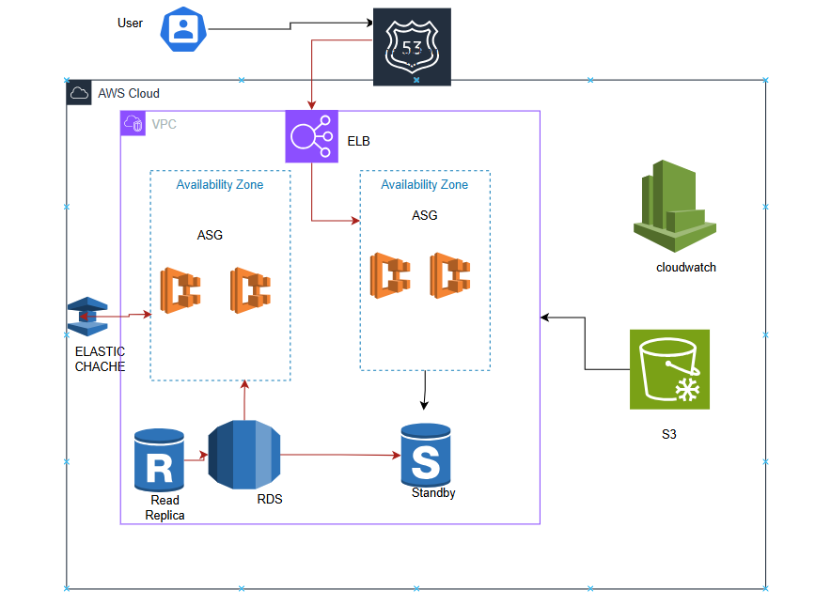

1️⃣

**User Interaction**: Users access the application through the internet.

2️⃣

**Route 53**: Handles domain name resolution and routes traffic efficiently.

3️⃣

**Elastic Load Balancer (ELB)**: Balances incoming traffic across multiple servers to prevent overload.

4️⃣

**Auto Scaling Group**: Automatically adds or removes EC2 instances based on demand.

5️⃣

**Elastic ache**: Stores frequently accessed data in memory to speed up responses.

6️⃣

**RDS Database**: Stores application data with a **primary instance**, a **read replica**, and a **standby instance** for backup.

7️⃣

**S3 Storage**: Stores static files like images, backups, and logs.

8️⃣

**CloudWatch & CloudTrail**: Monitors system performance, logs activities, and tracks security events.