1. Create one IAM user and assign ec2,s3 full access role.

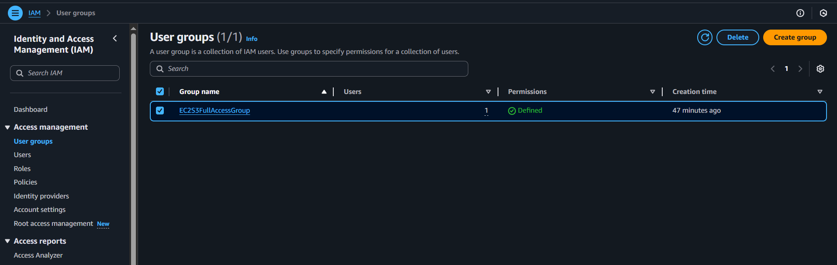

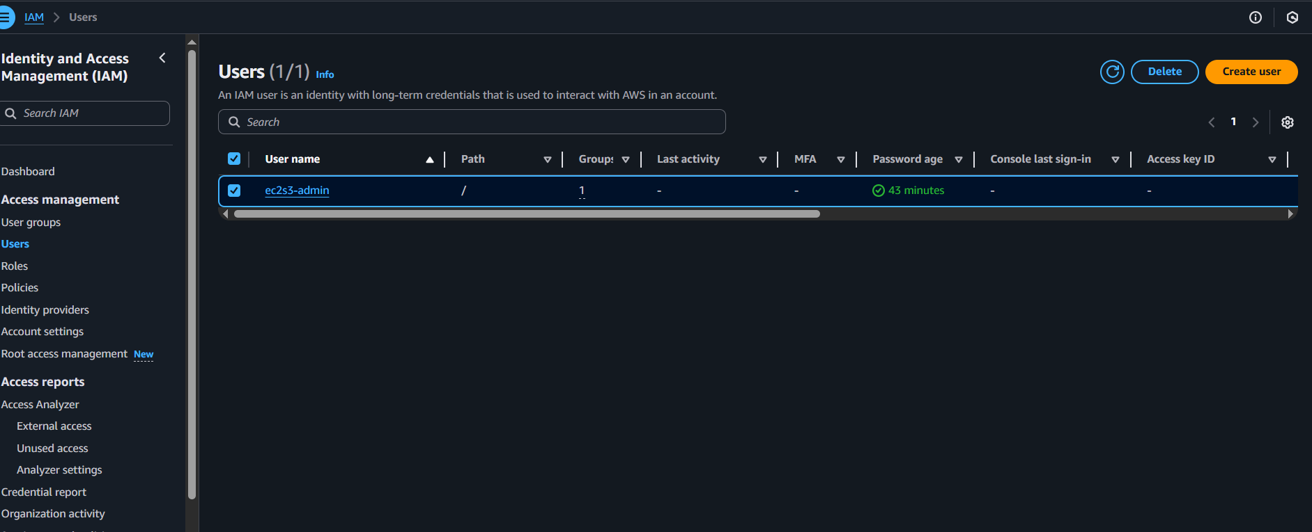

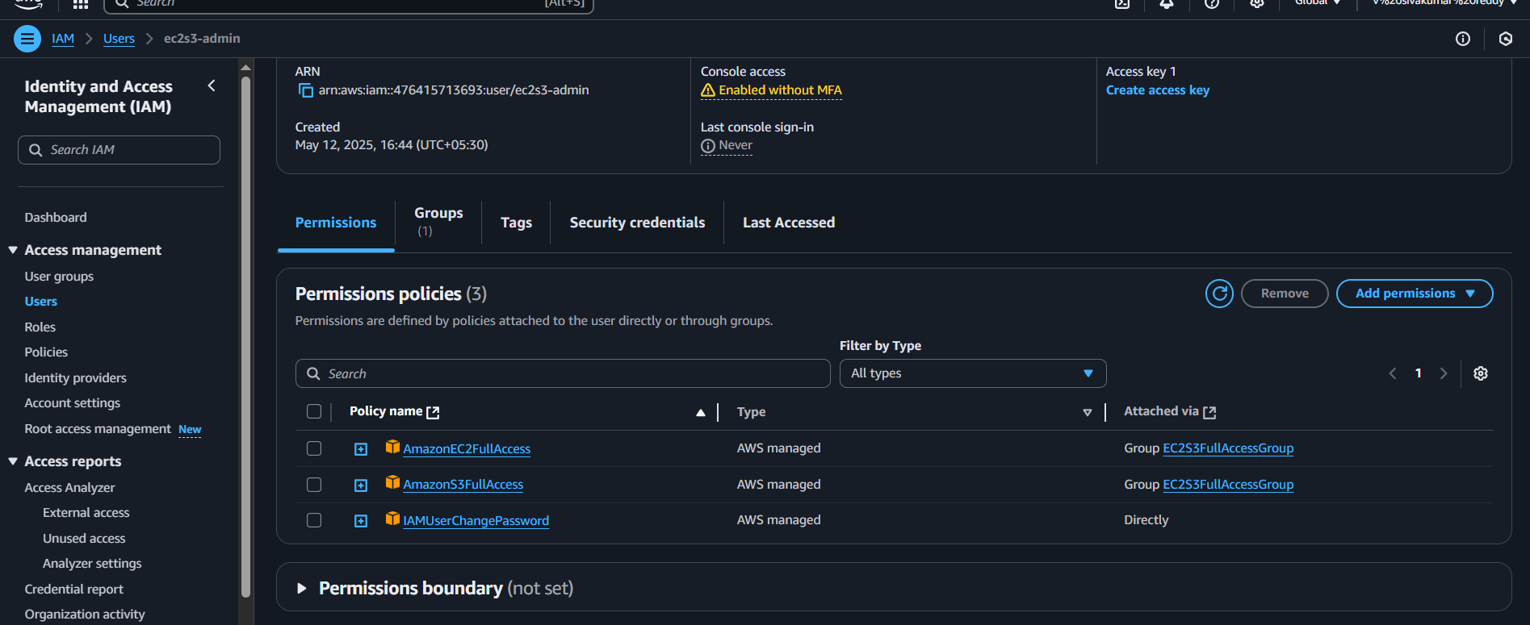

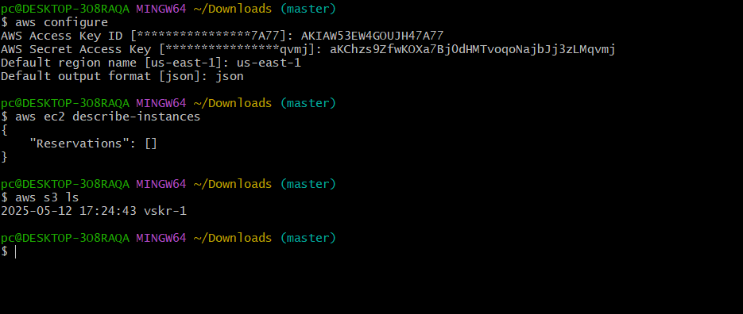

STEPS:

**1. Created an IAM User**

* ✅ You created a new IAM user.
* ✅ You obtained that user's **access key ID** and **secret access key**

**2. Assigned EC2 and S3 Full Access**

* ✅ You attached these AWS managed policies to the IAM user:
  + AmazonEC2FullAccess
  + AmazonS3FullAccess

**. Configured AWS CLI with IAM User Credentials**

* . Configured AWS CLI with IAM User Credentials
* • Entered your IAM user’s **Access Key**, **Secret Key**
* • Set region to us-east-1
* • Output format as json

Tested EC2 Access

aws ec2 describe-instances

Got a valid response: "Reservations": [] — this means CLI access is working, but no EC2 instances exist yet.

Tested S3 Access

aws s3 ls

Created an S3 Bucket

aws s3 mb s3://vskr-1

1. Create one Group in IAM and Assign Read access for ec2.

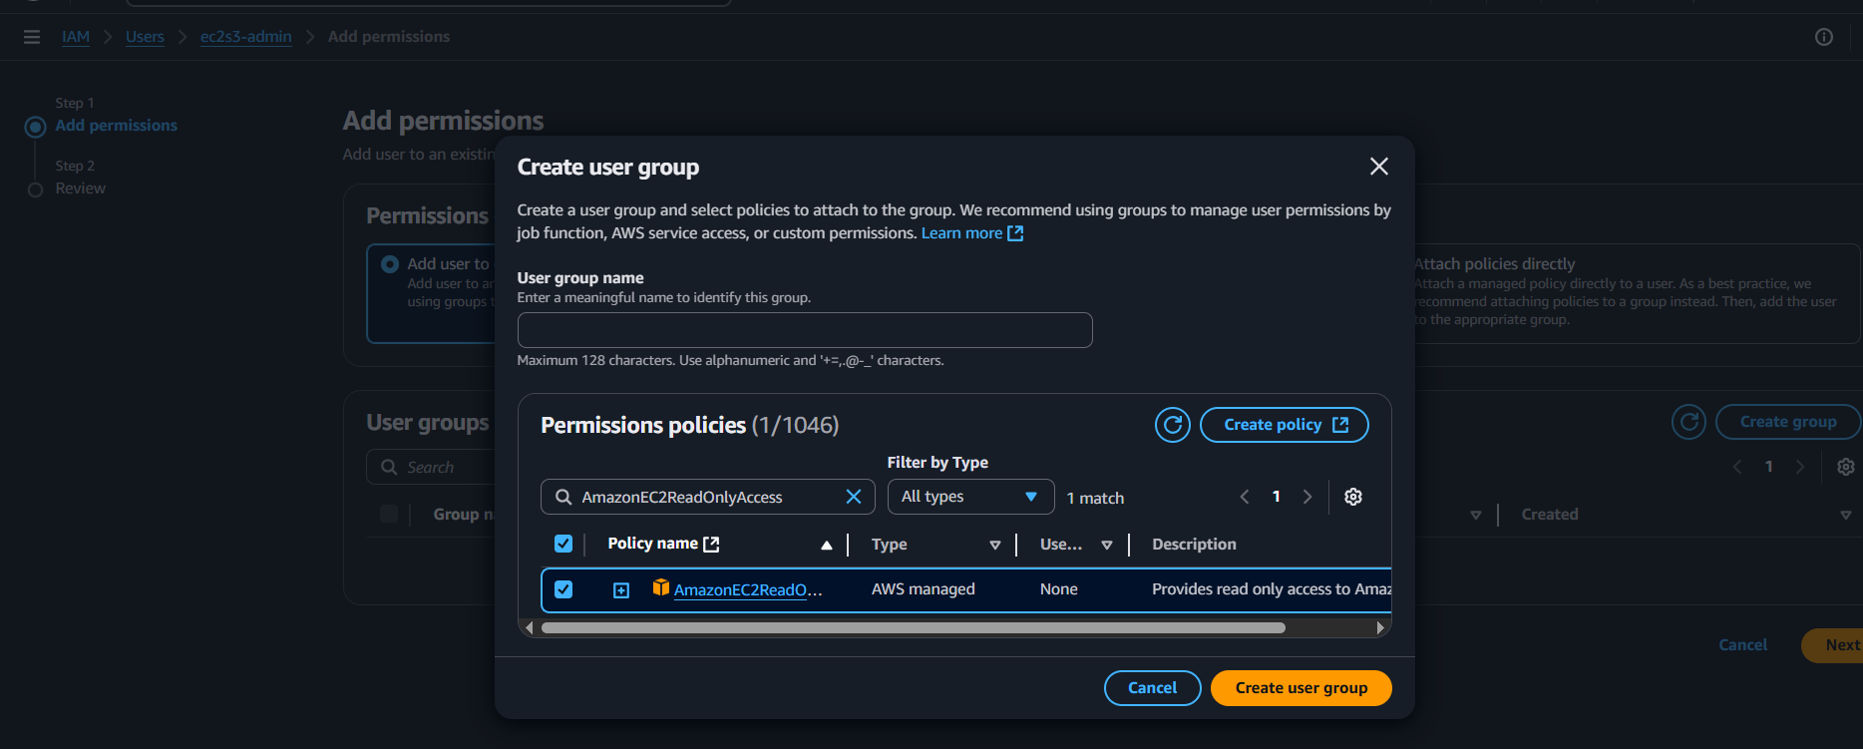

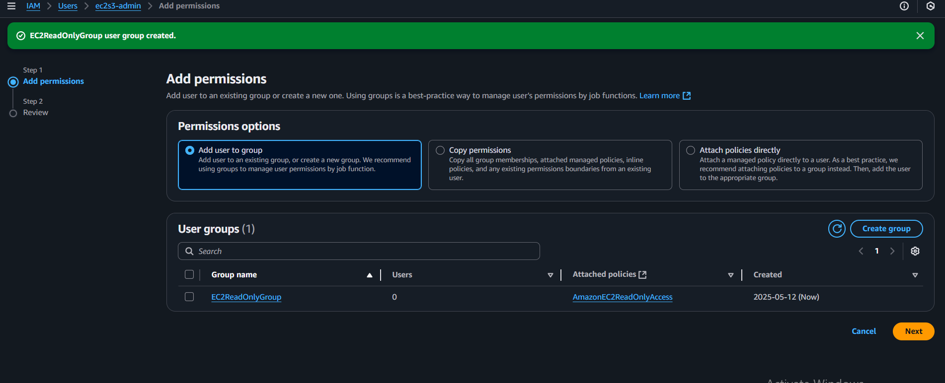

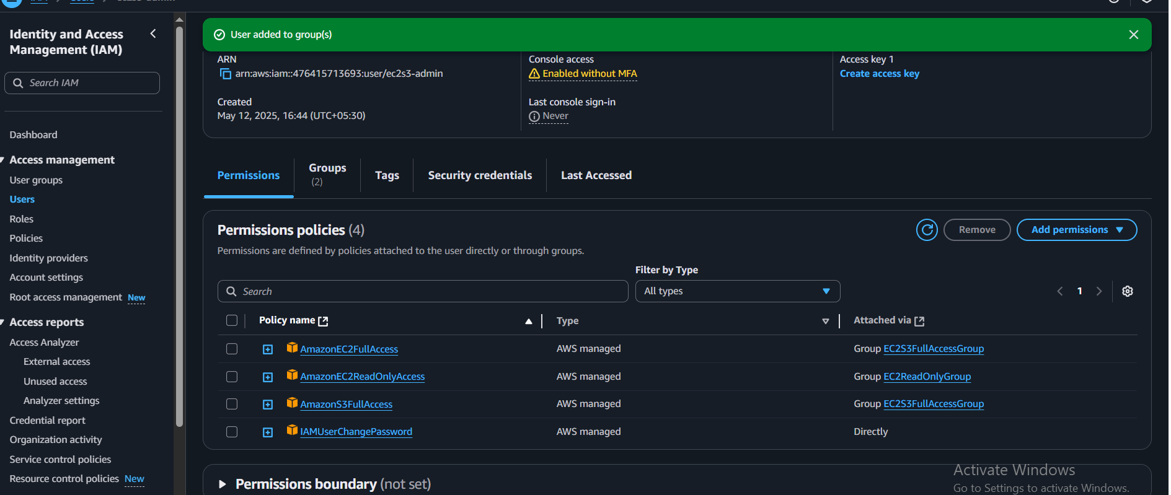

STEPS:

* + 1. Go to IAM Console

**Select the User**

* Click **Users** in the left menu
* Click the user **ec2s3-admin**
* Click **“Add permissions”**

**3. Choose Permission Option**

* Select **“Add user to group”**
* Click **“Create group”**

**4. Create Group**

* Group name: EC2ReadOnlyGroup
* In the policy search box, type: AmazonEC2ReadOnlyAccess
* Check the box next to the policy
* Click **“Create group”**

**5. Attach the Group to the User**

* The group EC2ReadOnlyGroup is selected
* Click **Next**
* Review the summary
* Click **“Add permissions”**

**Result:**

* User ec2s3-admin is now in EC2ReadOnlyGroup
* That group has **read-only access to** EC2Top of FormBottom of Form

1. Create a new user with name Devops and add to the group created in task2.

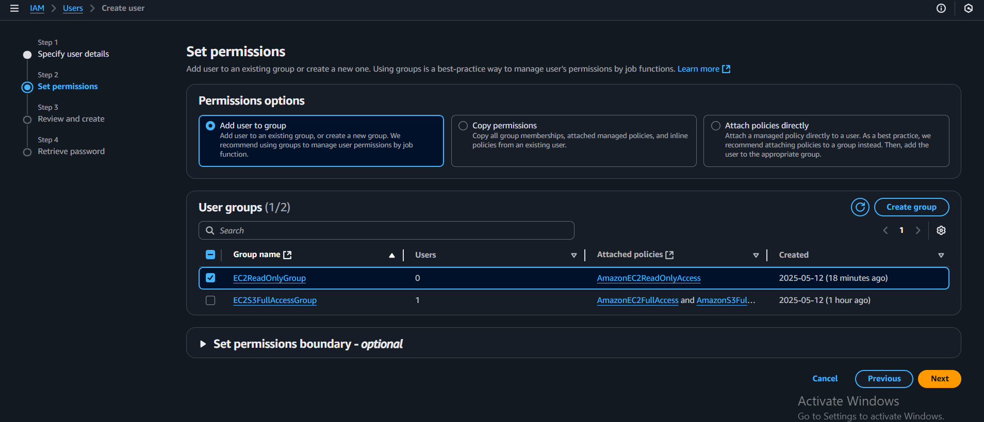

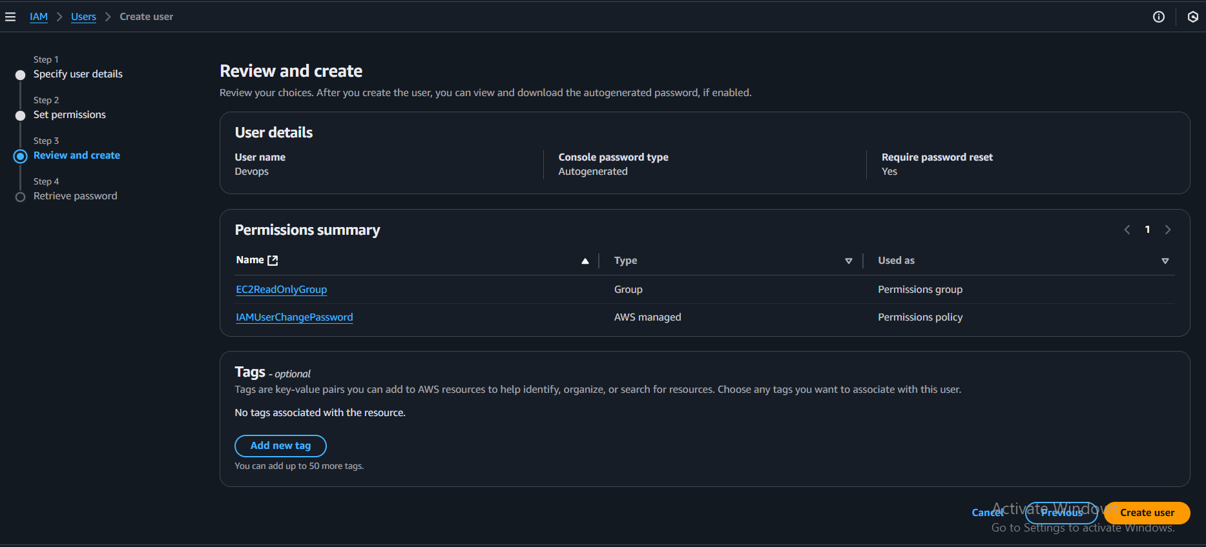

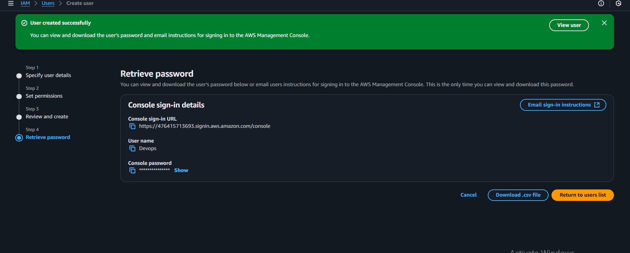

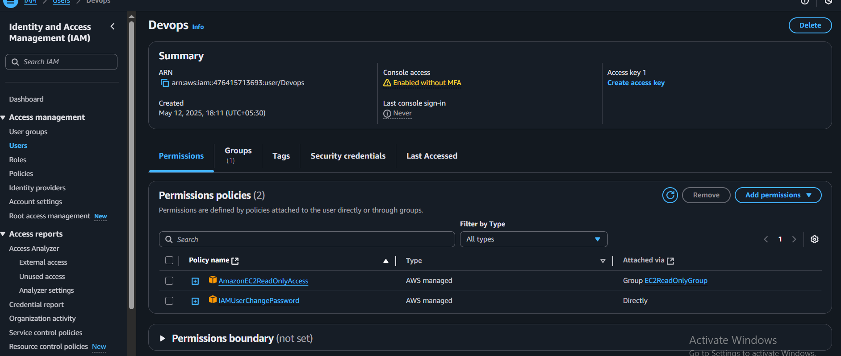

STEPS:

1.Go to IAM dashboard

2.Next create new user name as DEVOPS and give permission to AmazonEC2ReadOnlyAccess with access key also.

1. Write a bash script to create a IAM user with VPC full access.

Steps:

First we have save the bash script to create a iam user with vpc full access

Next we have to execute the script required commands

After that new iam user will be created and then we have to create access key

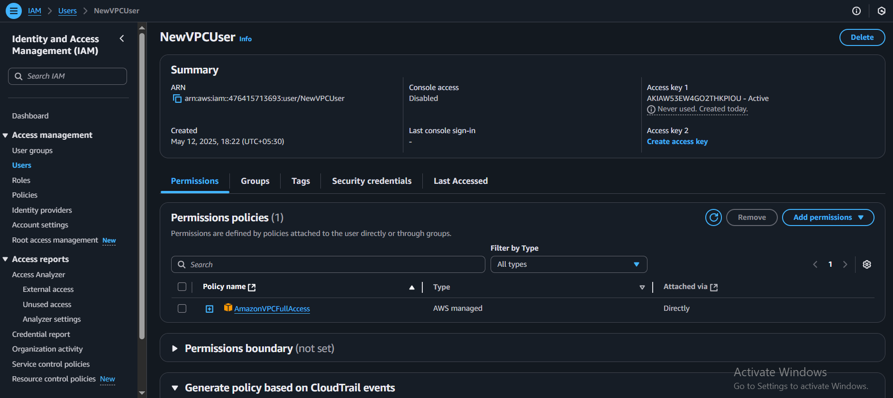

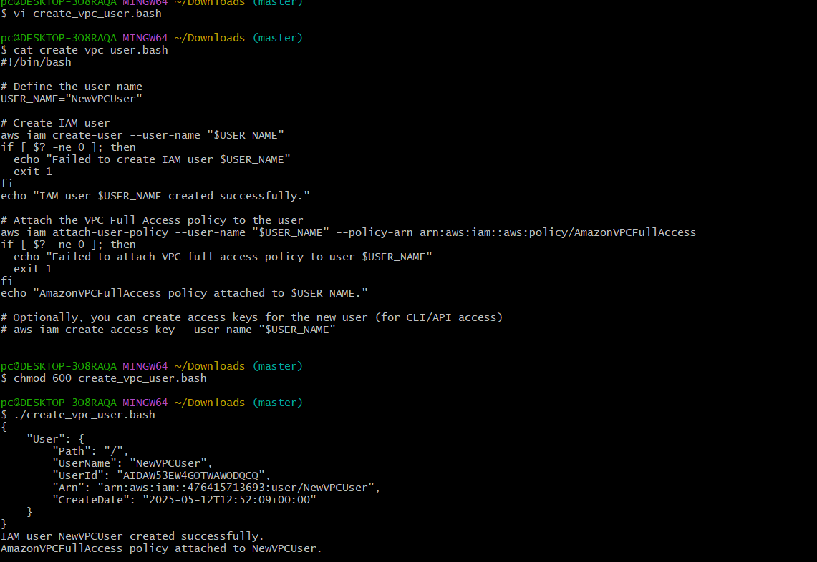

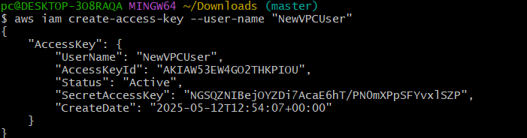

1. Create a IAM policy to access ec2 for a specific user in specific regions only.

Steps:

go to the policy’s and select EC2 and slect Describe regions

then in the request conditions give the regions and click on create policy

then attach that policy to the user and then verify it is working or not

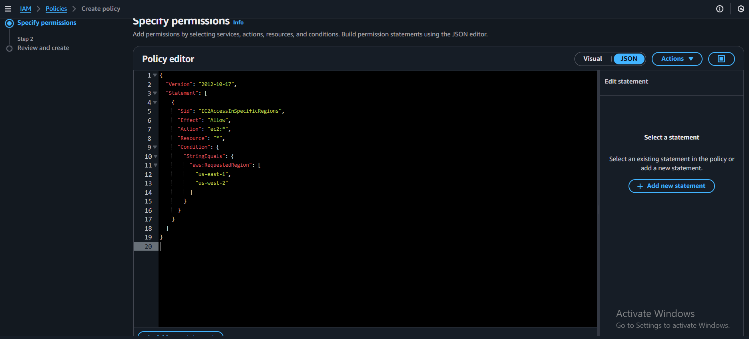

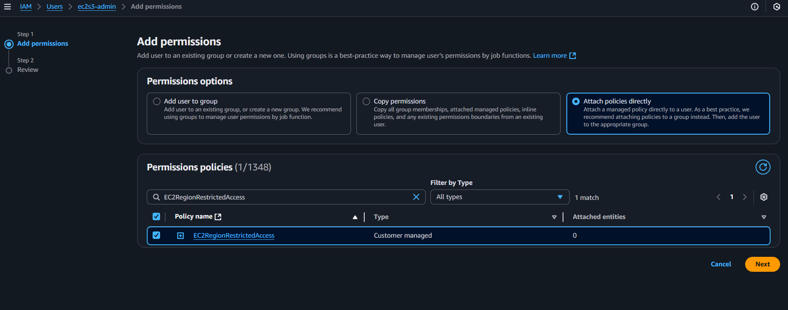

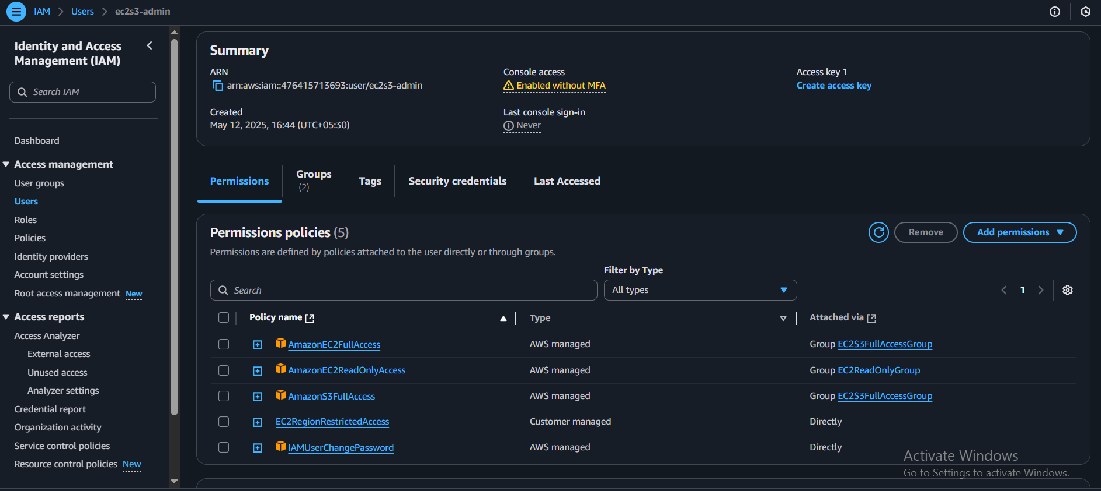

1. We have two accounts Account A and Account B, Account A user should access s3 bucket in Account B. (Collaborate with team member and execute this.Mostly asked in every interview)

Steps:

in **account a**

**s3 bucket policy :**

in policy attach s3 bucket arn and user arn

in **account b** users data

* **bucket policu edit :** to verify use the cammand :it will list the files

**aws s3 ls s3://theeshear.shop/ --profile s3bucket**

