1. Configure VPC peering in cross regions.

Steps:

First we have to create two vpc in two regions

Next for each vpc we have to give subnets, route tables,igw ,and nat gateway for the two vpc

Next we have to give peering connection to these two vpc and next we have two launch instances for this vpc and check the connectivity

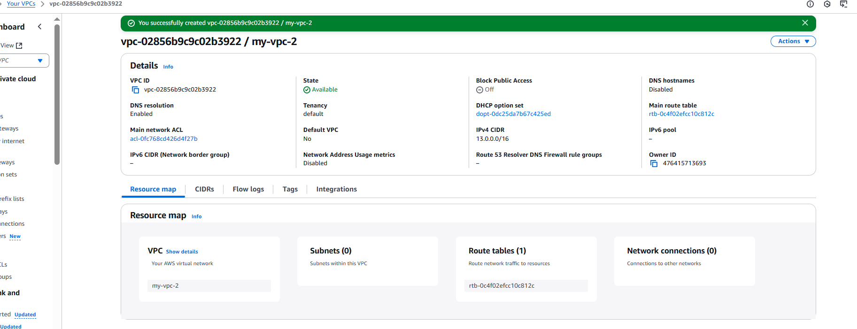

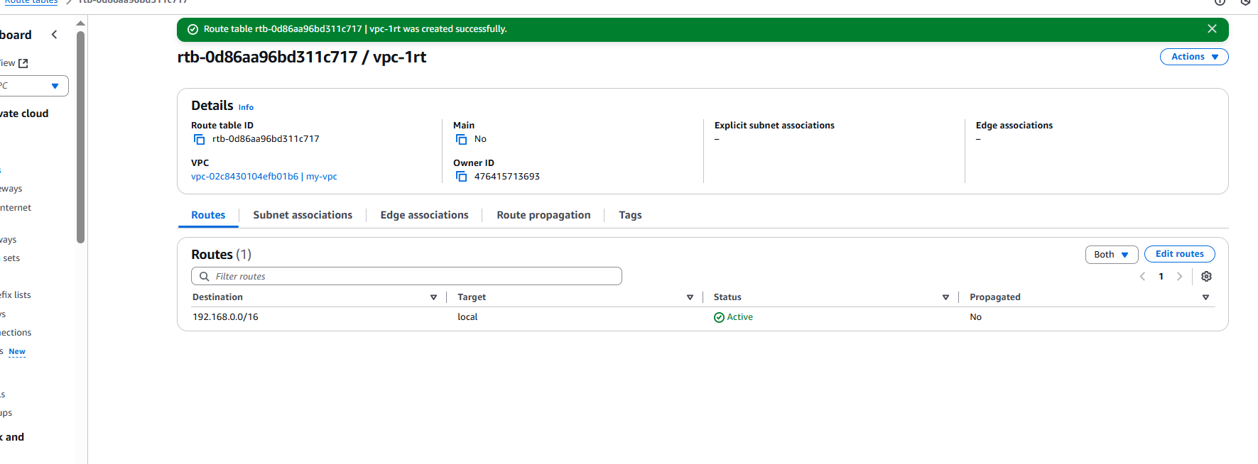

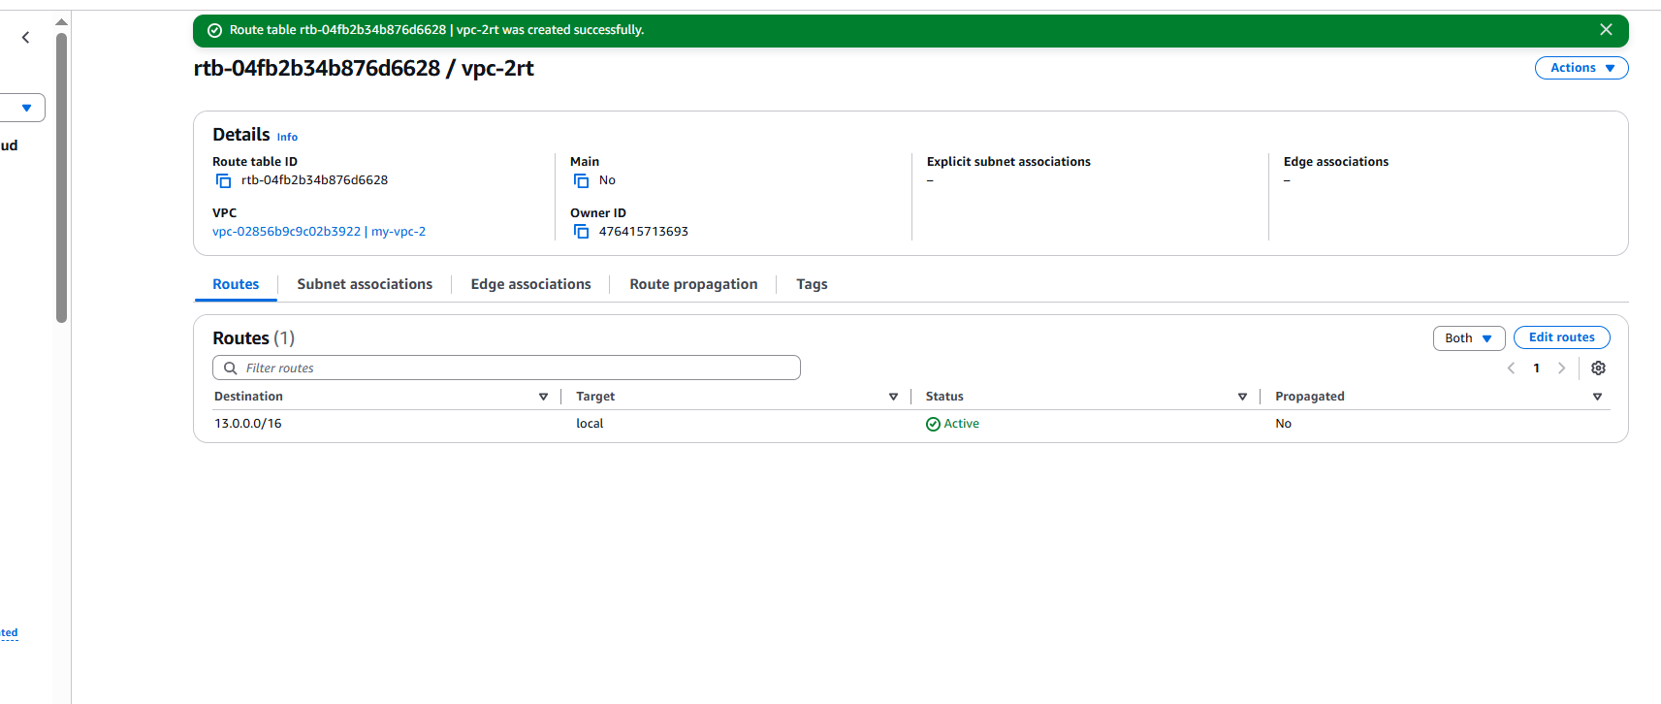

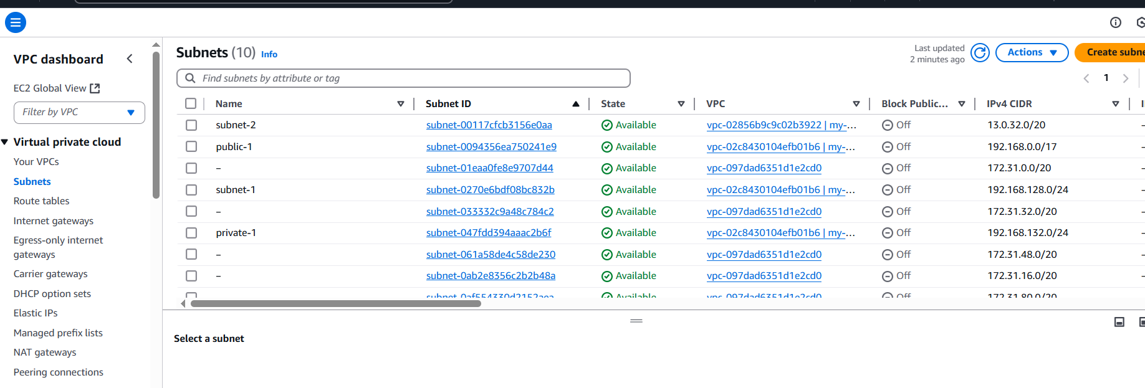

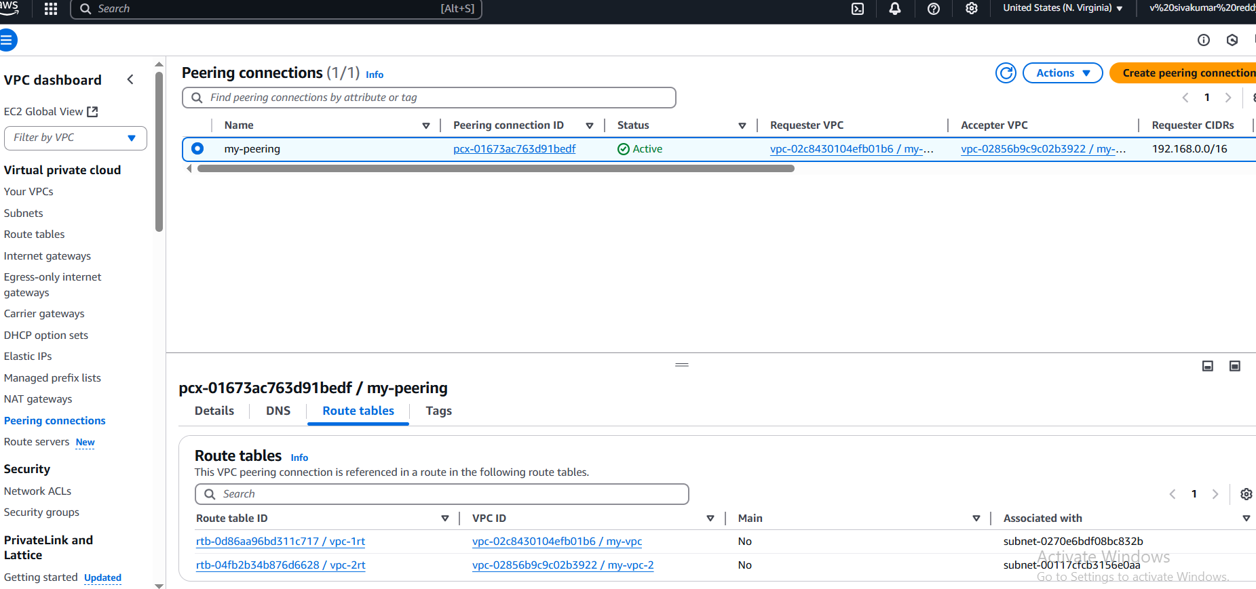

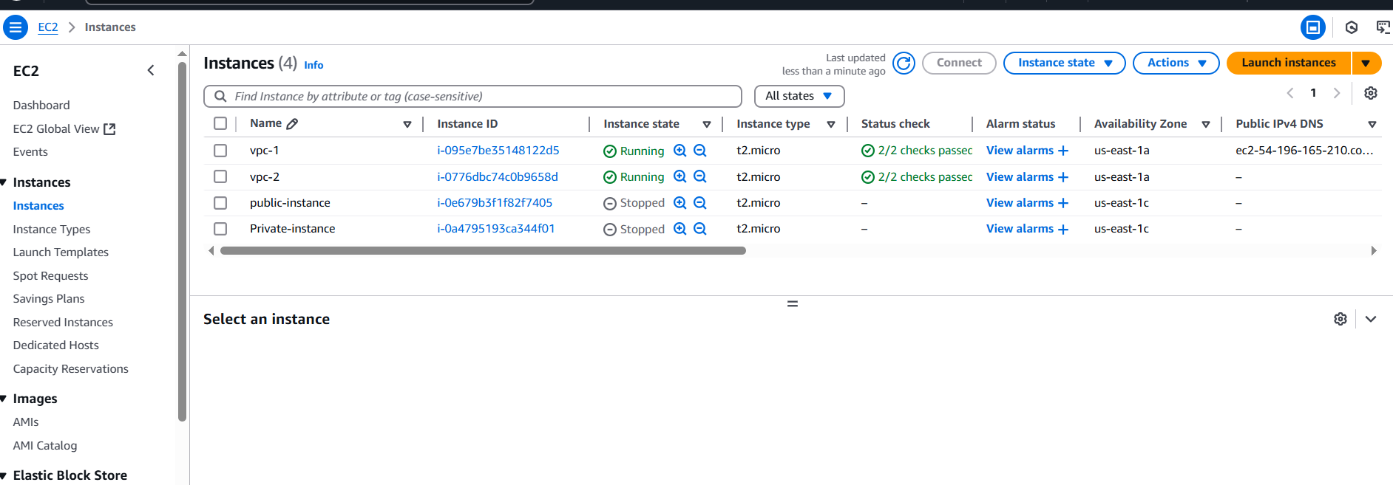

1. Purchase one domain from godaddy.

First we have to go to the godaddy website and

Next select domain which we want and

After that add to the cart and purchase the domain

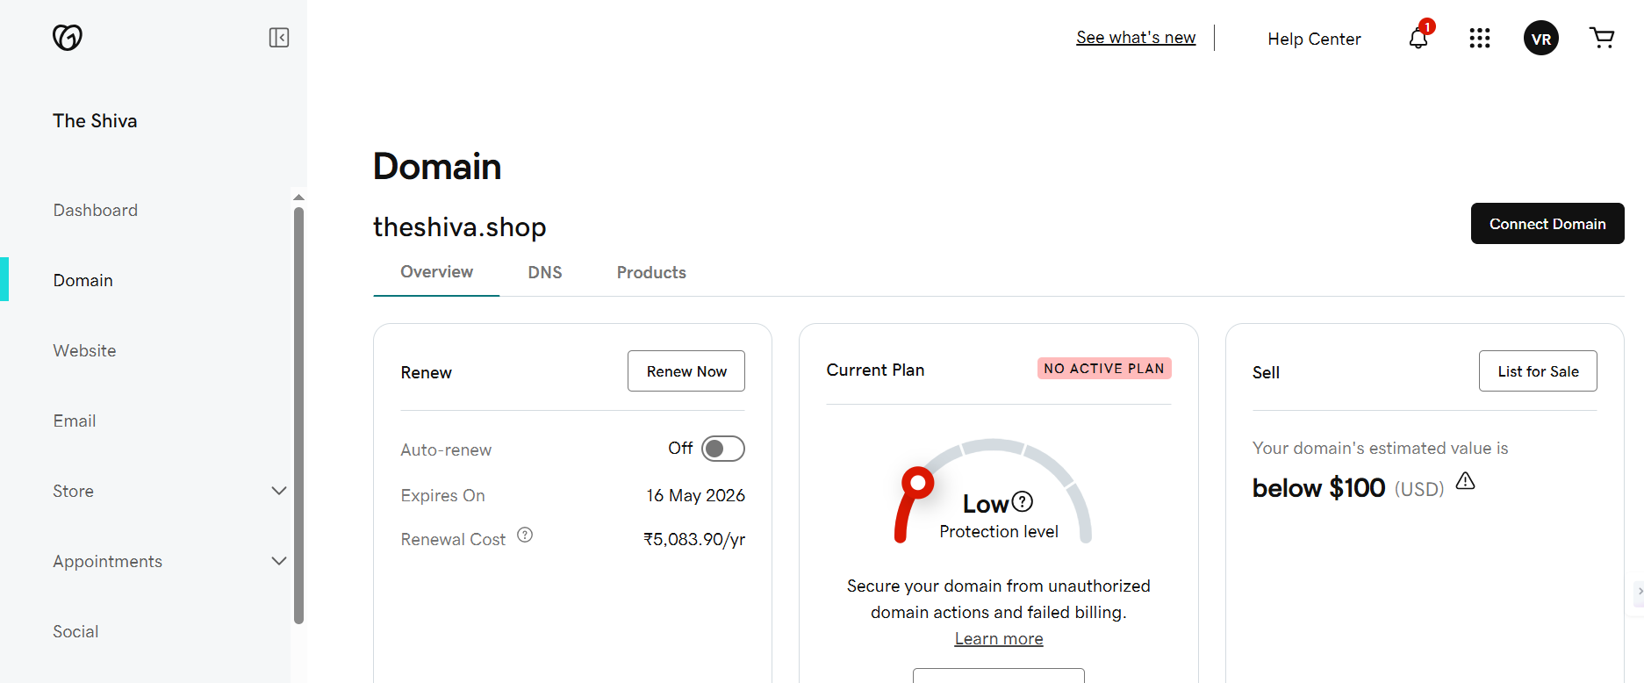

1. Deploy static webiste in s3.

Steps:

create one bucket and another is for accesslogs

and upload the **index.html in the s3 bucket**

got to the properties and click on static website >> add the index.html >> save

go the **server access logging** and add the **accesslog** bucket>>save it

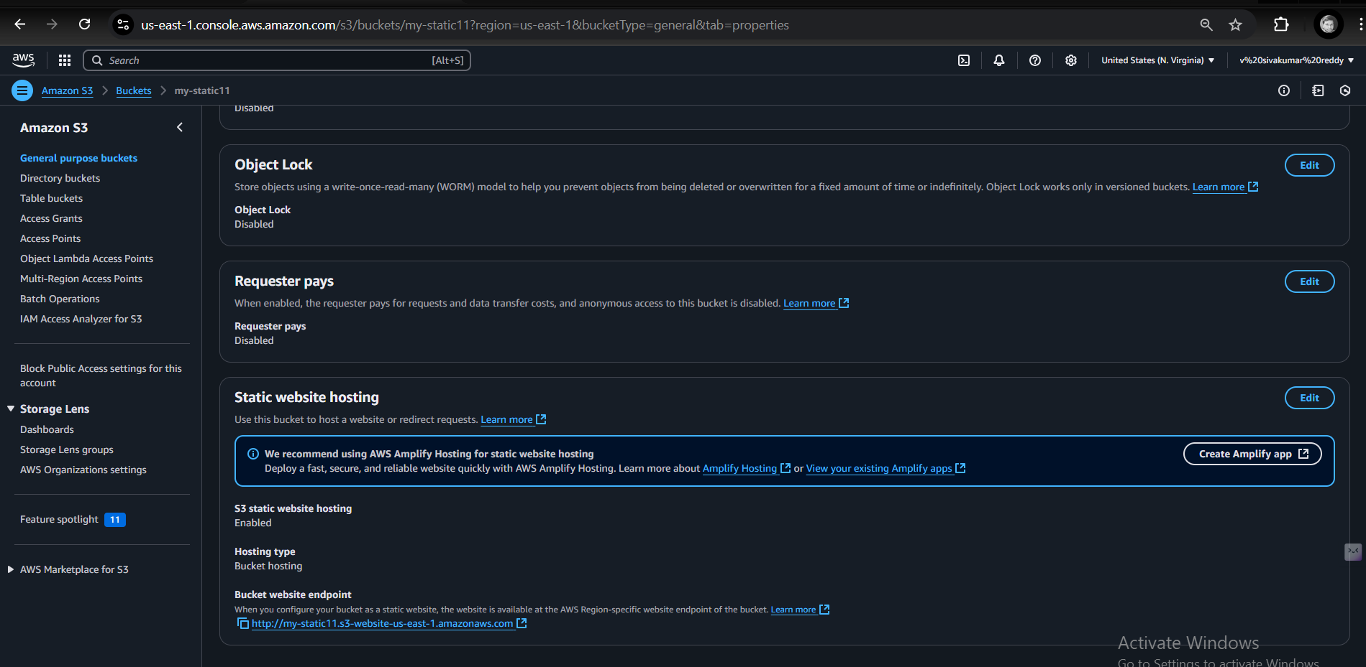

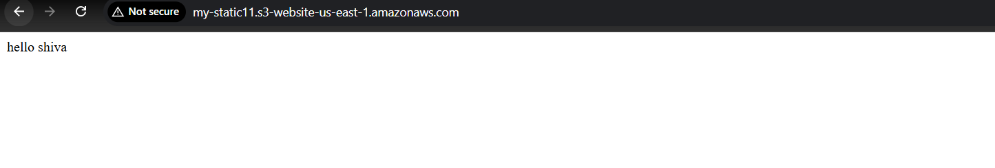

1. Create CDN and attach one SSL certificate.

Steps:

* First mosty go to **ACM’s and request a certificate with our domain name**
* after creation of **ssl certificate go to the Rote53 >>click on hosted zones >> create a with your domain name >>click on create hosted zones**
* attache the **CNAMES in our domain website**
* **I have purchased my domain in godaddy in that go to DNS and slect the name server and paste all the nameserver**
* Go to the **Cloud front and create the distribution and attach the domain name >>attach the ssl certificate and click on create**
* In the **cloudfront with domain name we verify that the website is openning or not**

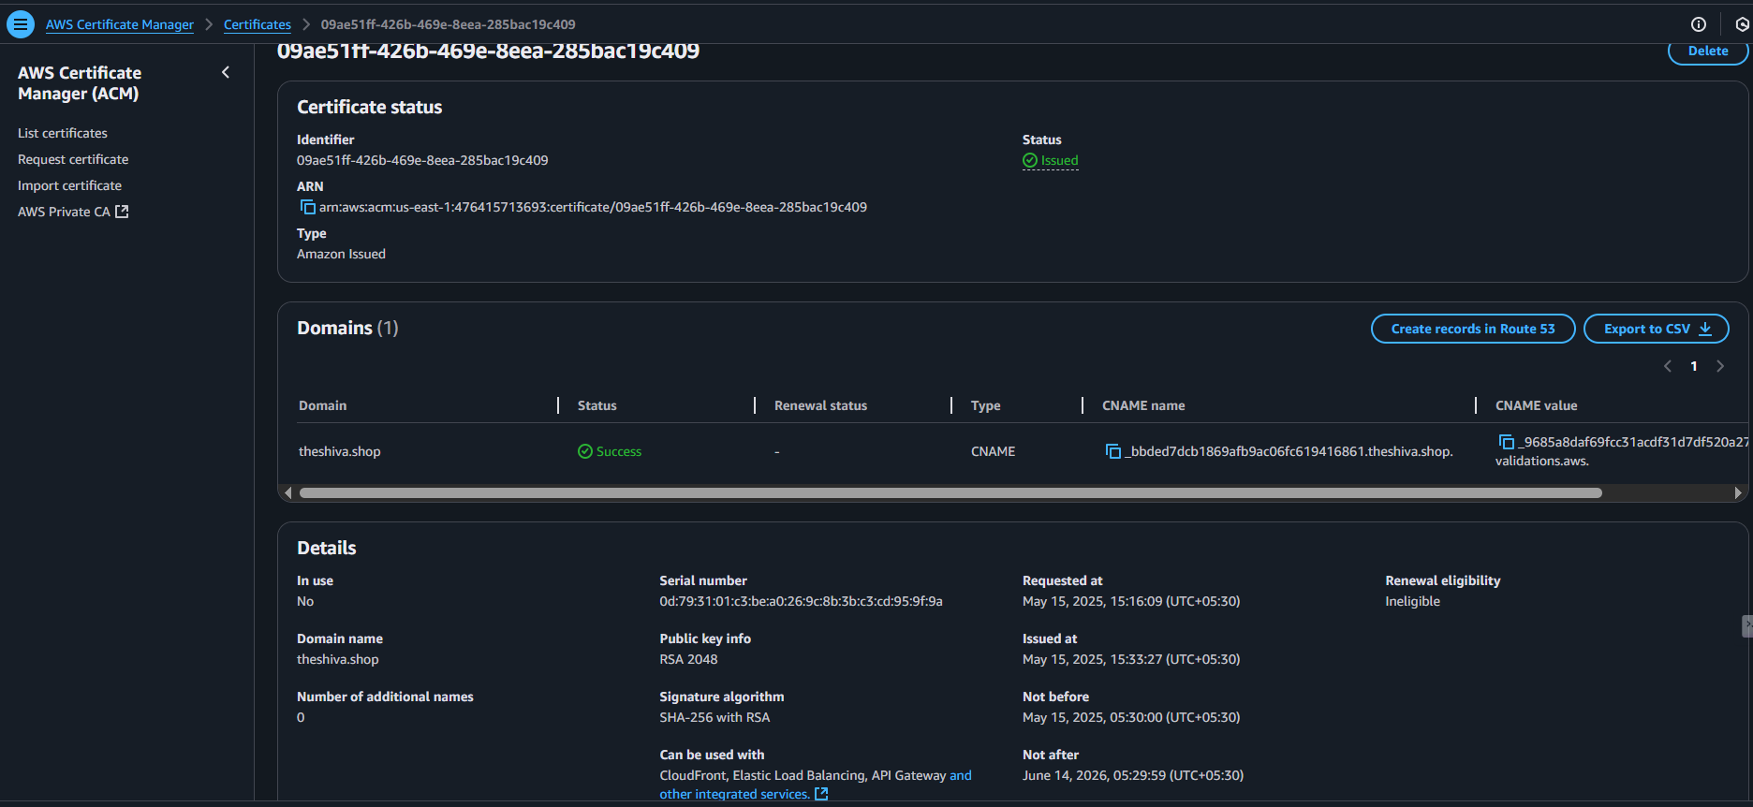

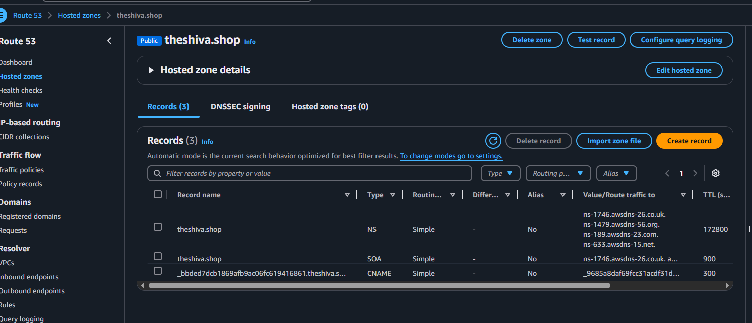

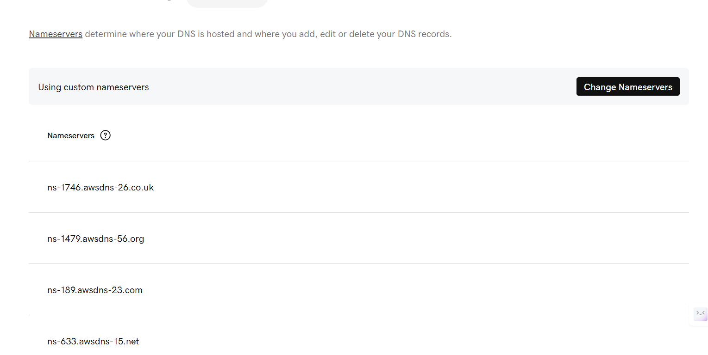

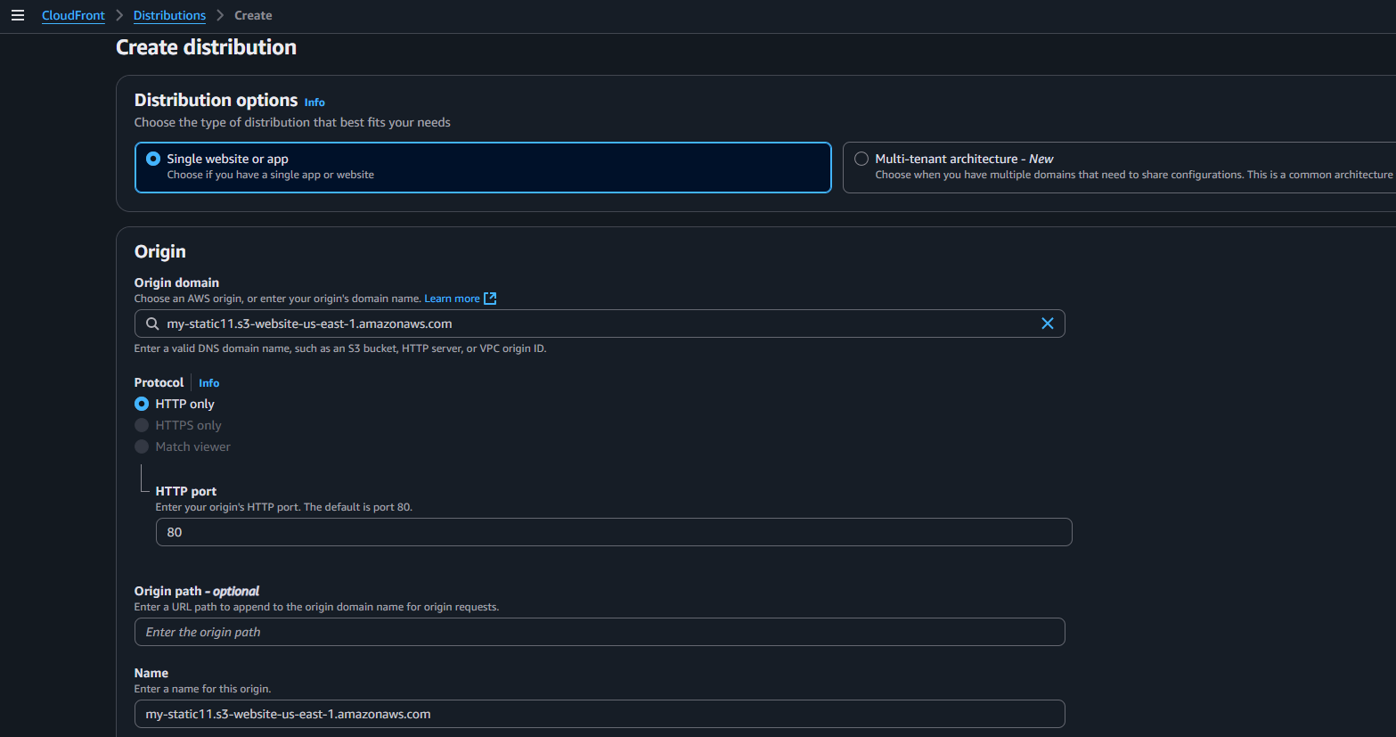

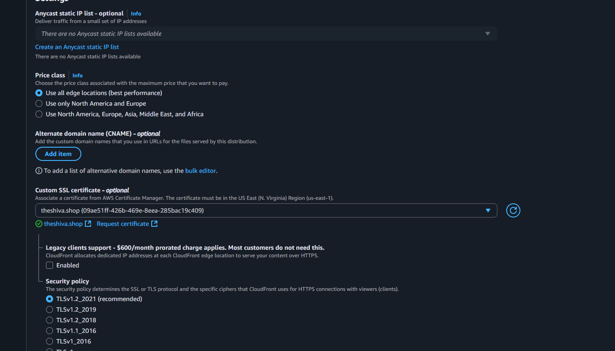

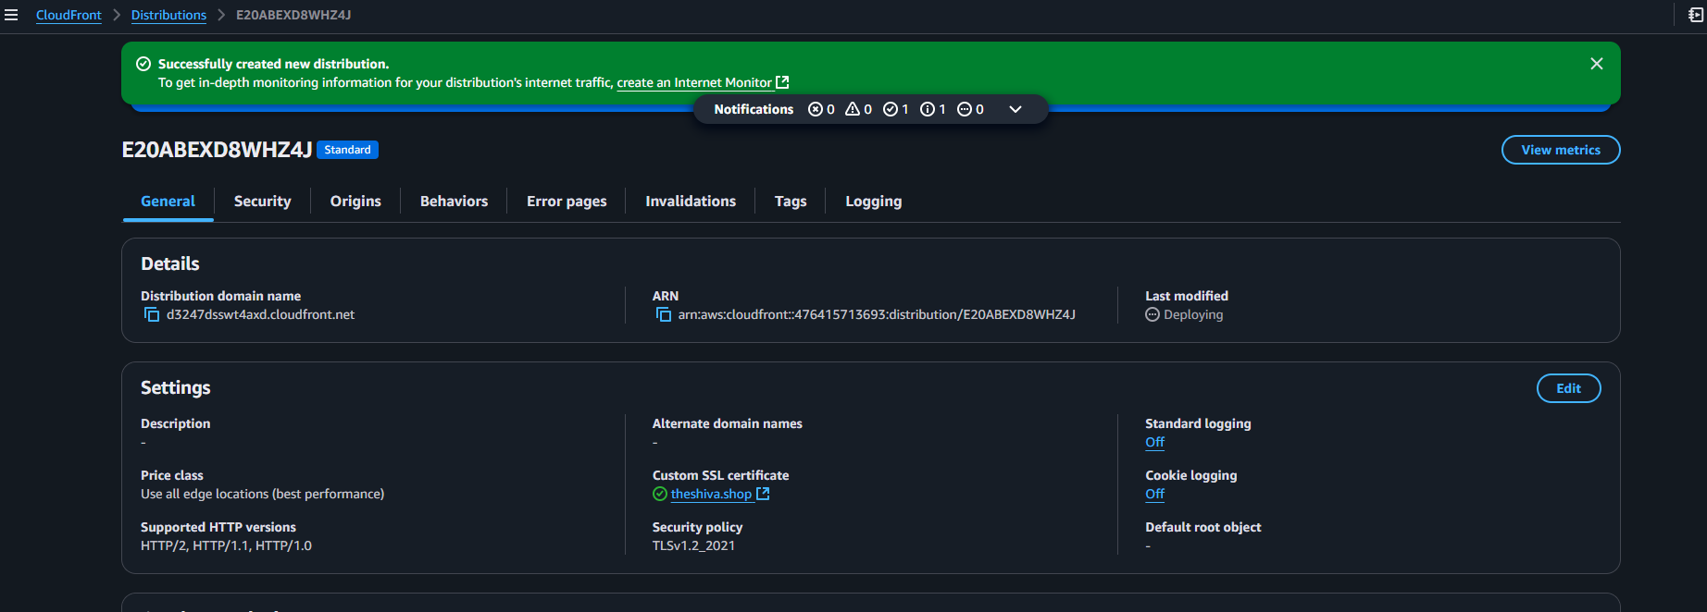

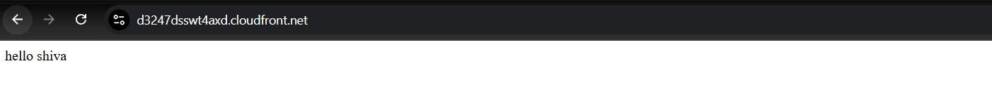

1. Create Route53 hosted zone and MAP the domain with CDN.

Steps:

**go to the Rote53 >>click on hosted zones >> create a with your domain name >>click on create hosted zones**

attache the **CNAMES in our domain website**

**I have purchased my domain in godaddy in that go to DNS and slect the name server and paste all the nameserver**

Go to the **Cloud front and create the distribution and attach the domain name >>attach the ssl certificate and click on create**

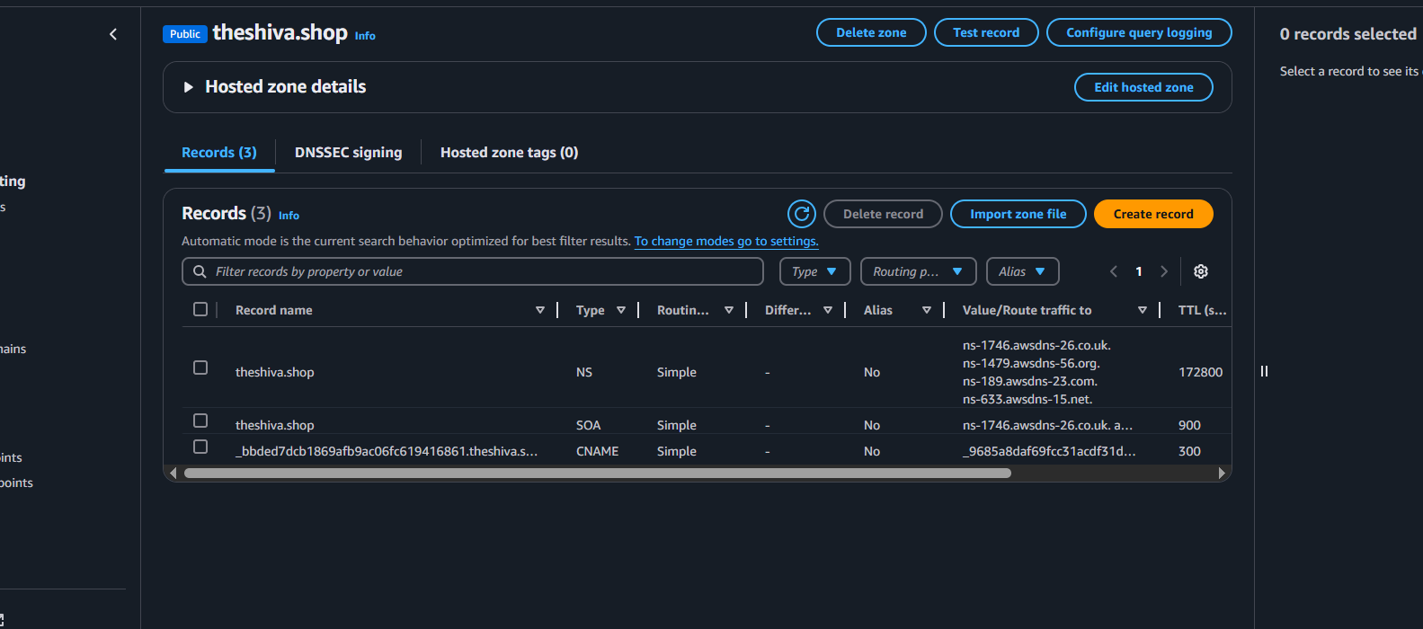



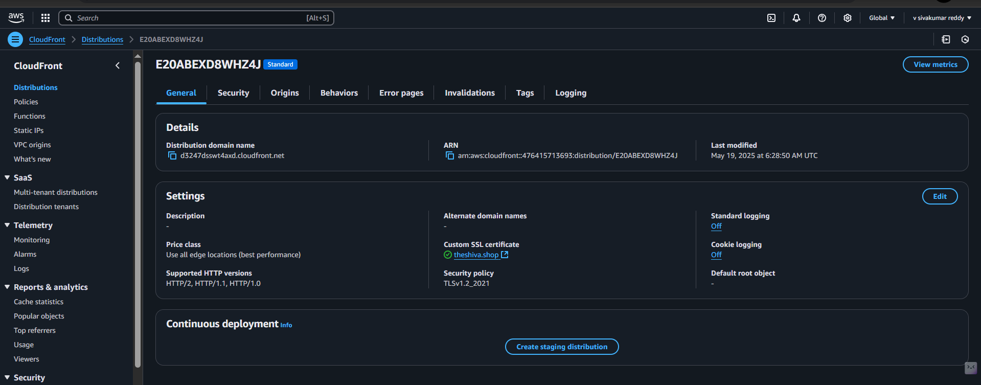

1. Update the index.html in s3 bucket and the updated file should be accessible by using domain name.

Steps:

add the **new index file in S3 bucket**

Go to **route53>>histezones>>create record>>on the alias>>select the alias to cloud distribution>>click on create record**

**Then check the domain**

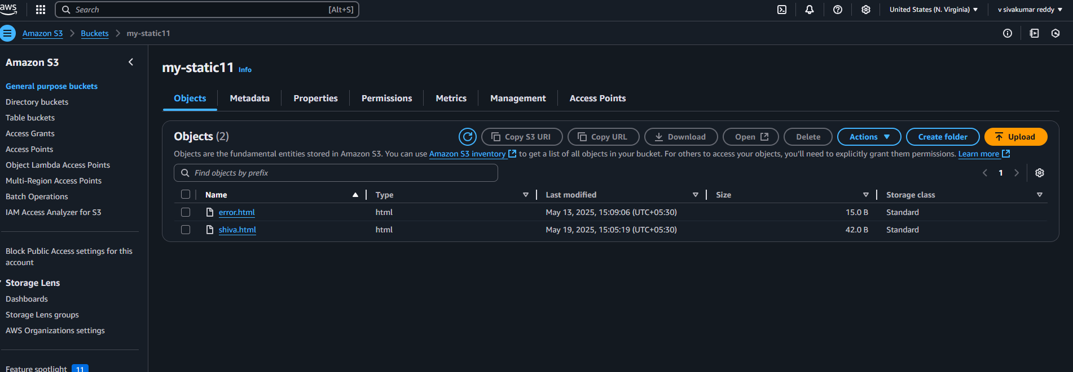

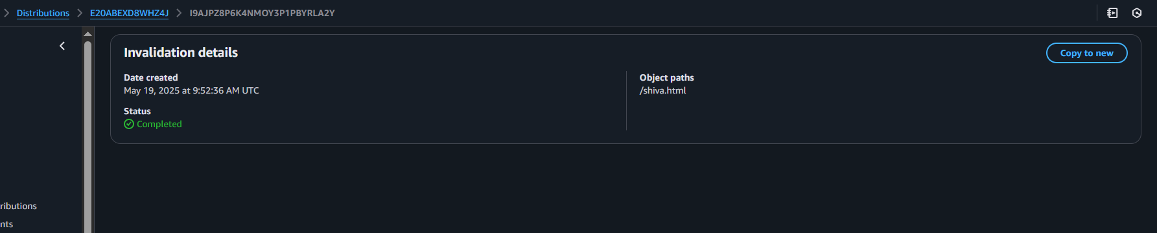

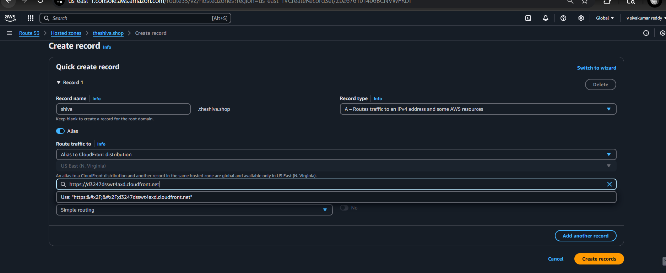

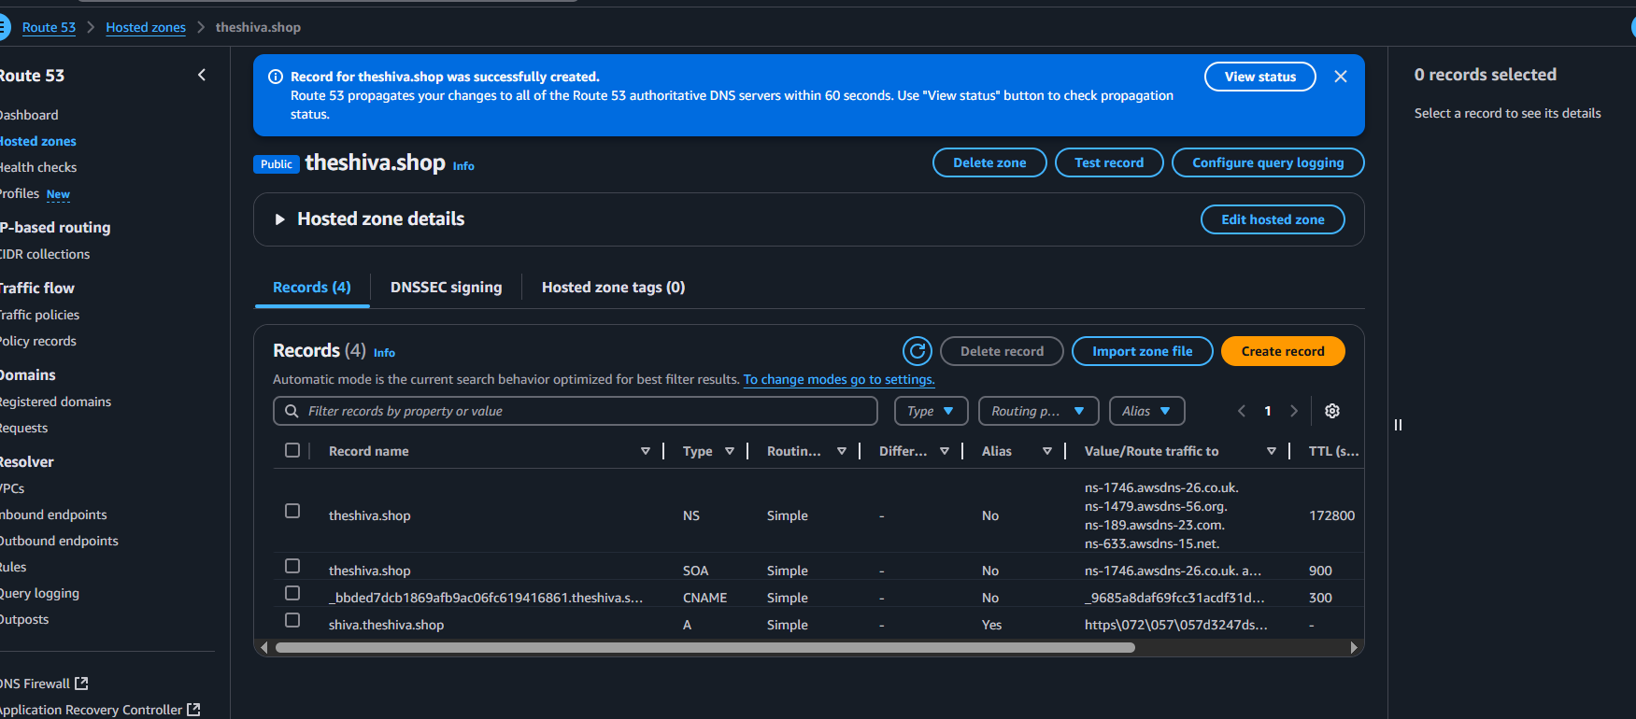

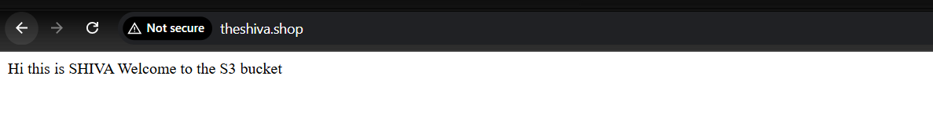

7) Share the Domain name in slack to test the connetivity.

