1. Create mariadb db on ec2.

Steps:

1. **Installed MariaDB server** on your EC2 instance.
2. **Started and enabled** the MariaDB service so it runs automatically.
3. **Secured MariaDB** using mysql_secure_installation by:
   * Setting the root password
   * Removing anonymous users
   * Disallowing remote root login
   * Removing test database
   * Reloading privilege tables
4. **Logged into MariaDB as root** user.
5. **Created a database** called inventorydb.
6. **Created a new user** called inv_admin with a password.
7. **Granted all privileges** on inventorydb to inv_admin.
8. **Tested logging in** as inv_admin and confirmed you can access the inventorydb database.

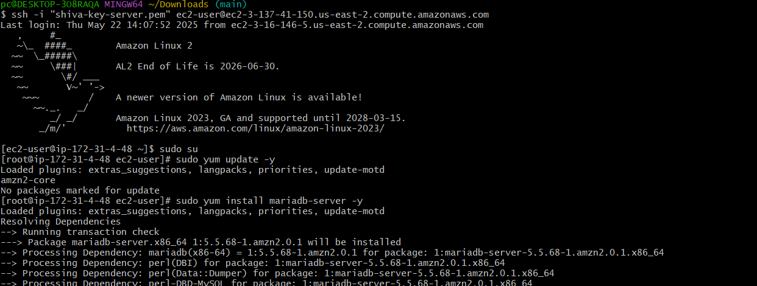

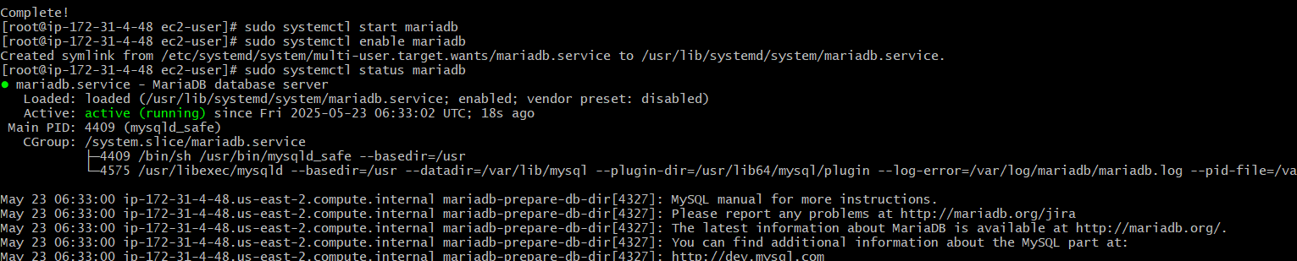

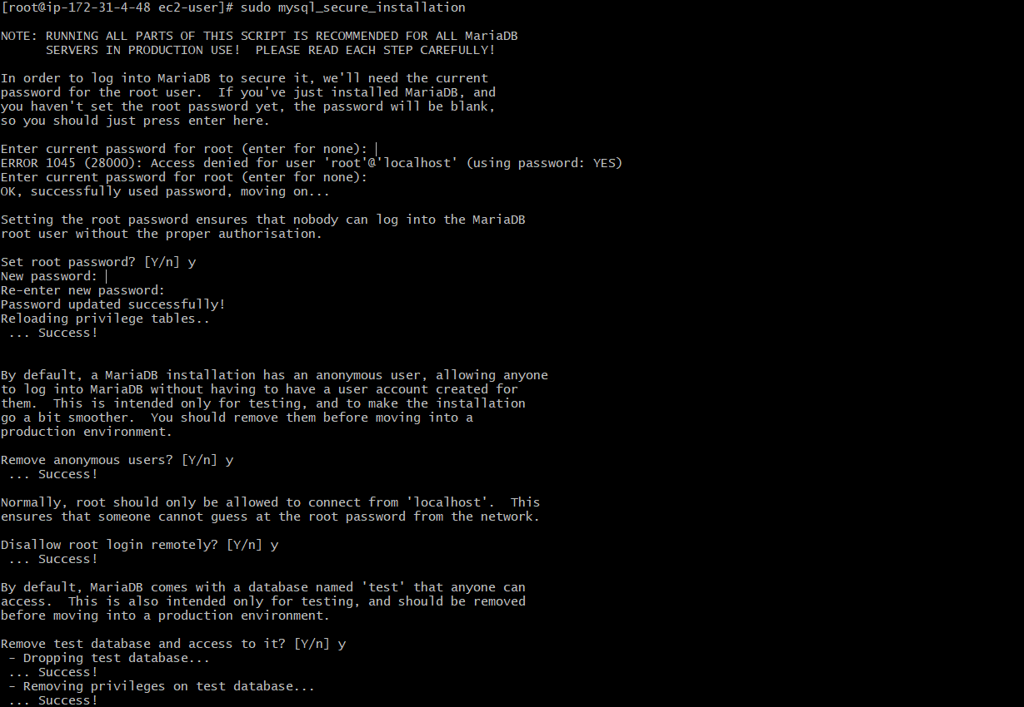

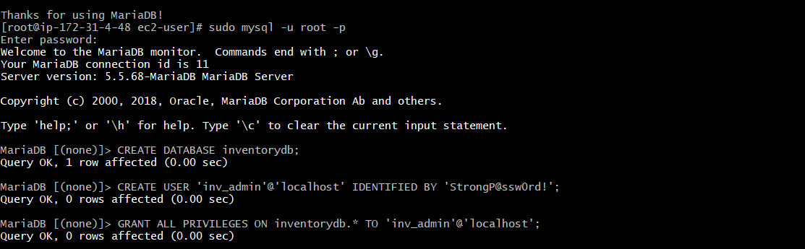

1. Insert some dummy data

Steps:

1. **Open MariaDB:**

sudo mysql

1. **Select your database:**

USE shivadb;

1. **Create a table:**

CREATE TABLE employees (

id INT AUTO_INCREMENT PRIMARY KEY,

name VARCHAR(100),

department VARCHAR(50),

salary DECIMAL(10,2)

);

1. **Insert dummy data:**

INSERT INTO employees (name, department, salary) VALUES

('Alice', 'HR', 55000.00),

('Bob', 'Engineering', 75000.00),

('Charlie', 'Marketing', 60000.00),

('Diana', 'Finance', 65000.00),

('Ethan', 'IT', 70000.00);

1. **Check the data:**

SELECT * FROM employees;

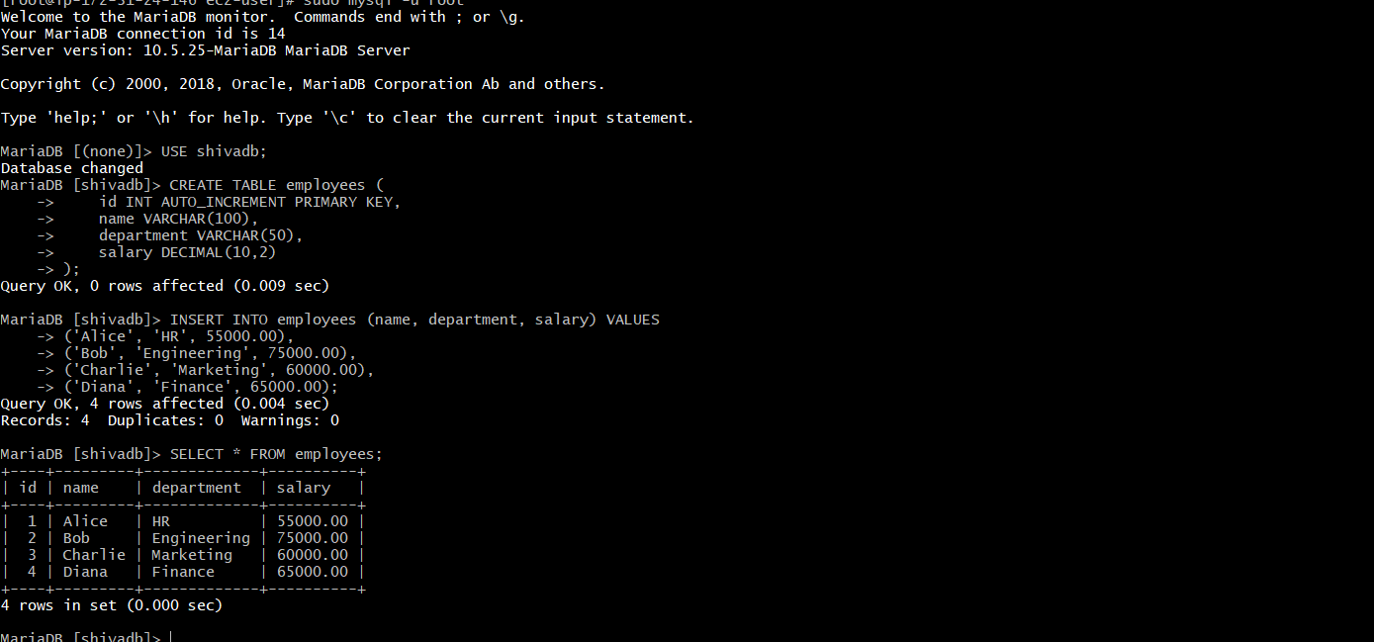

1. Take the backup of dummy data on ec2
2. **Logged into your EC2 instance via SSH.**
3. **Ran the mysqldump command** to export the shivadb database, including the dummy data, to a file

sudo mysqldump -u root -p shivadb > /home/ec2-user/shivadb_backup.sql

1. **Entered your MariaDB root password** when prompted.

On your **local PC terminal**, you ran this command to copy the backup file from EC2 to your PC:

scp -i ~/Downloads/shiva-key-server.pem ec2-user@18.191.143.172:/home/ec2-user/shivadb_backup.sql

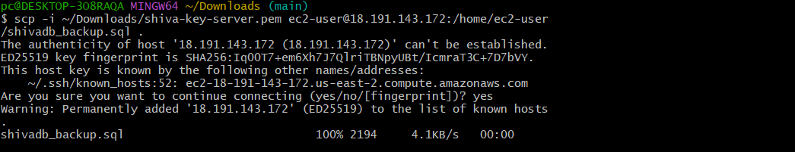

1. launch Mariadb RDS instance.

Logged into AWS Console and opened **RDS**.

Clicked **Create database** and picked **MariaDB**.

Set database name, username, and password.

Chose instance type and storage size.

Set network settings and allowed access (opened port 3306).

Clicked **Create** and waited for the database to be ready.

Got the database **endpoint** to connect to it.

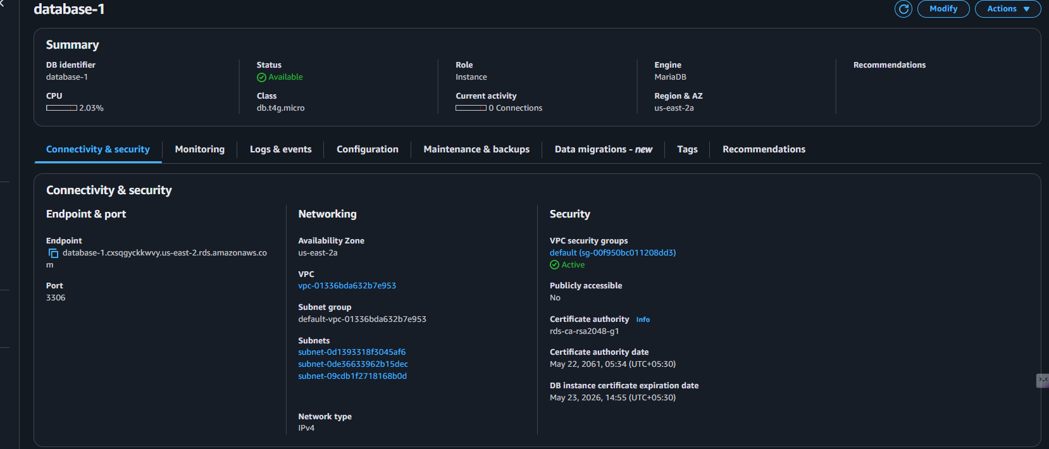

1. Migrate database from ec2 to RDS.

replace the rdc in the command  
λmysqldump -u root -p ec2db > ec2db.sql  
λmysql -h <replace-rds-end-point-here> -P 3306 -u   
rdsuser -p rdsdb < ec2db.sql  
λmysql -h <replace-rds-end-point-here> -P 3306 -u   
rdsuser -p  
USE rdsdb

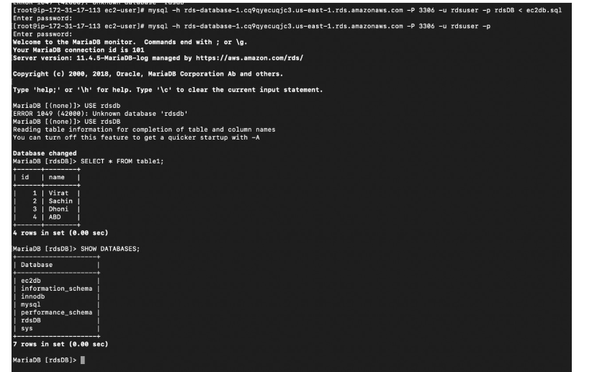

6) Install mysql db on ec2

Steps:

first mostly create one instance  
to install first we want install mariadb aswell  
sudo yum update -y  
sudo yum install -y mariadb-server  
sudo systemctl start mariadb  
sudo systemctl enable mariadb  
sudo mysql_secure_installation  
mysql -u root -p  
to verify the version :  
mysql --version

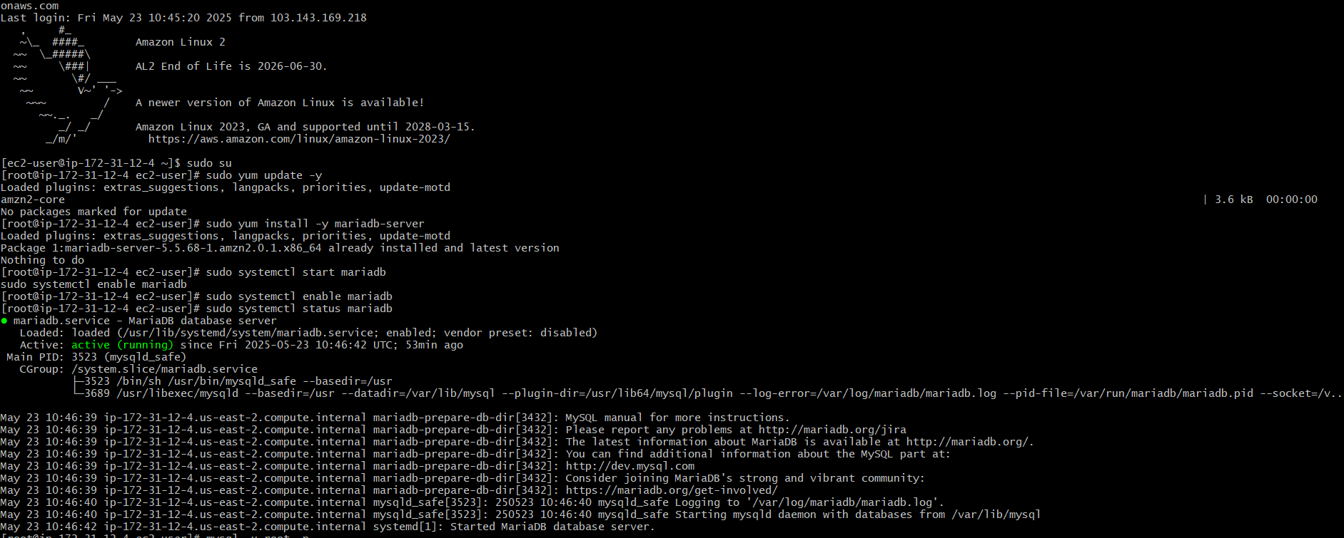

7) Launch mysql RDS image

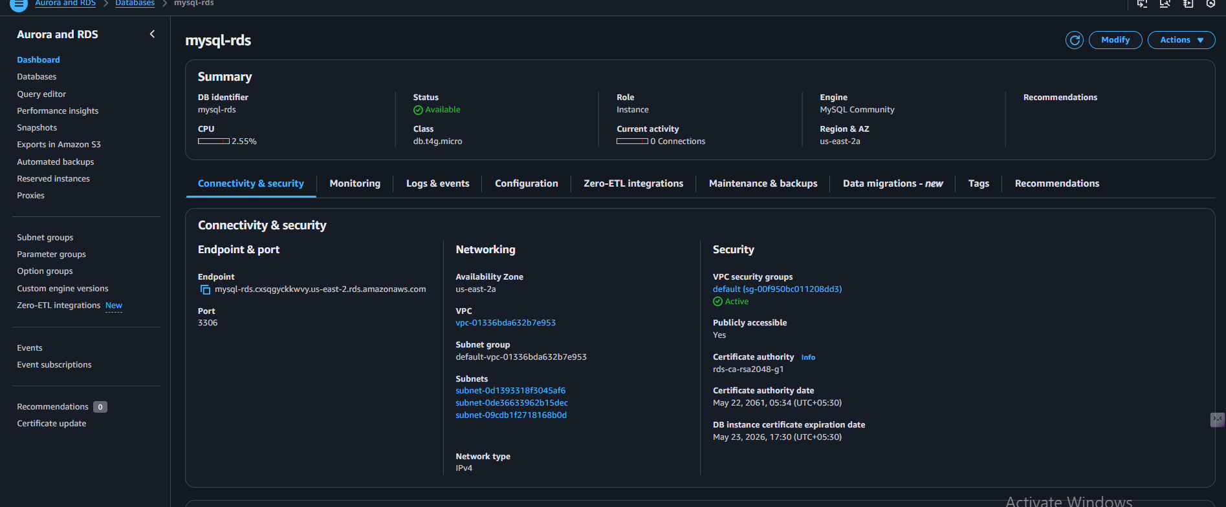

8) COnfigure multi AZ

Go to RDS console>>click on create Rds >>slect my   
sql>>give the Name>>in the templets select   
production >>selct multi availabilty zone >>give the   
admin password>>give the vpc >>subnets group   
what you have created >>give the db back up name   
>>click on create the database  
after creation delete the instance because it will more cost

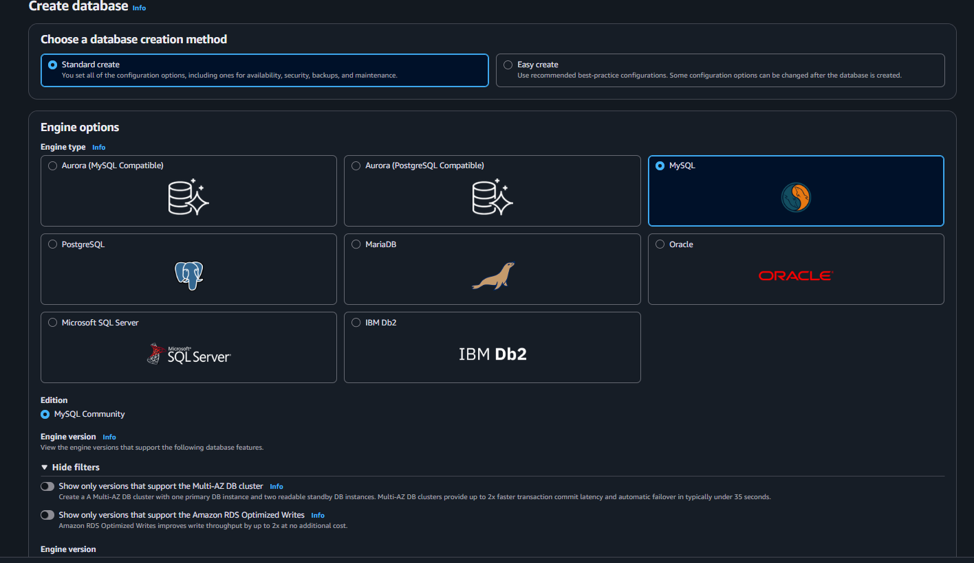

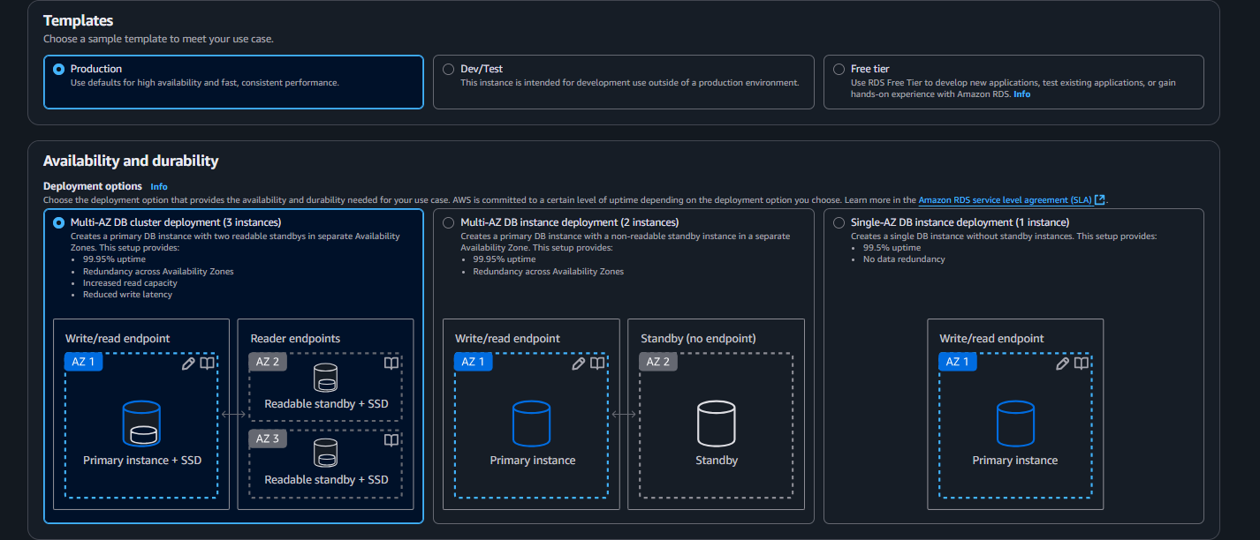

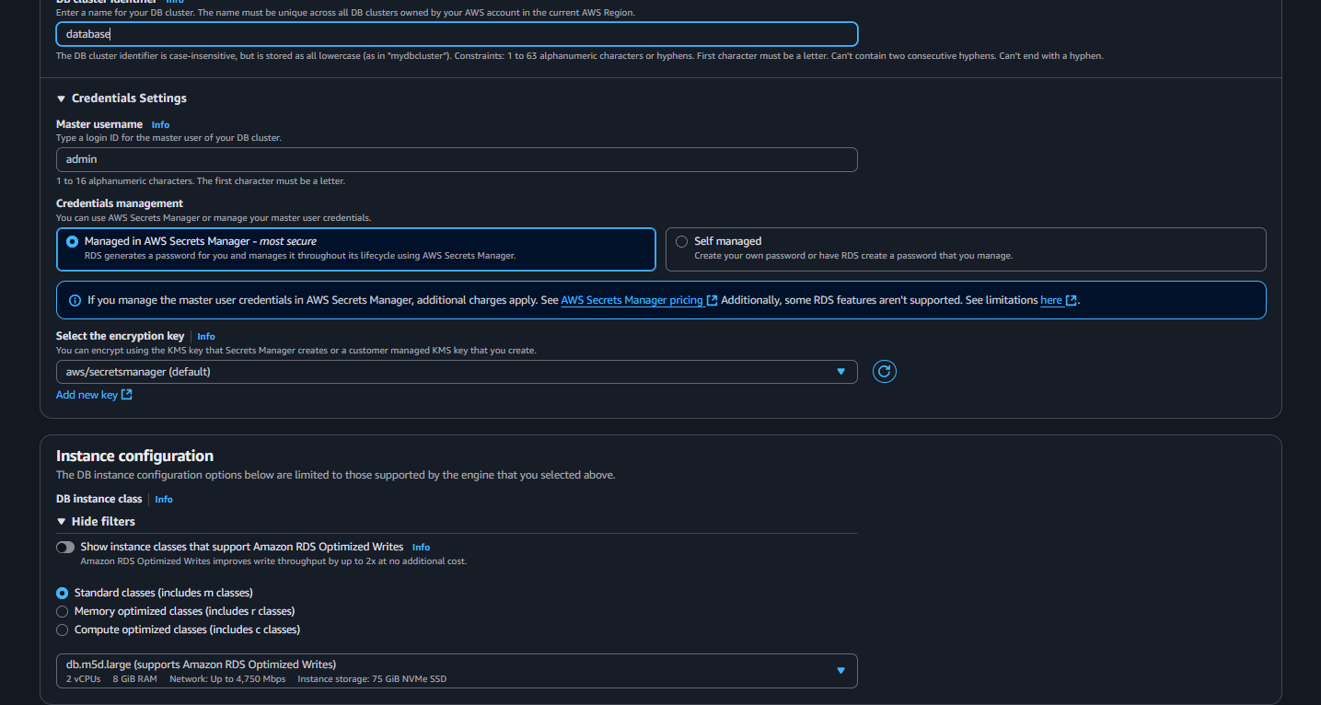

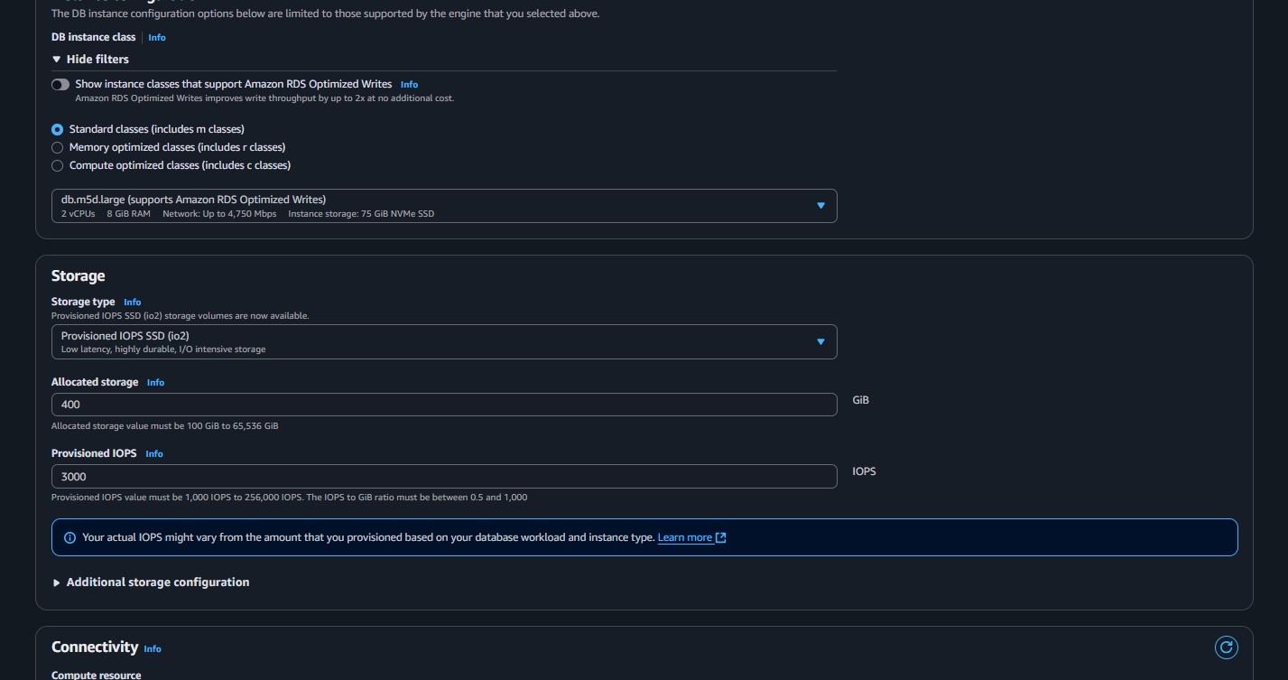

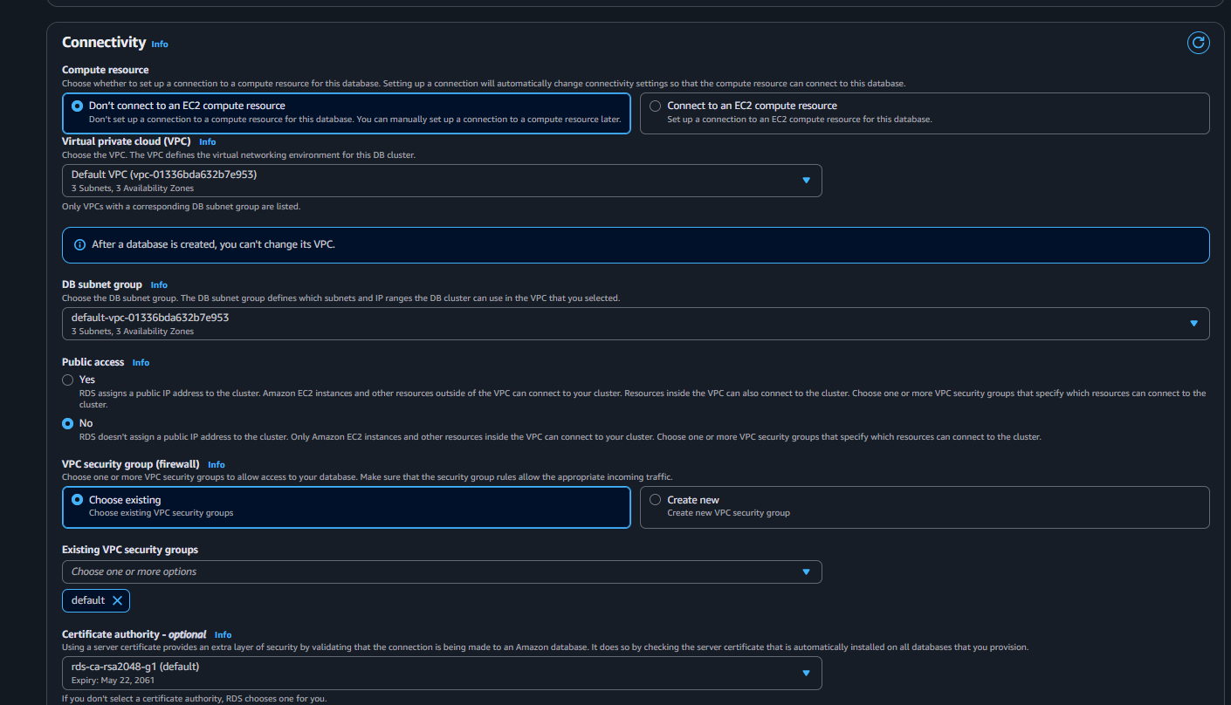

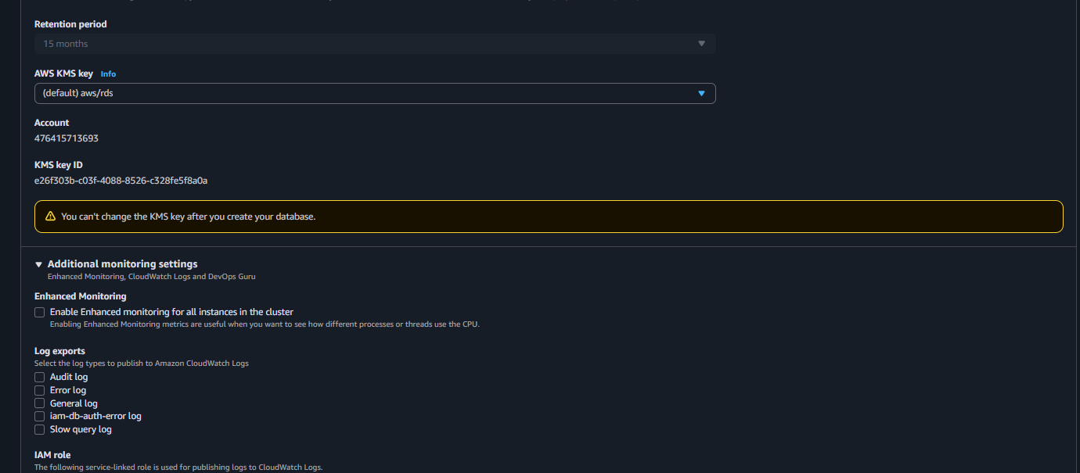

9) Take Backup of db and restore the DB

### **Took a Backup of the Database**

You ran this command from the terminal

mysqldump -u root -p ec2db > ec2db-backup.sql

➡️ This created a backup file named ec2db-backup.sql.

**🔹 3. Checked the Backup File**

You listed the backup file using:

ls -lh ec2db-backup.sql



10) Create ReadReplca

go to the RDS console >>go to data base which we   
have created >>go to actions>>click on create read   
replica>>then give the unique name >>see the   
configurations like vpc,subnets,security groups   
>>click on enter

