1. Create s3 bucket and upload some objects to s3.

Steps:

* first you need to **create s3 bucket**
* upload a file
* enable the file to public
* change ownership to **acls enabeld**
* to verify check the file with url

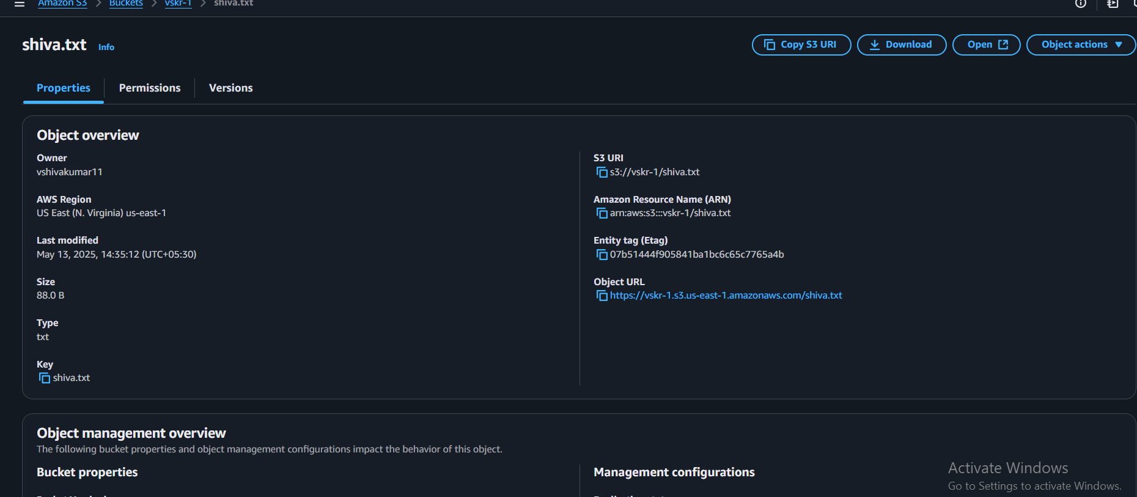

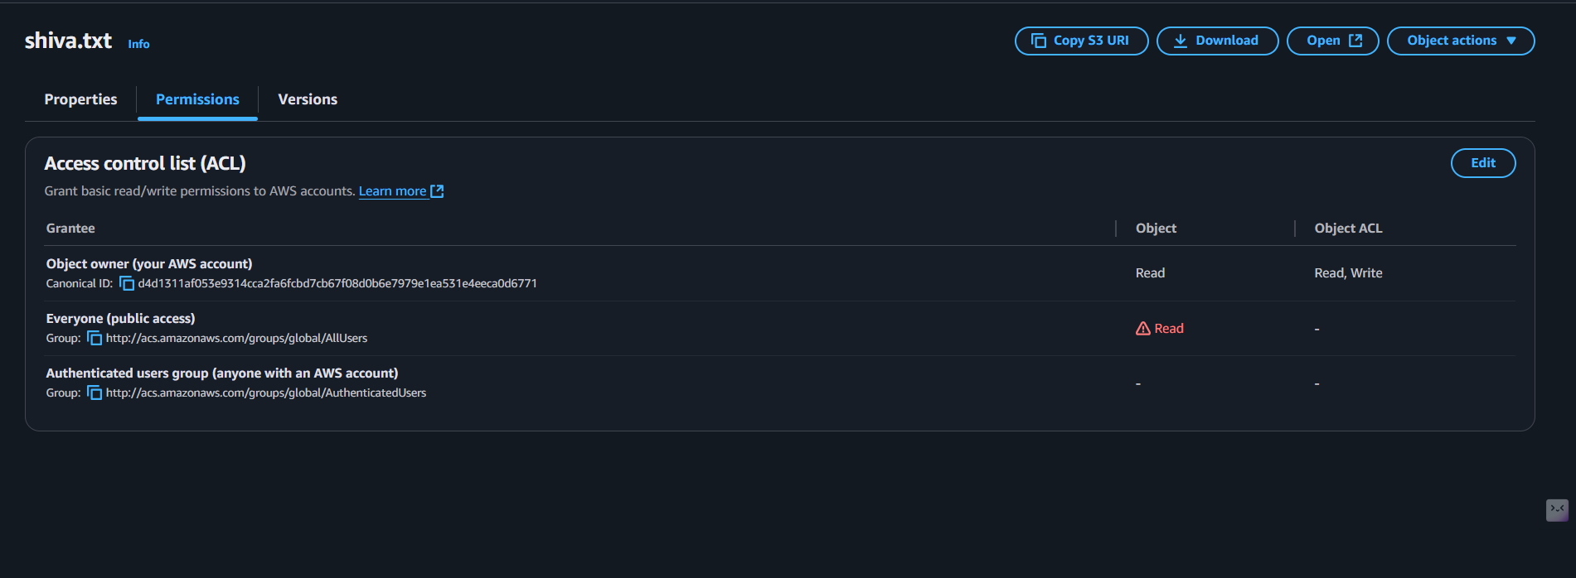

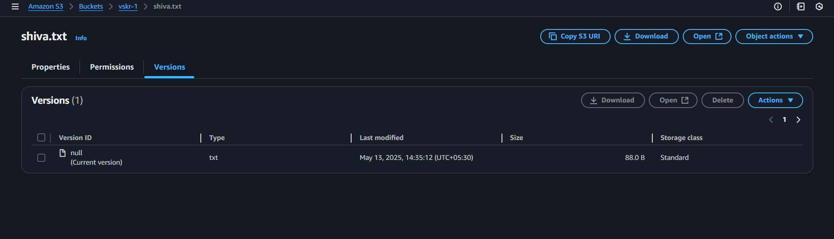

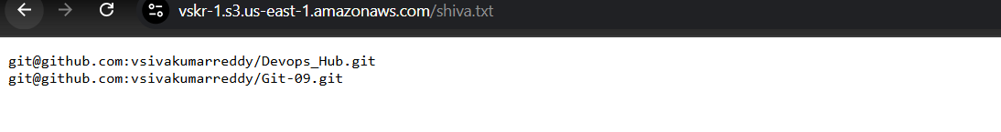

1. Deploy static website in s3 bucket.

* first create **two buckts** one is for main files and **one is acceslogs**
* upload all the website files
* go to the properties >>**select static website hosting enable it**
* To verify check with thr url

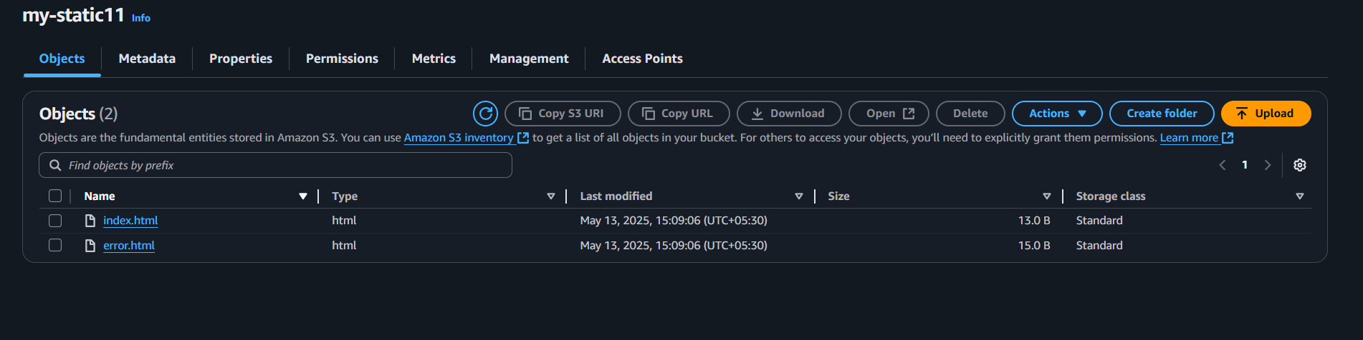

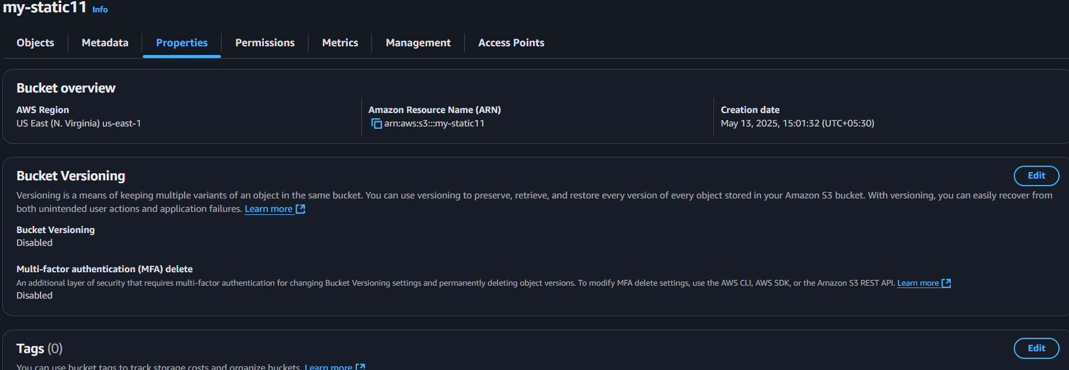

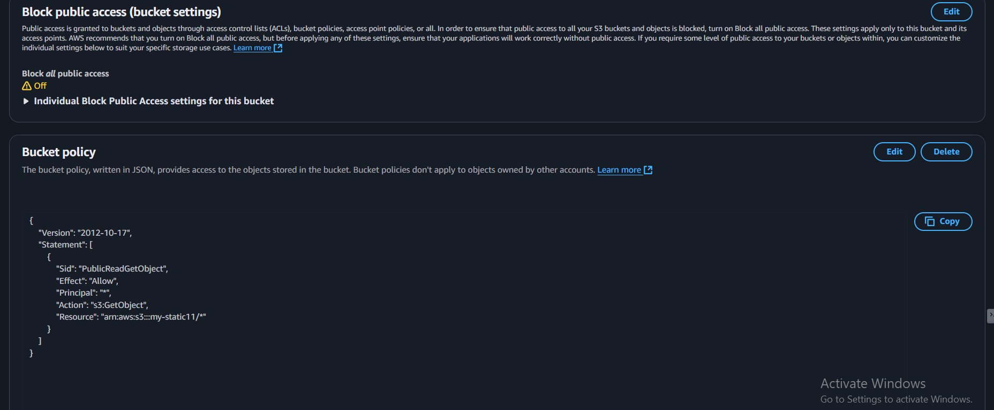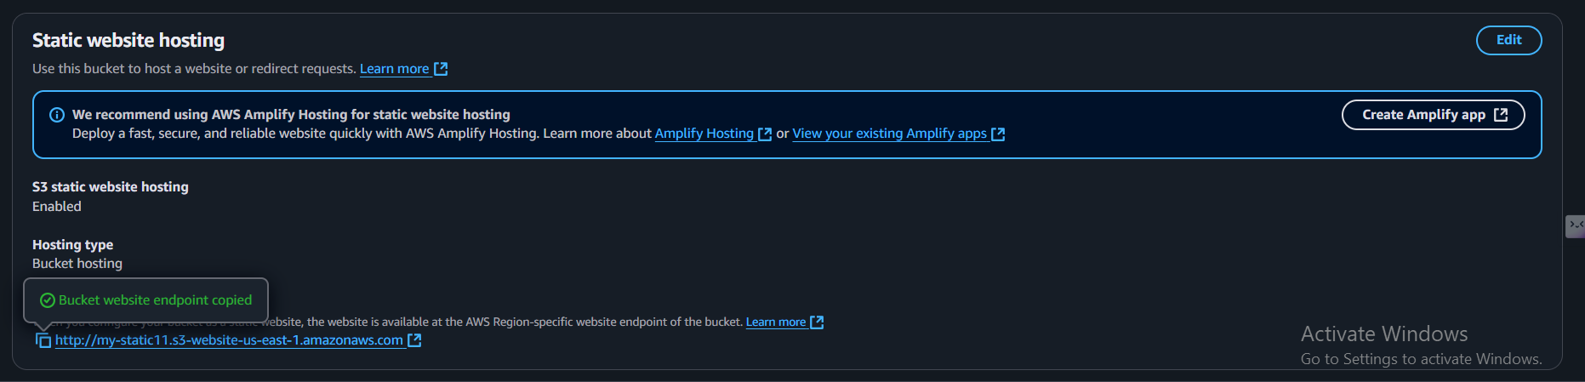

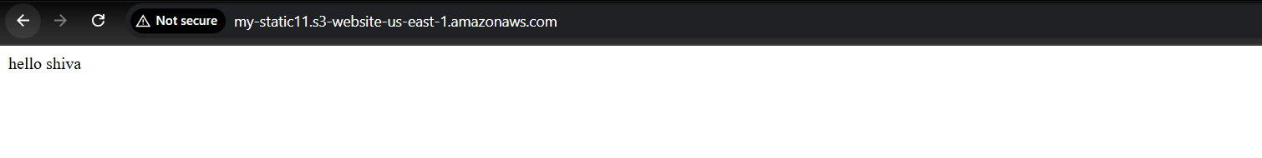

1. Enable cross region replication on s3 buckets.

* create a bucket in source region and create another bucket in another destination region
* go to the management and **click on create replicate rules**
* in that detination >>**give the another region file**
* give the Iam role or click on create Iam role then click on save

to verify add a file on source region and see that the destion region as that file

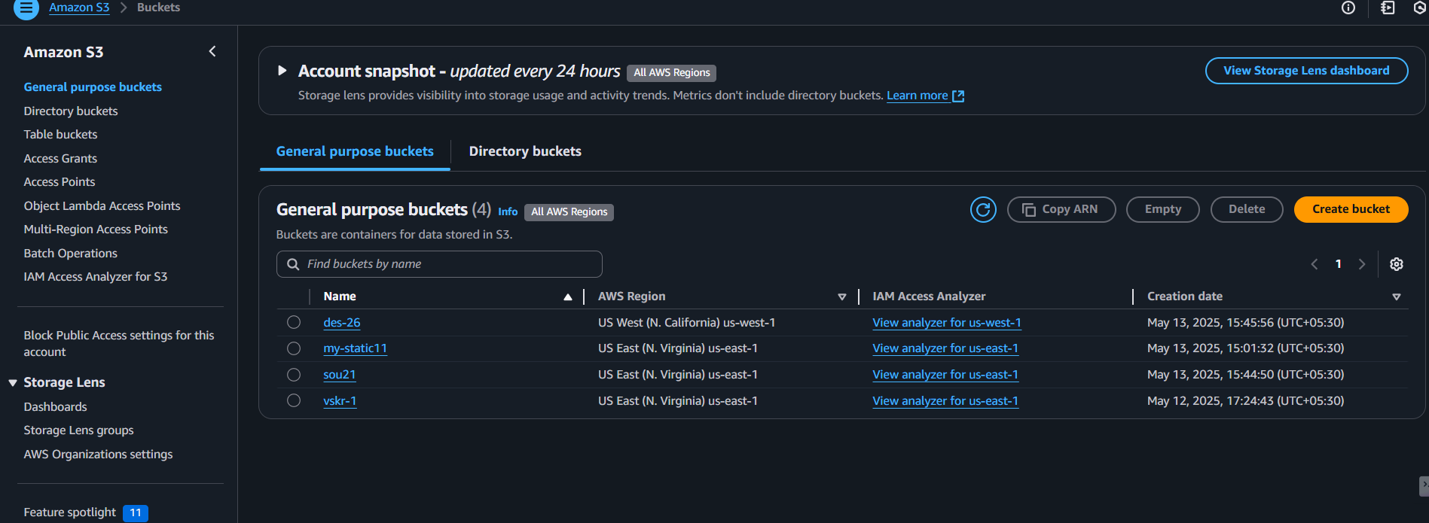

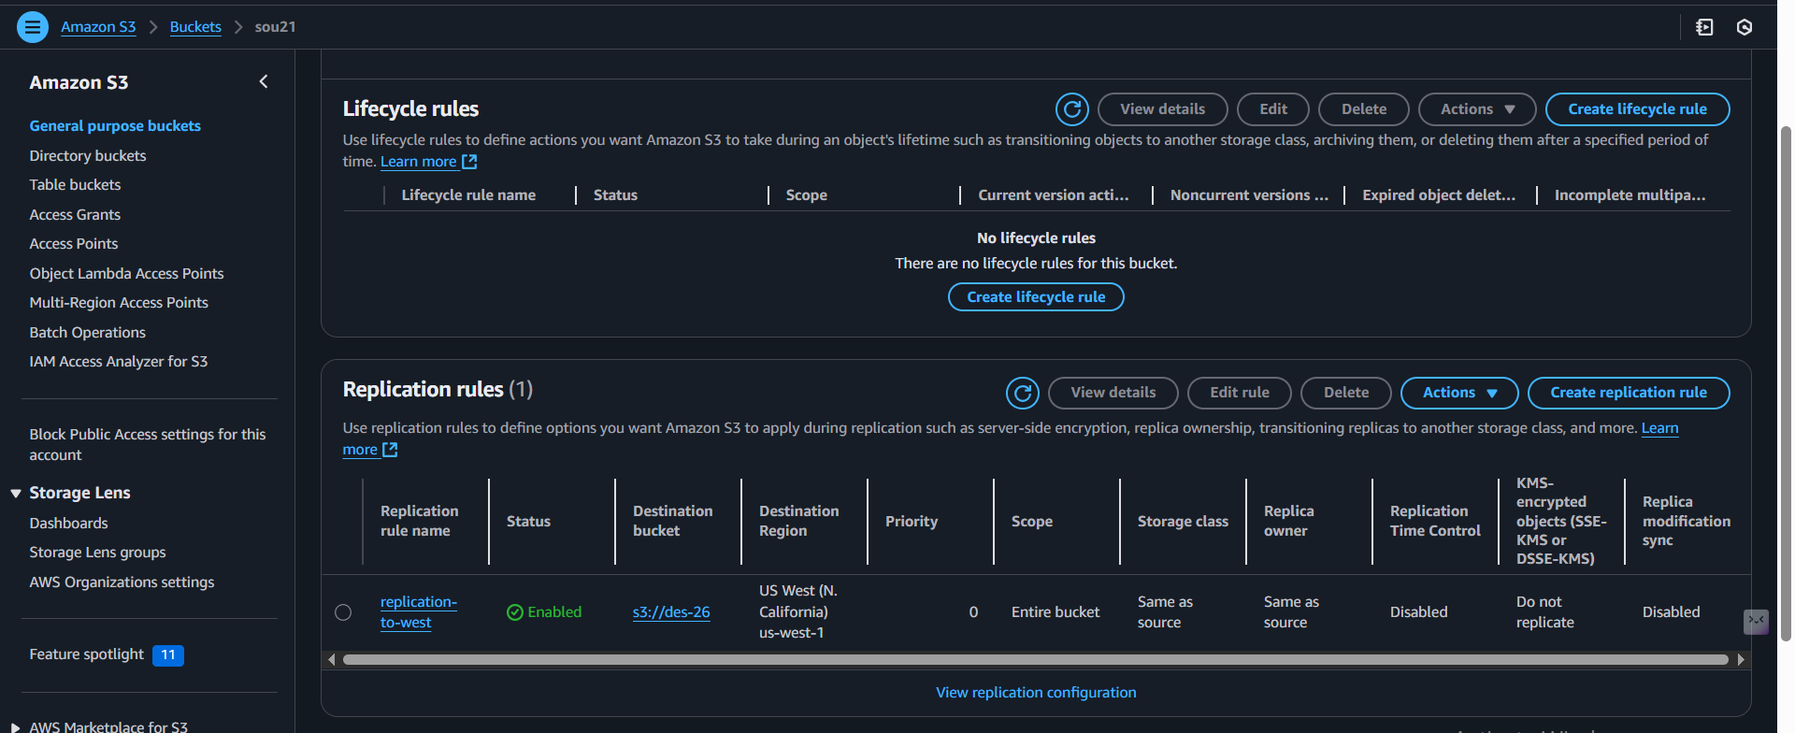

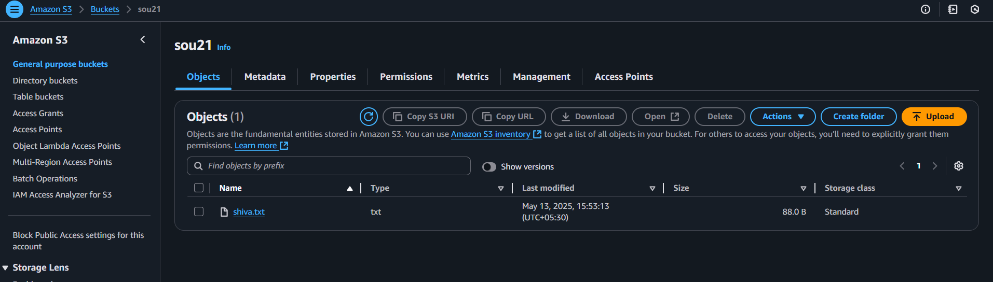

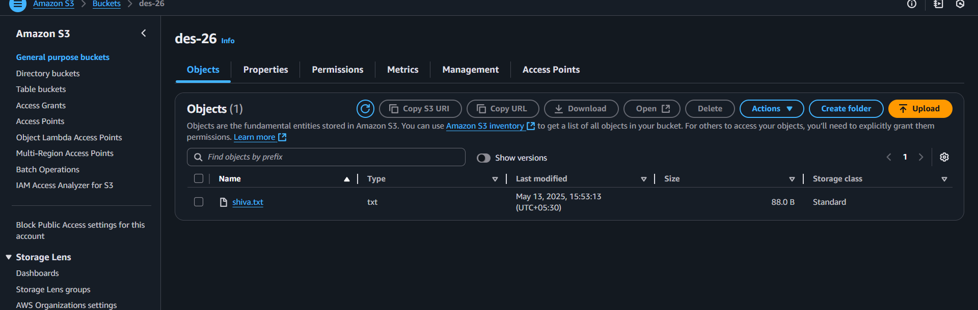

1. Configure bucket policy,only Admin user can see the objects of s3 bucket.

* first create the s3 bucket and in that bucket go to **bucket policys** and paste jason code
* to check wheather the devops user can see the objects

**aws sts get-caller-identity --profile Devops**

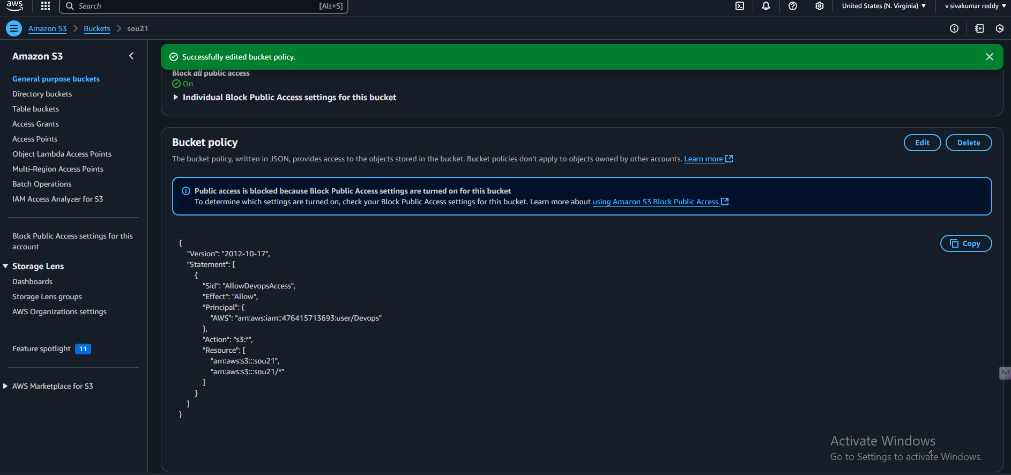

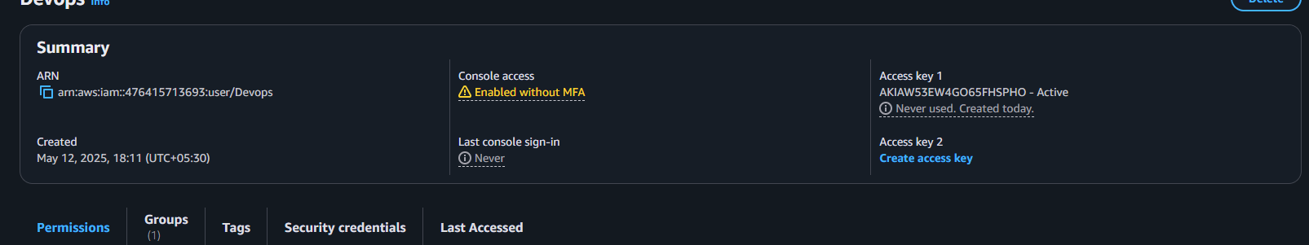

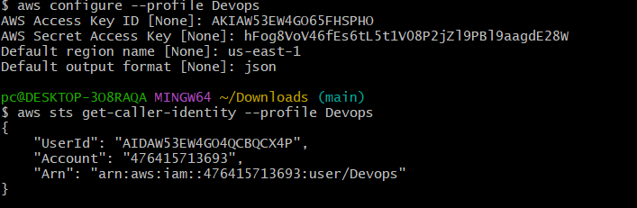

1. Setup lifecycle policies to automatically transition or delete objects based on specific criteria.

* go to the management in the **s3 buckets** and click **lifecycle rule**
* give the days **after object creation** and click create

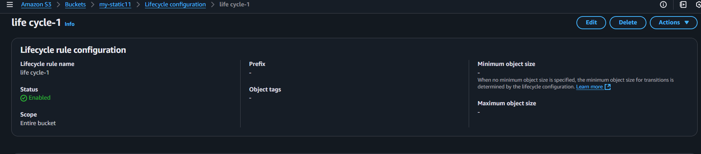

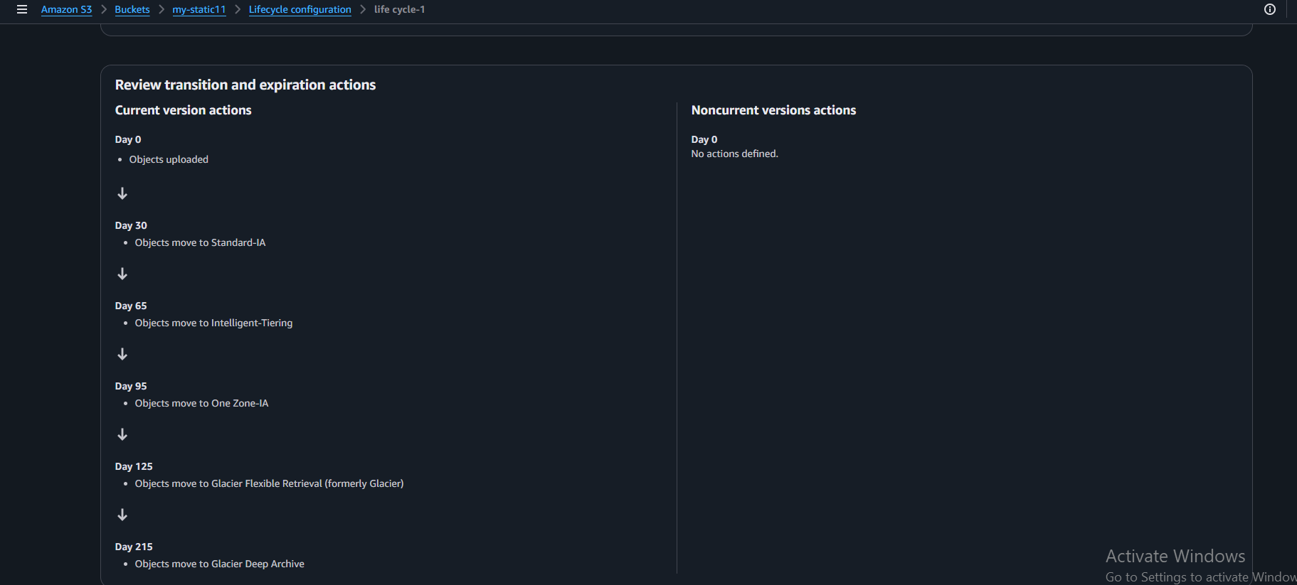

1. Push some objects in s3 using AWS CLI.

* first wee need to creat access key and go cli in git bash

**aws configure --profile Devops_Hub**

* to create a file in s3 bucket

**aws s3 cp ~/Desktop/index.html s3://vskr-1/webpages/ --profile Devops_Hub**

* to verify wheather the file is uploaded or not

**aws s3 ls s3://object0518/ --profile Devops_Hub**

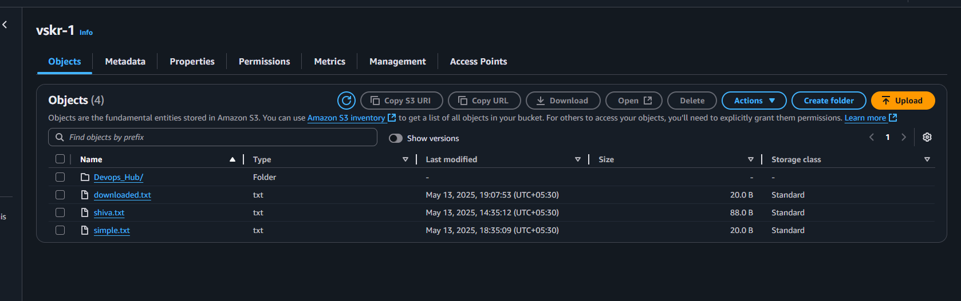

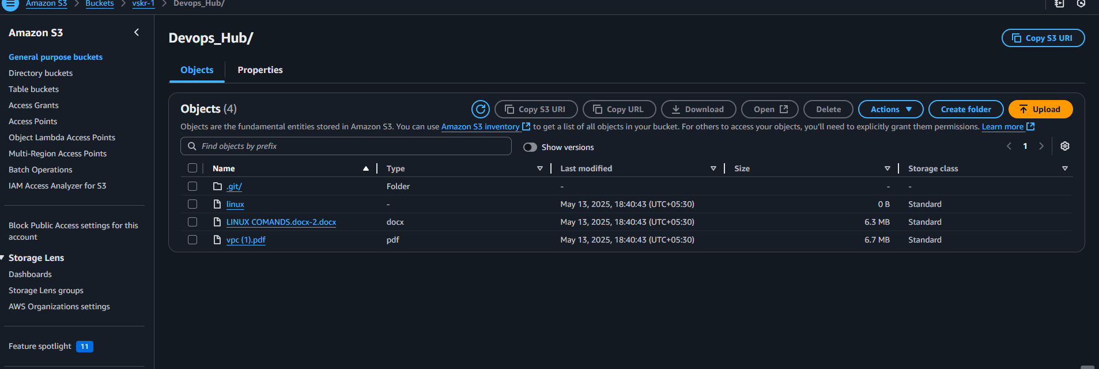

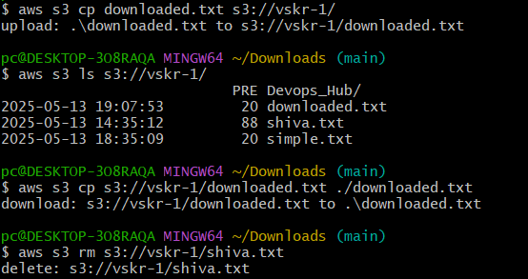

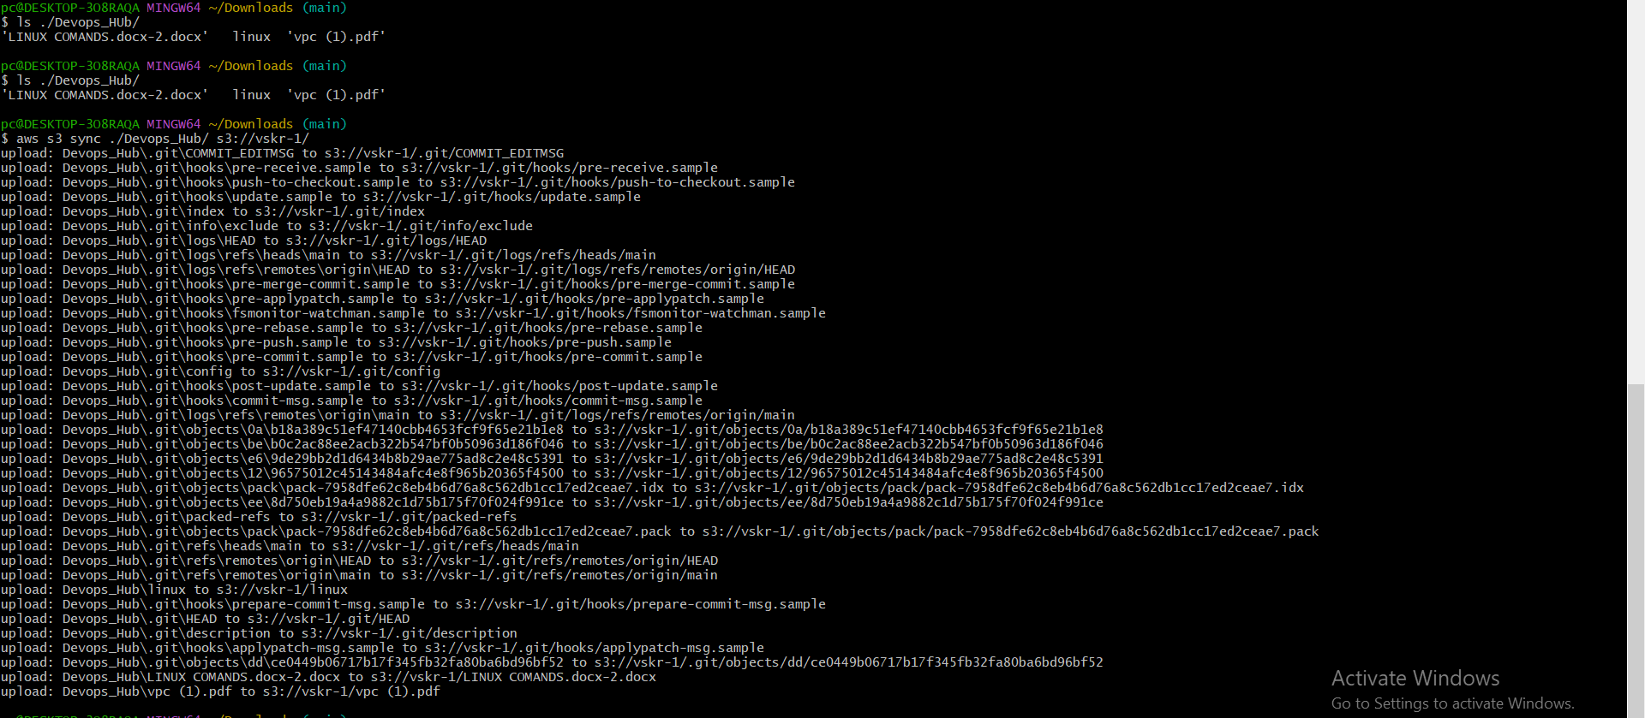

1. Write a bash script to create s3 bucket.

First we have create and save a bash script for to create s3

Then it show the location we the s3 bucket is created

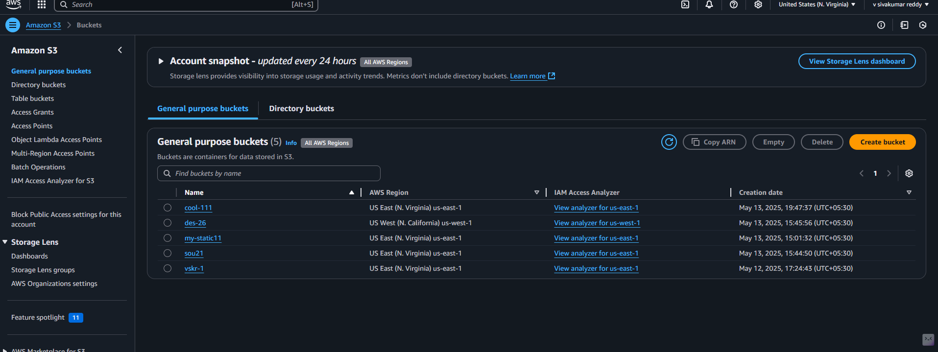

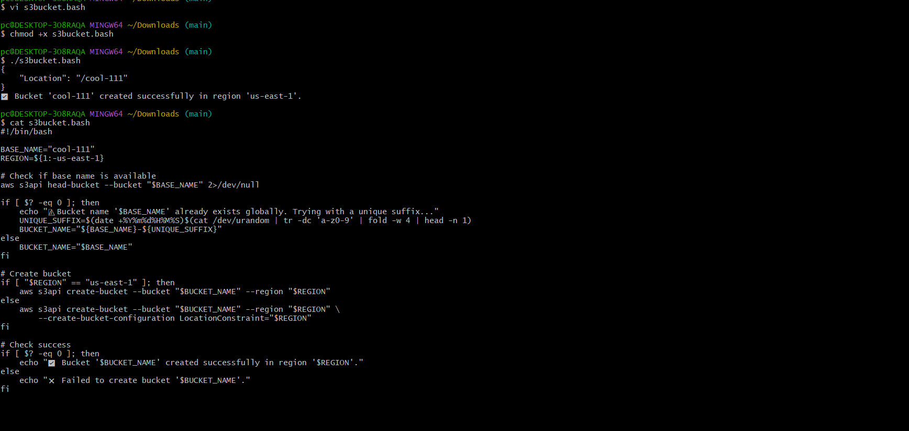

1. Upload one 1 gb of file to s3 using cli.

At first we have to go to s3 bucket

Then go to git bash give the command to download 1gb of file

Then give the command to upload this file to s3 bucket and verify it whether file uploaded or not

