1. Install Terraform on your PC

Download terraform from official website

Then extract the file and create a folder and add that terraform.exe file in it

Give the path in environment variables

After check the version

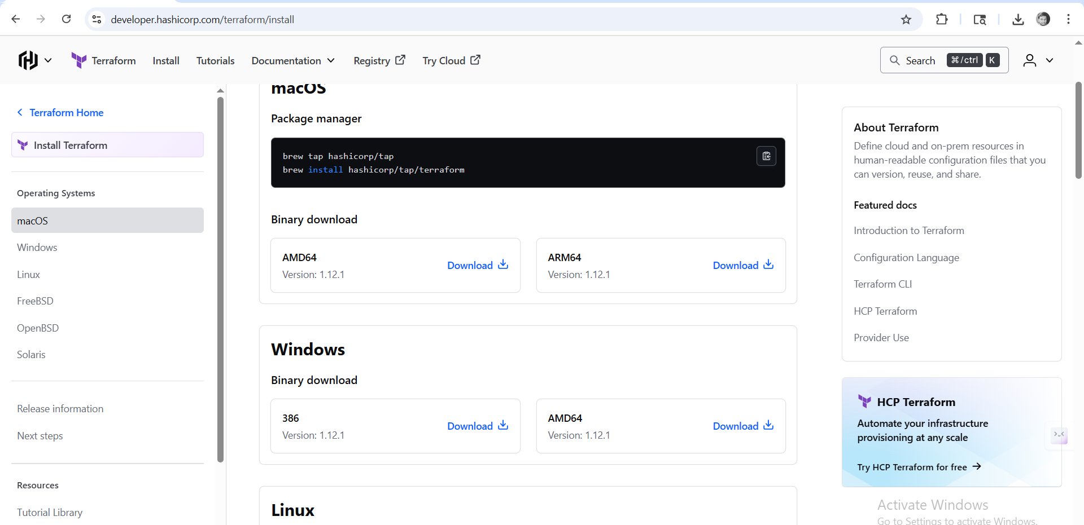

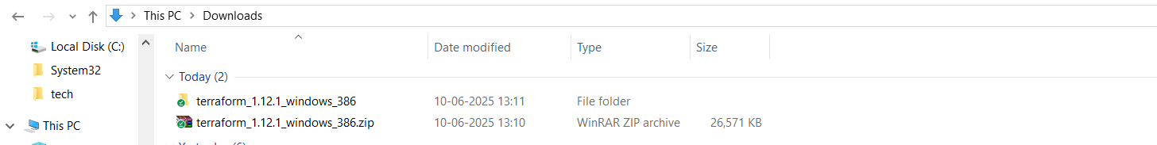



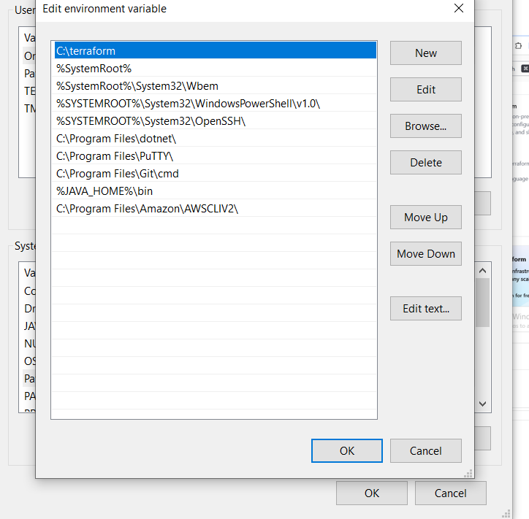

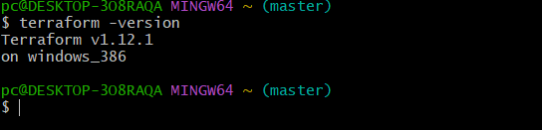

1. Execute all the templates shown in video.

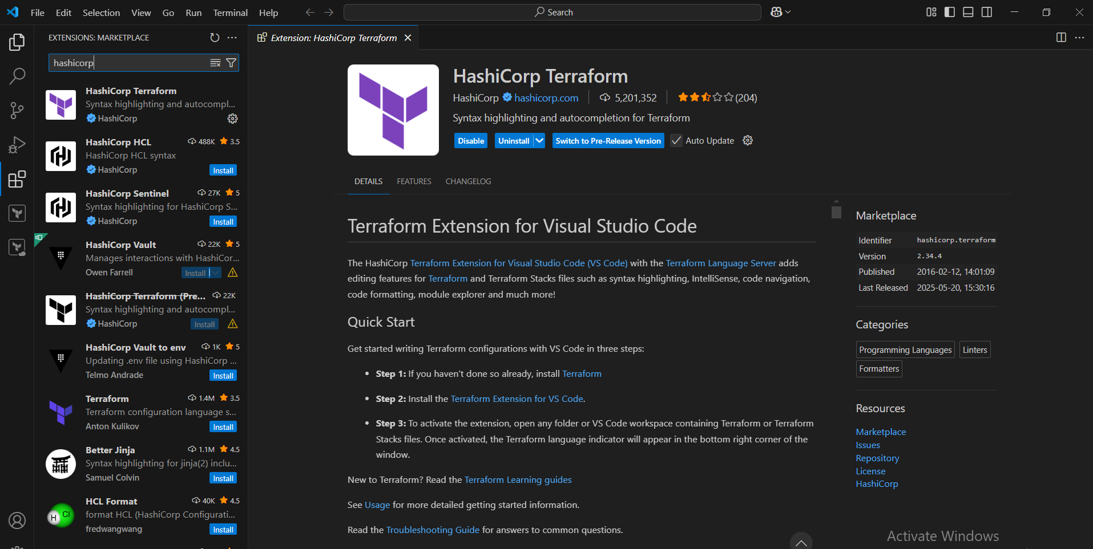

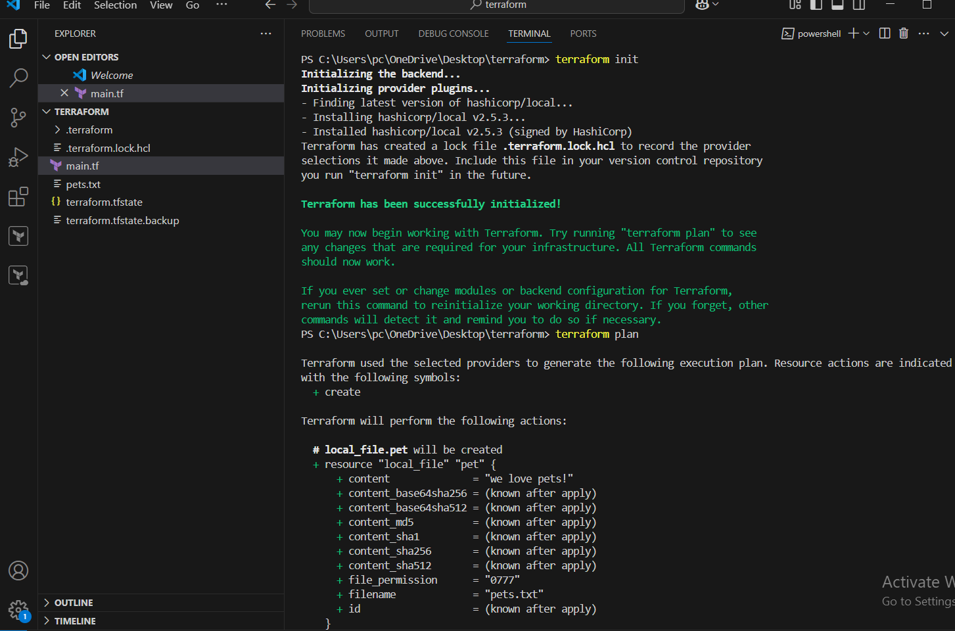

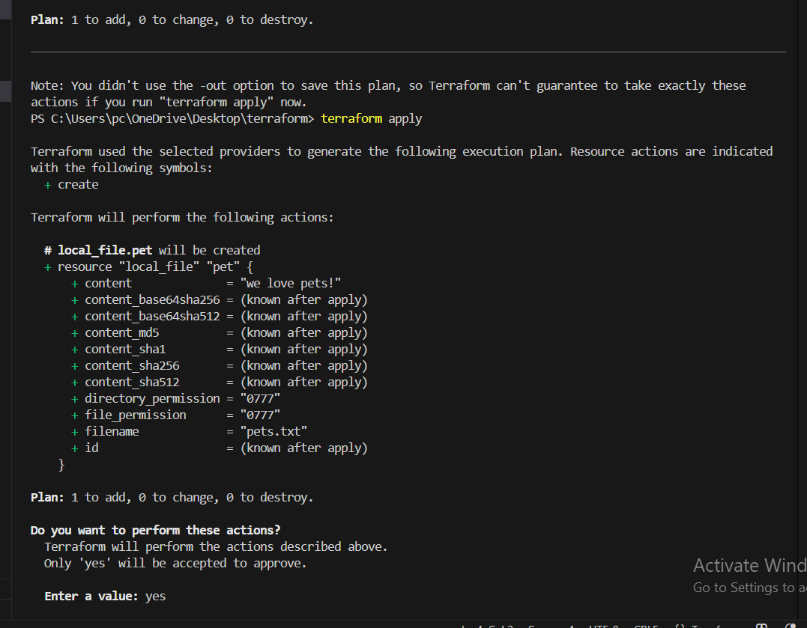

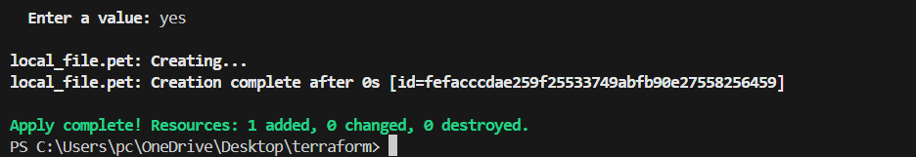

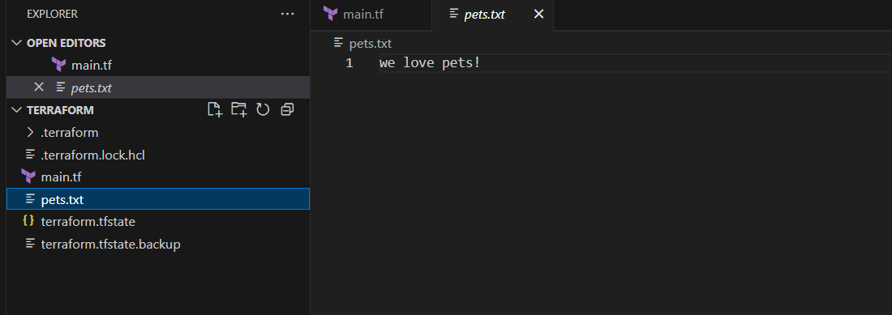

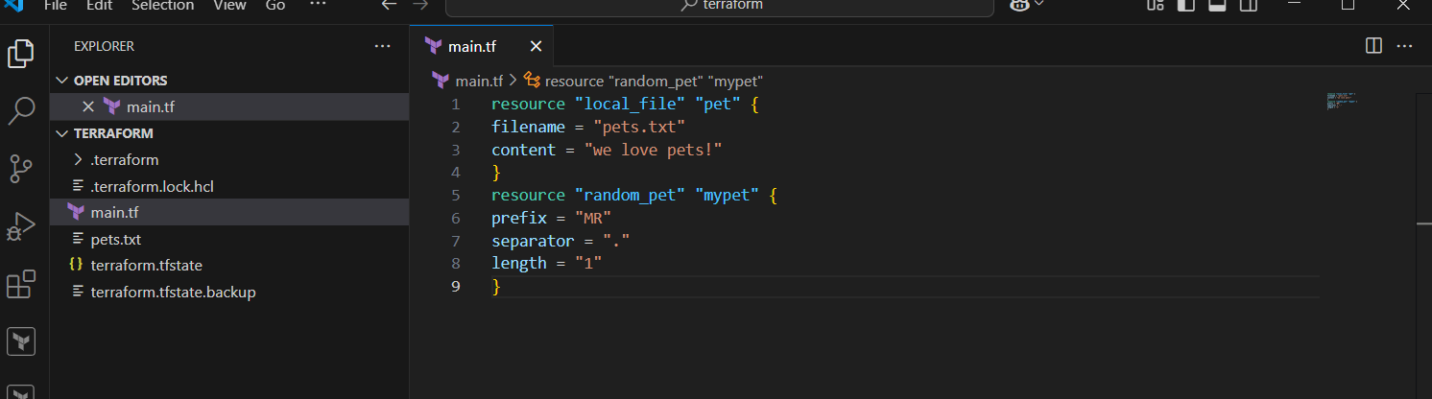

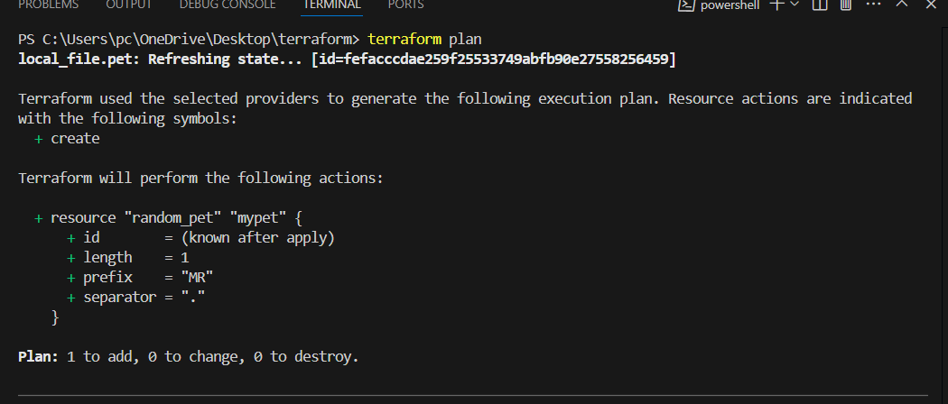

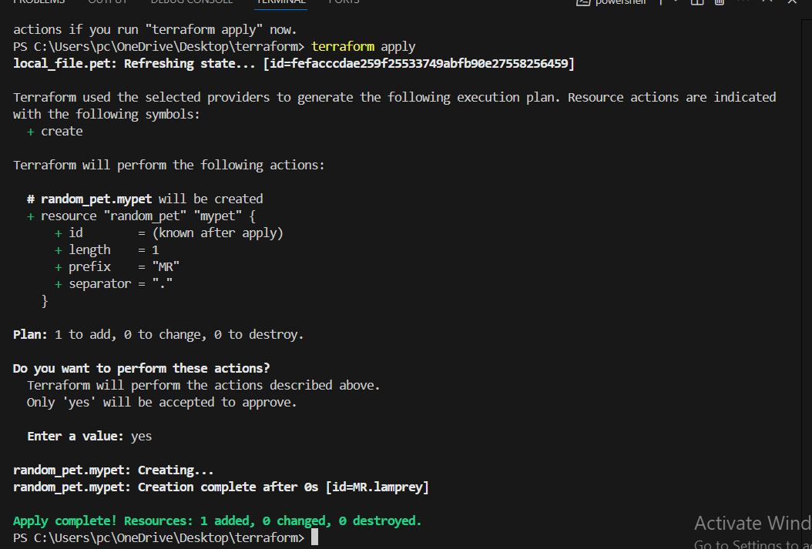

3) Note down below points,

Terraform Init

Terraform Plan

Terraform Apply

Terraform Provider.

**Terraform Init**

Initializes a Terraform working directory.

Downloads and installs required provider plugins.

Sets up the backend configuration (where state files are stored).

**Terraform Plan**

Creates an execution plan showing what actions Terraform will perform to reach the desired state.

Does not make any changes to infrastructure.

Helps preview changes and verify correctness before applying.

**Terraform Apply**

Applies the changes required to reach the desired state of the configuration.

Creates, modifies, or destroys infrastructure resources as needed.

Asks for confirmation before applying by default.

**Terraform Provider**

Providers are plugins that allow Terraform to interact with APIs of different cloud platforms and services (e.g., AWS, Azure, Google Cloud).

They define the resources and data sources Terraform can manage.

Declared in the Terraform configuration using provider blocks.

1. Integrate a sample Terraform template in jenkins.

Create a job in the jenkins server and create a new job

Add the git repo to it and build now check the console output

