1. Create VPC with 2 private and 2 public subnets.

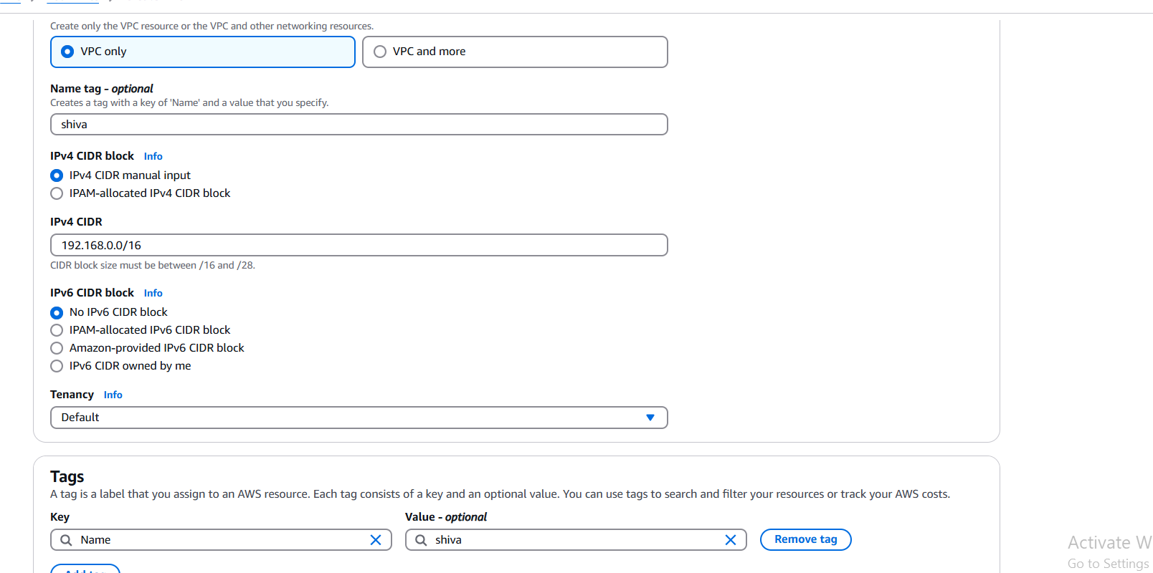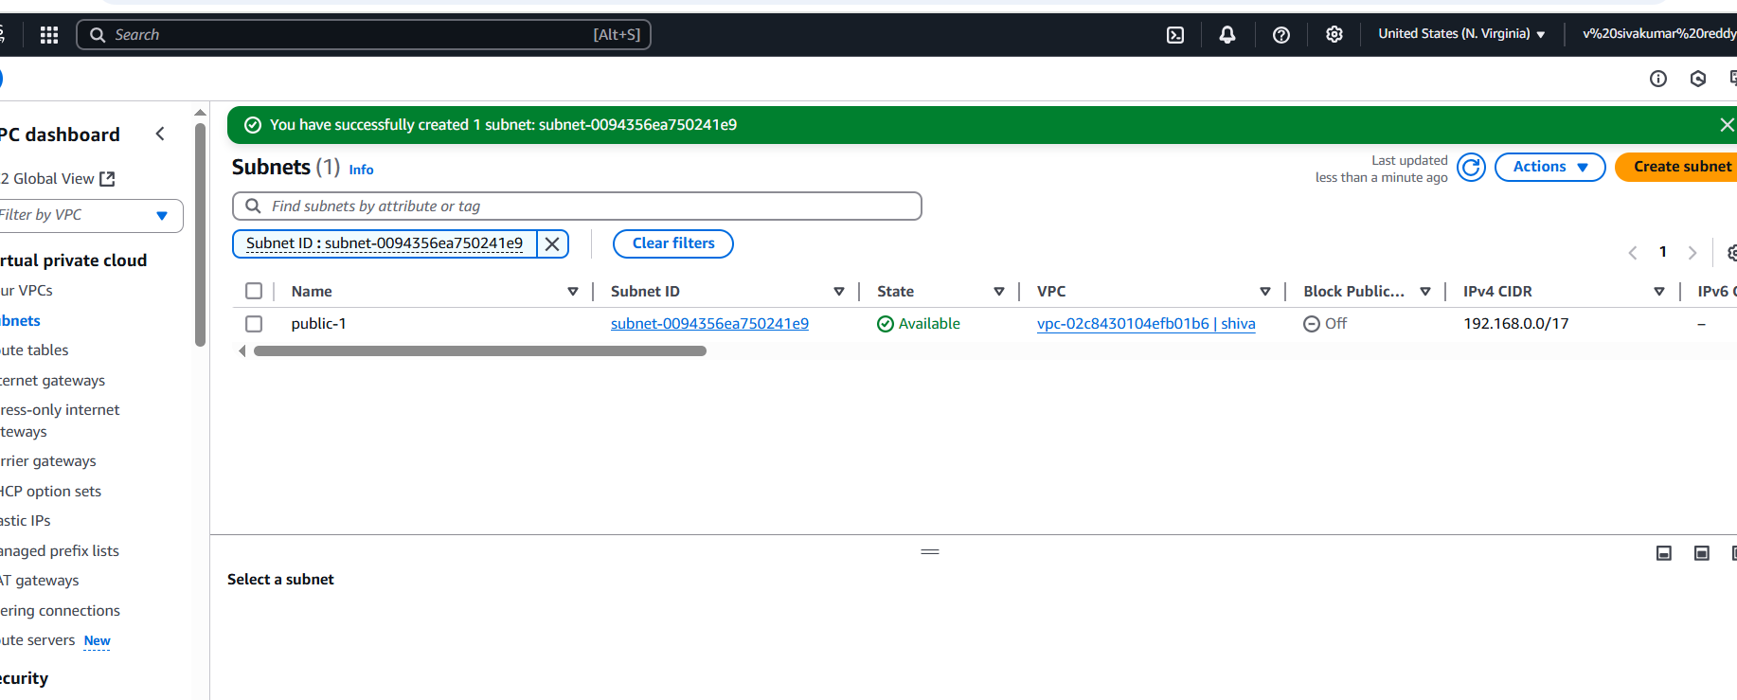

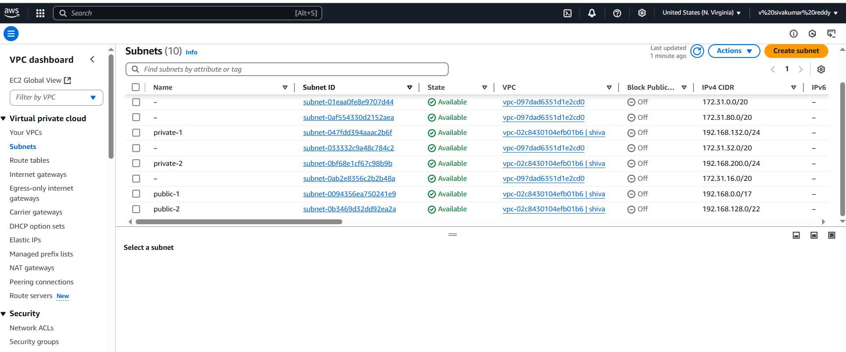

STEPS:

1. first go to AWS and select VPC

2. In VPC go to your VPC and create VPC

3. After that go to subnets and create 2 public and 2 private subnets without overlapping IPV4 CIDR Block.

1. Enable DNS Hostname in VPC

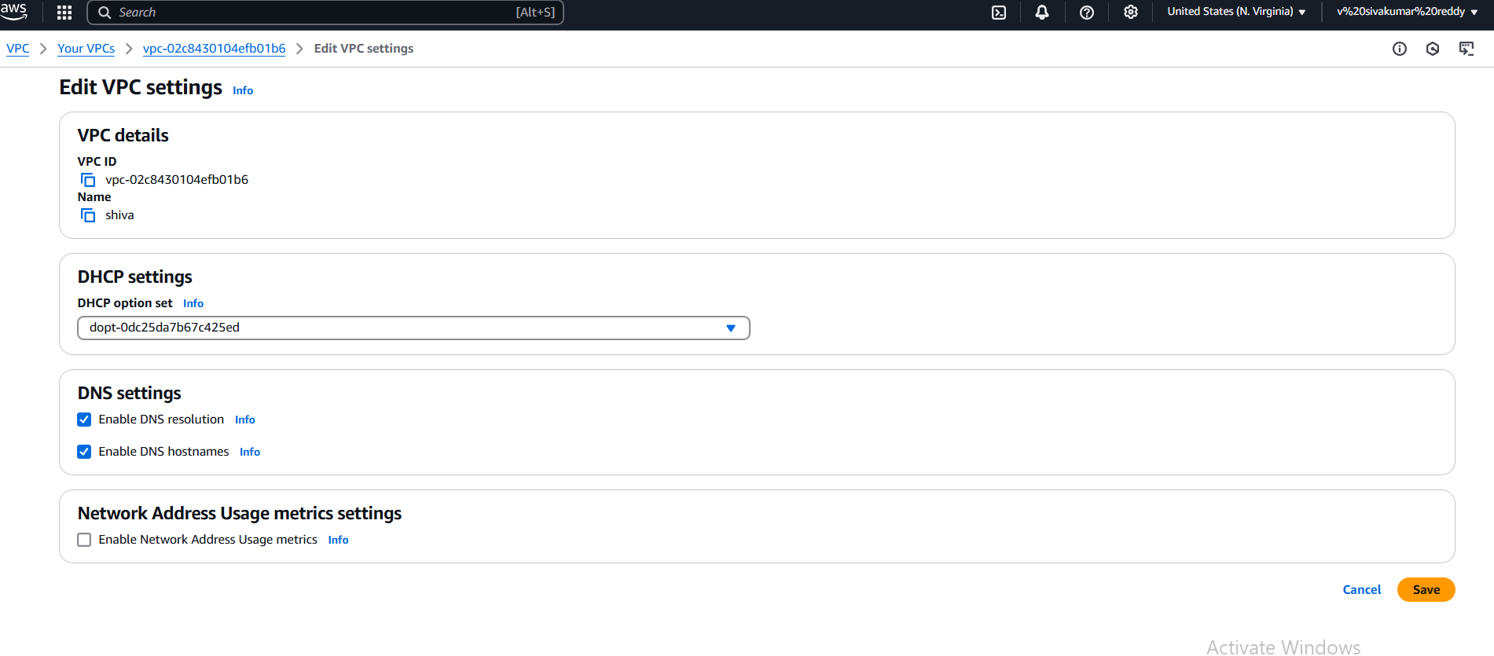

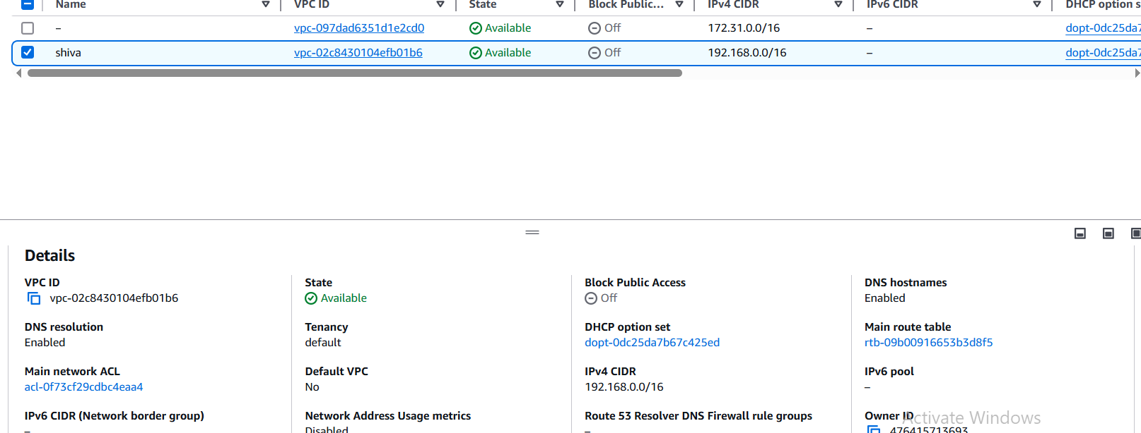

STEPS:

1. Go to VPC and select your VPC.
2. After that select action.
3. Click Edit VPC setting.
4. And Enable DNS hostnames .
5. After go back to your VPC and there it shows DNS HOSTNAME ENABLED.
6. Enable Auto Assign Public ip in 2 public subnets

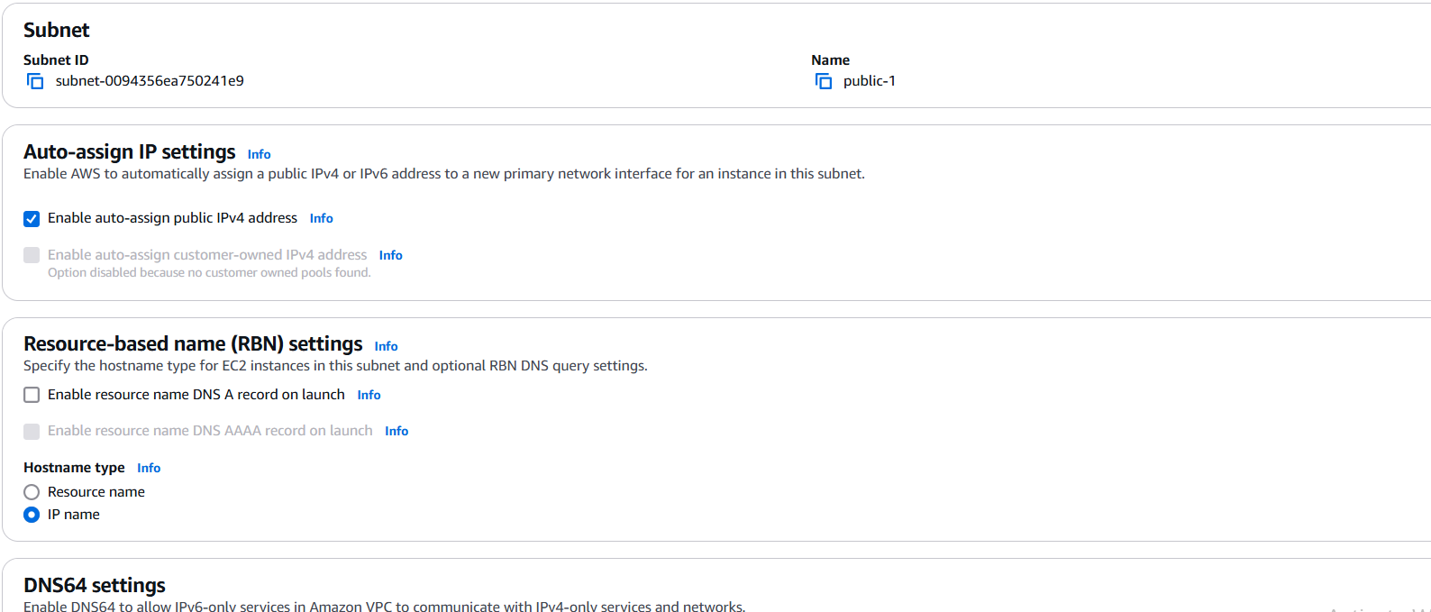

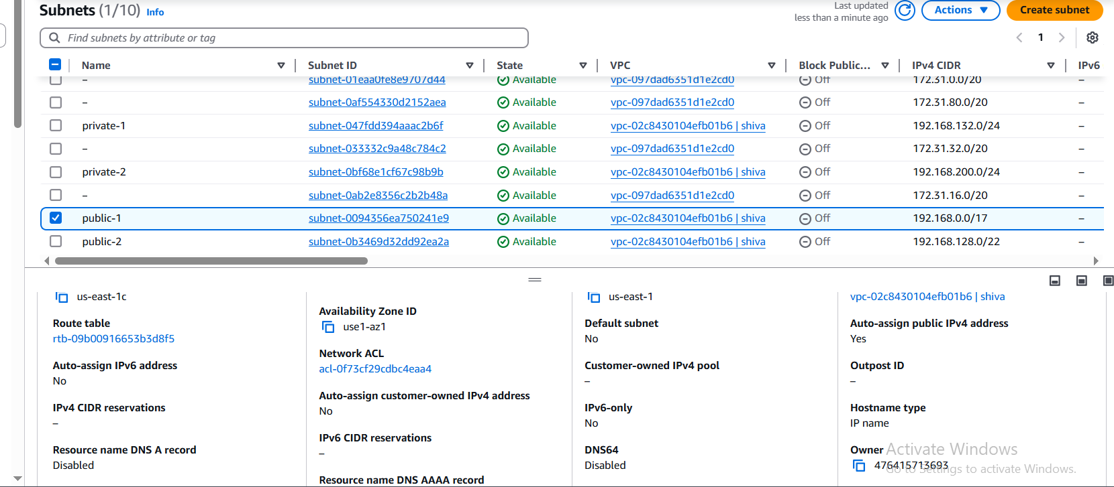

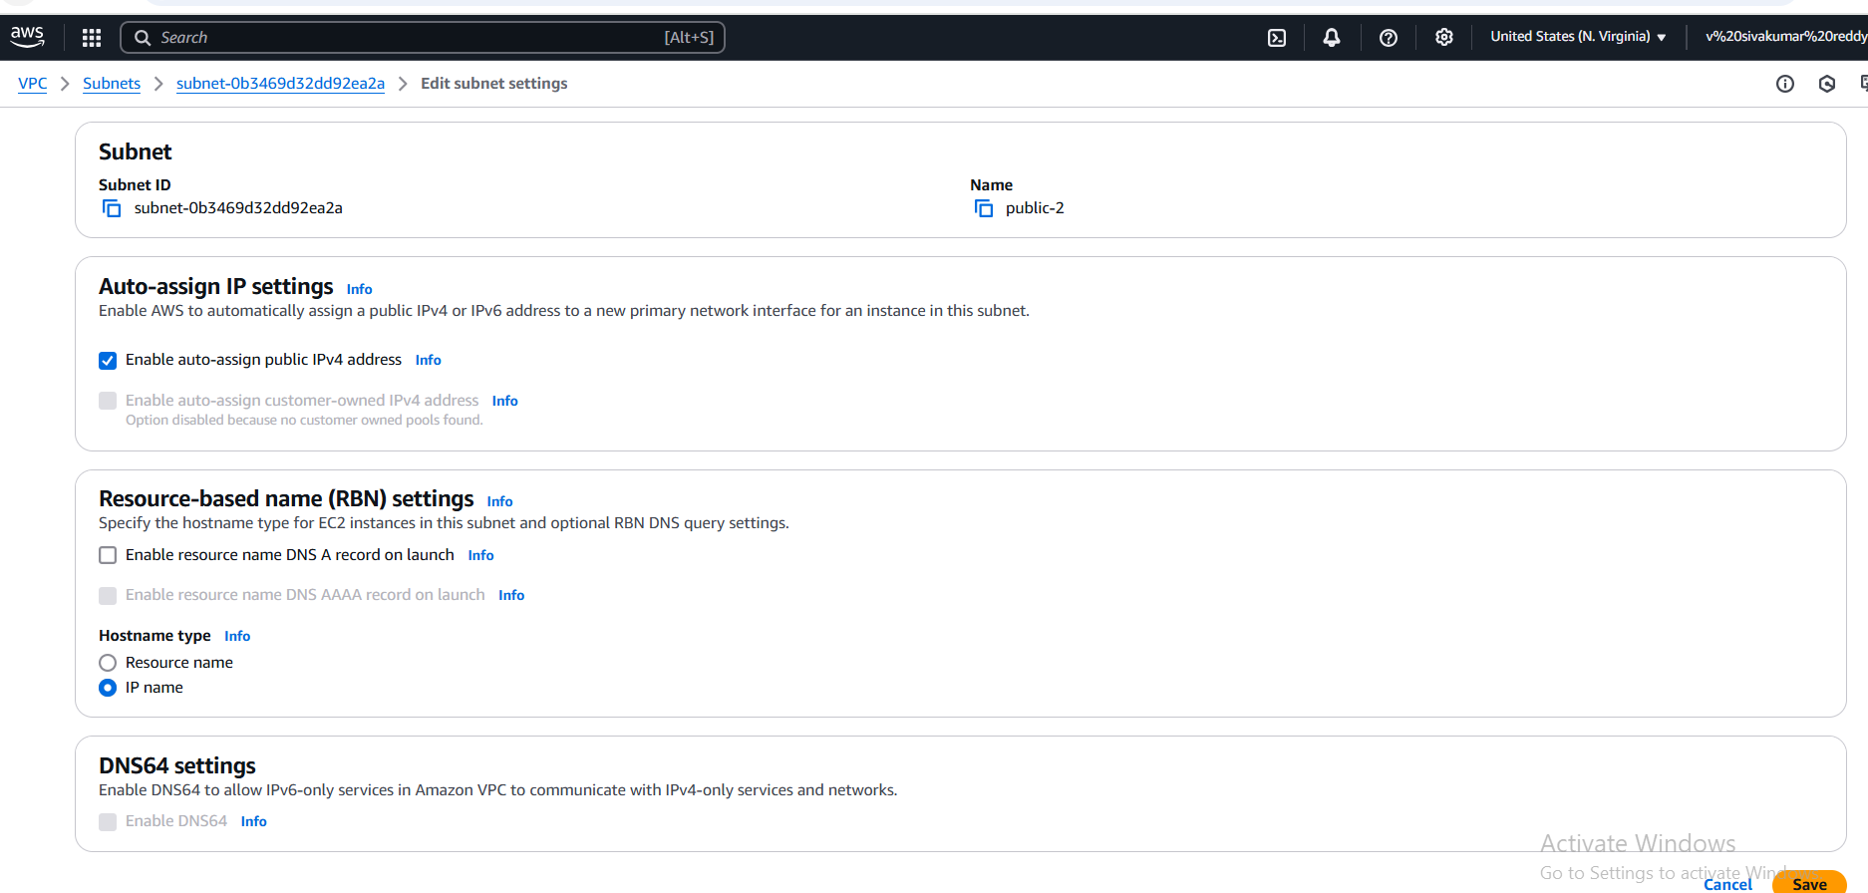

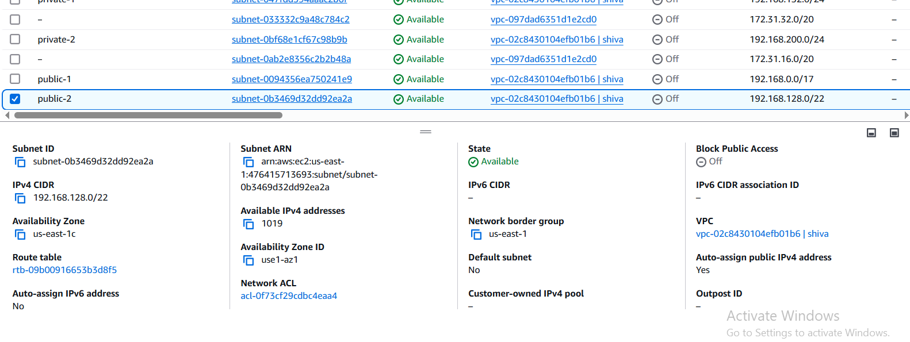

STEPS:

1. GO to VPC DASHBOARD
2. Select SUBNET in that first Select PUBLIC-1 .
3. After go to ACTIONS and select EDIT SUBNET SETTINGS.
4. In that go to AUTO ASSIGN PUBLIC IPV4 and click ENABLE and SAVE.
5. GO back to PUBLIC-1 it will show AUTO ASSIGN PUBLIC IPV4 as YES.
6. Similarly same process for the PUBLIC-2 subnet.
7. Add 2 private subnets in private route table

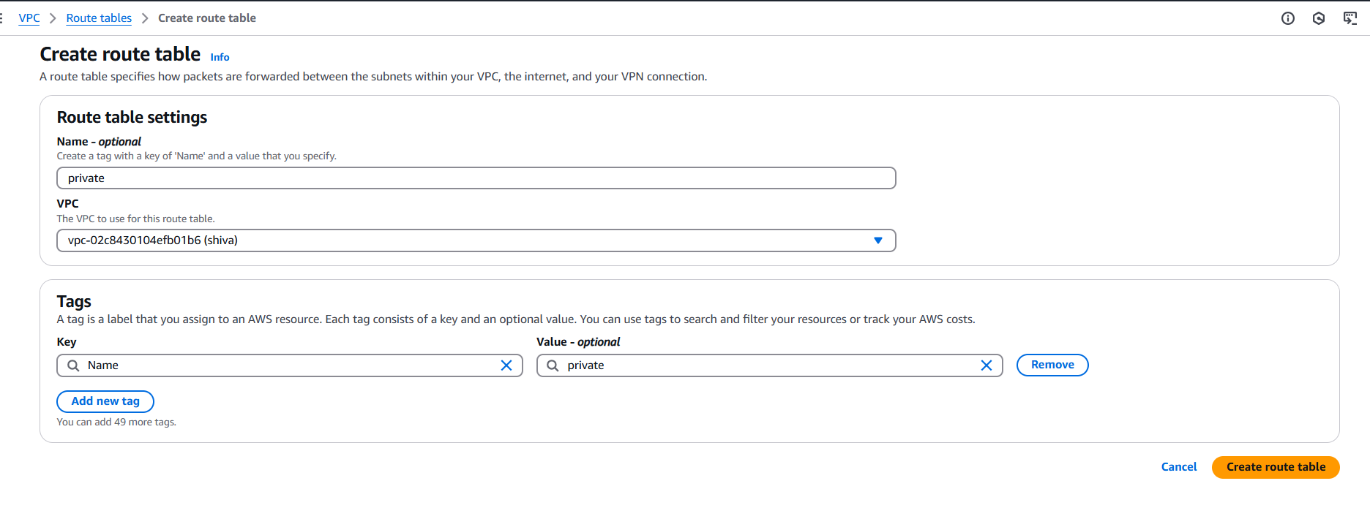

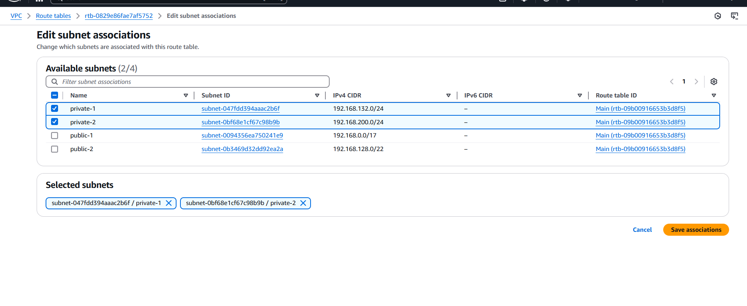

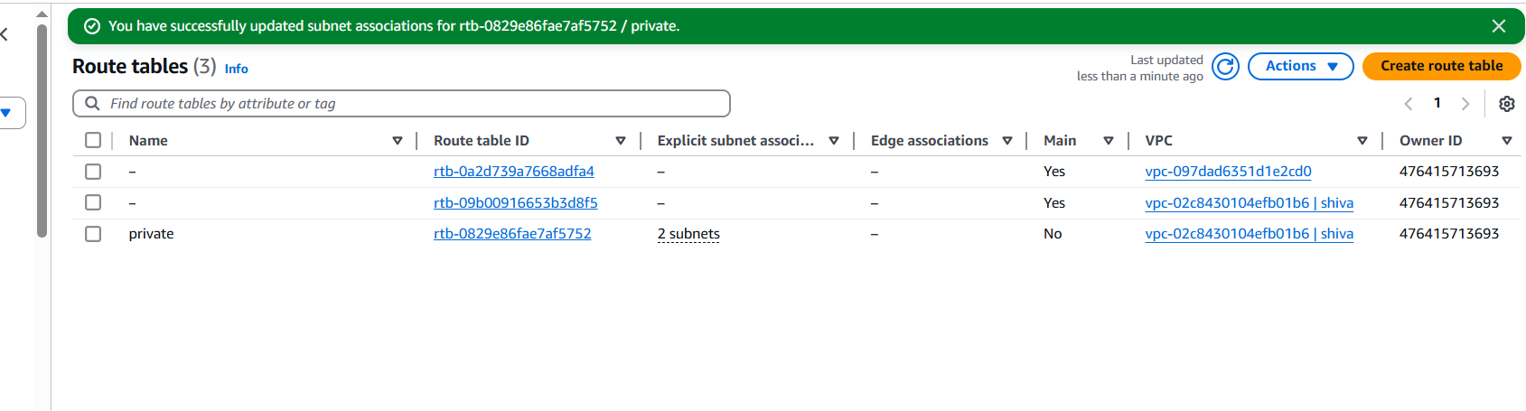

STEPS:

1. GO to VPC DASHBOARD.
2. Select ROUTE TABLE and CREATE a ROUTE TABLE.
3. After that go to actions and select EDIT SUBNET ASSOCIATES and save it.
4. AFTER that PRIVATE will be created in ROUTE TABLE.
5. Add 2 public subnets in public route table

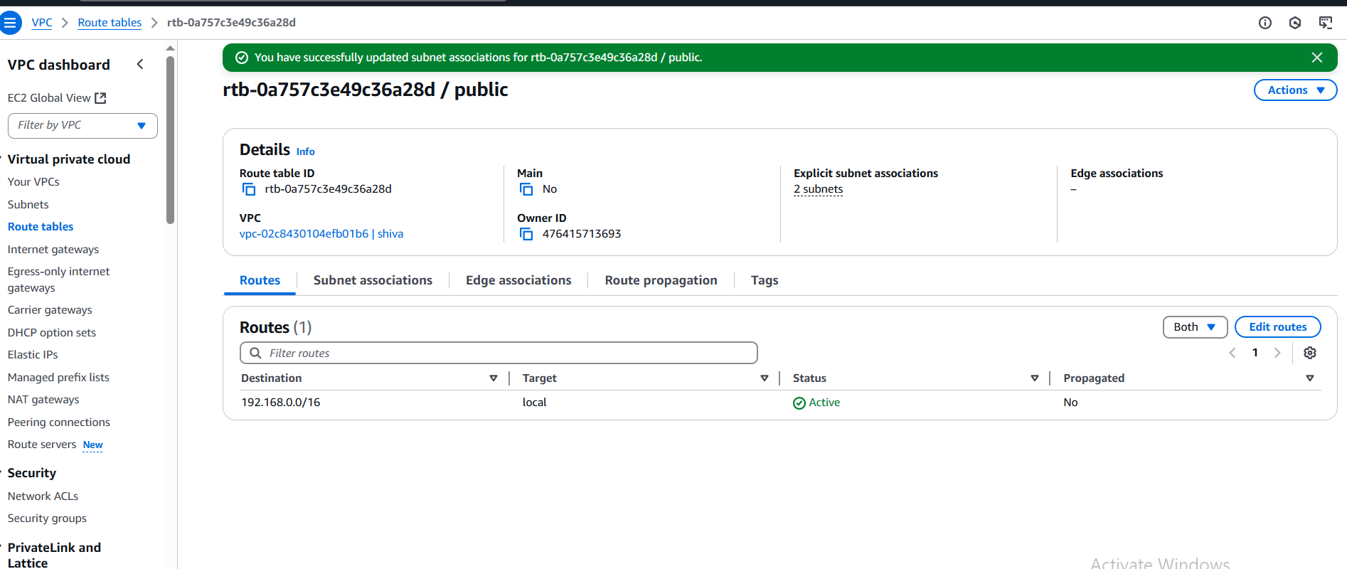

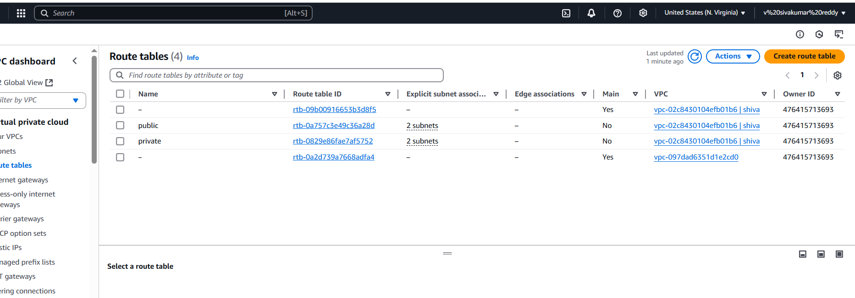

STEPS:

STEPS:

1. GO to VPC DASHBOARD.
2. Select ROUTE TABLE and CREATE a ROUTE TABLE.
3. After that go to actions and select EDIT SUBNET ASSOCIATES and save it.
4. AFTER that PUBLIC will be created in ROUTE TABLE.

1. Public route table will have the routes to internet and local

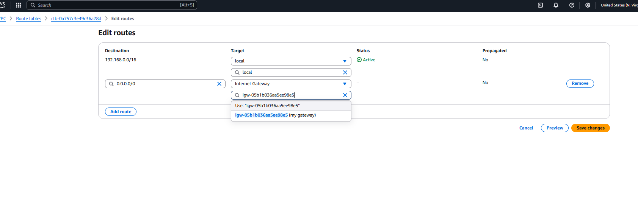

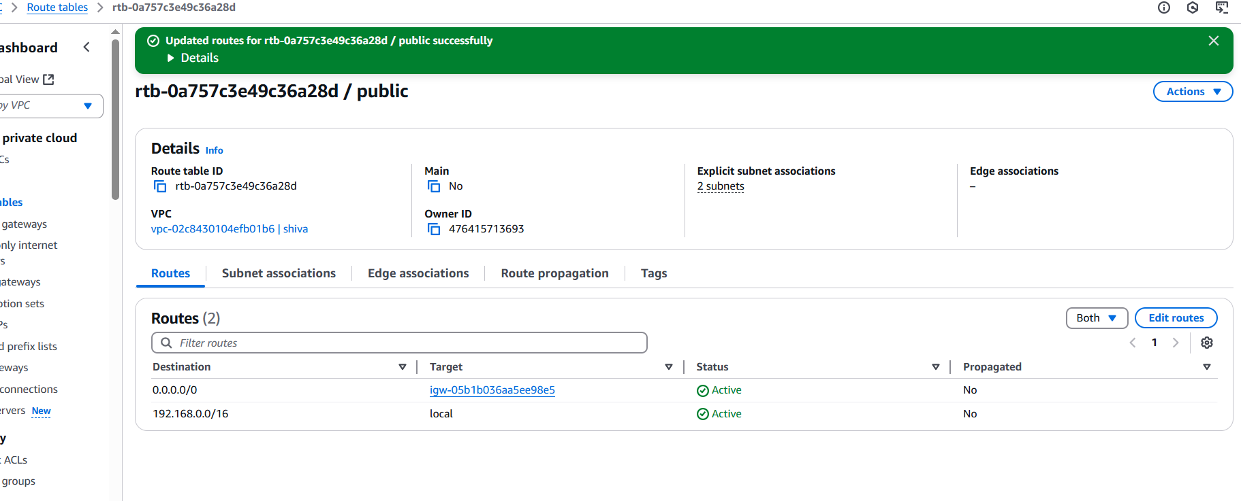

STEPS:

1.GO to VPC DASHBOARD.

2. Aftet that go to ROUTE TABLE AND SELECT PUBLIC.

3.Next click on the PUBLIC ID.

4. GO to EDIT ROUTE and GIVE THE IP 0.0.0.0/0 and select INTERNET GATEWAY and save it will like ACTIVE.

1. Create Ec2 in public subnet with t2micro and install php

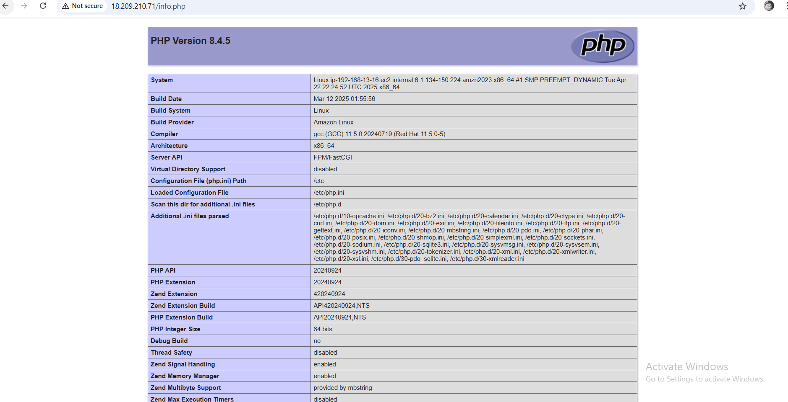

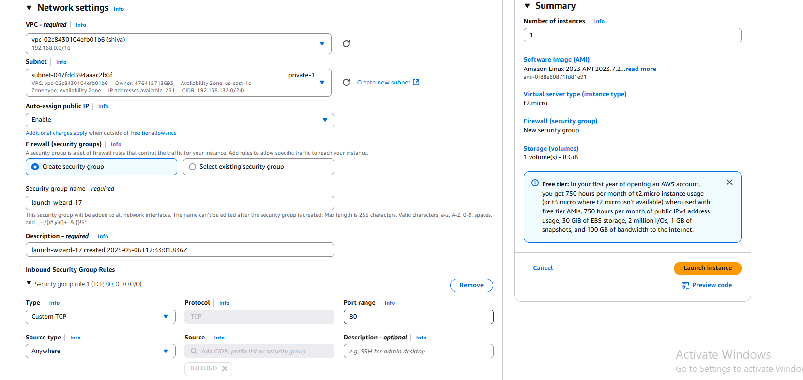

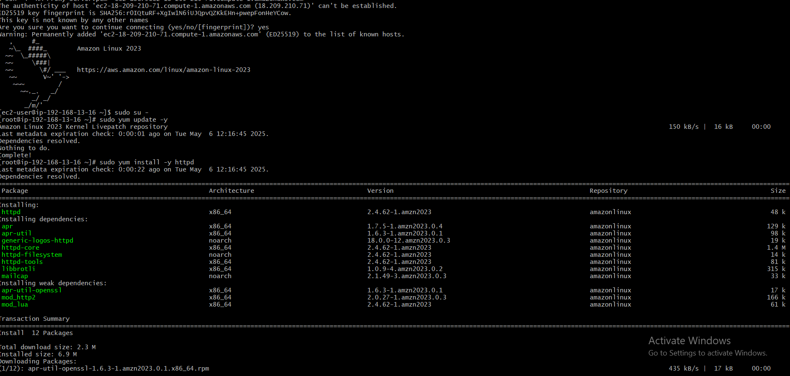

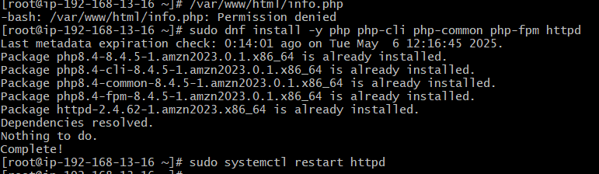

STEPS:

**✅ Steps to Launch EC2 and Install PHP (Amazon Linux 2023)**

1. **Created a VPC** with public and private subnets.
2. **Launched an EC2 instance** (t2.micro) in a **public subnet** with:
   * Auto-assign public IP enabled
   * Security group allowing **SSH (22)** and **HTTP (80)**
3. **Connected via SSH** to the EC2 instance:

ssh -i "HA-Proxy-server.pem" ec2-user@ec2-18-209-210-71.compute-1.amazonaws.com

1. **Installed Apache and PHP**:

sudo dnf install -y php php-cli php-common php-fpm httpd

1. **Started Apache web server**:

sudo systemctl start httpd

1. **Created a PHP test file**:

echo "<?php phpinfo(); ?>" | sudo tee /var/www/html/info.php

1. **Accessed PHP page** in browser:

pgsql

http://<your-ec2-public-ip>/info.php

1. COnfigure Nat gateway in public subnet and connect to private Instance

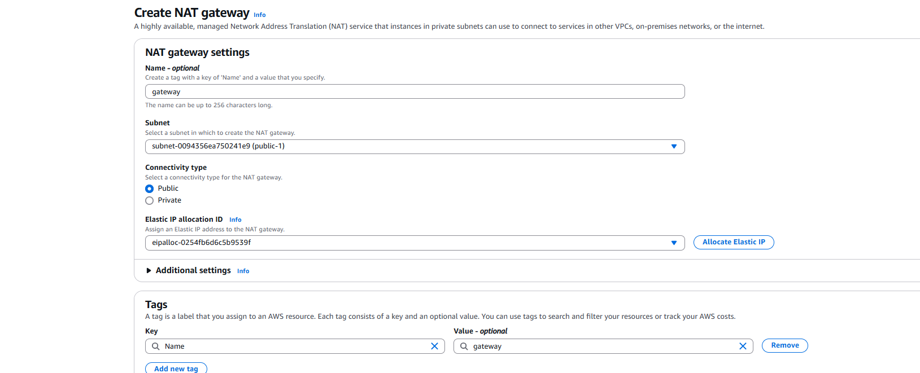

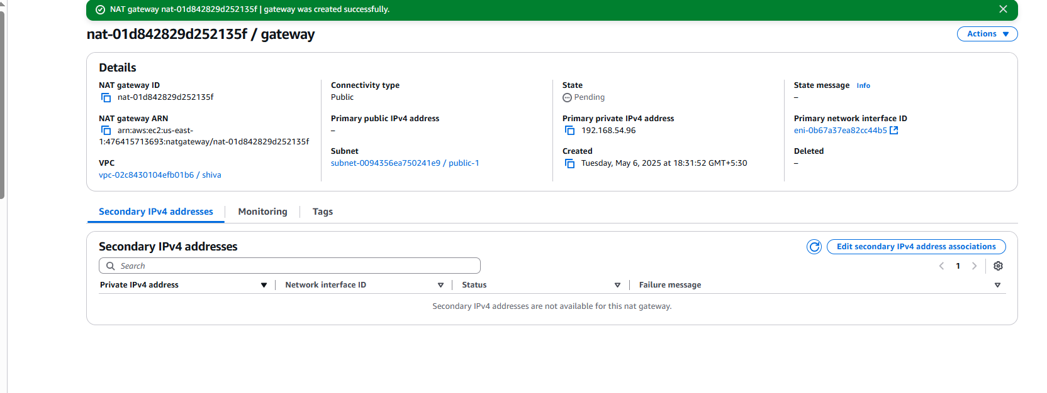

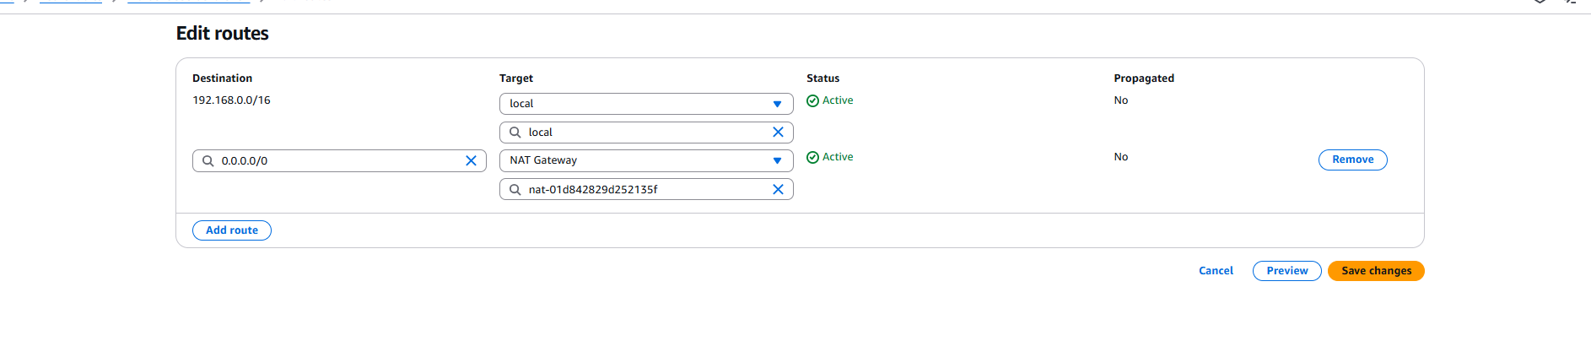

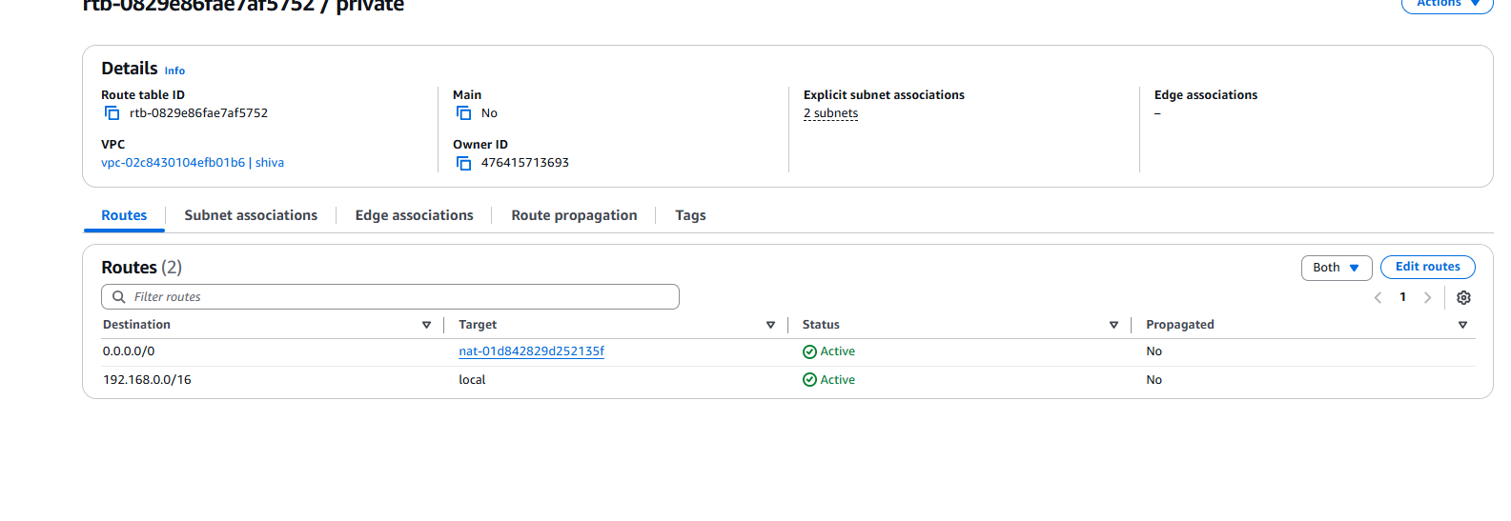

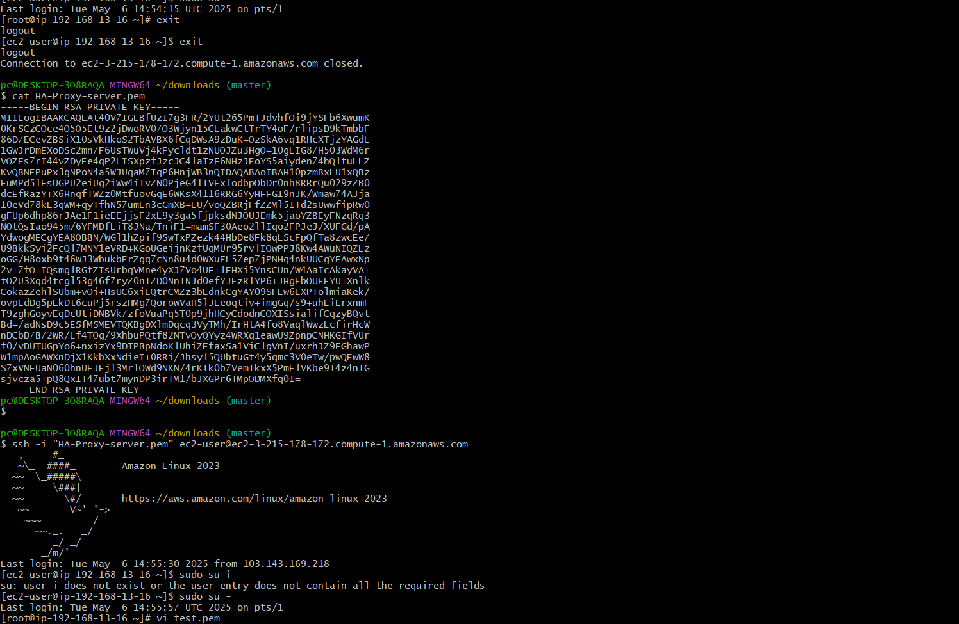

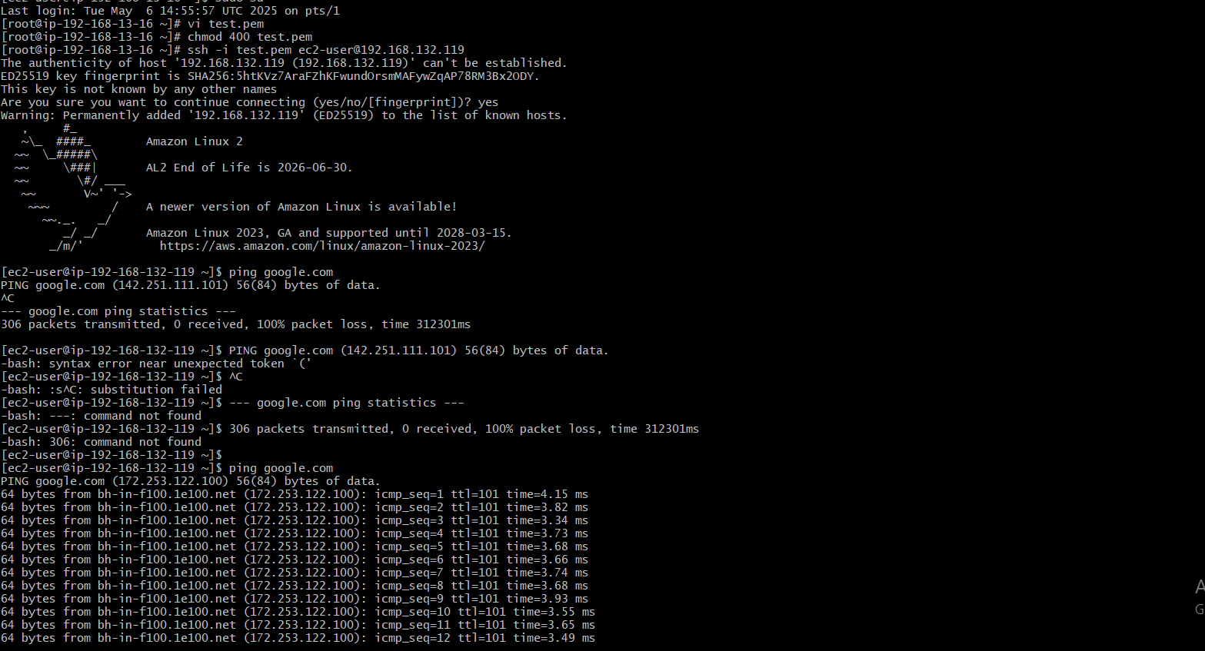

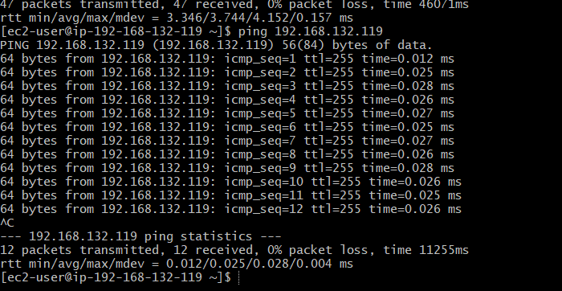

STEPS:

1. At first we need to go to vpc in that we need to create vpc,subnet,route table,IGW, and nat gate way .
2. After that go to EC2 and create 1 public and private instance with specific requirements to be give while launching these instances.
3. Next connet SSH with public instance in terminal.
4. After we have to create one file to save our pem key password in it and we have to give permissions to it.
5. Next SSH login with newly saved pem with private ip then it will connect successfully.
6. To check it use ping@private ip it will some list.

1. Install Apache Tomcat in private ec2 and deploy a sample app.

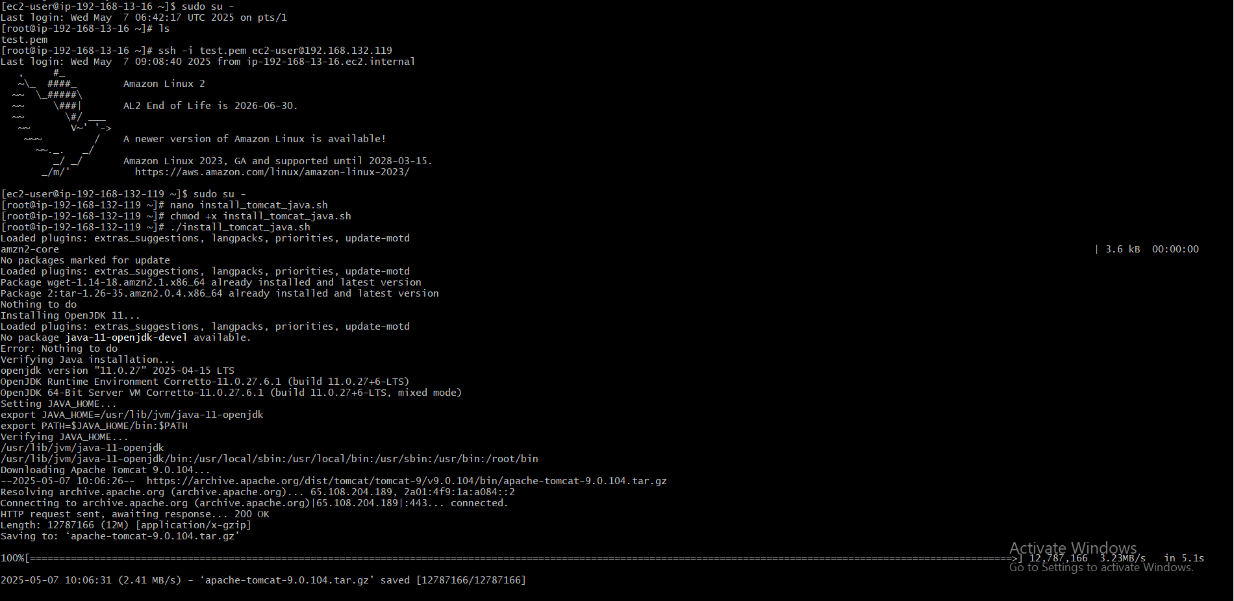

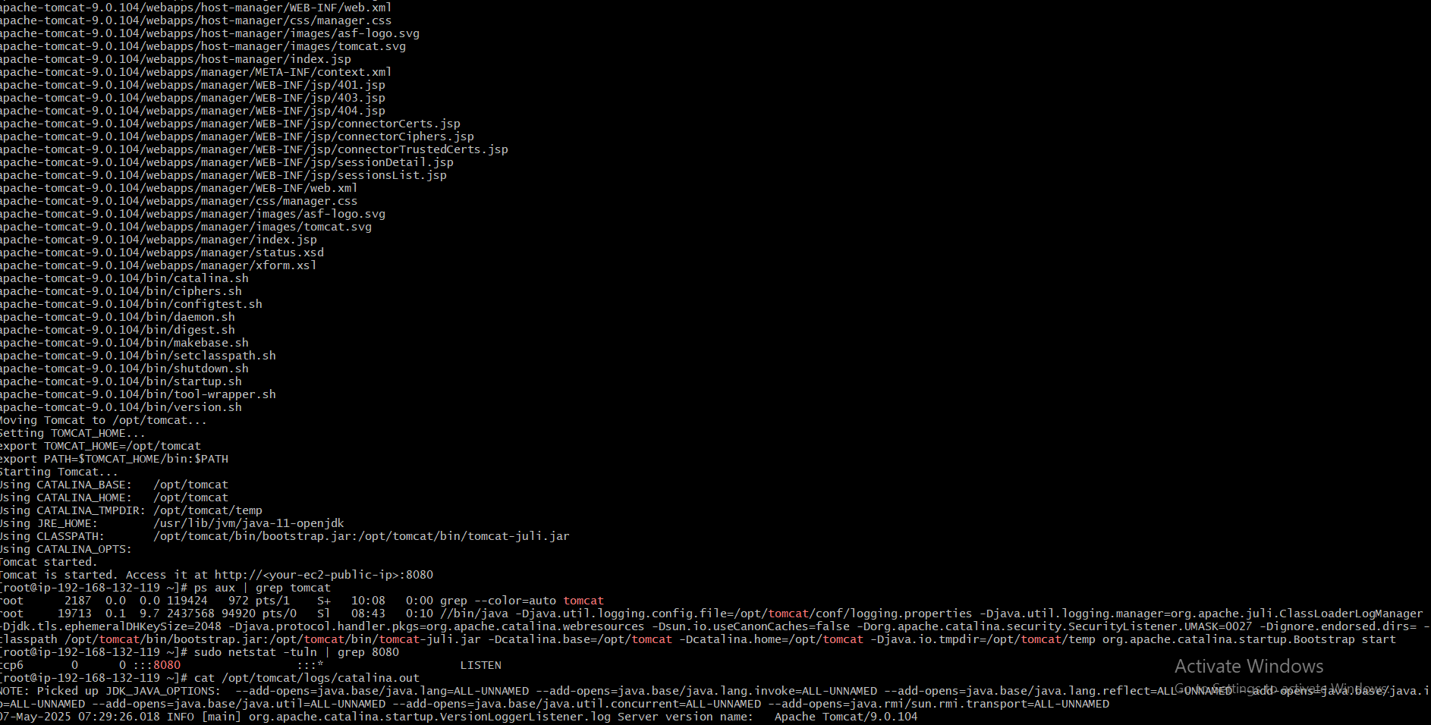

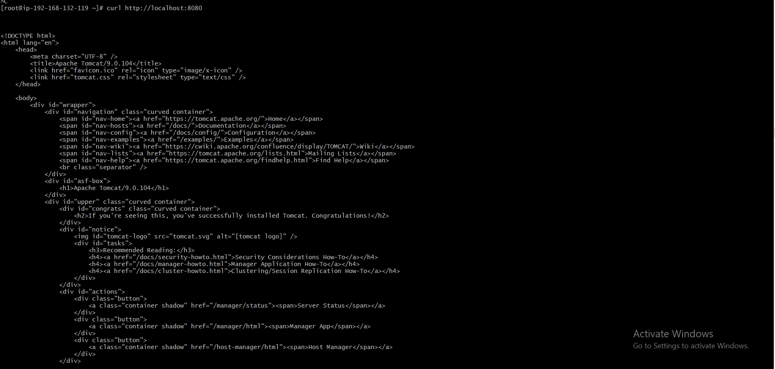

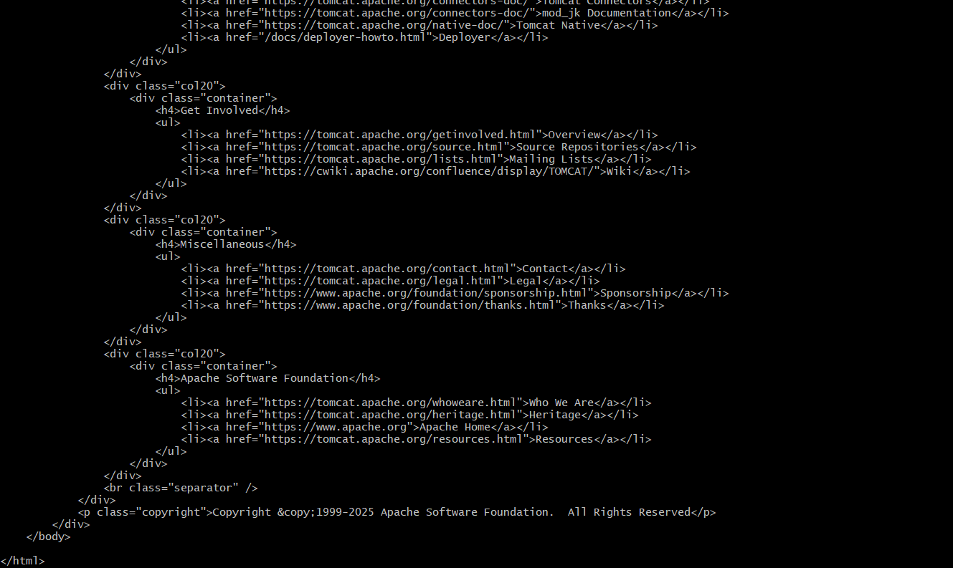

STEPS:

1. First we need SSH login with public instance and to again to private instance in this.
2. Next java installation and tomcat installation should be done.
3. Next we need check tomcat is started or not if it started then ok.
4. After this we need to give curl http:// localhost:8080 it will html that’s it.
5. Configure VPC flow logs and store the logs in s3 and cloudwatch.

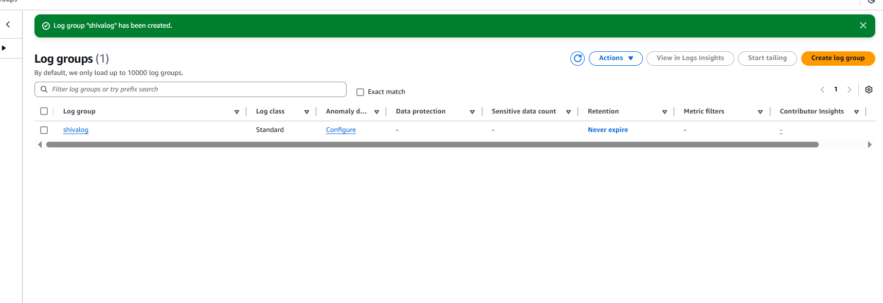

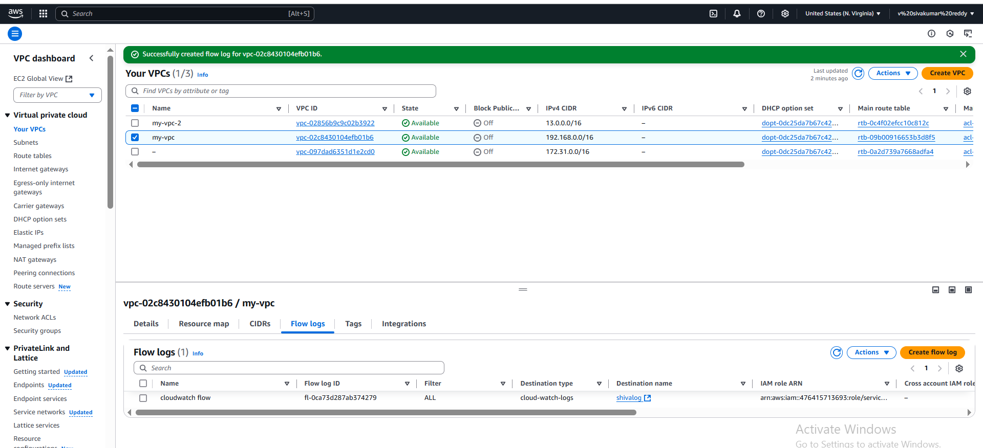

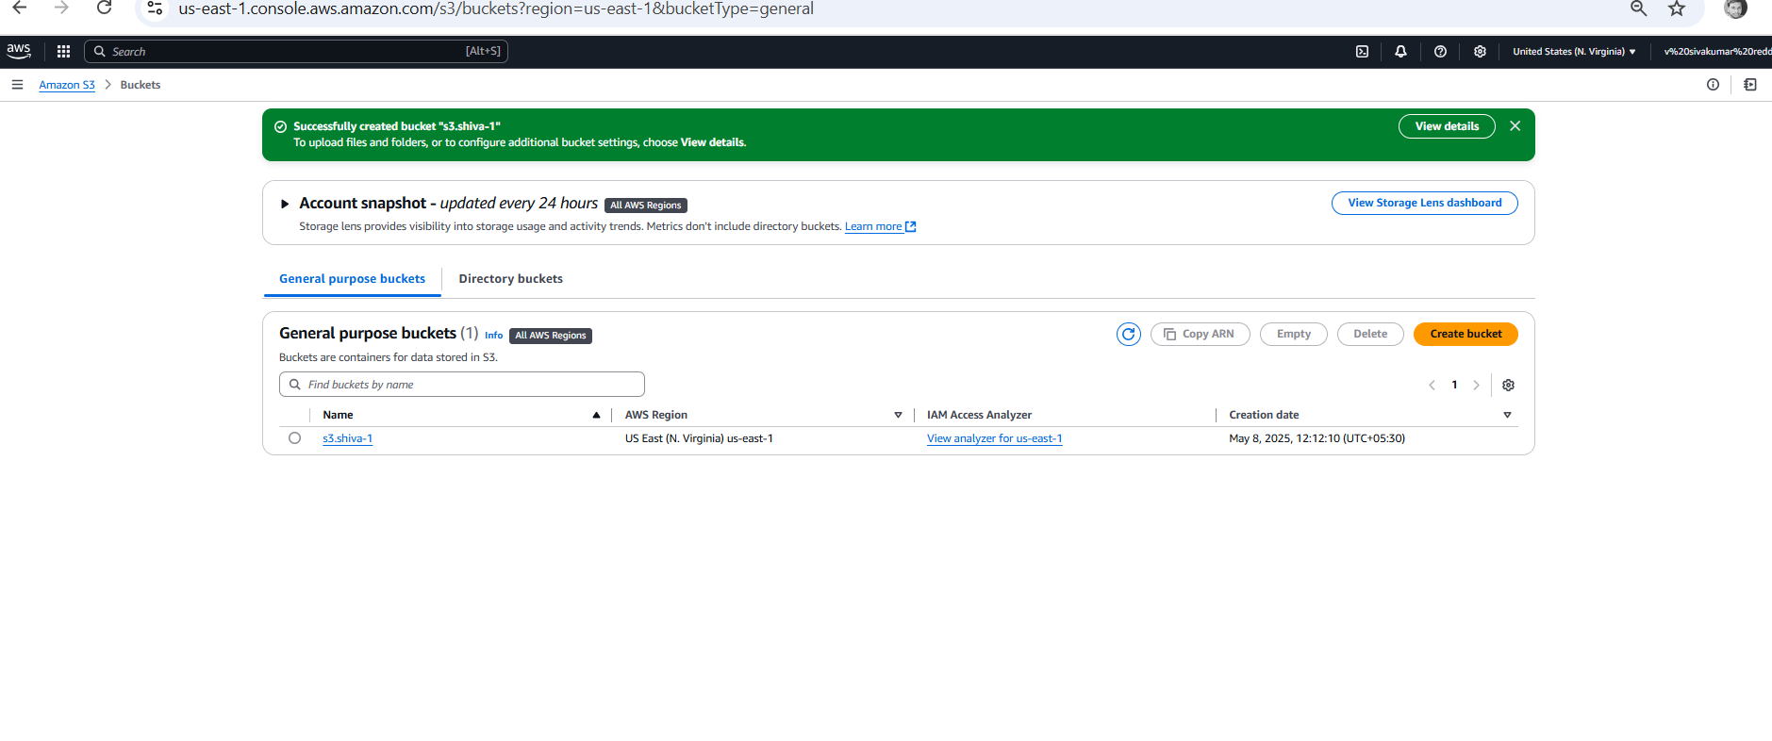

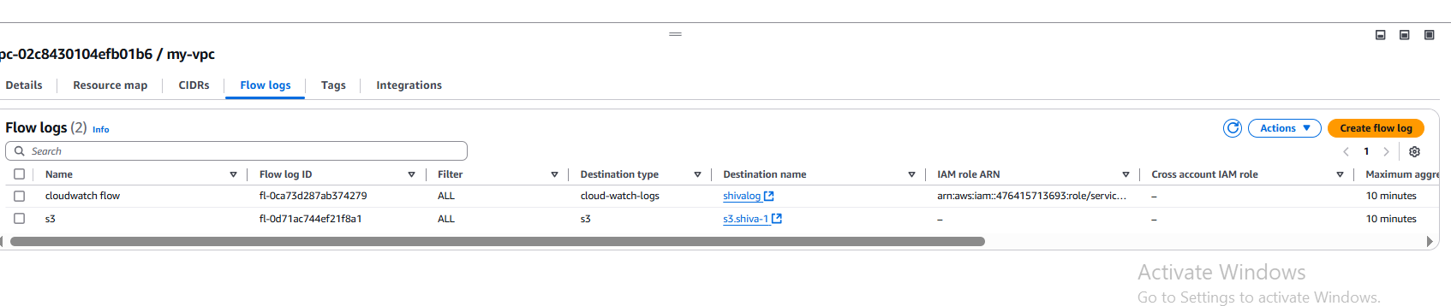

STEPS:

1. First we have to go to log groups and create one.
2. Next go to VPC and select my created VPC .
3. And go to flow logs and create one with before we created flow log we have to add to this.
4. After this go to the s3 bucket and create a new bucket.
5. Again come back to the VPC and select my-vpc and go to flow log again and create with select send to amazon s3 bucket option.