1. Install jenkins and run jenkins on port number 8081.

### **✅ Steps to Install and Run Jenkins on Port 8081**

1. **Install Java 17+ (Amazon Corretto):**

sudo yum install java-17-amazon-corretto -y

1. **Add Jenkins repo & install Jenkins:**

sudo wget -O /etc/yum.repos.d/jenkins.repo https://pkg.jenkins.io/redhat-stable/jenkins.repo

sudo rpm --import https://pkg.jenkins.io/redhat-stable/jenkins.io-2023.key

sudo yum install jenkins -y

**3.Create a systemd override to run Jenkins on port 8081:**

sudo systemctl edit jenkins

[Service]

ExecStart=

ExecStart=/usr/bin/java -Djava.awt.headless=true -jar /usr/share/java/jenkins.war --httpPort=8081

**4.Reload systemd and start Jenkins:**

sudo systemctl daemon-reload

sudo systemctl enable jenkins

sudo systemctl start jenkins

**5.Verify Jenkins is running:**

sudo systemctl status jenkins

**6.Access Jenkins in browser:**

http://<your-ec2-public-ip>:8081

1. **(Optional)**: Skipped admin setup and logged in without creating a user — **fine for testing only**.

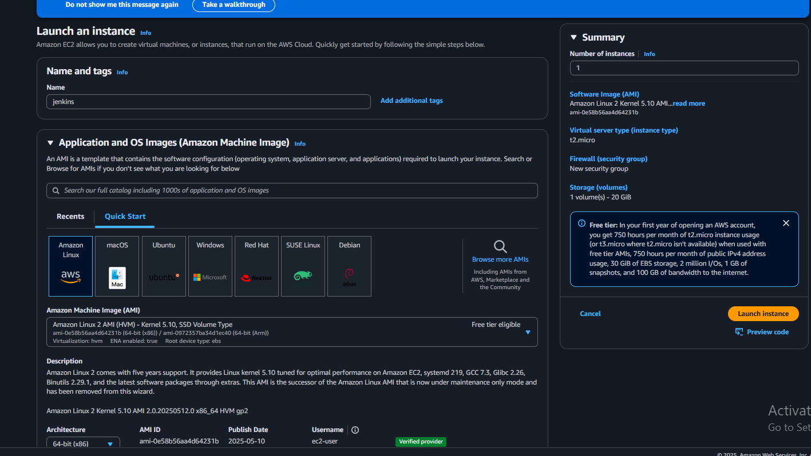

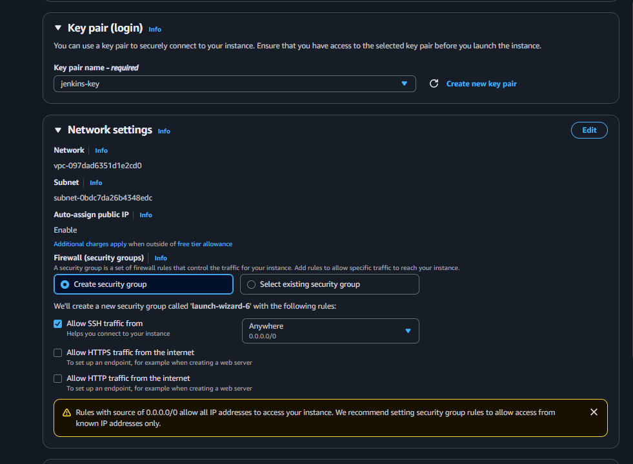

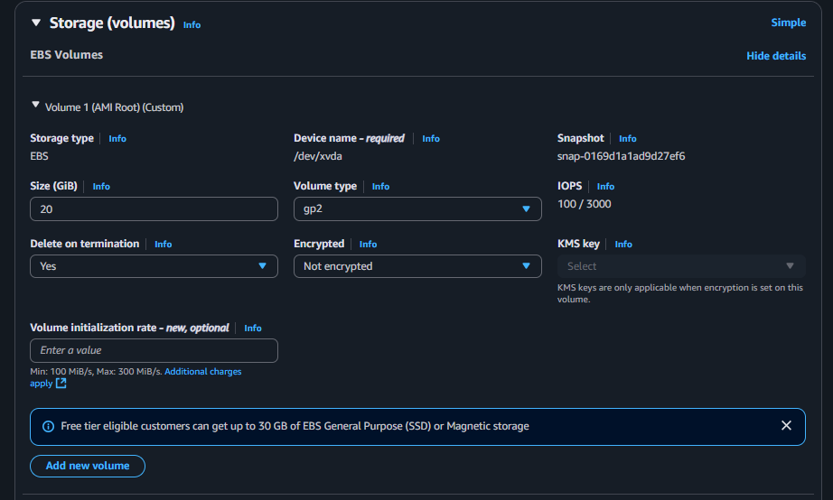

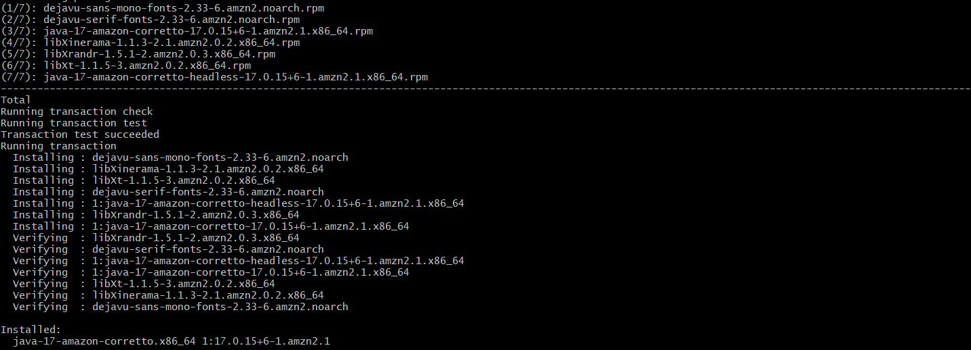

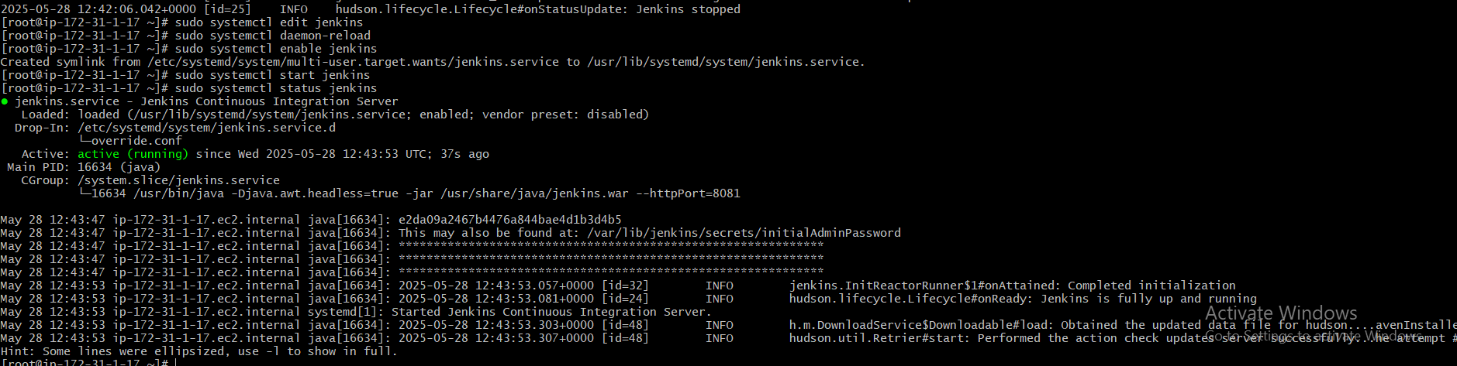

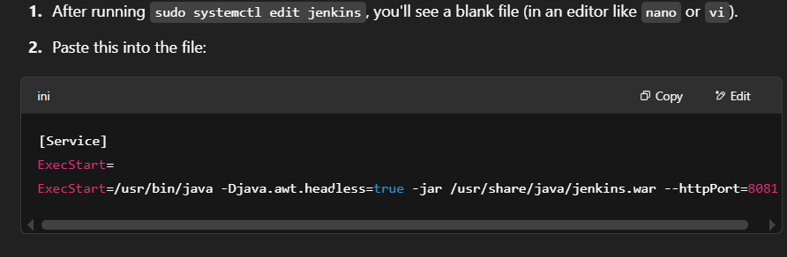



e2da09a2467b4476a844bae4d1b3d4b5

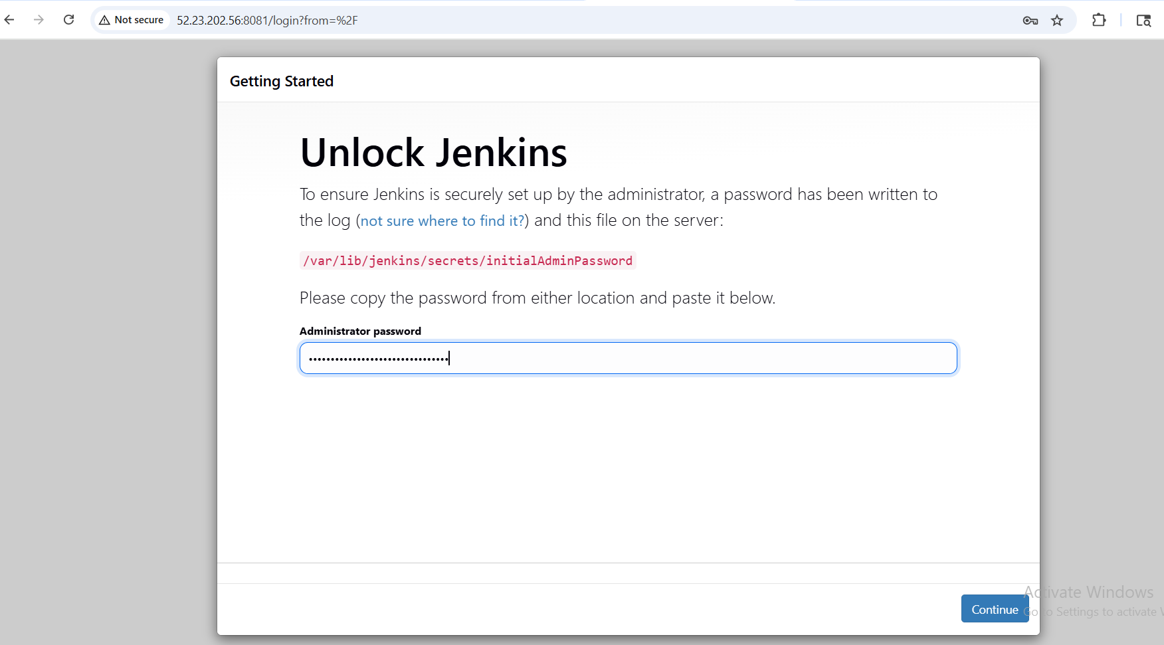

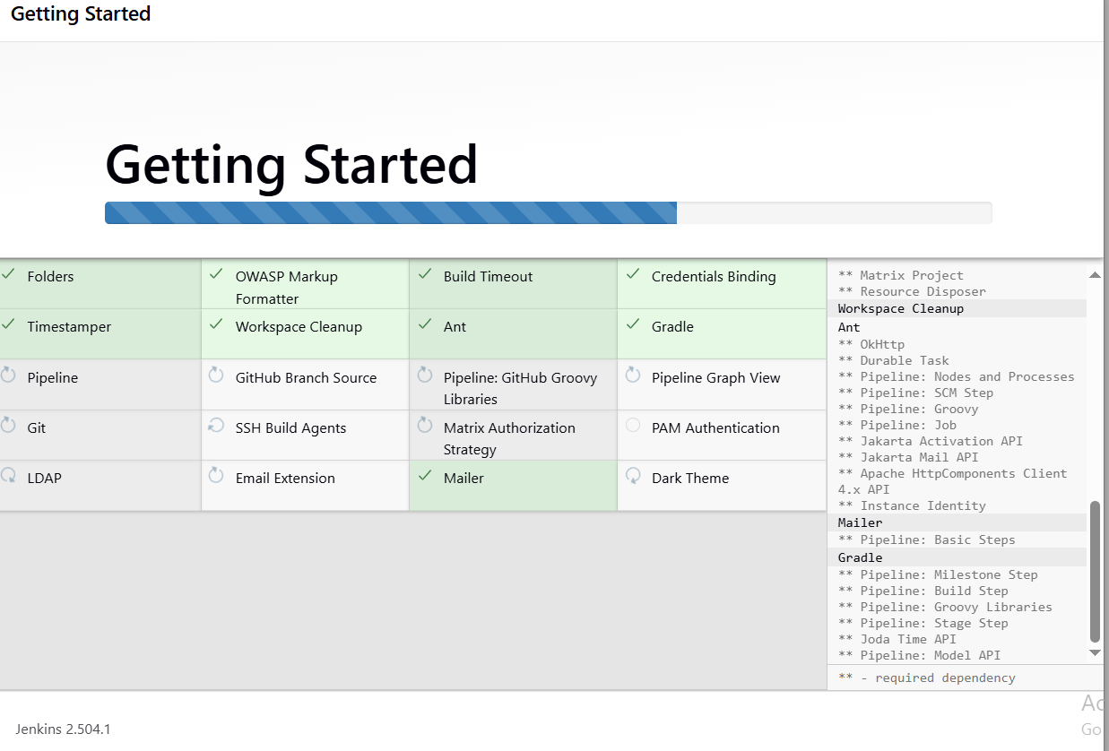

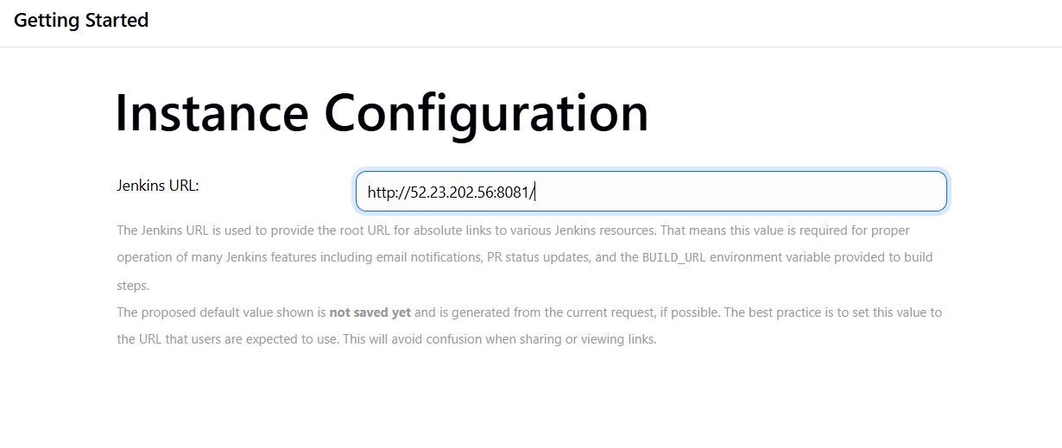

1. Secure Jenkins server.

Steps:

Firs use the command

sudo cat /var/lib/jenkins/secrets/initialAdminPassword

e2da09a2467b4476a844bae4d1b3d4b5

next go install plugins and select it

after that skip as admin login to jenkins

next go to admin and next to security and change the password with your requirements

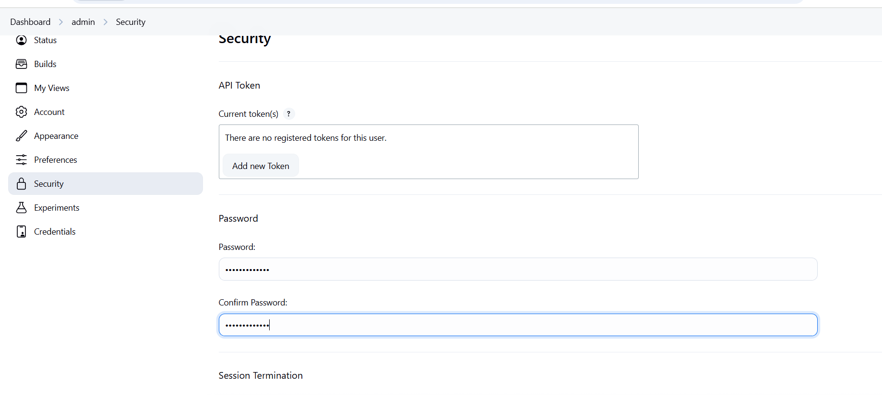

1. Create users called Devops, Testing in Jenkins with Limited access.

go to the user and create the user

go to the plugins and install the role-based authorization strategy

next go to security >>option authorization >>select project-based >>in that add user Devops >>give access only read

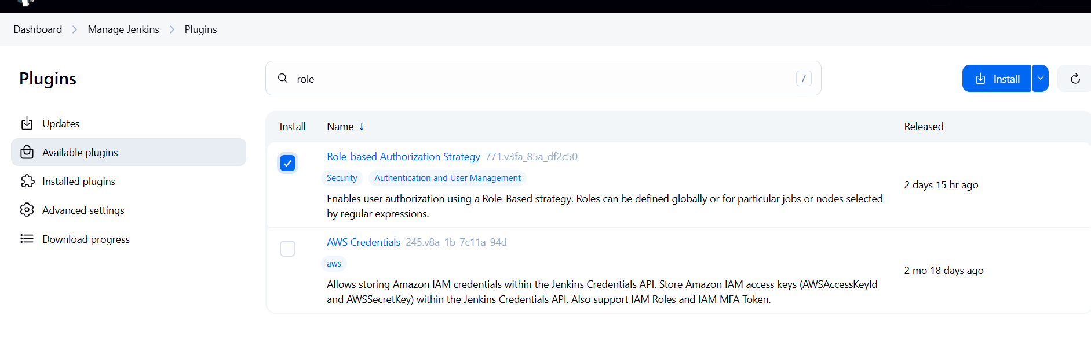

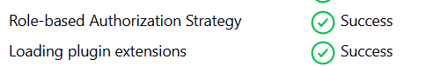

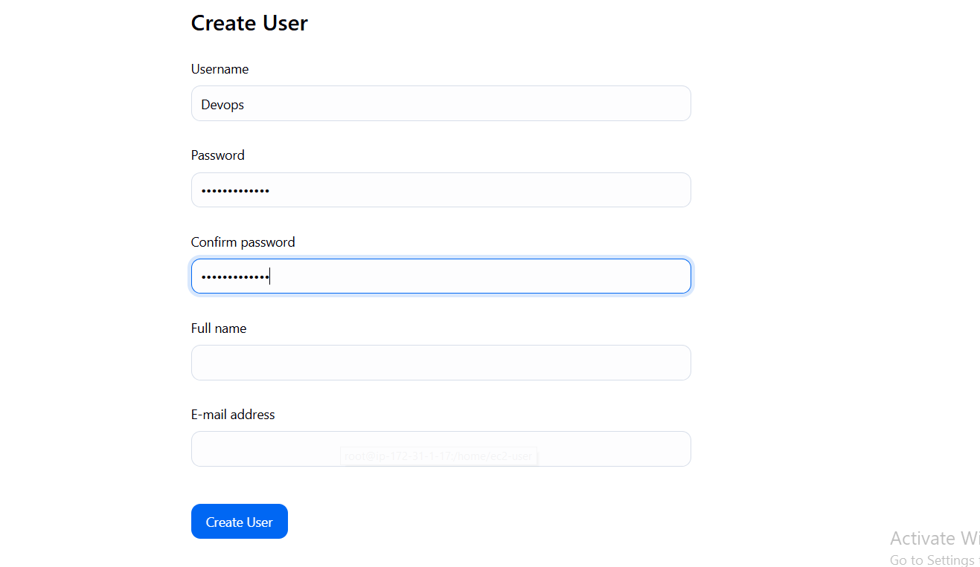

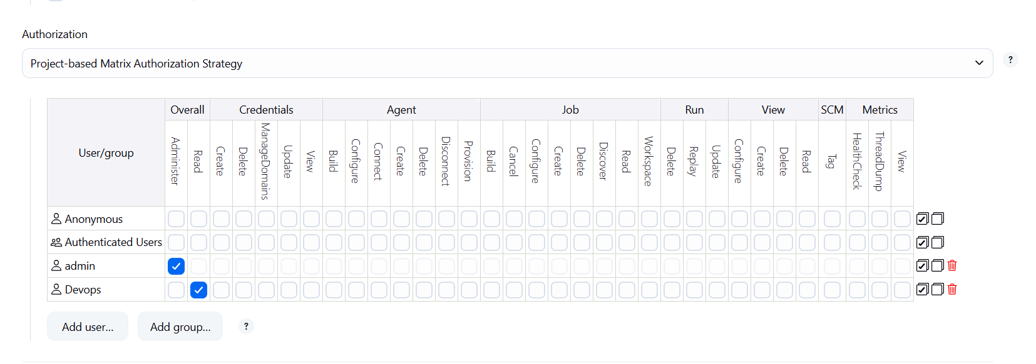

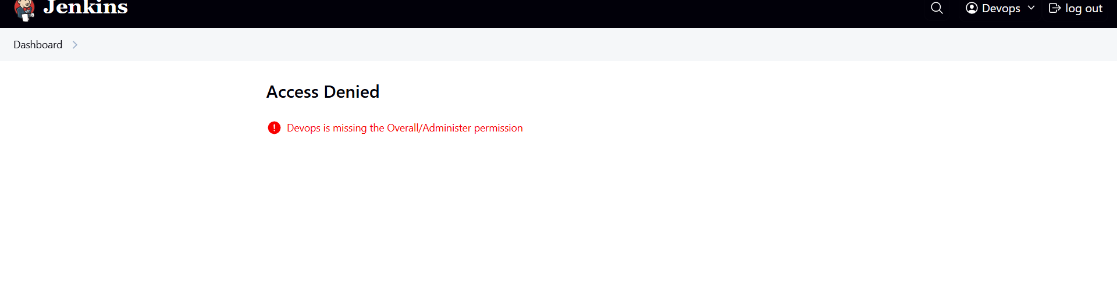

1. Configure labels and restrict the jobs to execute based on label only.

Go to the jobes and create a job

go to manage jenkins>>plugins>>install labels

go to manage jenkins>>notes >>got to build in>>configure>>give a name foe label>>click on save

go to jobs >>configure>>select the restrict option click on save

next go jobs>>click on build>>if the job is success then the job is done

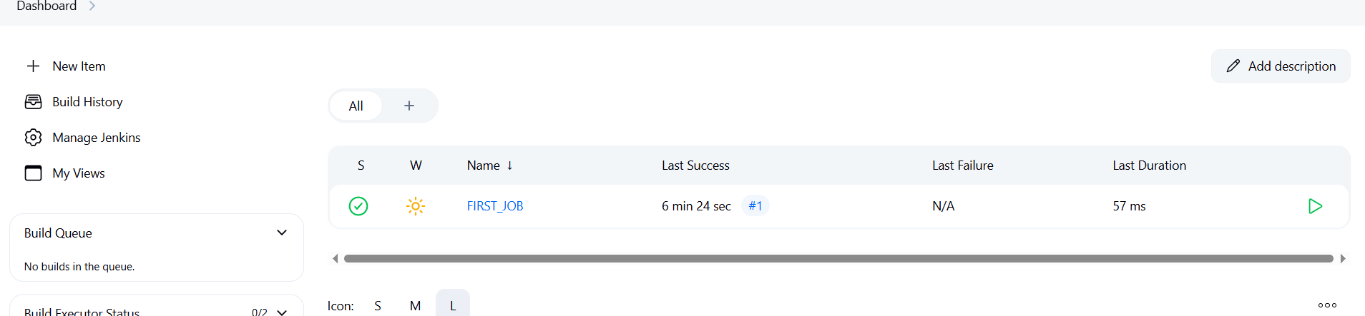

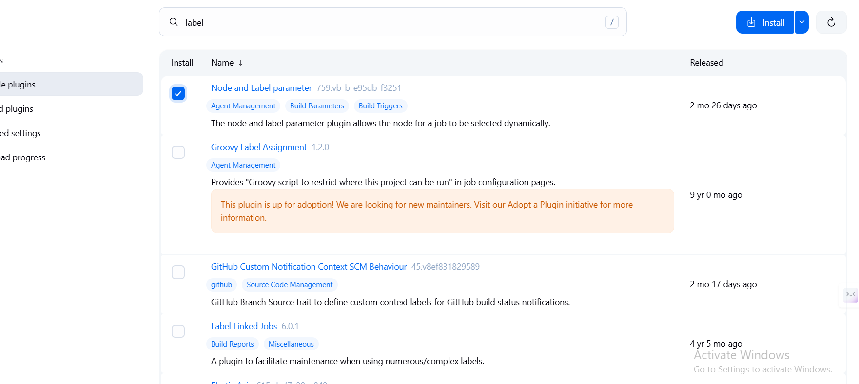



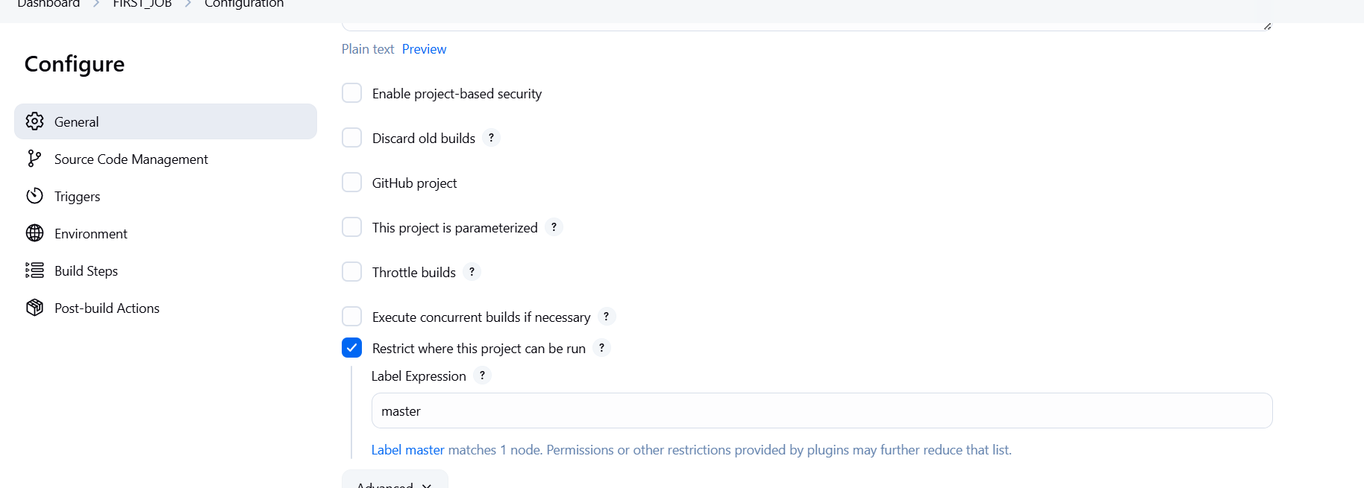

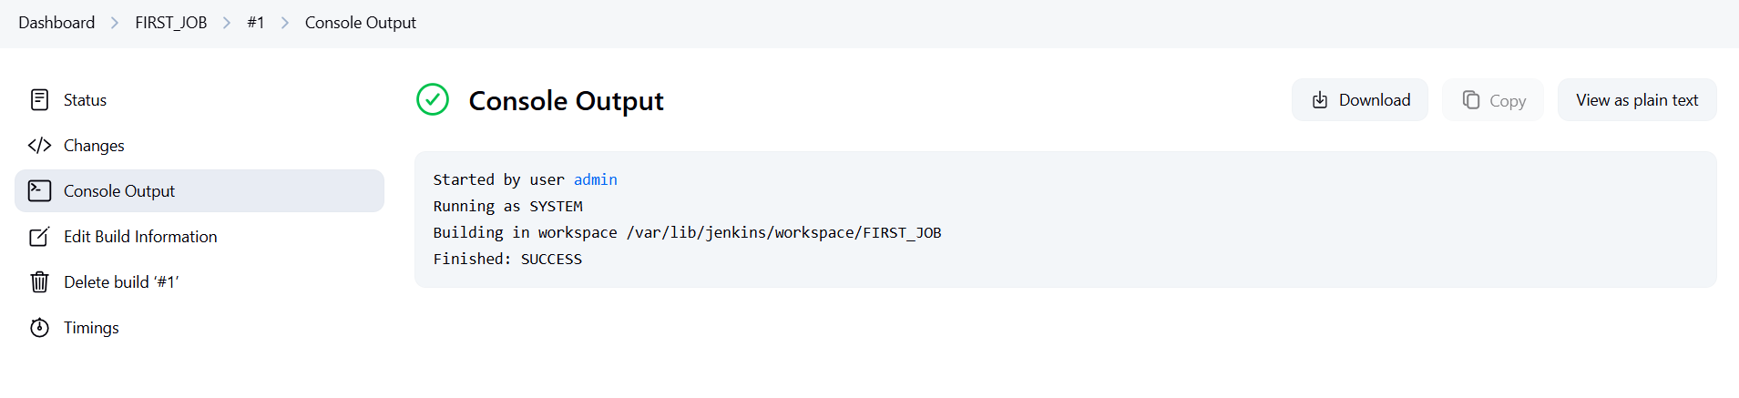

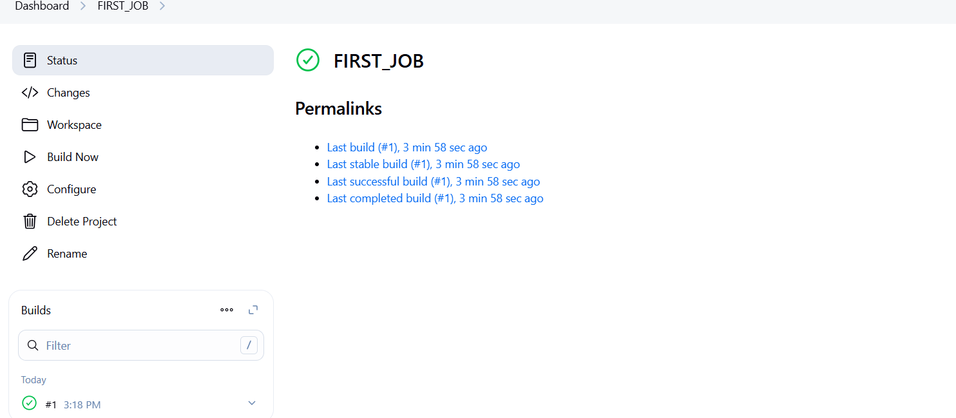

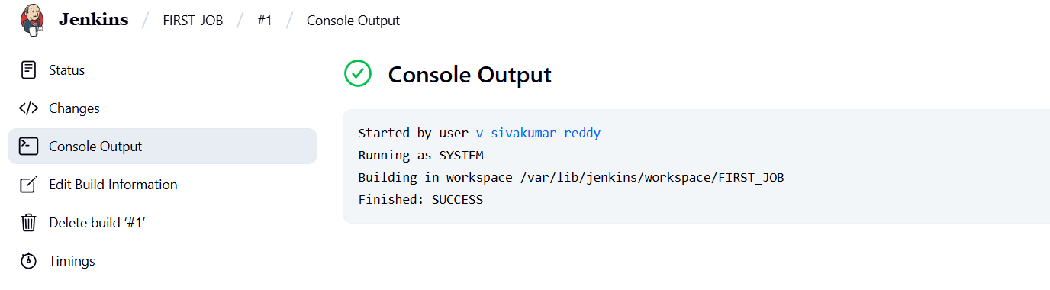

1. Create Three sample jobs using the below URL. <https://github.com/betawins/Techie_horizon_Login_app.git>

Go to the dashboard and clck on new item>>give a name >>select freestyle>>click save

go to general>>give discription>>go to option git>>paste the github url check twice that the url is working or not >>then in the triggers>>slect github triggers>>in the build test>>choose execute shell>>give a sample script and run >>save

click on build now>>if the status success>>go the ques >>see the output status

same do the for the next two sample jobs

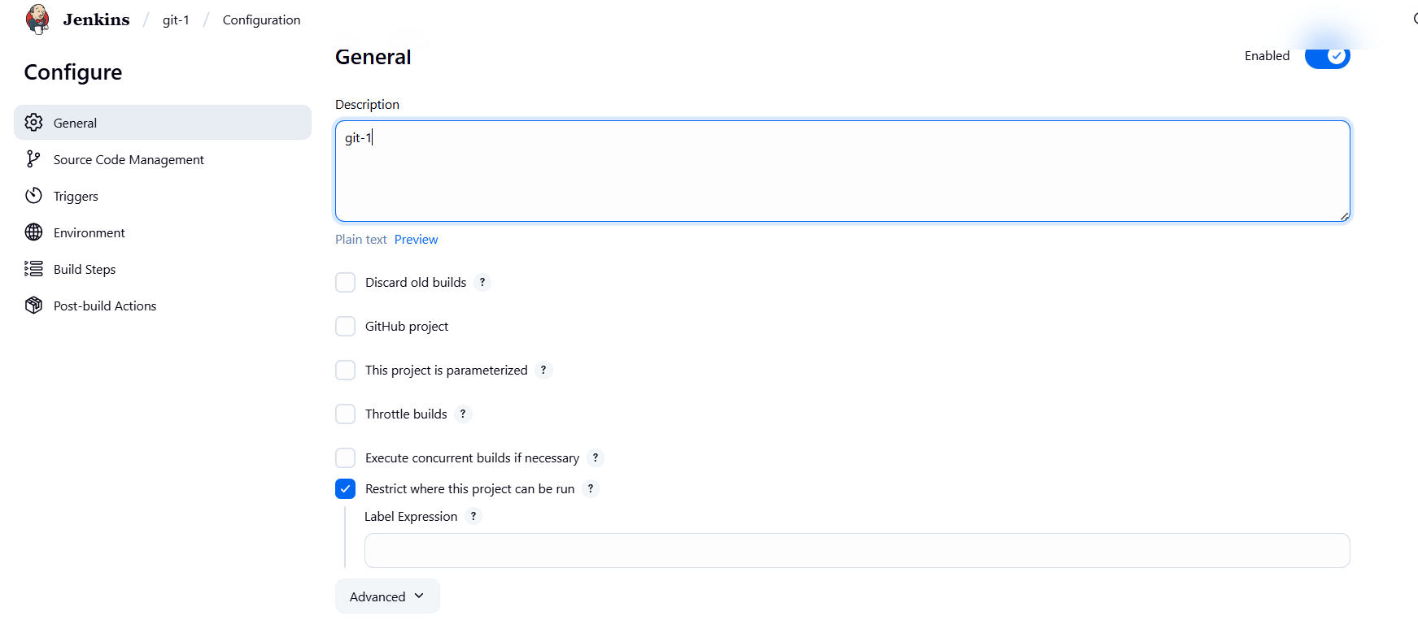

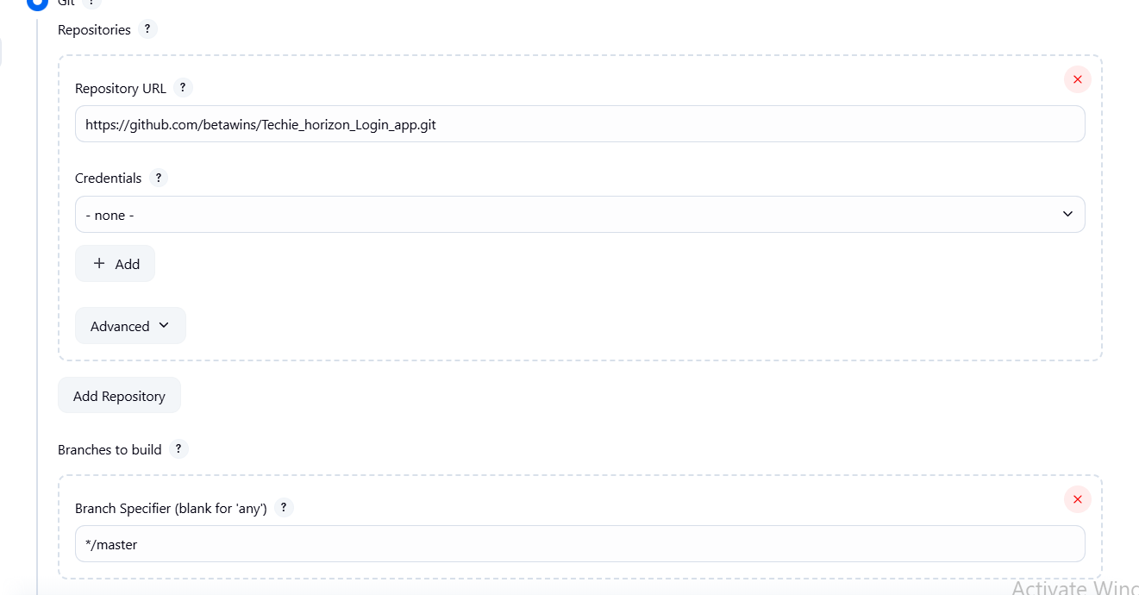

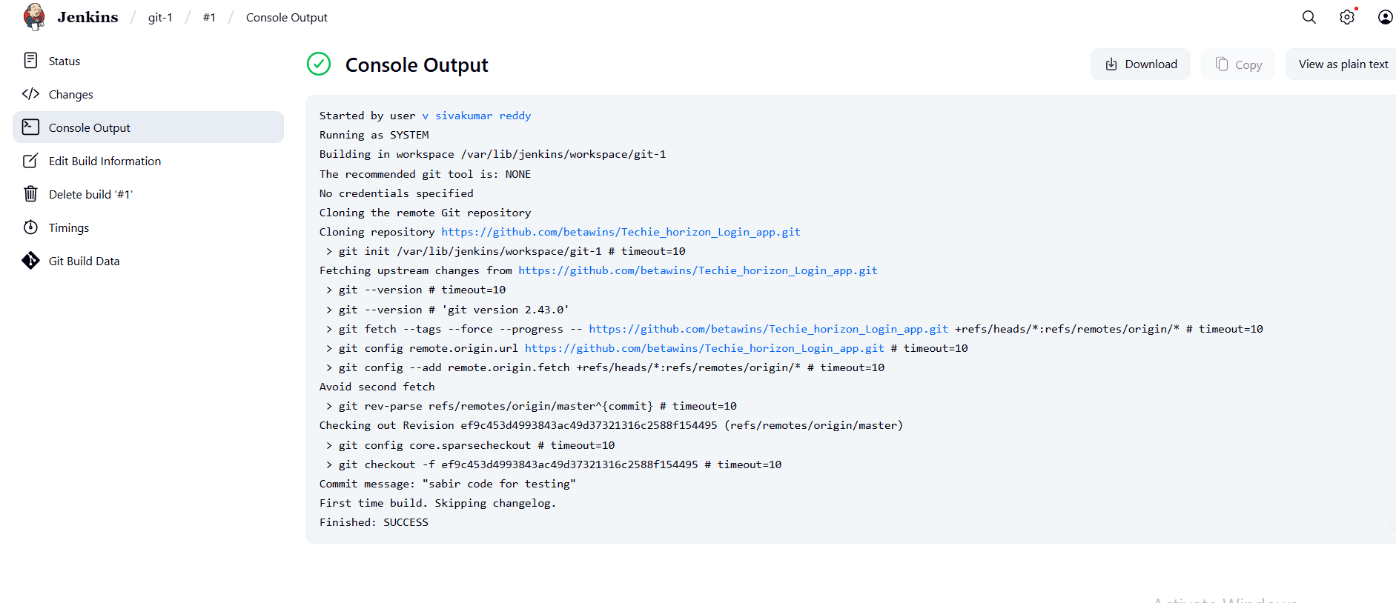

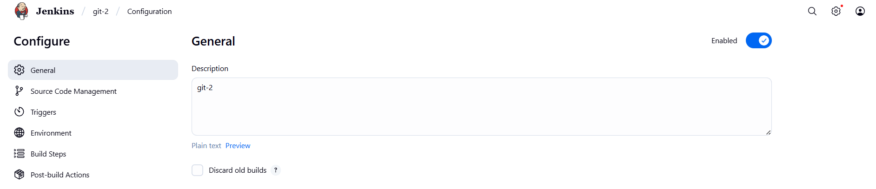

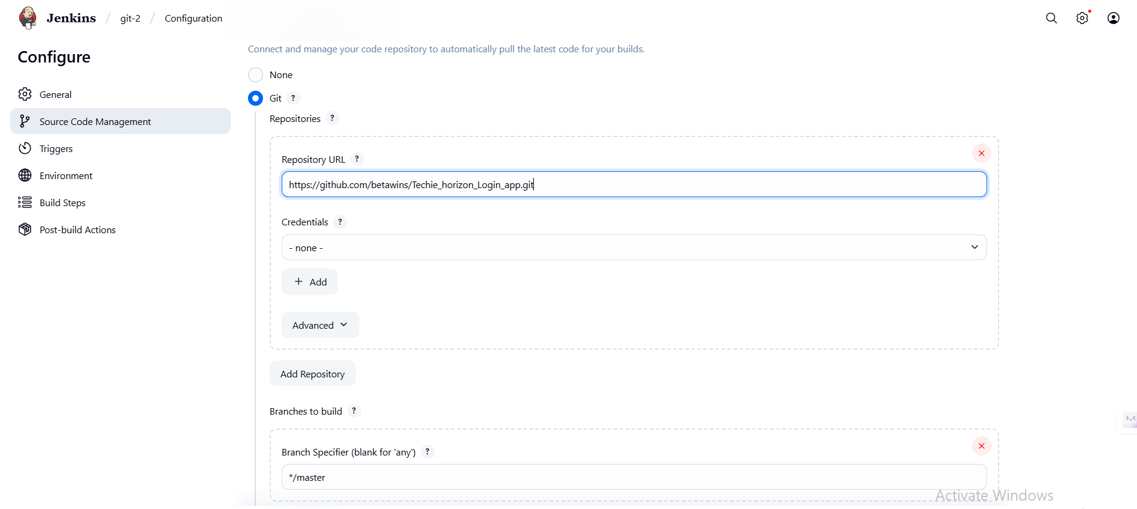

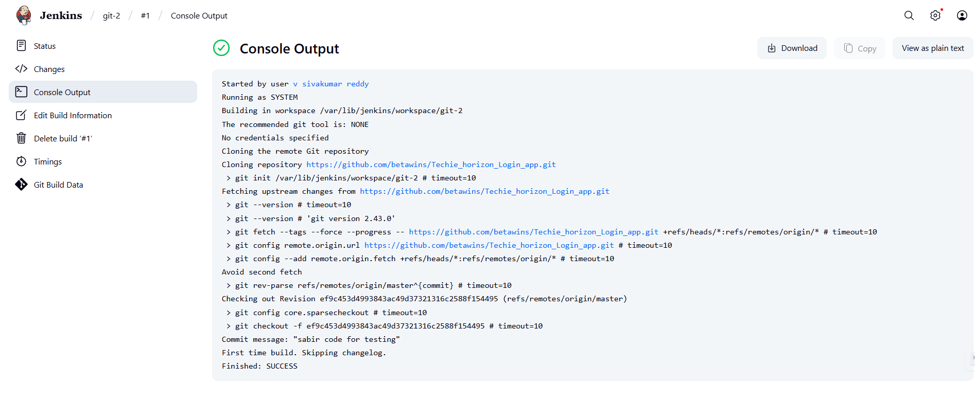

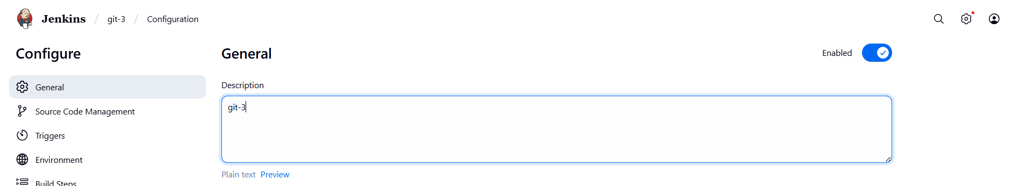

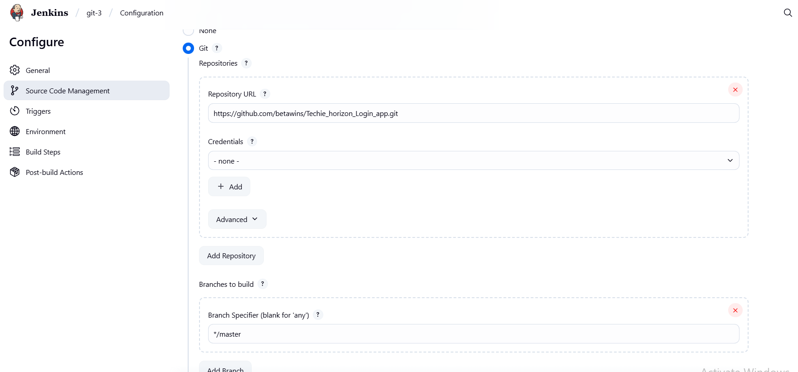

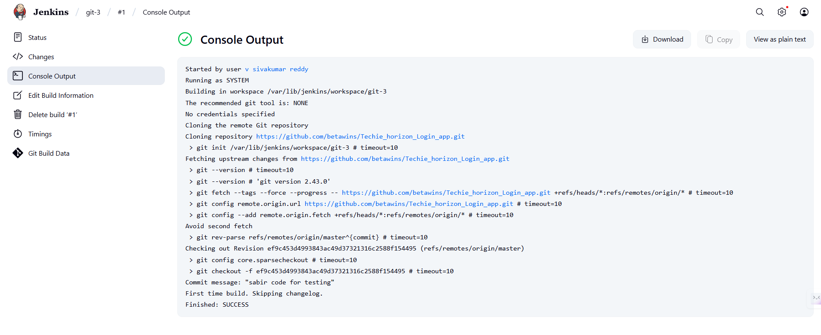

1. Create one jenkins job using git hub Private repository.

first you need to create personal key>>in github create private repo >>go settings>>go to developer settings>>then genrate a key>>give read access to the private repo >>in the permissions select content to read-only>>click on generate >>after generate copy the key

go to jenkins dashboard>>in the manage keys >>select credentials>>go to globol credentials>>click on create credentials>>give the repo username>>password is the generate key pateit there >>give the name >>give id any name >>click on save

go to dash board >> new item>>create new job>>in the job generals>>give the github url>>chose private repo>>give any buils test bash script >>click on save

now click on build now >>see in in the queue >>select the test and see the status it will success

