1. Configure 2 slave machines in jenkins master.

**Steps to be done on slave**

Login to slave machine..

switch to root user

install jdk 11 (amazon-linux-extras install java-openjdk11)

Create ssh-keygen

cat id_rsa.pub > authorized_keys

chmod 700 authorized_keys

**Steps to be done on master machine:**

Login to master machine

switch to root user.

mkdir -p /var/lib/jenkins/.ssh

cd /var/lib/jenkins/.ssh

ssh-keyscan -H SLAVE-NODE-IP-OR-HOSTNAME >>/var/lib/jenkins/.ssh/known_hosts

# ssh-keyscan -H 172.31.38.42 >>/var/lib/jenkins/.ssh/known_hosts

chown jenkins:jenkins known_hosts

#we need to change the owner as we ran ssh-keyscan command using “root” user.

# default user of Jenkins will be “jenkins”

chmod 700 known_hosts

# DOne !!

**Steps to be done on jenkins GUI:**

Go to manage jenkins

open manage node

under launch method select "Launch via SSh"

Host "public ip of slave"

creditals: select user with private key

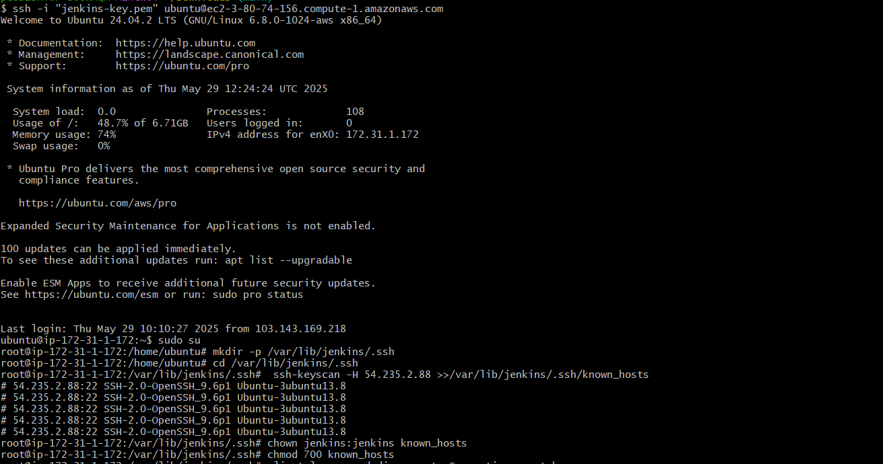

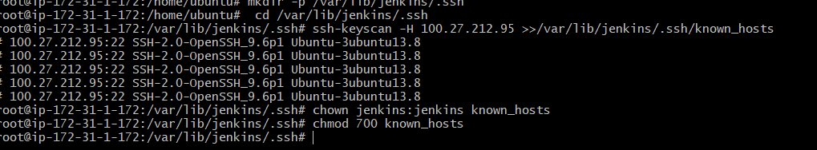

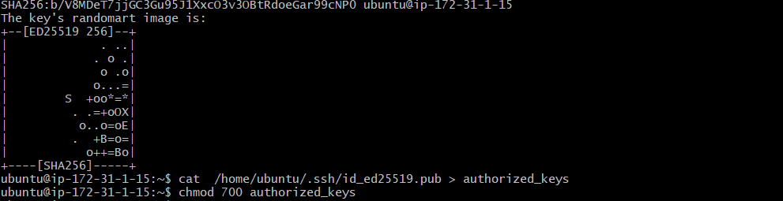

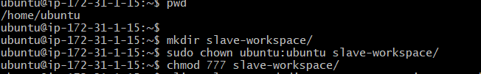

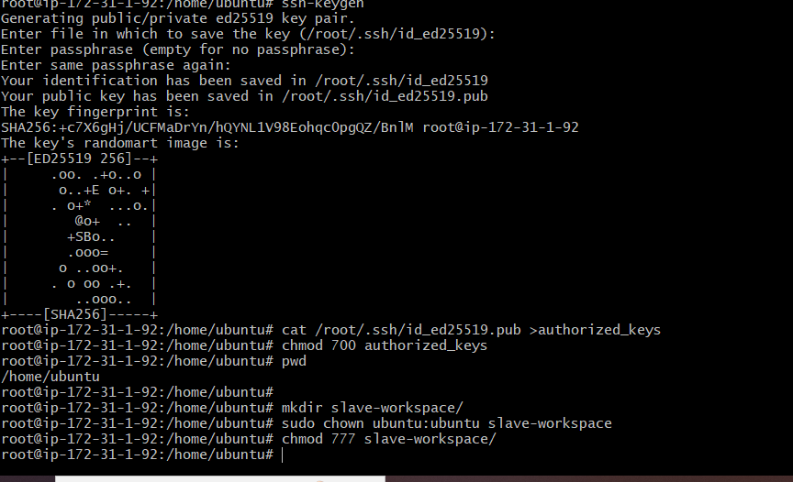

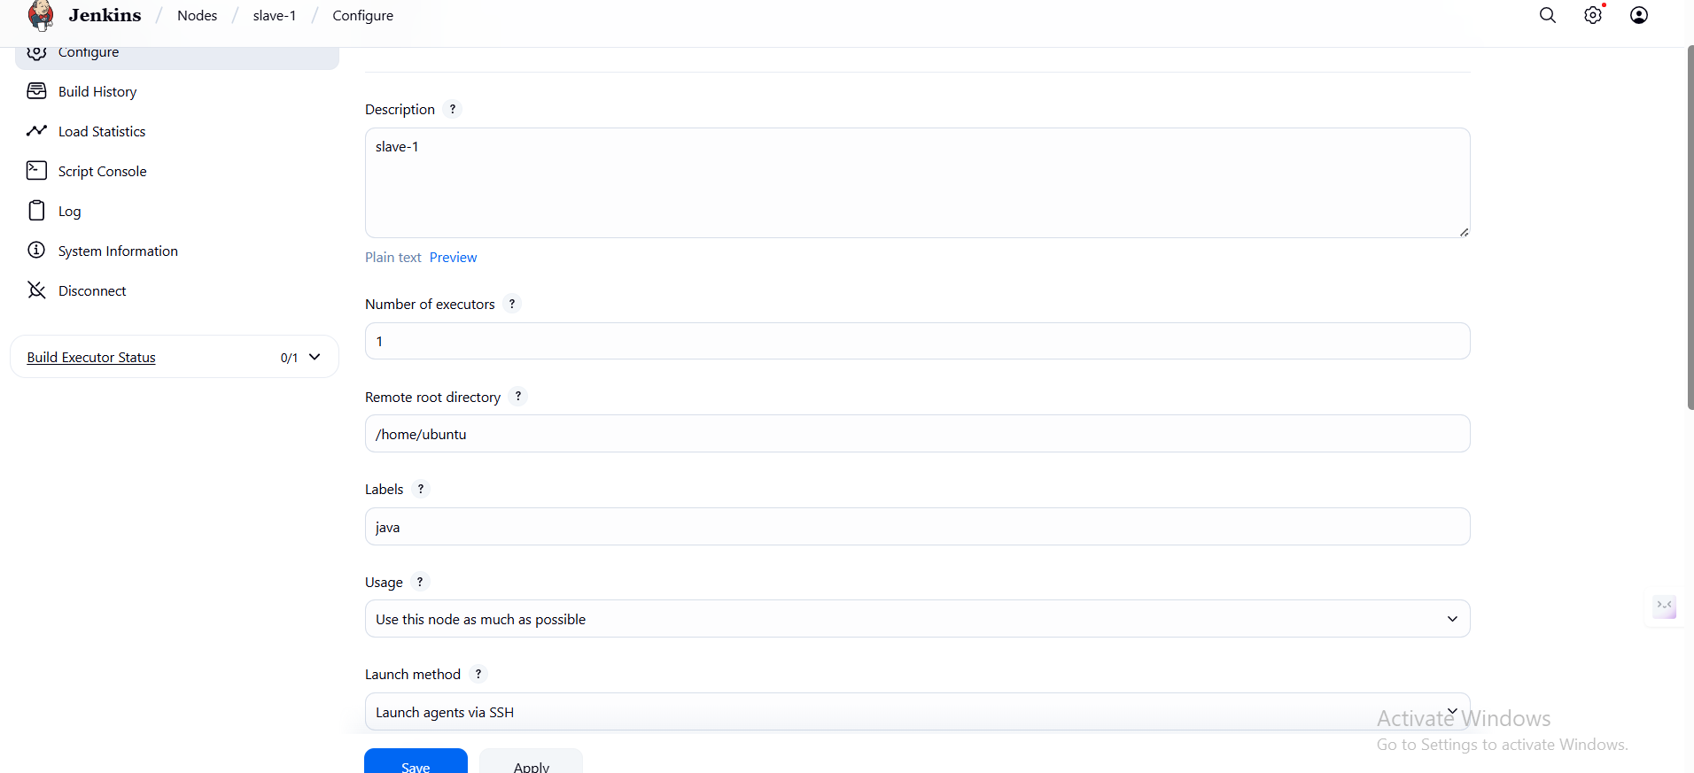

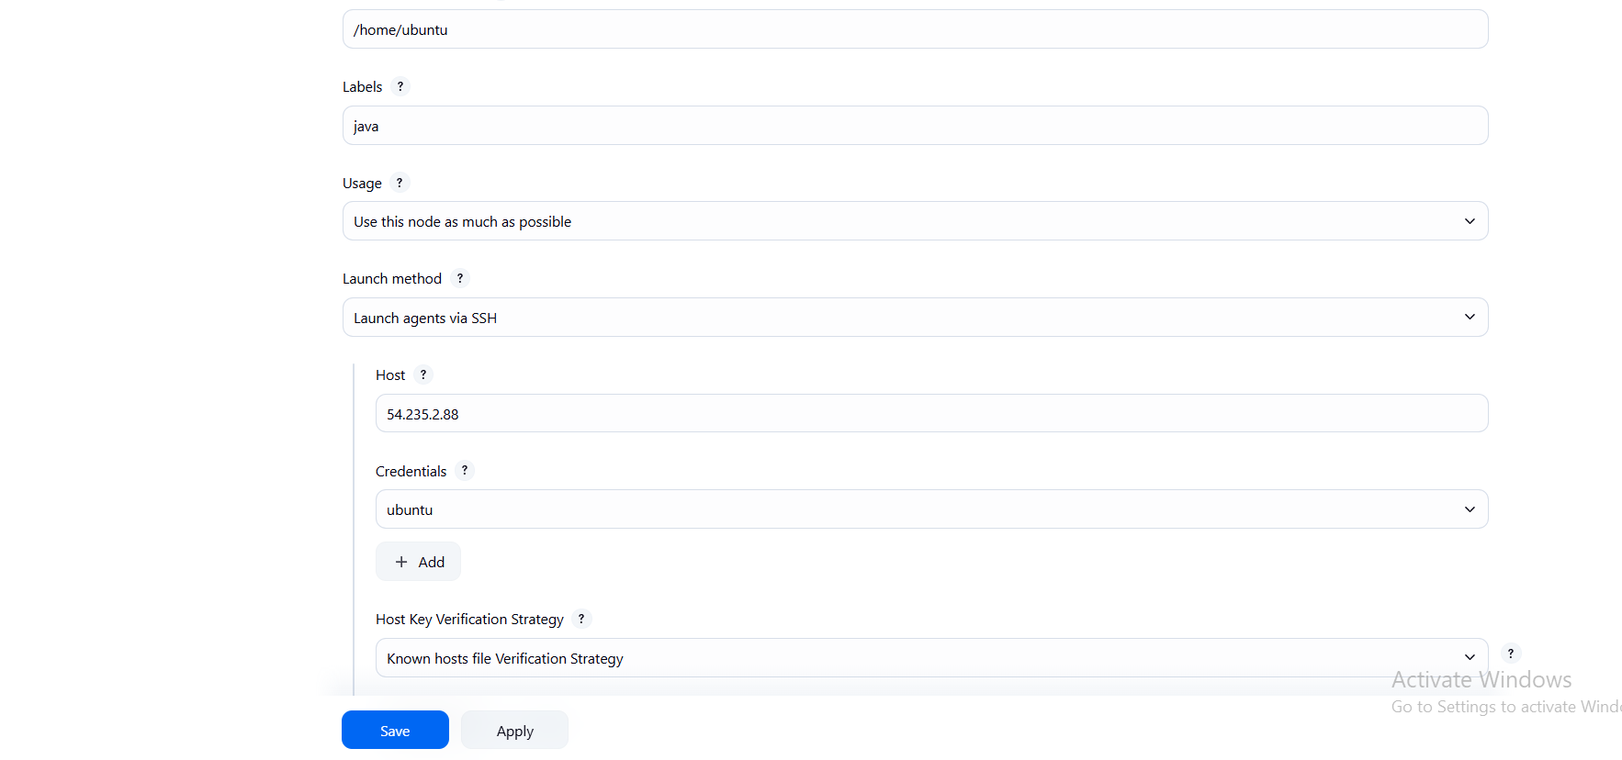

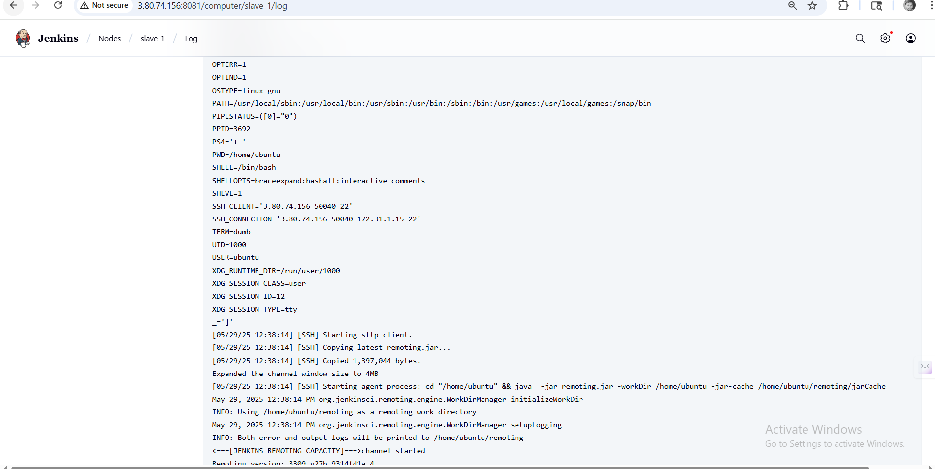

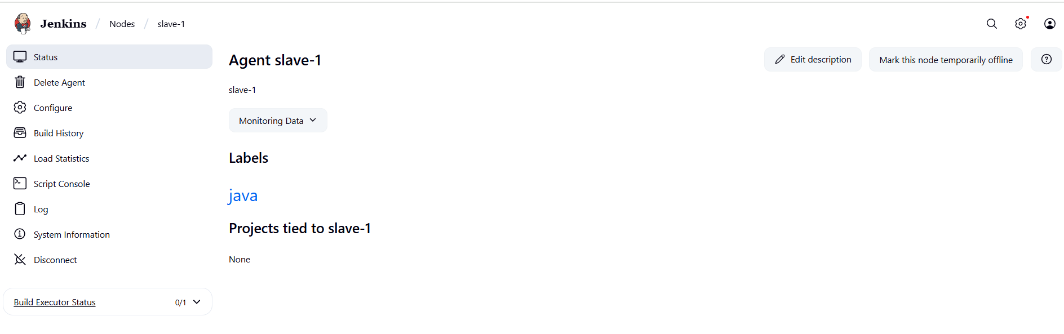

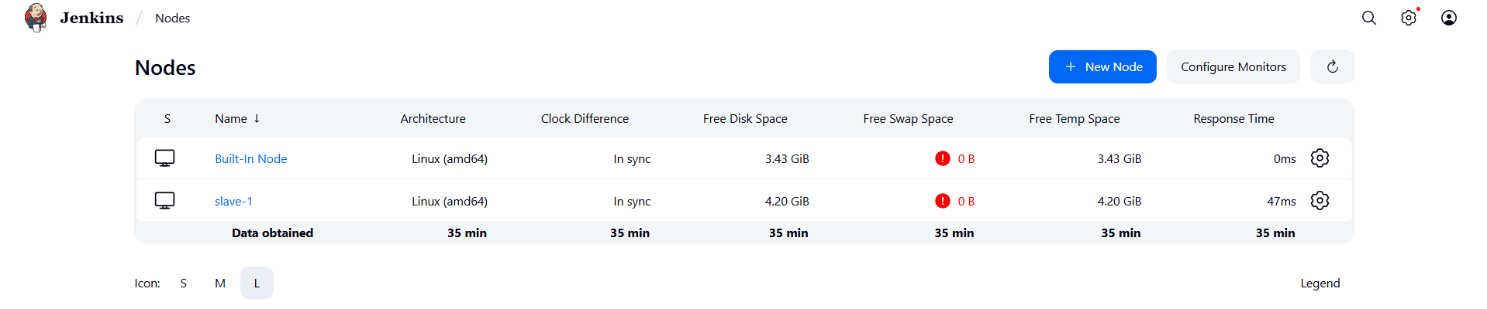

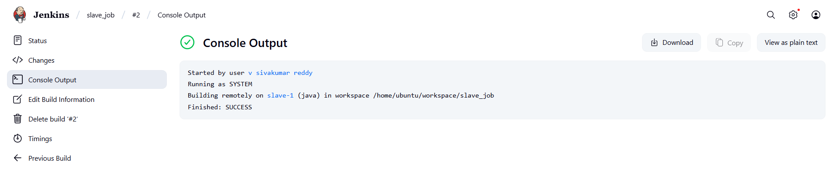

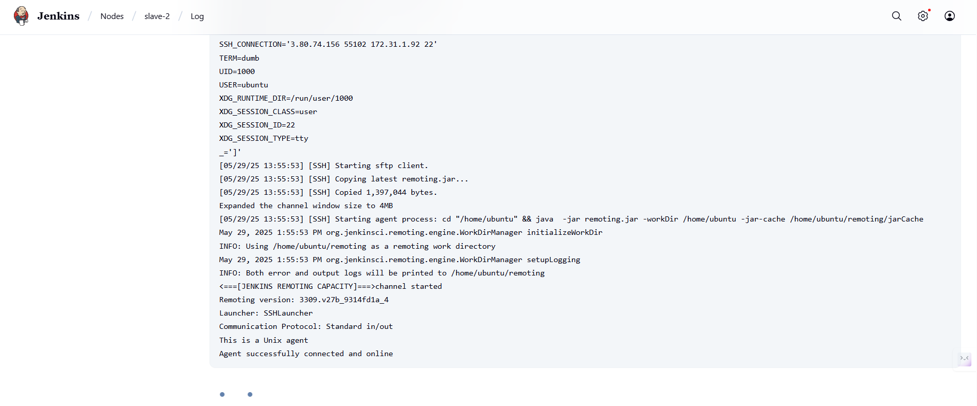

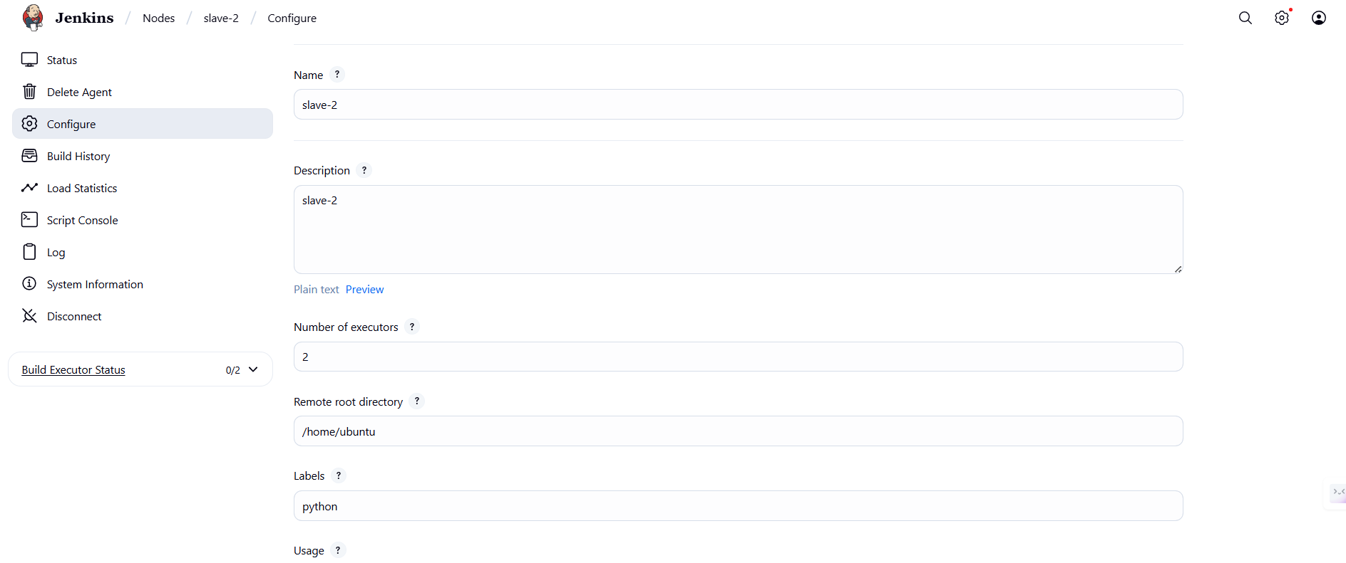

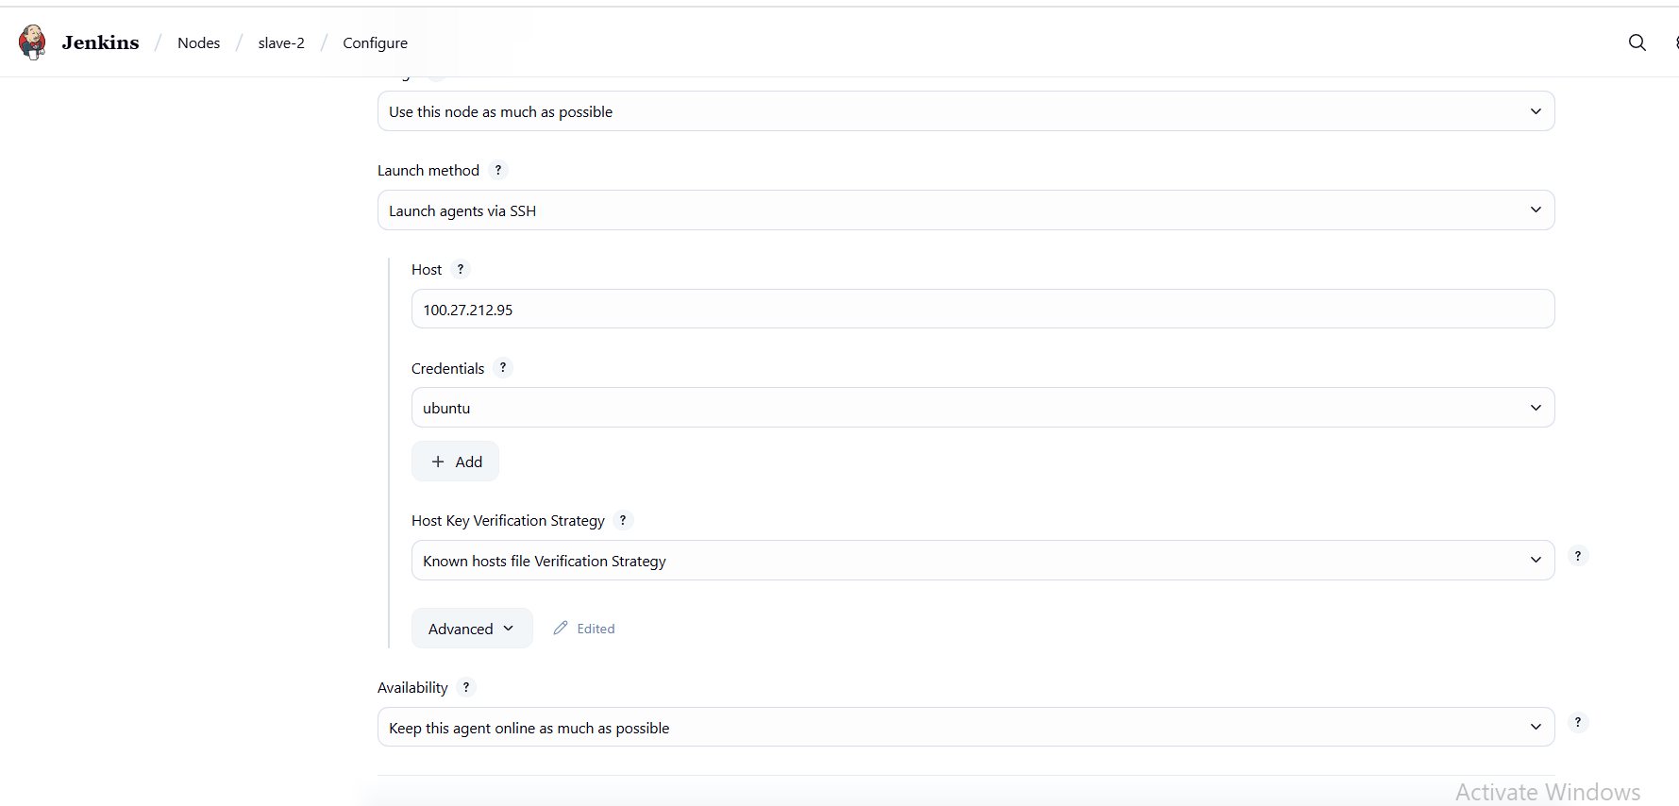

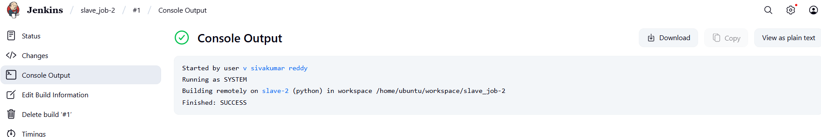

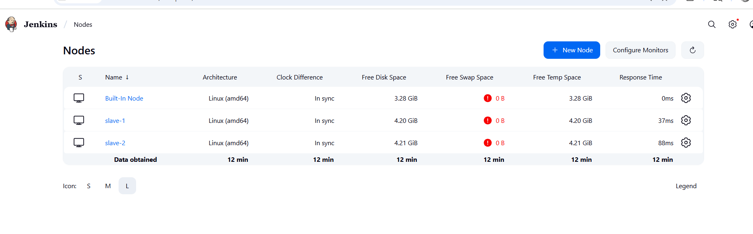

1. Configure webhooks to jenkins job.

Go to github and in the settings >>select webhoots>>give the url with ipaddres/github-webhook>>save it

In the jenkins job create a job >>give the git url>>selct git hooks trigger>>click on save>>for very change anything in the github it will automatically run the jobs

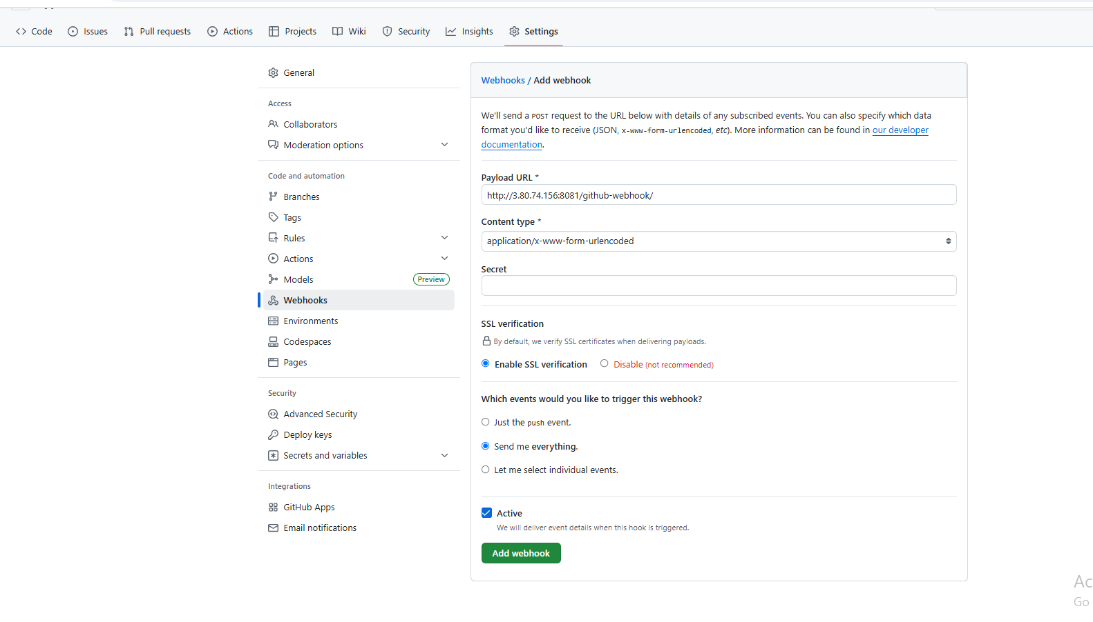

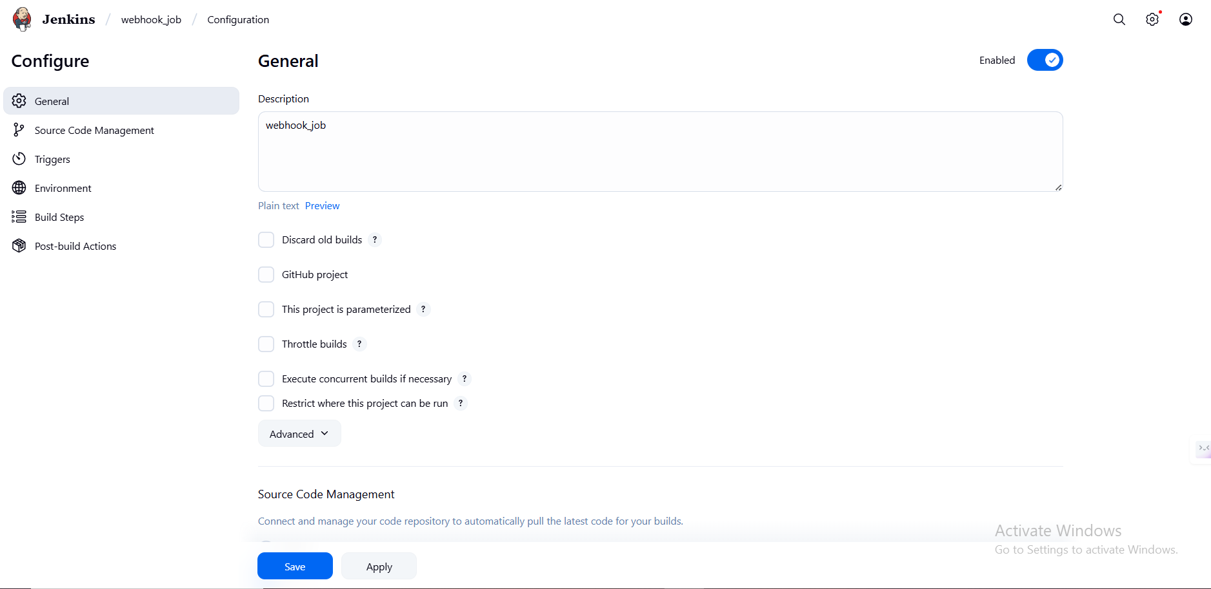

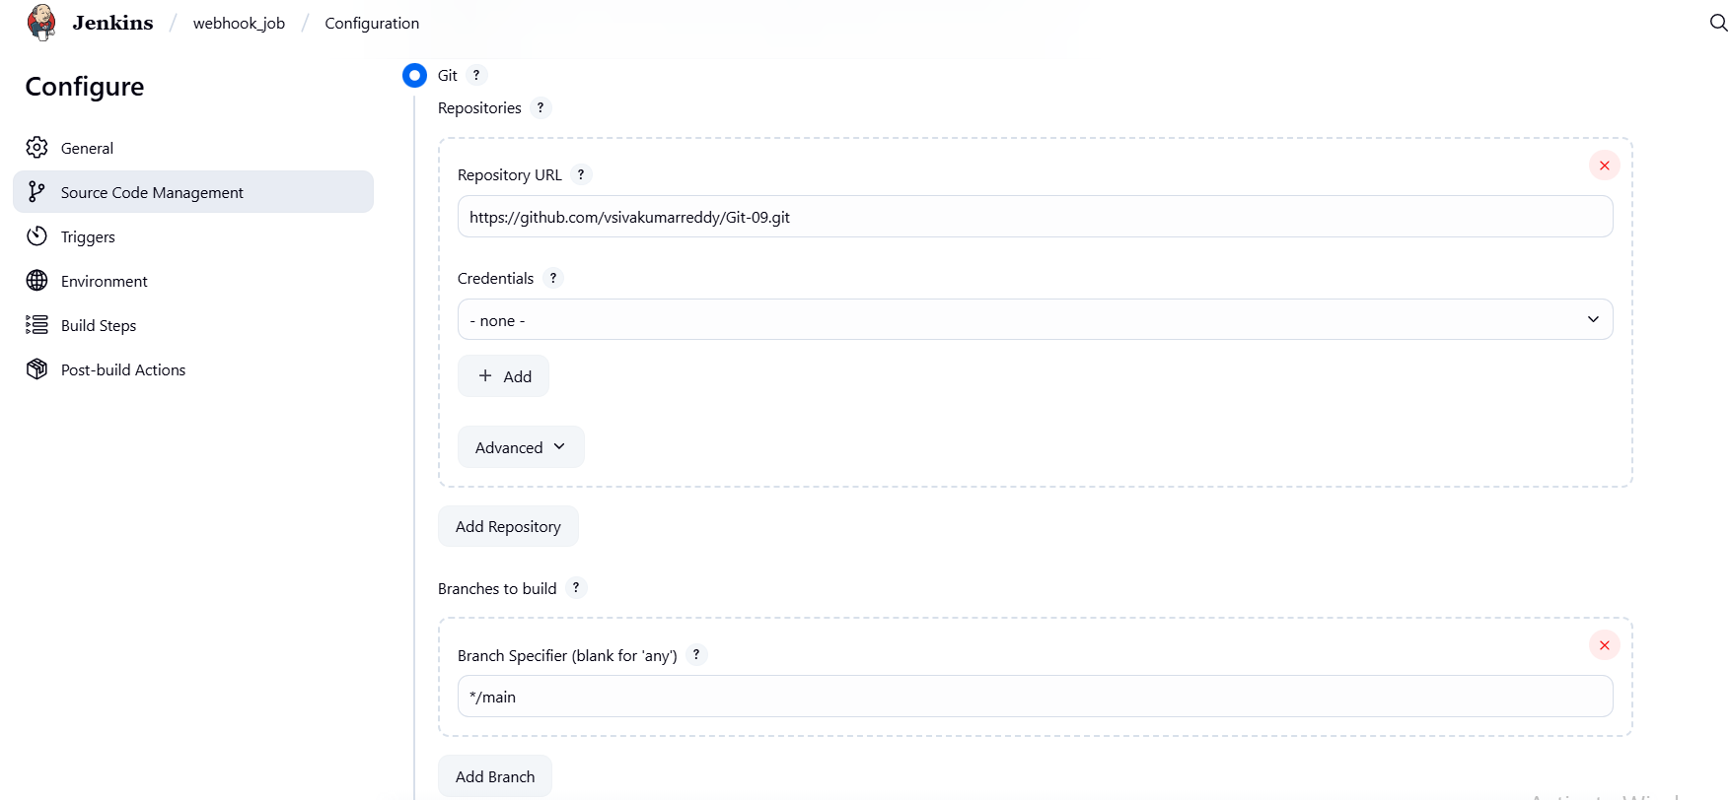



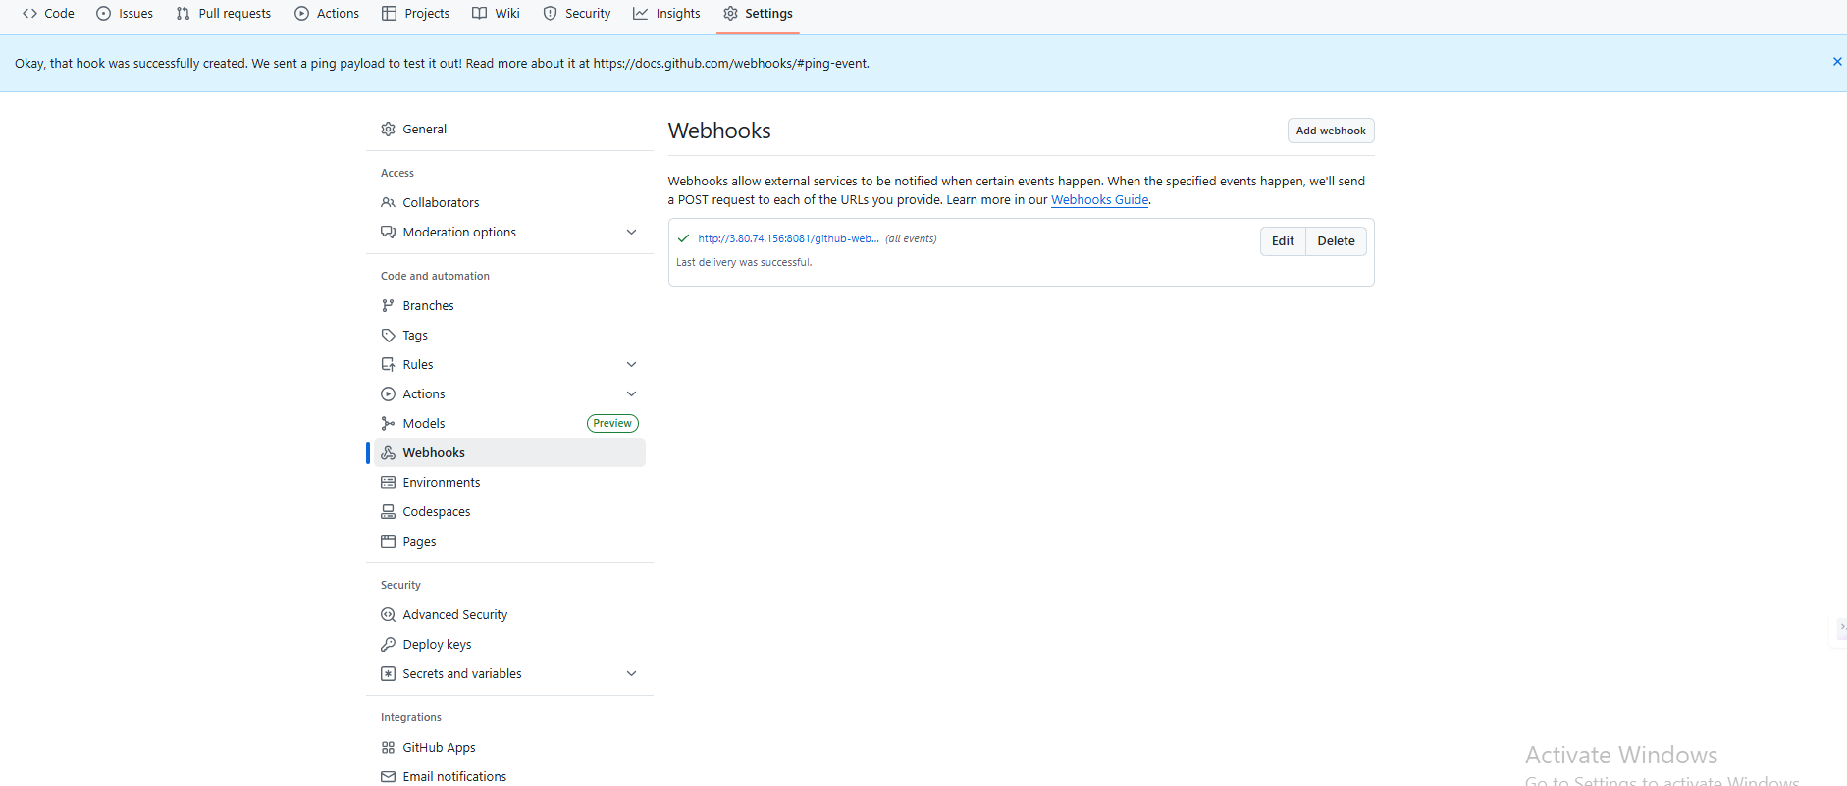

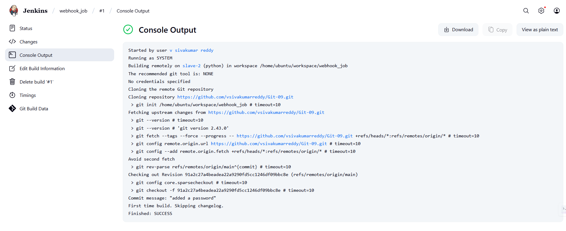

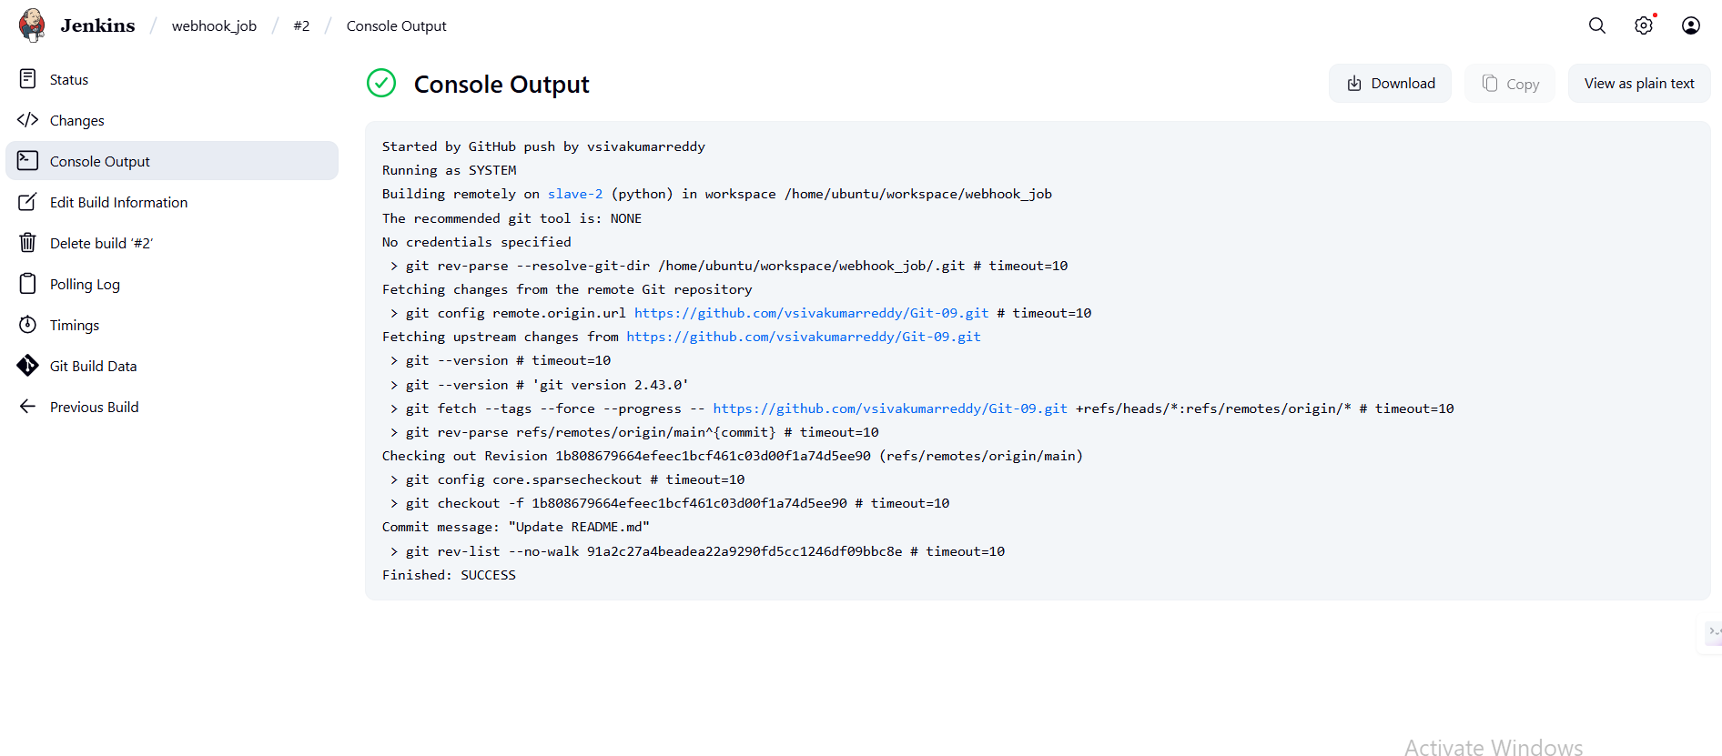

1. Configure poll scm and build periodical options in jenkins job.

Create a new job and give gitub details >>in the pool scm give time run 1 min>>save >>if you done any changes in the github it will run again automatically

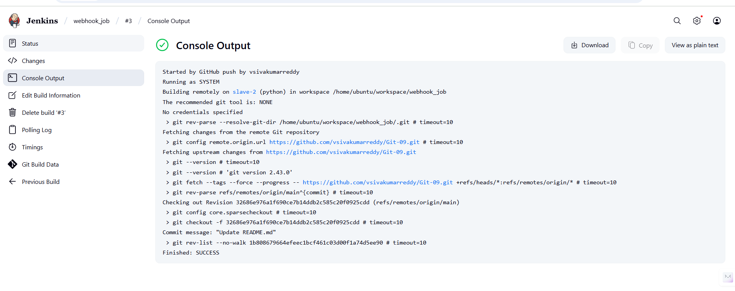

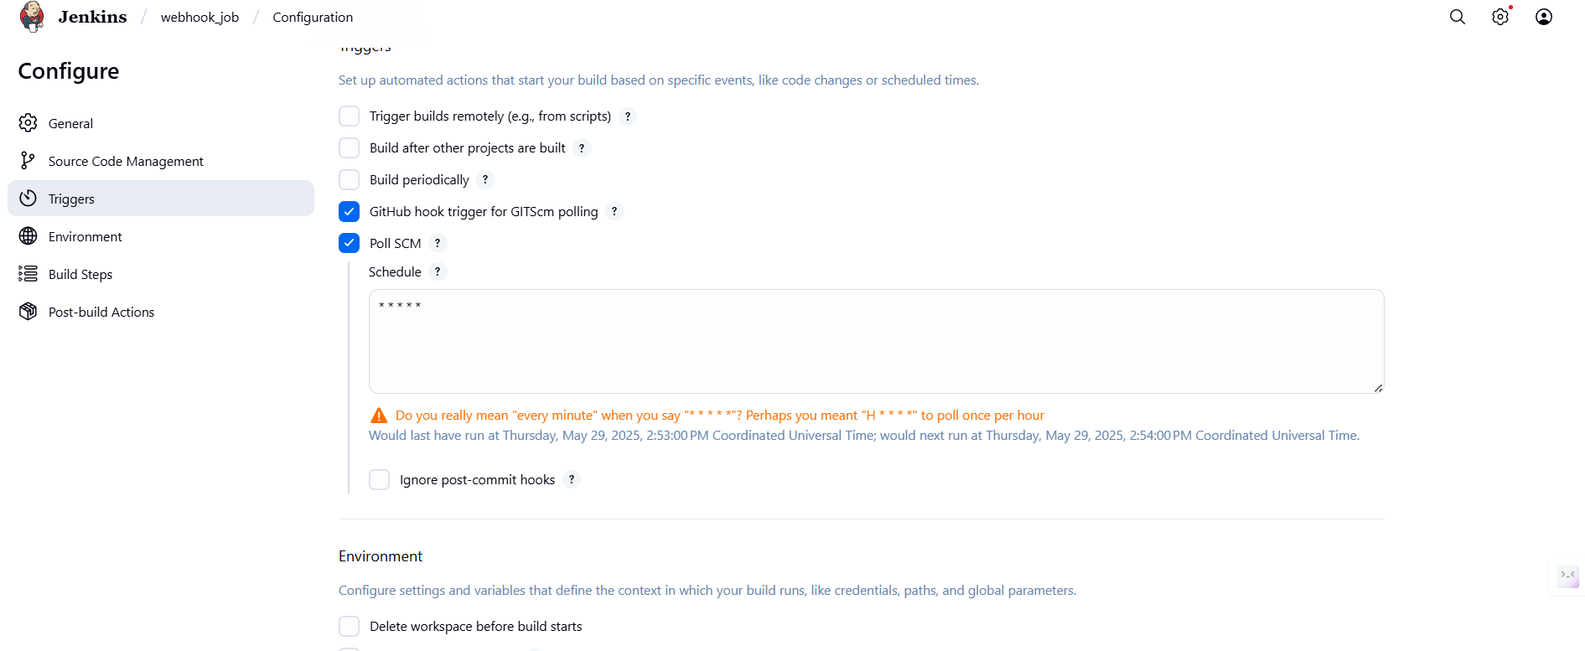

1. Take backup of jenkins server by using bash script.

* in the jenkins main CLI
* in that create a file

mkdir /var/lib/jenkins_backups

* vi /home/ubuntu/jenkins_backup.sh

#!/bin/bash

# Jenkins home directory

JENKINS_HOME="/var/lib/jenkins"

# Backup destination directory

BACKUP_DIR="/var/lib/jenkins_backups"

# Create backup directory if it doesn't exist

mkdir -p "$BACKUP_DIR"

# Current timestamp

TIMESTAMP=$(date +%F_%H-%M-%S)

# Backup file name

BACKUP_FILE="jenkins_backup_$TIMESTAMP.tar.gz"

# Stop Jenkins before backup (optional but safer)

echo "Stopping Jenkins service..."

sudo systemctl stop jenkins

# Create the backup

echo "Creating backup..."

tar -czf "$BACKUP_DIR/$BACKUP_FILE" -C "$JENKINS_HOME" .

# Start Jenkins after backup

echo "Starting Jenkins service..."

sudo systemctl start jenkins

# List created backup

echo "Backup created at: $BACKUP_DIR/$BACKUP_FILE"

* chmod +x jenkins_backup.sh
* sudo ./jenkins_backup.sh

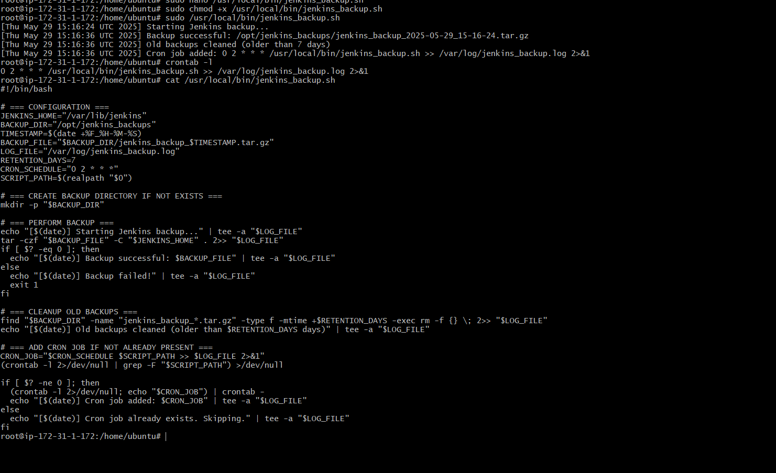

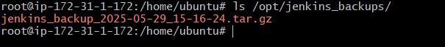

1. Take backup of jenkins using rethin backup plugin.

* Go to plugin>>click available install>>type thinbackup>>install it
* ater install go to manage jenkins>>click on system>>go to the option backup directory>>give the directory file location >>/var/lib/jenkins/thinbackup>>give the corn job time like one day or hourly>>slect all option for backup>>click on save
* go to manage junckins>>click on thin backup>>click on backup>>
* to verify>>go to cli >>go to the back up location>>ls /var/lib/jenkins/thinbackup>>you will see the backup time>>work done

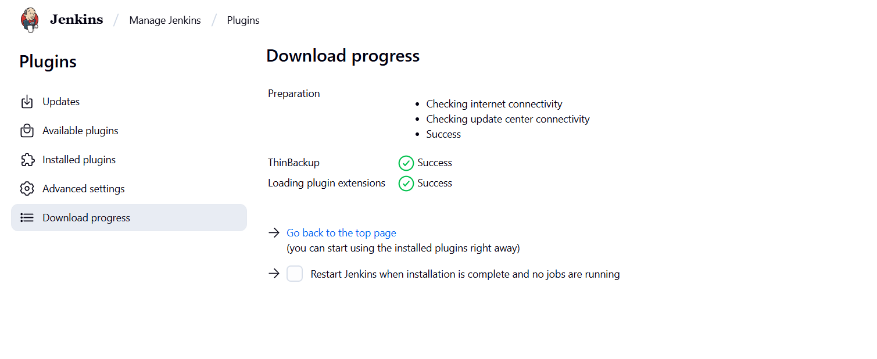

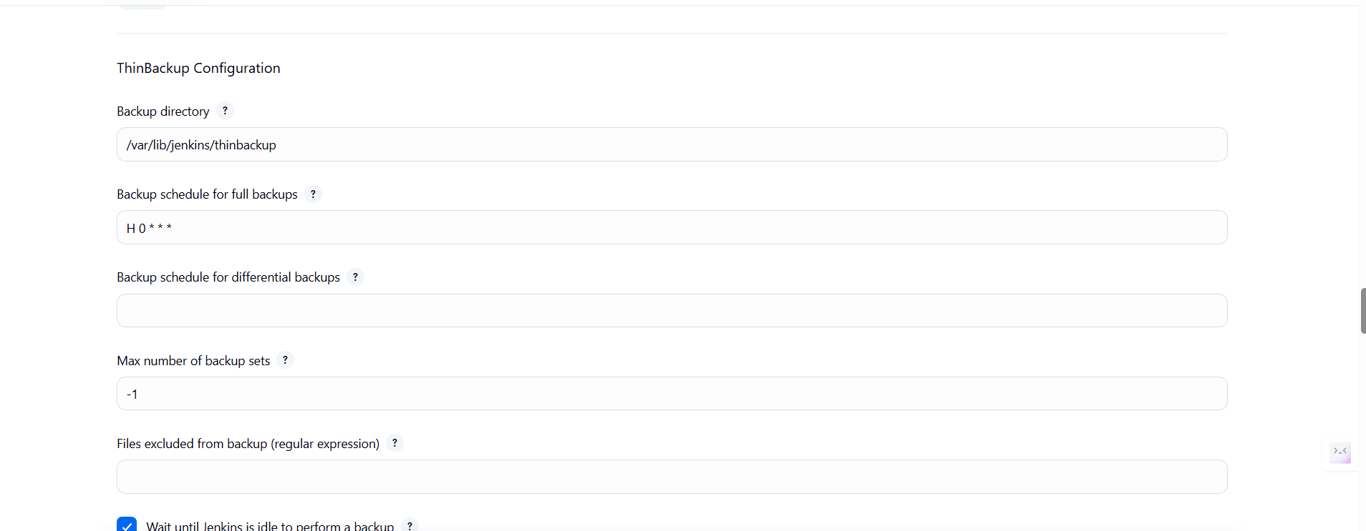

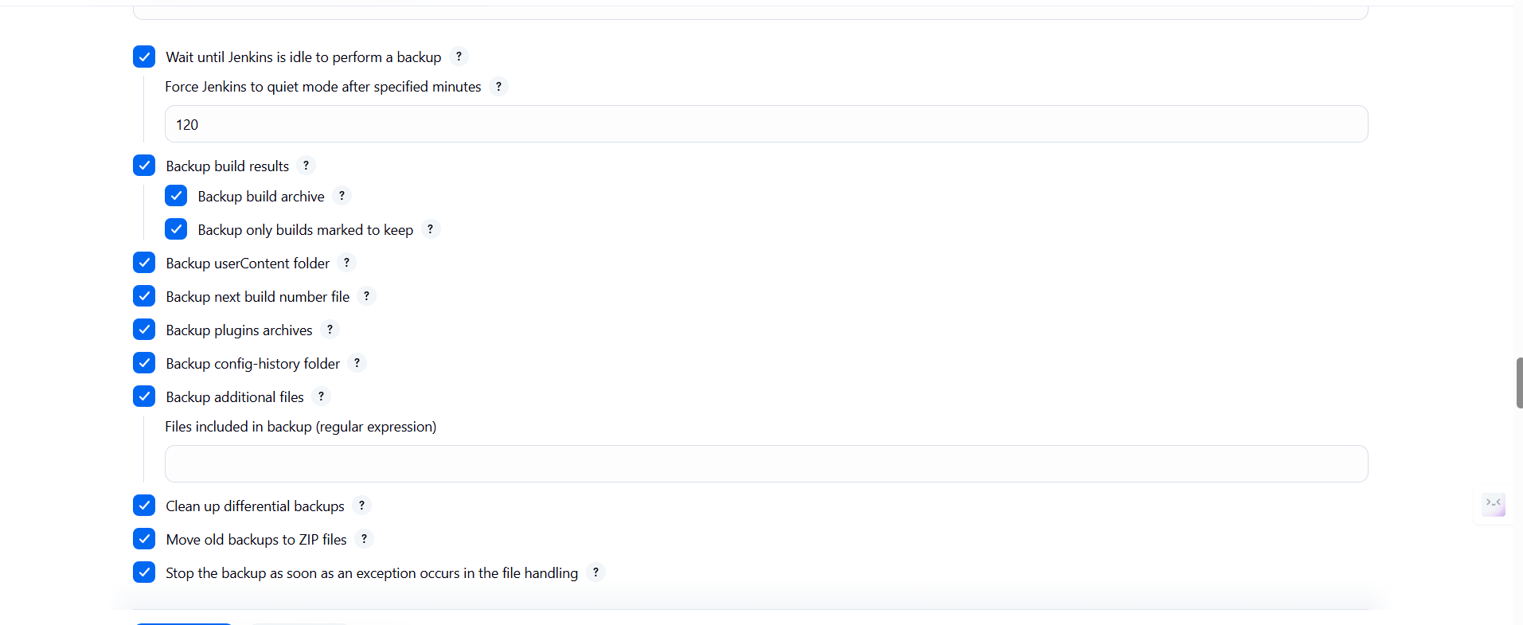

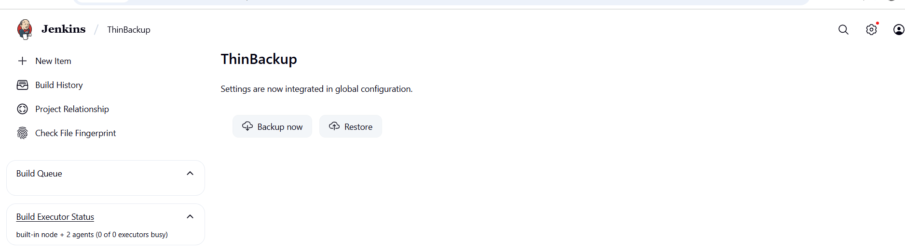

1. Setup a new jenkins server and dump the backup taken in task4.

* First create the intance with 20GB storage
* then open the instance in CLI and install the jenkins
* **Download jenkins Repo:**

sudo wget -O /etc/yum.repos.d/jenkins.repo https://pkg.jenkins.io/redhat-stable/jenkins.repo

* **Import the jenkins key:**

sudo rpm --import <https://pkg.jenkins.io/redhat-stable/jenkins.io-2023.key>

* **Update ec2:**

sudo yum upgrade

* **Add required dependencies for the jenkins package:**

sudo amazon-linux-extras enable corretto17

sudo yum clean metadata

sudo yum install java-17-amazon-corretto-devel -y

* **Install Jenkins:**

sudo yum install jenkins

sudo systemctl start jenkins

sudo systemctl status jenkins

**I have downloaded it from local repo not in the ec2 server:**

use old backup ip add:

scp -i ~/Downloads/jenkins.pem -r ubuntu@54.83.101.139:/var/lib/jenkins/thinbackup ~/Downloads/

**then download it to the new instance:**

**use the new ip address:**

scp -i ~/Downloads/jenkin.pem -r ~/Downloads/thinbackup [ubuntu@3.91.59.23:/home/ubuntu/](mailto:ubuntu@3.91.59.23:/home/ubuntu/)

**then login to the new server**:

use new ip and your pem.key

ssh -i ~/Downloads/jenkins.pem ubuntu@3.91.59.23

**move backup file to jenkins**:

sudo mv /home/ubuntu/thinbackup /var/lib/jenkins/

**change the ownership to jenkins :**

sudo chown -R jenkins:jenkins /var/lib/jenkins/thinbackup

**stop the jenkins:**

sudo systemctl stop jenkins

**copy the backup file to library:**

sudo cp -r /var/lib/jenkins/thinbackup/FULL-2025-05-30_06-58/* /var/lib/jenkins/

**change the owner:**

sudo chown -R jenkins:jenkins /var/lib/jenkins

**then start the jenkins:**

sudo chown -R jenkins:jenkins /var/lib/jenkins

