1) Watch terraform-03 video.

2) Execute the script shown in video.

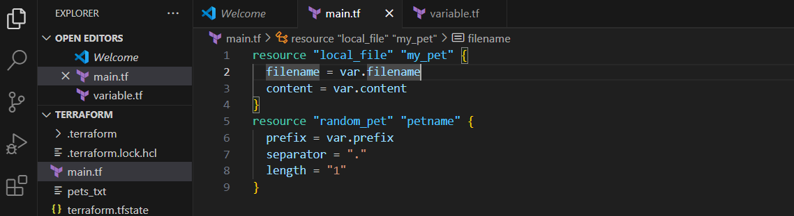

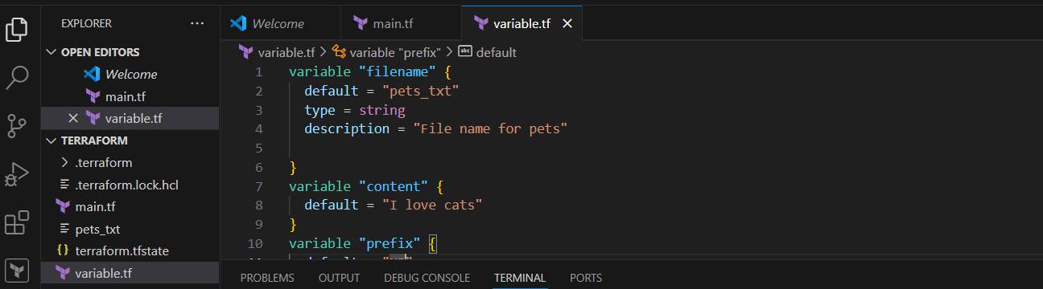

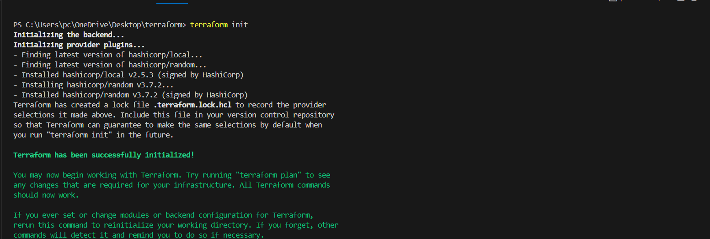

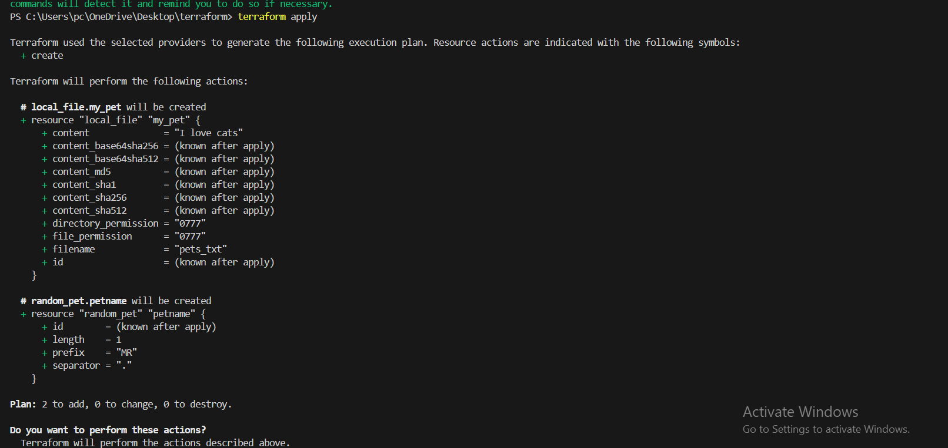

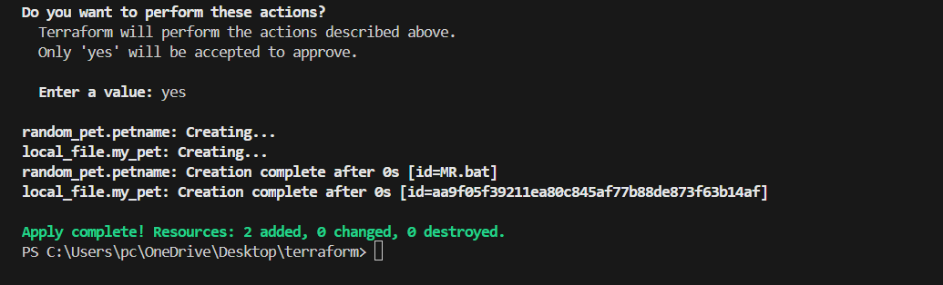

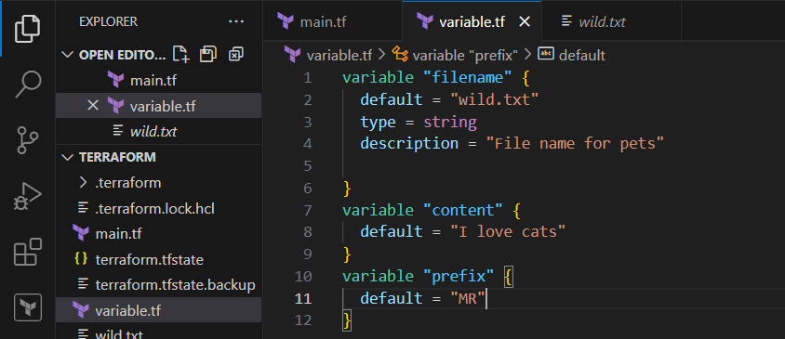

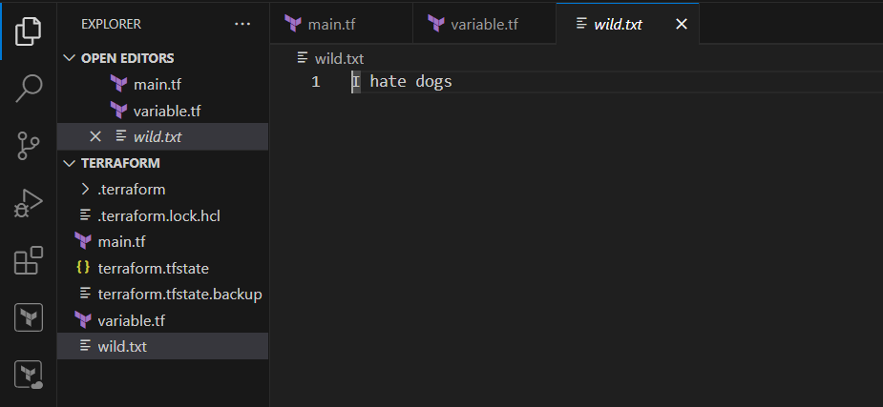

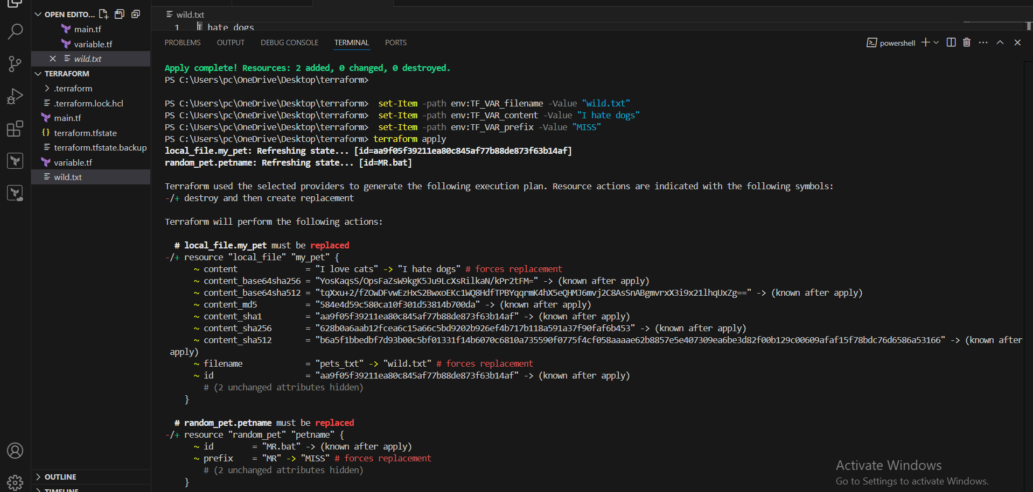

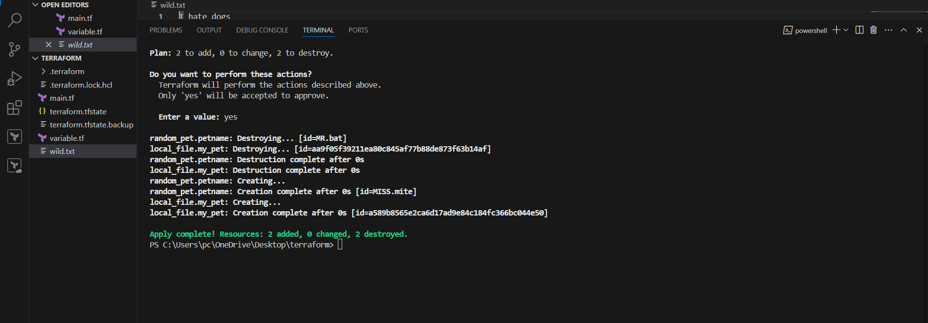

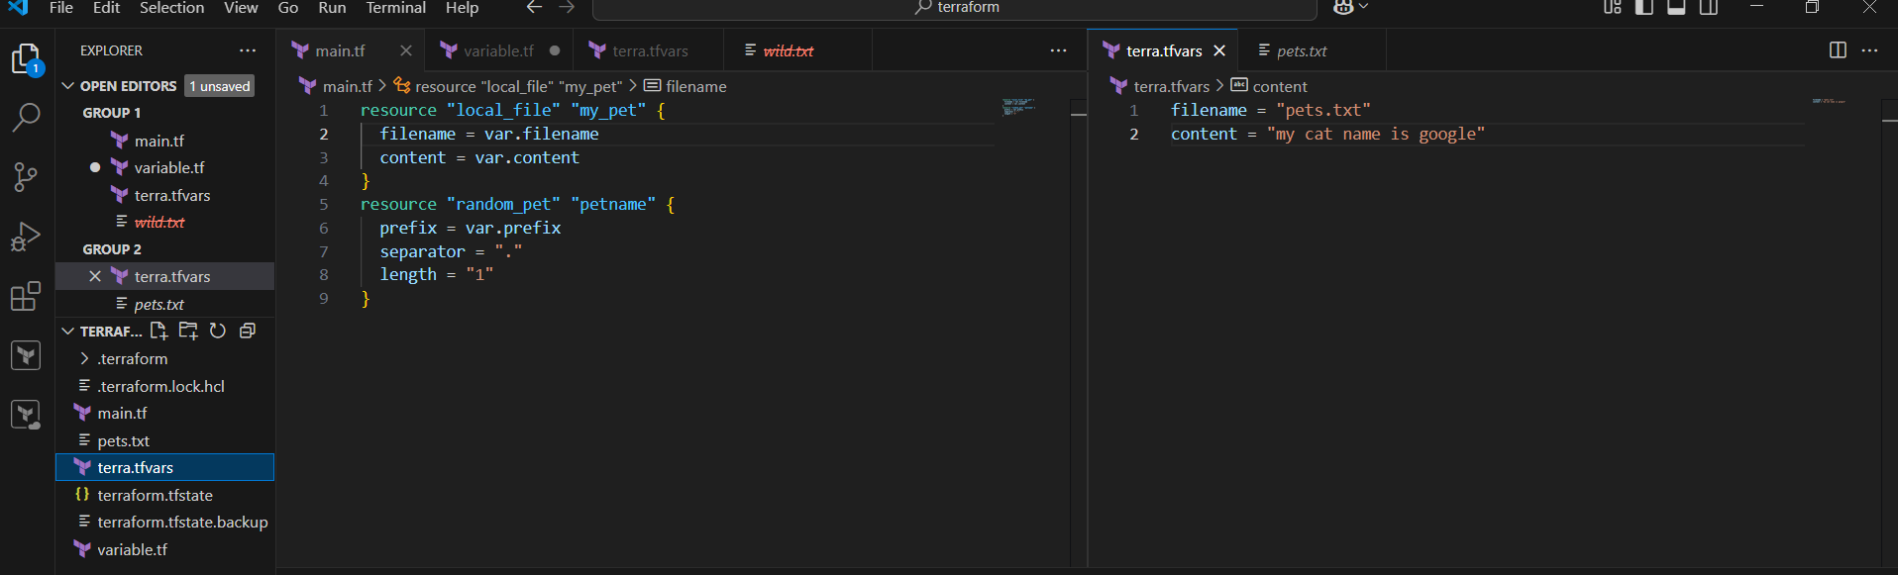

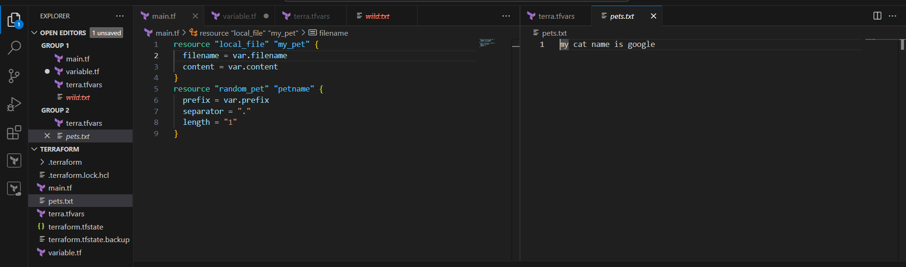

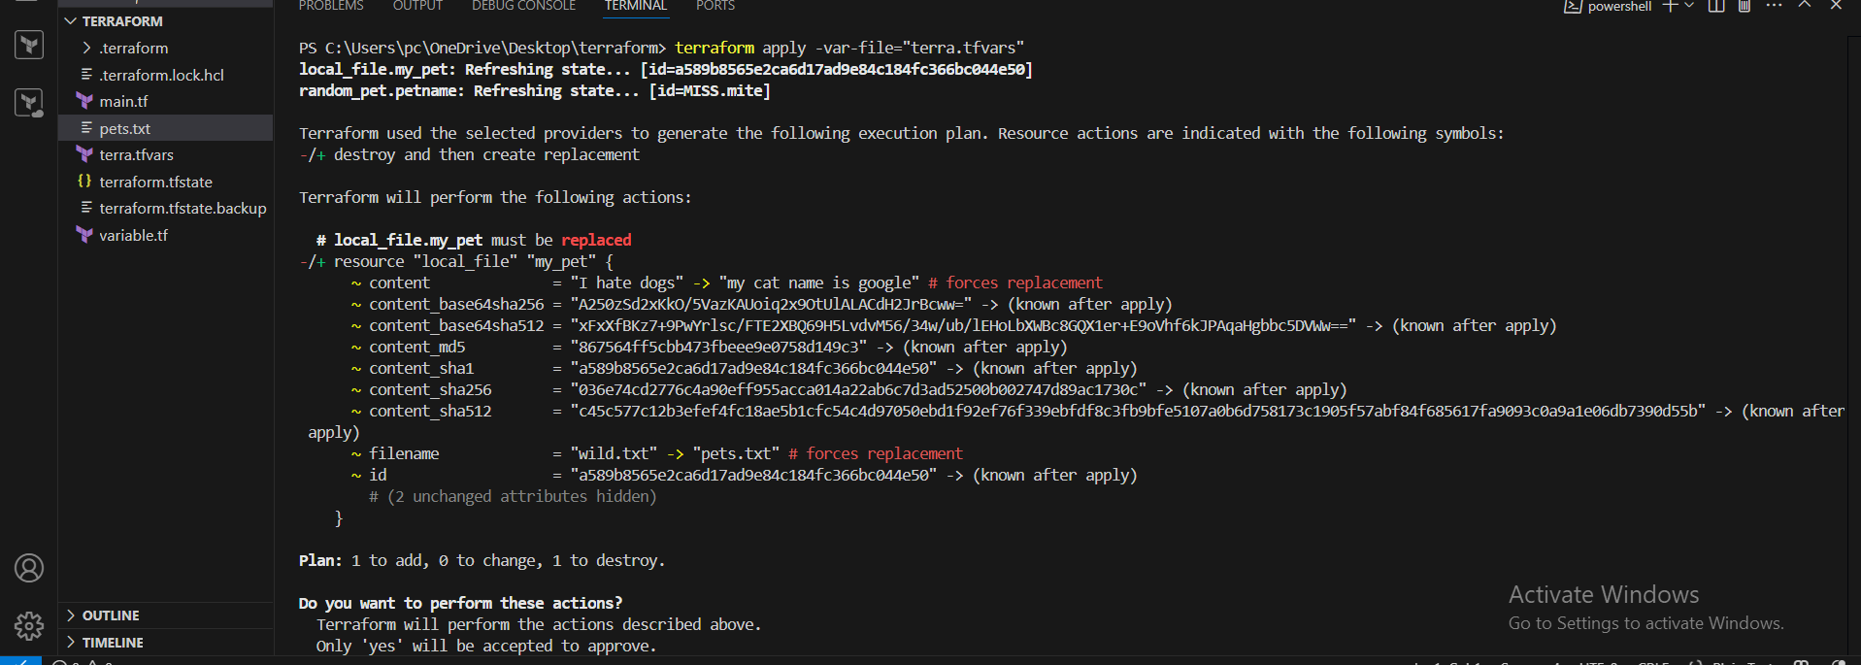

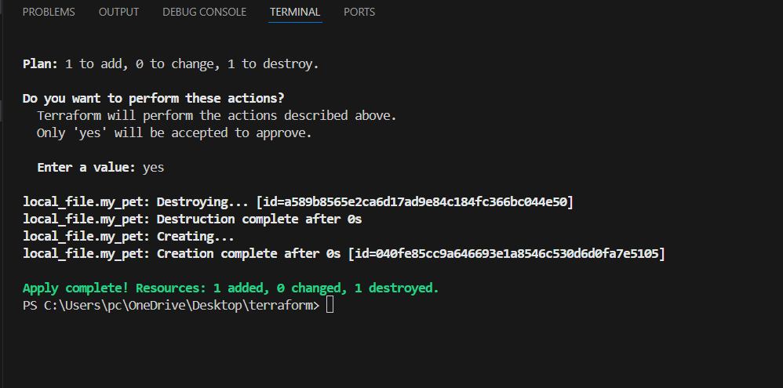

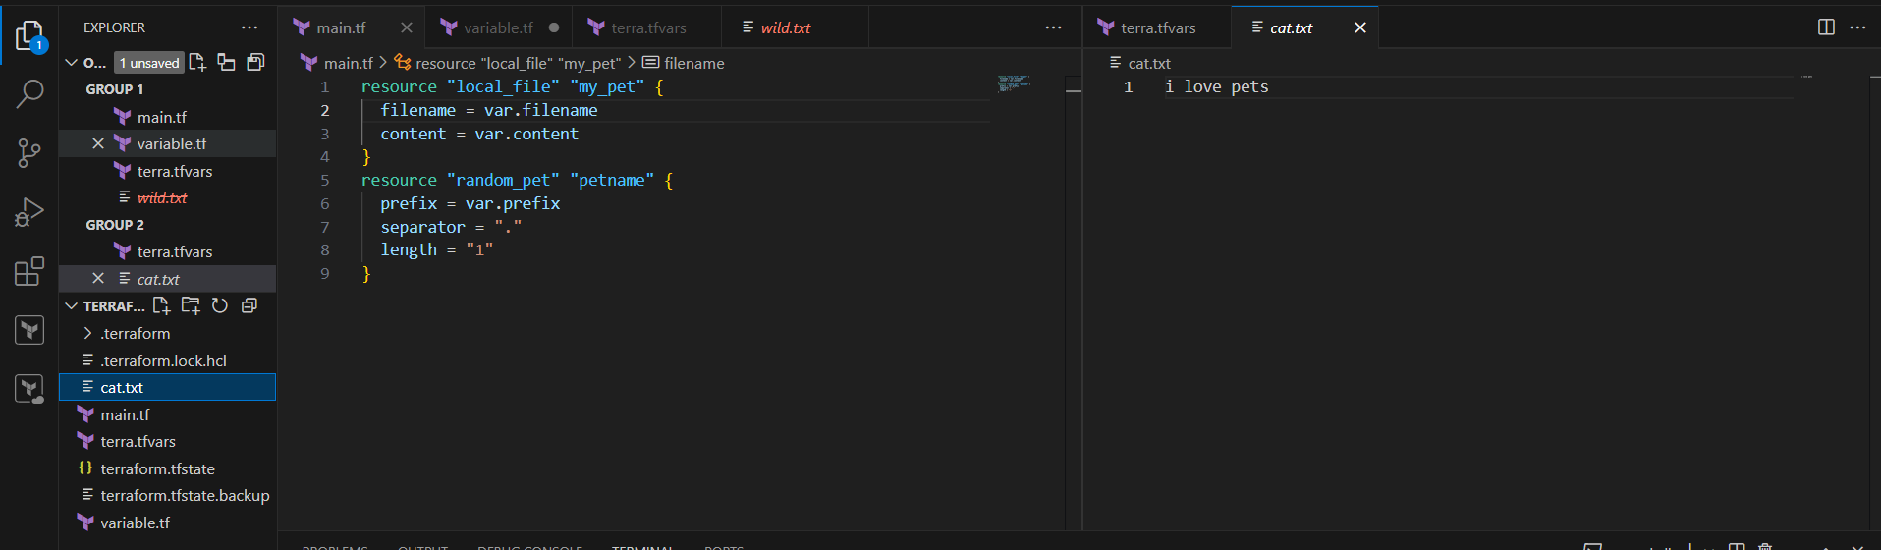

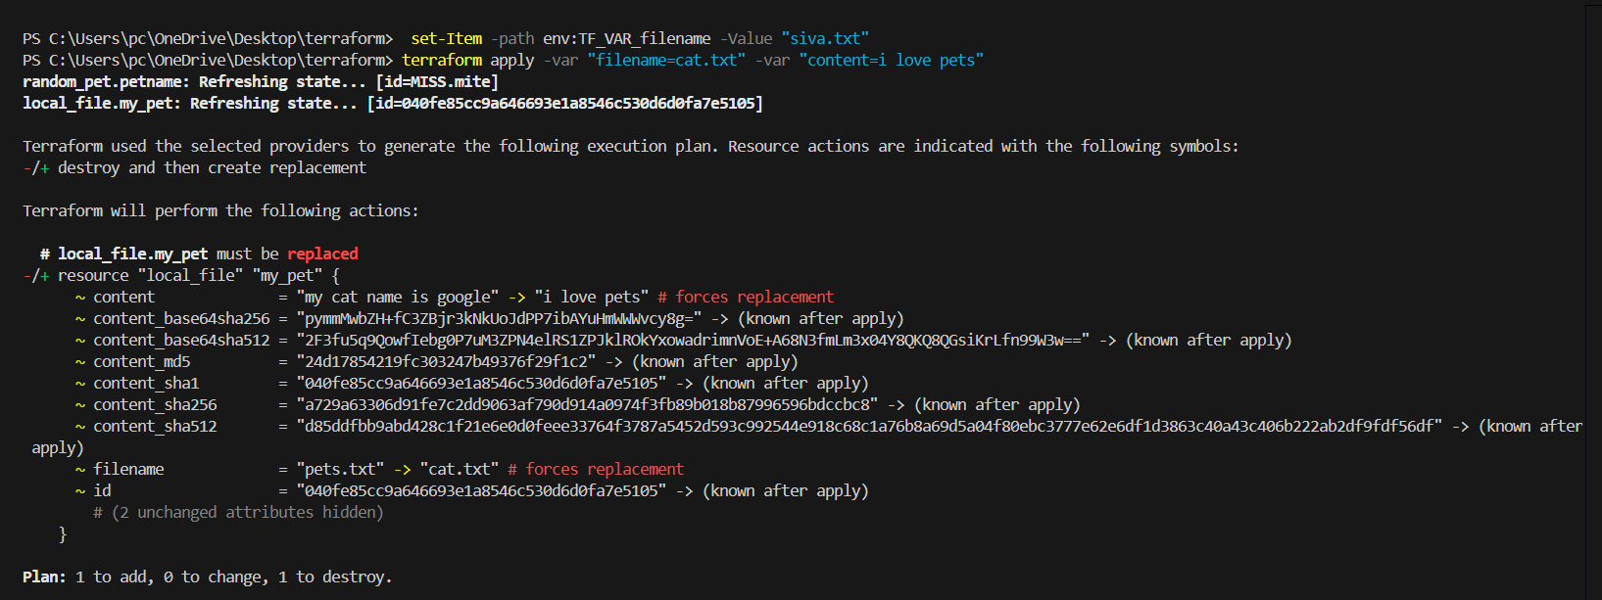

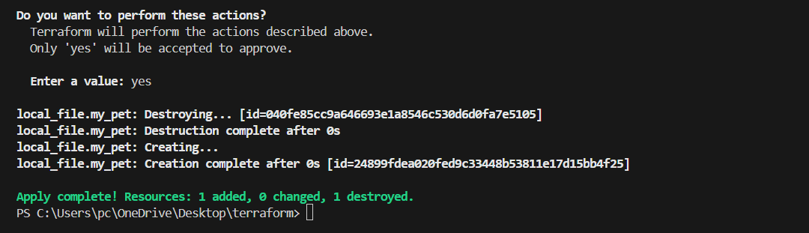

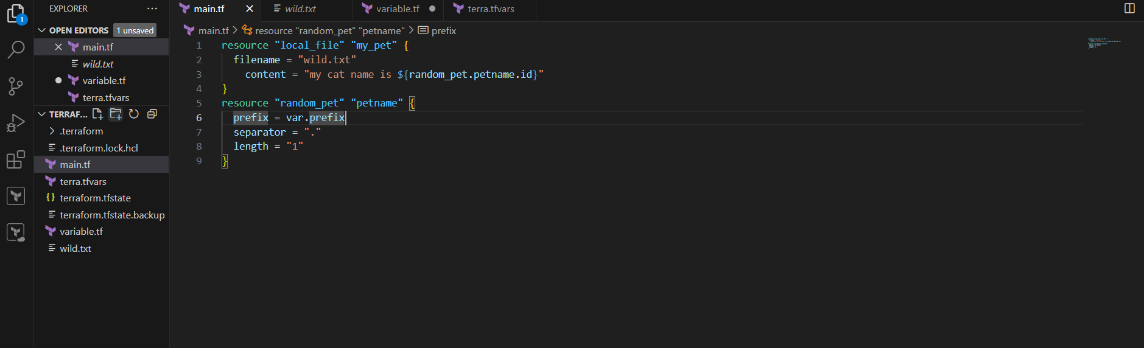

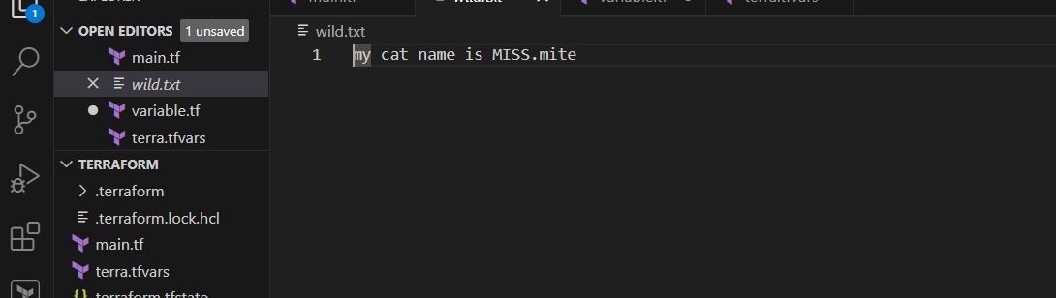

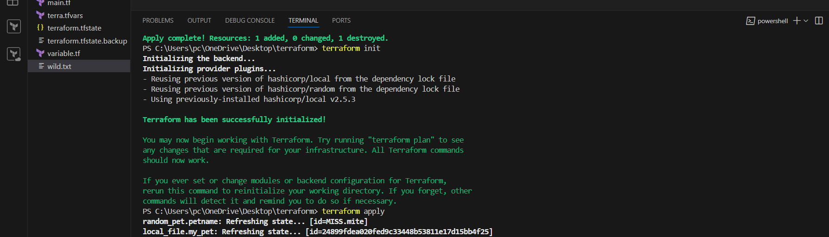

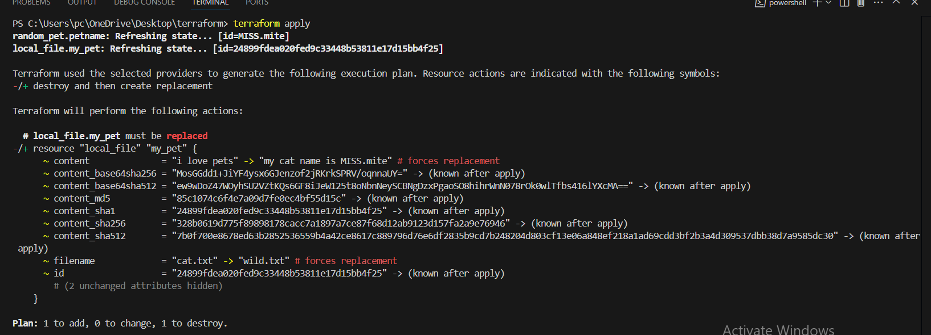

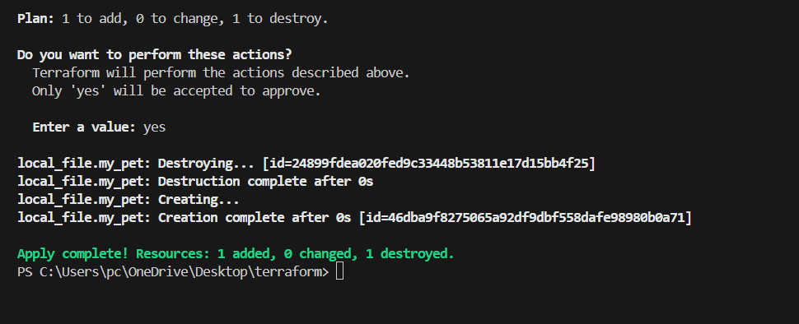

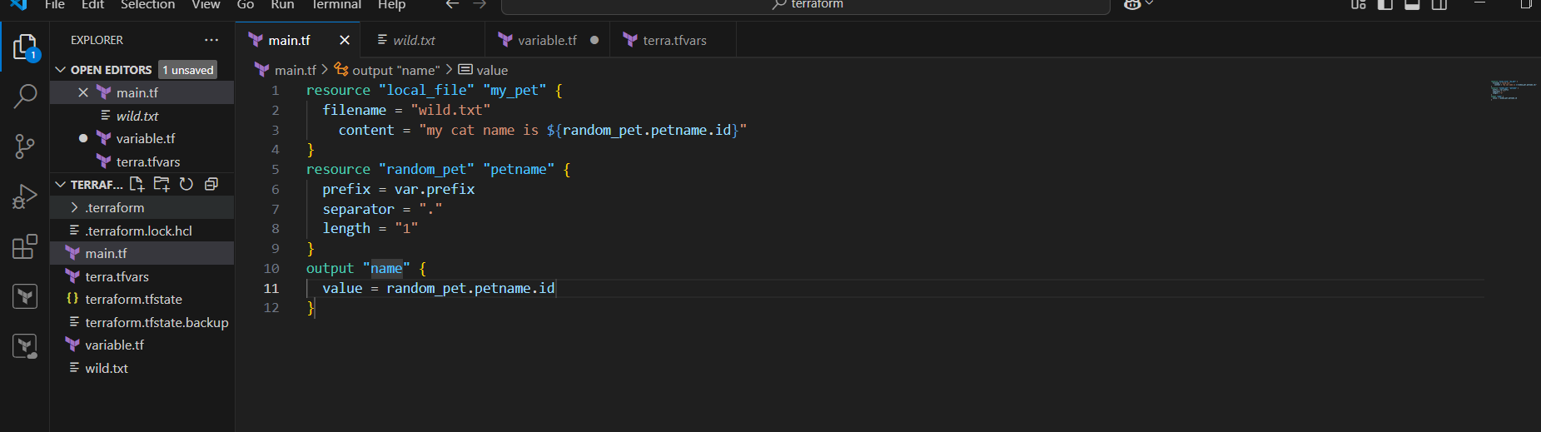

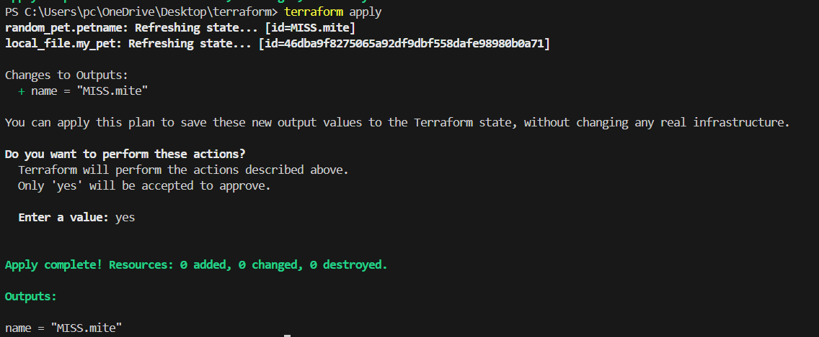

3) Intergrate terrafrom in jenkins using Terraform plugin.

First create a job with pipeline

Next install terraform plugin

Now clone the git repo and give path jenkinsfile

Next save and click build now

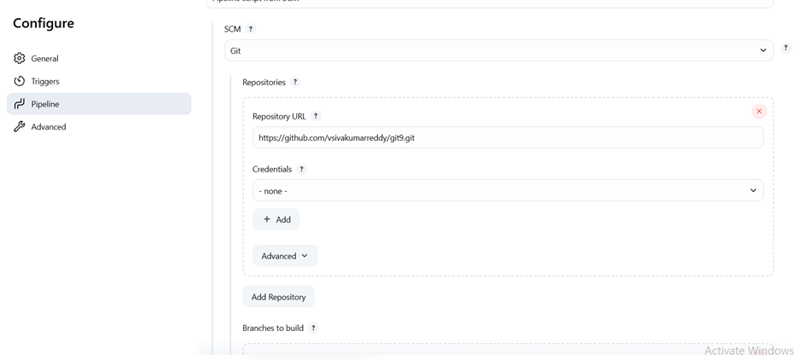

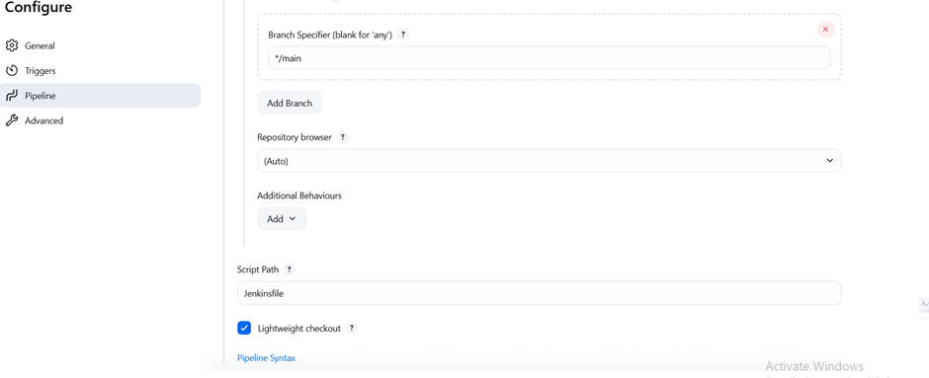

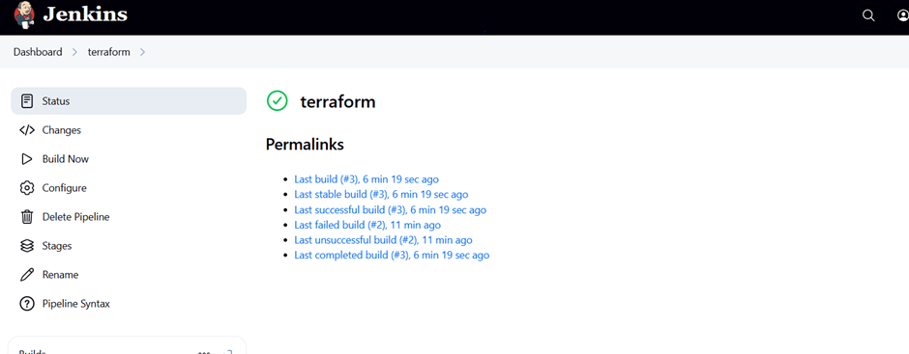

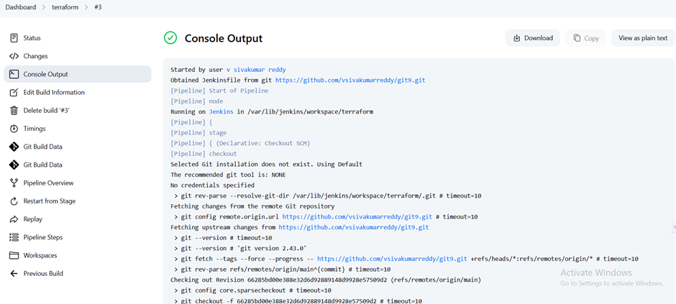

4) Create one jenkins job using MAVEN PROJECT for the below code with two stages.

stage 1: Git clone stage

2: Maven Compilation Code: <https://github.com/betawins/java-Working-app.git>

first create the jenkins job

in this source code >>select git >>give the git details

go to the build text >>select invoke top level maven

targets>>give the maven >>give clean package

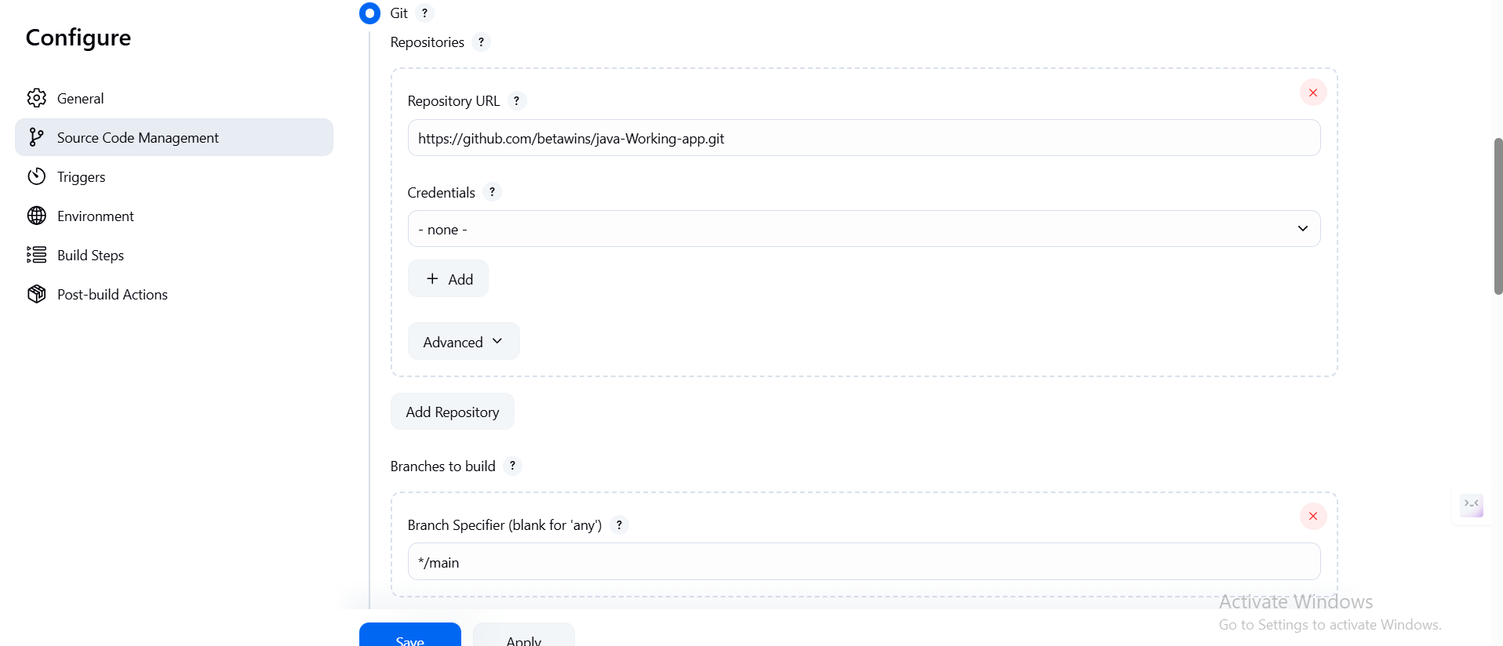

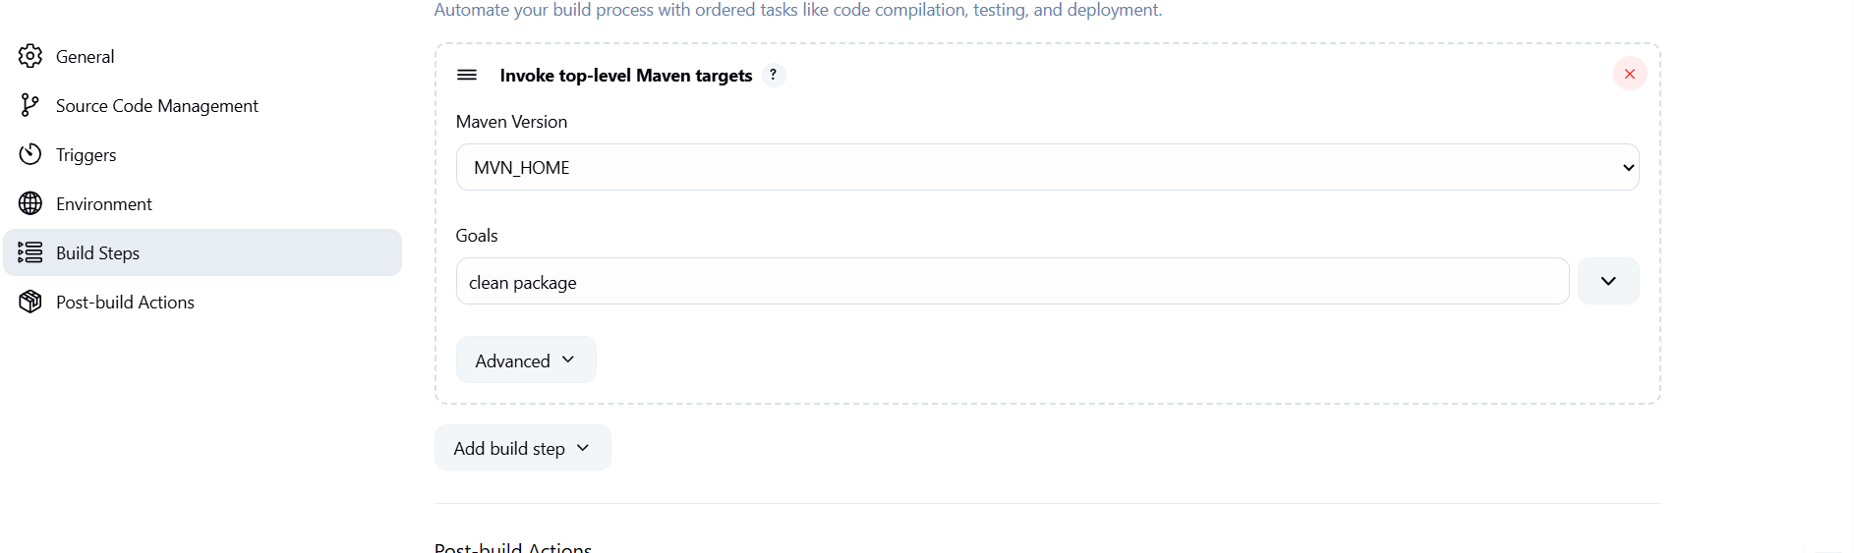

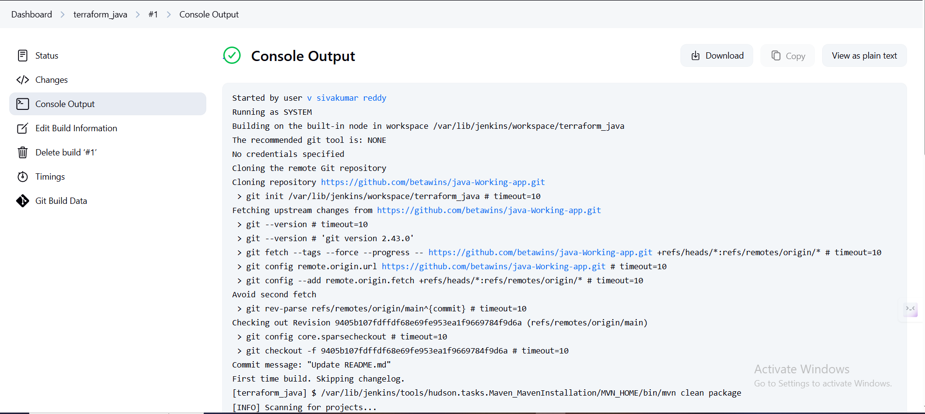

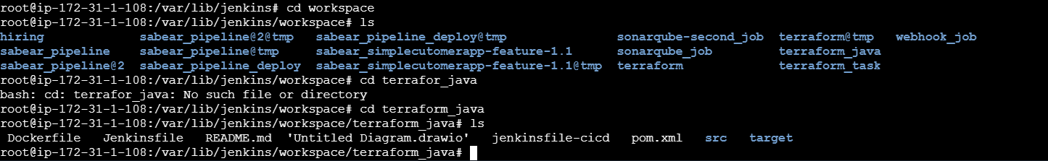

5) Use the below code and create a parameterized job in jenkins

stage 1: Git clone stage

2: Maven Compilation Code:

<https://github.com/betawins/java-Working-app.git>

first create the jenkins job

in this source code >>select git >>give the git details

go to the build text >>select invoke top level maven

targets>>give the maven >>give clean package

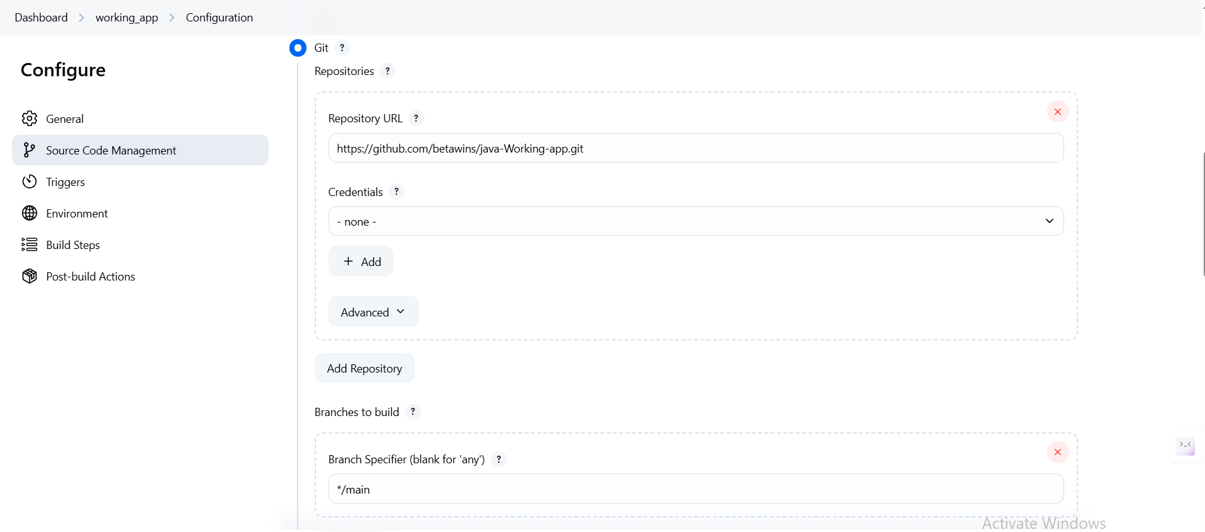

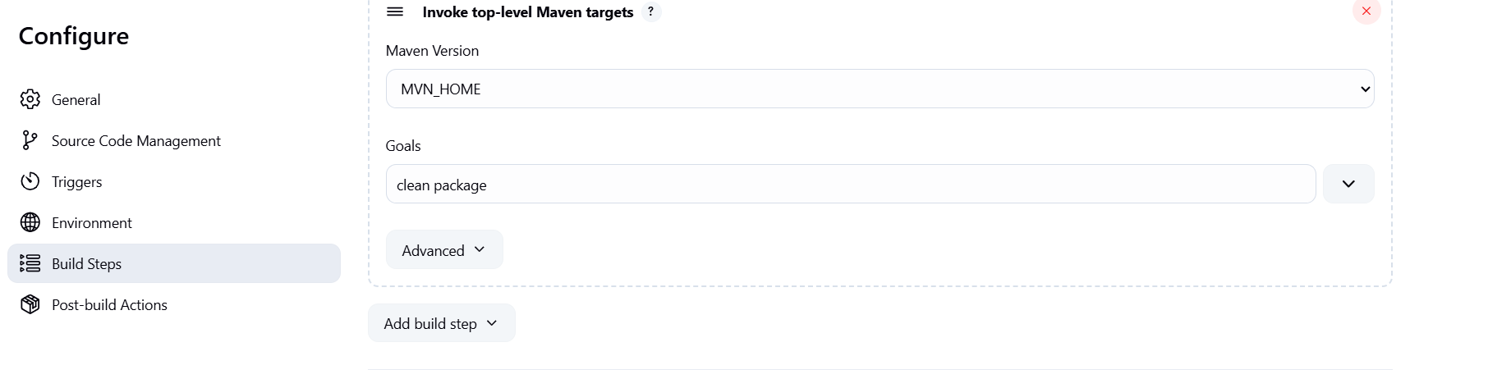

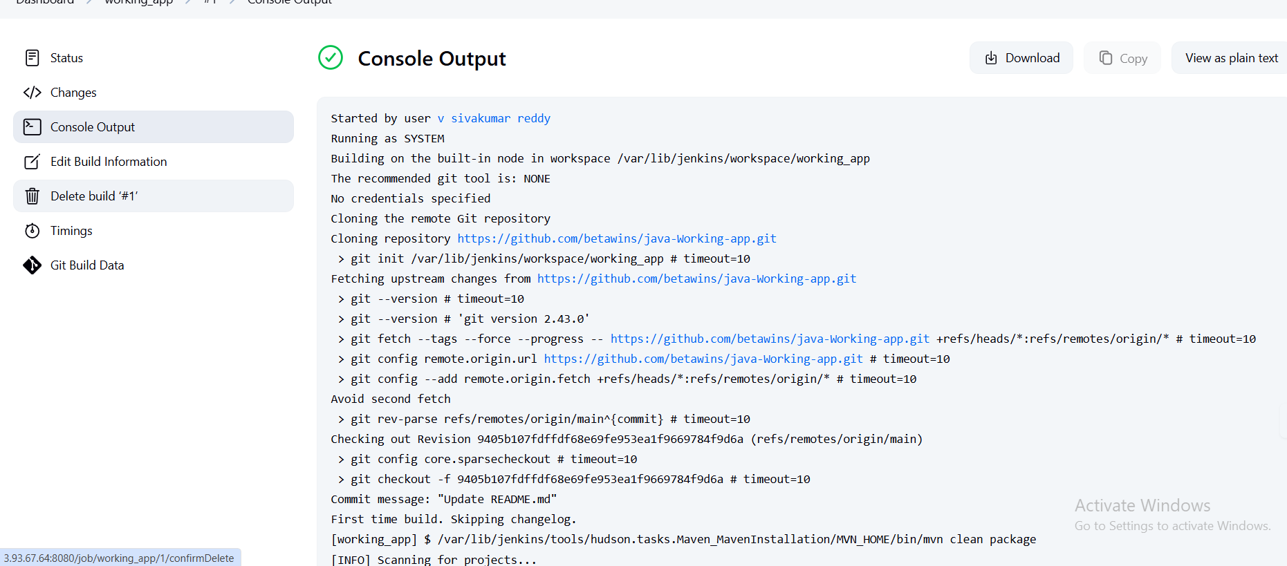

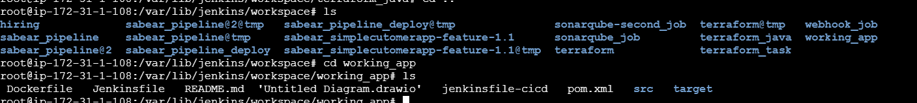

6) What are the global varaiables in jenkins?

| **Variable** | **Description** |
| --- | --- |
| BUILD_NUMBER | The current build number, e.g. 21 |
| BUILD_ID | The build ID (usually timestamp), e.g. 2025-06-11_16-00-00 |
| BUILD_URL | URL of the build result page |
| JOB_NAME | Name of the project/job, e.g. MyApp-Build |
| JOB_BASE_NAME | Base name of the job (without folder path) |
| WORKSPACE | File path to the workspace on the Jenkins node |
| JENKINS_HOME | Path to Jenkins installation directory |
| JENKINS_URL | URL of the Jenkins master |
| EXECUTOR_NUMBER | Number of the executor used for the build |
| NODE_NAME | Name of the node/slave the build is running on |
| NODE_LABELS | Labels of the node |
| GIT_COMMIT | Git commit hash being built (if using Git) |
| GIT_BRANCH | Git branch name |