1. Execute all the templates shown in video.

We have three life cycles

Create before destroy give the script for this and run the command terraform init ,plan ,apply,destory

Similarly for prevent destroy also and also for the ignore changes

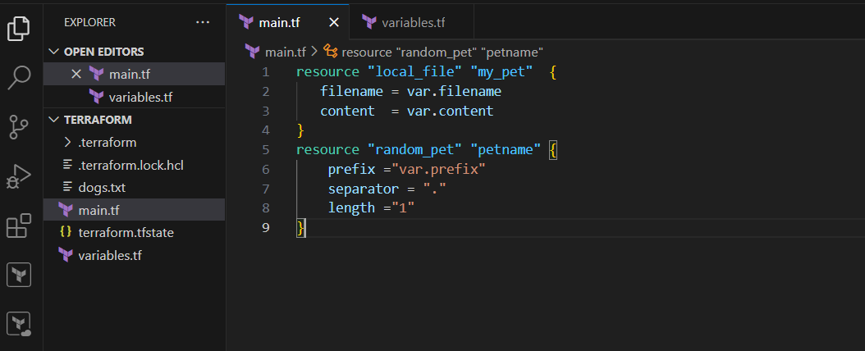

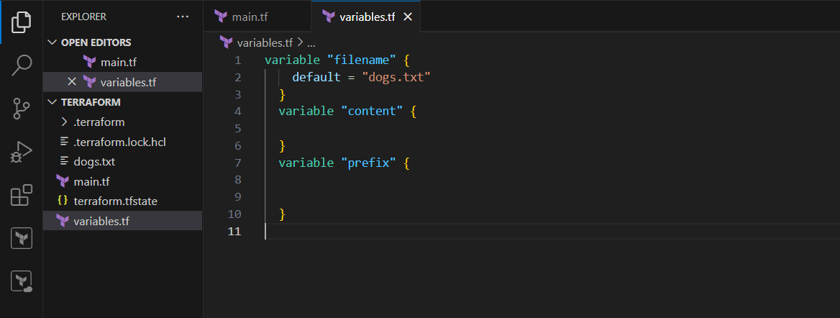

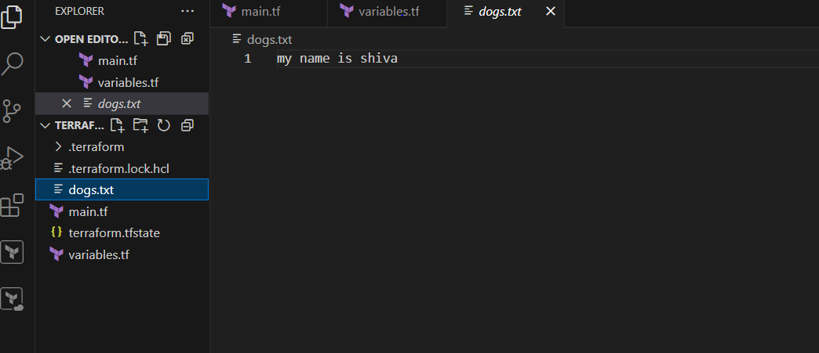

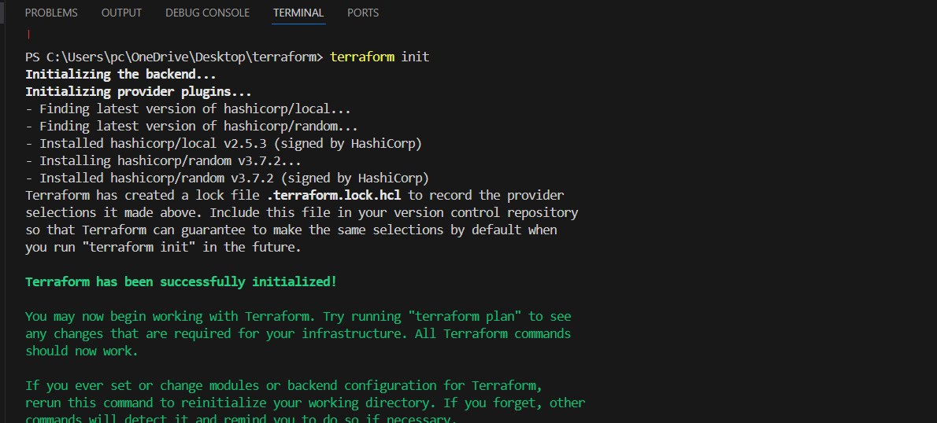

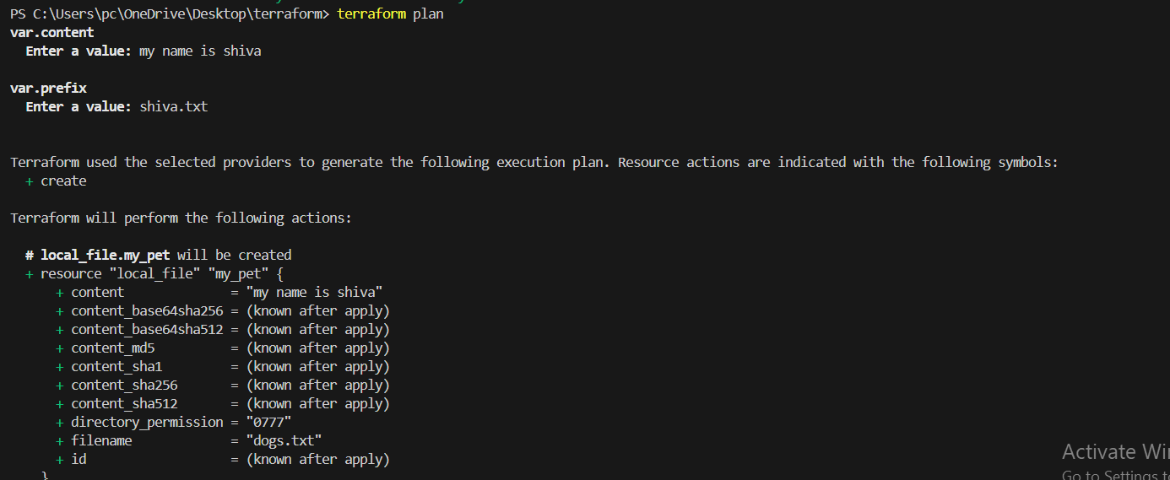

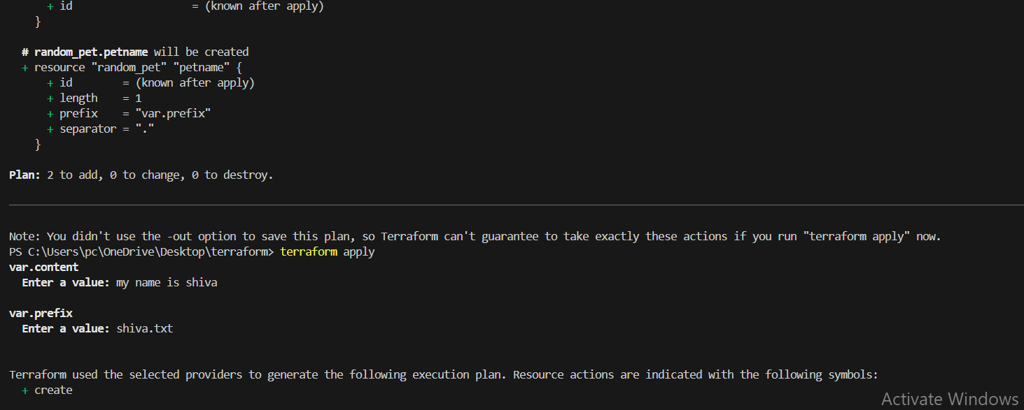

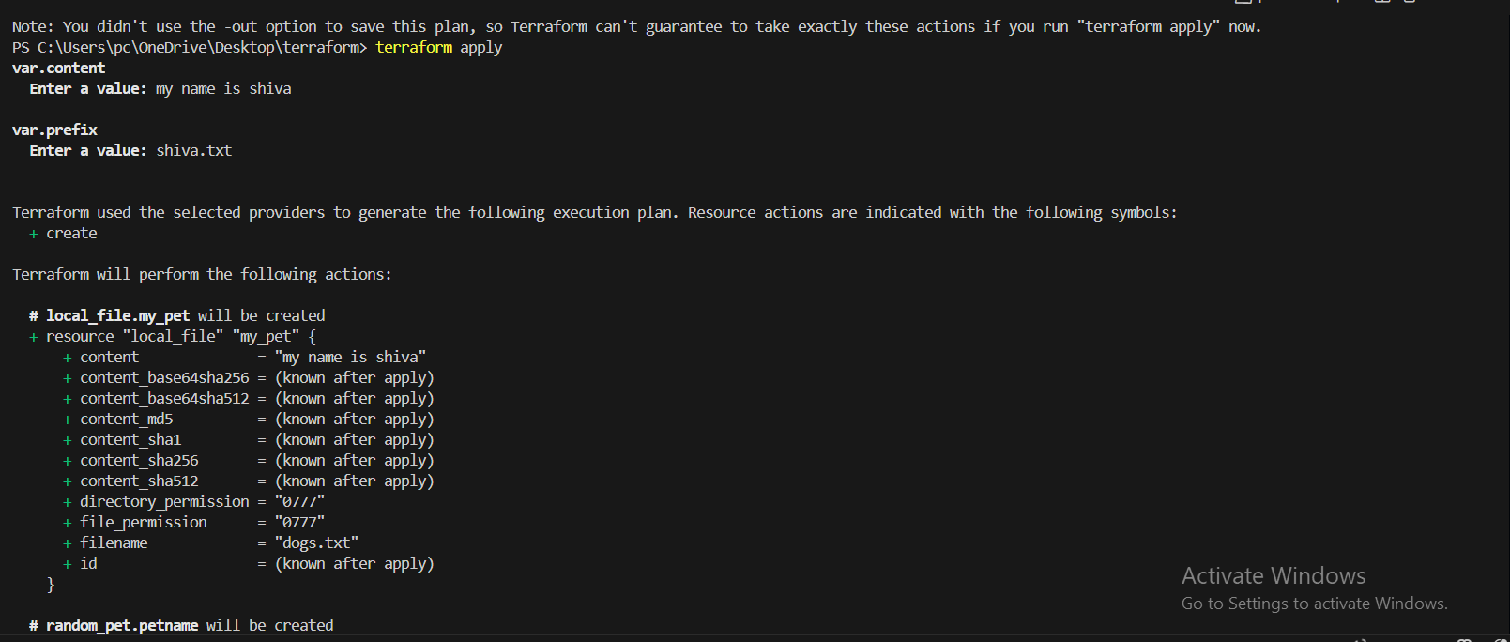

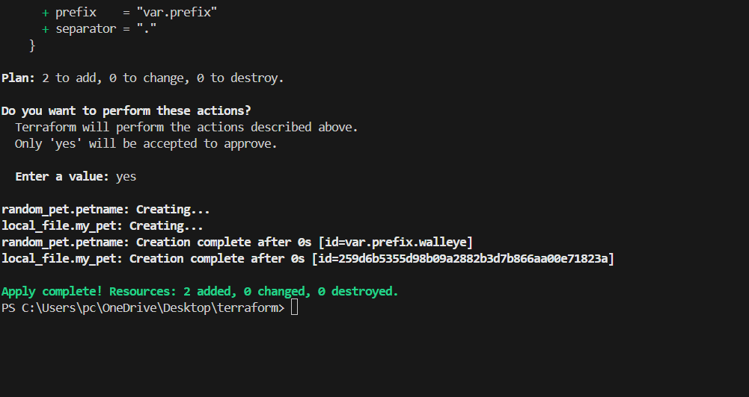

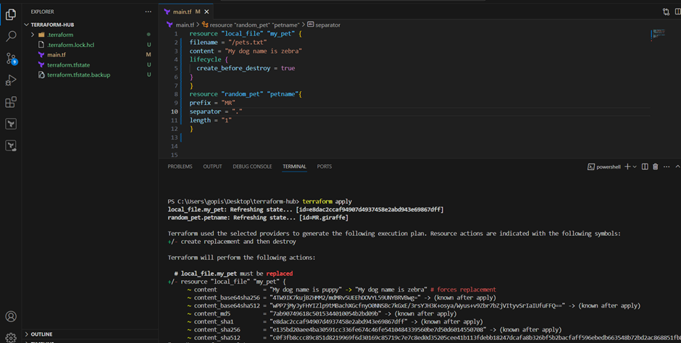

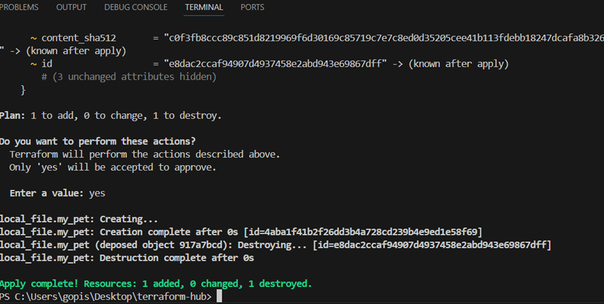



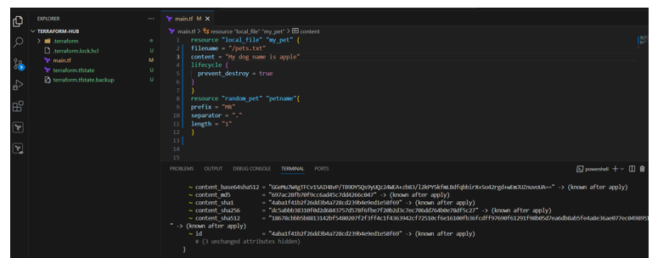

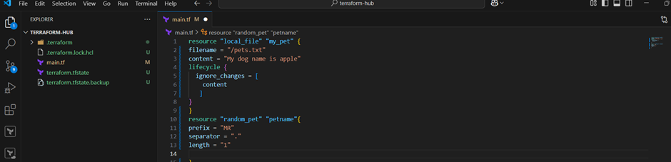

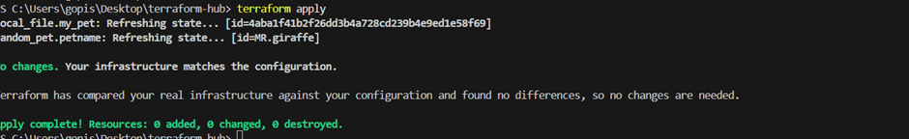

1. Integrate terraform in jenkins using Terraform plugin.

Declarative pipeline

pipeline {

agent any // You can specify a specific agent label if needed, e.g., agent { label 'terraform-agent' }

tools

{

terraform 'terraform'

}

stages {

stage('Checkout Code') {

steps {

// Using your specified Git URL and credential ID

git branch: 'main', credentialsId: 'github-manikiran7-pat', url: 'https://github.com/Saikiranbit/git9.git'

// IMPORTANT: Ensure 'main' is the correct branch name. Change to 'master' if needed.

// The 'github-manikiran7-pat' credential must be configured in Jenkins Credentials.

}

}

stage('Terraform Init') {

steps {

script {

sh 'terraform init'

}

}

}

stage('Terraform Plan') {

steps {

script {

sh 'terraform plan -out=tfplan'

}

}

}

stage('Terraform Apply (Manual Approval)') {

steps {

input message: 'Proceed with Terraform Apply for local_file?', ok: 'Apply'

script {

sh 'terraform apply -auto-approve tfplan'

}

}

}

// Optional: Stage to destroy the resource

stage('Terraform Destroy (Manual Approval)') {

steps {

input message: 'DO YOU REALLY WANT TO DESTROY THE LOCAL FILE?', ok: 'Destroy'

script {

sh 'terraform destroy -auto-approve'

}

}

}

}

}

