Q1

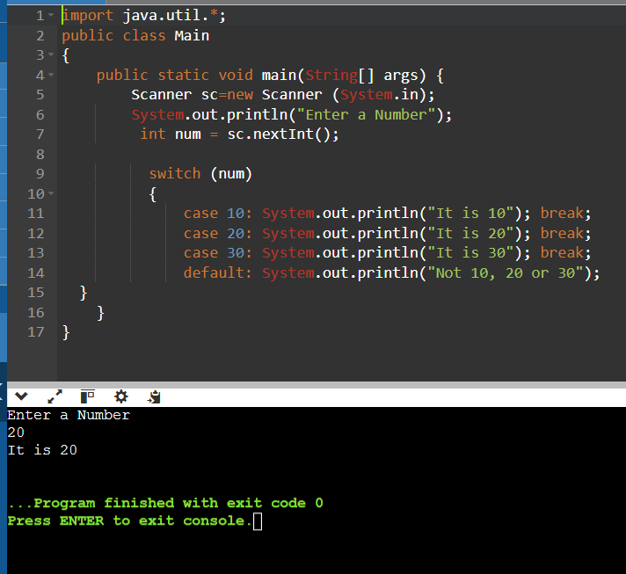

Q2 WAP to print days of the week according to the nos

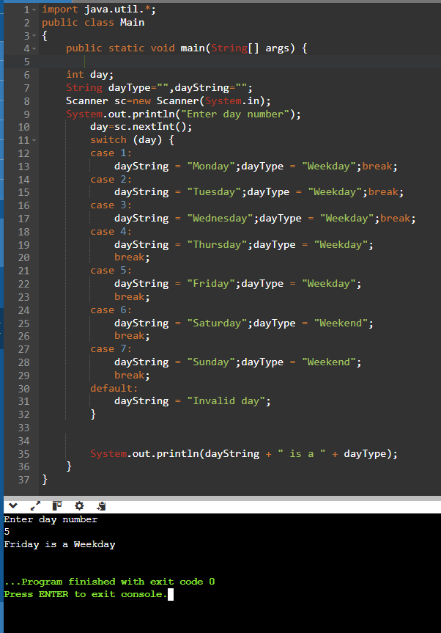

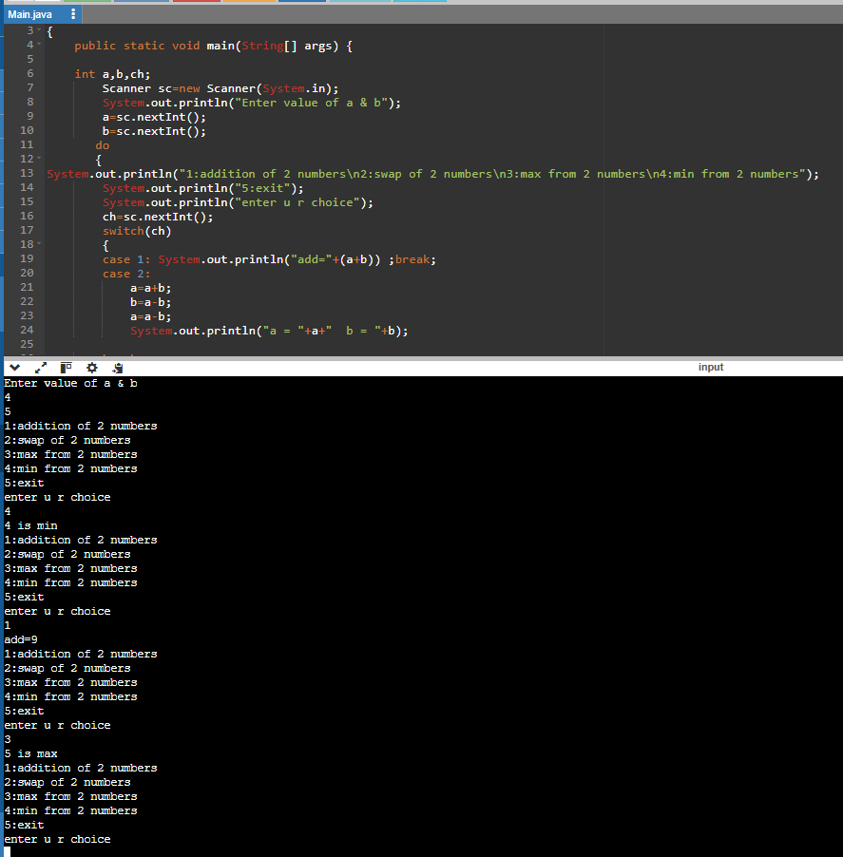Q3WAP to print all addition , swapping , maximum , minimum of 2 nos and exit ,all in one using switch case

.

Q4 WAP to print area of circle, area of triangle, KE, AM AND HM, all in one using switch case

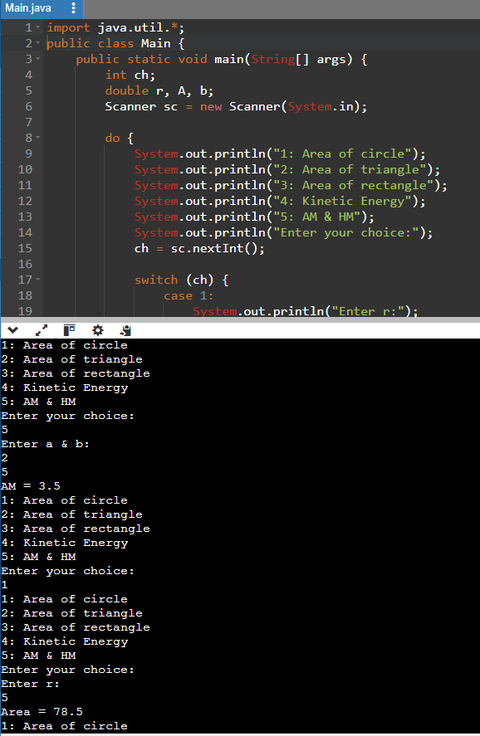

Q5 WAP to check whether the nos is even/odd, divisible by 17, divisible by 5and7, divisible by 5or7, leap year or not, positive or negative, calculate electricity bill, age classification, discount calculation, validate pin, and exit.

import java.util.\*;

public class Main {

public static void main(String[] args) {

int ch;

Scanner sc = new Scanner(System.in);

do {

System.out.println("1: Check even/odd");

System.out.println("2: Check divisible by 17");

System.out.println("3: Check divisible by 5 & 7");

System.out.println("4: Check divisible by 5 or 7");

System.out.println("5: Check leap year or not");

System.out.println("6: Check positive/negative");

System.out.println("7: Calculate electricity bill");

System.out.println("8: Age classification");

System.out.println("9: Discount calculation");

System.out.println("10: Validate PIN");

System.out.println("Enter your choice (or 0 to exit):");

ch = sc.nextInt();

switch (ch) {

case 1:

System.out.println("Enter a number:");

int num = sc.nextInt();

if (num % 2 == 0) {

System.out.println(num + " is even.");

} else {

System.out.println(num + " is odd.");

}

break;

case 2:

System.out.println("Enter a number:");

num = sc.nextInt();

if (num % 17 == 0) {

System.out.println(num + " is divisible by 17.");

} else {

System.out.println(num + " is not divisible by 17.");

}

break;

case 3:

System.out.println("Enter a number:");

num = sc.nextInt();

if (num % 5 == 0 && num % 7 == 0) {

System.out.println(num + " is divisible by both 5 and 7.");

} else {

System.out.println(num + " is not divisible by both 5 and 7.");

}

break;

case 4:

System.out.println("Enter a number:");

num = sc.nextInt();

if (num % 5 == 0 || num % 7 == 0) {

System.out.println(num + " is divisible by 5 or 7.");

} else {

System.out.println(num + " is not divisible by 5 or 7.");

}

break;

case 5:

System.out.println("Enter a year:");

int year = sc.nextInt();

if ((year % 4 == 0 && year % 100 != 0) || (year % 400 == 0)) {

System.out.println(year + " is a leap year.");

} else {

System.out.println(year + " is not a leap year.");

}

break;

case 6:

System.out.println("Enter a number:");

num = sc.nextInt();

if (num > 0) {

System.out.println(num + " is positive.");

} else if (num < 0) {

System.out.println(num + " is negative.");

} else {

System.out.println(num + " is zero.");

}

break;

case 7:

System.out.println("Enter units consumed:");

double units = sc.nextDouble();

double bill = 0;

if (units <= 100) {

bill = units \* 1.5;

} else if (units <= 300) {

bill = 100 \* 1.5 + (units - 100) \* 2.5;

} else {

bill = 100 \* 1.5 + 200 \* 2.5 + (units - 300) \* 4.0;

}

System.out.println("Electricity bill = $" + bill);

break;

case 8:

System.out.println("Enter age:");

int age = sc.nextInt();

if (age < 13) {

System.out.println("Child");

} else if (age <= 19) {

System.out.println("Teenager");

} else if (age <= 59) {

System.out.println("Adult");

} else {

System.out.println("Senior");

}

break;

case 9:

System.out.println("Enter original price:");

double price = sc.nextDouble();

System.out.println("Enter discount percentage:");

double discount = sc.nextDouble();

double finalPrice = price - (price \* discount / 100);

System.out.println("Final price after discount = $" + finalPrice);

break;

case 10:

System.out.println("Enter a 4-digit PIN:");

int pin = sc.nextInt();

if (String.valueOf(pin).length() == 4) {

System.out.println("Valid PIN");

} else {

System.out.println("Invalid PIN");

}

break;

default:

if (ch != 0) {

System.out.println("Invalid choice");

}

break;

}

} while (ch != 0);

}

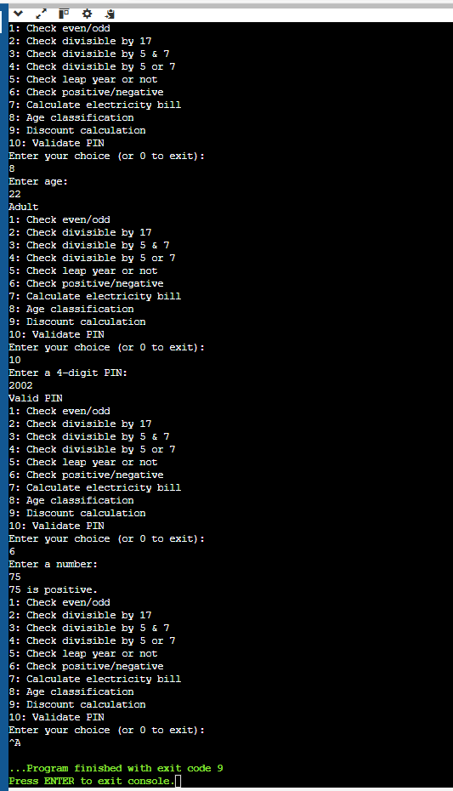}

Q6

import java.util.\*;

public class Main {

public static void main(String[] args) {

int ch;

Scanner sc = new Scanner(System.in);

do {

System.out.println("1: Check if first number is between second and third number");

System.out.println("2: Find minimum from 3 numbers");

System.out.println("3: Find maximum from 3 numbers");

System.out.println("4: Show result in form of pass, distinction, first class, ATKT, or fail");

System.out.println("5: Calculate area of triangle");

System.out.println("6: Blood donation eligibility");

System.out.println("7: Aptitude exam result");

System.out.println("Enter your choice (or 0 to exit):");

ch = sc.nextInt();

switch (ch) {

case 1:

System.out.println("Enter three numbers:");

int num1 = sc.nextInt();

int num2 = sc.nextInt();

int num3 = sc.nextInt();

if (num1 > num2 && num1 < num3) {

System.out.println(num1 + " is between " + num2 + " and " + num3);

} else {

System.out.println(num1 + " is not between " + num2 + " and " + num3);

}

break;

case 2:

System.out.println("Enter three numbers:");

num1 = sc.nextInt();

num2 = sc.nextInt();

num3 = sc.nextInt();

int min = Math.min(num1, Math.min(num2, num3));

System.out.println("Minimum number is " + min);

break;

case 3:

System.out.println("Enter three numbers:");

num1 = sc.nextInt();

num2 = sc.nextInt();

num3 = sc.nextInt();

int max = Math.max(num1, Math.max(num2, num3));

System.out.println("Maximum number is " + max);

break;

case 4:

System.out.println("Enter your marks:");

int marks = sc.nextInt();

if (marks >= 75) {

System.out.println("Distinction");

} else if (marks >= 60) {

System.out.println("First Class");

} else if (marks >= 50) {

System.out.println("Second Class");

} else if (marks >= 40) {

System.out.println("ATKT");

} else {

System.out.println("Fail");

}

break;

case 5:

System.out.println("Enter the base and height of the triangle:");

double base = sc.nextDouble();

double height = sc.nextDouble();

double area = 0.5 \* base \* height;

System.out.println("Area of triangle = " + area);

break;

case 6:

System.out.println("Enter age:");

int age = sc.nextInt();

System.out.println("Enter weight:");

double weight = sc.nextDouble();

if (age >= 18 && weight >= 50) {

System.out.println("Eligible for blood donation");

} else {

System.out.println("Not eligible for blood donation");

}

break;

case 7:

System.out.println("Enter your score in the aptitude exam:");

int score = sc.nextInt();

if (score >= 90) {

System.out.println("Excellent");

} else if (score >= 75) {

System.out.println("Good");

} else if (score >= 60) {

System.out.println("Average");

} else if (score >= 50) {

System.out.println("Below Average");

} else {

System.out.println("Poor");

}

break;

default:

if (ch != 0) {

System.out.println("Invalid choice");

}

break;

}

} while (ch != 0);

}

}

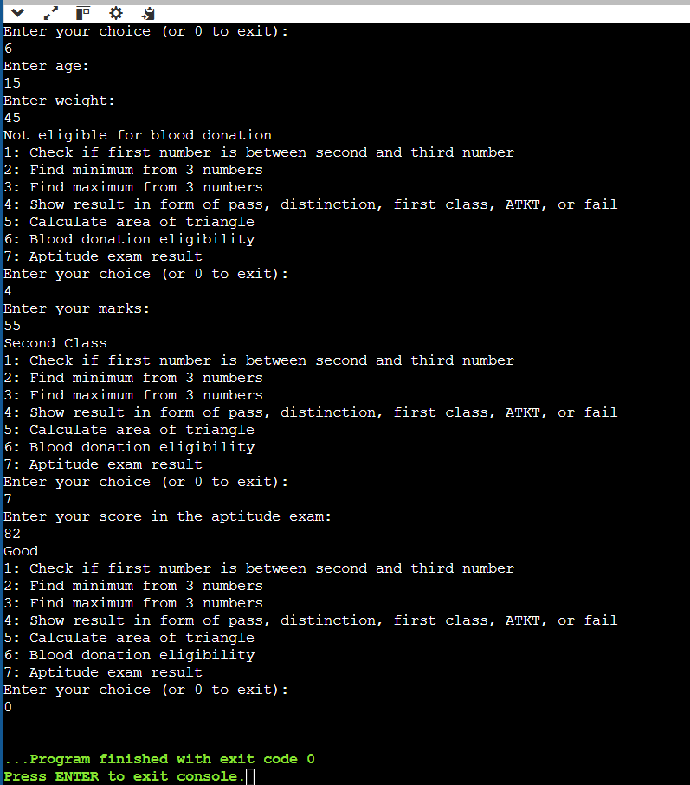

Q7

import java.util.\*;

public class Main {

public static void main(String[] args) {

int ch;

Scanner sc = new Scanner(System.in);

do {

System.out.println("1: Find maximum of 2 numbers");

System.out.println("2: Calculate loss or profit");

System.out.println("3: Determine quadrant of a point");

System.out.println("4: Bank money withdrawal (ATM)");

System.out.println("Enter your choice (or 0 to exit):");

ch = sc.nextInt();

switch (ch) {

case 1:

System.out.println("Enter two numbers:");

double num1 = sc.nextDouble();

double num2 = sc.nextDouble();

double max = Math.max(num1, num2);

System.out.println("Maximum number is " + max);

break;

case 2:

System.out.println("Enter cost price:");

double costPrice = sc.nextDouble();

System.out.println("Enter selling price:");

double sellingPrice = sc.nextDouble();

if (sellingPrice > costPrice) {

double profit = sellingPrice - costPrice;

System.out.println("Profit of " + profit);

} else if (costPrice > sellingPrice) {

double loss = costPrice - sellingPrice;

System.out.println("Loss of" + loss);

} else {

System.out.println("No profit, no loss");

}

break;

case 3:

System.out.println("Enter the x-coordinate:");

double x = sc.nextDouble();

System.out.println("Enter the y-coordinate:");

double y = sc.nextDouble();

if (x > 0 && y > 0) {

System.out.println("The point (" + x + ", " + y + ") is in the first quadrant.");

} else if (x < 0 && y > 0) {

System.out.println("The point (" + x + ", " + y + ") is in the second quadrant.");

} else if (x < 0 && y < 0) {

System.out.println("The point (" + x + ", " + y + ") is in the third quadrant.");

} else if (x > 0 && y < 0) {

System.out.println("The point (" + x + ", " + y + ") is in the fourth quadrant.");

} else if (x == 0 && y == 0) {

System.out.println("The point (" + x + ", " + y + ") is at the origin.");

} else if (x == 0) {

System.out.println("The point (" + x + ", " + y + ") is on the y-axis.");

} else {

System.out.println("The point (" + x + ", " + y + ") is on the x-axis.");

}

break;

case 4:

System.out.println("Enter your bank balance:");

double balance = sc.nextDouble();

System.out.println("Enter the amount to withdraw:");

double withdrawAmount = sc.nextDouble();

if (withdrawAmount > balance) {

System.out.println("Insufficient funds.");

} else {

balance -= withdrawAmount;

System.out.println("Withdrawal successful. Remaining balance: " + balance);

}

break;

default:

if (ch != 0) {

System.out.println("Invalid choice");

}

break;

}

} while (ch != 0);

}

}

