AI Assisted Coding
Lab Assignment 9.5
Name : V Sai Krishnachaithanya
Hall Ticket no : 2303A52154

Problem 1: String Utilities Function
Consider the following Python function:
def reverse_string(text):
return text[::-1]
Task:
1. Write documentation in:
o (a) Docstring
o (b) Inline comments
o (c) Google-style documentation
2. Compare the three documentation styles.
3. Recommend the most suitable style for a utility-based string
library.

Prompt:
generate a docstring , inline comments and Google-style documentation for String Utilities Function and compare the 3 types of documentation.

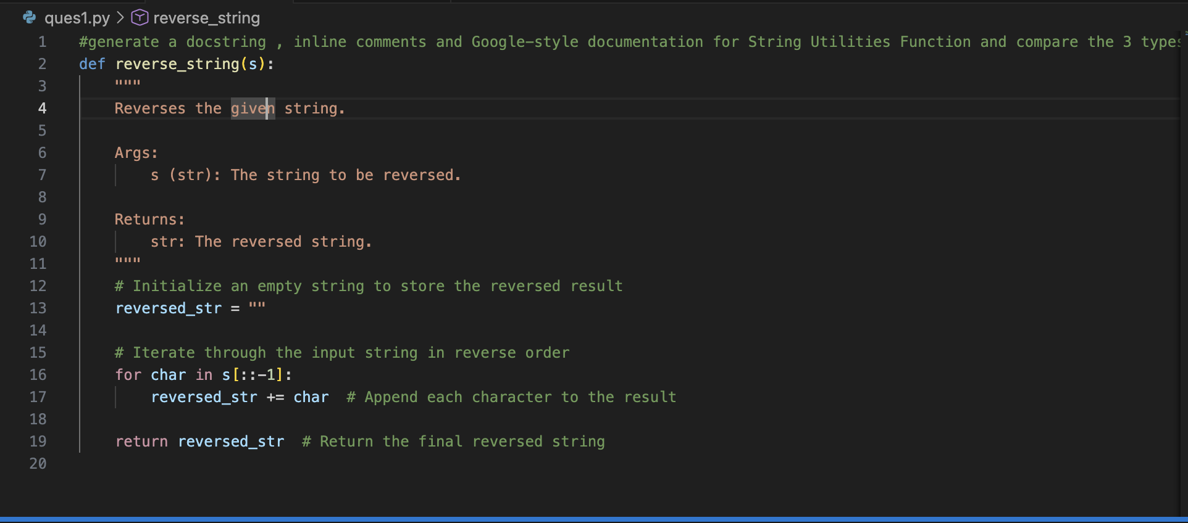
Output:

# python3 -m pydoc -p 1234
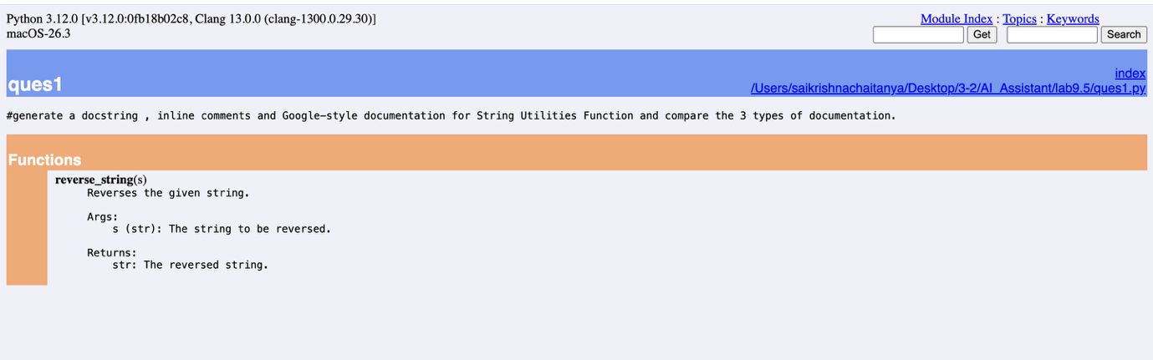

# python3 -m pydoc ques1

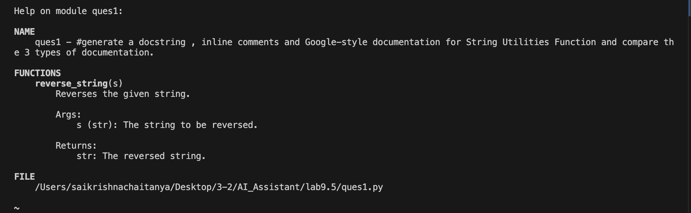

# python3 -m pydoc -w ques1

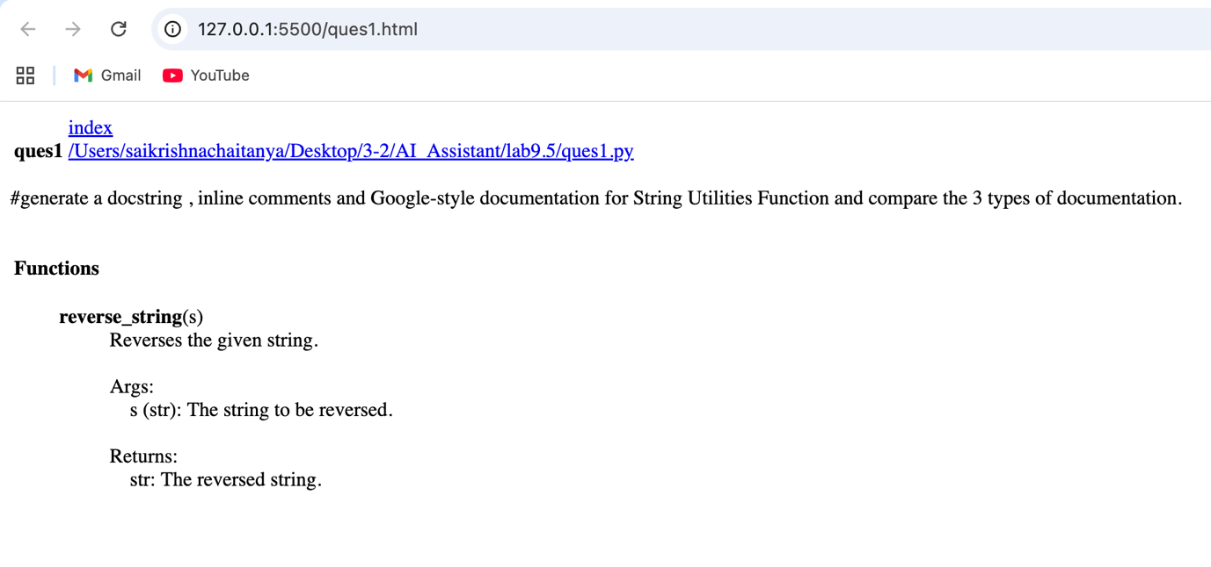

Problem 2: Password Strength Checker
Consider the function:
def check_strength(password):
return len(password) >= 8
Task:
1. Document the function using docstring, inline comments, and
Google style.
2. Compare documentation styles for security-related code.
3. Recommend the most appropriate style.

Prompt:
generate a docstring , inline comments and Google-style documentation for Password Strength Checker and compare the 3 types of documentation.

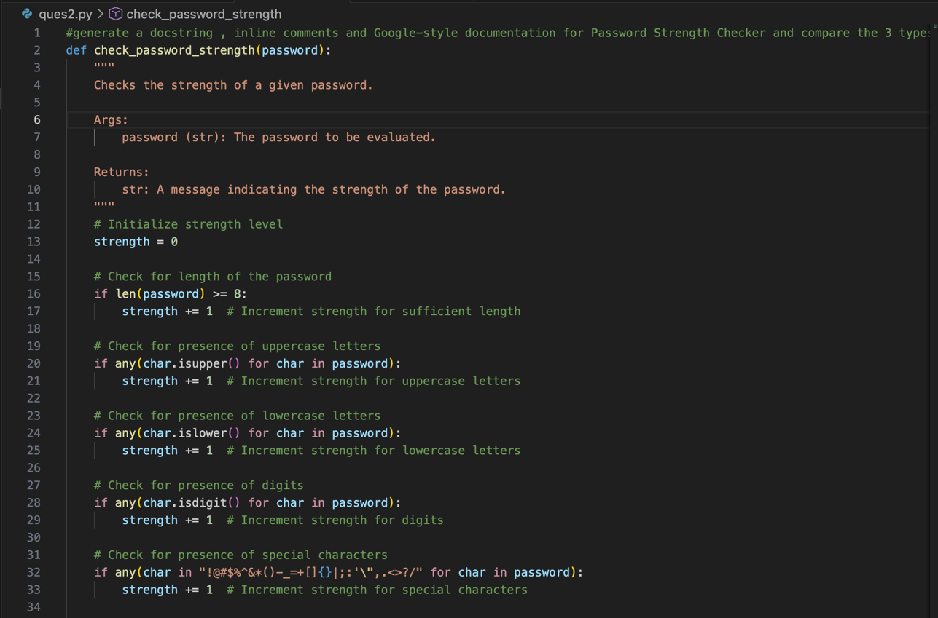

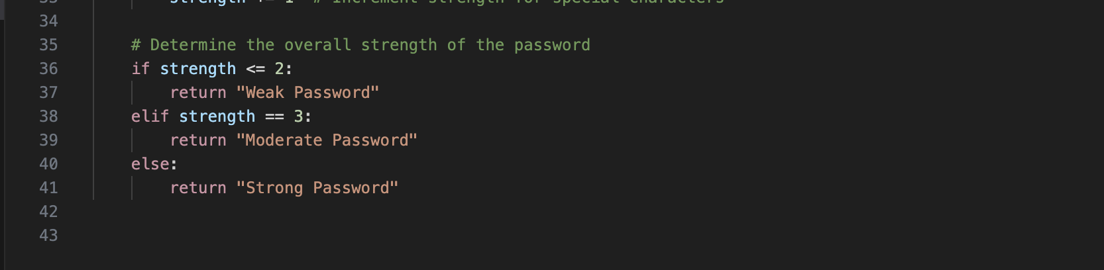Output:

# python3 -m pydoc ques2

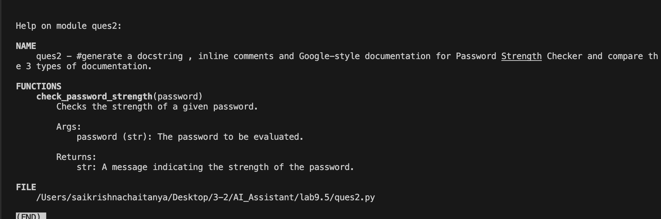

# python3 -m pydoc -w ques2

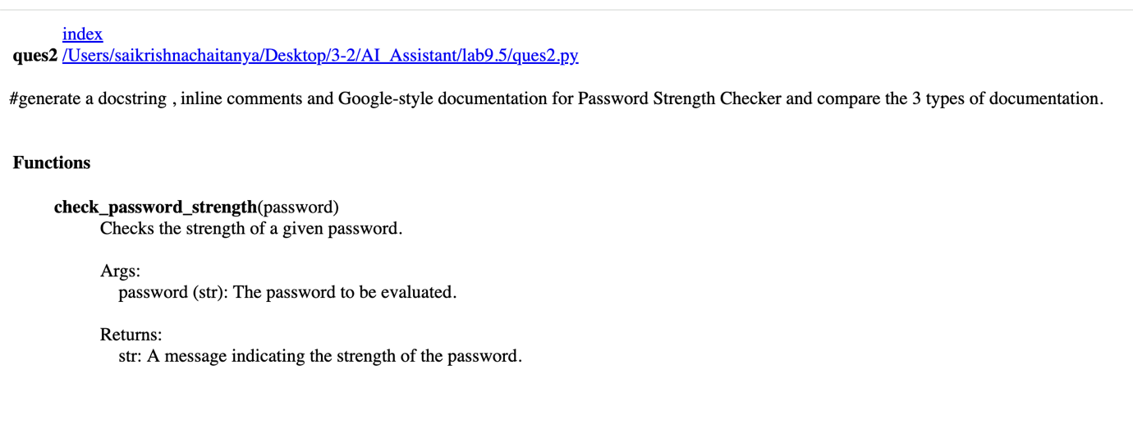

# python3 -m pydoc -p 1234

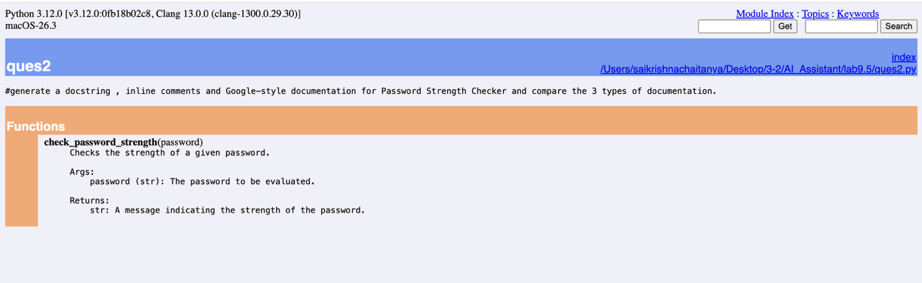
Problem 3: Math Utilities Module
Task:
1. Create a module math_utils.py with functions:
o square(n)
o cube(n)
o factorial(n)
2. Generate docstrings automatically using AI tools.
3. Export documentation as an HTML file.
Prompt :
generate a python function to calculate square,cube and factorial of a number and Generate docstrings and Export documentation as an HTML file

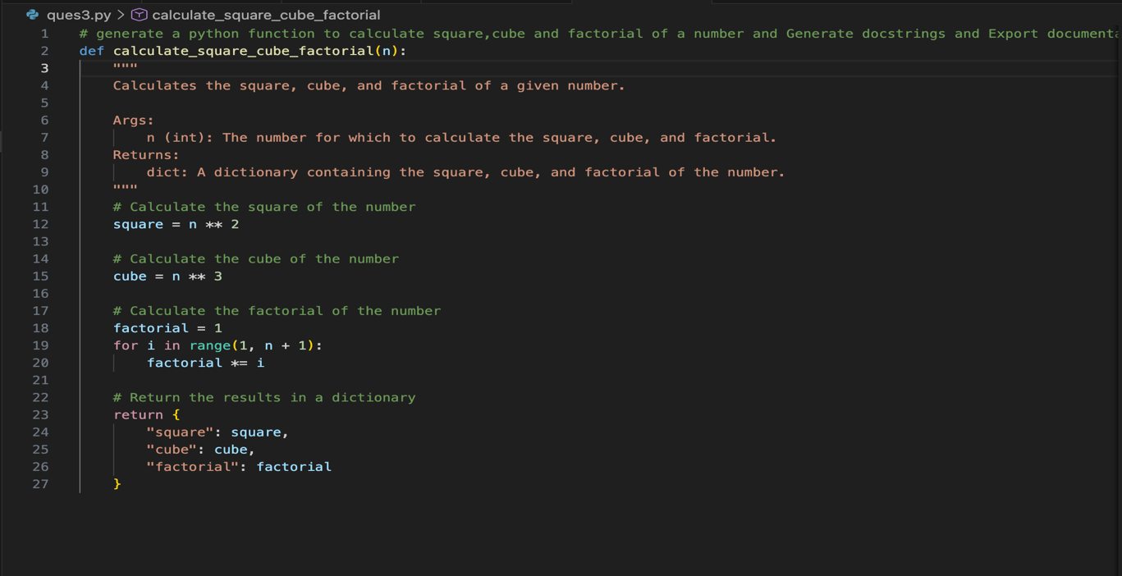
Output:

# python3 -m pydoc ques3

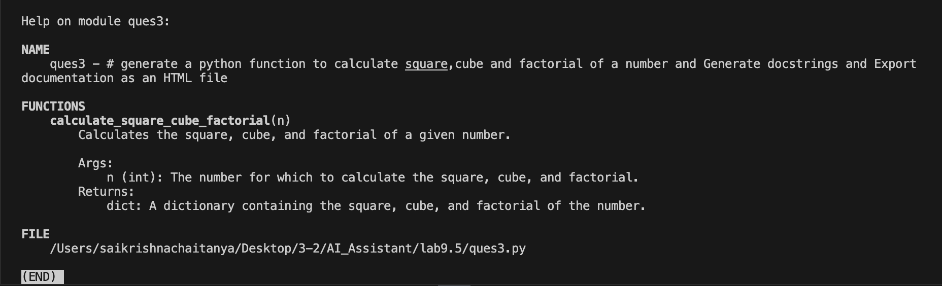
# python3 -m pydoc -w ques3

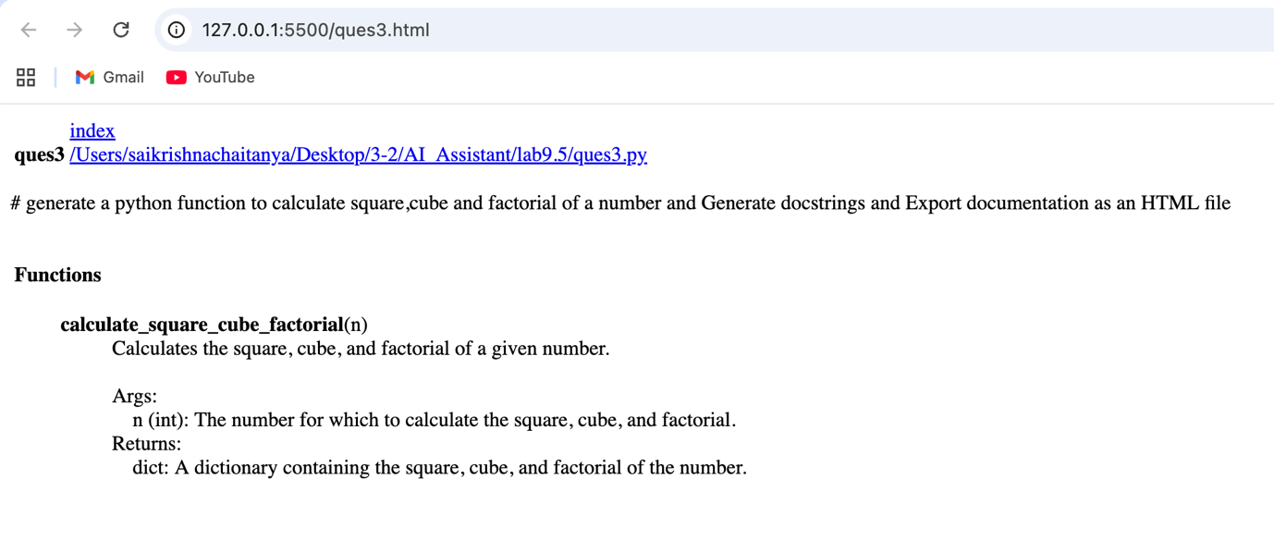

# python3 -m pydoc -p 1234

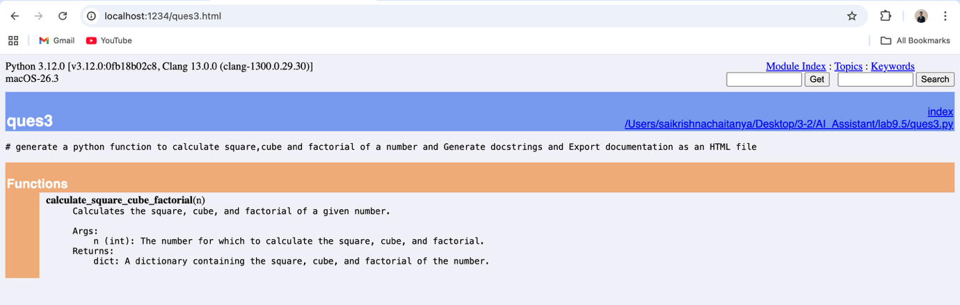

Problem 4: Attendance Management Module
Task:
1. Create a module attendance.py with functions:
mark_present(student)
mark_absent(student)
get_attendance(student)
2. Add proper docstrings.
3. Generate and view documentation in terminal and browse

Prompt:
generate a python Attendance Management Module with functions to mark attendance, mark absent, get attendence and generate attendance reports. Include docstrings and inline comments for each function.

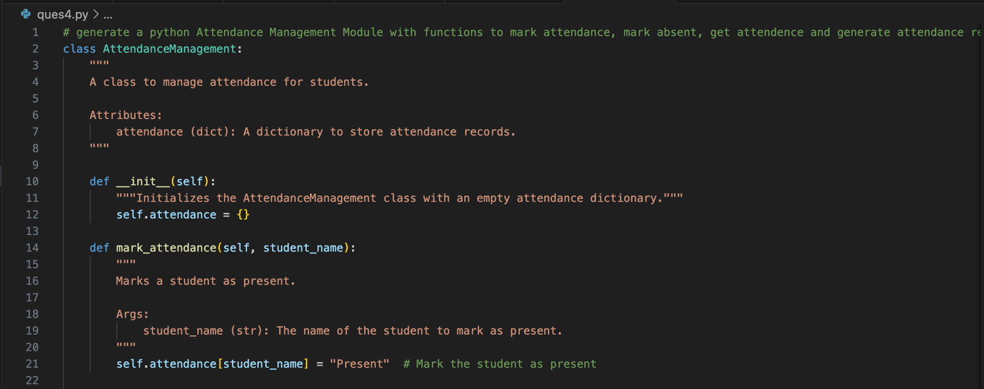
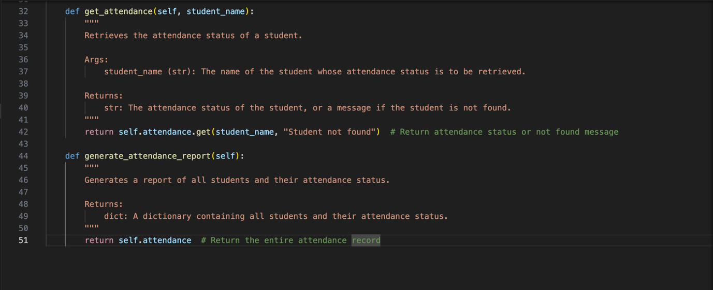
Output:
# python3 -m pydoc ques4

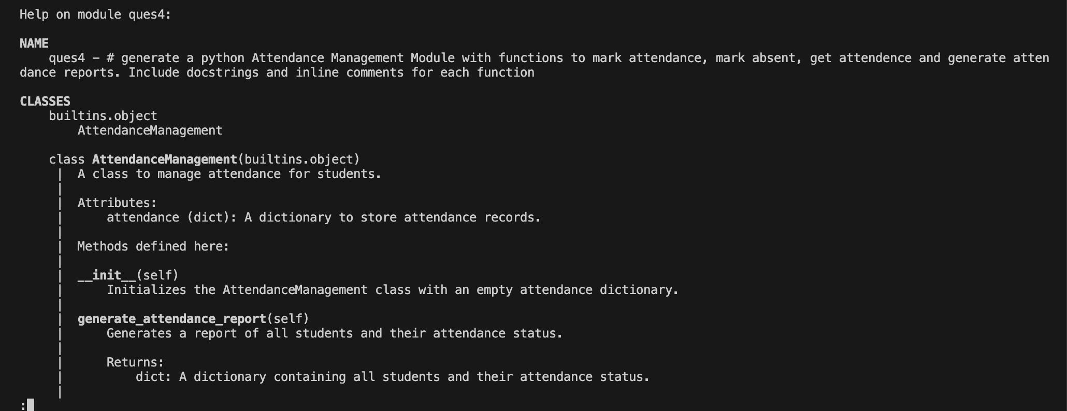
# python3 -m pydoc -w ques4

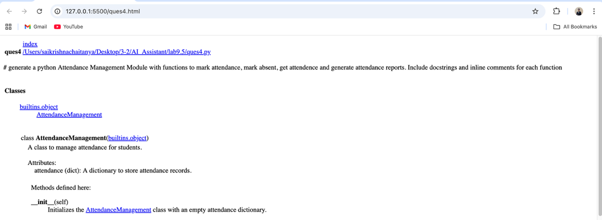
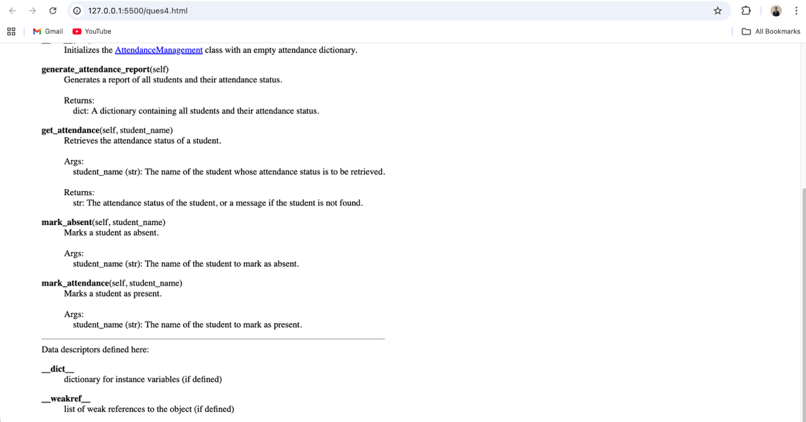

# python3 -m pydoc -p 1234

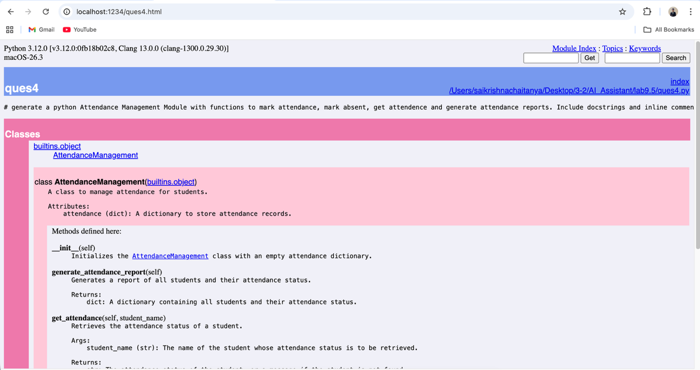
Problem 5: File Handling Function
Consider the function:
def read_file(filename):
with open(filename, 'r') as f:
return f.read()
Task:
1. Write documentation using all three formats.
2. Identify which style best explains exception handling.
3. Justify your recommendation.

Prompt:
generate a docstring , inline comments and Google-style documentation for python function File Handling contains def read_file(filename): with open(filename, 'r') as f: return f.read()

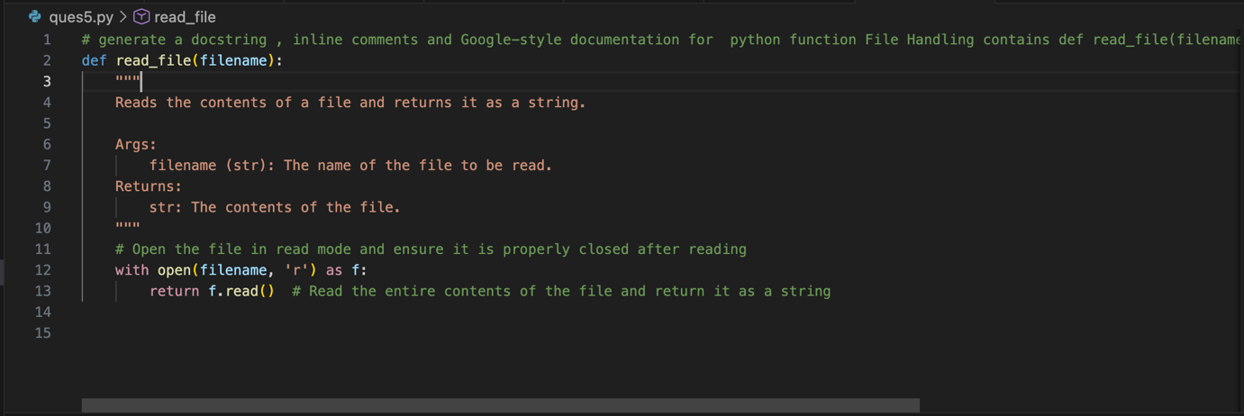

Output :
# python3 -m pydoc ques5

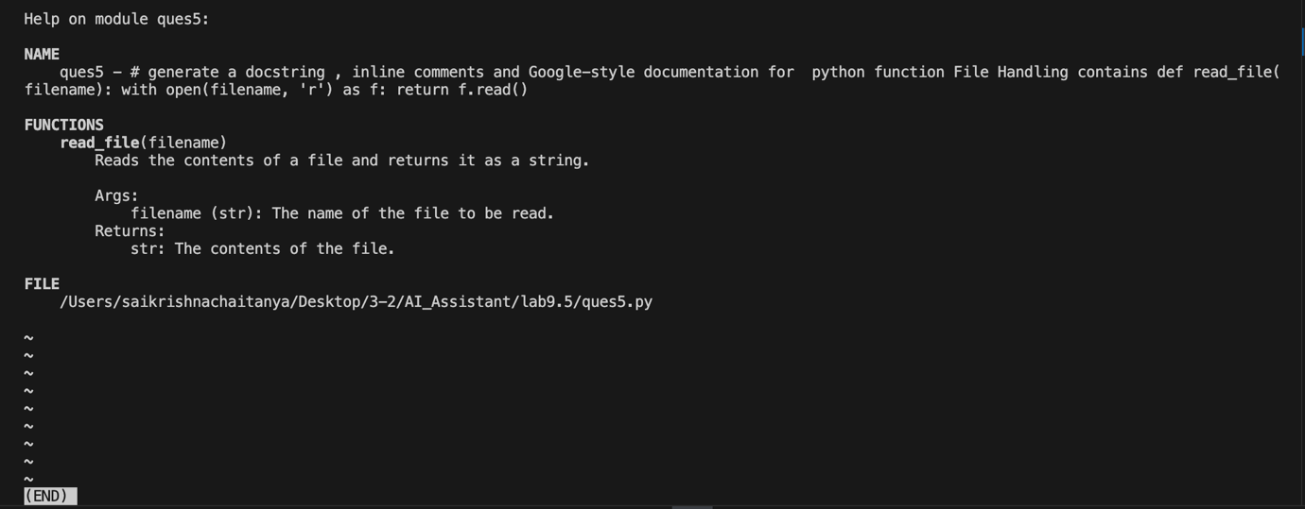
# python3 -m pydoc -w ques5

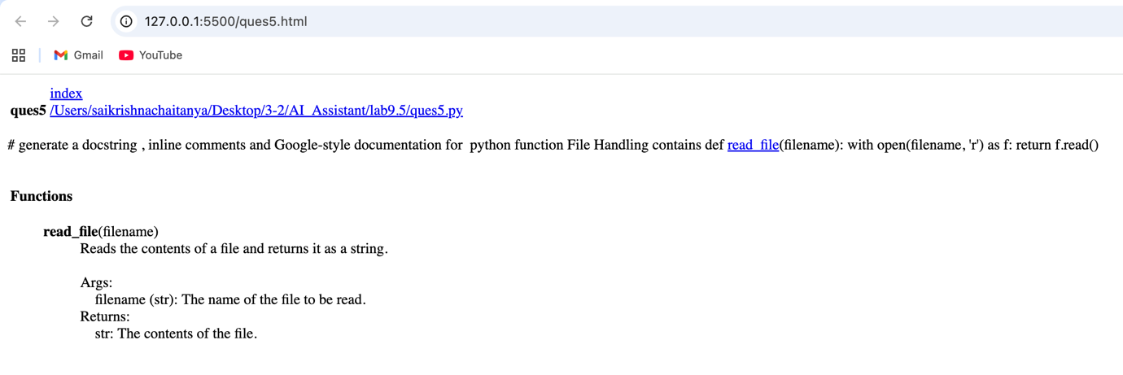

# python3 -m pydoc -p 1234

