AI Assisted Coding
Lab Assignment 1.5
Name : V Sai Krishnachaithanya
Hall Ticket no : 2303A52154
Task-01
Task Description
Use GitHub Copilot to generate a Python program that:
Reverses a given string
Accepts user input
Implements the logic directly in the main code
Does not use any user-defined functions
Prompt Given: # write a python code to reverse a string which should take input from user and don't use any user defined functions.
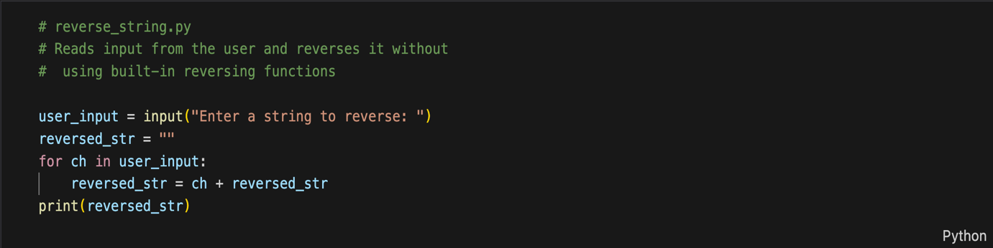
Output :
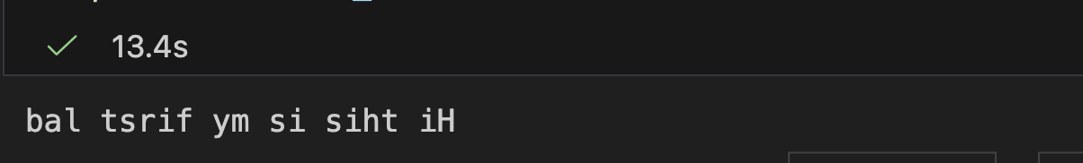

Justification:
This activity serves as a simple example of how to use GitHub Copilot to create a Python program that does not require the definition of any custom functions. The main program has the string reversal logic directly applied to it, and thus, it mainly deals with the programming concepts of handling user input, traversing strings, and manipulating characters. The use of no functions makes the logic clear and friendly for the beginner, so it is easier to see the Copilot's role in producing simple procedural code. The task is to implement a basic procedure that can later be improved upon and compared in the following tasks.
Task-02
Task Description
Examine the Copilot-generated code from Task 1 and improve it by:
Removing unnecessary variables
Simplifying loop or indexing logic
Improving readability
Use Copilot prompts like:
▪ “Simplify this string reversal code”
▪ “Improve readability and efficiency
Prompt Given:
# Generate code by removing unnecessary variables, simplifying loops and indexing logic, and improving overall readability and efficiency without changing the output

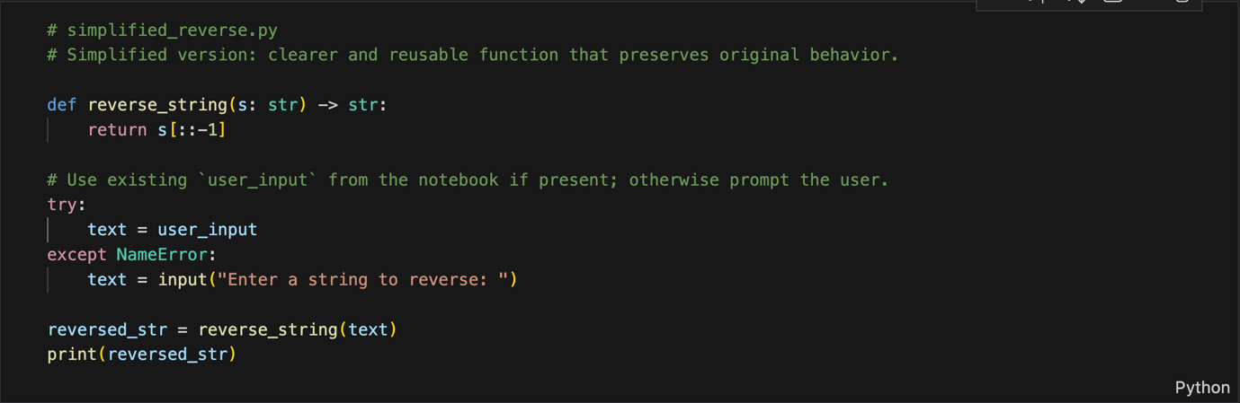

Output:
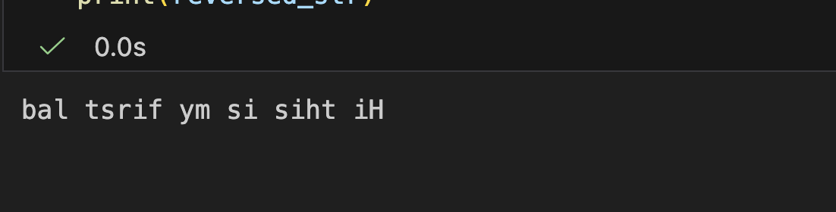
Justification:
The improved code version not only offers better performance but better readability by removing unnecessary control structures and variables that do not influence the output. Nevertheless, the linear time complexity O(n) is the same for both versions, but the optimized version reduces the overhead causedby extra operations, hence resulting in the best practical performance. This not only gives a neat appearance to the code but also makes it easy to maintain and suitable for a group of coders working in collaboration.
Task-03
Task Description
Use GitHub Copilot to generate a function-based Python program that:
Uses a user-defined function to reverse a string
Returns the reversed string
Includes meaningful comments (AI-assisted)
Prompt Given:
# Create a Python function that reverses a given string and returns the result. Keep the logic simple

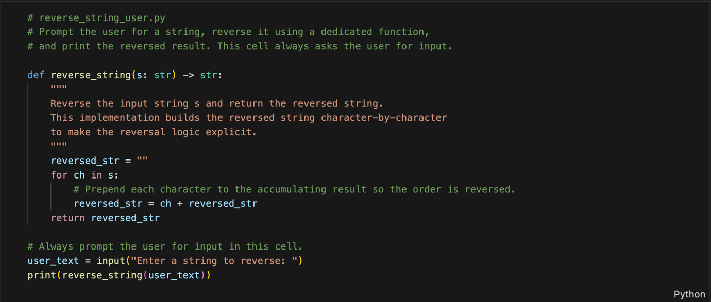

Output :
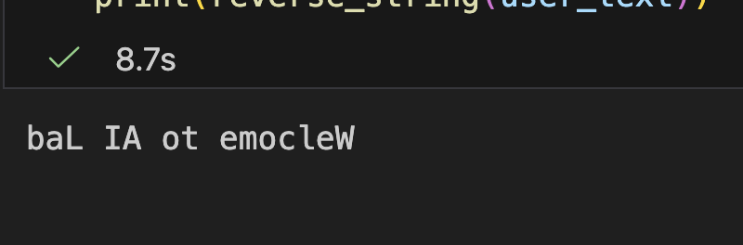
Justification:
Using a user-defined function for string reversal improves modularity and reusability, allowing the same logic to be used in multiple parts of the application without code duplication. Encapsulating the logic inside a function makes the program easier to maintain, test, and debug, especially as the application grows. Meaningful, AI-assisted comments enhance code readability and help other developers quickly understand the purpose and flow of the logic during collaboration or review.

Task 04
Task Description
Compare the Copilot-generated programs:
Without functions (Task 1)
With functions (Task 3)
Analyze them based on:
Code clarity
Reusability
Debugging ease
Suitability for large-scale applications
Prompt Given:
Compare the two Python programs below: one written without functions and one using user-defined functions.
Analyze and clearly explain the differences in terms of code clarity, reusability, ease of debugging,
and suitability for large-scale applications. Keep the comparison structured and easy to understand output in tabular form.

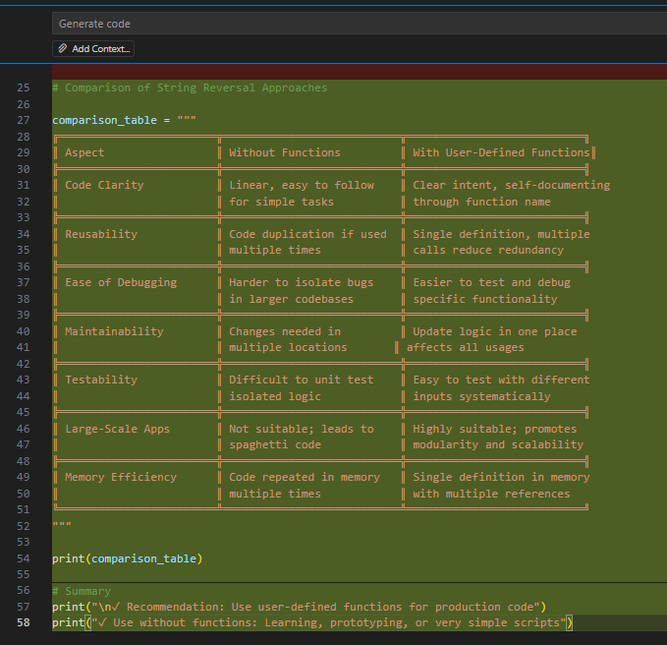

Output:
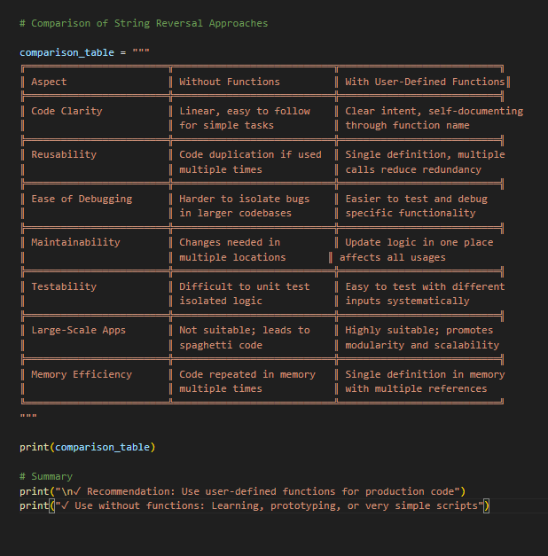
Task-05:
Task Description
Prompt GitHub Copilot to generate:
A loop-based string reversal approach
A built-in / slicing-based string reversal approach
Given Prompt:
Generate two Python implementations to reverse a string, one using a loop and one using slicing or built-in methods, and then compare them based on execution flow, time complexity, performance on large inputs, and when each approach should be used.
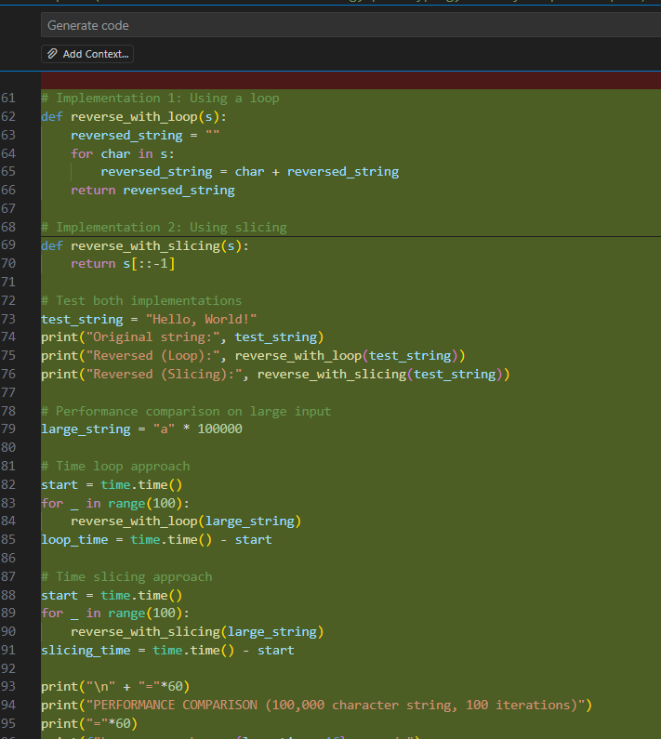

Output:
