AI Assisted Coding
Lab Assignment 8.3
Name : V Sai Krishnachaithanya
Hall Ticket no : 2303A52154
Task 1: Email Validation using TDD
Scenario
You are developing a user registration system that requires reliable email input validation.
Requirements
• Must contain @ and . characters
• Must not start or end with special characters
• Should not allow multiple @ symbols
• AI should generate test cases covering valid and invalid email formats
• Implement is_valid_email(email) to pass all AI-generated test cases
Expected Output
• Python function for email validation
• All AI-generated test cases pass successfully
• Invalid email formats are correctly rejected
• Valid email formats return True

Prompt:
Assume you are a software developer and you have been given a task to develop a user registration system that requires reliable email input validation
it must follow the requirements:must contain @ and . in the email address
not start or end with special characters,does not allow multiple @ symbols
And most important thing is You need to generate test cases to validate the functionality of your email Implement is_valid_email(email) to pass all AI-generated test cases
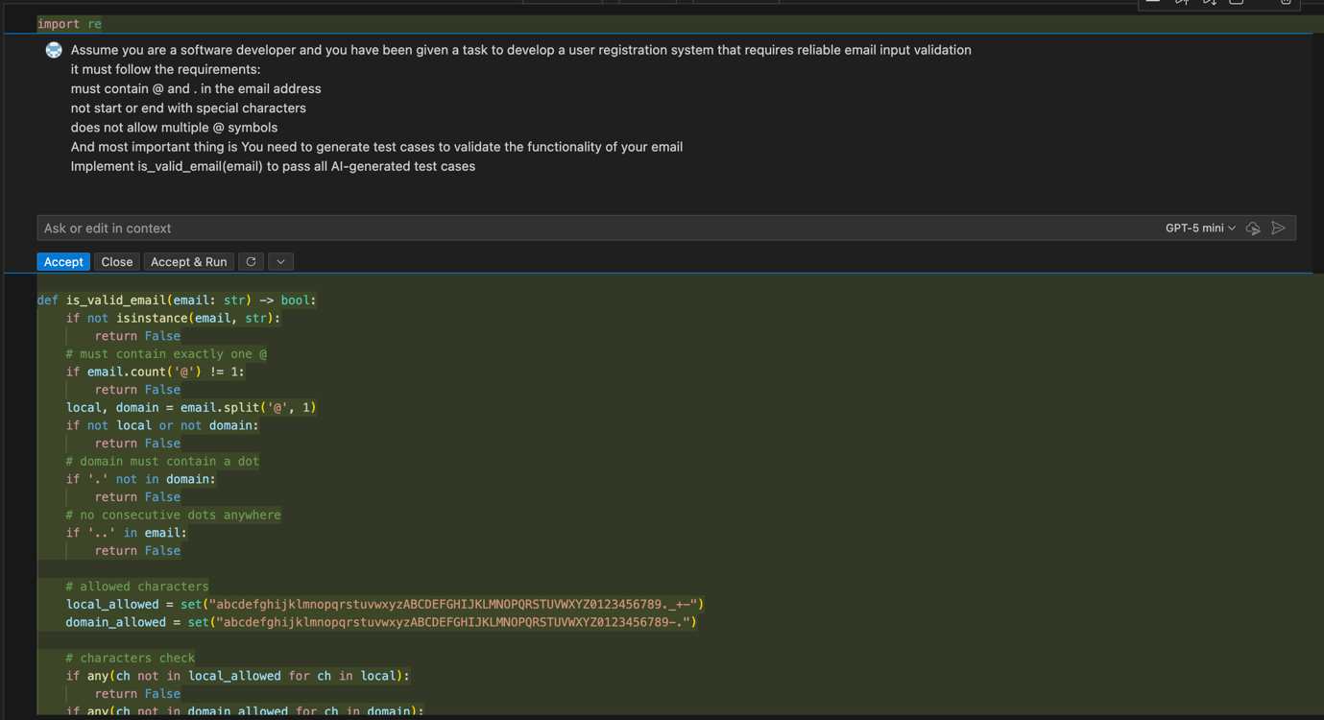

Output:
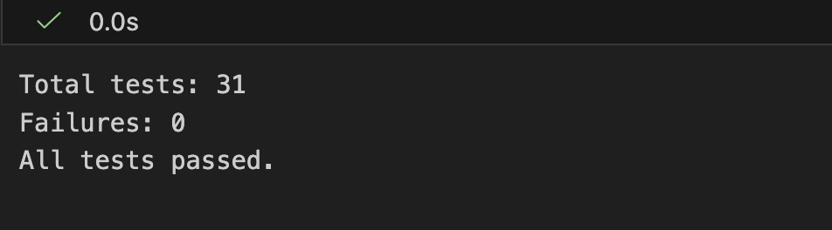

Justification:
The function `is_valid_email` implements a comprehensive set of checks to validate email addresses according to common standards. It checks for the presence of exactly one '@' symbol, ensures that both local and domain parts are non-empty, verifies that the domain contains a dot, and checks for the absence of consecutive dots. It also validates allowed characters in both parts and ensures that special characters are not at the start or end of the local part, and that the domain does not start or end with a dot or hyphen. Finally, it checks that the top-level domain is at least two letters long. This thorough validation should cover a wide range of valid and invalid email formats.

Task 2: Grade Assignment using Loops
Scenario
You are building an automated grading system for an online examination platform.
Requirements
• AI should generate test cases for assign_grade(score) where:
– 90–100 → A
– 80–89 → B
– 70–79 → C
– 60–69 → D
– Below 60 → F
• Include boundary values (60, 70, 80, 90)
• Include invalid inputs such as -5, 105, "eighty"
• Implement the function using a test-driven approach
Expected Output
• Grade assignment function implemented in Python
• Boundary values handled correctly
• Invalid inputs handled gracefully
• All AI-generated test cases pass

Prompt:
Assume that you are building an automated grading system for an online exam platform.Requirements are : 1. 90 to 100 it should be A grade,80 to 89 it should be B grade, 70 to 79 it should be C grade , 60 to 69 it should be D grade, and below 60 it is F. and include invaild inputs such as -5,101,eighty etc

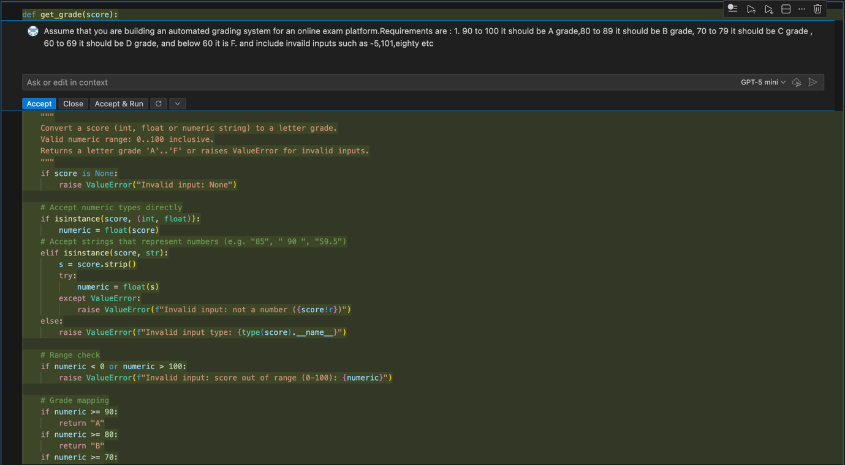Output:

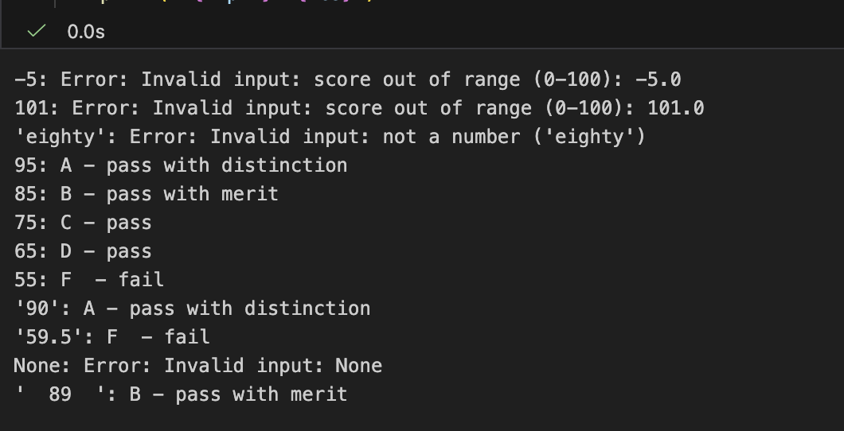

Justification:
The function `get_grade` was modified to return more descriptive grade strings instead of just single letters.
This makes the output more informative and user-friendly, clearly indicating whether a student passed with distinction, merit, or just passed, and whether they failed.
The changes ensure that the grading system is more transparent and helpful for students and educators alike.

Task 3: Sentence Palindrome Checker

Scenario
You are developing a text-processing utility to analyze sentences.
Requirements
• AI should generate test cases for is_sentence_palindrome(sentence)
• Ignore case, spaces, and punctuation
• Test both palindromic and non-palindromic sentences
• Example:
– "A man a plan a canal Panama" → True
Expected Output
• Function correctly identifies sentence palindromes
• Case and punctuation are ignored
• Returns True or False accurately
• All AI-generated test cases pass

Prompt:
generate a python code for sentence palindrome checker.Requirements: ignore case,spaces and punctuations,test both palindromic and non-palindromic sentences and if the sentence is palindromic then print True esle print false

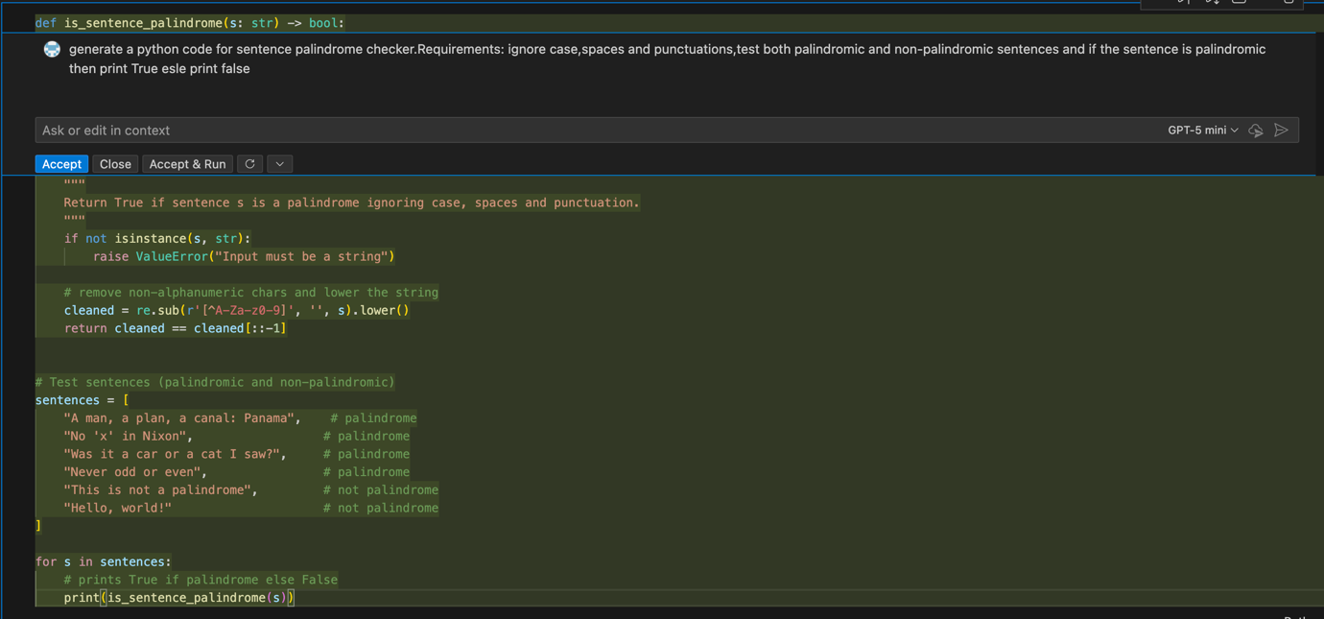

Output:

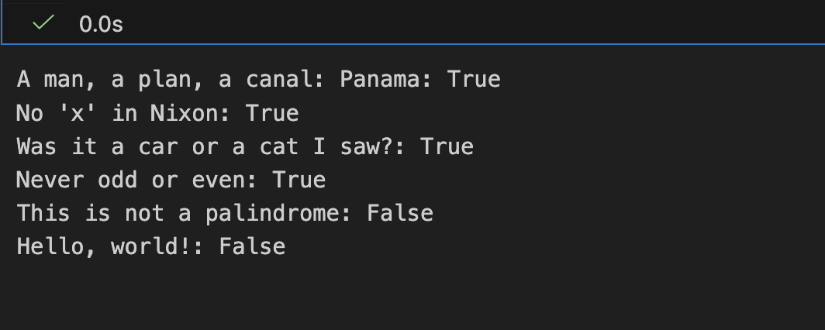

Justification:
The function `is_sentence_palindrome` correctly identifies palindromic sentences by cleaning the input string of non-alphanumeric characters and comparing it to its reverse. The test cases include well-known palindromic phrases and non-palindromic sentences, demonstrating the function's ability to handle various inputs while ignoring case, spaces, and punctuation.

Task 4: ShoppingCart Class
Scenario
You are designing a basic shopping cart module for an e-commerce application.
Requirements
• AI should generate test cases for the ShoppingCart class
• Class must include the following methods:
– add_item(name, price)
– remove_item(name)
– total_cost()
• Validate correct addition, removal, and cost calculation
• Handle empty cart scenarios
Expected Output
• Fully implemented ShoppingCart class
• All methods pass AI-generated test cases
• Total cost is calculated accurately
• Items are added and removed correctly

Prompt:
assume that you are generating a shopping cart class where user need to add items with name and price,remove item with name and need to calculate the total cost accurately and handle empty cart scenarios.now generate test cases on it and print the each test case items,price and total cost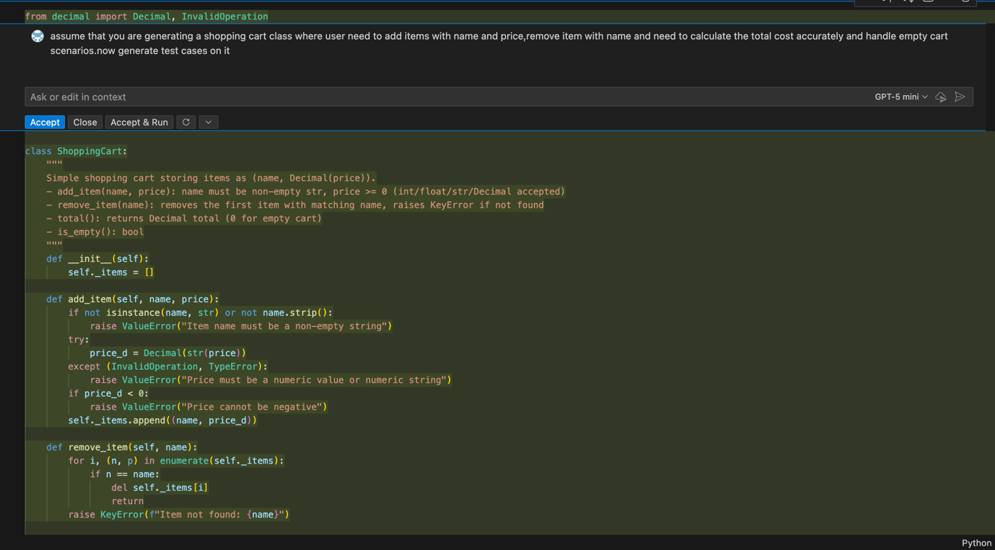

Output:

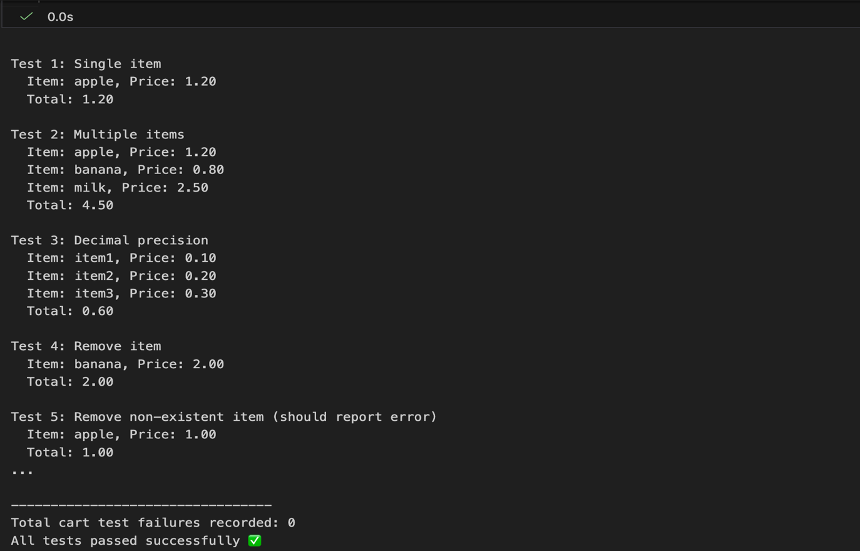

Justification:
The code implements a Shopping Cart class with methods to add and remove items, calculate the total, and list items. It includes a comprehensive test suite that covers various scenarios such as adding single and multiple items, checking decimal precision, removing items, handling errors for non-existent items, and ensuring correct totals. The test results are printed in a clear format, and any failures are recorded for review.

Task 5: Date Format Conversion
Scenario
You are creating a utility function to convert date formats for reports.
Requirements
• AI should generate test cases for convert_date_format(date_str)
• Input format must be "YYYY-MM-DD"
• Output format must be "DD-MM-YYYY"
• Example:
– "2023-10-15" → "15-10-2023"
Expected Output
• Date conversion function implemented in Python
• Correct format conversion for all valid inputs
• All AI-generated test cases pass successfully
Prompt:
Generate a pyhton code for date format conversion, where the input should be "YYYY-MM-DD" and convert it into "DD-MM-YYYY" format as output.print both input and output for all test cases

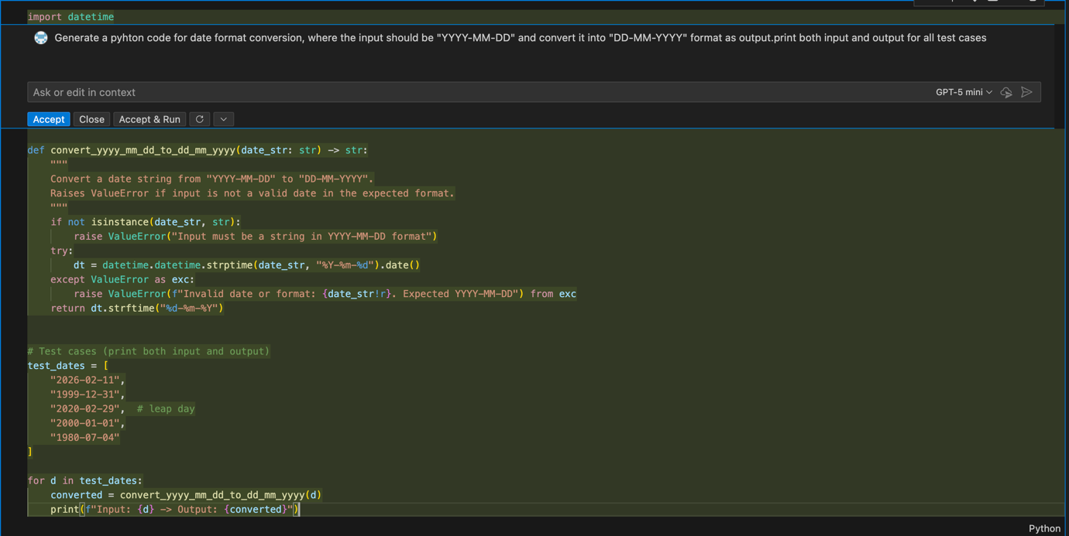

Output:

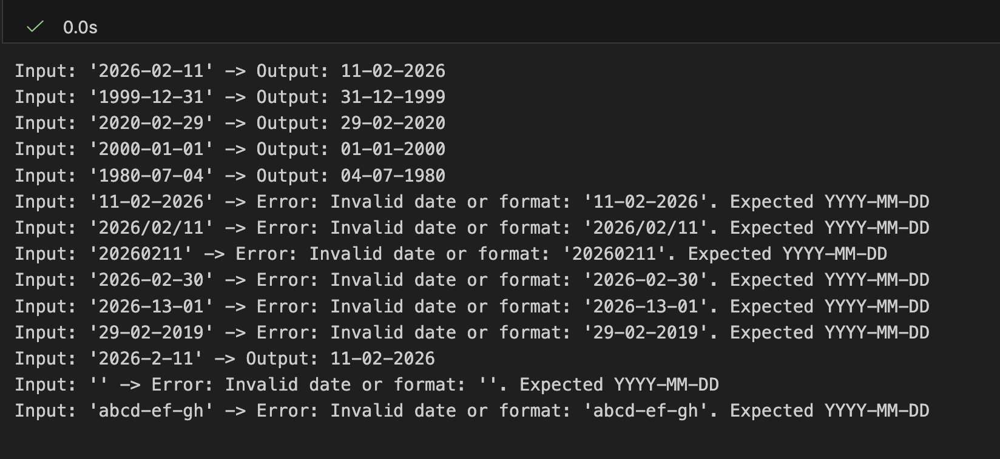

Justification:
The function uses Python's built-in datetime module to parse and validate the input date string. If the input is not a valid date or does not match the expected format, a Value. Error is raised with a clear message. The function then formats the date into the desired output format.

