AI Assisted Coding
Lab Assignment 4.3
Name : V Sai Krishnachaithanya Date : 28/01/2026
Hall Ticket no : 2303A52154

Task 1: Zero-Shot Prompting – Leap Year Check
Prompt : generate a python code to check given year is a Leap year or not
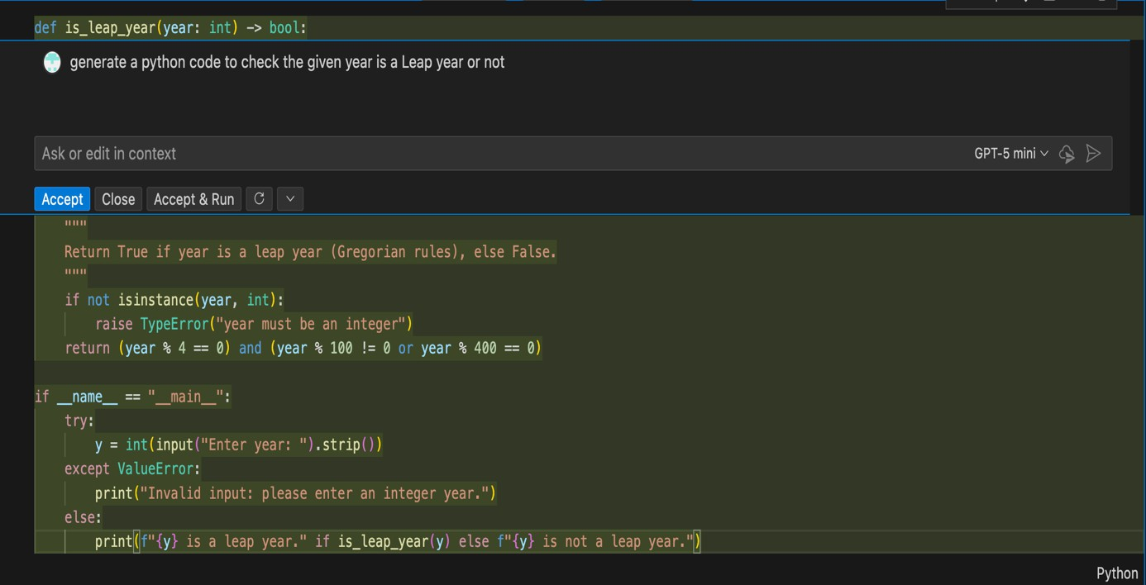

Output :
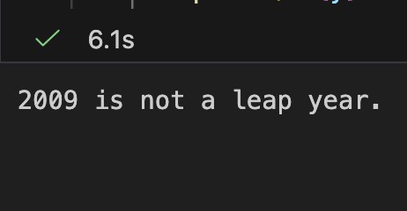

Task 2: One-Shot Prompting Centimetres to Inches Conversion
Prompt :Generate a python function which converts input 10 centimeters to inches and display it up to 2 decimal points
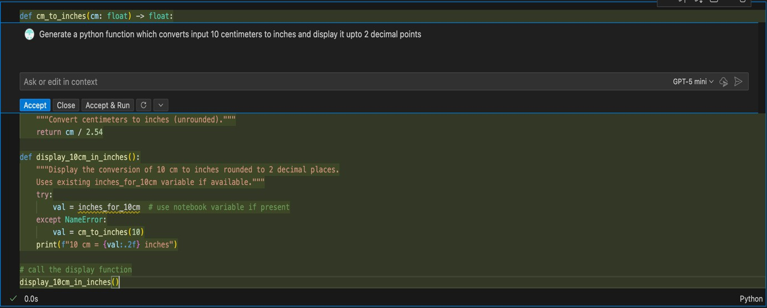

Output :
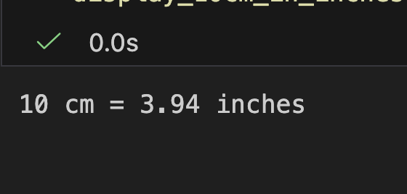

Task 3: Few-Shot Prompting – Name Formatting
Prompt :Generate a python function that accept the full name as input and format it as "Last , first". full names are "John Smith" and "Anita Rao"
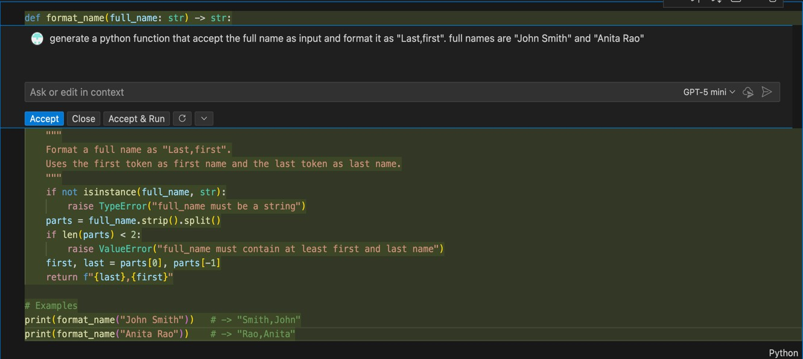

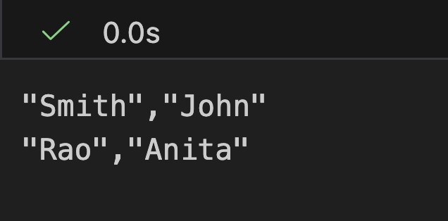

Task 4: Comparative Analysis – Zero-Shot vs Few-Shot

Prompt :
Generate a python function that count vowels in a string using zero shot and few shot and generate a comparative analysis for both shots with accuracy and readability
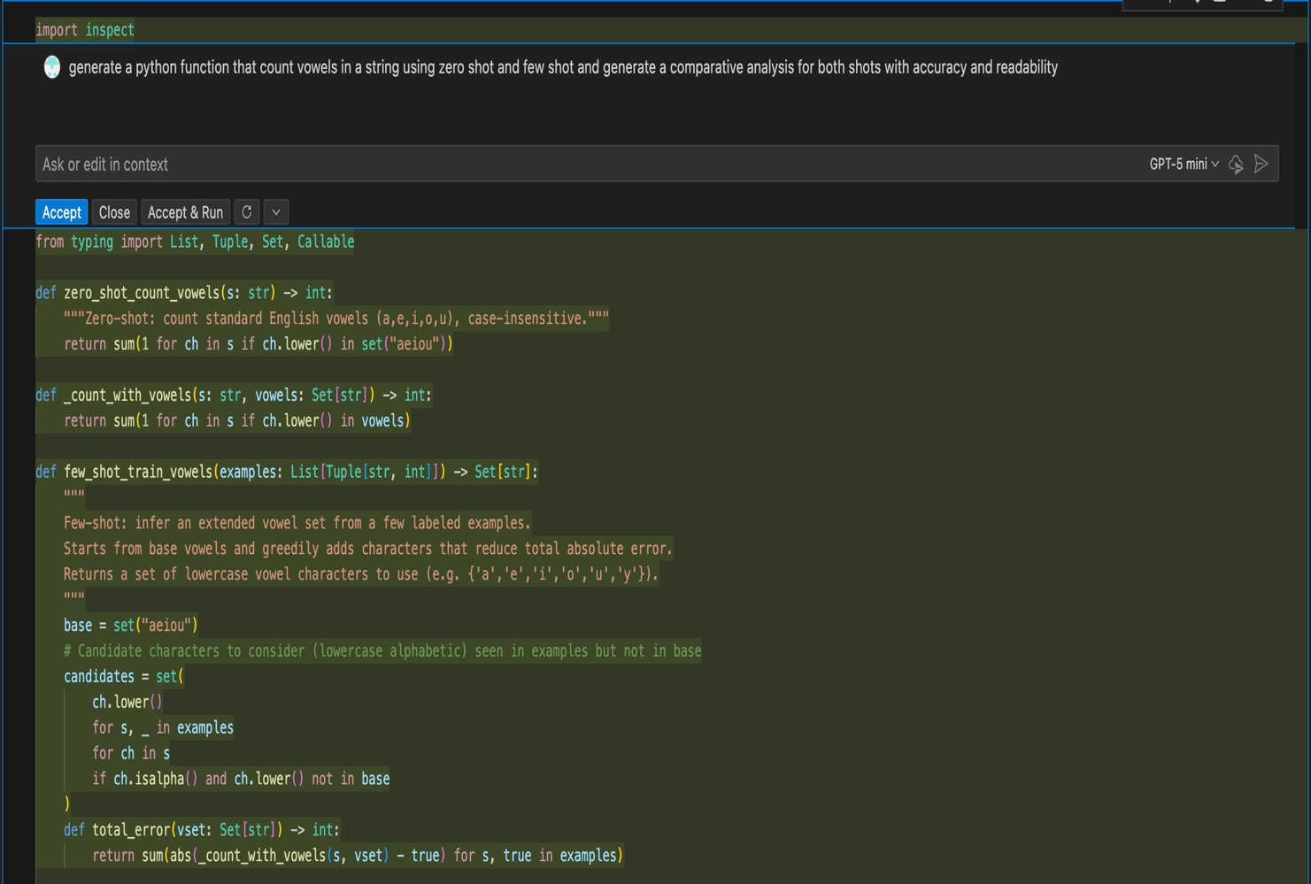

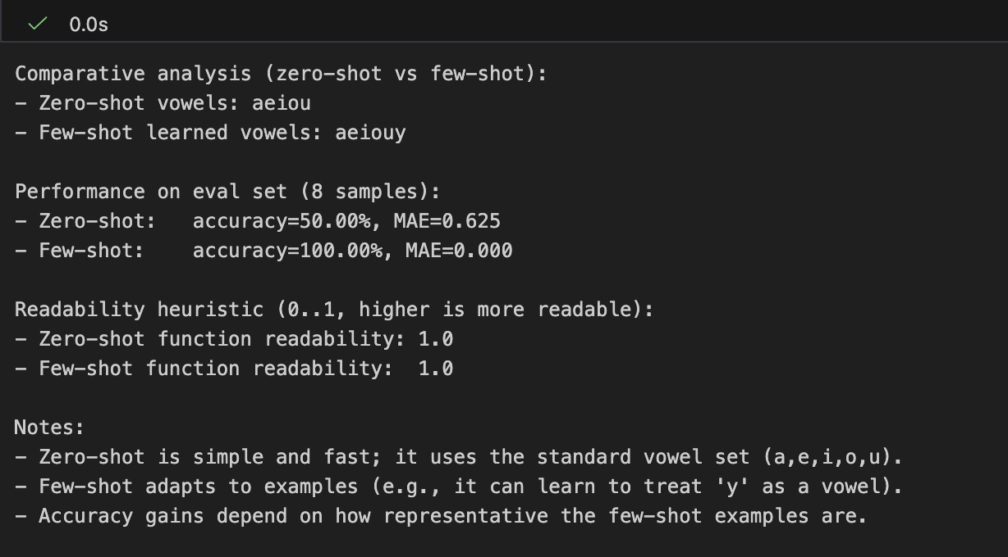

Task 5: Few-Shot Prompting – File Handling Prompt :
Write a Python function that reads a text file and counts the number of words.
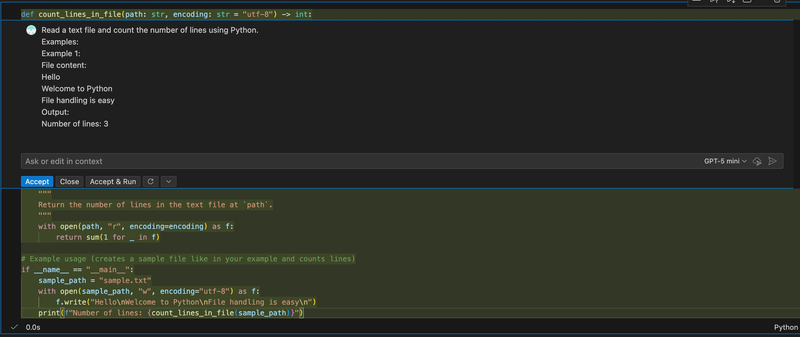

Output:
