AI Assisted Coding
Lab Assignment 3.5
Name : V Sai Krishnachaithanya Date : 23/01/2026
Hall Ticket no : 2303A52154

Task -1:
Prompt: generate a python function to find whether the given year is a leap year or not.
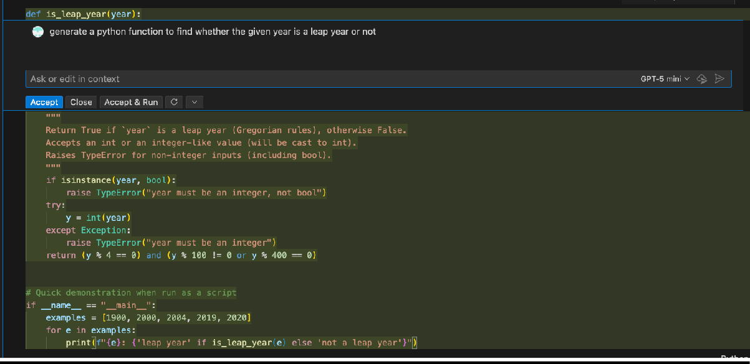
Output :

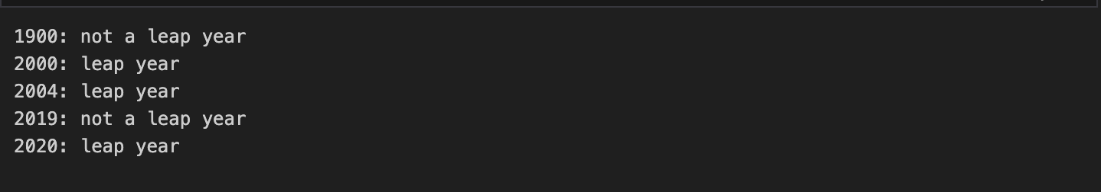

Task 2:
Prompt: generate a python code with one example to find the GCD of two numbers.

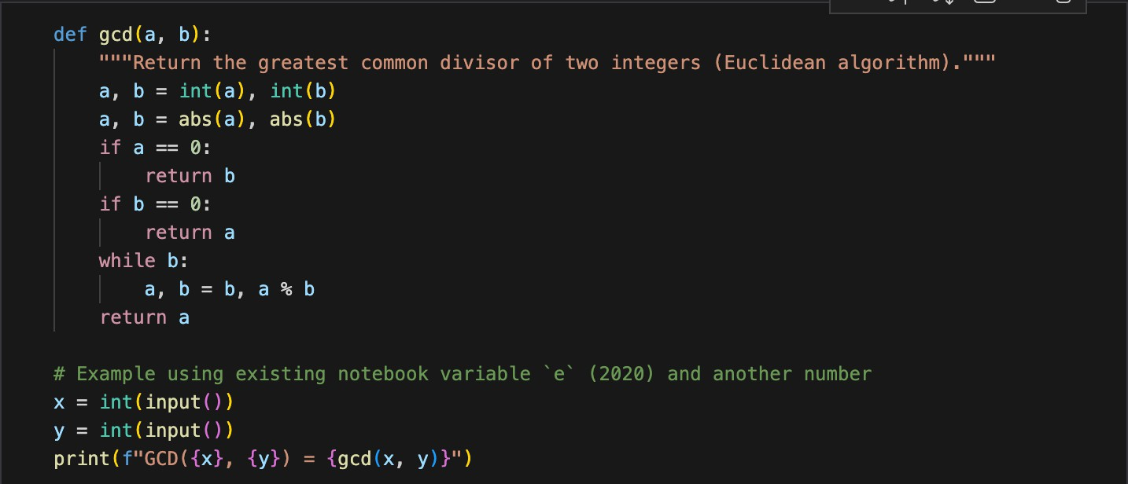
Output:
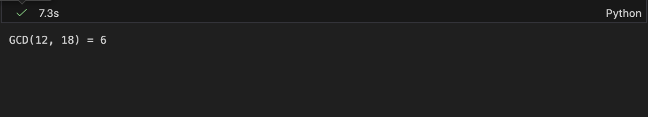

Task 3:
Prompt : generate a python code for multiple examples to find LCM Calculations.
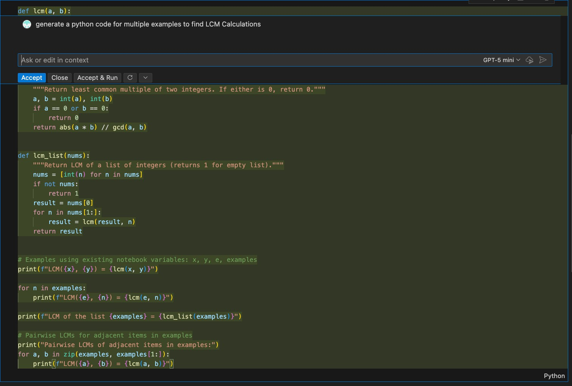

Output :

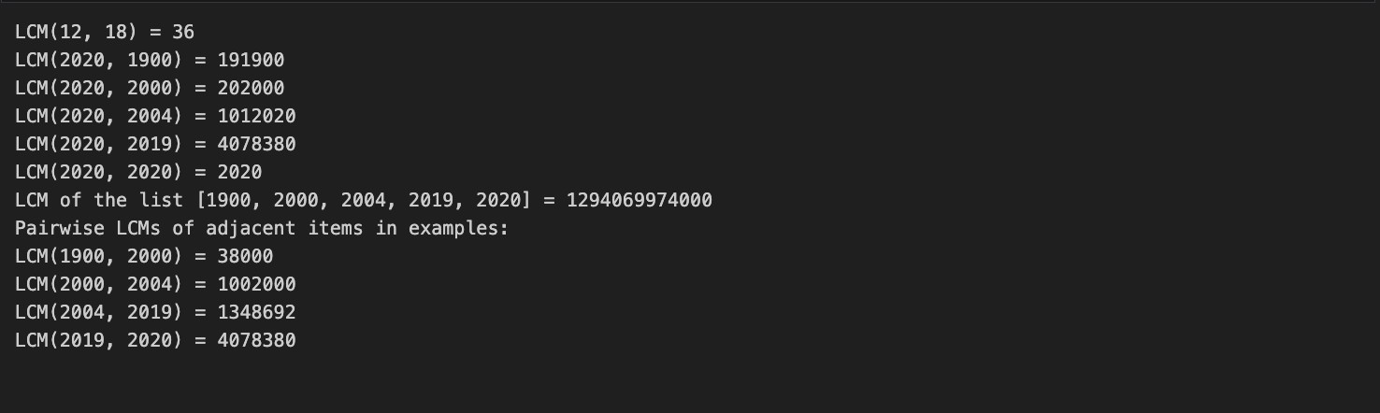

Task 4 :
Prompt : Generate a python code that checks the binary inputs and convert the binary number to decimal. if the given input is binary it should return invalid binary format.
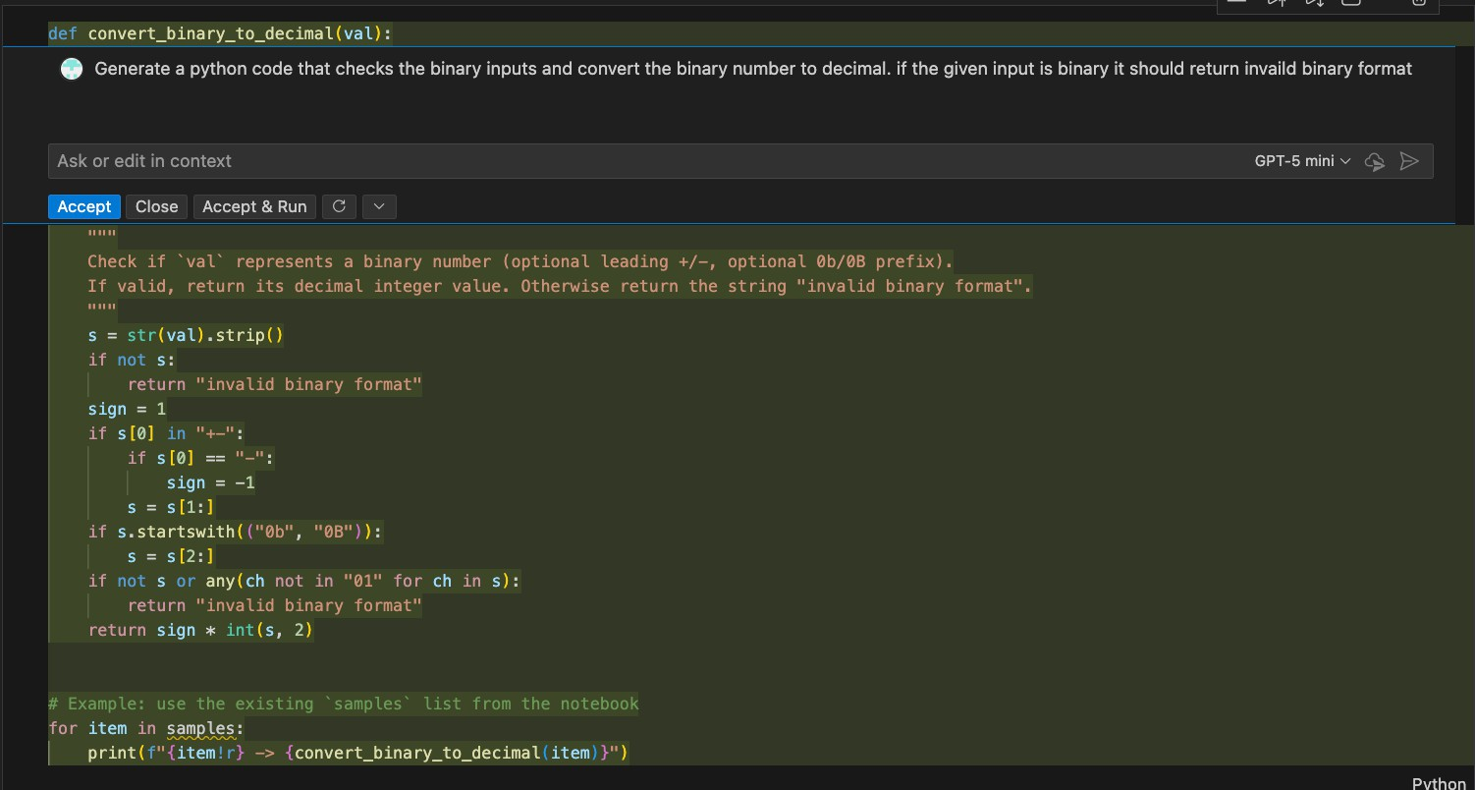

Output :

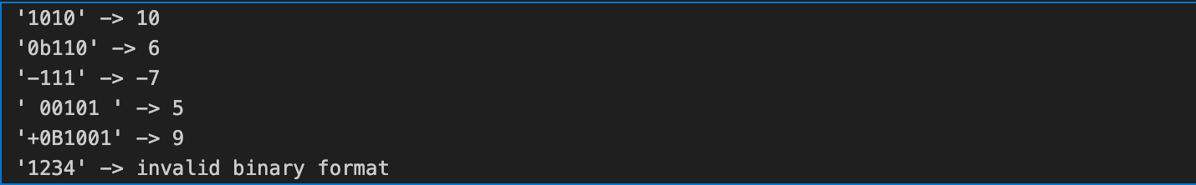

Task 5 :
Prompt : generate Python function with examples that converts decimal number to binary.

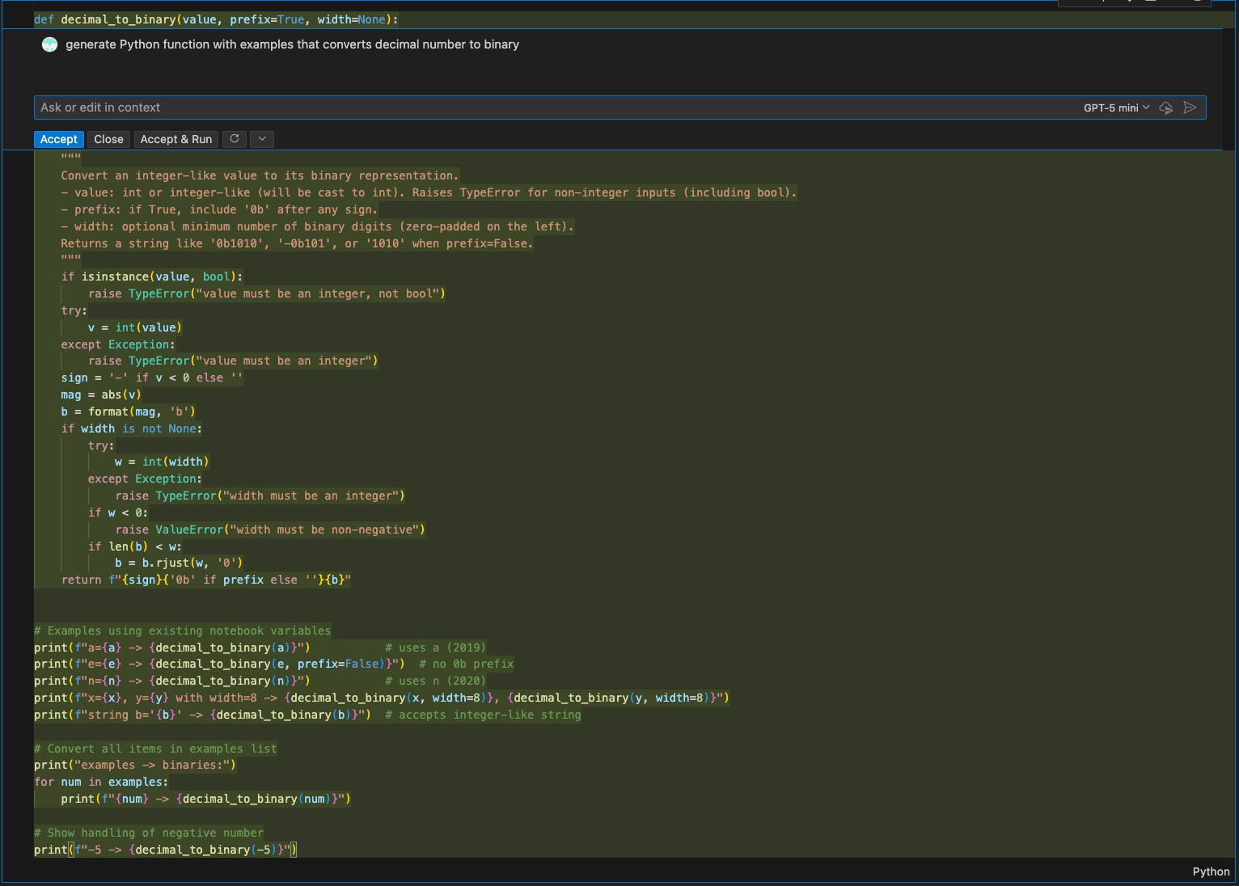

Output:
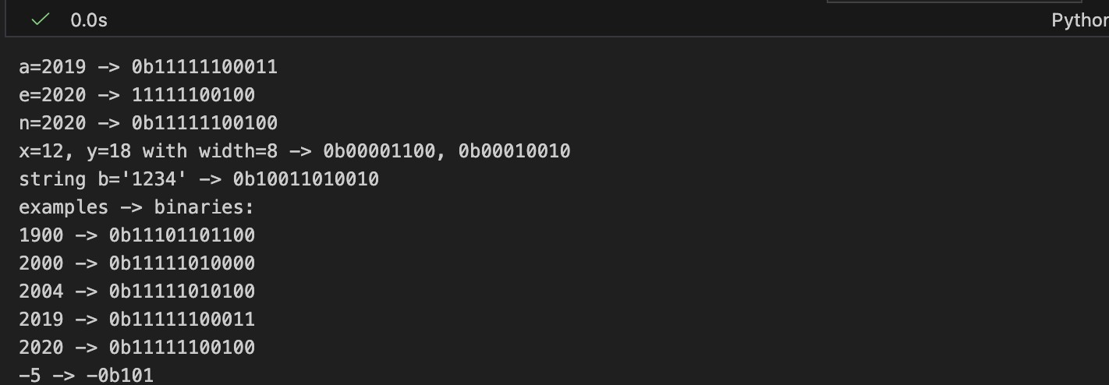

Task 6 :
Prompt : generate a python function that checks whether the given number is a Harshad number ,and print the number as Harshad number or not.

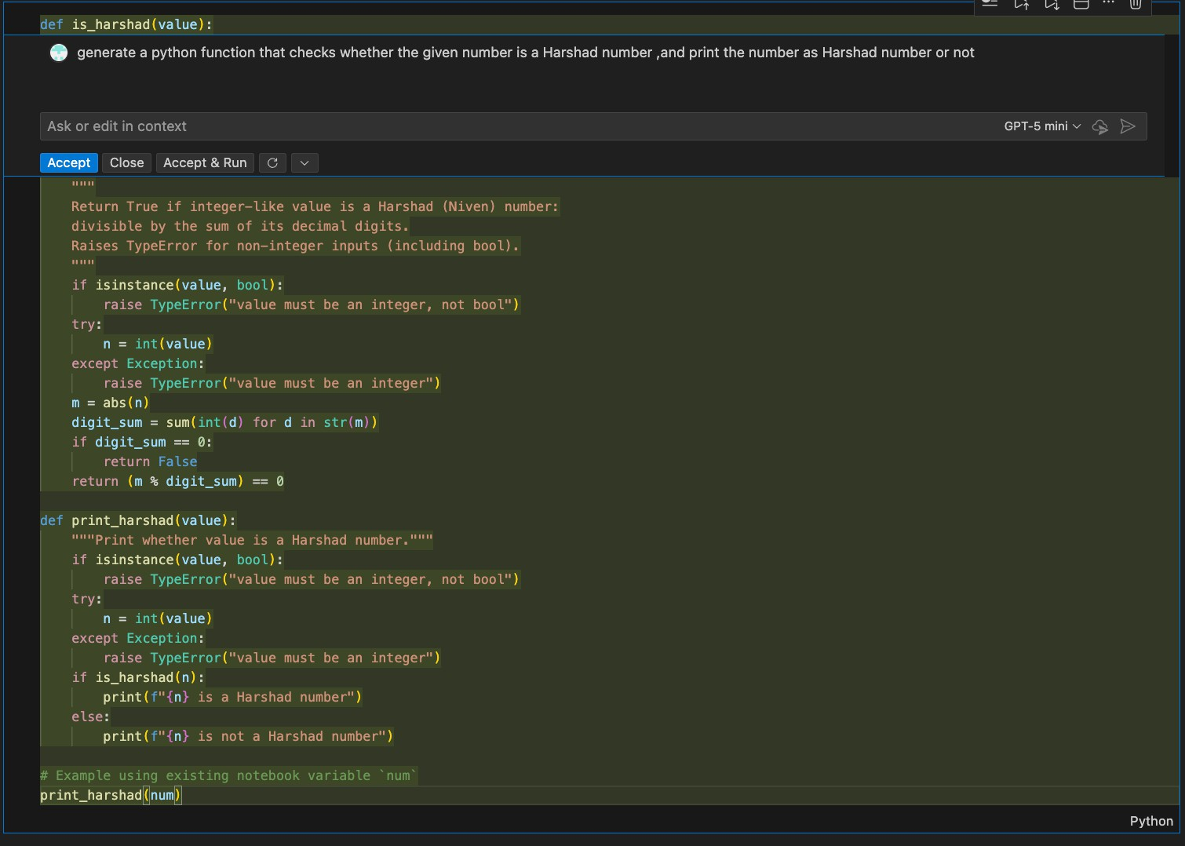

Output :
