AI Assisted Coding
Lab Assignment 4.5
Name : V Sai Krishnachaithanya Date : 23/01/2026
Hall Ticket no : 2303A52154

Task -1:
Prompt: generate a python program for classifying customer emails into billing, technical support, feedback, and others. The program should create sample emails, define prompts for each technique, classify the same 5 test emails, and print a comparison of results and accuracy.

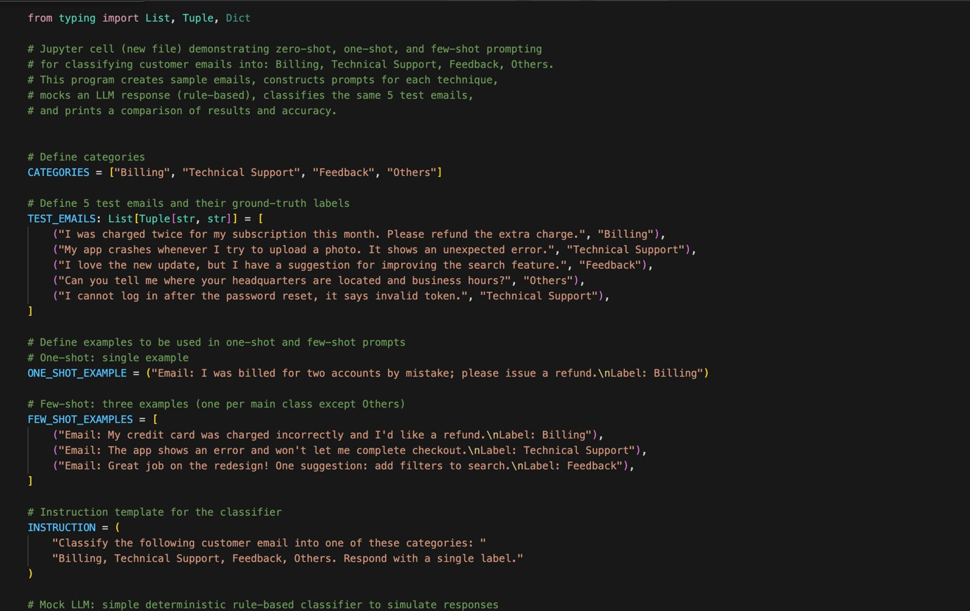
Output :
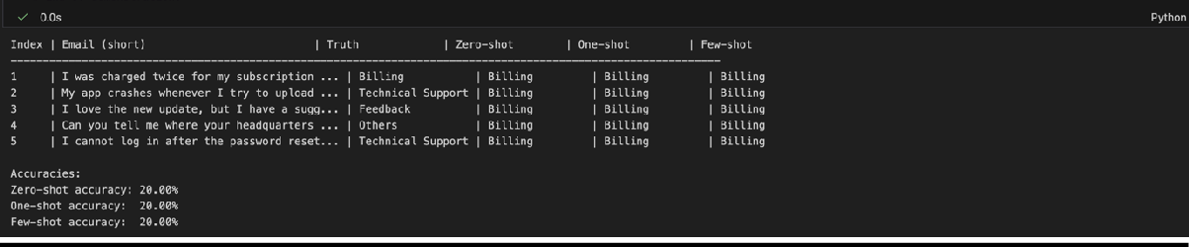

Task 2:
Prompt: generate a python program that classify travel queries into flight booking, hotel booking, cancellation, and general travel information. The program should create labeled travel queries, apply all three prompting techniques .

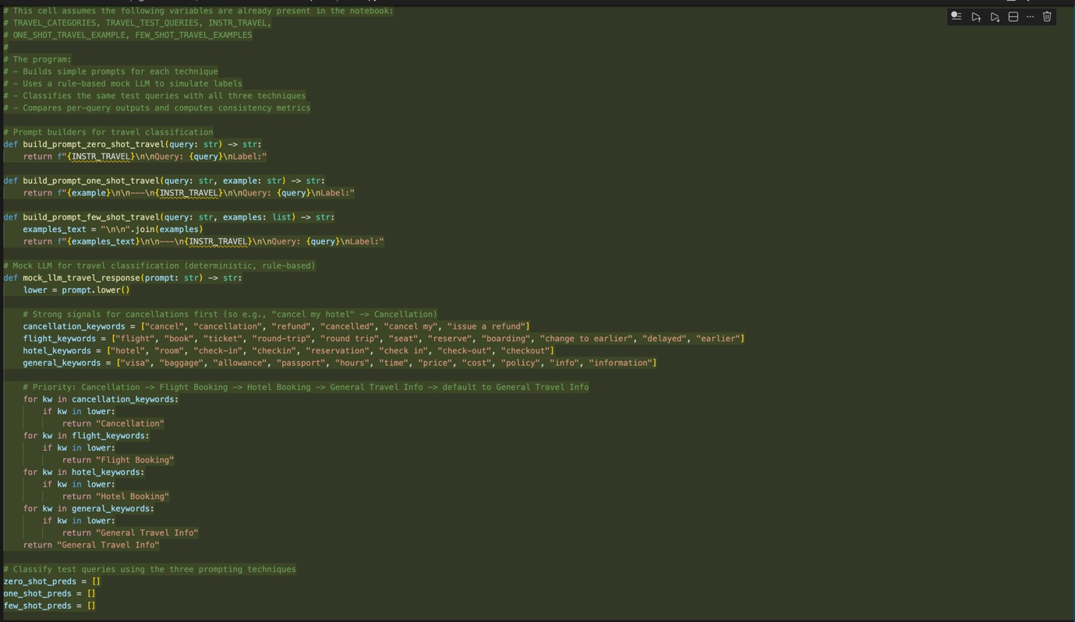
Output:

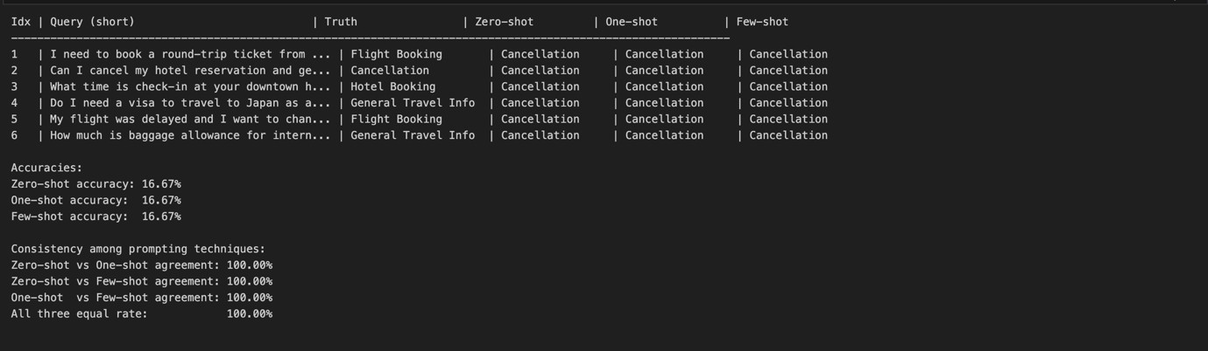

Task 3:
Prompt : generate a python code to help chatbot must classify queries into syntax error, logic error, optimisation . The program should also include coding- related user queries,Perform zero-shot , one-shot , few-shot classification and Analyse improvements in technical accuracy.

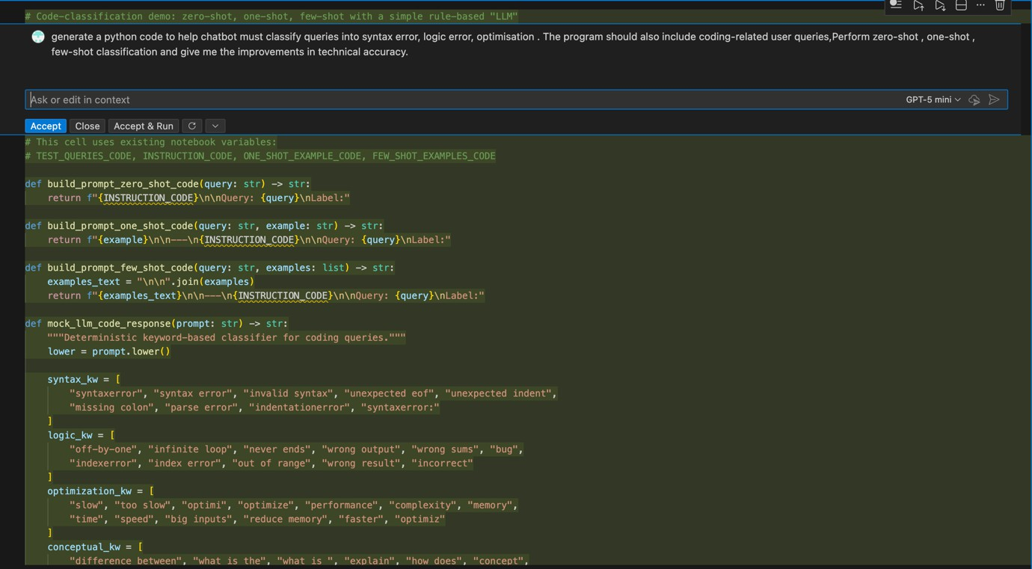
Output :

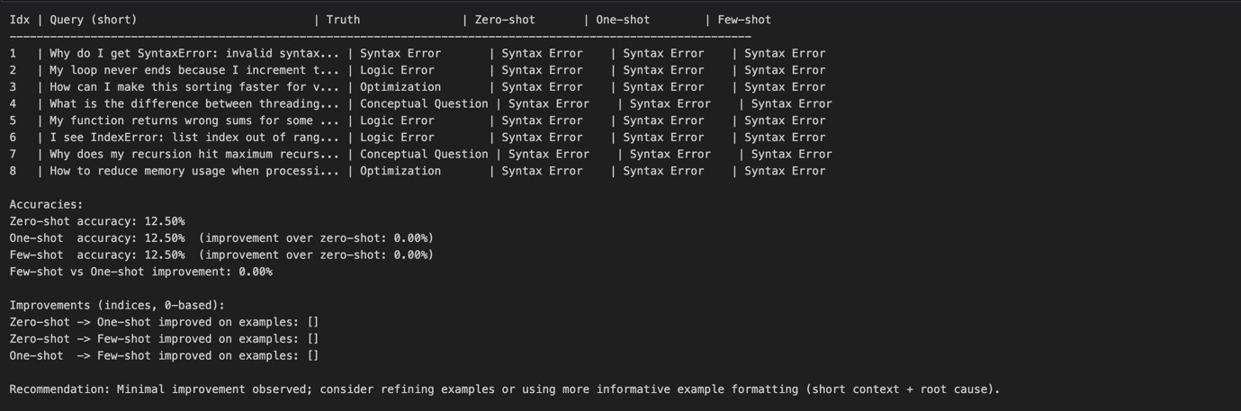

Task 4 :
Prompt : generate a python program to classify social media posts into Promotion, Complaint, Appreciation, or Inquiry using zero-shot, one-shot, and few-shot prompting, and compare informal language handling.

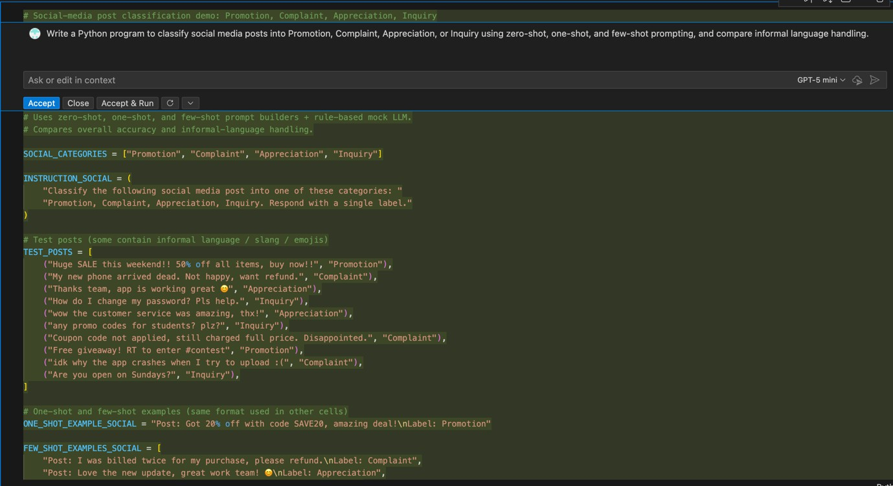

Output :
