AI Assisted Coding
Lab Assignment 6.3
Name : V Sai Krishnachaithanya Date : 04/02/2026
Hall Ticket no : 2303A52154
Task 1: Classes (Student Class)
Scenario
You are developing a simple student information management module.Task
• Use an AI tool (GitHub Copilot / Cursor AI / Gemini) to complete a Student class.
• The class should include attributes such as name, roll number, and branch.
• Add a method display_details() to print student information.
• Execute the code and verify the output.
• Analyze the code generated by the AI tool for correctness and clarity.
Expected Output #1
• A Python class with a constructor (__init__) and a display_details() method.
• Sample object creation and output displayed on the console.
• Brief analysis of AI-generated code.
Prompt :
assume you are a developer working on creating a student information module.create a student class with attributes name:String ,rollNumber: unique integer ,branch : string create a method to display_details to print student information in a proper manner so i want the expected outputA py class with a __init__ and display_details method and aslo a sample obj creation and output displayed on console

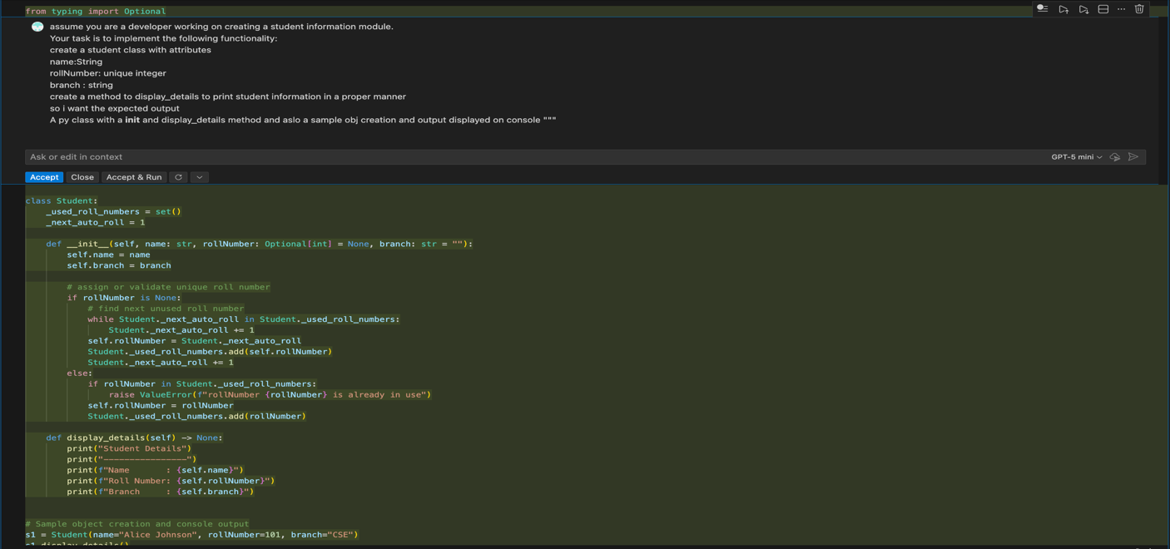

Output :
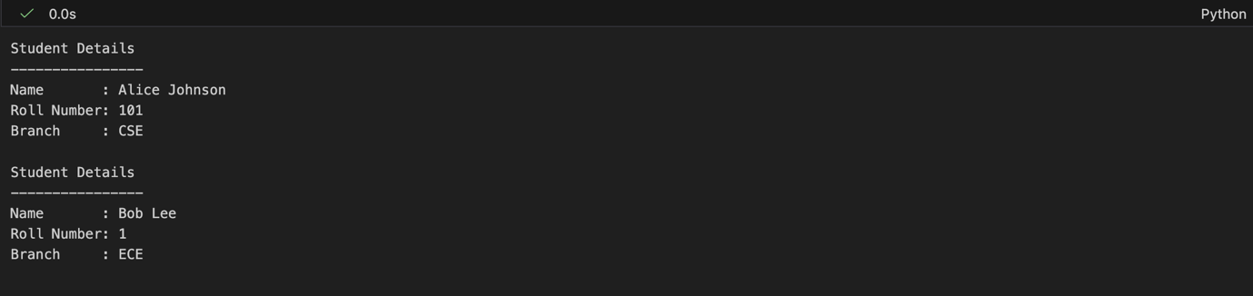
Justification:
The AI-generated code correctly implements a Student class with automatic roll number assignment and validation.It uses a class variable `_used_roll_numbers` to keep track of all assigned roll numbers and ensures uniqueness.The `_next_auto_roll` variable is used to generate the next available roll number.
The `display_details` method prints all student information in a formatted way.
The example usage demonstrates both manual assignment and automatic assignment of roll numbers.

Task 2: Loops (Multiples of a Number)
Scenario
You are writing a utility function to display multiples of a given number.
Task
• Prompt the AI tool to generate a function that prints the first 10 multiples of a given number
using a loop.
• Analyze the generated loop logic.
• Ask the AI to generate the same functionality using another controlled looping structure (e.g.,
while instead of for).
Expected Output #2
• Correct loop-based Python implementation.
• Output showing the first 10 multiples of a number.
• Comparison and analysis of different looping approaches
Prompt :
generate a python function to print the first 10 multiples of a given number using while loop and for loop
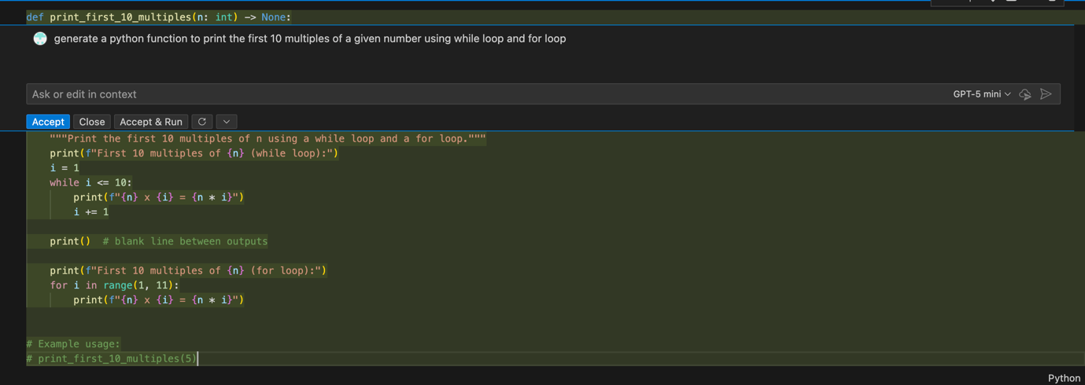
Output :
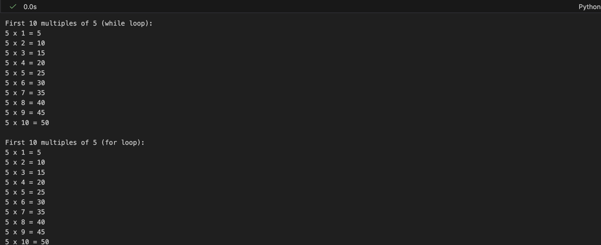
Justification:
The while loop is used to demonstrate a simple counting mechanism, incrementing a counter until it reaches 10. The for loop is used to iterate over a fixed range of numbers (1 to 10) directly, which is more concise and readable for this specific task.
Task 3: Conditional Statements (Age Classification)
Scenario
You are building a basic classification system based on age.
Task
• Ask the AI tool to generate nested if-elif-else conditional statements to classify age groups(e.g., child, teenager, adult, senior).
• Analyze the generated conditions and logic.
• Ask the AI to generate the same classification using alternative conditional structures (e.g.,
simplified conditions or dictionary-based logic).
Expected Output #3
• A Python function that classifies age into appropriate groups.
• Clear and correct conditional logic.
• Explanation of how the conditions work
Prompt :
Generate a python code to classification system based on age (child, teenager, adult, senior) using nested if-elif-else conditional statements
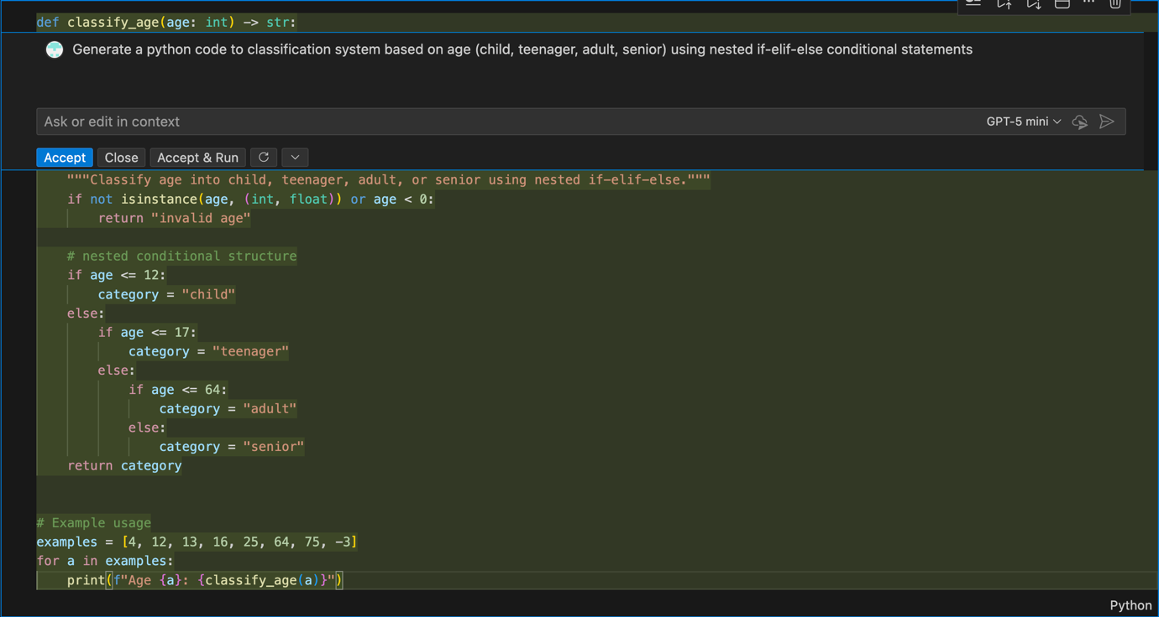
Output :
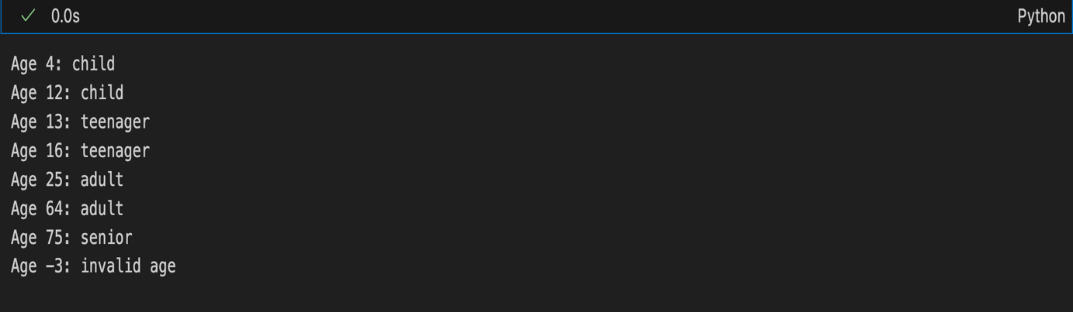
Justification:
The nested if-elif-else structure evaluates age in a hierarchical manner:
1. If age is less than or equal to 12, it is classified as "child".
2. If age is greater than 12 but less than or equal to 17, it is classified as "teenager".
3. If age is greater than 17 but less than or equal to 64, it is classified as "adult".
4. If age is greater than 64, it is classified as "senior".
This structure ensures that only one category is assigned based on the age value.

Task 4: For and While Loops (Sum of First n Numbers)
Scenario
You need to calculate the sum of the first n natural numbers.
Task
• Use AI assistance to generate a sum_to_n() function using a for loop.
• Analyze the generated code.
• Ask the AI to suggest an alternative implementation using a while loop or a mathematical formula.
Expected Output #4
• Python function to compute the sum of first n numbers.
• Correct output for sample inputs.
• Explanation and comparison of different approaches.
Prompt :
Generate a python function to print the sum of first n natural numbers using for and while loops
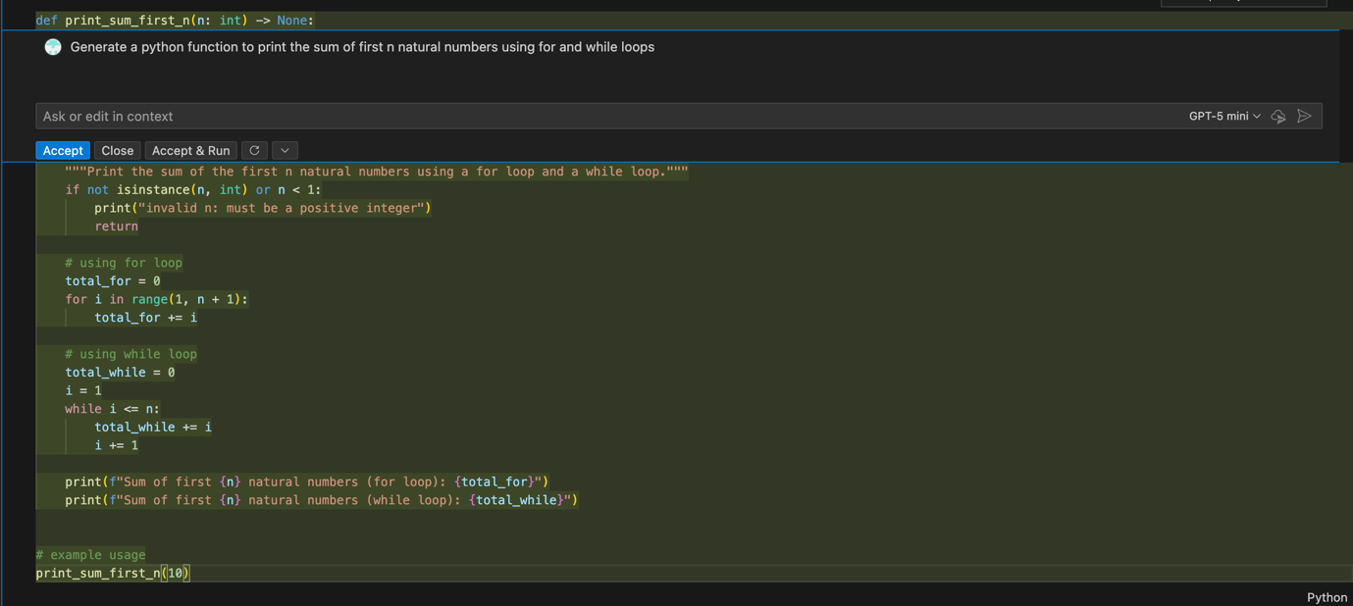
Output :
Justification:
The for loop approach is more concise and easier to read when the number of iterations is known in advance . The while loop approach provides more flexibility for scenarios where the number of iterations may not be predetermined. In this specific case, both approaches yield the same result, but the for loop is generally preferred for its clarity.
Task 5: Classes (Bank Account Class)
Scenario
You are designing a basic banking application.
Task
• Use AI tools to generate a Bank Account class with methods such as deposit(), withdraw(), and check_balance().
• Analyze the AI-generated class structure and logic.
• Add meaningful comments and explain the working of the code.
Expected Output #5
• Complete Python Bank Account class.
• Demonstration of deposit and withdrawal operations with updated balance.
• Well-commented code with a clear explanation.
Prompt :
Generate a python classes for banking application with methods such as deposit(), withdraw(),and check_balance()

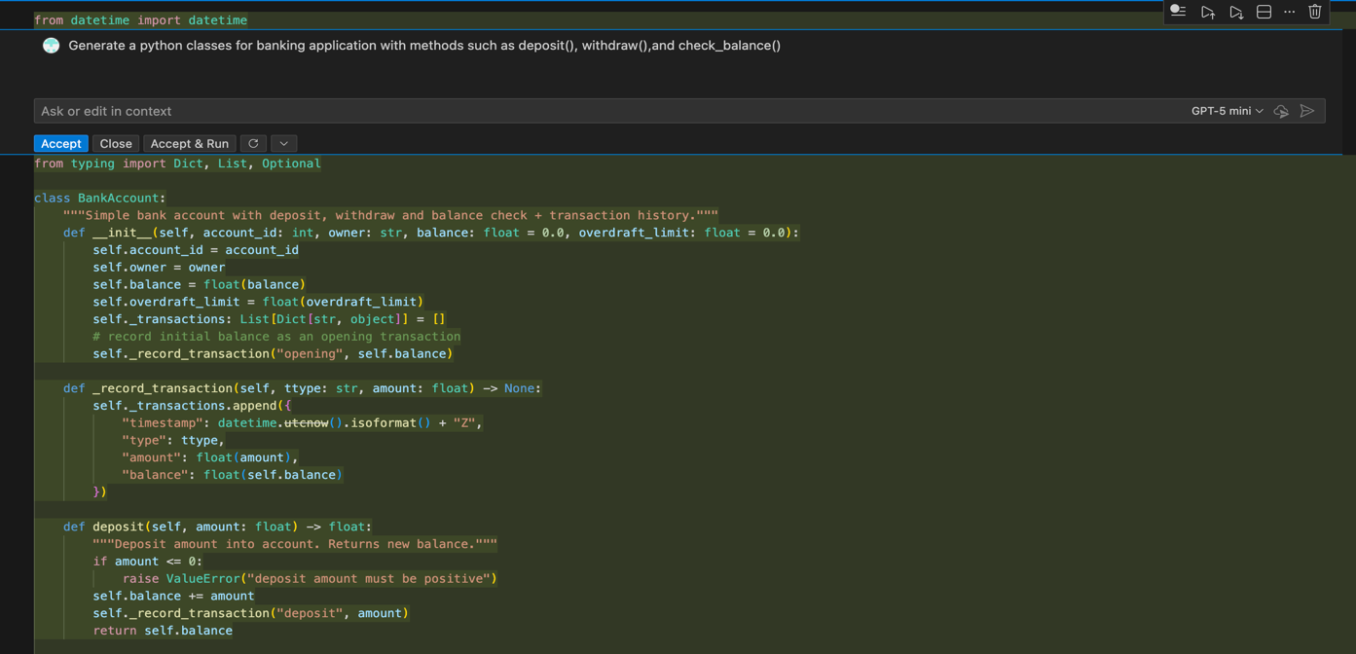
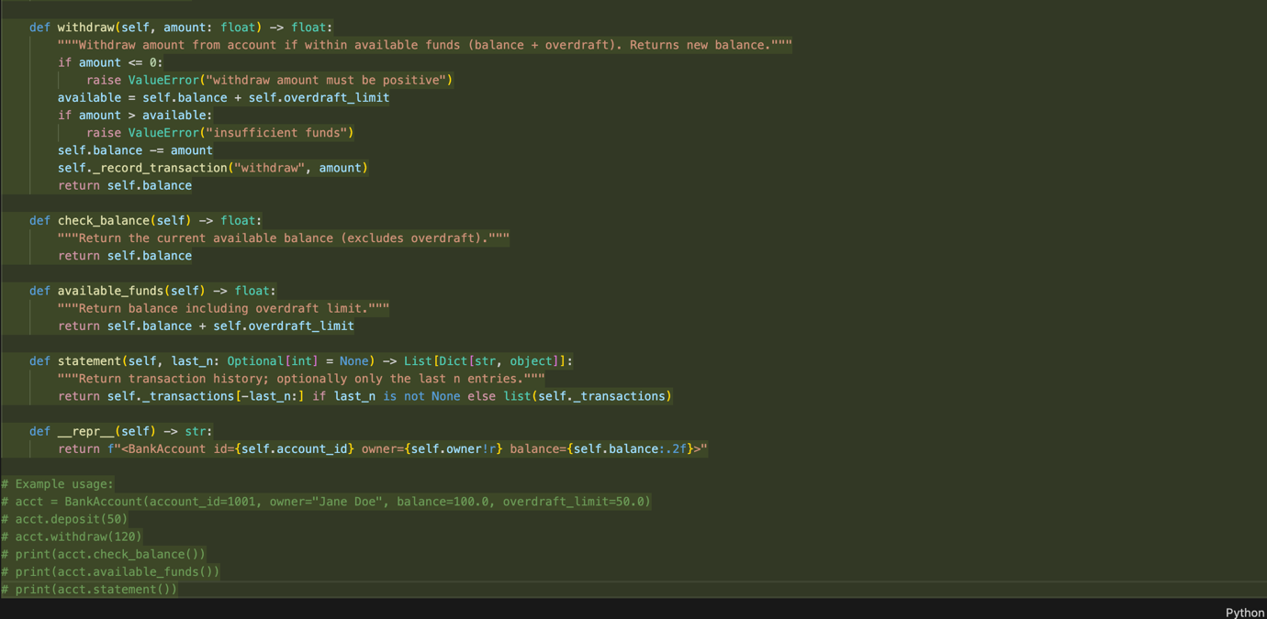

Output:
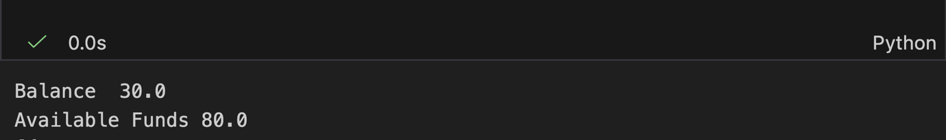
Justification:
The Bank Account class models a simple bank account with methods to deposit and withdraw funds, check the balance, and view transaction history. It includes an overdraft limit feature, allowing withdrawals beyond the current balance up to a specified limit. Each transaction is recorded with a timestamp, type, amount, and resulting balance. The class also provides a string representation for easy debugging and logging.

