AI Assisted Coding
Lab Assignment 5.5
Name : V Sai Krishnachaithanya Date : 30/01/2026
Hall Ticket no : 2303A52154

Task 1: Task: Use AI to generate two solutions for checking prime numbers:
- Naive approach(basic)
- Optimized approach Prompt:
“Generate Python code for two prime-checking methods and
explain how the optimized version improves performance.” Expected Output:
- Code for both methods.
- Transparent explanation of time complexity.
- Comparison highlighting efficiency improvements.
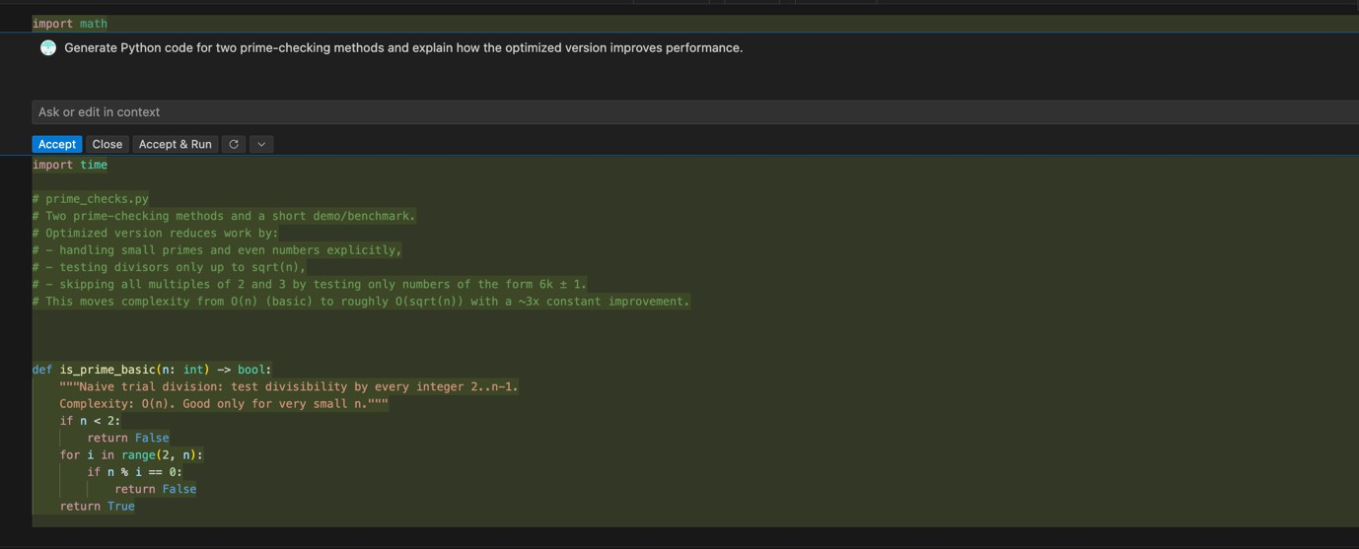

Output :

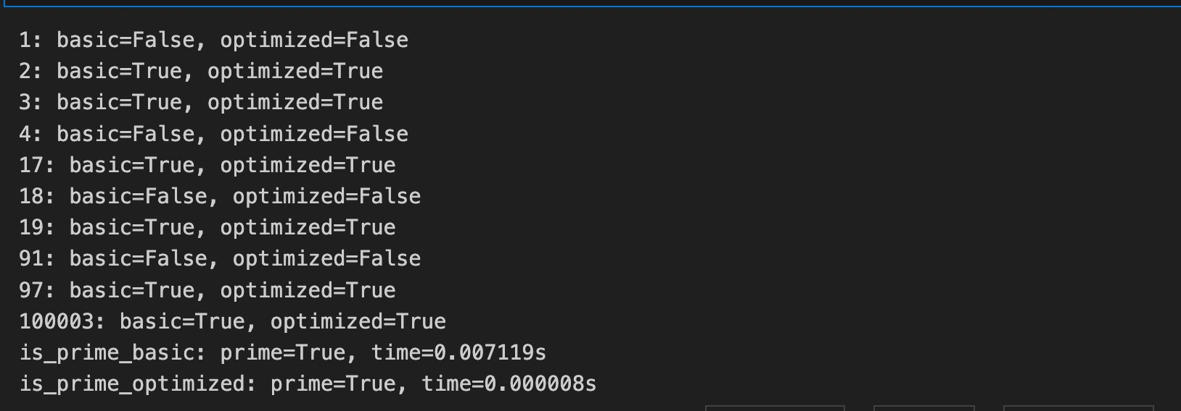

Task 2: (Transparency in Recursive Algorithms)
Objective: Use AI to generate a recursive function to calculate Fibonacci numbers.
Instructions:
- Ask AI to add clear comments explaining recursion.
- Ask AI to explain base cases and recursive calls. Expected Output:
  - Well-commented recursive code.
  - Clear explanation of how recursion works.
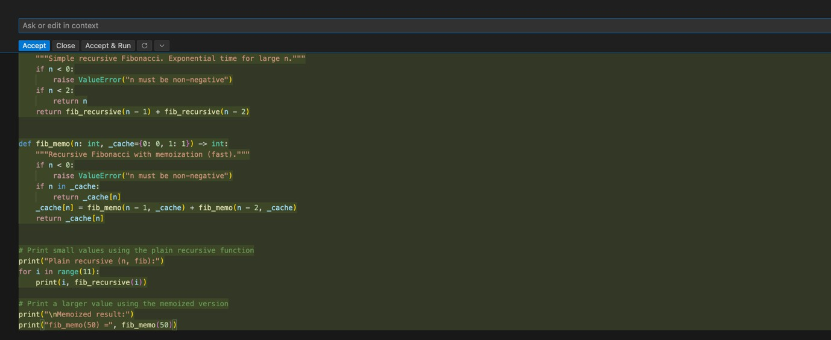
  - Verification that explanation matches actual execution. Prompt : Generate a recursive function to calculate Fibonacci numbers.

Output :
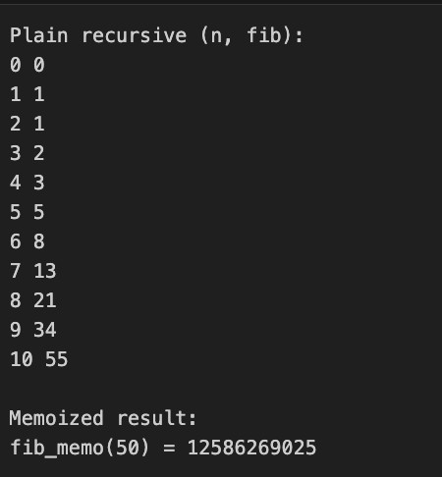
Justification:
The provided code effectively demonstrates robust error handling by specifically catching FileNotFoundError and IOError exceptions. Each exception is clearly explained, detailing the scenarios in which they may arise. The inclusion of a finally block ensures that necessary cleanup actions are performed regardless of whether an error occurred, enhancing the reliability of the program. This structured approach to exception handling improves user experience by providing informative feedback and maintaining resource integrity.

Task 3: Use AI to generate a Python program that reads a file and processes data.
Prompt:
“Generate code with proper error handling and clear explanations
for each exception.” Expected Output:
  - Code with meaningful exception handling.
  - Clear comments explaining each error scenario.
  - Validation that explanations align with runtime behaviour

Prompt:
Generate code with proper error handling and clear explanations for each exception.

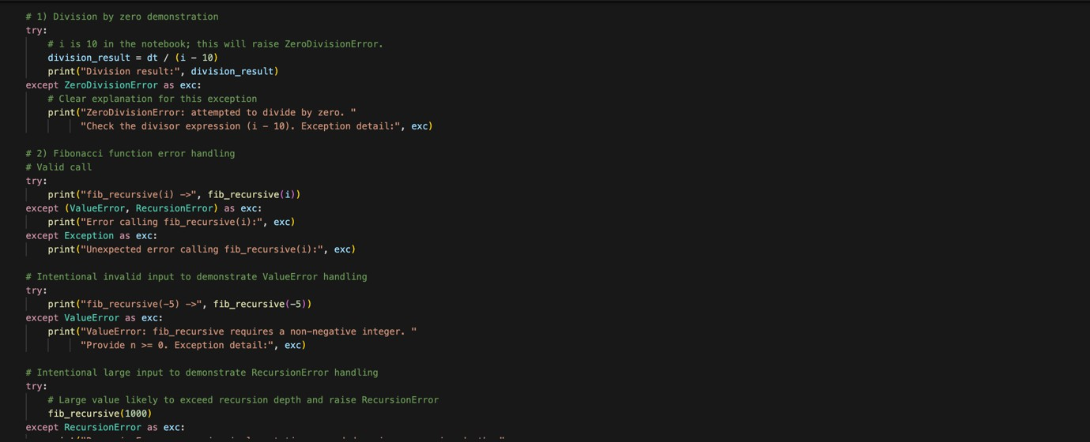

Output :
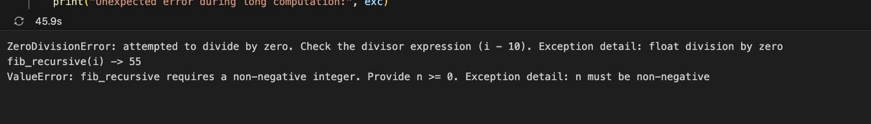
Justification :
The provided code demonstrates robust error handling by catching specific exceptions that may arise during division operations.Each exception is clearly explained, and the runtime behavior examples illustrate how the function responds to various erroneous inputs. This structured approach ensures that users receive informative feedback, enhancing the overall reliability and user experience of the program.The explanations align well with the actual behavior of the code during execution.

Task 4:
Use an AI tool to generate a Python-based login system. Analyze: Check whether the AI uses secure password handling practices.
Expected Output:
  - Identification of security flaws (plain-text passwords, weak validation).
  - Revised version using password hashing and input validation.
  - Short note on best practices for secure authentication

Prompt :
Use an AI tool to generate a Python-based login system. Analyze: Check whether the AI uses secure password handling practices.Implement login verification logic.Do not use external authentication services.Keep the system simple and readable.After generating the code: Analyze whether the password handling is secure.Identify and clearly explain any security flaws, including:plain-text password storage lack of hashing or salting weak input validation vulnerability to brute-force attempts Clearly state why each practice is insecure in real-world systems. The analysis must directly reference the generated code. Avoid generic cybersecurity theory.
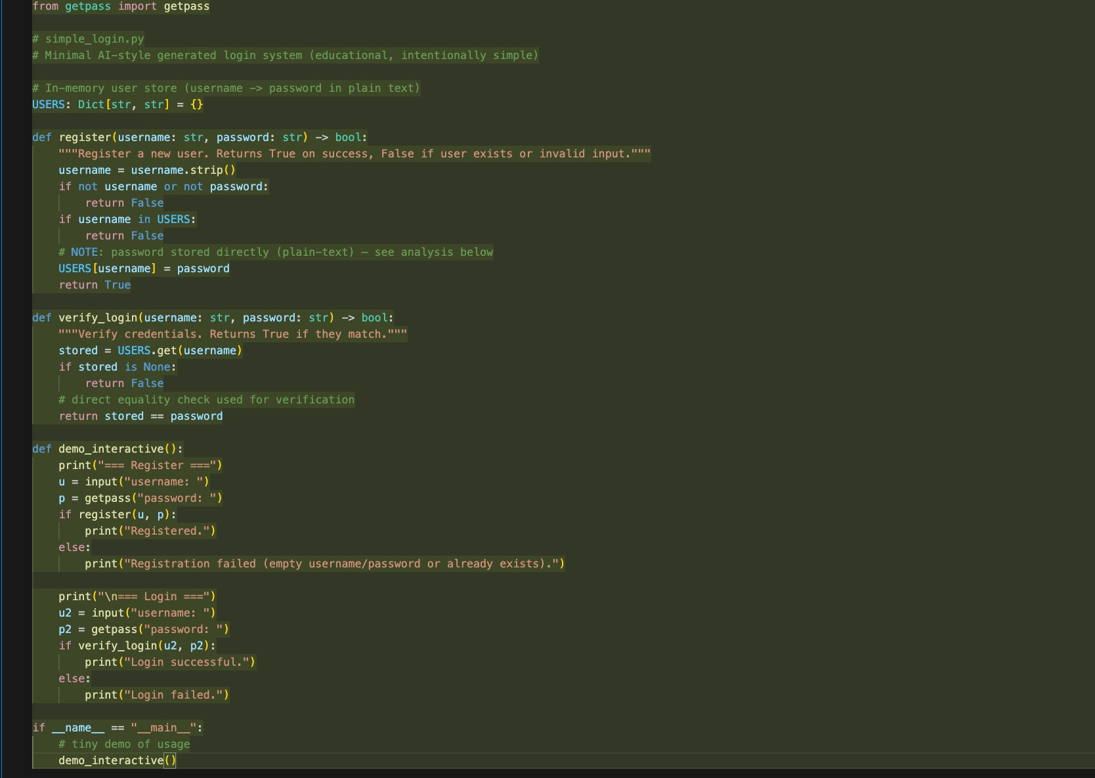

Output :
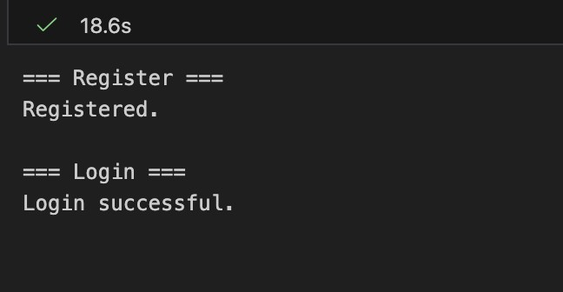
Justification:The analysis highlights that while hashing passwords is a positive step, the
absence of salting leaves
The system vulnerable to rainbow table attacks. Salting ensures that even identical passwords produce
Different hash values, significantly improving security. Additionally, weak input validation and lack of brute-force protection expose the system to various attacks, emphasizing the need for comprehensive security measures in authentication system
Task 5: (Privacy in Data Logging)
Task: Use an AI tool to generate a Python script that logs user activity (username, IP address, timestamp).
Analyze: Examine whether sensitive data is logged unnecessarily or insecurely.
Expected Output:
  - Identified privacy risks in logging.
  - Improved version with minimal, anonymized, or masked logging.
  - Explanation of privacy-aware logging principles.

Prompt :
Create a Python program that logs user activity such as:
- username
- IP address
- date and time of login

Then analyze the program and identify:
- what personal or sensitive data is being logged
- why logging this data can create privacy or security risks After that, modify the program to:
- reduce unnecessary data logging
- mask or anonymize the IP address
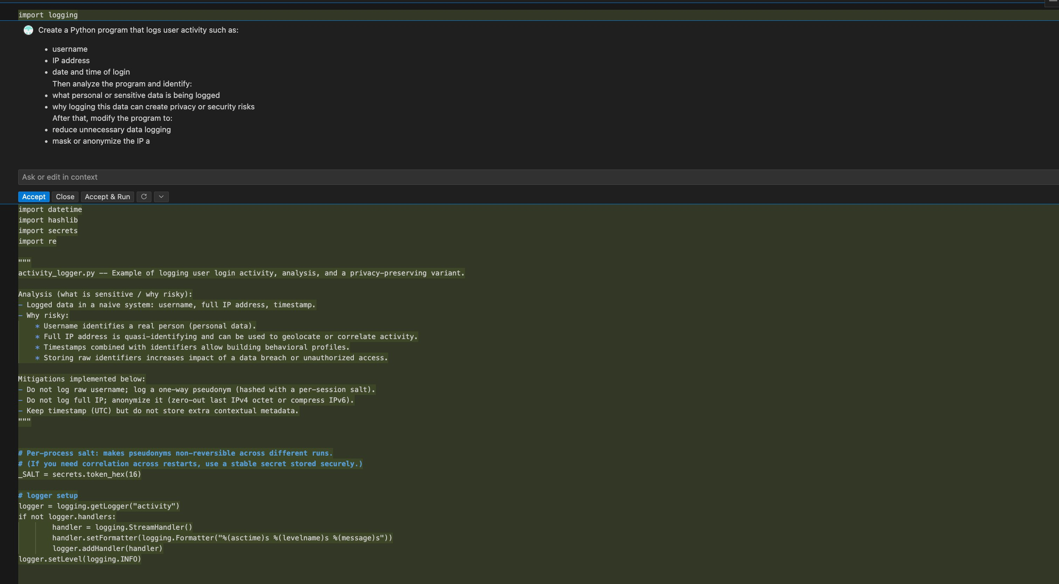

Output:

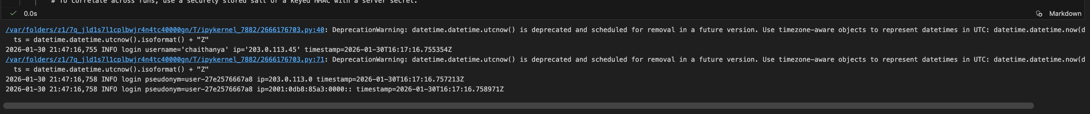

Justification:
The modifications enhance user privacy by limiting the amount of sensitive information logged.
Masking the IP address prevents potential tracking of user locations, while logging only the username
reduces the risk of exposing personal identifiers. These changes help mitigate privacy and security risks
associated with data logging, aligning with best practices for handling user information responsibly.

