AI Assisted Coding
Lab Assignment 8.5
Name : V Sai Krishnachaithanya
Hall Ticket no : 2303A52154

Task Description #1 (Username Validator – Apply AI in
Authentication Context)
• Task: Use AI to generate at least 3 assert test cases for a
function is_valid_username(username) and then implement
the function using Test-Driven Development principles.
• Requirements:
o Username length must be between 5 and 15 characters.
o Must contain only alphabets and digits.
o Must not start with a digit.
o No spaces allowed.
Example Assert Test Cases:
assert is_valid_username("User123") == True
assert is_valid_username("12User") == False
assert is_valid_username("Us er") == False
Expected Output #1:
• Username validation logic successfully passing all AI-
generated test cases.

Prompt :
generate the python code for Username Validator where username length must be between 5 to 15 characters, no special characters are allowed,dont start with digit and no spaces are allowed.assign some assert test cases and output should be true for valid usernames and false for invalid usernames.and print all test caes are passed

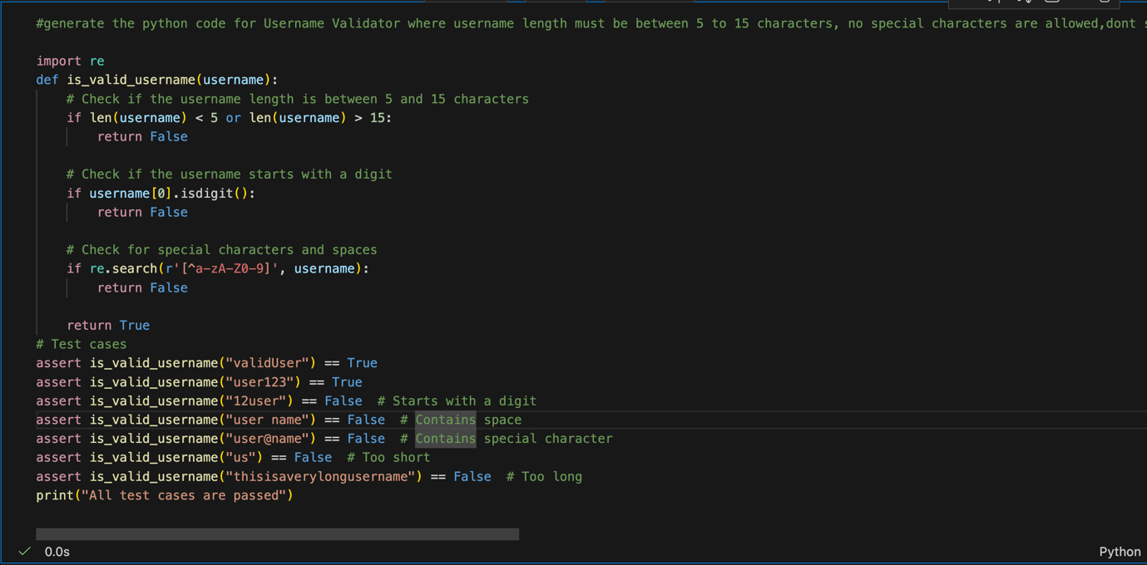

Output:
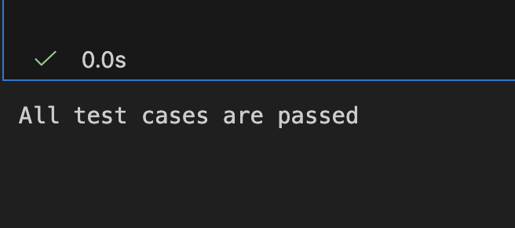

Task Description #2 (Even–Odd & Type Classification – Apply AI for Robust Input Handling)
• Task: Use AI to generate at least 3 assert test cases for a
function classify_value(x) and implement it using conditional
logic and loops.
• Requirements:
If input is an integer, classify as "Even" or "Odd".
If input is 0, return "Zero".
If input is non-numeric, return "Invalid Input".
Example Assert Test Cases:
assert classify_value(8) == "Even"
assert classify_value(7) == "Odd"
assert classify_value("abc") == "Invalid Input"
Expected Output #2:
• Function correctly classifying values and passing all test
cases.

Prompt:
generate a python function classify_value that takes an input value and classifies it as "Even", "Odd", or "zero". The function should return the classification as a string as invaild input. Include assert test cases to verify the correctness of the function.
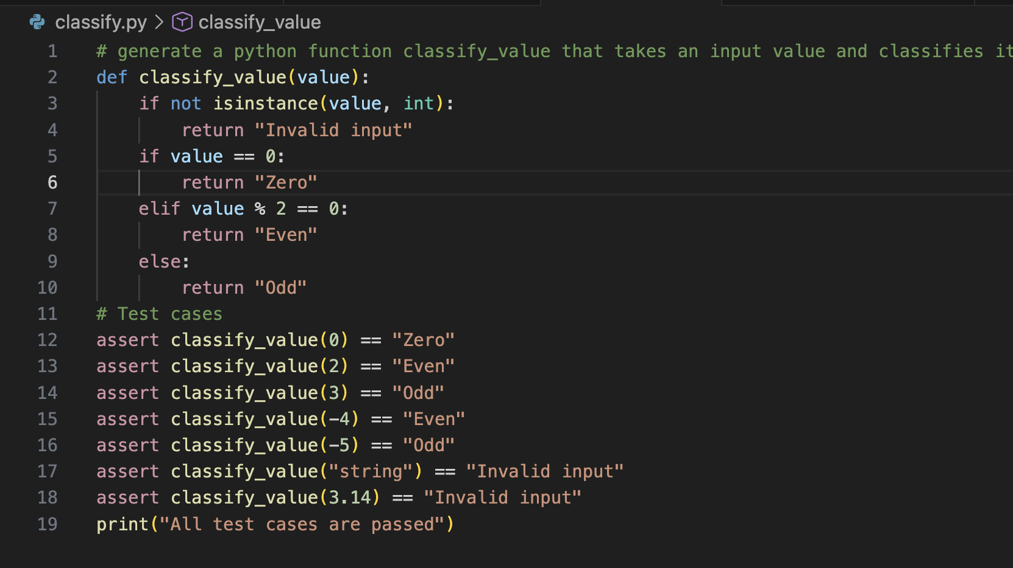

Output :
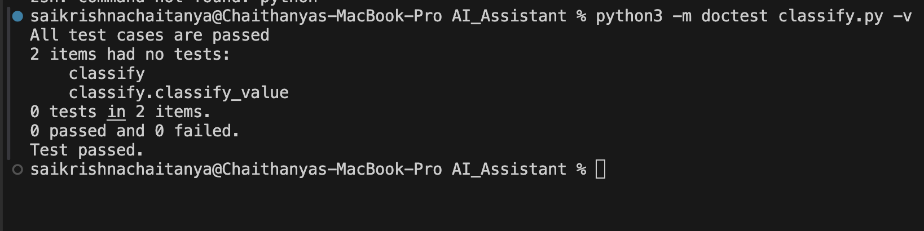

Task Description #3 (Palindrome Checker – Apply AI for
String Normalization)
• Task: Use AI to generate at least 3 assert test cases for a
function is_palindrome(text) and implement the function.
• Requirements:
Ignore case, spaces, and punctuation.
Handle edge cases such as empty strings and single
characters.
Example Assert Test Cases:
assert is_palindrome("Madam") == True
assert is_palindrome("A man a plan a canal Panama") ==
True
assert is_palindrome("Python") == False
Expected Output #3:
• Function correctly identifying palindromes and passing all
AI-generated tests.
Prompt:
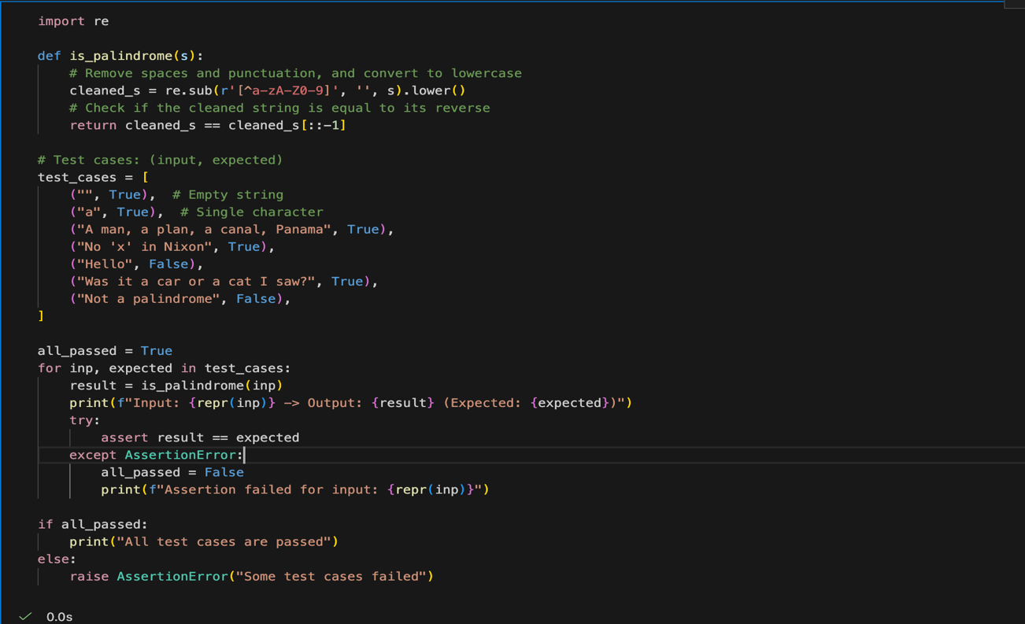
Output:
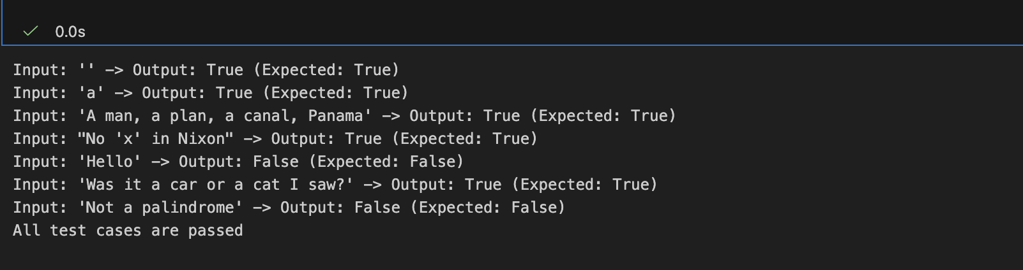

Task Description #4 (BankAccount Class – Apply AI for
Object-Oriented Test-Driven Development)
• Task: Ask AI to generate at least 3 assert-based test cases for
a BankAccount class and then implement the class.
• Methods:
deposit(amount)
withdraw(amount)
get_balance()
Example Assert Test Cases:
acc = BankAccount(1000)
acc.deposit(500)
assert acc.get_balance() == 1500
acc.withdraw(300)
assert acc.get_balance() == 1200
Expected Output #4:
• Fully functional class that passes all AI-generated assertions.

Prompt:
generate a python code for bank account class with methods to deposit, withdraw, and check balance. Include 3 assert test cases to verify the correctness of the class methods. and print the results of the test cases.

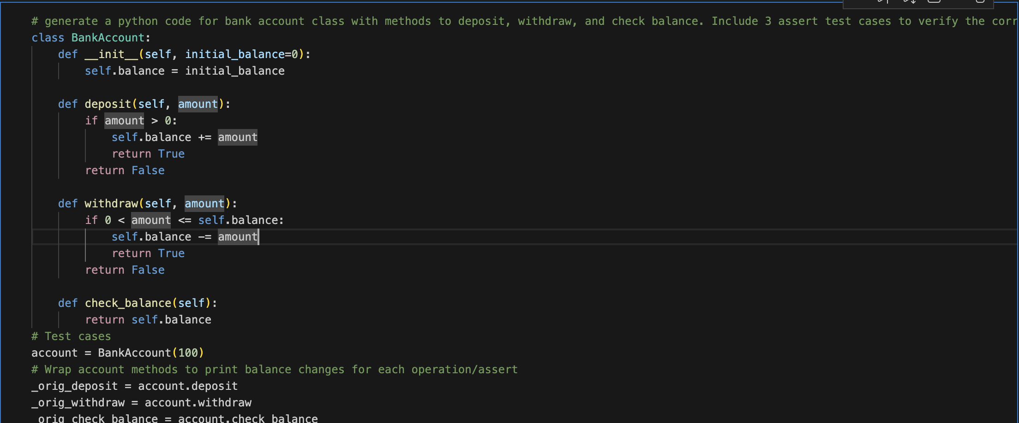
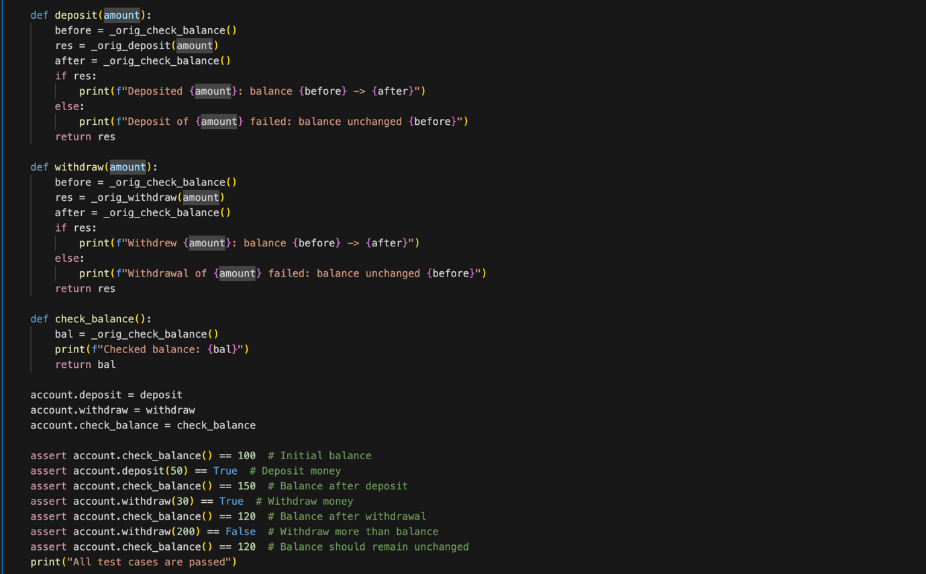
Output:
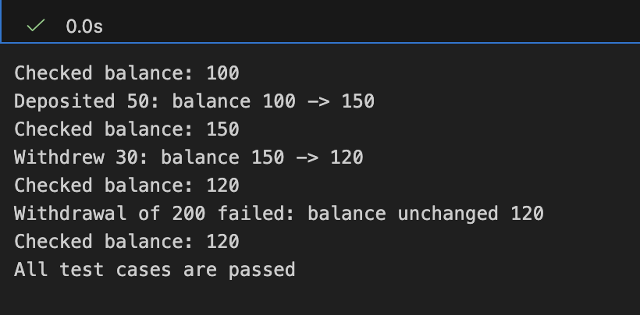

Task Description #5 (Email ID Validation – Apply AI for Data Validation)
• Task: Use AI to generate at least 3 assert test cases for a
function validate_email(email) and implement the function.
• Requirements:
Must contain @ and .
Must not start or end with special characters.
Should handle invalid formats gracefully.
Example Assert Test Cases:
assert validate_email("user@example.com") == True
assert validate_email("userexample.com") == False
assert validate_email("@gmail.com") == False
Expected Output #5:
• Email validation function passing all AI-generated test cases
and handling edge cases correctly
Prompt:
generate a python function validate_email . my requirements are email should contain @ and not start or end with special characters. Include 3 assert test cases to verify the correctness of the function.
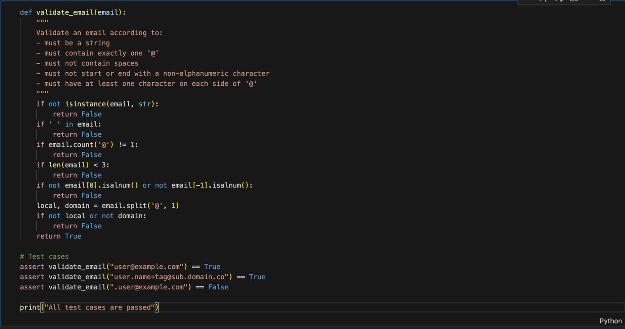

Output:
