

GO Implement

Technical Design and Specifications

Version 2019   
May 2019

 

Copyright

Copyright © 2000-2019 Hexagon AB and/or its subsidiaries and affiliates. All rights reserved.

Including software, documentation, file formats, and audiovisual displays; may be used pursuant to applicable software license agreement; contains confidential and proprietary information of Intergraph and/or third parties which is protected by copyright law, trade secret law, and international treaty, and may not be provided or otherwise made available without proper authorization from Intergraph Corporation.

Portions of this software are owned by Spatial Corp. © 1986-2017. All Rights Reserved.

Portions of the user interface are copyright © 2012-2017 Telerik AD.

U.S. Government Restricted Rights Legend

Use, duplication, or disclosure by the government is subject to restrictions as set forth below. For civilian agencies: This was developed at private expense and is "restricted computer software" submitted with restricted rights in accordance with subparagraphs (a) through (d) of the Commercial Computer Software - Restricted Rights clause at 52.227-19 of the Federal Acquisition Regulations ("FAR") and its successors, and is unpublished and all rights are reserved under the copyright laws of the United States. For units of the Department of Defense ("DoD"): This is "commercial computer software" as defined at DFARS 252.227-7014 and the rights of the Government are as specified at DFARS 227.7202-3.

Unpublished - rights reserved under the copyright laws of the United States.

Intergraph Corporation  
305 Intergraph Way  
Madison, AL 35758

Documentation

Documentation shall mean, whether in electronic or printed form, User's Guides, Installation Guides, Reference Guides, Administrator's Guides, Customization Guides, Programmer's Guides, Configuration Guides and Help Guides delivered with a particular software product.

Other Documentation

Other Documentation shall mean, whether in electronic or printed form and delivered with software or on Intergraph Smart Support, SharePoint, or box.net, any documentation related to work processes, workflows, and best practices that is provided by Intergraph as guidance for using a software product.

Terms of Use

1. Use of a software product and Documentation is subject to the Software License Agreement ("SLA") delivered with the software product unless the Licensee has a valid signed license for this software product with Intergraph Corporation. If the Licensee has a valid signed license for this software product with Intergraph Corporation, the valid signed license shall take precedence and govern the use of this software product and Documentation. Subject to the terms contained within the applicable license agreement, Intergraph Corporation gives Licensee permission to print a reasonable number of copies of the Documentation as defined in the applicable license agreement and delivered with the software product for Licensee's internal, non-commercial use. The Documentation may not be printed for resale or redistribution.
2. For use of Documentation or Other Documentation where end user does not receive a SLA or does not have a valid license agreement with Intergraph, Intergraph grants the Licensee a non-exclusive license to use the Documentation or Other Documentation for Licensee’s internal non-commercial use. Intergraph Corporation gives Licensee permission to print a reasonable number of copies of Other Documentation for Licensee’s internal, non-commercial use. The Other Documentation may not be printed for resale or redistribution. This license contained in this subsection b) may be terminated at any time and for any reason by Intergraph Corporation by giving written notice to Licensee.

Disclaimer of Warranties

Except for any express warranties as may be stated in the SLA or separate license or separate terms and conditions, Intergraph Corporation disclaims any and all express or implied warranties including, but not limited to the implied warranties of merchantability and fitness for a particular purpose and nothing stated in, or implied by, this document or its contents shall be considered or deemed a modification or amendment of such disclaimer. Intergraph believes the information in this publication is accurate as of its publication date.

The information and the software discussed in this document are subject to change without notice and are subject to applicable technical product descriptions. Intergraph Corporation is not responsible for any error that may appear in this document.

The software, Documentation and Other Documentation discussed in this document are furnished under a license and may be used or copied only in accordance with the terms of this license. THE USER OF THE SOFTWARE IS EXPECTED TO MAKE THE FINAL EVALUATION AS TO THE USEFULNESS OF THE SOFTWARE IN HIS OWN ENVIRONMENT.

Intergraph is not responsible for the accuracy of delivered data including, but not limited to, catalog, reference and symbol data. Users should verify for themselves that the data is accurate and suitable for their project work.

Limitation of Damages

IN NO EVENT WILL INTERGRAPH CORPORATION BE LIABLE FOR ANY DIRECT, INDIRECT, CONSEQUENTIAL INCIDENTAL, SPECIAL, OR PUNITIVE DAMAGES, INCLUDING BUT NOT LIMITED TO, LOSS OF USE OR PRODUCTION, LOSS OF REVENUE OR PROFIT, LOSS OF DATA, OR CLAIMS OF THIRD PARTIES, EVEN IF INTERGRAPH CORPORATION HAS BEEN ADVISED OF THE POSSIBILITY OF SUCH DAMAGES.

UNDER NO CIRCUMSTANCES SHALL INTERGRAPH CORPORATION’S LIABILITY EXCEED THE AMOUNT THAT INTERGRAPH CORPORATION HAS BEEN PAID BY LICENSEE UNDER THIS AGREEMENT AT THE TIME THE CLAIM IS MADE. EXCEPT WHERE PROHIBITED BY APPLICABLE LAW, NO CLAIM, REGARDLESS OF FORM, ARISING OUT OF OR IN CONNECTION WITH THE SUBJECT MATTER OF THIS DOCUMENT MAY BE BROUGHT BY LICENSEE MORE THAN TWO (2) YEARS AFTER THE EVENT GIVING RISE TO THE CAUSE OF ACTION HAS OCCURRED.

IF UNDER THE LAW RULED APPLICABLE ANY PART OF THIS SECTION IS INVALID, THEN INTERGRAPH LIMITS ITS LIABILITY TO THE MAXIMUM EXTENT ALLOWED BY SAID LAW.

Export Controls

Intergraph Corporation’s commercial-off-the-shelf software products, customized software and/or third-party software, including any technical data related thereto (“Technical Data”), obtained from Intergraph Corporation, its subsidiaries or distributors, is subject to the export control laws and regulations of the United States of America. Diversion contrary to U.S. law is prohibited. To the extent prohibited by United States or other applicable laws, Intergraph Corporation software products, customized software, Technical Data, and/or third-party software, or any derivatives thereof, obtained from Intergraph Corporation, its subsidiaries or distributors must not be exported or re-exported, directly or indirectly (including via remote access) under the following circumstances:

1. To Cuba, Iran, North Korea, the Crimean region of Ukraine, or Syria, or any national of these countries or territories.
2. To any person or entity listed on any United States government denial list, including, but not limited to, the United States Department of Commerce Denied Persons, Entities, and Unverified Lists, the United States Department of Treasury Specially Designated Nationals List, and the United States Department of State Debarred List (https://build.export.gov/main/ecr/eg_main_023148).
3. To any entity when Customer knows, or has reason to know, the end use of the software product, customized software, Technical Data and/or third-party software obtained from Intergraph Corporation, its subsidiaries or distributors is related to the design, development, production, or use of missiles, chemical, biological, or nuclear weapons, or other un-safeguarded or sensitive nuclear uses.
4. To any entity when Customer knows, or has reason to know, that an illegal reshipment will take place.

Any questions regarding export/re-export of relevant Intergraph Corporation software product, customized software, Technical Data and/or third-party software obtained from Intergraph Corporation, its subsidiaries or distributors, should be addressed to PPM’s Export Compliance Department, 305 Intergraph Way, Madison, Alabama 35758 USA or at exportcompliance@intergraph.com. Customer shall hold harmless and indemnify PPM and Hexagon Group Company for any causes of action, claims, costs, expenses and/or damages resulting to PPM or Hexagon Group Company from a breach by Customer.

Trademarks

Intergraph®, the Intergraph logo®, Intergraph Smart®, SmartPlant®, SmartMarine®, SmartSketch®, SmartPlant Cloud®, PDS®, FrameWorks®, I-Route, I-Export, Isogen®, SPOOLGEN, SupportManager®, SupportModeler®, SAPPHIRE®, TANK, PV Elite®, CADWorx®, CADWorx DraftPro®, GTSTRUDL®, and CAESAR II® are trademarks or registered trademarks of Intergraph Corporation or its affiliates, parents, subsidiaries. Hexagon and the Hexagon logo are registered trademarks of Hexagon AB or its subsidiaries. Microsoft and Windows are registered trademarks of Microsoft Corporation. ACIS is a registered trademark of SPATIAL TECHNOLOGY, INC. Infragistics, Presentation Layer Framework, ActiveTreeView Ctrl, ProtoViewCtl, ActiveThreed Ctrl, ActiveListBar Ctrl, ActiveSplitter, ActiveToolbars Ctrl, ActiveToolbars Plus Ctrl, and ProtoView are trademarks of Infragistics, Inc. Incorporates portions of 2D DCM, 3D DCM, and HLM by Siemens Product Lifecycle Management Software III (GB) Ltd. All rights reserved. Gigasoft is a registered trademark, and ProEssentials a trademark of Gigasoft, Inc. VideoSoft and VXFlexGrid are either registered trademarks or trademarks of ComponentOne LLC 1991-2017, All rights reserved. Oracle, JD Edwards, PeopleSoft, and Retek are registered trademarks of Oracle Corporation and/or its affiliates. Tribon is a trademark of AVEVA Group plc. Alma and act/cut are trademarks of the Alma company. Other brands and product names are trademarks of their respective owners.

Versions

|  |  |  |  |
| --- | --- | --- | --- |
| No. | Description | Author | Date |
| 0.5 | Technology update | Ashwini Kumar S |  |
| 0.4 | Second review | Ashwini Kumar S |  |
| 0.3 | First architecture draft | Ashwini Kumar S |  |
| 0.2 | First review | Ashwini Kumar S. |  |
| 0.1 | Initial version | Ashwini Kumar S | 14.04.2019 |

Contents

Introduction 7

Purpose 7

Scope 7

Definitions, Acronyms and Abbreviations 7

References 8

Requirement Traceability Matrix 8

Overview 9

Technologies 9

Look & Feel 9

Architecture 10

10

10

10

10

10

GO Implement application 10

GO Implement UI 11

GO Implement API: 12

Database/Custom Schema: 12

Development Setup: 12

About Information, Copyright and License Terms 13

Continuous Development and Delivery 13

Git Repository 13

Versioning 14

Unit & UI Testing 14

Deployment 14

Integration Testing 14

Regression Testing 15

Licensing 16

Features and Functionalities 17

Features 17

Installation 17

Virtual Environment creation

Upgrades/Downgrades 17

Configuration 17

Error Handling 17

Security 17

Troubleshooting 17

Audit 17

Basic Functionality 17

Design and Technical Solution Proposal 17

Installation 18

Server 18

Login 18

GO Implement UI 18

GO Implement Web API 18

Requirements 18

Documentation 19

User manual 19

Deployment manual 19

# Introduction

## Purpose

This document is a detailed design and technical specifications of the GO Implement, and is a reference document for future implementation and regression.

The targeted audience are PPM Services, sales users, developers who will implement it, testers who will test it and system architects.

## Scope

GO Implement is a platform where all services teams (regional, corporate & HCCI) would collaborate and deliver efficient professional services by sharing resources & knowledge across the globe. The key capabilities are being planned in the system to support the operating work processes of services business are Resource Management, Project Management, workflows Dashboards & Knowledge Management.

## Definitions, Acronyms and Abbreviations

|  |  |
| --- | --- |
| **UI** | GO ImplementUI |
| **API** | GO Implement Web API |
|  |  |

## References

|  |  |  |  |
| --- | --- | --- | --- |
| Title | Author | Date | Issue |
|  |  |  |  |
|  |  |  |  |

## Requirement Traceability Matrix

All requirements are tagged as follow: R<Number>-<MUST|OPTIONAL>: <Description>

* R: Requirement
* <Number>: Incremental number. It isn’t in any case a priority order number.
* <MUST|OPTIONAL>: Defines whether the requirement is mandatory or optional.
* <Description>: Short but detailed enough description of what is required.

# Overview

## Technologies

The GO Implement is web application is built with various technology stack.

* Python 3.5.7
* Django 2.1
* Django REST Framework
* Elasticsearch(ELK Stack) 6.1.3
* Angular 6
* Apache 2
* SQL Server 2017
* TFS 2018 with Git

Supported browsers are Chrome.

Visual Studio Code or PyCharm with necessary tools and extensions is recommended as Integrated Development Environment.

## Look & Feel

The Go Implement application is implemented using modern web UI rendering tools for smooth user experience.

Refer to the following share points for further UX resources:

<https://xd.adobe.com/view/85a5bbf6-f4a4-4717-5e77-598dafa6e4e0-f394/screen/4897691e-6121-4dd2-b8b8-a02c3b15b5c0/Homepage/?fullscreen&hints=off>

## Architecture

**USER INTERFACE**

### 

APPLICATION LAYER

### 

EcoSys

### 

Bynder

GO SELL

DataBase

### GO Implement application

Objectives of this project to help PPM Global Service Council/Services Team members to easy out their day to day operations with a web application which provides

* Knowledge Management
* Project Management
* Resource Management
* Workflows
* Notification
* Dashboards

### GO Implement UI

GO Implement app UI is developed using Angular 6 Framework;

Here is the folder structure;

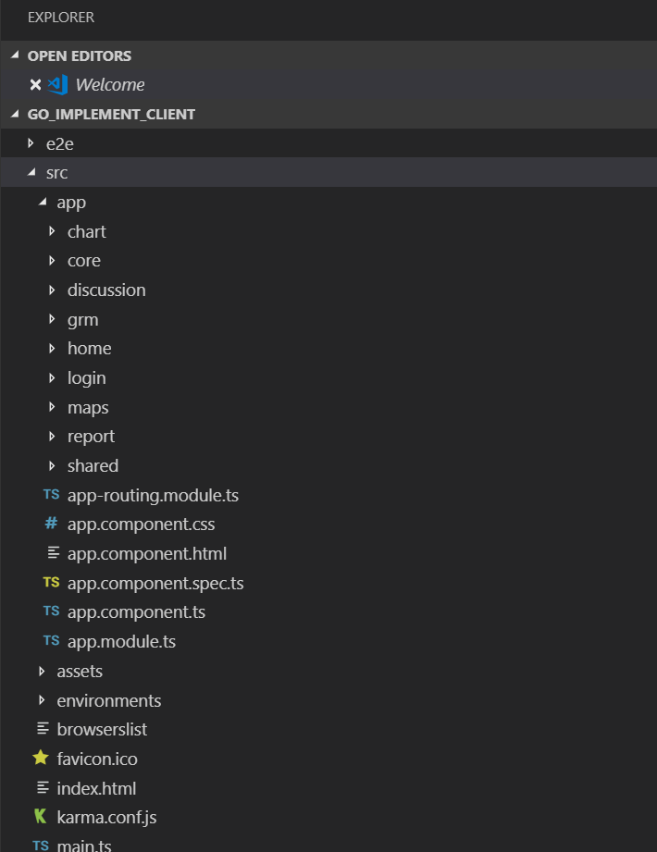

### GO Implement API:

GO Implement application layer exposed via Django REST APIs;

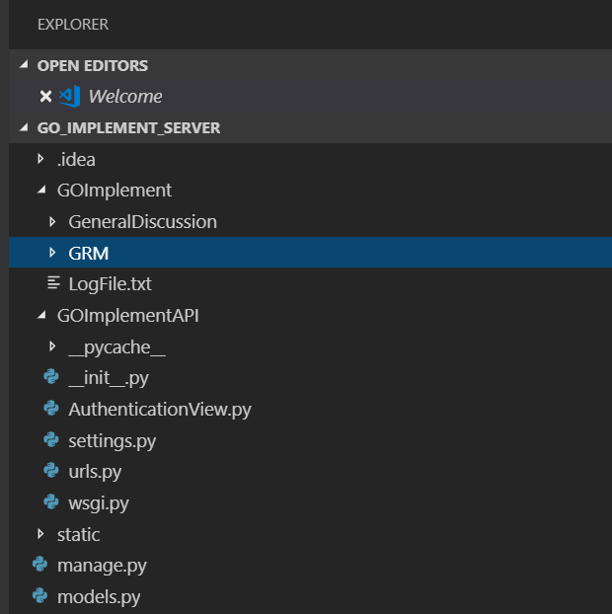

### Database/Custom Schema:

GO Implement application supported Database is sqlserver 2014 or higher version

### Development Setup:

**Client application Setup:**

**API Application Setup:**

**Elasticsearch Setup:**

**Discussion Forum Setup:**

## About Information, Copyright and License Terms

The GO Implement application has an “About” page like other applications. It must contain (see figure 2 for an example):

* **Version**: The application version number, e.g. 18.1.2.562
* **Build time**: The date of when the build was made, e.g. yyyy.mm.dd
* **Copyright line**: “Copyright © Hexgon PPM. All rights reserved”
* **A link to “Additional Copyright Notice and Software License Terms”**: localised detailed legal terms

The application number is set automatically when building the GO Implement application and follows the version numbering convention agreed at Hexagon PPM This can be obtained by reading the compiled assembly info.

The copyright line must be present and, as of now, there is no common place to get the copyright string. It is also important to mention that the copyright line must also be present in the assembly info class.

# Continuous Development and Delivery

## Git Repository

All source files must be managed in source control.

<http://in-ppmstfs1:8080/tfs/GSC/_git/GO%20Implement>

## Versioning

## Unit & UI Testing

## Deployment

## Integration Testing

Run integration tests from the emulated device?

Test data

## Regression Testing

# Licensing

Nothing required

# Features and Functionalities

## Features

### Installation

#### Server

#### Devices

.

### Create Virtual Environment

create a Python virtual environment and manage it, we use the module venv. Normally, it will install the latest version of Python for you, but you can choose that. But before we begin, let’s find out which version of Python we are using.

To do this, type the following in your Command Prompt (for Windows; type ‘cmd’ in search):  
python –version

This is what it will look like:

Microsoft Windows [Version 10.0.16299.248]

(c) 2017 Microsoft Corporation. All rights reserved.

C:\Users\lifei>python –version  
Python 3.6.0

C:\Users\lifei>  
Now, let’s check if we have pip installed.

C:\Users\lifei>pip –version  
pip 9.0.1 from c:\users\lifei\appdata\local\programs\python\python36-32\lib\site-packages (python 3.6)

We do. This is because we installed Python from python.org. In case you do not have pip installed, you may need to [**install**](https://pip.pypa.io/en/stable/installing/) it manually.

Now, let’s begin. In your command prompt, move to the directory you want to work in:

C:\Users\lifei>cd Desktop

Now, type in the following:

C:\Users\lifei\Desktop>python -m venv workwithenv

You will see the following directory on your Desktop

In side this, you can see the following contents:

[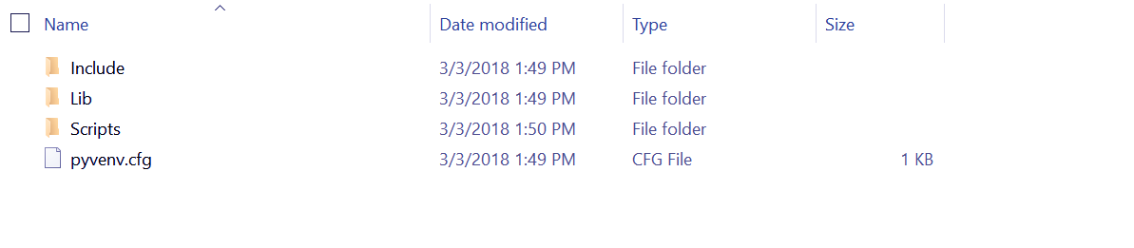](https://d2h0cx97tjks2p.cloudfront.net/blogs/wp-content/uploads/sites/2/2018/03/workwithenv-Python-Virtual-Environment-and-Packages-.png)

*Python Virtual Environment and Install Python Packages*

[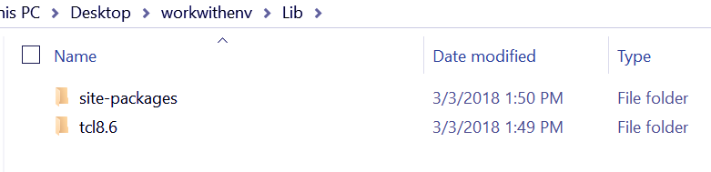](https://d2h0cx97tjks2p.cloudfront.net/blogs/wp-content/uploads/sites/2/2018/03/workwithenv-lib-Python-Virtual-Environment-and-Packages.png)

*Python Virtual Environment and Install Python Packages*

[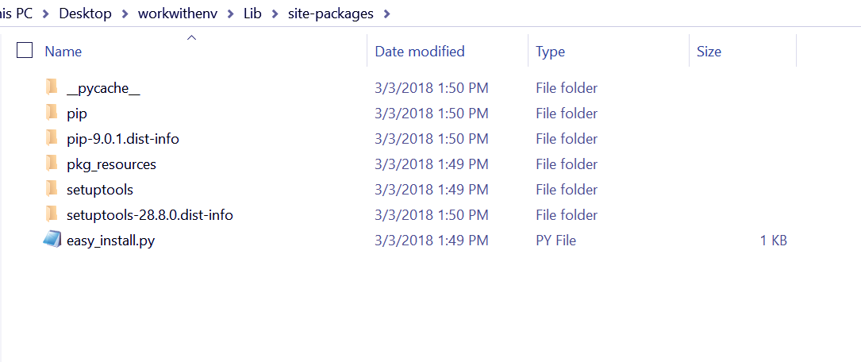](https://d2h0cx97tjks2p.cloudfront.net/blogs/wp-content/uploads/sites/2/2018/03/Python-virtualenv-sitepackages-.png)

*Virtual Environment and Install Python Packages – sitepackages*

[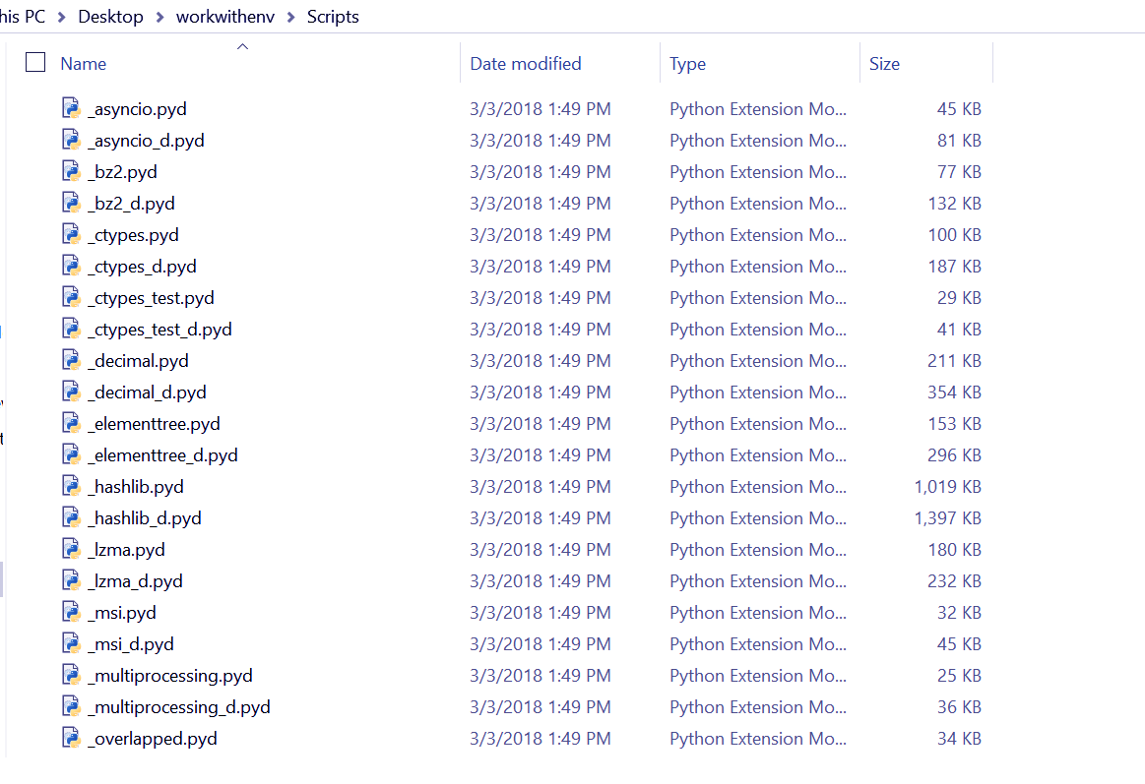](https://d2h0cx97tjks2p.cloudfront.net/blogs/wp-content/uploads/sites/2/2018/03/Python-virtualenv-scripts.png)

*Python Virtual Environment and Install Python Packages – scripts*

While the directory Include is empty, the other two aren’t:

As you can see, the command created the directory ‘workwithenv’ because it didn’t already exist. It also created subdirectories containing a copy of the Python interpreter, the standard library, and various supporting files.

Now, to activate the Python Virtual Environment, we will run the batch file activate.bat in the directory Scripts:

C:\Users\lifei\Desktop>workwithenv\Scripts\activate.bat

We get the following output:

(workwithenv) C:\Users\lifei\Desktop>

This script is for the bash shell.

### Upgrades/Downgrades

### Configuration

can be extended to build resources from the database.

### Error Handling

### Security

### Troubleshooting

### Audit

All requests sent to the GO Implement application are currently logged in the Apache access/error log.

In addition, the system tracks the device’s activity for further troubleshooting.

## Basic Functionality

# Design and Technical Solution Proposal

## Installation

### Server

### Login

The login page is displayed when starting the GO Implement application.

Figure : Login page flow chart

## **GO Implement UI**

## **GO Implement Web API**

# Requirements

**Error! Reference source not found.**

# Documentation

## User manual

Installation on devices

User guide

## Deployment manual

Installation on server

System settings