The following Screenshots will help you for installing SQL Client Tools & SQL Server 2008.

Note :

After MS SQL 2008 has been installed, then you need to use the MS SQL 2008 Management Studio to connect to both MS SQL 2008 and MS SQL 2005 instances.

Steps For installing SQL 2008

Installation Path : \\in-filesrv01\Software\Microsoft\EA\MSDN_Premium\Servers\SQL Server\SQL Server 2008 Enterprise Edition
(Or)
Installation Path : \\in-filesrv01\Software\Microsoft\EA\MSDN_Premium\Servers\SQL Server\SQL Server 2008 Standard Edition

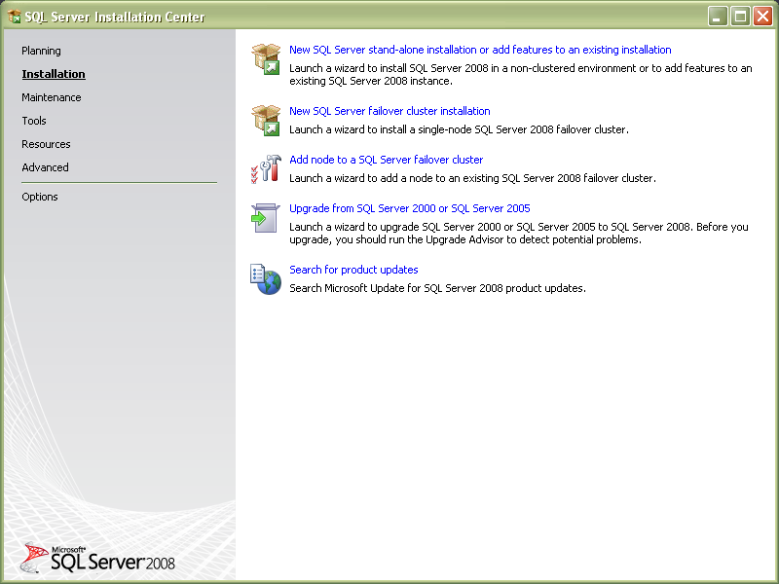

Click on New SQL Server stand-alone installation in the SQL Server Installation Center DialogBox.

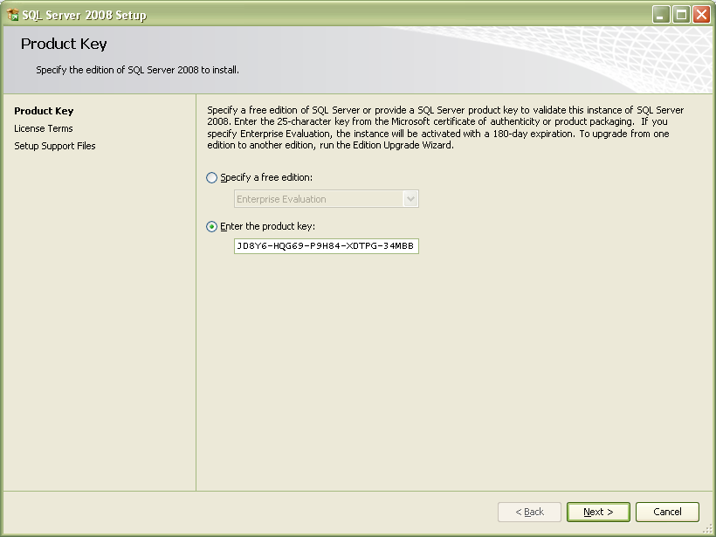

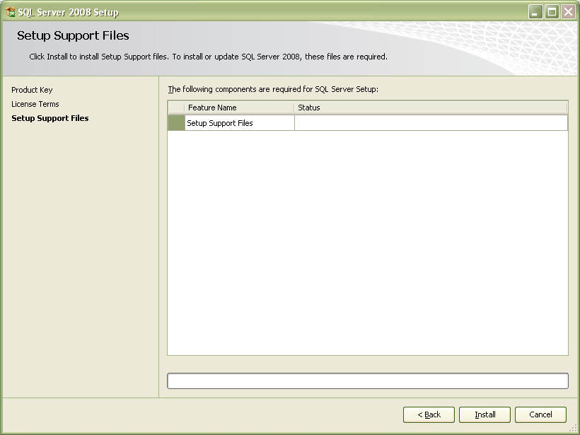

After Installing the Setup support files it will start the Feature Selection DialogBox.

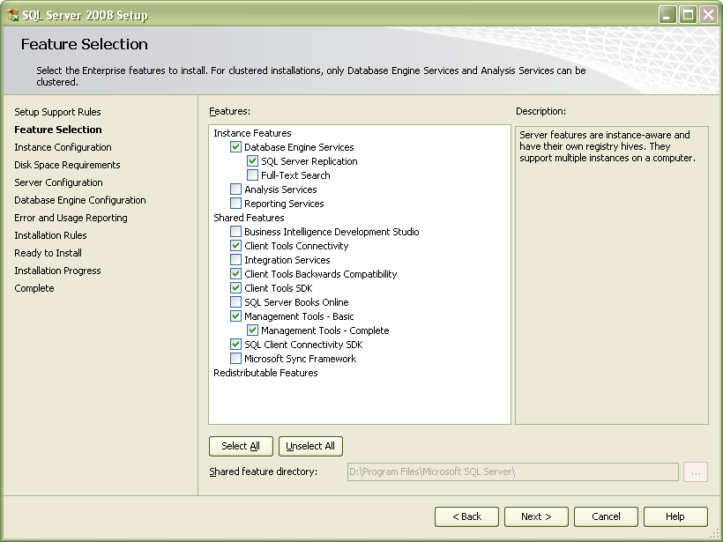

Important Note :

- If you don’t intend to create databases locally on your own machine, then you don’t need “Database Engine Services” or “SQL Server Replication”.
- If you don’t intend to compile anything against MS SQL 2008, then you don’t need “Client Tools SDK” or “SQL Client Connectivity SDK”.

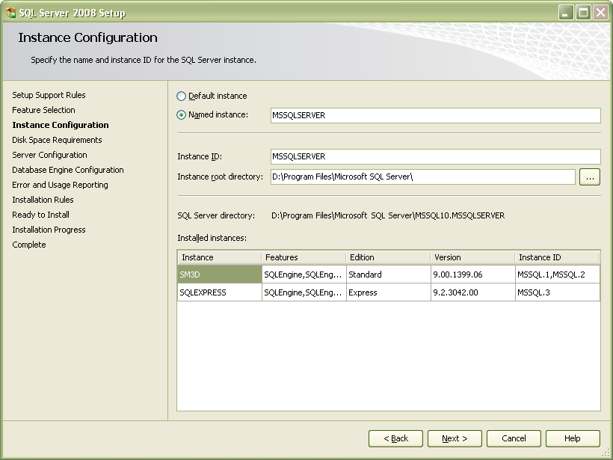

Here you can prefer Named Instance/Default Instance and Installation path for SQL Server 2008

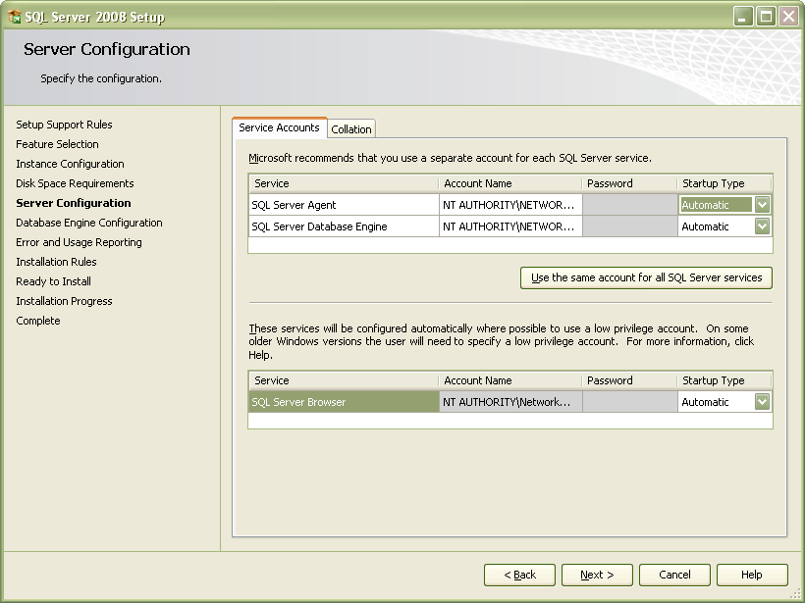

For most users, you should be fine selecting the NT AUTHORITY\NETWORK SERVICE account as the service account to use.

Also By default the Startup Type for SQL Server Agent will be Manual. Automatic is Preferable

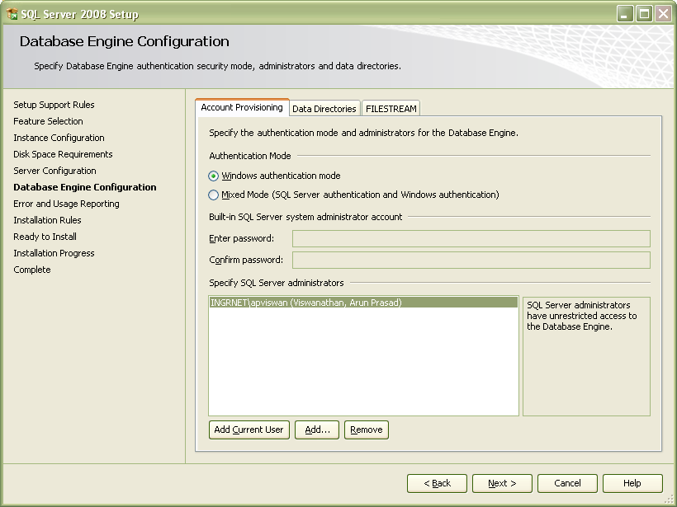

The Data Directories Tab will ask you the path for DB directories.
Click Add Current User and Next.

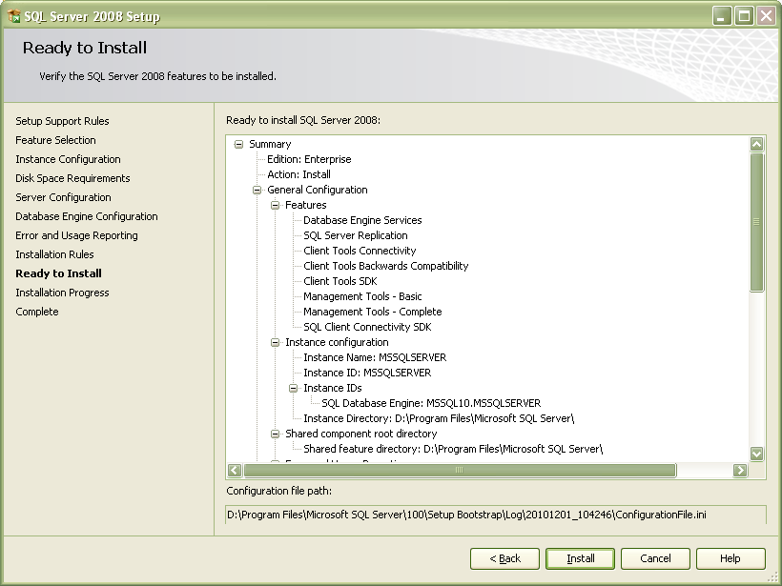

So Start the Installation process By clicking Install.

Note :

You need to get the base installation through your MSDN subscription.
It is available in \\in-filesrv01\Software\Microsoft\EA\MSDN_Premium\Service Packs\SQL Server 2008\SP1

Service Pack 1 can be downloaded from here: http://www.microsoft.com/downloads/en/details.aspx?familyid=66AB3DBB-BF3E-4F46-9559-CCC6A4F9DC19&displaylang=en

