***Proposal for:***

SmartPlant Cloud and   
Cloud Advantage Services

*Submitted to:*

<CUS>





**June 8, 2017**

**Document Number: <CUS>_ADVREMIAD_SPCloud_Cloud_Advantage_Proposal**

Copyright

Copyright© 2004-2016 Intergraph Corporation. All Rights Reserved.

Including software, file formats, and audiovisual displays; may be used pursuant to applicable software license agreement; contains confidential and proprietary information of Intergraph and/or third parties which is protected by copyright law, trade secret law, and international treaty, and may not be provided or otherwise made available without proper authorization.

Notice

This Proposal is Confidential Information of Intergraph Corporation and other third parties that shall not be disclosed outside LNGC or duplicated in whole or in part, for any purpose, except as stated herein. Where disclosure of Confidential Information requires review by third parties, LNGC shall formally request permission from an authorized representative of Intergraph Corporation to duplicate, use, or disclose in whole or in part the said Confidential Information. This Proposal does not in any way constitute a commercial offer from Intergraph Corporation, and Intergraph Corporation makes no representations or warranties with respect to any information contained herein. Any information Intergraph Corporation has shared during the proposal activities are merely to provide an overview of Intergraph Corporation’s current expected direction, roadmap or vision and is subject to change at any time at Intergraph Corporation’s sole discretion and without notice. Intergraph does not commit to develop any features, functions or products at the rates discussed in this proposal. LNGC should factor any information contained herein into its current buying decision because Intergraph Corporation makes no assurance that future features, functions or products described herein will be developed at any particular rate. No pricing or functionality commitments are intended, expressed, or implied.

Trademarks

Intergraph, the Intergraph logo, PDS®, SmartPlant®, SmartMarine®, FrameWorks®, SmartSketch®, I-Route,  I-Export, ISOGEN®, SPOOLGEN, SupportManager®, SupportModeler®, TANK, PV-Elite, CADWorx®, CADWorx DraftPro®, and CAESARII®  are trademarks or registered trademarks of Intergraph Corporation or its subsidiaries in the United States and other countries.  Microsoft® and Windows® are registered trademarks of Microsoft Corporation. MicroStation® is a registered trademark of Bentley Systems, Inc. SAP® and SAP NetWeaver® are registered trademarks of SAP AG in Germany and in several other countries. Other brands and product names are trademarks of their respective owners.

Revision History

|  |  |  |  |
| --- | --- | --- | --- |
| **Version** | **Date** | **Prepared By** | **Reason** |
| 1.0 | 1 Sep 2016 | Supratim Mukhopadhyay | Completed documenting Cloud Advantage services including SmartPlant Cloud Budgetary information for customer’s perusal. |

Contents

1 SmartPlant Cloud & Cloud Advantage For <CUS> 5

1.1 Executive Summary 5

1.2 Background 7

1.3 SmartPlant Cloud Services 7

1.3.1 Introduction To SmartPlant Cloud 7

1.3.2 What is included in SmartPlant Cloud 10

1.3.3 What is not included in SmartPlant Cloud 11

1.3.4 Scope Of Work To Establish SmartPlant Cloud 11

1.3.5 SmartPlant Cloud – Schedule to Initiate the Service 13

1.3.6 SmartPlant Cloud – End User Desktop Specification 13

1.4 Cloud Advantage 14

1.4.1 Customer Success Management 14

1.5 High Level Plan For Delivery of SmartPlant Cloud With Cloud Advantage 15

1.5.1 Readiness – Establish SmartPlant Cloud And Customer Readiness 15

1.5.2 Migration – Migrate Customer To SmartPlant Cloud 16

1.5.3 Adoption – Ensure Customer Success Through The Use Of SPCloud 16

1.6 Intergraph Roles 17

2 Change Management Process 17

3 Terms & Conditions 18

4 Pricing – SPCloud And Cloud Advantage Services 18

5 Pricing – Licenses <Use this section only if required> 19

6 Acceptance 20

# SmartPlant Cloud & Cloud Advantage For <CUS>

## Executive Summary

<Project Background>

**Intergraph PP&M** is the world’s leading provider of enterprise engineering software enabling smarter design and operation of plants, ships and offshore facilities. Intergraph PP&M engineering solutions increase productivity and accelerate projects by providing the full design, construction, materials, and engineering data management capabilities needed for the creation, safe operation and maintenance, and capital Project Life Cycle Management (cPLM) of large-scale process, power, marine and offshore projects.

Intergraph PP&M is part of Hexagon, a leading global provider of information technologies that drive quality and productivity improvements across geospatial and industrial enterprise applications.

Please visit our website to learn more: <http://ppm.intergraph.com/>

**SmartPlant Cloud** is a tailored computing environment offering a self-contained ecosystem of SmartPlant Enterprise, third-party solutions, and in-house applications supported by dedicated technical and business operations services uniquely tailored to the energy industry.

SPCloud is supported by Intergraph’s industry leading support and consulting services: our aim is to become business partner who also provides the necessary training and ongoing support.

**Cloud Advantage** is Intergraph’s structured adoption framework to help both owners and EPCs transition to a SmartPlant® Cloud environment, and to be more successful and get the most benefit from the technology on an ongoing basis. The program consists of seven distinct elements namely – Readiness, Migration, Adoption, Advice, Analysis and Innovations - which are overseen by an assigned Customer Success Manager to ensure the success of each program element.

Cloud Advantage – Readiness, Migration and Adoption elements are relevant to this document.

## Background

The purpose of this proposal is to provide the customer with an understanding of the process that will be followed to implement SPCloud and the successful delivery and adoption of SmartPlant Cloud with Cloud Advantage Success Management. This proposal includes the proposed pricing of the SmartPlant Cloud services and Cloud Advantage services <as well as the license pricing for the use of <applications(s)>.

The SPCloud and Cloud Advantages services being proposed are based on the following usage structure:

* <Usage Structure>

## SmartPlant Cloud Services

A comprehensive list of services provided by SmartPlant Cloud will be agreed to in the Master Services Agreement between <CUS> and Intergraph Corporation on the acceptance of the proposed pricing along with agreed levels of Service. A copy of the standard MSA can be made available to <CUS> on request. Please refer to the following information on SmartPlant Cloud for budgetary purposes:

### Introduction And Benefits Of SmartPlant Cloud

Cloud computing is a powerful option for organizations seeking to address improved performance and a lack of local skills by deploying from a central service. An experienced support organization can support and maintain the application environment to all projects and operating plants to increase quality, reduce schedule, lower CAPEX / OPEX and whilst improving safety.

Intergraph® SmartPlant Cloud (hereinafter referred to as SmartPlant Cloud) is Intergraph PP&M’s hosting solution, a dynamic cloud computing environment to support the entire suite of SmartPlant applications. SmartPlant Cloud removes the need for customer hardware and infrastructure and allows users to access SmartPlant applications / project environments via a simple URL.

The main areas where SmartPlant Cloud can help your business are around reducing costs, improve project security, provide useable software in weeks, maintain your data ownership, and increase collaboration, while providing industry leading support.

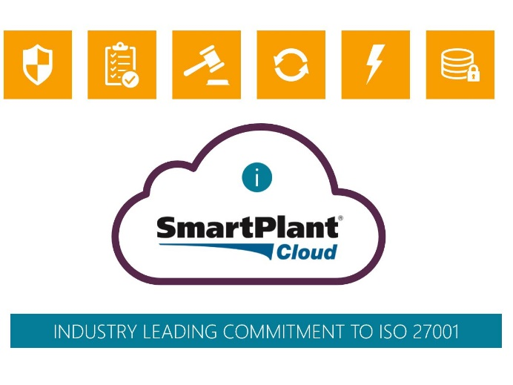Your data is secure. SmartPlant Cloud is *ISO27001 Certified*. SmartPlant Cloud also eliminates the need to add vendors, suppliers, and other 3rd parties to your internal network, which increases the risk of your internal and business systems. With SmartPlant Cloud you reduce your risk, IT overhead on configuring these accesses, and increase the security around the plant or project.

SmartPlant Cloud provides rapid deployment, robust security and a dynamically scalable environment that has been desig­ned to specifically support all sizes of projects and assets for both the owner operator (OO) and engineering procurement contractor (EPC) companies, regardless of global location. This agility and scalability allows you to ‘pay as you go’’ and react to opportunities more quickly.

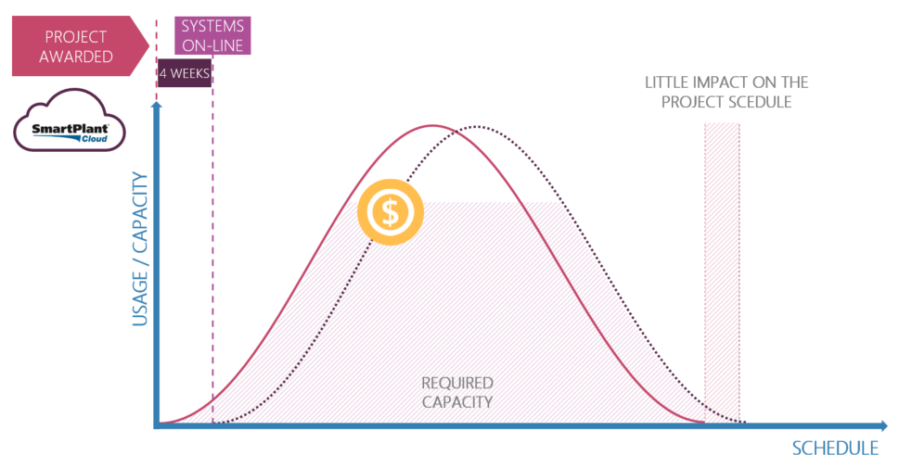

*Your data is always yours*. You can on board and off board your data as often as you desire. With SmartPlant Cloud you can receive backups of your data to keep on premise if you choose.

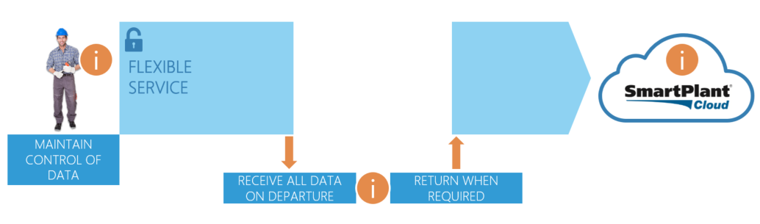

SmartPlant Cloud provides an entire software ecosystem that allows EPC’s and OO’s to provision users with the required engineering software tools and utilities. The service, which is accessed through an intuitive web-based portal, has been configured to adapt to com­pany specific standards, engineering workflows and processes. SmartPlant Cloud allows better global collaboration, increased quality, and lessens the hand-over and schedule impact of getting global projects up and working.

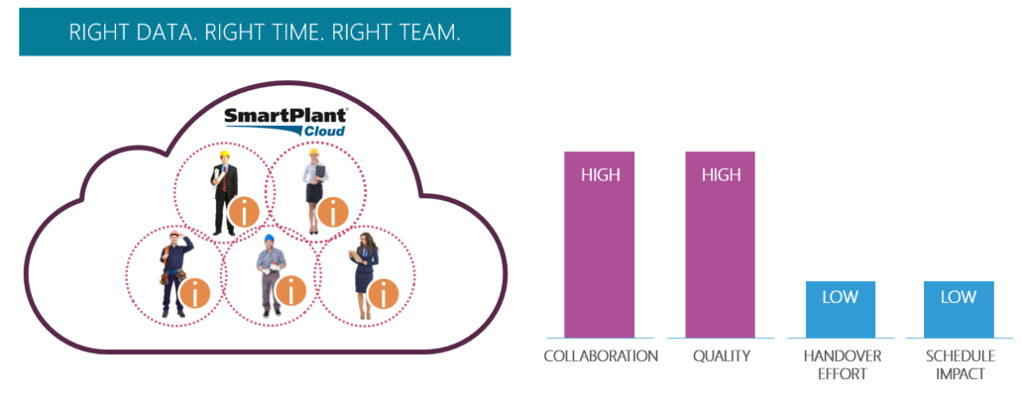

*Hypercare* is unique to SmartPlant Cloud. Hypercare is a combination of early technical investigations to make sure your infrastructure and connection to SmartPlant Cloud is up to the task and onsite or remote training is provided, removing any obstacles to user access and use. An Intergraph PP&M expert helps your users access, advise on work process changes and basically ‘walk the floor’ to support your transition to SmartPlant Cloud.

Intergraph also recognizes that the move to a Cloud based use of SmartPlant Applications in the Energy industry is not an easy decision to make and the change wouldn’t happen at the flick of a button. Intergraph have thus developed a structured adoption program aptly named *Cloud Advantage* to help companies make a successful transition to the Cloud and to continue to benefit from the user of Cloud for achieving their business outcomes. Details of the methodology are found in Section 1.4

### What is included in SmartPlant Cloud

SmartPlant Cloud supports customer objectives to reduce CAPEX / OPEX costs and shorten project schedules by enabling all parties involved in either the design of a project, or operations and maintenance of a facility to share a consistent common view of all documents and data available. With data silos effectively removed, greater efficiency can be achieved and both project and operational risk reduced whilst effectively delivering a higher quality and safer facility.

All items below are included in the SmartPlant Cloud application monthly fee.:

* Globally located Data Centers (co-located on tier 3 providers)
* IT staff for OS and DB notices, upgrades and routine maintenance
* IT Staff for proactive provisioning of CPU, table space, and memory requirements
* Computer hardware right-sized for usage requested
  + Servers, disc, memory, and processors
  + Firewalls, NetScaler, security devices
  + Specialized Scale Out File Storage (SOFS) for improved performance
* Zero Footprint file transfer mechanism
* Off Site Disaster Recovery (OSDR) as part of the standard application hosting fee
* Contractually agreed disaster recovery response times (RTO)
* 4 daily backups of application databases (1 going to OSDR)
* All applicable Operating System, Database and hosting technology licenses
* SmartPlant application install with customer seed files, templates and user privilege verification
* Simple to navigate portal for managing user access and privileges
* Proactive Security and governance
  + Vulnerability scanning, Hardening, Log Analysis
  + 16 different virus scanners
* Various third party applications i.e. 5 copies of MS Excel per Estate
* Proactive Estate management and maintenance
* 24 x 7 support of the infrastructure and applications
* Service Level Agreement (SLA) with agreed performance metrics
* Monthly service reports (usage, uptime, etc.)
* User administration and setup

### What is not included in SmartPlant Cloud

An additional fee is chargeable on top of the SmartPlant Cloud service fee for the following items:

* Microsoft O365
* MyCompliance
* Microsoft office tools for end users
* Third party applications
* On-Boarding of Estates
* Off-Boarding of Estates
* Configuration services for application set up
* Development Estates

Ultimately SmartPlant Cloud enables customers to drive down costs and reduce project schedules, by optimizing the use of standards and data across all facilities and projects, ensuring higher quality deliverables and safer operating facilities.

### Scope Of Work To Establish SmartPlant Cloud

It is important to note that for majority of application users SmartPlant Cloud neither removes any SmartPlant application functionality nor adds any SmartPlant application functionality. Some initial project creation and administrative settings/tasks are transferred to the SmartPlant Cloud team due to infrastructure naming, automation, and monitoring activities required to meet security and uptime agreement.

SmartPlant Cloud is a way to reduce costs and provision SmartPlant applications via the Web. It offers benefits of additional Intergraph direct and focused support by means of a Service Level Agreement (SLA) for accessibility and improved working environment for the customers.

The following process identifies what is needed to On-board an Estate.

Intergraph has a SmartPlant Cloud on-boarding process which is described as follows:

* Each customer has the ability to have one (1) or more “Estates” in the SmartPlant Cloud environment. An Estate is a single, unified and secure computer environment, which can contain multiple projects and user communities. An Estate is strictly bounded and isolated from communication with any other Estate.
* Each Estate consists of one or more SmartPlant software products, their associated SmartPlant software products’ engineering reference data, application databases, and other prerequisite third-party software.
* Where separate secure work areas are required for activities such as production development, testing, and training, each of these areas are separate Estates.
* An Estate is also able to support multiple EPCs, each having a secure area. In such an Estate, the EPC partition shares a single set of databases and starts at the plant level in the SmartPlant software data structure level. Each user in an Estate has access to personal Scratch Pad disk space.

In order for the Intergraph SmartPlant Cloud team to build a new Estate or extend an existing Estate / site for a customer, the customer must complete the following:

* A Sales Order Form (SOF) as part of the commercial process
* A Customer Requirement Specification (CRS) for the full technical specification of the Estate(s)
* The Permitted Named User Access List to be completed and returned to Intergraph or alternatively, customer can use the SmartPlant Cloud Administration web portal to add the users via a web interface

In addition, Intergraph has to have sufficient information pertaining to the customer’s planned use of:

* Standard and non-standard SmartPlant applications
* The configuration of the applications to be used, (i.e., standard or customer-specific)
* Standard and any additional third-party applications
* The project characteristics, such as size, duration, etc.
* The names and geographical locations of all groups of all potential users worldwide

Intergraph will review the forms, seek any clarifications or additional information if required, and then propose a build start date and then an operational start date.

### SmartPlant Cloud – Schedule to Initiate the Service

Following the completion and collection of all data required to provision the SmartPlant Cloud service, the timeframe to initiate a SmartPlant Cloud environment is approximately 2 weeks. The key activities that are completed include:

* Completion of all forms collecting relevant data to provision the service.   
  Note: the 2 weeks to provision the service only begins after all forms are completed.
* Provision of infrastructure and hardware
* Provision of relevant Oracle / Microsoft SQL databases
* Provision of SmartPlant applications
* Loading of customer-specific SmartPlant application configurations
* User creation and access right setup
* Backup and restore process configuration
* Basic Testing of the service, user permissions and access levels
* Release to customer

Intergraph anticipates that the vast majority of environments can be set up in a three-week timeframe, but reserves the right to review each configuration as it is requested by the customer to ensure project objectives are met.

Note: The Cloud Advantage (Section 1.4) READINESS phase includes these 2 weeks.

### SmartPlant Cloud – End User Desktop Specification

Only personal desktop and laptop computer devices are supported for use of the SmartPlant Cloud service environment at this time. Other devices such as tablets and smartphones can access the SmartPlant Cloud service environment, but are not recommended as there are limitations of use.

A computer device must have:

* Network Interface Card (NIC)
* Internet access network connection
* Windows-compatible sound card for sound support (if required)

Supported operating systems

* Windows 7, 32-bit and 64-bit editions
* Windows XP Professional, 32-bit and 64-bit editions
* Windows Vista, 32-bit and 64-bit editions

Supported Web browsers

* Microsoft Internet Explorer v9.0.8112.16421 or newer
* Mozilla Firefox® v16.0.2 or newer
* Google Chrome v23.0.1271.95m or newer

Supported Citrix client software

* Citrix Receiver for Windows Version 3.3 and later

## Cloud Advantage

Cloud Advantage is Intergraph’s structured adoption framework to help both owners and EPCs transition to a SmartPlant® Cloud environment, and to be more successful and get the most benefit from the technology on an ongoing basis. The program consists of seven distinct elements namely – *Readiness, Migration, Adoption, Advice, Analysis* and *Innovations* - which are overseen by an assigned Customer Success Manager to ensure the success of each program element. Cloud Advantage provides a step by step transition of a customer to the Cloud in a phased approach and ongoing management to ensure successful adoption of the service in helping achieve the customer’s business outcomes.

### Customer Success Management

Intergraph will assign a **Customer Success Manager** as part of Cloud Advantage Services to oversee the completion and ensuring success for <CUS> through each of the Cloud Advantage phases. The core objective of this service and the role will be to ensure the customer’s success in the adoption of SmartPlant Cloud services for the current and possible future initiatives. This role will also support the establishment of the Cloud Advantage strategy for <CUS> and their move to utilizing the Cloud services more effectively to gain efficiency in conducting their business.

## High-Level Plan For Delivery of SmartPlant Cloud With Cloud Advantage

Following is the high-level plan for the successful implementation of SmartPlant Cloud with Cloud Advantage.

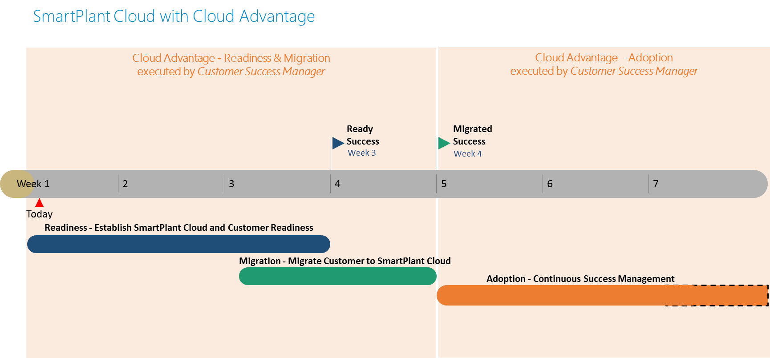

### Readiness – Establish SmartPlant Cloud And Customer Readiness

The readiness phase of the implementation is to ensure that the SmartPlant Cloud service is set up and ready as well as the customer and the application being moved to Cloud is ready for service. This phase is a pilot phase delivered under the supervision of the Customer Success Manager with the support of a Hyper Care manager provided by the SmartPlant Cloud Service for 2 weeks, in establishing:

* *Infrastructure Readiness* – Data Centre, Network, Backup/Restore
* *Application Readiness* – Core Application, Customizations, Versions, Additional Functionality/Tools/Services if any.
* *Work Process Readiness* – Understanding and ensuring that the work processes to be executed with the application(s) are Cloud ready.
* *People Readiness* – Ensuring that <CUS> engineers are ready to use the <application(s)> on the Cloud.



### Migration – Migrate Customer To SmartPlant Cloud

Once the *Readiness* has been achieved, the customer is moved to the *Migration* phase of the implementation of SmartPlant Cloud. *Migration* is a necessary step to undertake before the users start using SmartPlant Applications on the Cloud. The *Migration* phase will again be supervised by the Customer Success Manager in executing:

* *Migration Planning* – Schedule the migration process for clarity of all parties involved
* *Data Migration* – Final migration of all <application(s)> data for use by <CUS>.
* *Migration Training/ & Testing* – Training will be provided to Super Users on how to launch the <application(s)> from SmartPlant Cloud. Users are able to perform their own tests.
* *Performance Benchmarking* – Establishing the baseline of performance of <application(s)> ensuring that <CUS> engineers are ready to use the applications on the Cloud. This baseline will serve as a reference for the application performance and ongoing maintenance of the performance levels. The performance baseline could be re-established after a period of time depending on the amount of data and number of users accessing the applications.

### Adoption – Ensure Customer Success In The Use Of SPCloud

*Adoption* is an ongoing engagement with <CUS> in providing a single point of contact in the Customer Success Manager for all SPCloud and matters related to the applications hosted on SPCloud. The customer success manager will work closely with Intergraph Account Manager for <CUS> in expediting the resolution of issues and ensuring that customer’s business outcomes are achieved through the service.

Customer Success Management for SmartPlant Cloud will include:

* *Business outcomes management* – Ensuring all the services are ready to help achieve customer’s business outcomes as per their milestones.
* *Coordination of SPCloud issues* – Ongoing management of SPCloud service requests and prioritization per the customer’s business requirements.
* *Scope and Change Management* – Ongoing management of the scope of the service and changes as required by the customer.
* *Scheduling & resource allocation* – Scheduling of tasks and resources as required to address specific requirements raised by the customer for the service being provided. This includes *additional* services (charged separately) that may be requested for business consulting support or maintenance related activities (above and beyond standard maintenance provided by SPCloud Service)

## Intergraph Roles

Intergraph would like to propose the following roles and personnel (TBA) to provide the management and leadership of the above services. These members form the core team for delivery of the services, but more experts, analysts and engineers could be sourced as required to form the teams responsible for delivery.

|  |  |  |
| --- | --- | --- |
| Role | Lead | Scope |
| Customer Success Manager Asia Pacific | To be assigned | SPCloud Transition & Adoption Management |
| Intergraph Account Manager <CUS> |  | Account Management |
| SmartPlant Cloud HyperCare |  | 2 Weeks (1 *Readiness*, 1 *Migration*) technical expertise working with CSM to establish smooth running of the service. |
| SmartPlant Cloud Services |  | Ongoing SPCloud Services per MSA |

# Change Management Process

The management of change on a SmartPlant Cloud estate follows a strictly documented guideline as described in the MSA. Estate Change Management is one of the activities performed by the Customer Success Manager (CSM) on behalf of <CUS> as part of the *Adoption* phase. For major changes that might require impact/cost analysis (for e.g. not included in MSA) the following procedure will be followed by the CSM for any changes requested by the <CUS>:

* Customer Success Manager will evaluate the change request and assess how implementing the requested change might impact the overall price and schedule. Intergraph will provide the change request impact statement to the client as a Change Proposal (CP).
* The client will review the CP and evaluate its benefits and impact on other objectives to determine if the change should be implemented. If the CP is to be implemented, CSM will issue a Change Order to the client for final approval.
* Upon issuance of the Change Order by Intergraph, the client will sign the Change Order. The client will make the appropriate change(s) in the applicable PO to reflect the agreed-upon price, schedule, and Deliverable changes as noted in the Change Order and deliver same to Intergraph.
* The change will be undertaken by the relevant Intergraph organisation under the supervision of the CSM.

# Terms & Conditions

This proposal is covered under the following terms and conditions:

* For Delivery of the core SmartPlant Cloud Services detailed in Section 1.3 the Terms and Conditions of the SmartPlant Cloud Master Services Agreement are applicable.
* For Delivery of Cloud Advantage Adoption Services detailed in Section 1.4 the standard Intergraph PP&M Consulting Terms and Conditions are applicable.

This proposal is valid for 30 days from release and subject to change due to changes in requirements or pricing of these services during this period.

# Pricing – SPCloud And Cloud Advantage Services

Based on the background information provided for the range of users accessing <application(s)> at <CUS>, the following pricing is being proposed.

*<Please use the embedded CA pricing calculator. Remove this section and calculator before release> *

|  |  |  |  |  |
| --- | --- | --- | --- | --- |
| Phase | SmartPlant Cloud Services (USD) | Cloud Advantage-Adopt Services (USD) | Type | Total (USD) |
| Readiness (includes on-boarding fee) | $25,000 | $5,000 | **One-Off** | **$30,000** |
| Migration |  | $10,000 | **One-Off** | **$10,000** |
| Adoption (continuous success mgmt.) | **Based on <x> <application(s)> Licenses** | **CSM** | **Monthly** | **Total** |
| <$xxx> | <$xxx> | **<$xxx>** |

The *Readiness* price includes the SmartPlant Cloud On-Boarding fee.

Any additional Work requested outside of this scope of work will be charged at the prevailing rates as per the MSA.

# Pricing – Licenses <Use this section only if required>

|  |  |  |  |  |  |
| --- | --- | --- | --- | --- | --- |
| Software | License Type | Unit Price (USD) | Rate Type | Quantity Requested | Total (USD) |
| <application> | **<Lease>** | **<xxx>** | **<Monthly>** | **<xx>** | **<$xxx>** |
|  |  |  |  |  |  |

# Acceptance

|  |  |
| --- | --- |
| Intergraph Representative | <CUS> Representative |
| <<Name>> | <<Name>> |
| Signature: | Signature: |
|  |  |
| Date: MMM DD, YYYY | Date: MMM DD, YYYY |
|  |  |